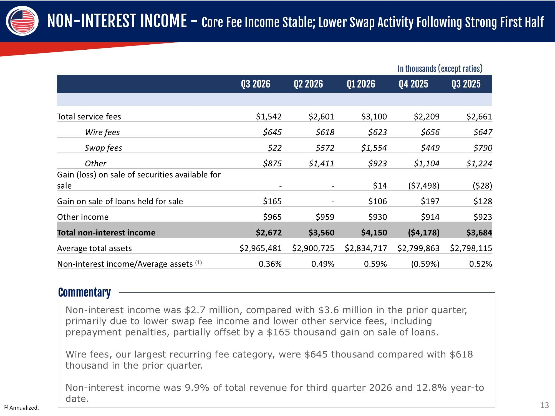
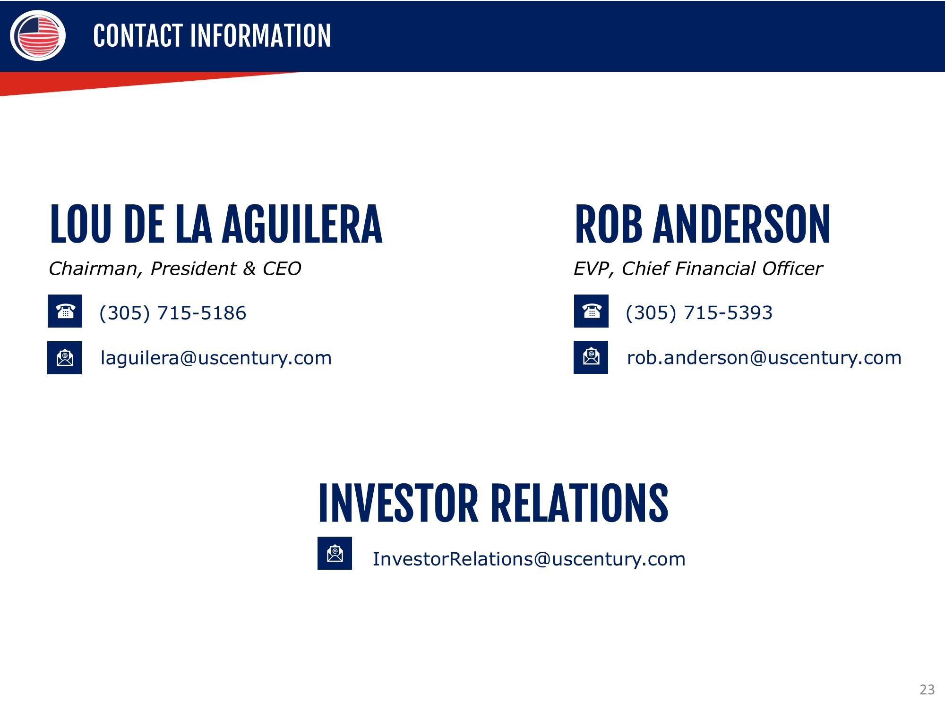
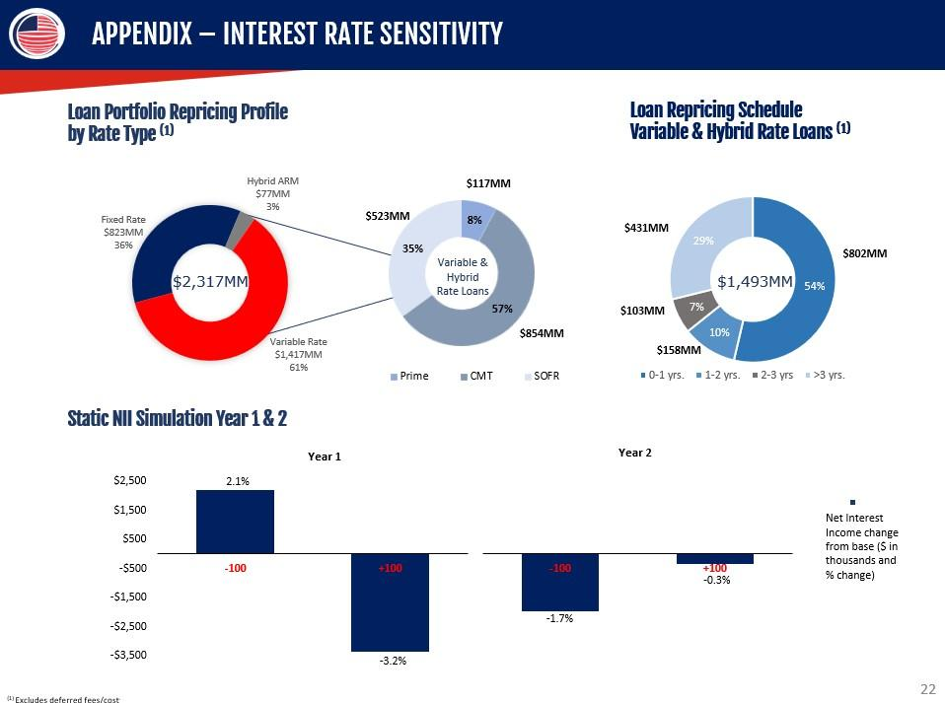
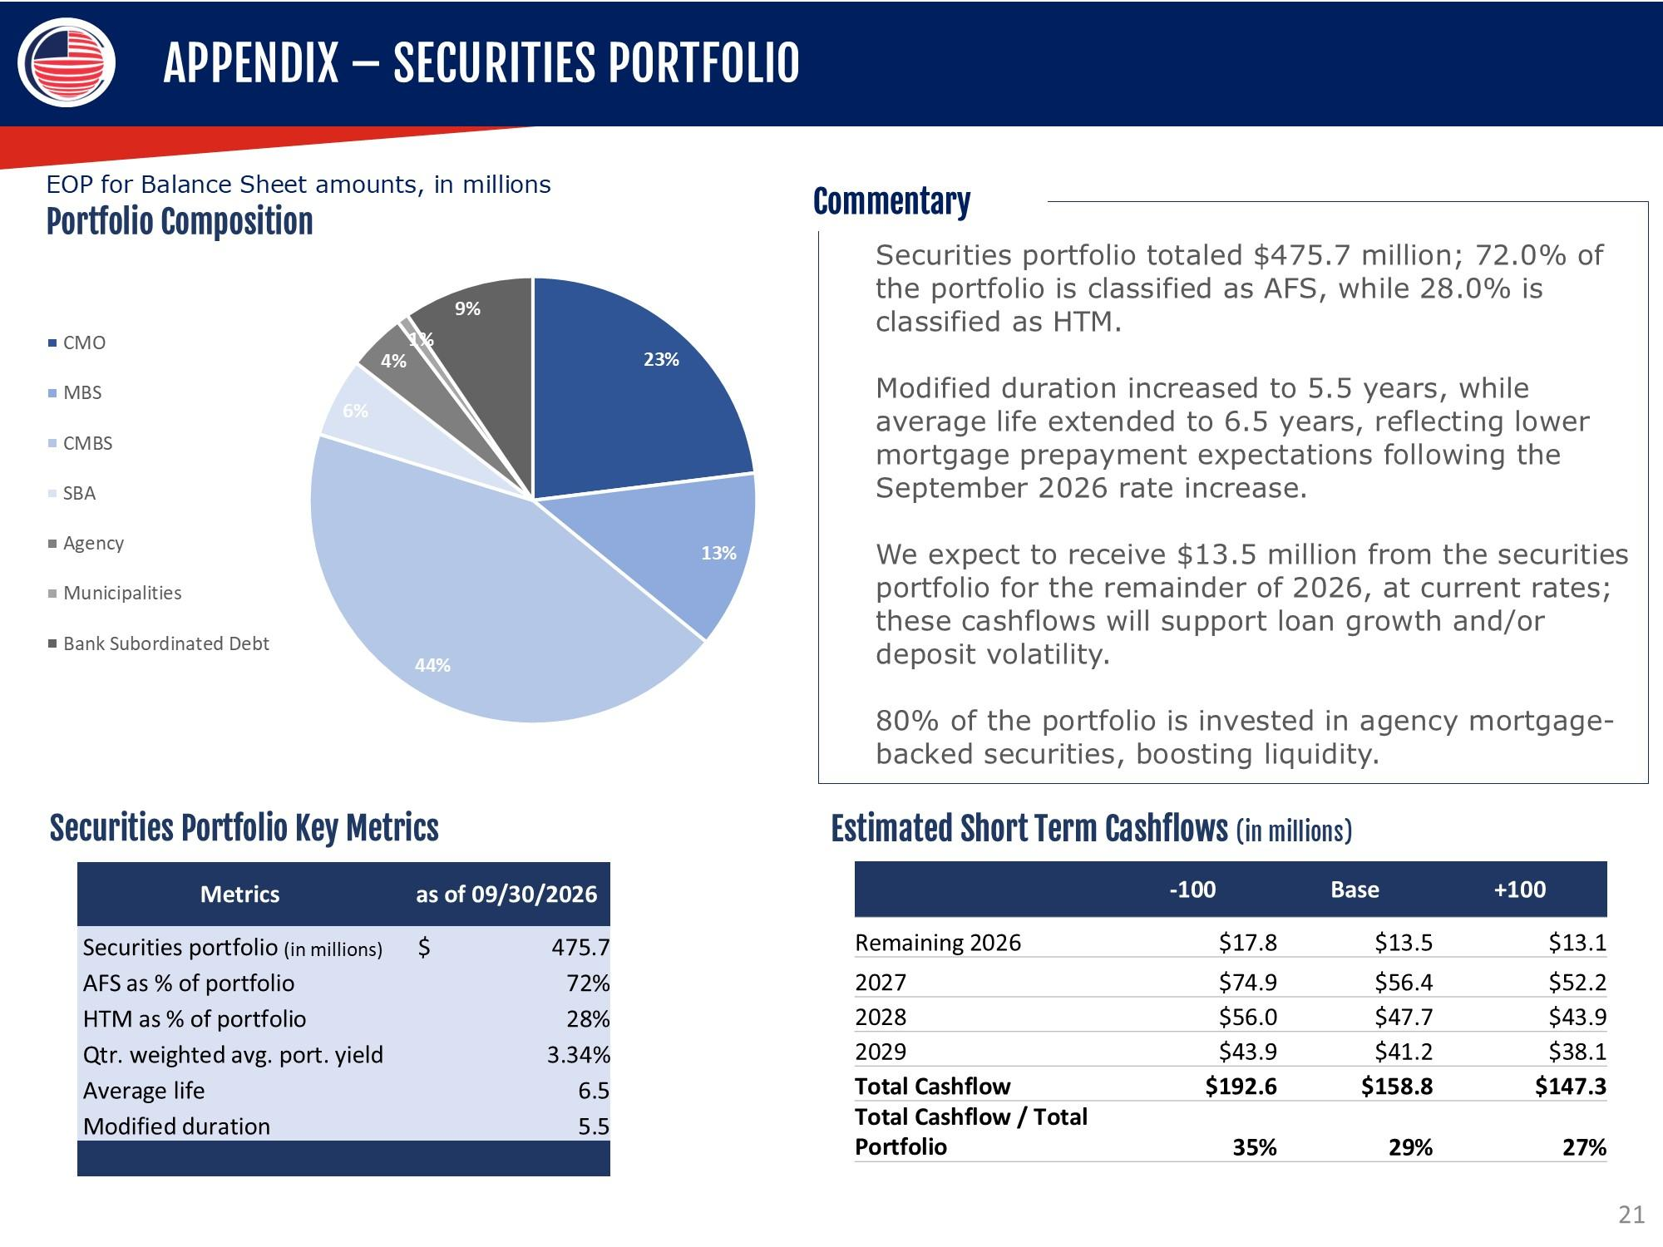
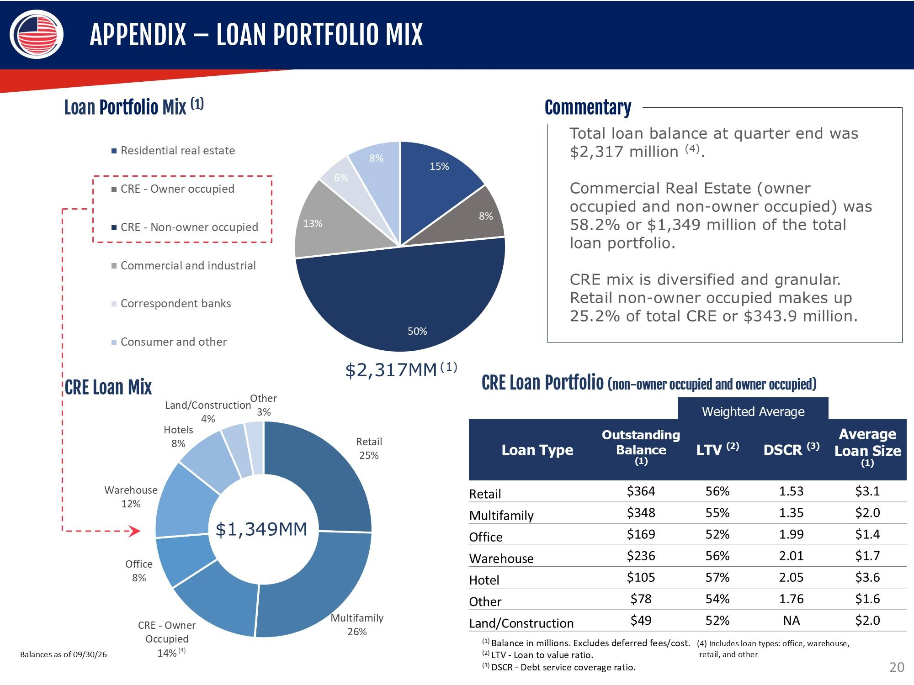
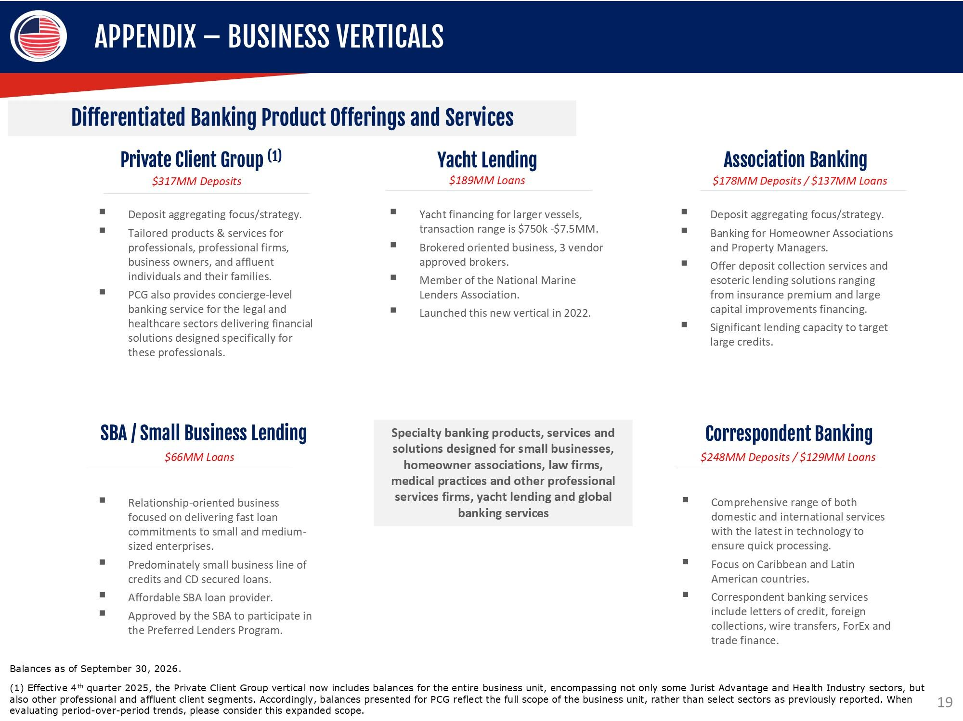
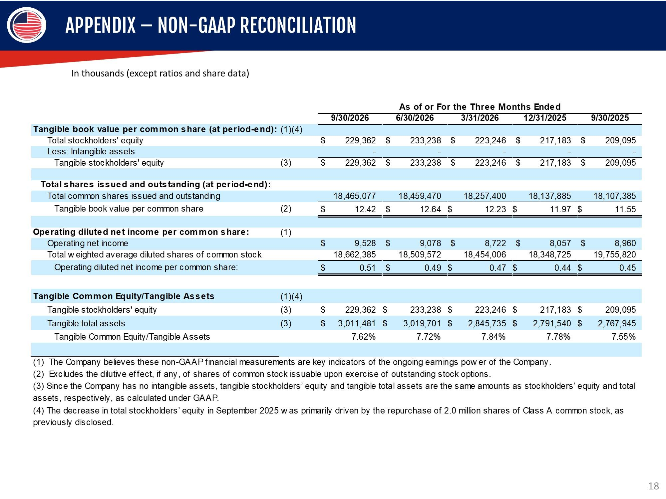
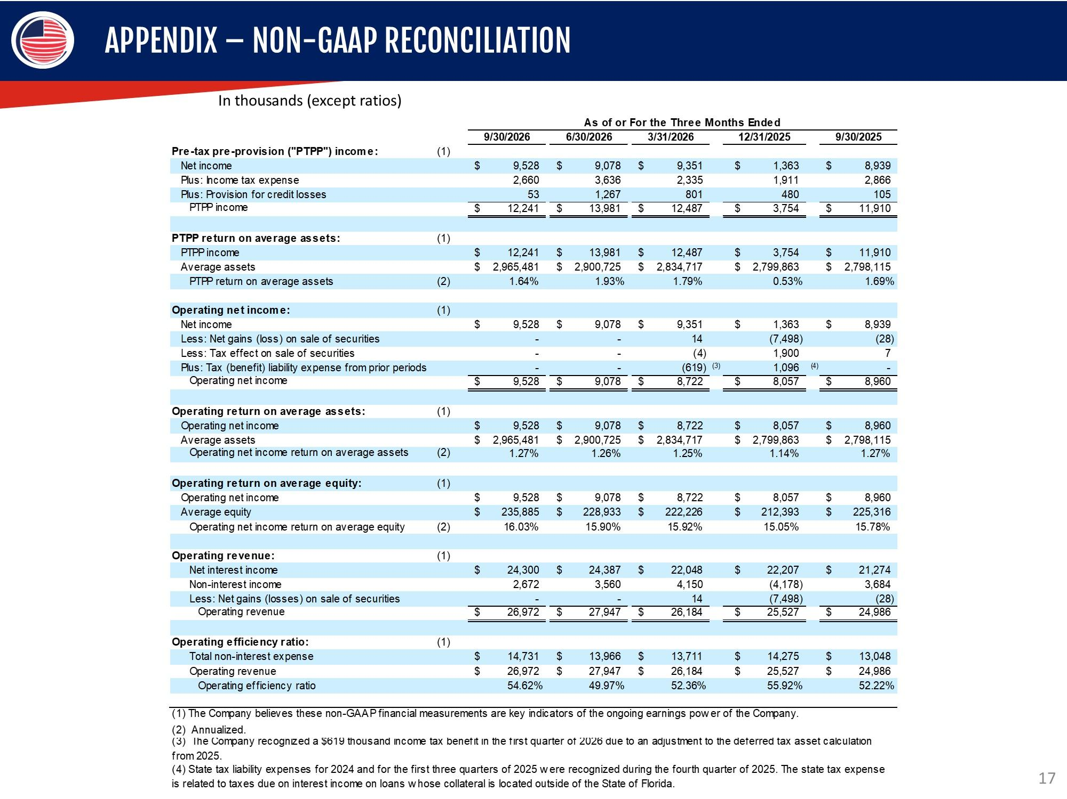
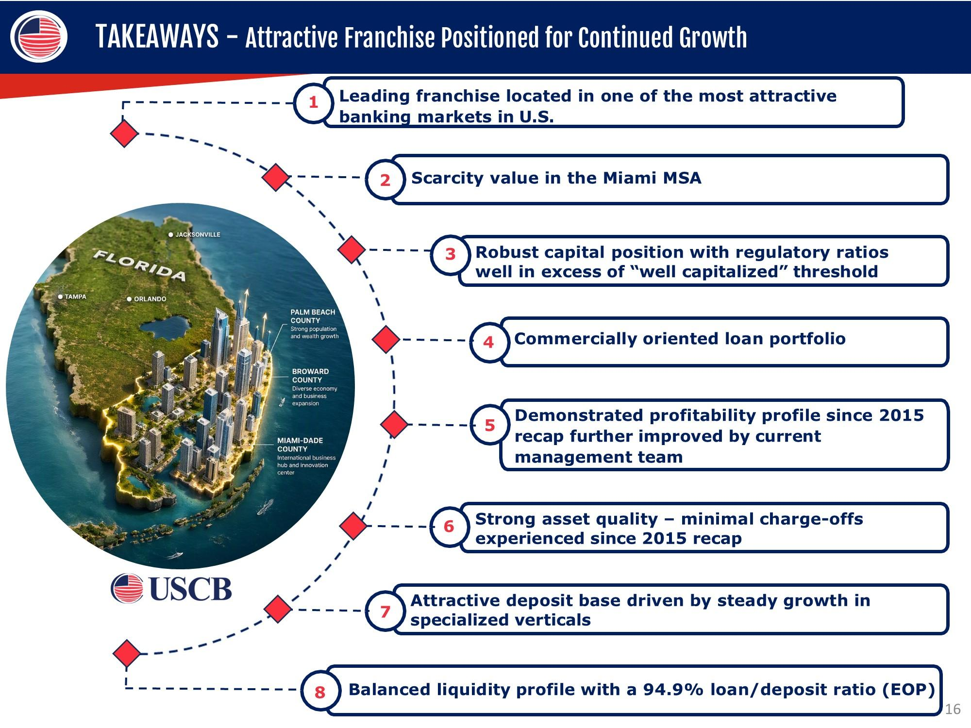
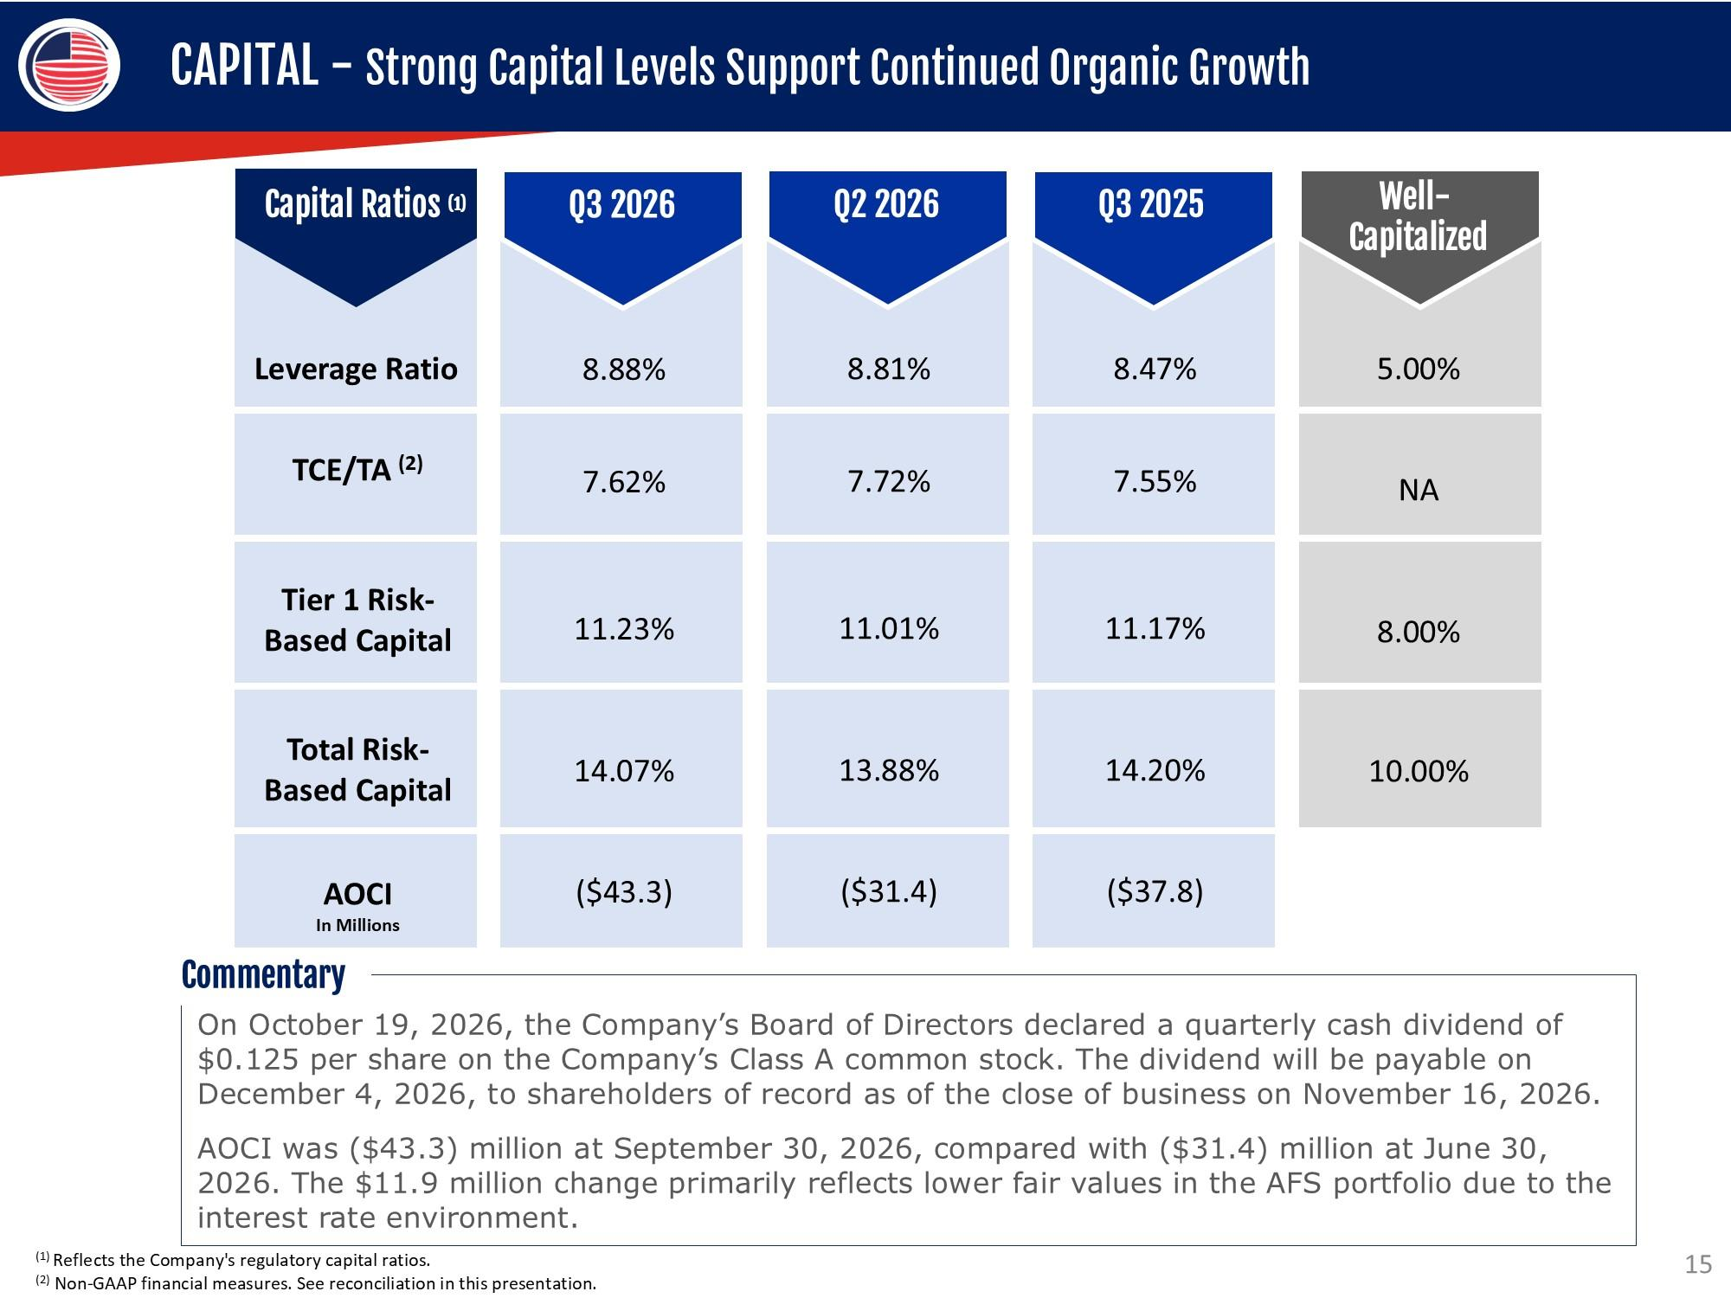
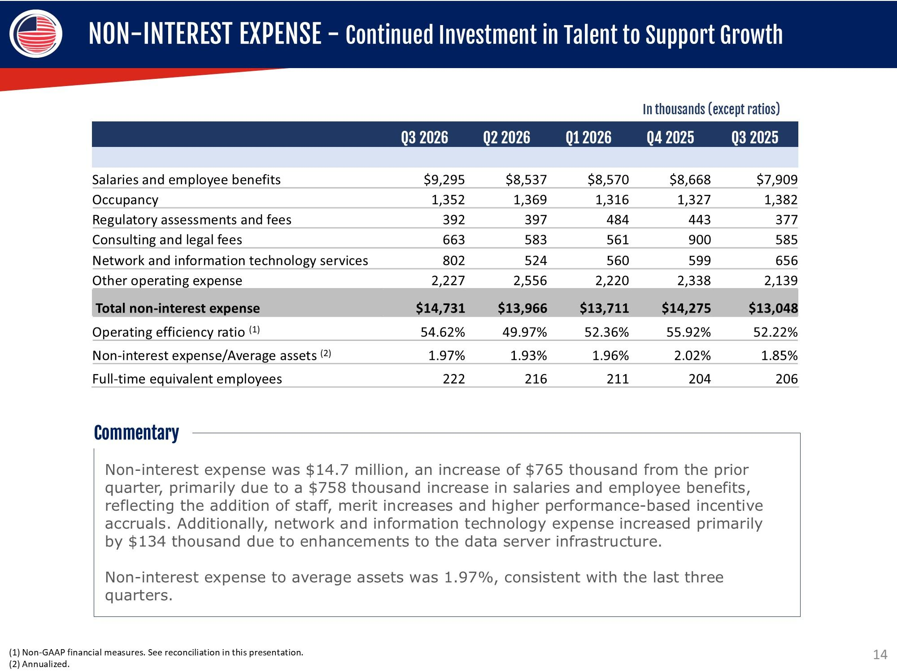
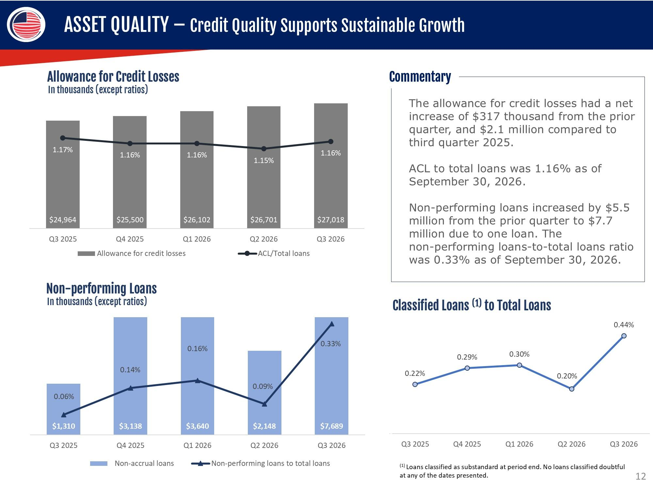
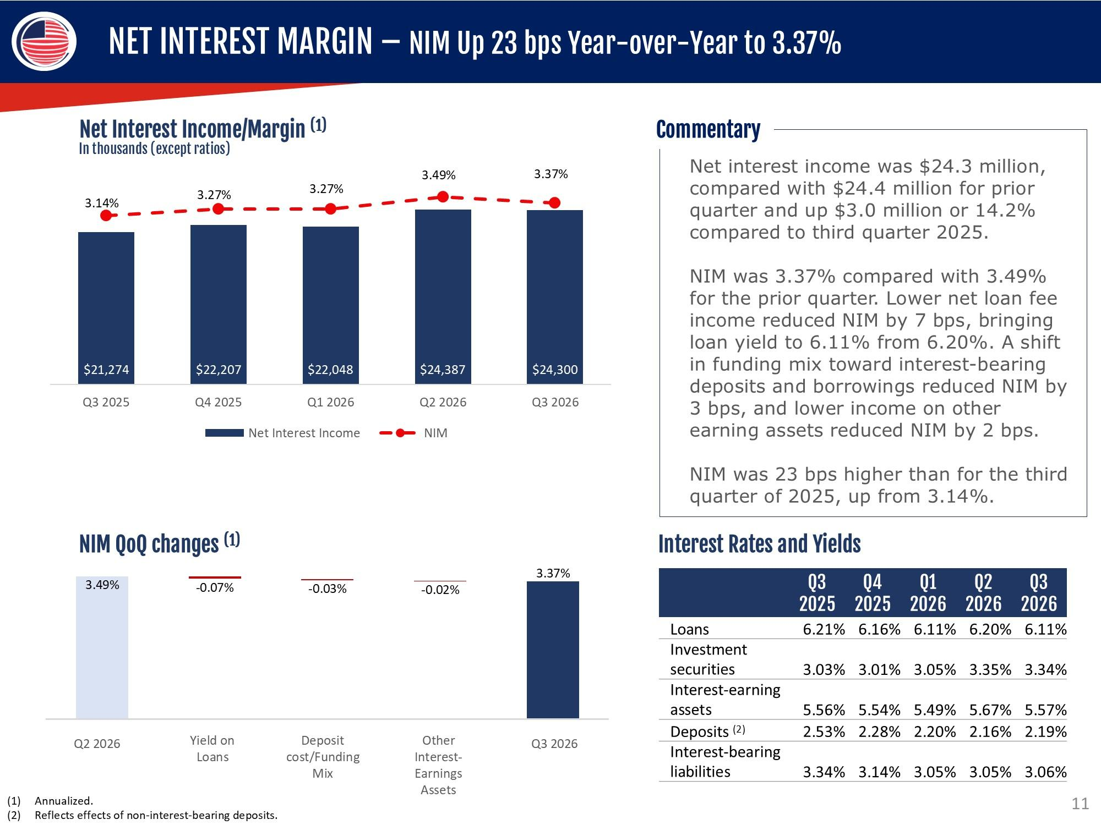
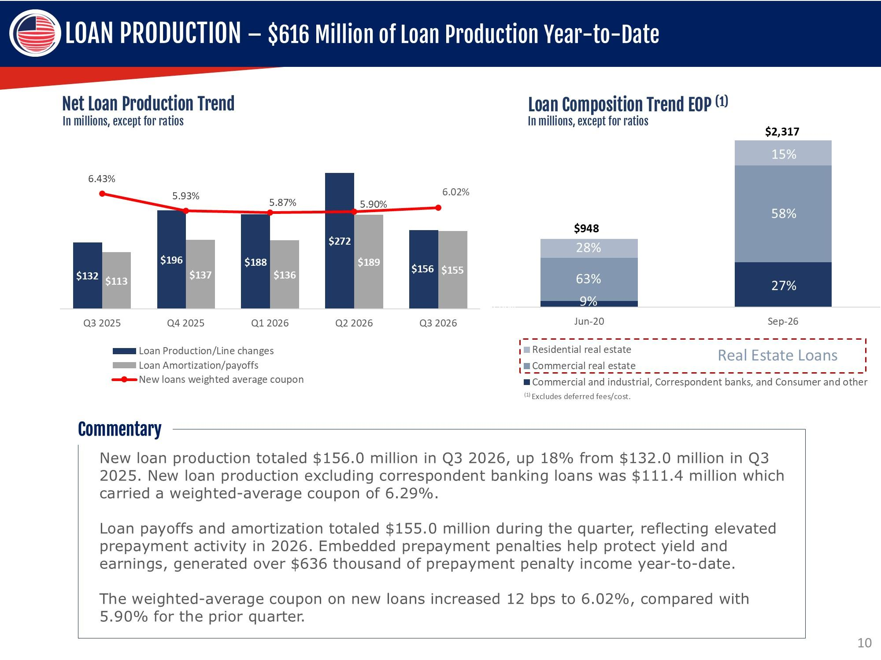
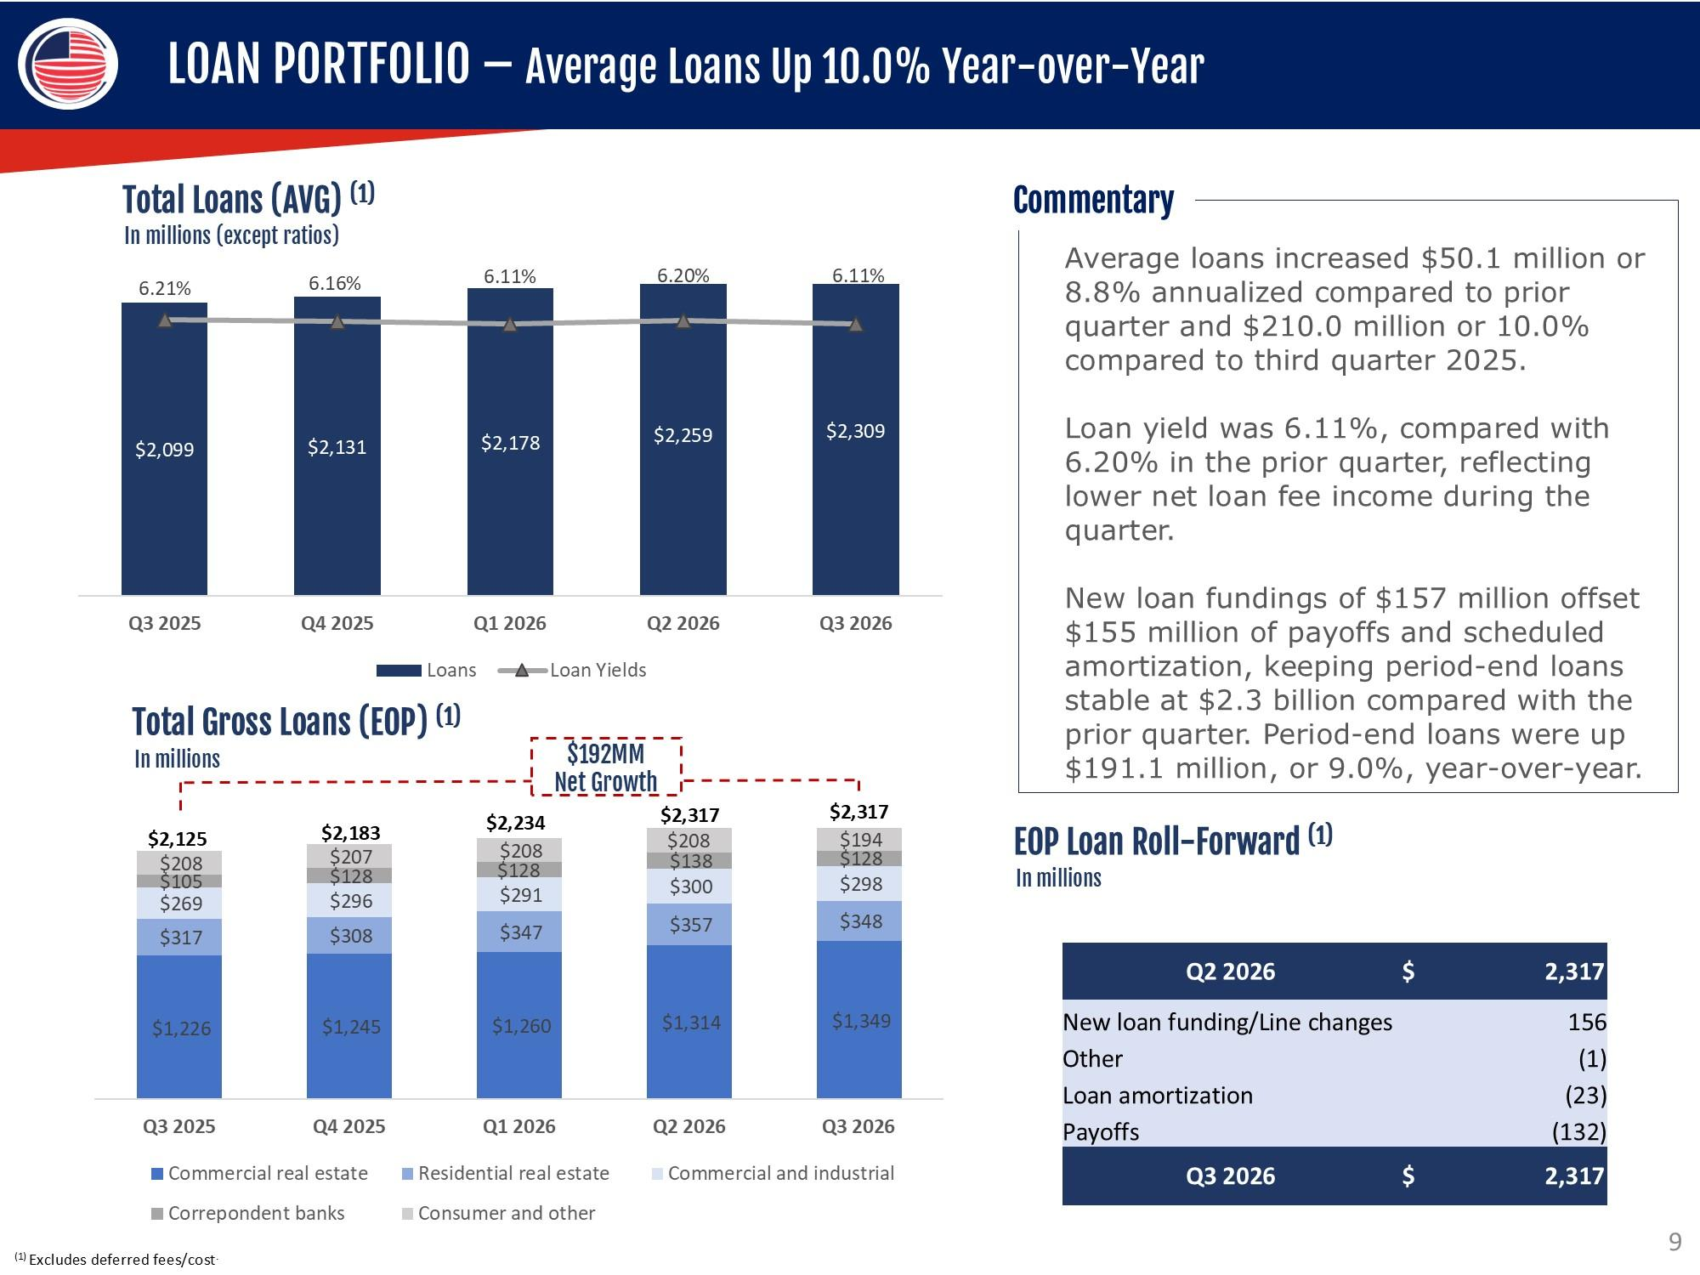
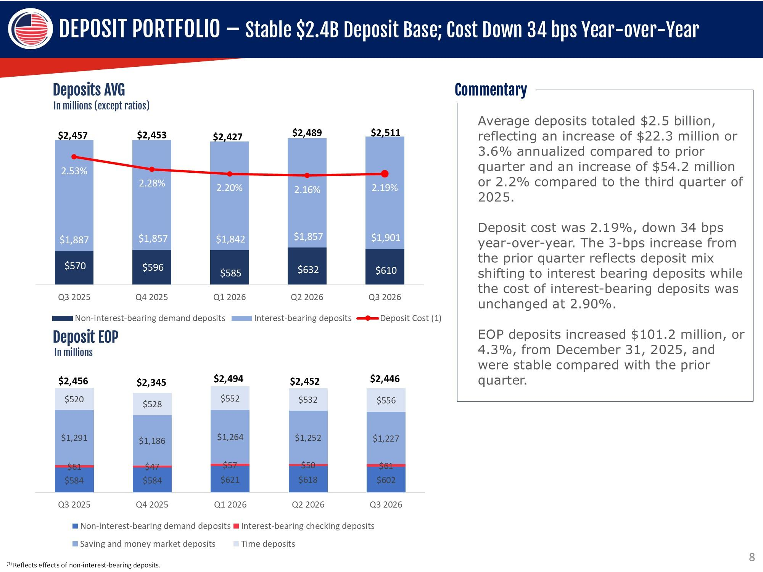
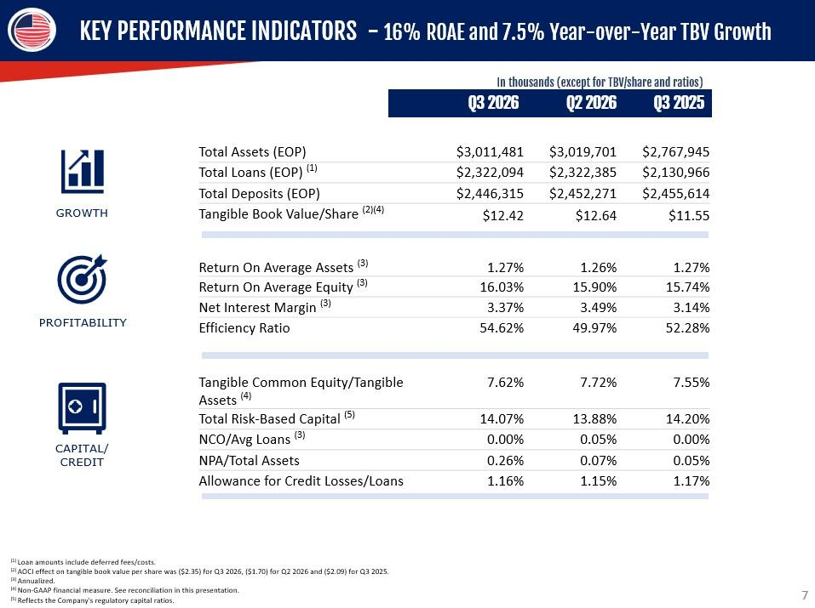
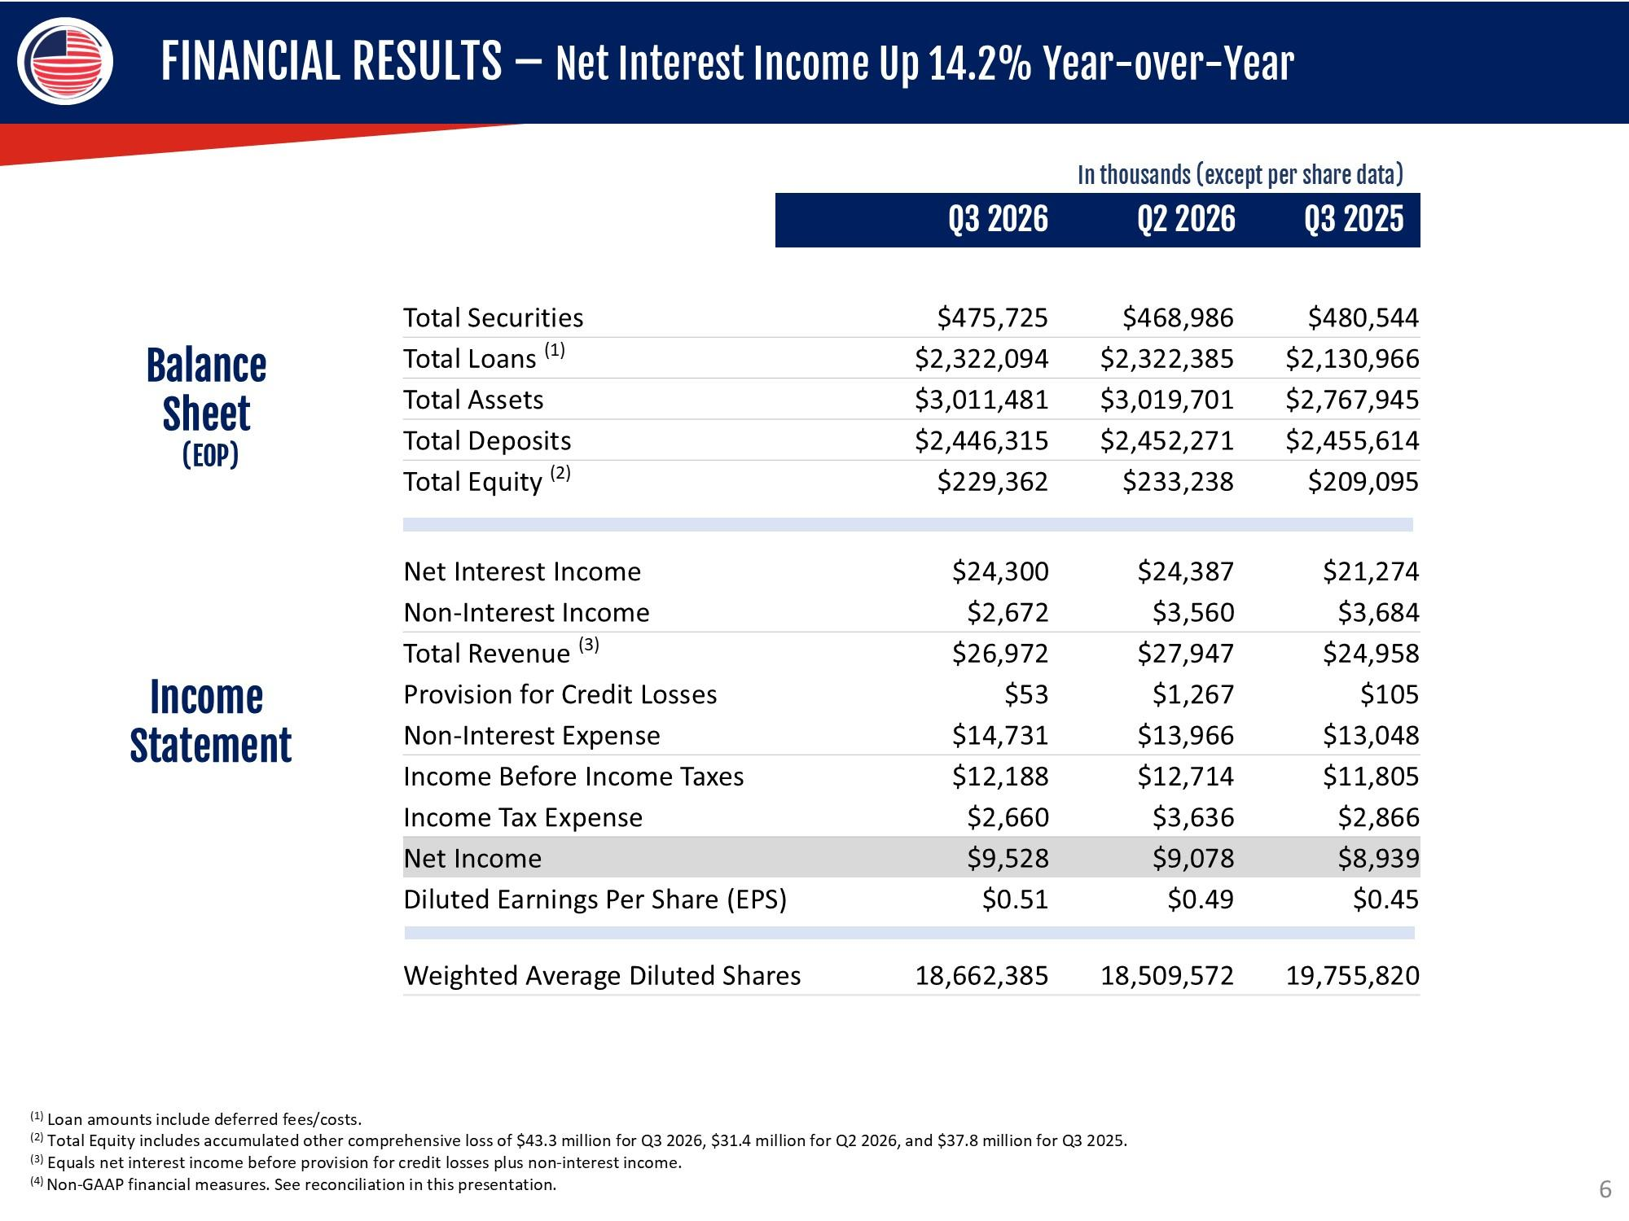
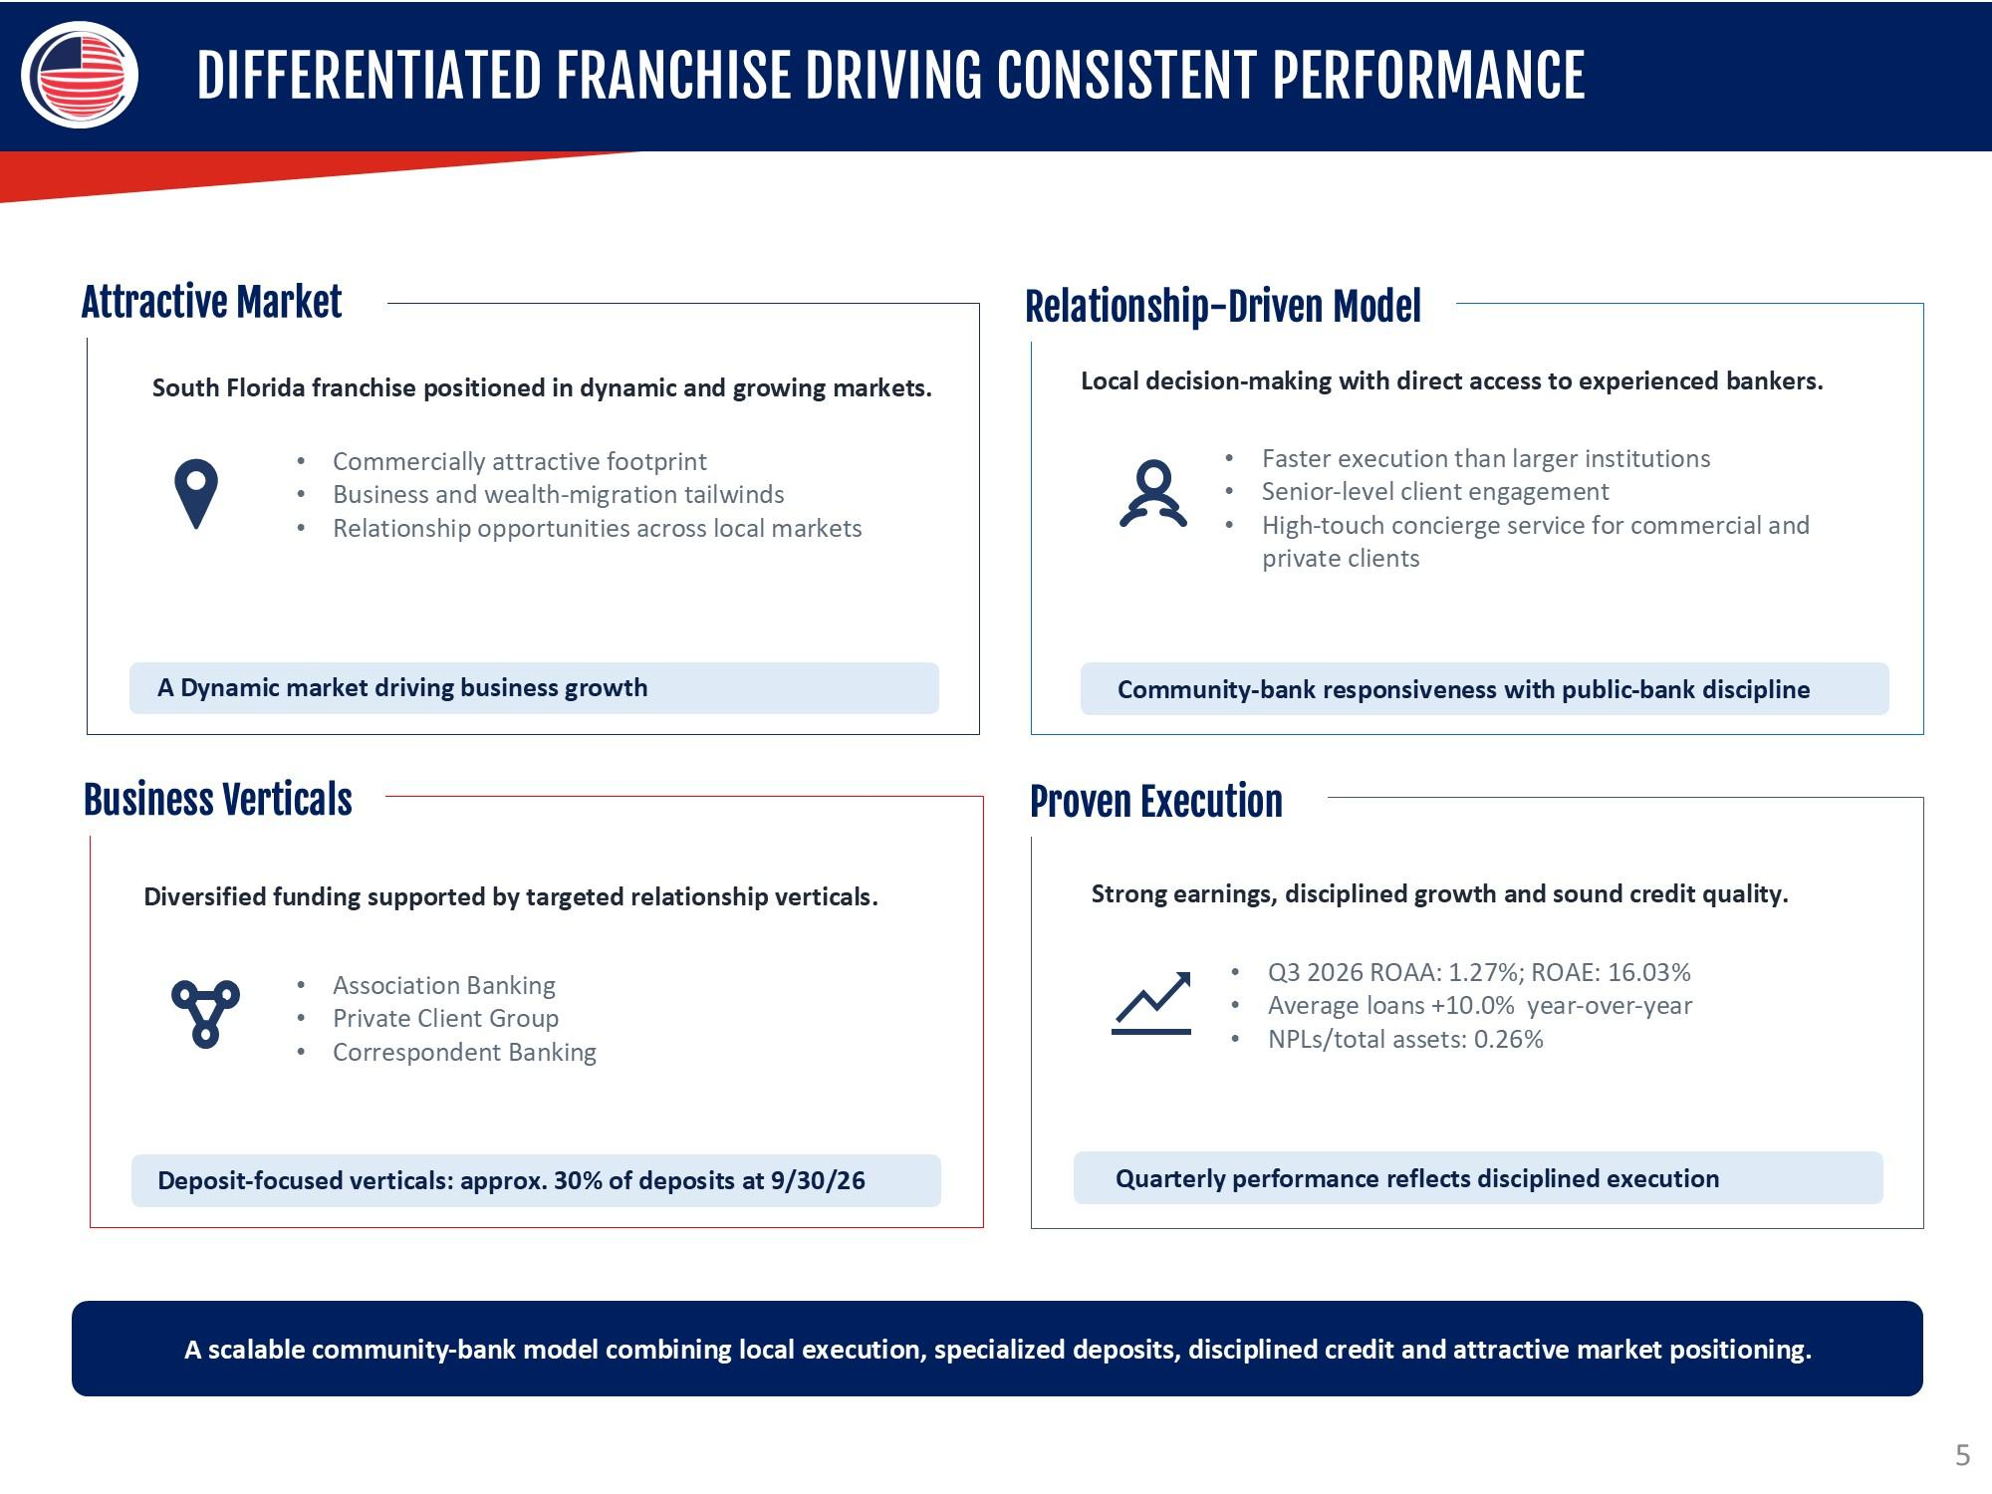
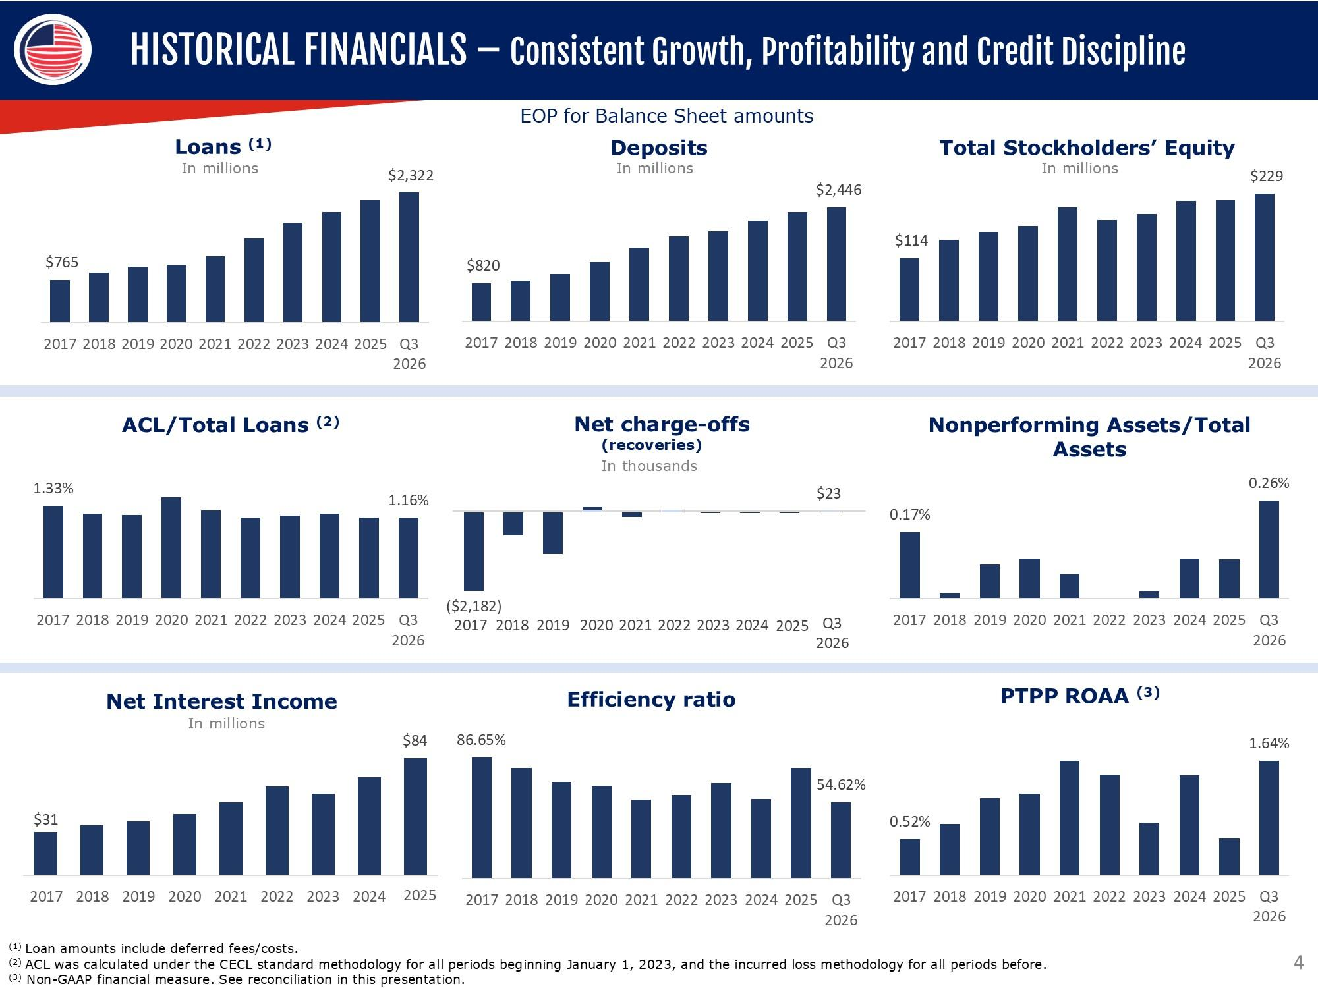
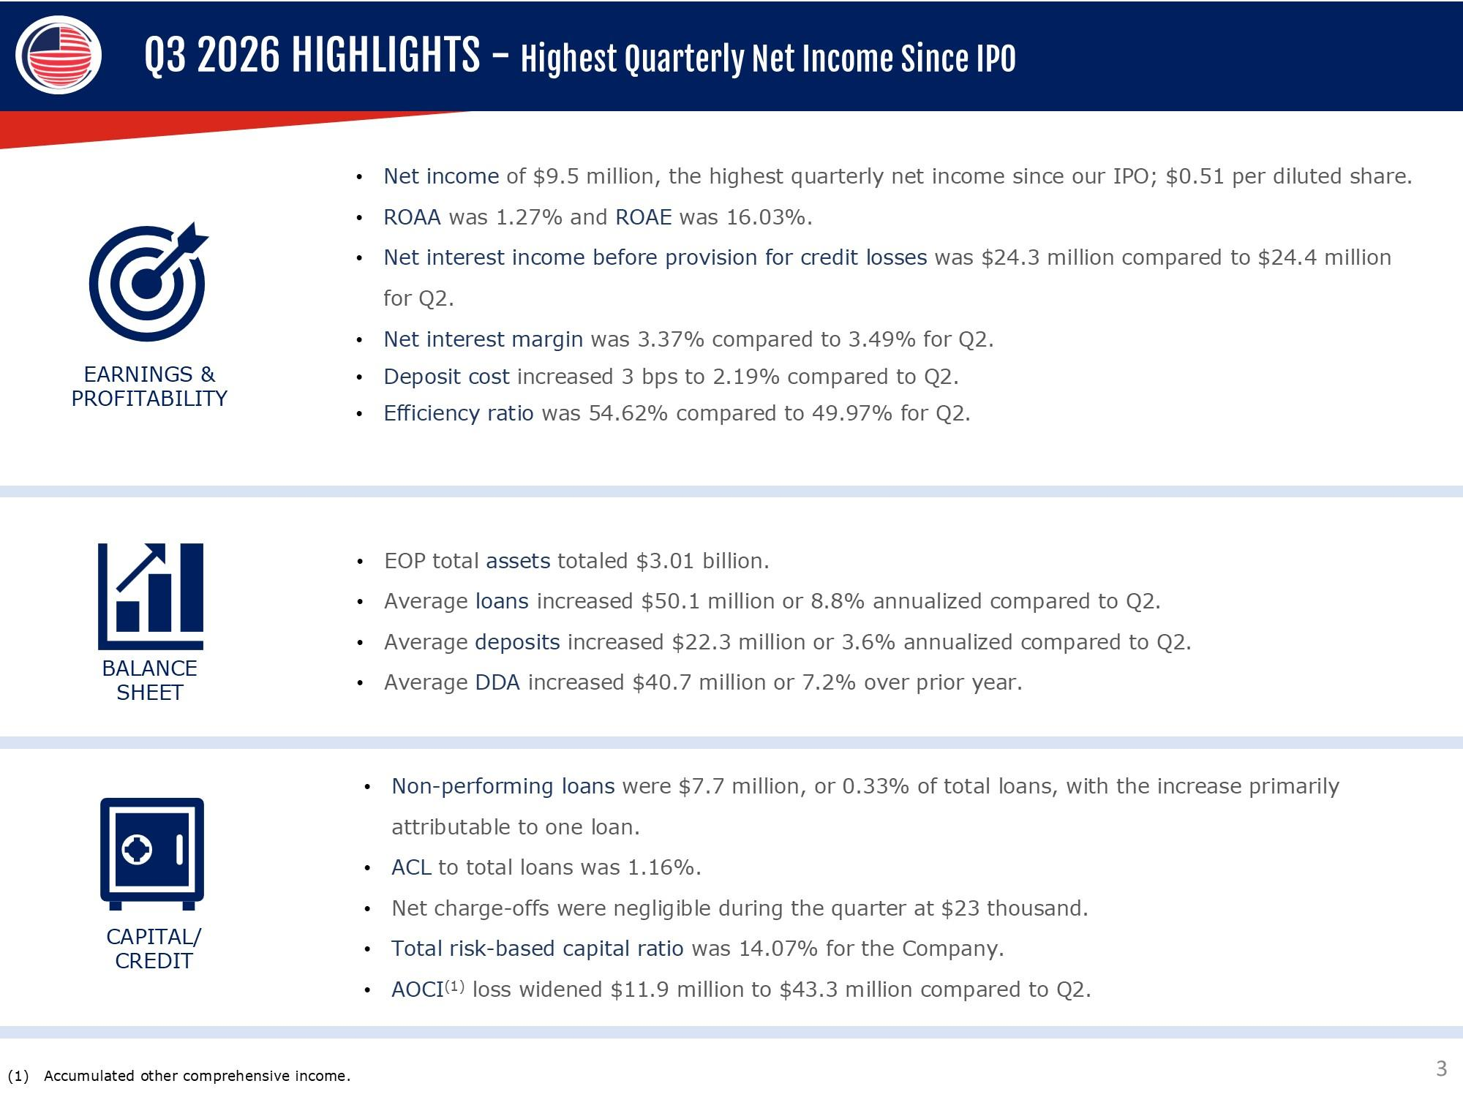
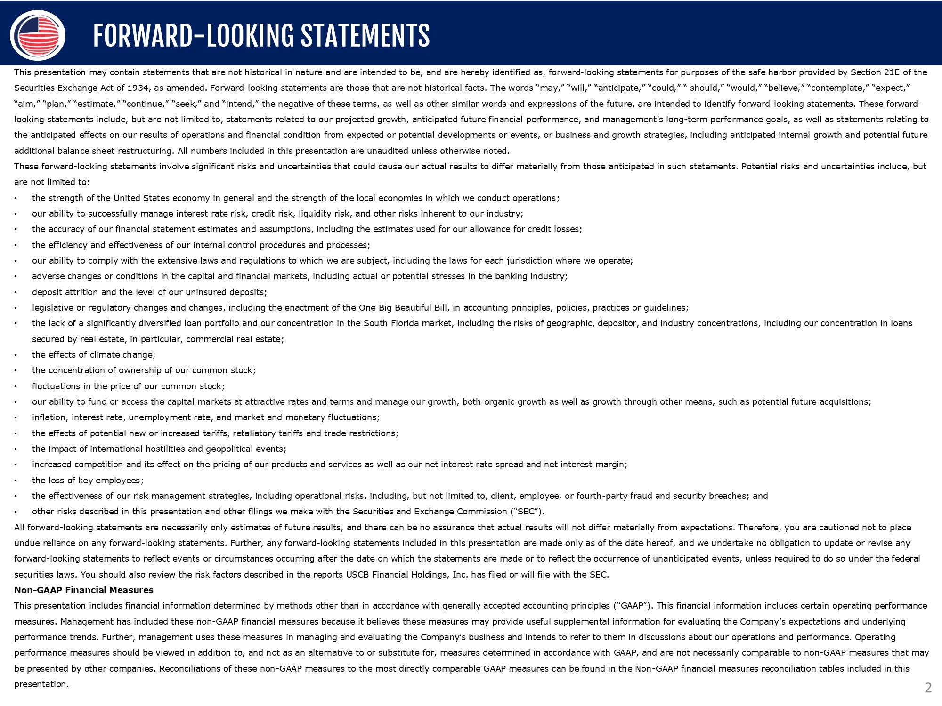
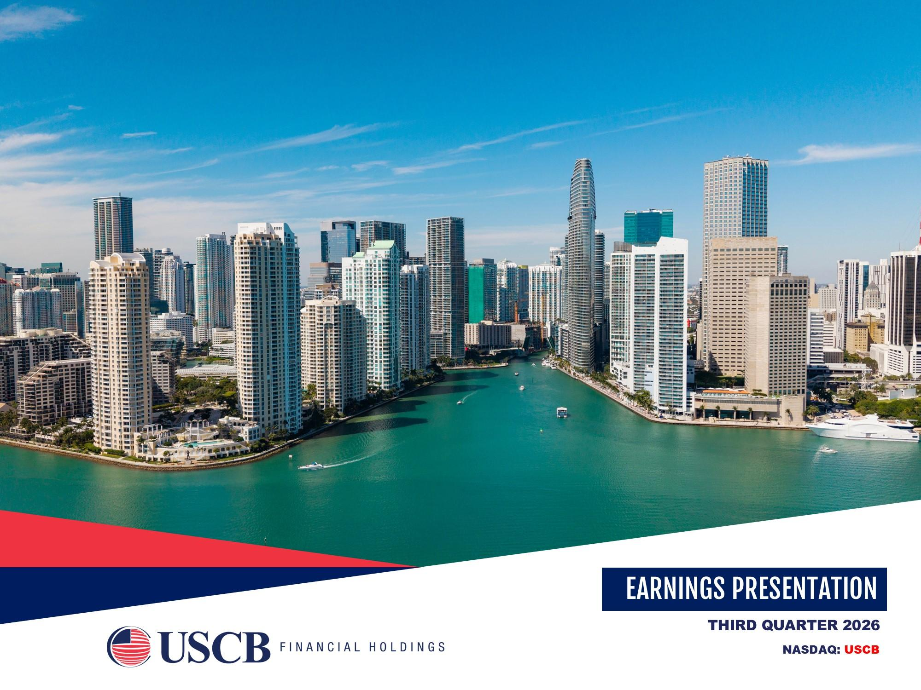


1

UNITED STATES

SECURITIES AND EXCHANGE COMMISSION

WASHINGTON,
D.C. 20549

__________________________

FORM

8-K

__________________________

CURRENT REPORT

Pursuant to Section
13 or
15(d) of
the Securities Exchange
Act of
1934

Date of
Report (Date
of earliest
event reported):

October 22, 2026

__________________________

USCB Financial Holdings, Inc.

(Exact name
of Registrant
as Specified
in Its Charter)

__________________________

Florida

001-41196

87-4070846

(State or
Other Jurisdiction

of Incorporation)

(Commission
File Number)

(IRS Employer

Identification
No.)

2301 N.W. 87th Avenue

,

Doral

,

Florida

33172

(Address of
Principal
Executive
Offices)

(Zip Code)

Registrant’s
Telephone
Number,
Including Area
Code: (

305

)

715-5200

__________________________

Check the
appropriate
box below if the Form 8-K filing
is intended to simultaneously
satisfy the
filing obligation
of the registrant
under

any
of the
following provisions:

☐

Written
communications
pursuant
to Rule 425
under the
Securities Act (17 CFR 230.425)

☐

Soliciting material
pursuant
to Rule 14a
-12 under
the Exchange
Act (17 CFR 240.14a
-12)

☐

Pre-commencement
communications
pursuant
to Rule 14d
-2(b) under the
Exchange
Act (17 CFR 240.14d
-2(b))

☐

Pre-commencement
communications
pursuant
to Rule 13e
-4(c) under the
Exchange
Act (17 CFR 240.13e
-4(c))

Securities
registered
pursuant
to Section
12(b) of
the Act:

Title of
each class

Trading

Symbol(s)

Name of each exchange on which
registered

Class A common stock, $1.00 par value per share

USCB

The Nasdaq Stock Market LLC

Indicate
by check
mark
whether
the
registrant
is an
emerging
growth
company
as defined
in Rule
405 of
the
Securities
Act of
1933

(§ 230.405
of this chapter)
or Rule 12b-2 of
the Securities Exchange
Act of 1934
(§ 240.12b
-2 of this chapter).

Emerging
growth company

☒

If
an
emerging
growth
company,
indicate
by
check
mark
if
the
registrant
has
elected
not
to
use
the
extended
transition
period
for

complying with
any
new or revised financial
accounting
standards
provided
pursuant
to Section
13(a) of
the Exchange
Act.

☐

2

Item 2.02.
Results of
Operations and
Financial
Condition.

On October
22,
2026, USCB
Financial
Holdings,
Inc. (the
“Company”)
issued a press
release announcing
its financial
results

for the
quarter ended
September
30, 2026
.
A copy
of the press
release
is furnished
as Exhibit
99.1 to
this Current
Report
on Form 8-

K

(“Form
8-K”) and
is incorporated
herein by reference.

The information
in
this Item 2.02, including Exhibit
99.1 hereto, is being furnished and
shall not be deemed “filed” for purposes

of Section
18 of
the Securities
Exchange
Act of 1934
(the
“Exchange
Act”), or
otherwise be
subject
to the liability
of that
section,
and

shall
not
be
deemed
to
be
incorporated
by
reference
into
any
filing
under
the
Securities
Act
of
1933
(the
“Securities
Act”)
or
the

Exchange
Act except
as expressly
set forth
by specific reference
in such filing to this
Form 8-K.

Item 7.01.
Regulation
FD Disclosure.

As previously announced,
at 11:00 a.m.
ET on
October 23,
2026, the Company
will
hold an earnings
conference
call to discuss

its financial
performance
for the
quarter
ended
September
30, 2026.
A copy of
the slides forming the
basis of
the presentation
is being

furnished
as Exhibit
99.2 to
this Form
8-K
and
is incorporated
herein
by reference.
A
copy
of
the slides
has
also
been posted
to
the

Company’s
investor relations
website, located
at
investors.uscenturybank.com.

The information
in
this Item 7.01, including Exhibit
99.2 hereto, is being furnished and
shall not be deemed “filed” for purposes

of Section
18 of the Exchange
Act, or otherwise
be subject
to the liability
of that section, and
shall not
be deemed to
be incorporated by

reference
into any filing under the Securities
Act or the Exchange
Act except as set forth by specific
reference
in such filing to this Form

8-K.

Item 9.01.
Financial
Statements
and Exhibits.

(d) Exhibits.

Exhibit
No.

Description

99.1

USCB Financial Holdings, Inc. Press Release, dated October 22, 2026

99.2

Earnings Presentation, dated October 22, 2026

104

Cover Page
Interactive
Data
File
(embedded
within the Inline XBRL document)

3

SIGNATURE

Pursuant to
the requirements
of the Securities
Exchange
Act of 1934,
the registrant
has duly caused
this report to be
signed
on

its behalf
by the
undersigned hereunto
duly authorized.

USCB Financial
Holdings, Inc.

By:

/s/ Robert
Anderson

Name:

Robert
Anderson

Title:

Chief Financial
Officer

Date:
October 22,
2026

1

Exhibit
99.1

EARNINGS
RELEASE

USCB Financial Holdings,
Inc. Reports
Third Quarter
2026
Fully Diluted EPS of $0.51,
ROAA of
1.27%,
and

ROAE of 16.03%

MIAMI,
FL – October
22, 2026
– USCB Financial
Holdings,
Inc. (the
“Company”) (NASDAQ:
USCB)

,
the holding
company
for

U.S.
Century
Bank
(the
“Bank”)
,
reported
net
income

of

$9.5
million
or
$0.51
per
fully
diluted
share
for
the
three
months
ended

September
30, 2026,
compared
with net income
of $8.9
million or $0.45 per fully diluted
share for
the same
period in 2025.

“Third quarter
net income
of $9.5 million
was the highest
quarterly net
income since
our initial public
offering in
2021, and
net income

of $28.0 million
for the first nine
months
of 2026 has already
surpassed full
-year net income
for every
year
since our IPO," said Luis de

la Aguilera, Chairman,
President and
CEO.
"We
delivered
a return on average equity of 16.03%
and a return on average
assets of 1.27%.

Compared
with the third
quarter
of 2025,
net interest
income
grew 14.2%,
loans grew
9.0%, and
our net interest
margin
expanded
23

basis points
to 3.37%.
We
remain
focused
on disciplined growth
and
building long-term
value
for our shareholders."

Unless
otherwise stated,
all percentage
comparisons
in the
bullet points
below are
calculated
at or for
the quarter
ended September
30,

2026
compared
to at
or for the
quarter
ended
September
30, 2025
and
annualized
where appropriate
.

Profitability

•

Annualized
return on
average
assets
for the
quarter
s
ended
September
30, 2026
and
2025
was 1.27%
.

•

Annualized
return on
average
stockholders’
equity for the
quarter ended
September
30, 2026 was
16.03%
compared
to 15.74% for

the third quarter
of 2025.

•

The efficiency
ratio for
the quarter
ended
September
30, 2026
was 54.62%
compared
to 52.28%
for the
third quarter

of

2025.

•

Net interest
margin for
the quarter
ended
September
30, 2026
was 3.37%
compared
to 3.14
%
for the
third quarter
of 2025.

•

Net interest
income
before
provision
for credit
losses was
$24.3 million
for
the quarter
ended
September
30,
2026, an
increase of

$3.0 million
or 14.2% compared
to $21.3
million for the same
period in 2025.

Balance
Sheet

•

Total
assets
were
$3.0
billion
at
September 30,
2026,
representing
an
increase
of
$243.5 million
or
8.8%
from
$2.8
billion
at

September
30, 2025
.

•

Total
loans
held for investment
were $2.3
billion at
September 30,
2026,
representing
an increase
of $191.1
million or
9.0% from

$2.1 billion
at
September
30, 2025.

•

Total
deposits
were
$2.4 billion
at
September
30,
2026,
representing
a
decrease
of
$9.3 million
or
0.4%
from
$2.5
billion
at

September
30, 2025.

•

Total stockholders’
equity was $229.4 million at
September 30, 2026, representing
an increase of $20.3 million or 9.7%
from $209.1

million
at
September
30,
2025.
Total
stockholders’
equity
included
accumulated
other comprehensive
loss
of
$43.3
million
at

September
30, 2026
compared
to accumulated
other comprehensive
loss of $37.8
million at September
30, 2025.

Asset Quality

•

The
allowance
for credit
losses
(“ACL”)
increased
by $2.1
million
to $27.0
million at
September 30,
2026
from
$25.0
million at

September
30, 2025.

•

The ACL
represented
1.16% of
total
loans at
September
30, 2026
and
1.17% of
total
loans
at
September
30, 2025.

2

•

The provision
for credit
losses was
$53 thousand
for the quarter
ended September
30, 2026, a
decrease of
$52 thousand
compared

to $105
thousand
for the
same
period in 2025.

•

The
ratio of
non-performing
loans to
total
loans was
0.33%
for
the quarter
ended
September 30,
2026
and
0.06% for
the
quarter

ended
September 30,
2025.
Non-performing
loans totaled
$7.7 million
at
September
30,
2026
and
$1.3 million
at
September
30,

2025.

Non-interest
Income
and Non-interest
Expense

•

Non-interest income was $2.7 million for the three months
ended September
30, 2026,
a decrease

of

$1.0 million
or 27.5% compared

to $3.7
million for the
same
period in 2025.

•

Non-interest
expense
was
$14.7 million
for
the
three
months
ended
September
30,
2026,
an
increase
of
$1.7
million
or
12.9%

compared
to $13.0
million for the three
months
ended
September
30, 2025.

Capital

•

On October
19, 2026, the
Company’s
Board of Directors
declared a quarterly
cash dividend
of $0.
125 per share
of the Company’s

Class
A
common
stock.
The
dividend
will
be
paid
on
December
4,
2026
to
shareholders
of
record
at
the
close
of
business
on

November
16, 202
6.

•

As of
September 30,
2026,

total
risk-based
capital
ratios
for
the Company
and
the Bank
were 14.07%
and
13.93%, respectively,

well in excess
of the
well-capitalized
minimum
threshold
regulatory requirements
.

•

Tangible
book value
per common
share (non-GAAP financial measure)
was $12.42 at September
30, 2026, representing an increase

of $0.87 or 7.6% from $11.55
at September 30, 2025
.
At September 30, 2026, tangible book
value per common
share was negatively

affected
by ($2.35)
per share
due to
an
accumulated
other comprehensive
loss of
$43.3
million primarily
due
to
changes
in
the

market
value
of the
Company’s
available
for sale securities.
At September
30, 2025,
tangible
book
value
per common
share was

negatively
affected
by ($2.09)
per share
due to
an
accumulated
other comprehensive
loss of $37.8
million.

Conference
Call and Webcast

The Company
will
host a conference
call on Friday,
October 23,
2026
,
at 11:00
a.m. Eastern Time
to discuss the
Company’s
unaudited

financial results
for the
quarter
ended
September 30,
2026
.
To
access
the conference
call, dial
(833)
816-1416
(U.S. toll-free)
and ask

to join the
USCB Financial
Holdings Call
.

Additionally,
interested
parties
can
listen
to
a live
webcast
of
the
call in
the
“Investor
Relations”
section
of
the
Company’s
website

at

www.uscentury.com
.
An archived
version of
the webcast
will
be available
in the same
location
shortly after
the live call has
ended.

About USCB
Financial
Holdings, Inc.

USCB Financial
Holdings,
Inc. is the
bank
holding company
for U.S. Century Bank.
Established
in 2002, U.S.
Century
Bank is one
of

the
largest community
banks
headquartered
in Miami,
and
one
of the
largest
community
banks
in the
State
of
Florida. U.S.
Century

Bank is
rated 5-Stars by
BauerFinancial,
the nation’s
leading independent
bank
rating firm. U.S.
Century Bank
offers customers
a wide

range
of financial
products
and
services
and
supports
numerous
community
organizations,
including
the
Greater
Miami
Chamber
o

f

Commerce,
the South Florida
Hispanic
Chamber
of Commerce,
and ChamberSouth.
For more information
about us or to find a banking

center near
you, please
call (305) 715
-5200
or visit www.uscentury.com.

Forward-Looking
Statements

This earnings release may
contain statements
that are not historical in
nature and
are intended to be, and are
hereby identified as, forward-

looking
statements
for purposes
of
the
safe
harbor
provided
by
Section
21E
of
the
Securities
Exchange
Act
of
1934,
as
amended.

Forward-looking
statements
are those that
are not historical
facts. The
words
“may,”
“will,” “anticipate,”
“could,” “should,”
“would,”

“believe,”
“contemplate,”
“expect,” “aim,”
“plan,” “estimate,”
“seek,”
“continue,” and
“intend,”
the negative
of these
terms, as
well as

other similar words and
expressions of the future, are intended to identify forward
-looking statements. These forward
-looking statements

include, but
are not limited
to, statements
related to our
projected
growth,
anticipated
future financial
performance,
and management’s

long-term
performance
goals, as well as statements
relating to the
anticipated
effects
on our results of operations and
financial condition

from expected
or potential developments
or events, or
business and growth strategies,
including
anticipated
internal growth and potential

future
additional
balance
sheet restructuring.

These forward
-looking statements
involve significant risks
and uncertainties
that could cause
our actual results to differ materially
from

those anticipated
in such statements.
Potential
risks and uncertainties
include, but
are not
limited to:

3

•

the strength
of the
United States
economy
in general and
the strength
of the
local economies
in which we conduct
operations;

•

our ability
to successfully
manage
interest rate
risk, credit risk, liquidity risk,
and
other risks inherent
to our industry;

•

the accuracy
of our financial statement
estimates and
assumptions, including the
estimates
used for our
allowance
for credit losses;

•

the efficiency
and
effectiveness
of our
internal control
procedures
and
processes;

•

our ability to comply
with the extensive laws and
regulations to which we are subject,
including the laws for each
jurisdiction where

we operate;

•

adverse
changes
or conditions
in capital
and
financial
markets,
including actual
or potential
stresses in the banking
industry;

•

deposit attrition
and
the level of our
uninsured
deposits;

•

legislative
or
regulatory
changes
,
including
the
enactment
of the
One
Big
Beautiful
Bill
and
changes
in
accounting
principles,

policies, practices
or guidelines;

•

the
lack
of
a
significantly
diversified
loan
portfolio
and
our
concentration
in
the
South
Florida
market,
including
the
risks
of

geographic,
depositor,
and
industry
concentrations,
including
our
concentration
in
loans
secured
by
real
estate,
in
particular,

commercial
real estate;

•

the effects
of climate
change;

•

the concentration
of ownership
of our
common
stock;

•

fluctuations
in the price of our
common
stock;

•

our
ability to fund
or access
the capital
markets
at
attractive
rates and
terms and
manage
our growth, both
organic growth as
well

as growth
through other
means,
such as
potential
future
acquisitions;

•

inflation,
interest rate,
unemployment
rate, and
market
and
monetary
fluctuations;

•

the effects
of potential
new or increased
tariffs,
retaliatory
tariffs
and
trade
restrictions;

•

the impact
of international
hostilities and geopolitical
events;

•

increased
competition
and its
effect
on the
pricing of
our
products and
services
as well
as our
interest
rate spread
and net
interest

margin;

•

the loss
of key
employees
;

•

the effectiveness
of our
risk management
strategies, including operational
risks, including,
but not limited
to,
client, employee,
or

third-party
fraud
and
security breaches;
and

•

other risks described
in this earnings
release and
other filings we make
with the Securities and
Exchange
Commission
(“SEC”).

All forward
-looking
statements
are necessarily
only estimates
of future
results,
and
there
can
be no assurance
that
actual
results will

not differ
materially
from
expectations.
Therefore, you
are
cautioned
not to
place undue
reliance on
any
forward
-looking statements.

Further,
any
forward
-looking
statements
included in
this earnings
release
are made
only
as of
the
date
hereof, and
we
undertake
no

obligation
to
update
or revise
any
forward
-looking statement
to reflect events
or circumstances
occurring
after
the date
on which
the

statements
are made
or to reflect the occurrence
of unanticipated
events, unless
required to do
so under
the federal
securities laws. You

should also
review the risk
factors
described in the
reports the
Company
has
filed or will
file
with the
SEC.

Non-GAAP
Financial
Measures

This earnings release includes
financial information
determined by methods
other than in accordance with generally accepted
accounting

principles (“GAAP”).
This financial
information
includes certain operating performance
measures. Management
has included these non-

GAAP
measures
because
it
believes
these
measures
may
provide
useful
supplemental
information
for
evaluating
the
Company’s

operations
and
underlying performance
trends. Further,
management
uses these
measures
in managing
and
evaluating
the Company’s

business
and intends to
refer to
them in
discussions
about
our operations and
performance.
Operating performance
measures
should be

viewed
in
addition
to,
and
not
as
an
alternative
to
or
substitute
for,
measures
determined
in
accordance
with
GAAP,
and
are
not

necessarily
comparable
to
non-GAAP
measures
that
may
be
presented
by
other
companies.
Reconciliations
of
these
non-GAAP

measures
to
the
most
directly
comparable
GAAP
measures
can
be
found
in the
‘Non-GAAP
Reconciliation
Tables’
included
in
the

exhibits to
this earnings release.

All numbers
included in
this press release
are unaudited
unless otherwise noted.

Contacts:

Investor
Relations

InvestorRelations@uscentury.com

Media
Relations

Martha
Guerra-Kattou

MGuerra@uscentury.com

4

USCB FINANCIAL
HOLDINGS,
INC.

CONSOLIDATED
STATEMENTS
OF INCOME
(UNAUDITED)

(Dollars in
thousands,
except
per share
data)

Three Months Ended September 30,

Nine Months Ended September 30,

2026

2025

2026

2025

Interest income:

Loans,
including
fees

$

35,547

$

32,866

$

103,235

$

95,057

Investment
securities

4,013

3,522

11,282

9,978

Interest-bearing
deposits
in financial
institutions

639

1,332

2,294

2,817

Total
interest
income

40,199

37,720

116,811

107,852

Interest expense:

Interest-bearing
checking
deposits

357

286

978

909

Savings
and
money
market
deposits

8,554

10,343

25,165

29,088

Time
deposits

4,974

5,036

14,302

13,297

FHLB advances

1,213

377

3,229

2,731

Subordinated
notes

801

404

2,402

404

Total
interest
expense

15,899

16,446

46,076

46,429

Net interest
income
before
provision
for
credit losses

24,300

21,274

70,735

61,423

Provision
for
credit losses

53

105

2,121

1,817

Net interest
income
after provision
for
credit losses

24,247

21,169

68,614

59,606

Non-interest
income:

Service fees

1,542

2,661

7,243

7,394

Gain (loss)
on sale
of securities
available-for-sale,
net

-

(28)

14

(28)

Gain on sale of loans held
for sale, net

165

128

271

804

Other non-interest income

965

923

2,854

2,600

Total
non-interest
income

2,672

3,684

10,382

10,770

Non-interest
expense:

Salaries
and
employee
benefits

9,295

7,909

26,402

23,499

Occupancy

1,352

1,382

4,037

4,003

Regulatory
assessments
and
fees

392

377

1,273

1,194

Consulting
and
legal fees

663

585

1,807

1,041

Network
and
information
technology
services

802

656

1,886

1,725

Other operating
expense

2,227

2,139

7,003

6,272

Total
non-interest
expense

14,731

13,048

42,408

37,734

Income before income tax expense

12,188

11,805

36,588

32,642

Income tax expense

2,660

2,866

8,631

7,905

Net income

$

9,528

$

8,939

$

27,957

$

24,737

Per share information:

Net income per common share, basic

$

0.52

$

0.46

$

1.52

$

1.25

Net income per common share, diluted

$

0.51

$

0.45

$

1.51

$

1.23

Cash dividends
declared

$

0.125

$

0.10

$

0.375

$

0.30

Weighted
average
shares outstanding:

Common
shares,
basic

18,467,835

19,524,798

18,343,870

19,866,514

Common
shares,
diluted

18,662,385

19,755,820

18,518,527

20,106,050

5

USCB FINANCIAL HOLDINGS, INC.

SELECTED
FINANCIAL DATA
(UNAUDITED)

(Dollars
in thousands,
except
per share
data)

As of or
For the
Three Months Ended

9/30/2026

6/30/2026

3/31/2026

12/31/2025

9/30/2025

Income statement
data:

Net interest
income
before
provision
for
credit losses

$

24,300

$

24,387

$

22,048

$

22,207

$

21,274

Provision
for
credit losses

53

1,267

801

480

105

Net interest
income
after provision
for
credit losses

24,247

23,120

21,247

21,727

21,169

Service fees

1,542

2,601

3,100

2,209

2,661

Gain (loss)
on sale
of securities
available
for
sale,
net

-

-

14

(7,498)

(28)

Gain on sale of loans held
for sale, net

165

-

106

197

128

Other non-interest income

965

959

930

914

923

Total
non-interest
income

2,672

3,560

4,150

(4,178)

3,684

Salaries
and
employee
benefits

9,295

8,537

8,570

8,668

7,909

Occupancy

1,352

1,369

1,316

1,327

1,382

Regulatory
assessments
and
fees

392

397

484

443

377

Consulting
and
legal fees

663

583

561

900

585

Network
and
information
technology
services

802

524

560

599

656

Other operating
expense

2,227

2,556

2,220

2,338

2,139

Total
non-interest
expense

14,731

13,966

13,711

14,275

13,048

Income before income tax expense

12,188

12,714

11,686

3,274

11,805

Income tax expense

2,660

3,636

2,335

1,911

2,866

Net income

$

9,528

$

9,078

$

9,351

$

1,363

$

8,939

Per share
information:

Net income per common share, basic

$

0.52

$

0.49

$

0.51

$

0.08

$

0.46

Net income per common share, diluted

$

0.51

$

0.49

$

0.51

$

0.07

$

0.45

Cash dividends
declared

$

0.125

$

0.125

$

0.125

$

0.10

$

0.10

Balance sheet
data
(at
period-end):

Cash and
cash
equivalents

$

92,727

$

118,154

$

78,963

$

38,477

$

56,811

Securities available
-for-sale

$

342,624

$

332,859

$

277,160

$

307,490

$

324,179

Securities
held-to-maturity

$

133,101

$

136,127

$

149,931

$

153,941

$

156,365

Total
securities

$

475,725

$

468,986

$

427,091

$

461,431

$

480,544

Loans held for investment

(1)

$

2,322,094

$

2,322,385

$

2,241,051

$

2,189,257

$

2,130,966

Allowance
for
credit losses

$

(27,018)

$

(26,701)

$

(26,102)

$

(25,500)

$

(24,964)

Total
assets

$

3,011,481

$

3,019,701

$

2,845,735

$

2,791,540

$

2,767,945

Non-interest
-bearing
demand
deposits

$

601,792

$

618,062

$

620,714

$

583,860

$

584,240

Interest-bearing
deposits

$

1,844,523

$

1,834,209

$

1,872,866

$

1,761,220

$

1,871,374

Total
deposits

$

2,446,315

$

2,452,271

$

2,493,580

$

2,345,080

$

2,455,614

FHLB advances

$

232,000

$

240,900

$

53,000

$

158,250

$

11,000

Subordinated
notes

$

39,414

$

39,376

$

39,338

$

39,300

$

39,262

Total
liabilities

$

2,782,119

$

2,786,463

$

2,622,489

$

2,574,357

$

2,558,850

Total
stockholders'
equity

$

229,362

$

233,238

$

223,246

$

217,183

$

209,095

Capital
ratios:

(2)

Leverage
ratio

8.88%

8.81%

8.61%

8.46%

8.47%

Common
equity
tier 1
capital

11.23%

11.01%

11.09%

10.92%

11.17%

Tier 1
risk-based
capital

11.23%

11.01%

11.09%

10.92%

11.17%

Total
risk-based
capital

14.07%

13.88%

14.09%

13.91%

14.20%

(1)
Loan amounts include deferred fees/costs.

(2)
Reflects the
Company's
regulatory
capital ratios.
The Bank's
total risk
-based
capital ratio
at September
30,
2026
was 13.93%.

6

USCB FINANCIAL HOLDINGS, INC.

AVERAGE
BALANCES, RATIOS, AND OTHER
DATA
(UNAUDITED)

(Dollars
in thousands)

As of or
For the
Three Months Ended

9/30/2026

6/30/2026

3/31/2026

12/31/2025

9/30/2025

Average
balance sheet
data:

Cash and
cash
equivalents

$

81,521

$

87,949

$

112,107

$

82,338

$

139,389

Securities available
-for-sale

$

334,203

$

314,581

$

295,065

$

332,356

$

299,892

Securities
held-to-maturity

$

134,917

$

140,533

$

152,144

$

155,269

$

157,702

Total
securities

$

469,120

$

455,114

$

447,209

$

487,625

$

457,594

Loans held for investment

(1)

$

2,309,091

$

2,258,965

$

2,177,734

$

2,130,898

$

2,099,043

Total
assets

$

2,965,481

$

2,900,725

$

2,834,717

$

2,799,863

$

2,798,115

Interest-bearing
deposits

$

1,900,985

$

1,856,763

$

1,842,283

$

1,857,218

$

1,887,545

Non-interest
-bearing
demand
deposits

$

610,271

$

632,198

$

584,784

$

595,969

$

569,522

Total
deposits

$

2,511,256

$

2,488,961

$

2,427,067

$

2,453,187

$

2,457,067

FHLB advances

$

121,110

$

100,685

$

110,045

$

51,462

$

40,065

Subordinated
notes

$

39,389

$

39,351

$

39,313

$

39,287

$

26,029

Total
liabilities

$

2,729,596

$

2,671,792

$

2,612,491

$

2,587,470

$

2,572,799

Total
stockholders'
equity

$

235,885

$

228,933

$

222,226

$

212,393

$

225,316

Performance ratios:

Return on
average assets

(2)

1.27%

1.26%

1.34%

0.19%

1.27%

Return on
average equity

(2)

16.03%

15.90%

17.07%

2.55%

15.74%

Net interest
margin

(2)

3.37%

3.49%

3.27%

3.27%

3.14%

Non-interest
income
to average
assets

(2)

0.36%

0.49%

0.59%

(0.59)%

0.52%

Non-interest
expense
to average
assets

(2)

1.97%

1.93%

1.96%

2.02%

1.85%

Efficiency ratio

(3)

54.62%

49.97%

52.34%

79.18%

52.28%

Loans by type
(at
period end):

(4)

Residential
real estate

$

347,565

$

356,747

$

346,917

$

307,692

$

316,557

Commercial
real estate

$

1,349,240

$

1,314,367

$

1,259,642

$

1,244,835

$

1,226,121

Commercial
and
industrial

$

298,362

$

300,265

$

291,333

$

295,548

$

269,430

Correspondent
banks

$

128,168

$

137,912

$

128,722

$

127,968

$

104,598

Consumer
and
other

$

193,688

$

207,404

$

207,794

$

207,215

$

207,939

Asset quality
data:

Allowance
for
credit losses
to total
loans

1.16%

1.15%

1.16%

1.16%

1.17%

Allowance
for
credit losses
to non
-performing
loans

351%

1243%

717%

813%

1906%

Total
non-performing
loans

(5)

$

7,689

$

2,148

$

3,640

$

3,138

$

1,310

Non-performing
loans
to total
loans

0.33%

0.09%

0.16%

0.14%

0.06%

Non-performing
assets
to total
assets

(5)

0.26%

0.07%

0.13%

0.11%

0.05%

Net charge-offs
(recoveries
of)
to average
loans

(2)

0.00%

0.05%

(0.00)%

(0.00)%

(0.00)%

Net charge-offs
(recoveries)
of credit
losses

$

23

$

288

$

(4)

$

(11)

$

(4)

Interest rates
and yields:

(2)

Loans held for investment

6.11%

6.20%

6.11%

6.16%

6.21%

Investment
securities

3.34%

3.35%

3.05%

3.01%

3.03%

Total
interest
-earning
assets

5.57%

5.67%

5.49%

5.54%

5.56%

Deposits

(6)

2.19%

2.16%

2.20%

2.28%

2.53%

FHLB advances

3.97%

3.89%

3.83%

3.91%

3.73%

Subordinated
notes

8.07%

8.15%

8.26%

8.09%

6.16%

Total
interest
-bearing
liabilities

3.06%

3.05%

3.05%

3.14%

3.34%

Other information:

Full-time
equivalent
employees

222

216

211

204

206

(1)
Loan amounts include deferred fees/costs.

(2)
Annualized.

(3)
Efficiency
ratio is
defined
as total
non-interest
expense
divided
by the
sum
of net
interest
income
and
total non
-interest
income.

(4)
Loan amounts exclude deferred fees/costs.

(5)
The amounts for
total non-performing
loans and
total non-performing
assets are the
same at the dates
presented
since there was
no other real
estate owned (OREO)

recorded at any of the dates
presented.

(6)
Reflects effect
of non
-interest
-bearing
deposits.

7

USCB FINANCIAL HOLDINGS, INC.

NET INTEREST
MARGIN (UNAUDITED)

(Dollars
in thousands)

Three Months Ended September 30,

2026

2025

Average

Balance

Interest

Yield/Rate

(1)

Average

Balance

Interest

Yield/Rate

(1)

Assets

Interest-earning
assets:

Loans held for investment

(2)

$

2,309,091

$

35,547

6.11%

$

2,099,043

$

32,866

6.21%

Investment
securities

(3)

476,825

4,013

3.34%

461,303

3,522

3.03%

Other interest-earning
assets

75,399

639

3.36%

130,740

1,332

4.04%

Total
interest
-earning
assets

2,861,315

40,199

5.57%

2,691,086

37,720

5.56%

Non-interest
-earning
assets

104,166

107,029

Total
assets

$

2,965,481

$

2,798,115

Liabilities and stockholders'
equity

Interest-bearing
liabilities:

Interest-bearing
checking
deposits

$

68,264

357

2.07%

$

47,338

286

2.40%

Savings
and
money
market
deposits

1,286,075

8,554

2.64%

1,319,862

10,343

3.11%

Time
deposits

546,646

4,974

3.61%

520,345

5,036

3.84%

Total
interest
-bearing
deposits

1,900,985

13,885

2.90%

1,887,545

15,665

3.29%

FHLB advances

121,110

1,213

3.97%

40,065

377

3.73%

Subordinated
notes

39,389

801

8.07%

26,029

404

6.16%

Total
interest
-bearing
liabilities

2,061,484

15,899

3.06%

1,953,639

16,446

3.34%

Non-interest
-bearing
demand
deposits

610,271

569,522

Other non-interest
-bearing
liabilities

57,841

49,638

Total
liabilities

2,729,596

2,572,799

Stockholders'
equity

235,885

225,316

Total
liabilities and
stockholders'
equity

$

2,965,481

$

2,798,115

Net interest income

$

24,300

$

21,274

Net interest
spread

(4)

2.51%

2.22%

Net interest
margin

(5)

3.37%

3.14%

(1)
Annualized.

(2)
Average
loan balances
include
non-accrual
loans.
Interest
income
on loans
includes
accretion
of deferred
loan fees,
net of
deferred
loan costs.

(3)
At fair value
except
for
securities
held-to-maturity.
This
amount
includes
FHLB stock.

(4)
Net interest
spread
is the
average yield
earned
on total
interest
-earning
assets
minus
the average
rate paid
on total
interest
-bearing
liabilities.

(5)
Net interest
margin is
the ratio
of net
interest
income
to total
interest
-earning
assets.

8

USCB FINANCIAL HOLDINGS, INC.

NON-GAAP
FINANCIAL MEASURES (UNAUDITED)

(Dollars
in thousands)

As of or
For the
Three Months Ended

9/30/2026

6/30/2026

3/31/2026

12/31/2025

9/30/2025

Pre-tax pre-provision ("PTPP") income:

(1)

Net income

$

9,528

$

9,078

$

9,351

$

1,363

$

8,939

Plus: Income
tax expense

2,660

3,636

2,335

1,911

2,866

Plus: Provision
for
credit losses

53

1,267

801

480

105

PTPP income

$

12,241

$

13,981

$

12,487

$

3,754

$

11,910

PTPP return
on average
assets:

(1)

PTPP income

$

12,241

$

13,981

$

12,487

$

3,754

$

11,910

Average
assets

$

2,965,481

$

2,900,725

$

2,834,717

$

2,799,863

$

2,798,115

PTPP return
on average
assets

(2)

1.64%

1.93%

1.79%

0.53%

1.69%

Operating
net income:

(1)

Net income

$

9,528

$

9,078

$

9,351

$

1,363

$

8,939

Less:
Net gain (loss)
on sale
of securities

-

-

14

(7,498)

(28)

Less:
Tax
effect
on sale
of securities

-

-

(4)

1,900

7

Plus: Tax
(benefit)
liability expense
from
prior
periods

-

-

(619)

(3)

1,096

(4)

-

Operating net
income

$

9,528

$

9,078

$

8,722

$

8,057

$

8,960

Operating
return on
average
assets:

(1)

Operating net
income

$

9,528

$

9,078

$

8,722

$

8,057

$

8,960

Average
assets

$

2,965,481

$

2,900,725

$

2,834,717

$

2,799,863

$

2,798,115

Operating net
income
return
on average
assets

(2)

1.27%

1.26%

1.25%

1.14%

1.27%

Operating return on average equity:

(1)

Operating net
income

$

9,528

$

9,078

$

8,722

$

8,057

$

8,960

Average
equity

$

235,885

$

228,933

$

222,226

$

212,393

$

225,316

Operating net
income
return
on average
equity

(2)

16.03%

15.90%

15.92%

15.05%

15.78%

Operating revenue:

(1)

Net interest income

$

24,300

$

24,387

$

22,048

$

22,207

$

21,274

Non-interest income

2,672

3,560

4,150

(4,178)

3,684

Less:
Net gain (loss)
on sale
of securities

-

-

14

(7,498)

(28)

Operating revenue

$

26,972

$

27,947

$

26,184

$

25,527

$

24,986

Operating efficiency ratio:

(1)

Total
non-interest
expense

$

14,731

$

13,966

$

13,711

$

14,275

$

13,048

Operating revenue

$

26,972

$

27,947

$

26,184

$

25,527

$

24,986

Operating efficiency
ratio

54.62%

49.97%

52.36%

55.92%

52.22%

(1)
The Company
believes
these
non-GAAP
financial
measurements
are key
indicators
of the
ongoing earnings
power
of the
Company.

(2)
Annualized.

(3)
The Company recognized
a $619
thousand income
tax benefit
in the
first quarter
of 2026 due to
an adjustment to the defer
red tax
asset
calculation
from
2025.

(4) State tax liability expenses
for 2024 and
for the first three
quarters of 2025
were recognized
during
the fourth quarter
of 2025. The state
tax expense
is related
to

taxes
due
on interest
income
on loans
whose
collateral is
located
outside
of the
State of
Florida.

9

USCB FINANCIAL HOLDINGS, INC.

NON-GAAP
FINANCIAL MEASURES (UNAUDITED)

(Dollars
in thousands,
except
per share
data)

As of or
For the
Three Months Ended

9/30/2026

6/30/2026

3/31/2026

12/31/2025

9/30/2025

Tangible
book value
per common share
(at
period-end):

(1)

Total
stockholders'
equity

$

229,362

$

233,238

$

223,246

$

217,183

$

209,095

Less:
Intangible
assets

-

-

-

-

-

Tangible
stockholders'
equity

(3)

$

229,362

$

233,238

$

223,246

$

217,183

$

209,095

Total
shares issued and outstanding
(at
period-end):

Total
common
shares
issued
and
outstanding

18,465,077

18,459,470

18,257,400

18,137,885

18,107,385

Tangible
book
value
per common
share

(2)

$

12.42

$

12.64

$

12.23

$

11.97

$

11.55

Operating
diluted net income
per common share:

(1)

Operating net
income

$

9,528

$

9,078

$

8,722

$

8,057

$

8,960

Total
weighted average
diluted
shares
of common
stock

18,662,385

18,509,572

18,454,006

18,348,725

19,755,820

Operating diluted
net income
per common
share:

$

0.51

$

0.49

$

0.47

$

0.44

$

0.45

Tangible
Common Equity/Tangible
Assets

(1)

Tangible
stockholders'
equity

(3)

$

229,362

$

233,238

$

223,246

$

217,183

$

209,095

Tangible
total assets

(3)

$

3,011,481

$

3,019,701

$

2,845,735

$

2,791,540

$

2,767,945

Tangible
Common
Equity/Tangible
Assets

7.62%

7.72%

7.84%

7.78%

7.55%

(1)
The Company
believes
these
non-GAAP
financial
measurements
are key
indicators
of the
ongoing earnings
power
of the
Company.

(2)
Excludes
the dilutive
effect,
if any,
of shares
of common
stock
issuable
upon
exercise
of outstanding
stock
options.

(3) Since the Company has no
intangible
assets, tangible
stockholders’
equity and
tangible total
assets
are the same
amounts as stockholders’
equity
and
total assets,

respectively,
as calculated
under
GAAP.

Exhibit
99.2

USCB FINANCIAL HOLDINGS EARNINGS PRESENTATION THIRD QUARTER
2026 NASDAQ: USCB

FORWARD-LOOKING
STATEMENTS
This presentation may contain statements
that are
not historical
in nature and are
intended to be, and are
hereby identified
as, forward-looking
statements
for purposes of the safe
harbor provided by Section 21E of
the Securities
Exchange Act of 1934, as amended. Forward-looking statements
are
those that are
not historical
facts.
The words “may,” “will,”
“anticipate,”
“could,” “ should,”
“would,” “believe,”
“contemplate,”
“expect,”
“aim,”
“plan,”
“estimate,”
“continue,”
“seek,”
and “intend,” the
negative
of these
terms, as
well as
other similar
words and expressions of
the future, are
intended to identify
forward-looking statements.
These forward-looking statements
include,
but are not limited
to, statements
related
to our projected growth, anticipated
future financial
performance,
and management’s long-term
performance
goals, as
well as
statements
relating
to the anticipated
effects
on our results of operations
and financial
condition from expected or
potential
developments or events,
or business and
growth strategies,
including anticipated
internal
growth and potential future
additional
balance
sheet
restructuring.
All numbers included in this presentation
are
unaudited unless otherwise
noted. These forward-looking statements
involve significant
risks
and uncertainties
that
could cause our actual
results
to differ materially
from those anticipated
in such statements.
Potential
risks
and uncertainties
include,
but are not limited
to: the strength of
the United States
economy in general and the strength
of the local
economies in
which we conduct operations; our ability
to successfully
manage interest
rate
risk,
credit
risk,
liquidity risk, and other
risks inherent
to our industry; the accuracy
of our financial
statement
estimates
and assumptions, including the
estimates
used for our allowance
for credit
losses;
the efficiency
and effectiveness
of our internal
control procedures
and

processes;
our ability to comply with the extensive
laws and regulations
to which we are subject,
including the laws for
each
jurisdiction where
we operate; adverse
changes or conditions
in the capital
and financial
markets,
including actual
or potential stresses
in the banking industry; deposit attrition
and the level
of our uninsured deposits; legislative
or regulatory changes
and changes, including the enactment
of the One Big Beautiful
Bill, in accounting principles,
policies,
practices
or guidelines; the lack
of a significantly
diversified
loan portfolio and our concentration
in the South Florida market, including the risks
of geographic, depositor,
and industry concentrations,
including our concentration
in loans secured
by real estate,
in particular,
commercial
real
estate;
the effects
of climate
change;
the concentration
of ownership of our common
stock; fluctuations
in the price
of our common
stock; our ability
to fund or
access
the capital
markets
at attractive
rates
and terms
and manage our growth, both
organic growth as well as
growth through
other means, such as
potential
future
acquisitions;
inflation,
interest
rate,
unemployment rate, and market and
monetary fluctuations;
the effects
of potential new or increased
tariffs,
retaliatory
tariffs
and trade restrictions;
the impact of international
hostilities
and geopolitical
events; increased
competition and its effect
on the pricing of our products and services
as well
as our net interest
rate
spread
and net interest
margin; the
loss of key employees; the
effectiveness
of our risk management strategies,
including operational
risks,
including, but not limited to, client,
employee, or
fourth-party fraud
and security breaches;
and other risks
described
in this presentation
and other filings
we make with the Securities
and Exchange Commission (“SEC”). All forward-looking statements
are necessarily
only estimates
of future results,
and there can
be no assurance
that actual
results
will

not differ materially
from expectations.
Therefore,
you are cautioned
not to place
undue reliance
on any forward-looking statements.
Further,
any forward-looking statements
included in this
presentation
are
made only as of the date
hereof,
and we undertake no obligation to update or revise any forward-looking statements
to reflect
events or circumstances
occurring after
the date on which the statements
are
made or to reflect
the occurrence
of unanticipated
events,
unless
required
to do so
under the federal
securities
laws. You should also review
the risk
factors
described
in the reports
USCB
Financial
Holdings, Inc. has
filed or will file
with the SEC. Non-GAAP
Financial
Measures
This presentation
includes
financial
information determined
by methods
other than in accordance
with generally
accepted
accounting principles
(“GAAP”). This financial
information includes
certain
operating performance
measures.
Management has included these
non-GAAP
financial
measures
because
it believes
these
measures
may provide useful supplemental
information for evaluating
the Company’s expectations
and underlying performance trends.
Further,
management uses
these
measures
in managing and evaluating the Company’s business and intends
to refer
to them in discussions
about our operations and performance.
Operating performance
measures
should be viewed in addition to, and not as an alternative
to or substitute
for, measures
determined
in accordance
with
GAAP,
and are
not necessarily
comparable to
non-GAAP
measures that
may be presented by other companies.
Reconciliations
of these
non-GAAP
measures to
the most directly
comparable
GAAP
measures
can be found in the Non-GAAP
financial
measures
reconciliation
tables
included in this presentation.
2

Q3 2026
HIGHLIGHTS
- Highest Quarterly
Net Income Since
IPO EARNINGS
& PROFITABILITY
Net income of $9.5 million,
the highest quarterly
net income since
our IPO; $0.51 per
diluted share.
ROAA
was 1.27% and
ROAE
was 16.03%. Net interest
income before
provision for credit
losses
was $24.3 million compared
to $24.4 million for Q2. Net interest
margin was 3.37% compared to 3.49% for
Q2. Deposit cost increased
3 bps to
2.19% compared to Q2. Efficiency ratio
was 54.62% compared to 49.97%
for Q2. BALANCE
SHEET EOP
total assets
totaled
$3.01 billion. Average loans
increased
$50.1 million or 8.8% annualized compared to Q2. Average
deposits
increased
$22.3 million or 3.6% annualized compared to Q2. Average
DDA
increased
$40.7 million or 7.2% over prior year. Accumulated
other comprehensive
income. CAPITAL/ CREDIT
Non-performing loans were
$7.7 million,
or 0.33%
of total loans,
with the increase
primarily attributable
to one loan. ACL
to total loans
was 1.16%. Net charge-offs
were negligible
during the quarter
at
$23 thousand. Total risk-based
capital
ratio
was 14.07% for the Company. AOCI(1)
loss widened $11.9 million to $43.3 million compared to Q2. Accumulated other comprehensive
income. 3

HISTORICAL
FINANCIALS
– Consistent Growth, Profitability
and Credit Discipline
EOP for Balance Sheet amounts Loans (1)
(In millions)
$765 $2,322 2017 2017 2018 2019 2020 2021 2022 2023 2024 2025 Q3 2026 Deposits
(In millions)
$820 $2,446 2017 2017 2018 2019 2020 2021 2022 2023 2024 2025 Q3 2026 Total
Stockholders’ Equity (In millions)
$114 $229 2017 2017 2018 2019 2020 2021 2022 2023 2024 2025 Q3 2026 ACL/Total
Loans (2) 1.33% 1.16%
2017 2017 2018 2019 2020 2021 2022 2023 2024 2025 Q3 2026 Net
charge-offs (recoveries) (In thousands) ($2,182) $23 2017 2017 2018 2019 2020 2021 2022 2023 2024 2025 Q3 2026 Nonperforming
Assets/Total Assets
0.17% 0.26% 2017 2017 2018 2019 2020 2021 2022 2023 2024 2025 Q3
2026 Net Interest
Income
(In millions)
$31 $84 2017 2017 2018 2019 2020 2021 2022 2023 2024 2025 Q3 2026 Efficiency
ratio 86.65% 54.62% 2017 2017 2018 2019 2020 2021 2022 2023 2024 2025 Q3
2026 PTPP ROAA
(3) 0.52% 1.64%
2017 2017 2018 2019 2020 2021 2022 2023 2024 2025 Q3 2026 (1)
Loan amounts
include deferred fees/costs.
(2) ACL
was calculated
under the CECL
standard methodology
for all periods
beginning January 1, 2023,
and the incurred
loss methodology
for all periods
before. (3) Non-GAAP
financial measure.
See reconciliation in
this presentation. 4

DIFFERENTIATED
FRANCHISE
DRIVING
CONSISTENT
PERFORMANCE
Attractive
Market South Florida franchise
positioned in dynamic and growing
markets.
Commercially attractive
footprint Business and wealth-migration
tailwinds Relationship
opportunities
across
local
markets A Dynamic market driving business
growth Relationship-Driven
Model Local decision-making
with direct
access
to experienced
bankers. Faster
execution
than larger
institutions Senior-level
client
engagement High-touch concierge
service
for commercial
and private clients
Community-bank
responsiveness
with public-bank discipline Business
Verticals
Diversified
funding supported by targeted relationship
verticals.
Association Banking Private
Client Group Correspondent Banking Deposit-focused
verticals:
approx. 30%
of deposits at
9/30/26 Proven Execution Strong earnings, disciplined
growth and
sound credit quality.
Q3 2026
ROAA:
1.27%; ROAE:
16.03% Average loans +10.0% year-over-year NPLs/total
assets:
0.26% Quarterly performance
reflects
disciplined
execution
A scalable
community-bank
model combining local execution,
specialized
deposits,
disciplined
credit
and attractive
market positioning. 5

FINANCIAL
RESULTS
– Net Interest
Income Up 14.2% Year-over-Year
Balance
Sheet (EOP) Income Statement
Q3 2026 Q2
2026 Q3 2025 In thousands
(except per share
data)
Total Securities
$475,725 $468,986 $480,544 Total Loans (1) $2,322,094 $2,322,385 $2,130,966 Total
Assets $3,011,481 $3,019,701 $2,767,945 Total Deposits
$2,446,315 $2,452,271 $2,455,614 Total Equity (2)
$229,362 $233,238 $209,095 Net Interest
Income $24,300 $24,387 $21,274 Non-Interest
Income
$2,672 $3,560 $3,684 Total Revenue
(3) $26,972 $27,947 $24,958 Provision for
Credit Losses $53 $1,267 $105 Non-Interest
Expense $14,731 $13,966 $13,048 Income Before
Income Taxes
$12,188 $12,714 $11,805 Income Tax
Expense $2,660 $3,636 $2,866 Net Income
$9,528 $9,078 $8,939 Diluted Earnings
Per Share (EPS)
$0.51 $0.49 $0.45 Weighted Average
Diluted Shares
18,662,385 18,509,572 19,755,820 (1) Loan amounts
include deferred fees/costs.
(2) Total Equity includes
accumulated
other comprehensive
loss of $43.3 million for Q3 2026, $31.4 million for Q2
2026, and $37.8 million
for Q3 2025. (3) Equals net interest
income before
provision for credit
losses
plus non-interest
income. (4)
Non-GAAP
financial
measures.
See reconciliation
in this presentation.
6

KEY
PERFORMANCE
INDICATORS
- 16% ROAE
and 7.5% Year-over-Year TBV Growth In thousands (except
for TBV/share and ratios)
Q3 2026 Q2
2026 Q3 2025 GROWTH
PROFITABILITY
CAPITAL/CREDIT
Total Assets (EOP) $3,011,481 $3,019,701 $2,767,945 Total Loans
(EOP) (1) $2,322,094 $2,322,385 $2,130,966 Total
Deposits (EOP)
$2,446,315 $2,452,271 $2,455,614 Tangible Book
Value/Share (2)(4) $12.42 $12.64 $11.55 Return
On Average
Assets (3) 1.27%
1.26% 1.27% Return
On Average Equity (3) 16.03% 15.90%
15.74% Net
Interest
Margin (3) 3.37% 3.49% 3.14%
Efficiency Ratio
54.62% 49.97% 52.28%
Tangible Common
Equity/Tangible Assets (4)
7.62% 7.72% 7.55%
Total Risk-Based Capital
(5) 14.07% 13.88%
14.20% NCO/Avg
Loans (3)
0.00% 0.05% 0.00%
NPA/Total
Assets
0.26% 0.07% 0.05%
Allowance for Credit Losses/Loans
1.16% 1.15%
1.17% (1) Loan amounts include deferred
fees/costs.
(2) AOCI effect
on tangible book value per share
was ($2.35) for Q3 2026,
($1.70) for Q2 2026
and ($2.09) for
Q3 2025.
(3) Annualized. (4) Non-GAAP
financial
measure.
See reconciliation
in this presentation.
(5) Reflects
the Company's regulatory capital
ratios.
7

DEPOSIT
PORTFOLIO
– Stable $2.4B Deposit Base; Cost Down 34 bps
Year-over-Year
Deposits
AVG In millions (except
ratios)
$2,457 $2,453 $2,427 $2,489 $2,511 2.53% 2.28% 2.20%
2.16% 2.19% $1,887 $1,857 $1,842 $1,857 $1,901 $570 $596 $585 $632 $610 Q3
2025 Q4 2025 Q1
2026 Q2 2026 Q3
2026 Non-Interest-bearing demand
deposits Interest-bearing deposits Deposit
Cost (1) Deposit
EOP In millions $2,456
$2,345 $2,494 $2,452 $2,446 $520 $528 $552 $532 $556 $1,291 $1,186 $1,264 $1,252 $1,227 $61 $47 $57 $50 $61 $584 $584 $621 $618 $602 Q3 2025 Q4
2025 Q1 2026 Q2
2026 Q3 2026 Non-interest-bearing
demand deposits Interest-bearing
checking deposits Saving and
money market
deposits Time
deposits Commentary
Average deposits totaled
$2.5 billion, reflecting an
increase
of $22.3 million or 3.6%
annualized
compared to prior quarter
and an increase
of $54.2 million or 2.2%
compared to the third
quarter
of 2025. Deposit cost was 2.19%, down 34 bps
year-over-year.
The 3-bps increase
from the prior quarter
reflects
deposit mix shifting to interest
bearing
deposits while
the cost of
interest-bearing
deposits
was unchanged at 2.90%. EOP deposits increased
$101.2 million,
or 4.3%, from December 31, 2025, and were stable
compared with the prior quarter.
(1) Reflects
effects
of non-interest-bearing
deposits.
8

LOAN
PORTFOLIO
– Average Loans Up 10.0%
Year-over-Year
Total Loans (AVG) (1) In millions
(except
ratios)
6.21% 6.16% 6.11%
6.20% 6.11% $2,099 $2,131 $2,178 $2,259 $2,309 Q3
2025 Q4 2025 Q1
2026 Q2 2026 Q3
2026 Loans Loan Yields
Total Gross
Loans (EOP)
(1) In millions $2,125 $2,183 $2,234 $2,317 $2,317 $208 $207 $208 $208 $194 $105 $128 $128 $138 $128 $269 $296 $291 $300 $298 $317 $308 $347 $357 $348 $1,226 $1,245 $1,260 $1,314 $1,349 Q3
2025 Q4 2025 Q1
2026 Q2 2026 Q3
2026 Commercial
real estate Residential
real estate Commercial
real estate Correspondent
banks Consumer
and other Commentary
Average loans increased
$50.1 million or 8.8%
annualized
compared to prior quarter
and $210.0 million or
10.0% compared to third quarter 2025. Loan yield was 6.11%, compared with 6.20%
in the prior quarter,
reflecting
lower net
loan fee income
during the quarter. New loan fundings of $157 million offset $155 million of payoffs
and scheduled amortization,
keeping period-end loans stable
at $2.3 billion compared with the
prior quarter.
Period-end loans
were up $191.1 million,
or 9.0%, year-over-year.
EOP Loan
Roll-Forward (1) In millions
Q2 2026 $ 2,317 New
loan funding/Line changes
156 Other (1) Loan amortization
(23) Payoffs
(132) Q3 2026 $ 2,317 (1)
Excludes deferred
fees/cost.
9

LOAN
PRODUCTION
– $616 Million
of Loan Production Year-to-Date
Net Loan Production Trend In millions,
except
for ratios
6.43% 5.93% 5.87%
5.90% 6.02% $132 $113 $196 $137 $188 $136 $272 $189 $156 $155 Q3
2025 Q4 2025 Q1
2026 Q2 2026 Q3
2026 Loan Production/Line
changes Loan Amortization/payoffs
New
loans weighted
average coupon Loan Composition
Trend EOP
(1) In millions,
except for ratios
$948 $2,317 28% 15% 63%
58% 9% 27%
Jun-20 Sep-26 Residential real
estate
Commercial real
estate
Real Estate
Loans Commercial and industrial,
correspondent
banks, and Consume
rand other Commentary New loan production totaled $156.0 million in Q3
2026, up 18%
from $132.0 million
in Q3 2025. New
loan production excluding correspondent banking loans was $111.4 million which carried
a weighted-average
coupon of 6.29%.
Loan payoffs and amortization totaled
$155.0 million during the quarter,
reflecting
elevated
prepayment activity
in 2026. Embedded
prepayment penalties
help protect
yield and earnings, generated
over $636 thousand of prepayment penalty income year-to-date.
The weighted-average
coupon on new
loans increased
12 bps to
6.02%, compared with 5.90%
for the prior
quarter. 10

NET
INTEREST
MARGIN
– NIM Up
23 bps Year-over-Year
to 3.37% Net Interest
Income/Margin (1) In thousands (except
ratios)
3.14% 3.27% 3.27%
3.49% 3.37%
$21,274 $22,207 $22,048 $24,387 $24,300 Q3 2025 Q4
2025 Q1 2026 Q2
2026 Q3 2026 Net
interest income
NIM NIM
QoQ
changes (1) 3.49% -0.07%
-0.03% -0.02% 3.37%
Q2 2026 Yield
on Loans Deposit
cost/Funding Mix
Other Interest-Eearnings
Assets Q3 2026 Commentary Net interest
income was $24.3 million,
compared with $24.4 million for prior quarter
and up $3.0 million or
14.2% compared to third quarter 2025. NIM was 3.37%
compared with 3.49% for the prior quarter.
Lower net loan fee
income reduced
NIM by 7
bps, bringing loan
yield to 6.11% from 6.20%.
A shift in funding mix toward interest-bearing
deposits
and borrowings reduced NIM by 3
bps, and lower income on other earning assets
reduced NIM by 2 bps. NIM
was 23 bps higher than for the third quarter
of 2025, up
from 3.14%.
Interest
Rates and Yields Q3 2025 Q4 2025 Q1 2026 Q2 2026 Q3 2026 Loans
6.21% 6.16% 6.11%
6.20% 6.11% Investment
securities 3.03% 3.01% 3.05%
3.35% 3.34% Interest-earning
assets
5.56% 5.54% 5.49%
5.67% 5.57% Deposits (2) 2.53%
2.28% 2.20% 2.16%
2.19% Interest-bearing
liabilities
3.34% 3.14% 3.05%
3.05% 3.06% Annualized.
Reflects
effects
of non-interest-bearing
deposits.
11

ASSET
QUALITY
– Credit Quality Supports Sustainable
Growth Allowance for Credit Losses
In thousands (except
ratios)
1.17% 1.16% 1.16%
1.15% 1.16%
$24,964 $25,500 $26,102 $26,701 $27,018 Q3 2025 Q4
2025 Q1 2026 Q2
2026 Q3 2026 Allowance
for credit losses
Non-performing
Loans In thousands (except ratios)
0.06% 0.14% 0.16%
0.09% 0.33% $1,310 $3,138 $3,640 $2,148 $7,689 Q3
2025 Q4 2025 Q1
2026 Q2 2026 Q3
2026 Non-accrual loans
Non-performing
loans to total
loans Commentary
The allowance
for credit
losses
had a net increase
of $317 thousand from the prior quarter,
and $2.1 million compared to third quarter
2025. ACL
to total loans
was 1.16% as of September 30, 2026. Non-performing loans increased
by $5.5 million from the prior quarter
to $7.7 million due to one loan. The non-performing loans-to-total
loans ratio
was 0.33% as of September 30, 2026. Classified
Loans (1) to Total Loans 0.22% 0.29% 0.30% 0.20%
0.44% Q3
2025 Q4 2025 Q1
2026 Q2 2026 Q3
2026 (1) Loans classified
as substandard
at period end. No loans classified
doubtful at any of the dates
presented. 12

NON-INTEREST
INCOME
- Core Fee
Income Stable; Lower Swap Activity Following Strong First Half In thousands (except
ratios)
Q3 2026 Q2
2026 Q1 2026 Q4
2025 Q3 2025 Total
service fees $1,542 $2,601 $3,100 $2,209 $2,661 Wire fees $645 $618 $623 $656 $647 Swap fees $22 $572 $1,554 $449 $790 Other
$875 $1,411 $923 $1,104 $1,224 Gain (loss)
on sale of
securities available for
sale - -
$14 ($7,498) ($28) Gain on
sale
of loans held for sale
$165 - $106 $197 $128 Other income
$965 $959 $930 $914 $923 Total non-interest income
$2,672 $3,560 $4,150 ($4,178) $3,684 Average total assets $2,965,481 $2,900,725 $2,834,717 $2,799,863 $2,798,115 Non-interest income/Average
assets (1) 0.36% 0.49% 0.59% (0.59%)
0.52% Commentary
Non-interest
income was $2.7 million,
compared with $3.6 million in the
prior quarter,
primarily due
to lower swap fee income
and lower other service
fees,
including prepayment penalties,
partially offset
by a $165 thousand gain
on sale of
loans. Wire fees,
our largest
recurring
fee
category,
were $645 thousand compared with $618 thousand in the prior quarter.
Non-interest
income was 9.9% of total revenue
for third quarter
2026 and 12.8%
year-to date.
(1) Annualized.
13

NON-INTEREST
EXPENSE
- Continued Investment in Talent to
Support Growth
In thousands (except
ratios)
Q3 2026 Q2
2026 Q1 2026 Q4
2025 Q3 2025 Salaries
and employee
benefits
$9,295 $8,537 $8,570 $8,668 $7,909 Occupancy 1,352 1,369 1,316 1,327 1,382 Regulatory assessments
and fees 392 397 484 443 377 Consulting and legal fees 663 583 561 900 585 Network
and information
technology services 802 524 560 599 656 Other operating expense 2,227 2,556 2,220 2,338 2,139 Total non-interest expense $14,731 $13,966 $13,711 $14,275 $13,048 Operating efficiency ratio (1) 54.62% 49.97% 52.36%
55.92% 52.22% Non-interest
expense/Average
assets
(2) 1.97% 1.93%
1.96% 2.02% 1.85%
Full-time equivalent employees
222 216 211 204 206 Commentary
Non-interest expense
was $14.7 million,
an increase
of $765 thousand from the prior quarter,
primarily due to a
$758 thousand increase
in salaries
and employee benefits,
reflecting
the addition of
staff,
merit increases
and higher performance-based
incentive
accruals.
Additionally, network and information technology expense
increased
primarily by $134 thousand due to enhancements
to the data
server
infrastructure.
Non-interest
expense
to average
assets
was 1.97%, consistent
with the last
three
quarters.
(1) Non-GAAP
financial
measures.
See reconciliation
in this presentation.
(2) Annualized. 14

CAPITAL
- Strong Capital Levels
Support Continued
Organic Growth Capital Ratios
(1) Leverage
Ratio TCE/TA (2) Tier 1 Risk-Based Capital
Total Risk-Based Capital
AOCI In Millions Q3
2026 8.88% 7.62% 11.23%
14.07% ($43.3) Q2
2026 8.81% 7.72% 11.01%
13.88% ($31.4) Q3
2025 8.47% 7.55% 11.17%
14.20% ($37.8) Well-Capitalized
5.00% NA
8.00% 10.00% Commentary
On October 19, 2026,
the Company’s Board
of Directors
declared
a quarterly
cash
dividend of $0.125
per share on the Company’s Class
A common
stock. The dividend will be payable
on December 4, 2026, to shareholders
of record as
of the close
of business on November 16, 2026. AOCI
was ($43.3) million at September
30, 2026, compared with ($31.4) million at June 30,
2026. The $11.9 million
change primarily
reflects
lower fair
values in the
AFS portfolio
due to the interest
rate
environment. (1) Reflects
the Company's regulatory capital
ratios. (2)
Non-GAAP
financial
measures.
See
reconciliation
in this presentation.
15

TAKEAWAYS
- Attractive
Franchise
Positioned for Continued Growth Commercially oriented
loan portfolio Leading franchise
located
in one of the most attractive
banking markets in U.S. Scarcity
value in the Miami MSA Robust
capital
position with regulatory ratios
well in excess
of “well
capitalized”
threshold Commercially
oriented
loan portfolio Demonstrated
profitability
profile
since
2015 recap further
improved by current management team Strong asset
quality – minimal charge-offs
experienced
since
2015 recap Attractive
deposit base
driven by steady growth in specialized
verticals
Balanced liquidity
profile
with a 94.9% loan/deposit ratio
(EOP) 16

APPENDIX
– NON-GAAP
RECONCILIATION
In thousands (except
ratios)
As of or For the Three Months Ended Line item 9/30/2026 6/30/2026 3/31/2026 12/31/2025 9/30/2025 Pre-tax pre-provision (“PTPP”)
income: (1) Net income $9,528 $9,078 $9,351 $1,363 $8,939 Plus:
Income tax
expense 2,660 3,636 2,335 1,911 2,866 Plus:
Provision for credit losses 53 1,267 801 480 105 PTPP income $12,241 $13,981 $12,487 $3,754 $11,910 PTPP
return on average
assets: (1) PTPP
income $12,241 $13,981 $12,487 $3,754 $11,910 Average assets $2,965,481 $2,900,725 $2,834,717 $2,799,863 $2,798,115 PTPP
return on average
assets (2) 1.64% 1.93%
1.79% 0.53% 1.69%
Operating net
income: (1) Net income $9,528 $9,078 $9,351 $1,363 $8,939 Less: Net
gains (loss) on sale
of securities
– – 14 (7,498) (28) Less: Tax effect
on sale of securities
– – (4) 1,900 7 Plus: Tax (benefit)
liability
expense from prior periods – – (619) (3)
1,096 (4) – Operating net income $9,528 $9,078 $8,722 $8,057 $8,960 Operating return on
average assets:
(1) Operating net income
$9,528 $9,078 $8,722 $8,057 $8,960 Average assets $2,965,481 $2,900,725 $2,834,717 $2,799,863 $2,798,115 Operating
net income
return on average
assets
(2) 1.27% 1.26%
1.25% 1.14% 1.27%
Operating return on average
equity: (1) Operating
net income $9,528 $9,078 $8,722 $8,057 $8,960 Average equity $235,885 $228,933 $222,226 $212,393 $225,316 Operating net
income return
on average equity
(2) 16.03% 15.90%
15.92% 15.05% 15.78%
Operating revenue:
(1) Net interest
income $24,300 $24,387 $22,048 $22,207 $21,274 Non-interest income
2,672 3,560 4,150 (4,178) 3,684 Less: Net
gains (losses)
on sale of
securities
– – 14 (7,498) (28) Operating revenue
$26,972 $27,947 $26,184 $25,527 $24,986 Operating efficiency
ratio: (1) Total non-interest
expense
$14,731 $13,966 $13,711 $14,275 $13,048 Operating revenue
$26,972

$27,947 $26,184 $25,527 $24,986 Operating efficiency
ratio
54.62% 49.97% 52.36%
55.92% 52.22%
Footnotes: The
Company
believes these
non-GAAP
financial
measurements
are
key indicators
of the ongoing earnings power of the Company. Annualized. The Company
recognized
a $619 thousand income tax benefit
in the first
quarter
of 2026 due
to an adjustment to the deferred
tax asset
calculation
from 2025. State tax liability
expenses
for 2024 and for the first three
quarters
of 2025 were recognized
during the fourth quarter of 2025. The state
tax expense
is related
to taxes due on interest
income on loans whose collateral
is located
outside of the
State of Florida. 17

APPENDIX
– NON-GAAP
RECONCILIATION
In thousands (except
ratios
and share
data) As of or For the Three Months Ended Line item 9/30/2026 6/30/2026 3/31/2026 12/31/2025 9/30/2025 Tangible book value per common
share (at period-end): (1)(4) Total
stockholders’
equity $229,362 $233,238 $223,246 $217,183 $209,095 Less: Intangible assets – – – – – Tangible stockholders’ equity (3) $229,362 $233,238 $223,246 $217,183 $209,095 Total shares issued and outstanding (at
period-end):
Total common shares issued
and outstanding 18,465,077 18,459,470 18,257,400 18,137,885 18,107,385 Tangible book value per
common
share (2) $12.42 $12.64 $12.23 $11.97 $11.55 Operating diluted
net income
per common
share: (1) Operating net income
$9,528 $9,078 $8,722 $8,057 $8,960 Total weighted
average diluted shares
of common stock 18,662,385 18,509,572 18,454,006 18,348,725 19,755,820 Operating
diluted net income
per common
share $0.51 $0.49 $0.47 $0.44 $0.45 Tangible
Common
Equity/Tangible Assets
(1)(4) Tangible stockholders’
equity (3) $229,362 $233,238 $223,246 $217,183 $209,095 Tangible total assets (3) $3,011,481 $3,019,701 $2,845,735 $2,791,540 $2,767,945 Tangible
Common
Equity/Tangible Assets
7.62% 7.72% 7.84%
7.78% 7.55% Footnotes:
The Company
believes these non-GAAP
financial measurements
are
key indicators
of the ongoing earnings power of the Company. Excludes the dilutive effect,
if any, of shares
of common stock issuable upon exercise
of outstanding stock options. Since the
Company
has no intangible assets,
tangible stockholders’
equity and tangible total
assets
are
the same
amounts as stockholders’ equity
and total assets,
respectively,
as calculated
under GAAP. The
decrease
in total stockholders’
equity in September 2025 was primarily driven by the repurchase
of 2.0 million shares
of Class
A common
stock,
as previously disclosed.

18

APPENDIX
– BUSINESS
VERTICALS
Private Client
Group (1) $317MM
Deposits Deposit aggregating focus/strategy.
Tailored
products & services
for professionals,
professional
firms,
business
owners, and affluent
individuals and their
families.
PCG
also
provides concierge-level
banking service
for the legal
and healthcare
sectors
delivering
financial
solutions designed specifically
for these
professionals.
Yacht Lending $189MM
Loans Yacht financing
for larger
vessels,
transaction
range is
$750k -$7.5MM.
Brokered oriented business,
3 vendor approved brokers. Member of the National Marine
Lenders Association.
Launched this new vertical
in 2022. Association Banking $178MM
Deposits / $137MM
Loans Deposit aggregating focus/strategy.
Banking for Homeowner Associations and Property Managers.
Offer
deposit collection
services
and esoteric
lending solutions ranging from insurance
premium and large capital
improvements
financing.
Significant
lending capacity
to target
large
credits.
SBA
/ Small Business
Lending $66MM
Loans Relationship-oriented
business
focused
on delivering fast
loan commitments to small
and medium-sized
enterprises.
Predominately small
business
line of credits
and CD
secured
loans. Affordable SBA loan provider. Approved by the
SBA
to participate
in the Preferred
Lenders Program. Specialty
banking products, services
and solutions designed
for small
businesses,
homeowner associations,
law firms,
medical practices
and other professional
services
firms,
yacht lending and global banking services
Correspondent Banking $248MM
Deposits / $129MM
Loans Comprehensive
range
of both domestic and international
services
with the latest
in technology to ensure quick processing.
Focus on Caribbean and Latin American countries.
Correspondent banking services
include letters
of credit,
foreign collections,
wire transfers,
ForEx and
trade
finance. Balances
as
of

September 30, 2026. (1) Effective
4th quarter
2025, the Private Client
Group vertical
now includes balances
for the entire
business
unit, encompassing
not only some Jurist Advantage and Health Industry
sectors,
but also other
professional
and affluent client
segments. Accordingly,
balances
presented
for PCG reflect
the full scope
of the business
unit, rather
than select
sectors
as previously reported.
When evaluating period-over-period
trends,
please
consider this
expanded scope. 19

APPENDIX
– LOAN
PORTFOLIO
MIX Loan
Portfolio Mix (1) Residential
real
estate
15% CRE
– Owner occupied 8% CRE
– Non-owner occupied 50% Commercial and industrial
13% Correspondent banks 6% Consumer
and other 8% Commentary Total loan balance at
quarter
end was $2,317 million (4). Commercial
Real Estate
(owner occupied and non-owner occupied) was
58.2% or
$1,349 million of the total loan
portfolio. CRE
mix is diversified
and granular. Retail
non-owner occupied makes up 25.2% of
total CRE or $343.9 million.
CRE
Loan Mix Other 3%
Retail
25% Multifamily 26% CRE
– Owner Occupied 14% Office 8% Warehouse 12% Hotels
8% Land/Construction 4%
$1,349MM
CRE
Loan Portfolio (non-owner occupied and owner occupied) Weighted Average
Loan Type Outstanding Balance (1) LTV (2) DSCR
(3) Average Loan Size
(1) Retail
$364 56% 1.53 $3.1 Multifamily
$348 55% 1.35 $2.0 Office $169 52% 1.99 $1.4 Warehouse
$236 56% 2.01 $1.7 Hotel $105 57%
2.05 $3.6 Other $78 54%
1.76 $1.6 Land/Construction $49 52% NA
$2.0 (1) Balance in millions.
Excludes deferred
fees/cost.
(2) LTV - Loan to value ratio. (3)
DSCR - Debt service
coverage
ratio. (4)
Includes
loan types: office,
warehouse,
retail
and other 20

APPENDIX
– SECURITIES
PORTFOLIO
EOP for
Balance
Sheet amounts, in millions Portfolio
Composition CMO
24% MBS
13% CMBS
44% SBA
6% Agency 4%
Municipalities
1% Bank Subordinated Debt 9%
Commentary Securities
portfolio totaled
$475.7 million;
72.0% of the portfolio is classified
as
AFS, while 28.0%
is classified
as
HTM.
Modified duration increased
to 5.5 years,
while average
life
extended to 6.5 years,
reflecting
lower mortgage prepayment
expectations
following the September 2026 rate increase.
We expect to
receive
$13.5 million from the securities
portfolio for the
remainder of
2026, at current
rates;
these
cashflows
will support loan growth and/or deposit volatility. 80% of the portfolio is invested
in agency mortgage-backed
securities,
boosting liquidity. Securities
Portfolio Key Metrics
Metrics
as of 09/30/2026 Securities
portfolio (in millions)
$ 475.7 AFS as %
of portfolio 72% HTM
as % of portfolio 28% Qtr. weighted avg. port. yield
3.34% Average life
6.5 Modified duration 5.5 Estimated
Short Term Cashflows (in millions)
-100 Base +100 Remaining 2026 $17.8 $13.5 $13.1 2027 $74.9 $56.4 $52.2 2028 $56.0 $47.7 $43.9 2029 $43.9 $41.2 $38.1 Total
Cashflow $192.6 $158.8 $147.3 Total Cashflow
/ Total Portfolio 35%
29% 27% 21

APPENDIX
– INTEREST
RATE
SENSITIVITY
Loan Portfolio Repricing Profile
by Rate Type (1) Fixed
Rate $823MM 36%
Hybrid ARM
$77M 3%
Variable Rate
$1,417MM
61 $2,317MM
Variable & Hybrid Rate Loans $523MM
35% $177MM
8% $854MM
57% Prime
CMT
SOFR Loan
Repricing Schedule Variable
& Hybrid Rate Loans (1) $431MM
29% $802MM
54% $158MM
10% $103MM
7% $1,493MM
Yrs 1-2 yrs
2-3 yrs >3
yrs. Static
NII Simulation Year
1 &
2 Net Interest
Income change
from base
($ in thousands and % change) 2.1% -100 +100
-3.2% -100 -1.7% +100
-0.3% Excludes deferred
fees/cost.
22 $2,500

CONTACT
INFORMATION
LOU
DE LA AGUILERA
Chairman, President
& CEO
(305) 715-5186 laguilera@uscentury.com
ROB
ANDERSON
EVP, Chief Financial
Officer
(305) 715-5393 rob.anderson@uscentury.com INVESTOR
RELATIONS
InvestorRelations@uscentury.com
23

