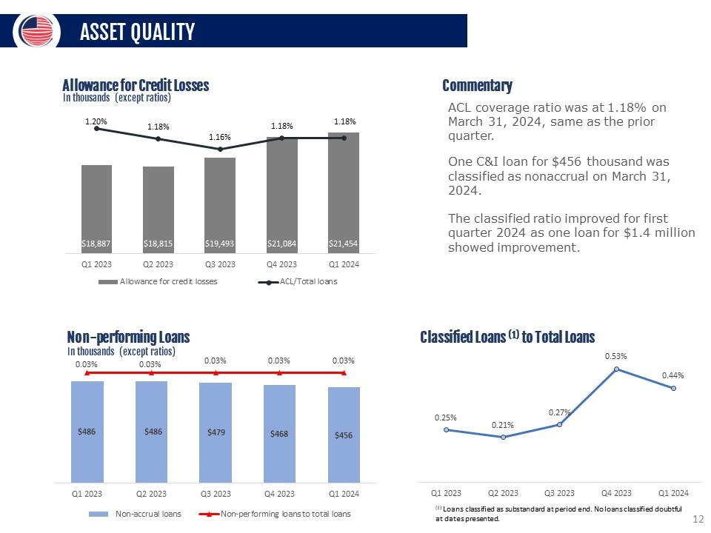
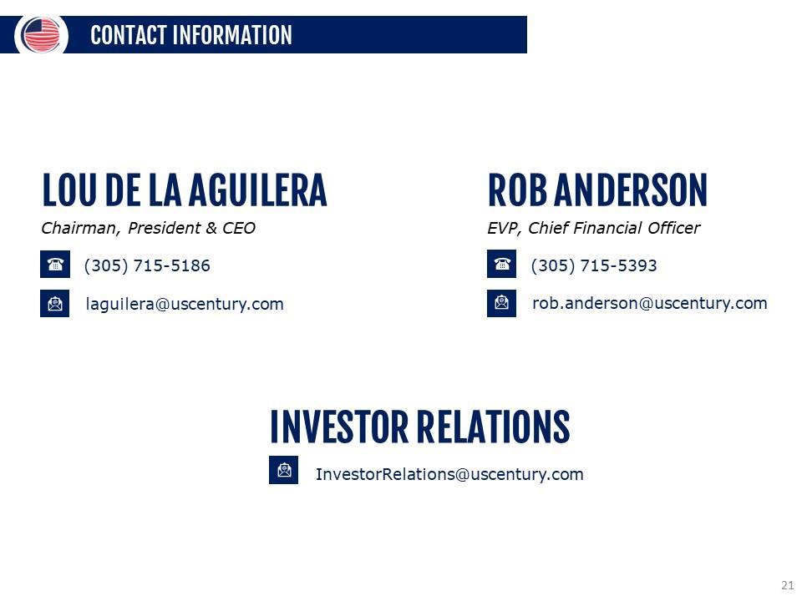
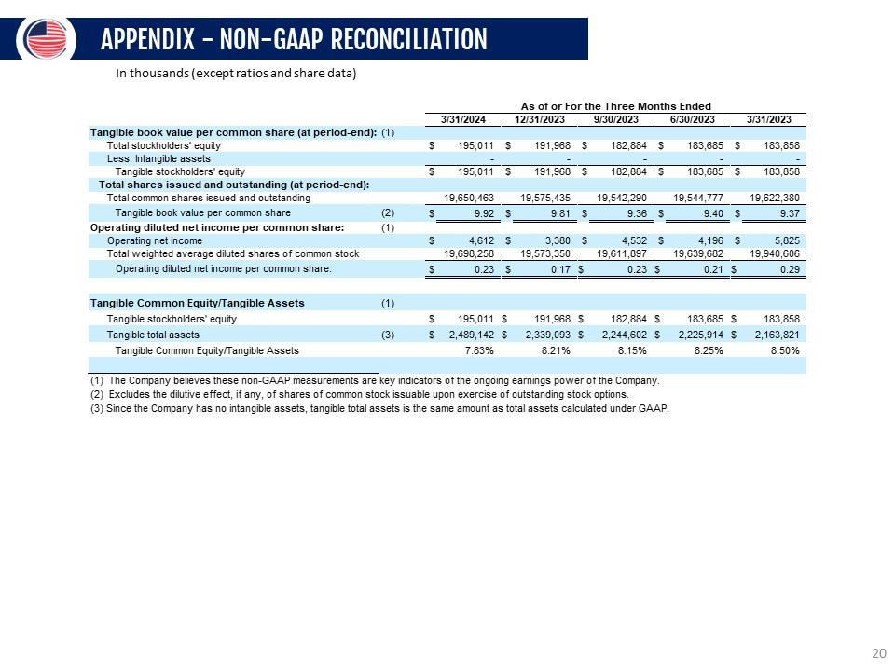
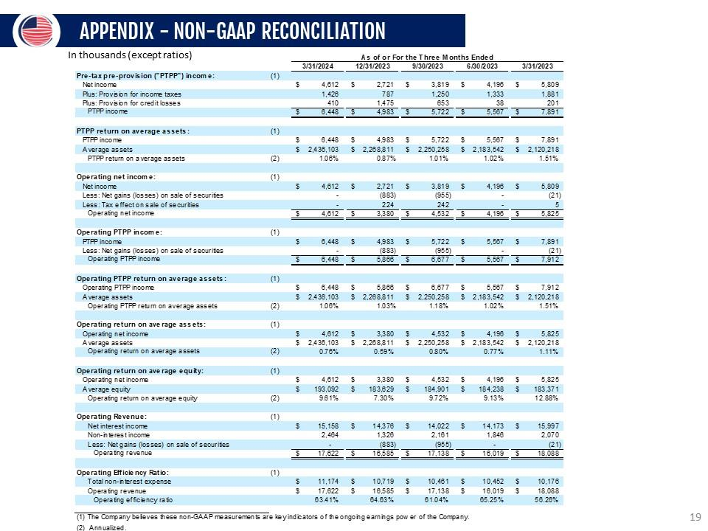
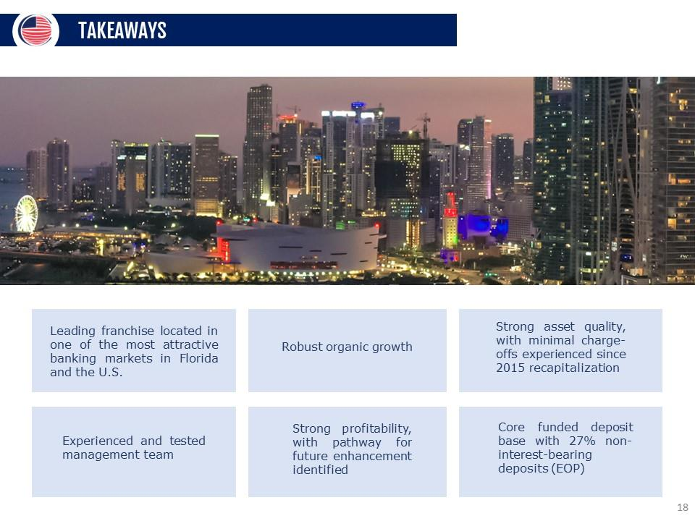
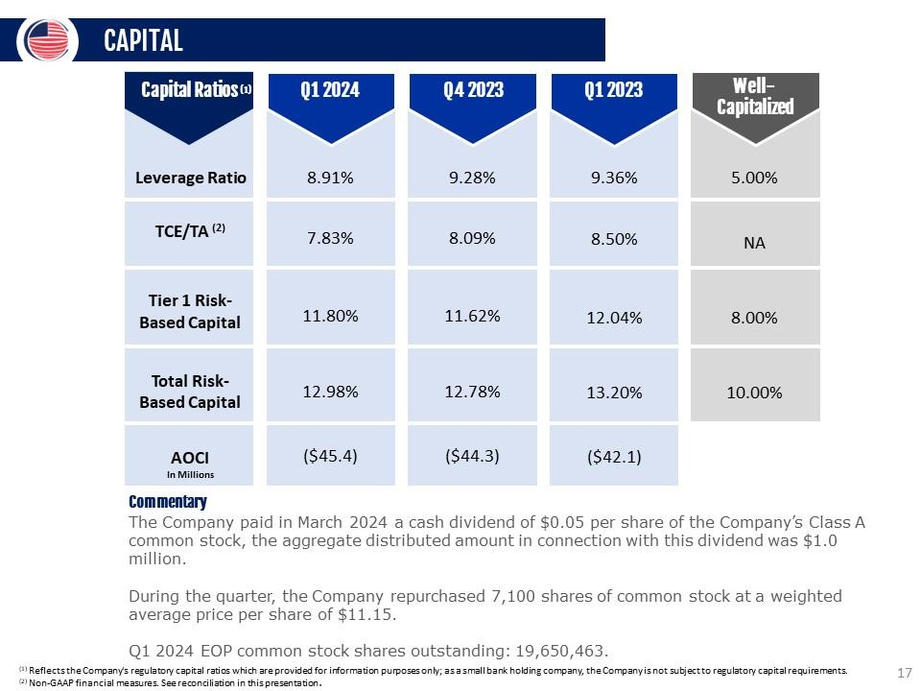
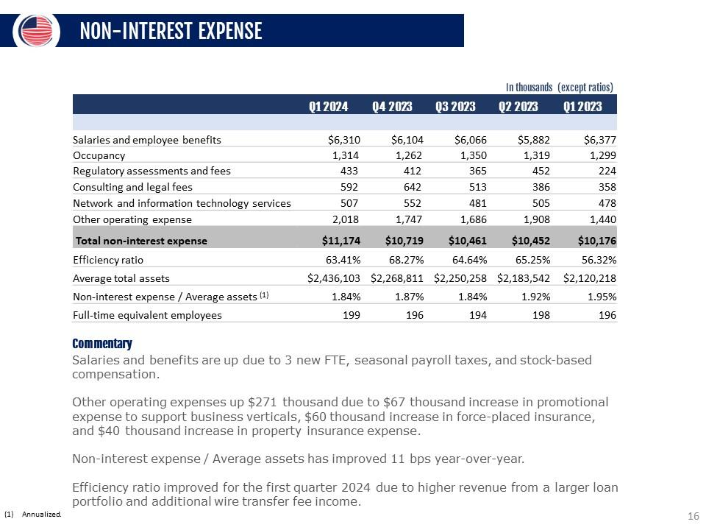
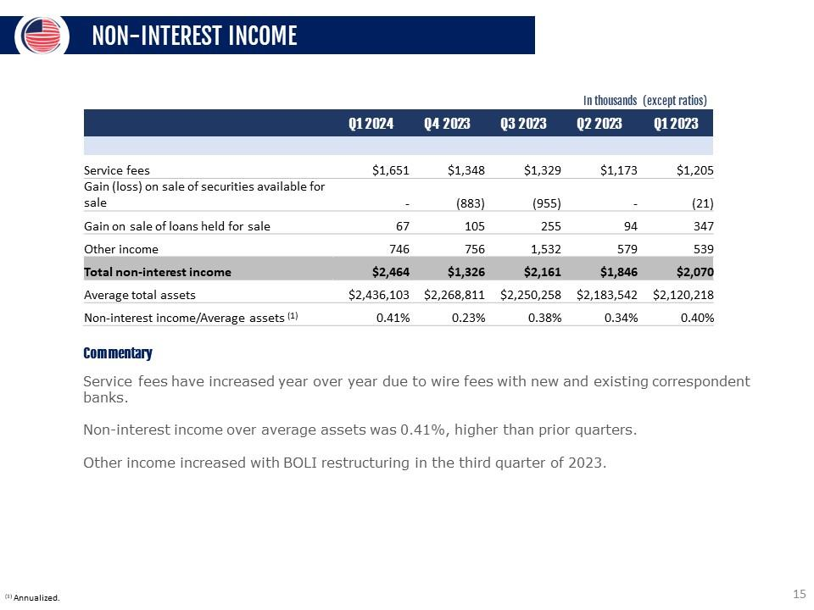
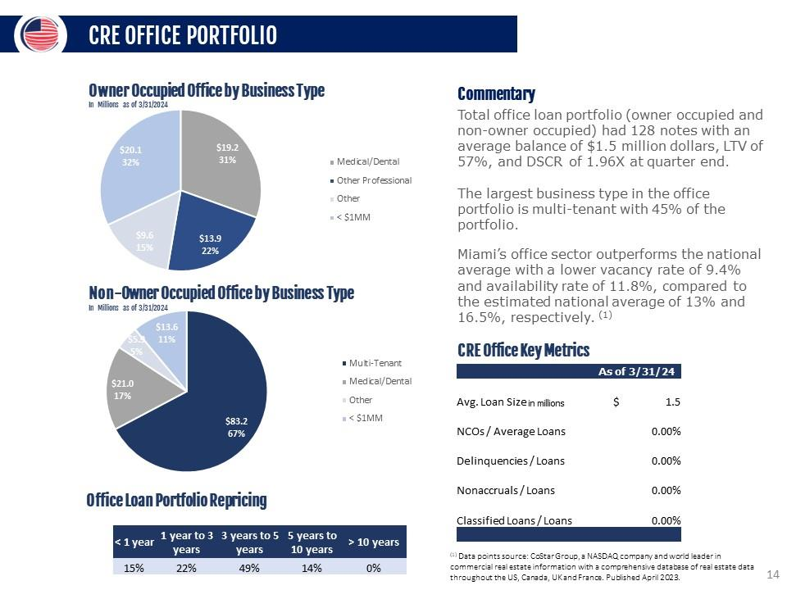
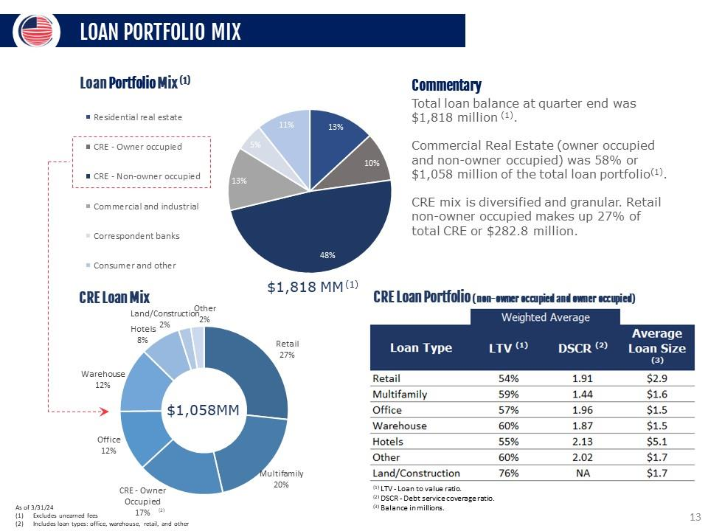
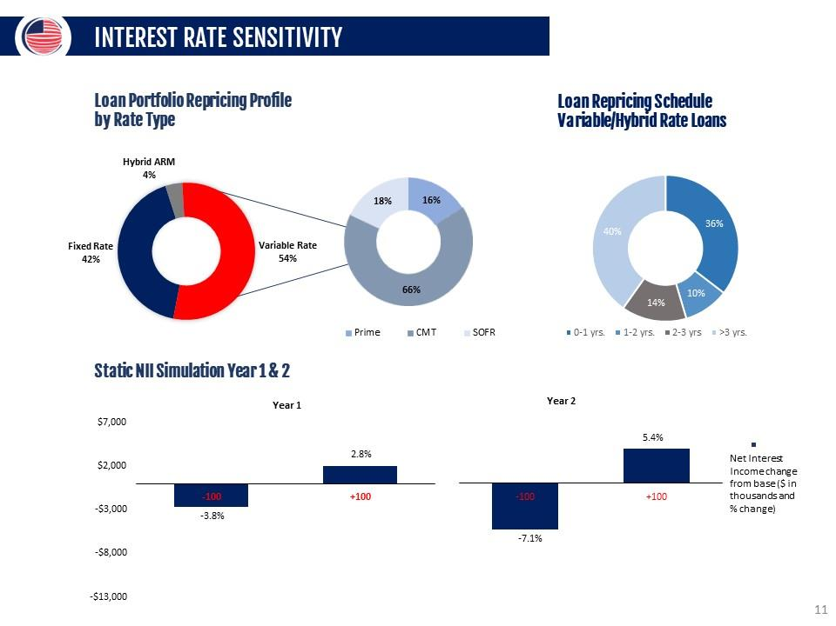
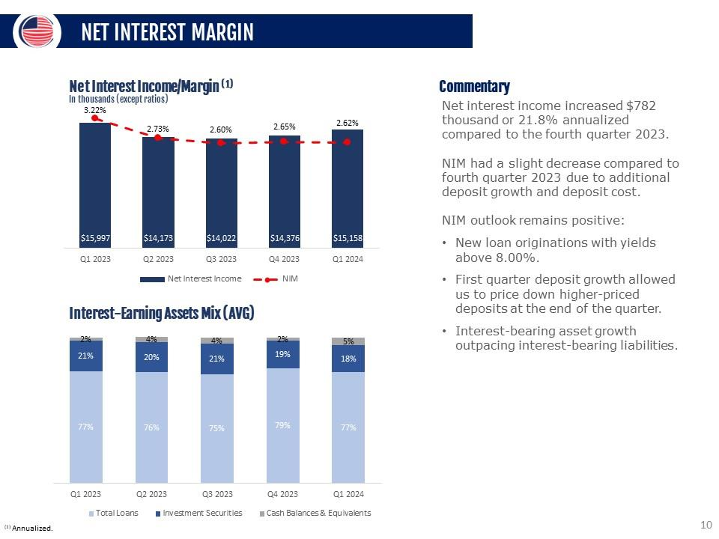
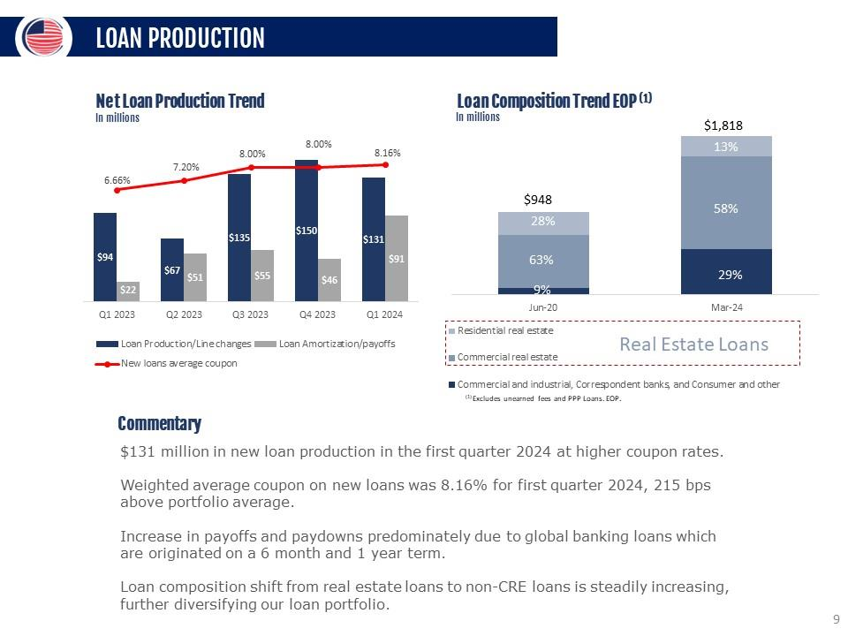
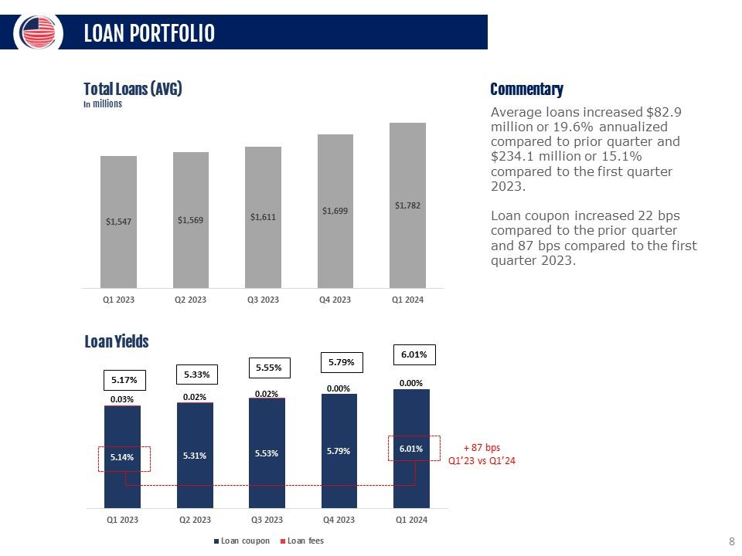
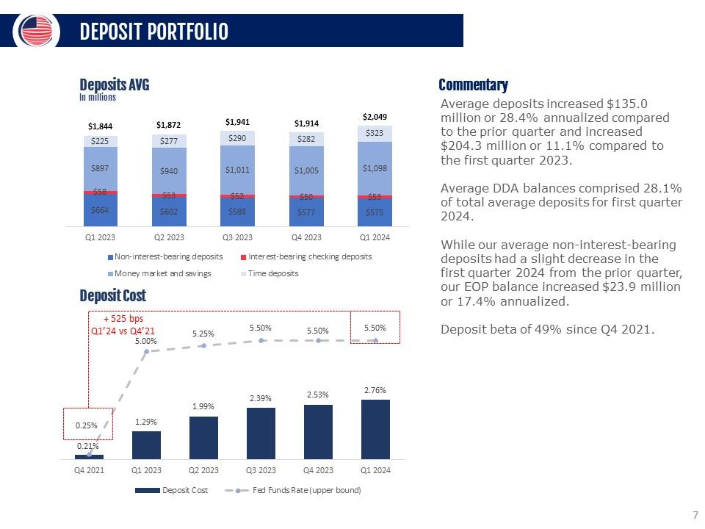
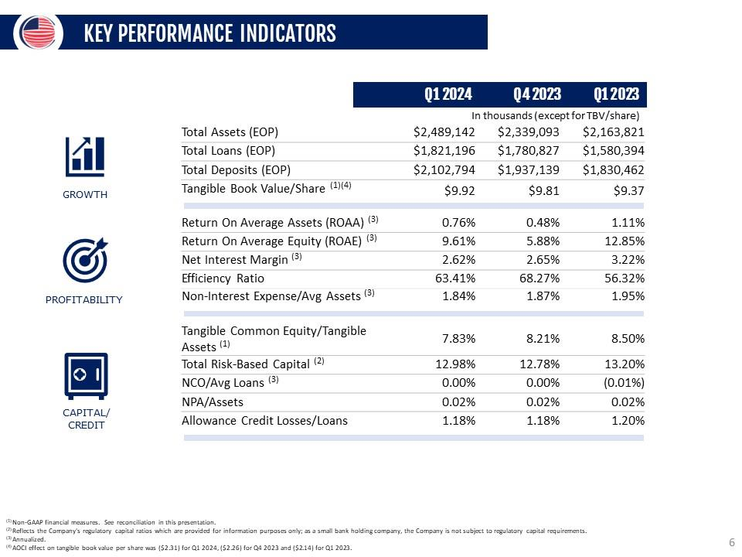
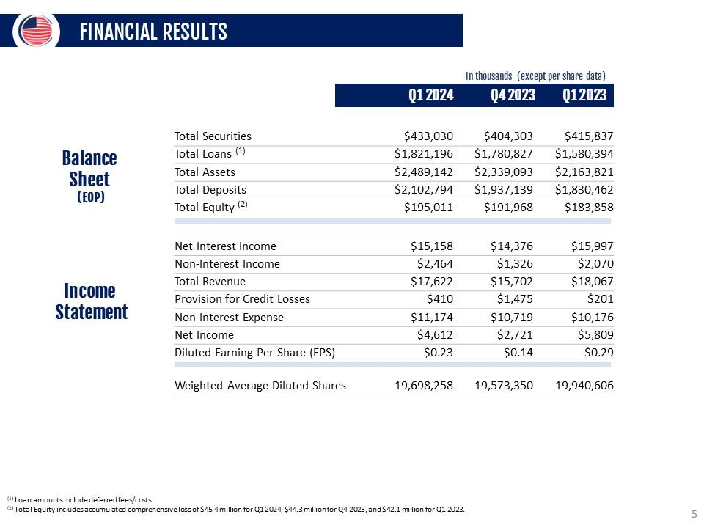
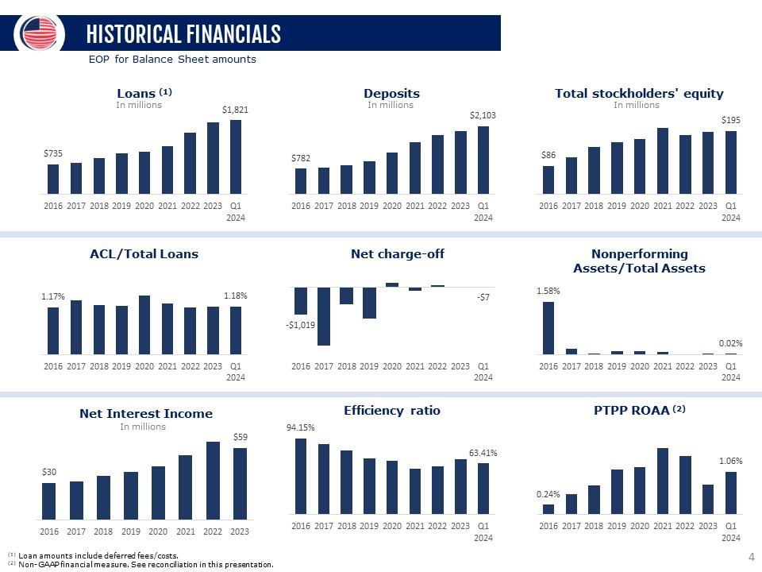
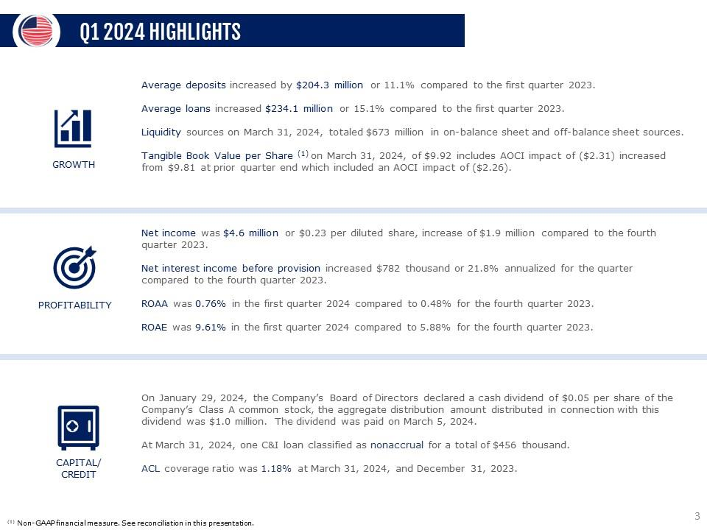
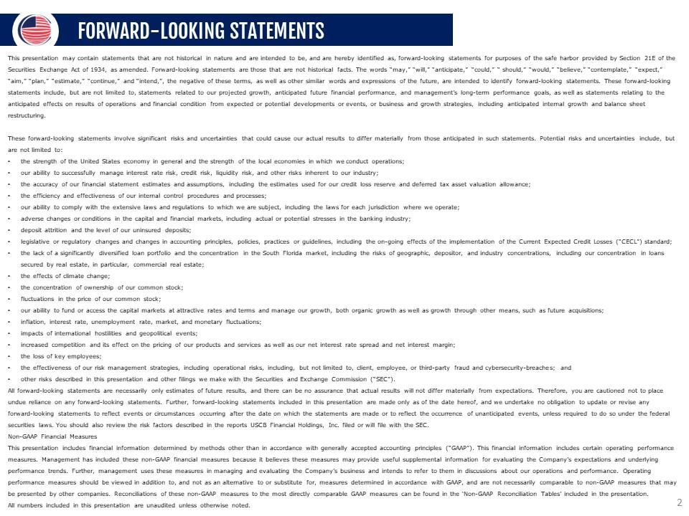



1

UNITED STATES

SECURITIES AND EXCHANGE COMMISSION

WASHINGTON,

D.C. 20549

__________________________

FORM

8-K

__________________________

CURRENT REPORT

Pursuant to Section 13 or 15(d) of the Securities Exchange Act

of 1934

Date of Report (Date of earliest event reported):

April 25, 2024

__________________________

USCB Financial Holdings, Inc.

(Exact name of Registrant as Specified in Its Charter)

__________________________

Florida

001-41196

87-4070846

(State or Other Jurisdiction

of Incorporation)

(Commission File Number)

(IRS Employer

Identification No.)

2301 N.W. 87th Avenue

,

Doral

,

Florida

33172

(Address of Principal Executive Offices)

(Zip Code)

Registrant’s Telephone

Number, Including Area Code: (

305

)

715-5200

__________________________

Check the appropriate box below if the Form 8-K filing is intended to simultaneously satisfy the filing obligation

of the registrant under

any of the following provisions:

☐

Written communications pursuant

to Rule 425 under the Securities Act (17 CFR 230.425)

☐

Soliciting material pursuant to Rule 14a-12 under the Exchange Act (17 CFR 240.14a

-12)

☐

Pre-commencement communications pursuant to Rule 14d-2(b)

under the Exchange Act (17 CFR 240.14d-2(b))

☐

Pre-commencement communications pursuant to Rule 13e-4(c) under the Exchange

Act (17 CFR 240.13e-4(c))

Securities registered pursuant to Section 12(b) of the Act:

Title of each class

Trading

Symbol(s)

Name of each exchange on which registered

Class A common stock, $1.00 par value per share

USCB

The Nasdaq Stock Market LLC

Indicate by

check mark

whether the

registrant is

an emerging

growth company

as defined

in Rule

405 of

the Securities

Act of

1933

(§ 230.405 of this chapter) or Rule 12b-2 of the Securities Exchange Act of 1934 (§ 240.12b

-2 of this chapter).

Emerging growth company

☒

If

an

emerging

growth

company,

indicate

by

check

mark

if

the

registrant

has

elected

not

to

use

the

extended

transition

period

for

complying with any new or revised financial accounting standards provided

pursuant to Section 13(a) of the Exchange Act.

☐

2

Item 2.02. Results of Operations and Financial Condition.

On April 25, 2024, USCB Financial Holdings, Inc. (the “Company”) issued a press release announcing

its financial results for

the quarter ended March 31, 2024.

A copy of the press release is

furnished as Exhibit 99.1 to

this Current Report on Form 8-K

(“Form

8-K”) and is incorporated herein by reference.

The information

in this Item

2.02, including

Exhibit 99.1, is

being furnished

and shall not

be deemed

“filed” for purposes

of

Section 18 of the

Securities Exchange Act

of 1934 (the “Exchange

Act”), or otherwise subject

to the liability of

that section, and

shall

not be deemed

to be incorporated

by reference into

any filing under

the Securities Act of

1933 (the “Securities

Act”) or the

Exchange

Act except as expressly set forth by specific reference in such filing to this Form 8-K.

Item 7.01. Regulation FD Disclosure.

As previously

announced, at 11:00

a.m. ET on

April 26, 2024,

the Company will

hold an earnings

conference call to

discuss

its financial

performance

for the

quarter

ended

March 31,

2024.

A copy

of the

slides forming

the basis

of

the

presentation

is being

furnished as

Exhibit 99.2

to this

Form 8-K

and is

incorporated herein

by reference.

A copy

of the

slides has

also been

posted to

the

Company’s investor relations website,

located at investors.uscenturybank.com.

The information

in this Item

7.01, including

Exhibit 99.2, is

being furnished

and shall not

be deemed

“filed” for purposes

of

Section 18

of the

Exchange Act,

or otherwise

subject to

the

liability of

that section,

and

shall not

be deemed

to be

incorporated

by

reference into any filing under the

Securities Act or the Exchange Act

except as set forth by

specific reference in such filing to

this Form

8-K.

Item 9.01. Financial Statements and Exhibits.

(d) Exhibits.

Exhibit No.

Description

99.1

USCB Financial Holdings, Inc. Press Release, dated April 25, 2024

99.2

Earnings Presentation, dated April 25, 2024

104

Cover Page Interactive Data File (embedded within the Inline XBRL document)

3

SIGNATURE

Pursuant to the requirements of the Securities Exchange Act of 1934, the registrant has duly

caused this report to be signed on

its behalf by the undersigned hereunto duly authorized.

USCB Financial Holdings, Inc.

By:

/s/ Robert Anderson

Name:

Robert Anderson

Title:

Chief Financial Officer

Date: April 25, 2024

1

Exhibit 99.1

EARNINGS RELEASE

USCB Financial Holdings, Inc. Reports Diluted EPS of $0.23 for Q1 2024 and

announces adoption of new 500,000

share repurchase program

MIAMI,

FL – April 25,

2024 – USCB

Financial Holdings, Inc. (the

“Company”) (NASDAQ: USCB)

, the holding

company for U.S. Century

Bank (the “Bank”),

reported net income of $4.6 million or

$0.23 per diluted share for the three

months ended March 31, 2024, compared with

net income of $5.8 million or $0.29

per diluted

share for the same period in 2023.

“We are pleased to report

a robust start

to the year, marked

by a strong

increase in deposits

of $165.7 million

from the close

of 2023. This

achievement reflects our

diligent

execution of

strategic plans emphasizing

organic growth,

including business and

retail banking

initiatives to deepen

existing relationships, new

production hires, and

innovative deposit-aggregating business verticals,” said Luis de la Aguilera,

Chairman, President, and CEO. The growth in deposits continues to bolster our capacity for

safe and sound lending activities, delivering accretive quarter-over-quarter improvement

in average loan coupon rates which contributes to interest

income.”

“Last month,

we initiated

a dividend

program starting

with a

rate of

$0.05 per

share, underscoring

our commitment

to delivering

shareholder value,”

affirmed de

la

Aguilera. “Looking ahead to the coming year and evaluating

our thriving Florida economy, we anticipate diversified sustainable growth in both loans and

deposits.”

Unless otherwise

stated, all

percentage comparisons

in

the bullet

points below

are

calculated for

the quarter

ended March 31,

2024 compared

to the

quarter ended

March 31, 2023 and annualized where appropriate.

Profitability

•

Annualized return on average assets for the quarter ended March

31, 2024 was 0.76% compared to 1.11% for the first quarter of 2023.

•

Annualized return on average stockholders’ equity for

the quarter ended March 31, 2024 was 9.61% compared

to 12.85% for the first quarter of 2023.

•

The efficiency ratio for the quarter ended March 31, 2024 was 63.41%

compared to 56.32% for the first quarter of 2023.

•

Net interest margin for the quarter ended March 31, 2024 was 2.62%

compared to 3.22% for the first quarter of

2023.

•

Net interest income before provision for

credit losses was $15.2 million for the

quarter ended March 31, 2024, a

decrease of $839 thousand or 5.2% compared

to

the first quarter of 2023.

Balance Sheet

•

Total assets were $2.5 billion at March 31, 2024, representing an increase of $325.3 million or

15.0% from March 31, 2023.

•

Total loans were $1.8 billion at March 31, 2024, representing an increase of $240.8 million or

15.2% from March 31, 2023.

•

Total deposits were $2.1 billion at March 31, 2024, representing an increase of $272.3 million or 14.9%

from March 31, 2023.

•

Total stockholders’ equity was

$195.0 million at

March 31, 2024, representing

an increase of

$11.2 million or 6.1%

from March 31, 2023.

Total stockholders’ equity

included accumulated comprehensive loss of $45.4 million at March

31, 2024 compared to accumulated comprehensive loss of $42.1 million

at March 31, 2023.

Asset Quality

•

The allowance for credit losses (“ACL”) increased by $2.6 million

to $21.5 million at March 31, 2024 from $18.9 million

at March 31, 2023.

•

The allowance for credit losses represented 1.18% of total loans

at March 31, 2024 and 1.20% at March 31, 2023.

•

Non-performing loans to total loans was 0.03% at both March

31, 2024 and March 31, 2023.

Non-interest Income and Non-interest Expense

•

Non-interest income was $2.5 million for the

three months ended March 31, 2024, an increase of

$394 thousand or 19.0%

compared to $2.1 million for

the same

period in 2023.

•

Non-interest expense was $11.2 million for the three months ended March 31, 2024, an increase of $998

thousand or 9.8% compared to $10.2 million for the same

period in 2023.

Capital

•

On January 29, 2024, the Company’s Board of Directors declared a

cash dividend of $0.05 per share of the Company’s Class A

common stock. The dividend was

paid on March 5, 2024 to shareholders of record at the close of business on

February 15, 2023. The aggregate amount distributed in connection with this dividend

was $1.0 million.

•

The Company’s Board of Directors declared a cash dividend of $0.05 per share of the Company’s

Class A common stock on April 22, 2024. The dividend will be

paid on June 5, 2024 to shareholders of record at the close

of business on May 15, 2024.

2

•

As of March 31, 2024,

total risk-based capital ratios for the Company and the

Bank were 12.98%

and 12.89%, respectively.

•

Tangible book value per common share (a non-GAAP measure)

of $9.92 was negatively affected by $2.31

due to accumulated comprehensive loss of

$45.4 million

at March 31, 2024.

At March 31, 2023,

tangible

book value per

common share of

$9.37 was

negatively affected by

$2.14 due

to $42.1

million in accumulated

comprehensive loss.

•

During the quarter the Company repurchased 7,100

shares of Class A common stock at a weighted average

price per share of $11.15. The aggregate purchase price

for these transactions was approximately $79.2 thousand, including transaction

costs. As of March 31, 2024, 72,980 shares remain authorized for repurchase

under

the Company’s previously announced share repurchase program.

•

On April 22, 2024, the Board of Directors approved a new share

repurchase program of up to 500,000 shares of Class A common stock or

approximately 2.5% of

the Company’s issued and outstanding shares of common stock. Under the repurchase program, the Company may purchase shares of Class A common stock on a

discretionary basis from time to

time through open market repurchases,

privately negotiated transactions, or

other means. The repurchase program

has no expiration

date and may be modified, suspended, or terminated at any

time. The new repurchase program will commence upon completion

of the current repurchase program.

Repurchases under this program will be funded from the

Company’s existing cash and cash equivalents or

future cash flow.

As of April 22, 2024, 572,980 shares

remain authorized for repurchase under the Company’s share repurchase programs.

Conference Call and Webcast

The Company will host

a conference call on

Friday, April 26, 2024, at 11:00 a.m.

Eastern Time to discuss the

Company’s unaudited financial results for

the quarter ended

March 31, 2024. To access the conference call, dial (833) 816-1416 (U.S. toll-free) and ask

to join the USCB Financial Holdings Call.

Additionally, interested parties can listen to a live webcast of the call in the “Investor Relations” section of the Company’s website at www.uscentury.com

.

An archived

version of the webcast will be available in the same location

shortly after the live call has ended.

About USCB Financial Holdings, Inc.

USCB Financial

Holdings, Inc. is

the bank

holding company for

U.S. Century

Bank. Established in

2002, U.S. Century

Bank is

one of

the largest

community banks

headquartered in

Miami, and

one of

the largest

community banks

in the

State of

Florida. U.S.

Century Bank

is rated

5-Stars by

BauerFinancial, the

nation’s leading

independent bank

rating firm. U.S.

Century Bank offers

customers a

wide range

of financial products

and services and

supports numerous community

organizations,

including the Greater Miami Chamber of Commerce,

the South Florida Hispanic Chamber of Commerce,

and ChamberSouth. For more information about us

or to find a

banking center near you, please call (305) 715-5200 or visit www.uscentury.com.

Forward-Looking Statements

This earnings release may contain

statements that are not

historical in nature and are

intended to be, and are

hereby identified as, forward-looking

statements for purposes

of the safe harbor provided by Section 21E

of the Securities Exchange Act of 1934, as amended.

Forward-looking statements are those that are not historical facts. The

words “may,” “will,” “anticipate,” “could,” “ should,” “would,”

“believe,” “contemplate,” “expect,” “aim,”

“plan,” “estimate,” “continue,” and “intend,”, the

negative of

these terms, as well as other similar words and expressions of the future, are

intended to identify forward-looking statements. These forward-looking

statements include,

but are not limited

to, statements related to our

projected growth, anticipated future financial performance,

and management’s long-term performance

goals, as well as

statements relating to the anticipated effects on results

of operations and financial condition from expected or potential developments or events, or

business and growth

strategies, including anticipated internal growth and balance

sheet restructuring.

These

forward-looking statements

involve significant

risks

and

uncertainties that

could

cause

our

actual

results to

differ

materially

from

those

anticipated

in

such

statements. Potential risks and uncertainties include, but are

not limited to:

•

the strength of the United States economy in general and the strength

of the local economies in which we conduct operations;

•

our ability to successfully manage interest rate risk, credit risk,

liquidity risk, and other risks inherent to our industry;

•

the accuracy of

our financial statement

estimates and assumptions,

including the estimates

used for our

credit loss reserve

and deferred tax

asset valuation allowance;

•

the efficiency and effectiveness of our internal control procedures and processes;

•

our ability to comply with the extensive laws and regulations

to which we are subject, including the laws for

each jurisdiction where we operate;

•

adverse changes or conditions in capital and financial markets,

including actual or potential stresses in the banking

industry;

•

deposit attrition and the level of our uninsured deposits;

•

legislative or regulatory changes and changes in

accounting principles, policies, practices or guidelines,

including the on-going effects of the implementation of the

Current Expected Credit Losses (“CECL”) standard;

•

the lack of

a significantly diversified loan

portfolio and the

concentration in the

South Florida market,

including the risks

of geographic, depositor,

and industry

concentrations, including our concentration in loans secured

by real estate, in particular, commercial real estate;

•

the effects of climate change;

•

the concentration of ownership of our common stock;

•

fluctuations in the price of our common stock;

•

our ability to fund or access the

capital markets at attractive rates and terms and

manage our growth, both organic growth as

well as growth through other means,

such as future acquisitions;

•

inflation, interest rate, unemployment rate, market and monetary

fluctuations;

•

impacts of international hostilities and geopolitical events;

•

increased competition and its effect on the pricing of our products

and services as well as our interest rate spread

and net interest margin;

•

the loss of key employees;

•

the effectiveness of

our risk

management strategies, including

operational risks, including,

but not

limited to, client,

employee, or third-party

fraud and

security

breaches; and

•

other risks described in this earnings release and other filings we

make with the Securities and Exchange Commission (“SEC”).

All

forward-looking

statements

are

necessarily

only

estimates

of

future

results,

and

there

can

be

no

assurance

that

actual

results

will

not

differ

materially

from

expectations. Therefore, you are cautioned not to place undue reliance on any forward-looking statements. Further, forward-looking statements included in this earnings

release are made only as of the date hereof, and

we undertake no obligation to update or revise

any forward-looking statement to reflect events

or circumstances after the

date on which

the statements are made

or to reflect

the occurrence of unanticipated

events, unless required to

do so under

the federal securities

laws. You

should also

review the risk factors described in the reports the Company

filed or will file with the SEC.

3

Non-GAAP Financial Measures

This earnings

release includes

financial information

determined by

methods other

than in

accordance with

generally accepted

accounting principles

(“GAAP”). This

financial information includes

certain operating performance

measures. Management has

included these non-GAAP measures

because it believes

these measures may

provide useful

supplemental information

for evaluating

the Company’s

operations and

underlying performance

trends. Further,

management uses

these measures

in

managing and evaluating the

Company’s business

and intends to

refer to them in

discussions about our operations

and performance. Operating performance

measures

should be viewed in addition to,

and not as an alternative to

or substitute for, measures determined in accordance

with GAAP, and are not necessarily comparable to non-

GAAP measures that may

be presented by other companies.

Reconciliations of these non-GAAP

measures to the most

directly comparable GAAP measures

can be found

in the ‘Non-GAAP Reconciliation Tables’ included in the exhibits to this earnings release.

All numbers included in this press release are unaudited

unless otherwise noted.

Contacts:

Investor Relations

InvestorRelations@uscentury.com

Media Relations

Martha Guerra-Kattou

MGuerra@uscentury.com

4

USCB FINANCIAL HOLDINGS, INC.

CONSOLIDATED STATEMENTS

OF INCOME (UNAUDITED)

(Dollars in thousands, except per share data)

Three Months Ended March 31,

2024

2023

Interest income:

Loans, including fees

$

26,643

$

19,711

Investment securities

2,811

2,286

Interest-bearing deposits in financial institutions

1,433

382

Total interest income

30,887

22,379

Interest expense:

Interest-bearing checking

369

43

Savings and money market accounts

10,394

4,785

Time deposits

3,294

1,057

FHLB advances and other borrowings

1,672

497

Total interest expense

15,729

6,382

Net interest income before provision for credit losses

15,158

15,997

Provision for credit losses

410

201

Net interest income after provision for credit losses

14,748

15,796

Non-interest income:

Service fees

1,651

1,205

Gain (loss) on sale of securities available for sale, net

-

(21)

Gain on sale of loans held for sale, net

67

347

Other non-interest income

746

539

Total non-interest income

2,464

2,070

Non-interest expense:

Salaries and employee benefits

6,310

6,377

Occupancy

1,314

1,299

Regulatory assessments and fees

433

224

Consulting and legal fees

592

358

Network and information technology services

507

478

Other operating expense

2,018

1,440

Total non-interest expense

11,174

10,176

Net income before income tax expense

6,038

7,690

Income tax expense

1,426

1,881

Net income

$

4,612

$

5,809

Per share information:

Net income per common share, basic

$

0.23

$

0.29

Net income per common share, diluted

$

0.23

$

0.29

Cash dividends declared

$

0.05

$

-

Weighted average shares outstanding:

Common shares, basic

19,633,330

19,855,409

Common shares, diluted

19,698,258

19,940,606

5

USCB FINANCIAL HOLDINGS, INC.

SELECTED FINANCIAL DATA (UNAUDITED)

(Dollars in thousands, except per share data)

As of or For the Three Months Ended

3/31/2024

12/31/2023

9/30/2023

6/30/2023

3/31/2023

Income statement data:

Net interest income

$

15,158

$

14,376

$

14,022

$

14,173

$

15,997

Provision for credit losses

410

1,475

653

38

201

Net interest income after provision for credit losses

14,748

12,901

13,369

14,135

15,796

Service fees

1,651

1,348

1,329

1,173

1,205

Gain (loss) on sale of securities available for sale, net

-

(883)

(955)

-

(21)

Gain on sale of loans held for sale, net

67

105

255

94

347

Other income

746

756

1,532

579

539

Total non-interest income

2,464

1,326

2,161

1,846

2,070

Salaries and employee benefits

6,310

6,104

6,066

5,882

6,377

Occupancy

1,314

1,262

1,350

1,319

1,299

Regulatory assessments and fees

433

412

365

452

224

Consulting and legal fees

592

642

513

386

358

Network and information technology services

507

552

481

505

478

Other operating expense

2,018

1,747

1,686

1,908

1,440

Total non-interest expense

11,174

10,719

10,461

10,452

10,176

Net income before income tax expense

6,038

3,508

5,069

5,529

7,690

Income tax expense

1,426

787

1,250

1,333

1,881

Net income

$

4,612

$

2,721

$

3,819

$

4,196

$

5,809

Per share information:

Net income per common share, basic

$

0.23

$

0.14

$

0.20

$

0.21

$

0.29

Net income per common share, diluted

$

0.23

$

0.14

$

0.19

$

0.21

$

0.29

Cash dividends declared

$

0.05

$

-

$

-

$

-

$

-

Balance sheet data (at period-end):

Cash and cash equivalents

$

126,546

$

41,062

$

33,435

$

87,280

$

63,251

Securities available-for-sale

$

259,992

$

229,329

$

218,609

$

218,442

$

229,409

Securities held-to-maturity

$

173,038

$

174,974

$

197,311

$

220,956

$

186,428

Total securities

$

433,030

$

404,303

$

415,920

$

439,398

$

415,837

Loans held for investment

(1)

$

1,821,196

$

1,780,827

$

1,676,520

$

1,595,959

$

1,580,394

Allowance for credit losses

$

(21,454)

$

(21,084)

$

(19,493)

$

(18,815)

$

(18,887)

Total assets

$

2,489,142

$

2,339,093

$

2,244,602

$

2,225,914

$

2,163,821

Non-interest-bearing deposits

$

576,626

$

552,762

$

573,546

$

572,360

$

633,606

Interest-bearing deposits

$

1,526,168

$

1,384,377

$

1,347,376

$

1,348,941

$

1,196,856

Total deposits

$

2,102,794

$

1,937,139

$

1,920,922

$

1,921,301

$

1,830,462

FHLB advances and other borrowings

$

162,000

$

183,000

$

102,000

$

87,000

$

120,000

Total liabilities

$

2,294,131

$

2,147,125

$

2,061,718

$

2,042,229

$

1,979,963

Total stockholders' equity

$

195,011

$

191,968

$

182,884

$

183,685

$

183,858

Capital ratios:

(2)

Leverage ratio

8.91%

9.28%

9.26%

9.32%

9.36%

Common equity tier 1 capital

11.80%

11.62%

11.97%

12.27%

12.04%

Tier 1 risk-based capital

11.80%

11.62%

11.97%

12.27%

12.04%

Total risk-based capital

12.98%

12.78%

13.10%

13.42%

13.20%

(1)

Loan amounts include deferred fees/costs.

(2) Reflects the Company's regulatory capital ratios which are

provided for information purposes only; as a small bank holding

company, the Company is not subject to

regulatory capital requirements.

6

USCB FINANCIAL HOLDINGS, INC.

AVERAGE BALANCES, RATIOS, AND OTHER DATA

(UNAUDITED)

(Dollars in thousands)

As of or For the Three Months Ended

3/31/2024

12/31/2023

9/30/2023

6/30/2023

3/31/2023

Average balance sheet data:

Cash and cash equivalents

$

132,266

$

57,069

$

90,742

$

94,313

$

50,822

Securities available-for-sale

$

239,896

$

215,649

$

222,134

$

224,913

$

230,336

Securities held-to-maturity

$

174,142

$

181,151

$

218,694

$

192,628

$

187,826

Total securities

$

414,038

$

396,800

$

440,828

$

417,541

$

418,162

Loans held for investment

(1)

$

1,781,528

$

1,698,611

$

1,610,864

$

1,569,266

$

1,547,393

Total assets

$

2,436,103

$

2,268,811

$

2,250,258

$

2,183,542

$

2,120,218

Interest-bearing deposits

$

1,473,831

$

1,336,470

$

1,353,516

$

1,270,657

$

1,179,878

Non-interest-bearing deposits

$

574,760

$

577,133

$

587,917

$

601,778

$

664,369

Total deposits

$

2,048,591

$

1,913,603

$

1,941,433

$

1,872,435

$

1,844,247

FHLB advances and other borrowings

$

164,187

$

139,000

$

85,326

$

93,075

$

61,600

Total liabilities

$

2,243,011

$

2,085,182

$

2,065,357

$

1,999,304

$

1,936,847

Total stockholders' equity

$

193,092

$

183,629

$

184,901

$

184,238

$

183,371

Performance ratios:

Return on average assets

(2)

0.76%

0.48%

0.67%

0.77%

1.11%

Return on average equity

(2)

9.61%

5.88%

8.19%

9.13%

12.85%

Net interest margin

(2)

2.62%

2.65%

2.60%

2.73%

3.22%

Non-interest income (loss) to average assets

(2)

0.41%

0.23%

0.38%

0.34%

0.40%

Efficiency ratio

(3)

63.41%

68.27%

64.64%

65.25%

56.32%

Loans by type (at period end):

(4)

Residential real estate

$

237,906

$

204,419

$

188,880

$

183,093

$

184,427

Commercial real estate

$

1,057,800

$

1,047,593

$

1,005,280

$

989,401

$

987,757

Commercial and industrial

$

228,045

$

219,757

$

212,975

$

169,401

$

160,947

Foreign banks

$

100,182

$

114,945

$

94,640

$

85,409

$

97,405

Consumer and other

$

194,325

$

191,930

$

173,096

$

167,845

$

149,410

Asset quality data:

Allowance for credit losses to total loans

1.18%

1.18%

1.16%

1.18%

1.20%

Allowance for credit losses to non-performing loans

4,705%

4,505%

4,070%

3,871%

3,886%

Total non-performing loans

(5)

$

456

$

468

$

479

$

486

$

486

Non-performing loans to total loans

0.03%

0.03%

0.03%

0.03%

0.03%

Non-performing assets to total assets

(5)

0.02%

0.02%

0.02%

0.02%

0.02%

Net charge-offs (recoveries of) to average loans

(2)

(0.00)%

(0.00)%

(0.00)%

0.01%

(0.01)%

Net charge-offs (recovery) of credit losses

$

(7)

$

(3)

$

(5)

$

29

$

(49)

Interest rates and yields:

(2)

Loans

6.01%

5.79%

5.55%

5.33%

5.17%

Investment securities

2.69%

2.46%

2.52%

2.26%

2.20%

Total interest-earning assets

5.34%

5.16%

4.89%

4.68%

4.51%

Deposits

2.76%

2.53%

2.39%

1.99%

1.29%

FHLB advances and other borrowings

4.10%

4.04%

3.19%

3.42%

3.27%

Total interest-bearing liabilities

3.86%

3.66%

3.41%

2.97%

2.08%

Other information:

Full-time equivalent employees

199

196

194

198

196

(1)

Loan amounts include deferred fees/costs.

(2)

Annualized.

(3)

Efficiency ratio is defined as total non-interest expense divided

by sum of net interest income and total non-interest

income.

(4)

Loan amounts exclude deferred fees/costs.

(5)

The amounts for total non-performing loans and total non-performing

assets are the same at the dates presented since there were

no impaired investments or other

real estate owned (OREO) recorded.

7

USCB FINANCIAL HOLDINGS, INC.

NET INTEREST MARGIN (UNAUDITED)

(Dollars in thousands)

Three Months Ended March 31,

2024

2023

Average

Balance

Interest

Yield/Rate

(1)

Average

Balance

Interest

Yield/Rate

(1)

Assets

Interest-earning assets:

Loans

(2)

$

1,781,528

$

26,643

6.01%

$

1,547,393

$

19,711

5.17%

Investment securities

(3)

419,989

2,811

2.69%

421,717

2,286

2.20%

Other interest-earning assets

125,244

1,433

4.60%

43,084

382

3.60%

Total interest-earning assets

2,326,761

30,887

5.34%

2,012,194

22,379

4.51%

Non-interest-earning assets

109,342

108,024

Total assets

$

2,436,103

$

2,120,218

Liabilities and stockholders' equity

Interest-bearing liabilities:

Interest-bearing checking

$

53,344

369

2.78%

$

58,087

43

0.30%

Saving and money market deposits

1,097,575

10,394

3.81%

897,061

4,785

2.16%

Time deposits

322,912

3,294

4.10%

224,730

1,057

1.91%

Total interest-bearing deposits

1,473,831

14,057

3.84%

1,179,878

5,885

2.02%

FHLB advances and other borrowings

164,187

1,672

4.10%

61,600

497

3.27%

Total interest-bearing liabilities

1,638,018

15,729

3.86%

1,241,478

6,382

2.08%

Non-interest-bearing demand deposits

574,760

664,369

Other non-interest-bearing liabilities

30,233

31,000

Total liabilities

2,243,011

1,936,847

Stockholders' equity

193,092

183,371

Total liabilities and stockholders' equity

$

2,436,103

$

2,120,218

Net interest income

$

15,158

$

15,997

Net interest spread

(4)

1.48%

2.43%

Net interest margin

(5)

2.62%

3.22%

(1)

Annualized.

(2)

Average loan balances include non-accrual loans. Interest income on loans includes accretion

of deferred loan fees, net of deferred loan costs.

(3)

At fair value except for securities held to maturity. This amount includes FHLB

stock.

(4)

Net interest spread is the average yield earned on total

interest-earning assets minus the average rate paid on total interest-bearing

liabilities.

(5)

Net interest margin is the ratio of net interest income to total

interest-earning assets.

8

USCB FINANCIAL HOLDINGS, INC.

NON-GAAP FINANCIAL MEASURES (UNAUDITED)

(Dollars in thousands)

As of or For the Three Months Ended

3/31/2024

12/31/2023

9/30/2023

6/30/2023

3/31/2023

Pre-tax pre-provision ("PTPP") income:

(1)

Net income

$

4,612

$

2,721

$

3,819

$

4,196

$

5,809

Plus: Provision for income taxes

1,426

787

1,250

1,333

1,881

Plus: Provision for credit losses

410

1,475

653

38

201

PTPP income

$

6,448

$

4,983

$

5,722

$

5,567

$

7,891

PTPP return on average assets:

(1)

PTPP income

$

6,448

$

4,983

$

5,722

$

5,567

$

7,891

Average assets

$

2,436,103

$

2,268,811

$

2,250,258

$

2,183,542

$

2,120,218

PTPP return on average assets

(2)

1.06%

0.87%

1.01%

1.02%

1.51%

Operating net income:

(1)

Net income

$

4,612

$

2,721

$

3,819

$

4,196

$

5,809

Less: Net gains (losses) on sale of securities

-

(883)

(955)

-

(21)

Less: Tax effect on sale of securities

-

224

242

-

5

Operating net income

$

4,612

$

3,380

$

4,532

$

4,196

$

5,825

Operating PTPP income:

(1)

PTPP income

$

6,448

$

4,983

$

5,722

$

5,567

$

7,891

Less: Net gains (losses) on sale of securities

-

(883)

(955)

-

(21)

Operating PTPP income

$

6,448

$

5,866

$

6,677

$

5,567

$

7,912

Operating PTPP return on average assets:

(1)

Operating PTPP income

$

6,448

$

5,866

$

6,677

$

5,567

$

7,912

Average assets

$

2,436,103

$

2,268,811

$

2,250,258

$

2,183,542

$

2,120,218

Operating PTPP return on average assets

(2)

1.06%

1.03%

1.18%

1.02%

1.51%

Operating return on average assets:

(1)

Operating net income

$

4,612

$

3,380

$

4,532

$

4,196

$

5,825

Average assets

$

2,436,103

$

2,268,811

$

2,250,258

$

2,183,542

$

2,120,218

Operating return on average assets

(2)

0.76%

0.59%

0.80%

0.77%

1.11%

Operating return on average equity:

(1)

Operating net income

$

4,612

$

3,380

$

4,532

$

4,196

$

5,825

Average equity

$

193,092

$

183,629

$

184,901

$

184,238

$

183,371

Operating return on average equity

(2)

9.61%

7.30%

9.72%

9.13%

12.88%

Operating Revenue:

(1)

Net interest income

$

15,158

$

14,376

$

14,022

$

14,173

$

15,997

Non-interest income

2,464

1,326

2,161

1,846

2,070

Less: Net gains (losses) on sale of securities

-

(883)

(955)

-

(21)

Operating revenue

$

17,622

$

16,585

$

17,138

$

16,019

$

18,088

Operating Efficiency Ratio:

(1)

Total non-interest expense

$

11,174

$

10,719

$

10,461

$

10,452

$

10,176

Operating revenue

$

17,622

$

16,585

$

17,138

$

16,019

$

18,088

Operating efficiency ratio

63.41%

64.63%

61.04%

65.25%

56.26%

(1) The Company believes these non-GAAP measurements are

key indicators of the ongoing earnings power of the

Company.

(2)

Annualized.

9

USCB FINANCIAL HOLDINGS, INC.

NON-GAAP FINANCIAL MEASURES (UNAUDITED)

(Dollars in thousands, except per share data)

As of or For the Three Months Ended

3/31/2024

12/31/2023

9/30/2023

6/30/2023

3/31/2023

Tangible book value per common share (at period-end):

(1)

Total stockholders' equity

$

195,011

$

191,968

$

182,884

$

183,685

$

183,858

Less: Intangible assets

-

-

-

-

-

Tangible stockholders' equity

$

195,011

$

191,968

$

182,884

$

183,685

$

183,858

Total shares issued and outstanding (at period-end):

Total common shares issued and outstanding

19,650,463

19,575,435

19,542,290

19,544,777

19,622,380

Tangible book value per common share

(2)

$

9.92

$

9.81

$

9.36

$

9.40

$

9.37

Operating diluted net income per common share:

(1)

Operating net income

$

4,612

$

3,380

$

4,532

$

4,196

$

5,825

Total weighted average diluted shares of common stock

19,698,258

19,573,350

19,611,897

19,639,682

19,940,606

Operating diluted net income per common share:

$

0.23

$

0.17

$

0.23

$

0.21

$

0.29

Tangible Common Equity/Tangible Assets

(1)

Tangible stockholders' equity

$

195,011

$

191,968

$

182,884

$

183,685

$

183,858

Tangible total assets

(3)

$

2,489,142

$

2,339,093

$

2,244,602

$

2,225,914

$

2,163,821

Tangible Common Equity/Tangible Assets

7.83%

8.21%

8.15%

8.25%

8.50%

(1)

The Company believes these non-GAAP measurements

are key indicators of the ongoing earnings power

of the Company.

(2)

Excludes the dilutive effect, if any, of shares of common stock issuable upon exercise of outstanding

stock options.

(3) Since the Company has no intangible assets, tangible

total assets is the same amount as total assets calculated

under GAA

P.

Exhibit 99.2

EARNINGS PRESENTATION FIRST QUARTER

2024 NASDAG: USCB USCB FINANCIAL HOLDINGS | U.S.

CENTURY BANK

FORWARD-LOOKING STATEMENTS This presentation

may contain statements that are not historical in nature and are

intended to be, and are hereby identified as, forward-looking statements

for purposes of the safe harbor provided by Section 21E of the

Securities Exchange Act of 1934, as amended. Forward-looking statements

are those that are not historical facts. The words “may,” “will,”

“anticipate,” “could,” “ should,” “would,” “believe,” “contemplate,”

“expect,” “aim,” “plan,” “estimate,” “continue,” and “intend,”, the negative

of these terms, as well as other similar words and expressions of the

future, are intended to identify forward-looking statements. These forward

-looking statements include, but are not limited to, statements related

to our projected growth, anticipated future financial performance,

and management’s long-term performance goals, as well as statements

relating to the anticipated effects on results of operations and financial

condition from expected or potential developments or events,

or business and growth strategies, including anticipated internal growth

and balance sheet restructuring. These forward-looking statements

involve significant risks and uncertainties that could cause our

actual results to differ materially from those anticipated in such statements.

Potential risks and uncertainties include, but are not limited to: the

strength of the United States economy in general and the strength

of the local economies in which we conduct operations; our ability

to successfully manage interest rate risk, credit risk, liquidity risk,

and other risks inherent to our industry; the accuracy of

our financial statement estimates and assumptions, including the estimates

used for our credit loss reserve and deferred tax asset valuation allowance;

the efficiency and effectiveness of our internal control procedures

and processes; our ability to comply with the extensive laws and regulations

to which we

are subject, including the laws for each jurisdiction where we

operate; adverse changes or conditions in the capital and financial markets,

including actual or potential stresses in the banking industry;

deposit attrition and the level of our uninsured deposits; legislative

or regulatory changes and changes in accounting principles,

policies, practices or guidelines, including the on-going effects

of the implementation of the Current Expected Credit Losses (“CECL”)

standard; the lack of a significantly diversified loan portfolio and

the concentration in the South Florida market, including the risks

of geographic, depositor, and industry concentrations, including

our concentration in loans secured by real estate, in particular,

commercial real estate; the effects of climate change; the concentration

of ownership of our common stock; fluctuations in the price of our

common stock; our ability to fund or access the capital markets

at attractive rates and terms and manage our growth, both organic growth

as well as growth through other means, such as future acquisitions;

inflation, interest rate, unemployment rate, market, and monetary

fluctuations; impacts of international hostilities and geopolitical

events; increased competition and its effect on the pricing of our products

and services as well as our net interest rate spread and net

interest margin; the loss of key employees; the effectiveness of

our risk management strategies, including operational risks, including,

but not limited to, client, employee, or third-party fraud and

cybersecurity-breaches; and other risks described in this presentation

and other filings we make with the Securities and Exchange

Commission (“SEC”). All forward-looking statements are necessarily

only estimates of future results, and there can be no assurance that actual

results will not differ materially from expectations. Therefore,

you are cautioned not to place undue reliance on any forward-looking

statements. Further, forward-looking statements included in this

presentation are made only as of the date hereof, and we undertake

no obligation to update

or revise any forward-looking statements to reflect events or circumstances

occurring after the date on which the statements are made

or to reflect the occurrence of unanticipated events, unless required

to do so under the federal securities laws. You should also

review the risk factors described in the reports USCB Financial

Holdings, Inc. filed or will file with the SEC. Non-GAAP Financial

Measures This presentation includes financial information determined

by methods other than in accordance with generally accepted

accounting principles (“GAAP”). This financial information includes certain

operating performance measures. Management has included

these non-GAAP financial measures because it believes these

measures may provide useful supplemental information for evaluating

the Company’s expectations and underlying performance

trends. Further, management uses these measures in managing and evaluating

the Company’s business and intends to refer to them in discussions

about our operations and performance. Operating performance

measures should be viewed in addition to, and not as an alternative to

or substitute for, measures determined in accordance

with GAAP, and are not necessarily comparable to non-GAAP measures

that may be presented by other companies. Reconciliations of

these non-GAAP measures to the most directly compara

ble GAAP measures can be found in the ‘Non-GAAP Reconciliation Tables’

included in the presentation. All numbers included in this presentation

are unaudited unless otherwise noted. 2

Q1 2024 HIGHLIGHTS Growth Average deposits increased

by $204.3 million or 11.1% compared to the first quarter 2023. Average

loans increased $234.1 million or 15.1% compared to the first quarter

2023. Liquidity sources on March 31, 2024, totaled $673 millio

n

in on-balance sheet and off-balance sheet sources. Tangible

Book Value per Share (1) on March 31, 2024, of $9.92 includes

AOCI impact of ($2.31) increased

from $9.81 at prior quarter end which included an AOCI impact of ($2.26).

Profitability Net income was $4.6 million or $0.23 per diluted share,

increase of $1.9 million compared to the fourth quarter 2023. Net

interest income before provision increased $782 thousand or

21.8% annualized for the quarter compared to the fourth quarter

2023. ROAA was 0.76% in the first quarter 2024 compared to 0.48% for

the fourth quarter 2023. ROAE was 9.61% in the first quarter

2024 compared to 5.88% for the fourth quarter 2023. Capital/Credit

On January 29, 2024, the Company’s Board of Directors declared

a cash dividend of $0.05 per share of the Company’s Class A common

stock, the aggregate distribution amount distributed in connection

with this dividend was $1.0 million. The dividend was paid on March

5, 2024. At March 31, 2024, one C&I loan classified as nonaccrual

for a total of $456 thousand. ACL coverage ratio was 1.18% at March

31, 2024, and December 31, 2023. 3

HISTORICAL FINANCIALS EOP for Balance Sheet amounts Loans

(1) In millions $735 $1,821 2016 2017 2018 2019 2020 2021

2022 2023 Q1 2024 Deposits In millions $782 $2,103 2016

2017 2018 2019 2020 2021 2022 2023 Q1 2024 Total stockholders’

equity In millions $86 $195 2016 2017 2018 2019 2020 2021 2022 2023

Q1 2024 ACL/Total Loans 1.17% 1.18% 2016 2017 2018

2019 2020 2021 2022 2023 Q1 2024 Net charge-off -$1,019 -$7 2016

2017 2018 2019 2020 2021 2022 2023 Q1 2024 Net charge

off Nonperforming Assets/Total Assets 158.00% 0.02% 2016

2017 2018 2019 2020 2021 2022 2023 Q1 2024 Net interest

income In millions $30 $59 2016 2017 2018 2019 2020 2021 2022

2023 Q1 2024 Efficiency ratio 94.15% 63.41% 2016 2017 2018

2019 2020 2021 2022 2023 Q1 2024 PTPP ROAA (2) 0.24% 1.06%

2016 2017 2018 2019 2020 2021 2022 2023 Q1 2024 (1) Loan

amounts include deferred fees/costs. (2) Non-GAAP financial

measure. See reconciliation in this presentation. 4

FINANCIAL RESULTS Balance Sheet (EOP) In thousands (except

per share data) Q1 2024 Q4 2023 Q1 2023 Total Securities $433,030

$404,303 $415,837 Total Loans (1) $1,821,196 $1,780,827

$1,580,394 Total Assets $2,489,142 $2,339,093 $2,163,821

Total Deposits $2,102,794 $1,937,139 $1,830,462 Total

Equity (2) $195,011 $191,968 $183,858 Income Statement

Net Interest Income $15,158 $14,376

$15,997 Non-Interest Income $2,464 $1,326 $2,070 Total

Revenue $17,622 $15,702 $18,067 Provision for Credit Losses $410

$1,475 $201 Non-Interest Expense $11,174 $10,719 $10,176 Net

Income $4,612 $2,721 $5,809 Diluted Earning Per Share

(EPS) $0.23 $0.14 $0.29 Weighted Average Diluted

Shares 19,698,258 19,573,350 19,940,606 (1) Loan amounts include deferred

fees/costs. (2) Total Equity

includes accumulated comprehensive loss of $45.4 million for

Q1 2024, $44.3 million for Q4 2023, and $42.1 million for Q1 2023.

5

KEY PERFORMANCE INDICATORS Q1 2024 Q4 2023 Q1

2023 In thousands (except for TBV/share) GROWTH Total Assets

(EOP) $2,489,142 $2,339,093 $2,163,821 Total Loans (EOP)

$1,821,196 $1,780,827 $1,580,394 Total Deposits (EOP) $2,102,794

$1,937,139 $1,830,462 Tangible Book Value/Share

(1)(4) $9.92 $9.81 $9.37 PROFITABILITY Return On Average

Assets (ROAA) (3) 0.76% 0.48% 1.11% Return On Average

Equity (ROAE) (3) 9.61% 5.88% 12.85% Net Interest Margin (3) 2.62% 2.65%

3.22% Efficiency Ratio 63.41% 68.27% 56.32% Non-Interest

Expense/Avg Assets (3) 1.84% 1.87% 1.95% CAPITAL/CREDIT

Tangible Common Equity/Tangible Assets (1) 7.83% 8.21%

8.50% Total Risk-Based Capital (2) 12.98% 12.78% 13.20%

NCO/Avg Loans (3) 0.00% 0.00% (0.01%) NPA/Assets

0.02% 0.02% 0.02% Allowance Credit Losses/Loans 1.18% 1.18%

1.20% (1) Non-GAAP financial measures. See reconciliation in this

presentation. (2) Reflects the Company's regulatory capital ratios

which are provided for information purposes only; as a small bank

holding company, the Company is not subject to regulatory capital

requirements. (3) Annualized. (4) AOCI effect on tangible book value

per share was ($2.31) for Q1 2024, ($2.26) for Q4 2023 and ($2.14)

for Q1 2023. 6

DEPOSIT PORTFOLIO Deposits AVG In millions $1,844

$1,872 $194 $1,914 $2,049 $225 $277 $290 $282 $323 $897

$940 $1,011 $1,005 $1,098 $58 $53 $52 $50 $53 $664 $602 $588 $577

$575 Q1 2023 Q2 2023 Q3 2023 Q4 2023 Q1 2024 Non-interest

-bearing deposits Interest-bearing checking deposits Money

market and savings Time deposits Deposit Cost 0.25% 5.00% 5.25%

5.50% 5.50% 5.50% 0.21% 1.29% 1.99% 2.39% 2.53% 2.76% Q4

2021 Q1 2023 Q2 2023 Q3 2023 Q4 2023 Q1 2024 Deposit Cost

Fed Fund Rate (upper bound) Commentary Average

deposits increased $135.0 million or 28.4% annualized compared

to the prior quarter and increased $204.3 million or 11.1% compared

to the first quarter 2023. Average DDA balances comprised

28.1% of total average deposits for the first quarter 2024. While our

average non-interest-bearing deposits had a slight decrease

in the first quarter 2024 from the prior quarter, our EOP balance increased

$23.9 million or 17.4% annualized. Deposit beta of 49% since Q4 2021.

7

LOAN PORTFOLIO Total Loans (AVG) In millions

$1,547 $1,569 $1,611 $1,699 $1,782 Q1 2023 Q2 2023 Q3 2023 Q4

2023 Q1 2024 Loan Yields 5.17% 5.33% 5.55% 5.79% 6.01%

0.03% 0.02% 0.02% 0.00% 0.00% 5.14% 5.31% 5.53% 5.79% 6.01%

+87 bps Q1'23 vs Q1'24 Q1 2023 Q2 2023 Q3 2023 Q4 2023 Q1

2024 Loan co upon Loan fees Commentary Average

loans increased $82.9 million or 19.6% annualized compared to prior

quarter and $234.1 million or 15.1% compared to the first quarter

2023. Loan coupon increased 22 bps compared to the prior quarter

and 87 bps compared to the first quarter 2023. 8

LOAN PRODUCTION Net Loan Production Trend In millions

6.66% 7.20% 8.00% 8 8.16 $96 $22 $67 $51 $135 $55 $150 $46 $131

$91 Q1 2023 Q2 2023 Q3 2023 Q4 2023 Q1 2024 Loan Production/Line

change Loan Amortization/payoffs New loans average coupon

Loan Composition Trend EOP (1) In millions $948 $1,818 28%

12% 63% 58%

9% 29% 10-Jun 24-Mar Residential real estate Commercial real

estate Real Estate Loans Commercial and industrial, Foreign banks, and

Consume rand other (1) Excludes unearned fees and PPP Loans, EOP

Commentary $131 million in new loan production in the first quarter

2024 at higher coupon rates. Weighted average coupon on new

loans was 8.16% for first quarter 2024, 215 bps above portfolio average.

Increase in payoffs and paydowns predominately due to global banking

loans which are originated on a 6 month and 1 year term. Loan composition

shift from real estate loans to non-CRE loans is steadily increasing,

further diversifying our loan portfolio. 9

NET INTEREST MARGIN Net Interest Income/Margin (1) In thousands

(except ratios) 3.22% 2.73% 2.60% 2.65% 2.62% $15,997 $14,173

$14,022 $14,376 $15,158 Q1 2023 Q2 2023 Q3 2023 Q4 2023

Q1 2024 Net Interest Income NIM Interest-Earning Assets

Mix (AVG) 2% 4% 4% 2% 5% 21% 20% 21% 19% 18%

77% 76% 75% 79% 77% Q1 2023 Q2 2023 Q3 2023 Q4 2023

Q1 2024 Total Loans Investment Securities Cash Balances

& Equivalents Commentary Net interest income increased

$782 thousand or 21.8% annualized compared to the fourth quarter

2023. NIM had a slight decrease compared to fourth quarter 2023

due to additional deposit growth and deposit cost. NIM outlook remains

positive: New loan originations with yields above 8.00%. First

quarter deposit growth allowed us to price down higher-priced

deposits at the end of the quarter. Interest-bearing asset growth

outpacing interest-bearing liabilities. (1) Annualized. 10

INTEREST RATE SENSITIVITY Loan Portfolio Repricing

Profile by Rate Type Hybrid ARM 4% Fixed Rate 42% Variable

Rate 54% 18% 16% 66% Prime CMT SOFR 40% 36% 10% 14%

0-1 yrs. 0-2 1-2 yrs. 0-3 2-3 yrs. 0-4 >3 yrs. Static NII Simulation

Year 1 & 2 Year 1 Yer 2 $7,000 $2,000 2.8%

5.4% -$3,000 -100 `+100 `-100 +100 -$8,000 3.8% -7.1% Net Interest

Income change from base ($ in thousands and % change) 11

ASSET QUALITY Allowance for Credit Losses In thousands (except

ratios) 1.20% 1.18% 1.16% 1.18% 1.18% $18,887 $18,815 $19,493 $21,084

$21,454 Q1 2023 Q2 2023 Q3 2023 Q4 2023 Q1 2024 Allowance

for credit losses ACL/Total Loans Non-performing Loans In thousan

ds (except ratios) 0.03% 0.03% 0.03% 0.03% 0.03% $486 $486

$479 $468 $456 Q1 2023 Q2 2023 Q3 2023 Q4 2023 Q1 2024 Non

-accrual loans Non-performing loans to total loans Classified Loans

(1) to Total Loans 0.25% 0.21% 0.27% 0.53% 0.44% Q1

2023 Q2 2023 Q3 2023 Q4 2023 Q1 2024 (1) Loans classified as substandard

at period end. No loans classified doubtful at dates presented.

Commentary ACL coverage ratio was at 1.18% on March 31, 2024, same

as the prior quarter. One C&I loan for $456 thousand was classified

as nonaccrual on March 31, 2024. The classified ratio improved

for first quarter 2024 as one loan for $1.4 million showed improvement.

12

LOAN PORTFOLIO MIX Loan Portfolio Mix (1) Residential real

estate CRE -Owner occupied CRE - Non-owner occupied Commercial

and industrial Correspondent banks Consumer and other 11%

11% 13% 10% 48% 13% 5% $1,818MM(1) Commentary Total

loan balance at quarter end was $1,818 million (1). Commercial

Real Estate (owner occupied and non-owner occupied) was 58%

or $1,058 million of the total loan portfolio(1). CRE mix

is diversified and granular. Retail non-owner occupied makes

up 27% of total CRE or $282.8 million. CRE Loan Mix Land/Construction

2% Other 2% Retail 27% Multifamily 20% CRE - Owner

Occupied 17% Office 12% Warehouse 12% Hotels 8%

$1,058MM CRE Loan Portfolio (non-owner occupied and owner

occupied) Weighted Average Average

Loan Type LTV (1> DSCR (2) Loan Size (3) Retail Multifamily 54%

59% 1.91 1.44

$2.9 $1.6 Office 57% 1.96 $1.5 Warehouse 60% 1.87 $1.5 Hotels

55% 2.13 $5.1 Other 60% 2.02 $1.7 Land/Construction 76% NA

$1.7 l0lTV Loan to value rallo. 10 DSCR Debt service coverage

ratio. Balance in millions As of 3/31/24 Excludes unearned fees

Includes loan types: office, warehouse, retail, and other 13

CRE OFFICE PORTFOLIO Owner Occupied Office by Business Type

In Millions as of 3/31/2024 $20.1 32% $19.2 31% $13.9 22%

$9.6 15% Medical/Dental Other Professional Other < $1MM Non-Owner

Occupied Office by Business Type $13.6 11% $83.2

67% $21.0 17% $5.9 5% Multi-Tenant Medical/Dental

Other < $1MM Commentary Total office loan portfolio (owner

occupied and non-owner occupied) had 128 notes with an average

balance of $1.5 million dollars, LTV of 57%, and DSCR of 1.96X

at quarter end. The largest business type in the office portfolio

is multi-tenant with 45% of the portfolio. Miami’s office

sector outperforms the national average with a lower vacancy rate

of 9.4% and availability rate of 11.8%, compared to the estimated national

average of 13% and 16.5%, respectively. (1) CRE Office

Key Metrics As of 3/31/240 Avg. Loan Size in millions $ 1.5 NCOs

/ Average Loans 0.00% Delinquencies / Loans 0.00% Nonaccruals

/ Loans 0.00% Classified Loans / Loans 0.00% (1) Data points

source: CoStar Group, a NASDAQ company and world leader

in commercial real estate information with a comprehensive database of

real estate data throughout the US, Canada, UK and France.

Published April 2023. 14

NON-INTEREST INCOME In thousands (except ratios) Q1 2024 Q4

2023 Q3 2023 Q2 2023 Q1 2023 Service fees $1,651 $1,348 $1,329

$1,173 $1,205 Gain (loss) on sale of securities available

for sale - (883) (955) - (21) Gain on sale of loans held for sale 67

105 255 94 347 Other income 746 756 1,532 579 539 Total non-interest

income $2,464 $1,326 $2,161 $1,846 $2,070 Average

total assets $2,436,103 $2,268,811 $2,250,258 $2,183,542 $2,120,21

8

Non-interest income/Average assets (1) 0.41% 0.23%

0.38% 0.34% 0.40% Commentary Service fees have increased

year over year due to wire fees with new and existing correspondent banks.

Non-interest income over average assets was 0.41%, higher than

prior quarters. Other income increased with BOLI restructuring

in the third quarter of 2023. (1) Annualized. 15

NON-INTEREST EXPENSE In thousands (except ratios) Q1 2024 Q4

2023 Q3 2023 Q2 2023 Q1 2023 Salaries and employee benefits

$6,310 $6,104 $6,066 $5,882 $6,377 Occupancy 1,314 1,262 1,350

1,319 1,299 Regulatory assessments and fees 433 412 365

452 224 Consulting and legal fees 592 642 513 386 358 Network and

information technology services 507 552 481 505 478 Other operating

expense 2,018 1,747 1,686 1,908 1,440 Total non-interest

expense $11,174 $10,719 $10,461 $10,452 $10,176 Efficiency

ratio 63.41% 68.27% 64.64% 65.25% 56.32% Average

total assets $2,436,103 $2,268,811 $2,250,258 $2,183,542 $2,120,218

Non-interest expense / Average assets (1) 1.84% 1.87%

1.84% 1.92% 1.95% Full-time equivalent employees 199 196 194

198 196 Commentary Salaries and benefits are up due to 3 new

FTE, seasonal payroll taxes, and stock-based compensation. Other

operating expenses up $271 thousand due to $67 thousand

increase in promotional expense to support business verticals, $60 thousand

increase in force-placed insurance, and $40 thousand increase

in property insurance expense. Non-interest expense / Average

assets has improved 11 bps year-over-year. Efficiency

ratio improved for the first quarter 2024 due to higher revenue from a

larger loan portfolio and additional wire transfer fee

income. Annualized. 16

CAPITAL 'S Capital Ratios Ql 2024 8.91% Leverage Ratio TCE/TA

(2) 7.83% Tier 1 Risk- Based Capital 11.80% Total

Risk- 12.98% Based Capital AOCI ($45.4) ln Millions Well

-Capitalized 9.28% 8.09% 11.62% 12.78% ($44.3) 9.36% 8.50%

12.04% 13.20% ($42.1) 5.00% NA 8.00% 10.00% Commentary

The Company paid in March 2024 a cash dividend of $0.05 per share

of the Company’s Class A common stock, the aggregate distributed

amount in connection with this dividend was $1.0 million.

During the quarter, the Company repurchased 7,100 share

s

of common stock at a weighted average price per share

of $11.15. Q1 2024 EOP common stock shares outstanding: 19,650,463. (1)

Reflects the Company's regulatory capital ratios which are provided

for information purposes only; as a small bank holding comp

any, the Company is not subject to regulatory capital requirements.

(2) Non-GAAP financial measures. See reconciliation in this presentation.

17

TAKEAWAYS Leading franchise located in

one of the most attractive banking markets in Florida and the U.S.

Robust organic growth Strong asset quality, with minimal

charge-offs experienced since 2015 recapitalization Experienced

and tested management team Strong profitability, with pathway

for future enhancement identified Core funded deposit base

with 27% non-interest-bearing deposits (EOP) 18

APPENDIX - NON-GAAP RECONCILIATION In thousands

(except ratios) As of or For the Three Months Ended 3/31/2024 12/31/2023

9/30/2023 6/30/2023 3/31/2023 Pre-tax pre-provision ("PTPP")

income: (1) Net income $4,612$2,721$3,819$4,196$5,809 Plus:

Provision for income taxes 1,426 A A fl 787 1 17C 1,250 cc? 1,333

OQ 1,881 on a Plus: Provision for credit losses PTPP income

$41U 6,448 s 1,4/ 4,983$bW 5,722 s 0Ö 5,567 s Z) 1 7,891 PTPP

return on average assets: (1) PTPP income $6,448$4,983$5,722$5,567$7,891

Average assets $2,436,103$2,268,811$2,250,258$2,183,542$2,120,218

PTPP return on average assets (2) 1.06% 0.87% 1.01% 1.02% 1.51%

Operating net income: (1) Net income $4,612$2,721$3,819$4,196$5,809

Less: Net gains (losses) on sale of securities - (883) (955) - (21)

Less: Tax effect on sale of securities - 224 242 - 5 Operating

net income $4,612$3,380$4,532$4,196$5,825 Operating PTPP

income: (1) PTPP income Less: Net gains (losses) on sale of securities

$6,448$4,983 (883) s 5,722 (955) s 5,567$7,891 (21) Operating

PTPP income S 6,448 S 5,866 S 6,677 S 5,567 S 7,912 Operating

PTPP return on average assets: (1) Operating PTPP income Average

assets s s 6,448 2,436,103 s s 5,866 2,268,811 s s 6,677 2,250,258 s s

5,567 2,183,542 s s 7,912 2,120,218 Operating PTPP return on

average assets (2) 1.06% 1.03% 1.18% 1.02% 1.51% Operating return

on average assets: (1) Operating net income AvPrflHP acepte

$4,612 ? 436 1 03 s 3,380 ? 266 611 s 4,532 ? 250 2S6 s 4,196 2 163

542 s 5,825 2 120 216 ni vi utjv floOvlo Operating return on average

assets (2) 4. ,*T JW , 1 V sJ 0.76% 4. . Í-.SJ V, \J 1 1 0.59% 4. V

,4 w’U 0.80% 4 , 1 \JyJ (Jt4 0.77% 4. I 4 U, 4 1 \J 1.11% Operating

PTPP income: (1) PTPP income S 6,448 S 4,983 S 5,722

S 5,567 S 7,891 Less: Net gains (losses) on sale of securities Operating

PTPP income $6,448$(883) 5,866 s (955)

6,677 s 5,567$(21) 7,912 Operating PTPP return on average

assets: (1) Operating PTPP income Average assets s s 6,448 2,436,10

3

s s 5,866 2,268,811 s s 6,677 2,250,258 s s 5,567 2,183,542

s s 7,912 2,120,218 Operating PTPP return on average

assets (2) 1.06% 1.03% 1.18% 1.02% 1.51% Operating return on average

assets: (1) Operating net income $4,612$3,380$4,532$4,196$5,825 Average

assets $2,436,103$2,268,811$2,250,258$2,183,542$2,120,218

Operating return on average assets (2) 0.76% 0.59% 0.80% 0.77%

1.11% Operating return on average equity: (1) Operating net

income Average equity s s 4,612 193,092 s s 3,380 183,629

s s 4,532 184,901 s s 4,196 184,238 s s 5,825 183,371 Operating return

on average equity (2) 9.61% 7.30% 9.72% 9.13% 12.88% Operating

Revenue: (1) Net interest income $15,158$14,376$14,022$14,173$15,997

Non-interest income 2,464 1,326 2,161 1,846 2,070 Less: Net gains (losses)

on sale of securities - (883) (955) - (21) Operating revenue $17,622$16,5

85$17,138$16,019$18,088 Operating Efficiency Ratio: (1) Total

non-interest expense s c 11,174 47 C77 s c 10,719 a c C9C s c 10,461

47 4 OO s c 10,452 A C s c 10,176 4 O fíO O Operating revenu

e

Operating efficiency ratio 5 1 ( ,b ¿Z 63.41% 5 1 b, bob 64.63% 1 f

,1 bo 61.04% 5 iotuiy 65.25% 5 1 O'Uoo 56.26% 1. The Company

believes these non-GAAP measurements are key indicators of

the ongoing earnings power of the Company. 2. Annualized.

19

APPENDIX - NON-GAAP RECONCILIATION In thousands

(except ratios and share data) As of or For the Three Months Bided

3/31/2024 12/31/2023 9/30/2023 6/30/2023 3/31/2023 Tangible

book value per common share (at period-end): (1) Total stockholders'

equity $195.011$191,968$182.884$183,685$183.858 Less:

Intangible assets - - - - - Tangible stockholders' equity $195.011$191,968$182.884$183,685$183,858

Total shares issued and outstanding (at period-end): Total

common shares issued and outstanding 19.650.463 19.575,435

19.542.290 19.544.777 19.622.380 Tangible book value per

common share (2)$9.92$9.81$9.36$9.40$9.37 Operating diluted

net income per common share: (1) Operating net income $4,612$3,380$4,532$4,196$5,825

Total weighted average diluted shares of common stock 19.698.258

19.573,350 19.611,897 19.639.682 19.940.606 Operating diluted

net income per common share: $0.23$0.17$0.23$0.21$0.29 Tangible

Com m on Equity/Tangible Assets (1) Tangible stockholders'

equity $195.011$191,968$182.884$183.685$183.858 Tan

gible total assets (3)$2.489,142$2.339.093$2.244.602$2.225,914$2,163.821

Tangible Common Equity/Tangible Assets 7.83%

8.21% 8.15% 8.25% 8.50% 1. The Company believes these non-GAAP

measurements are key indicators of the ongoing earnings pew er

of the Company. 2. Excludes the dilutive effect if any.

of shares of common stock issuable upon exercise of outstanding stock

options. 3. Since the Company has no intangible assets, tangible

total assets is the same amount as total assets calculated under

GAAP 20

CONTACT INFORMATION LOU DE LA AGUILERA

Chairman, President & CEO (305) 715-5186 laguilera@uscentury.com

ROB ANDERSON EVP, Chief Financial Officer (305)

715-5393 rob.anderson@uscentury.com INVESTOR RELATIONS

InvestorRelations@uscentury.com 21

