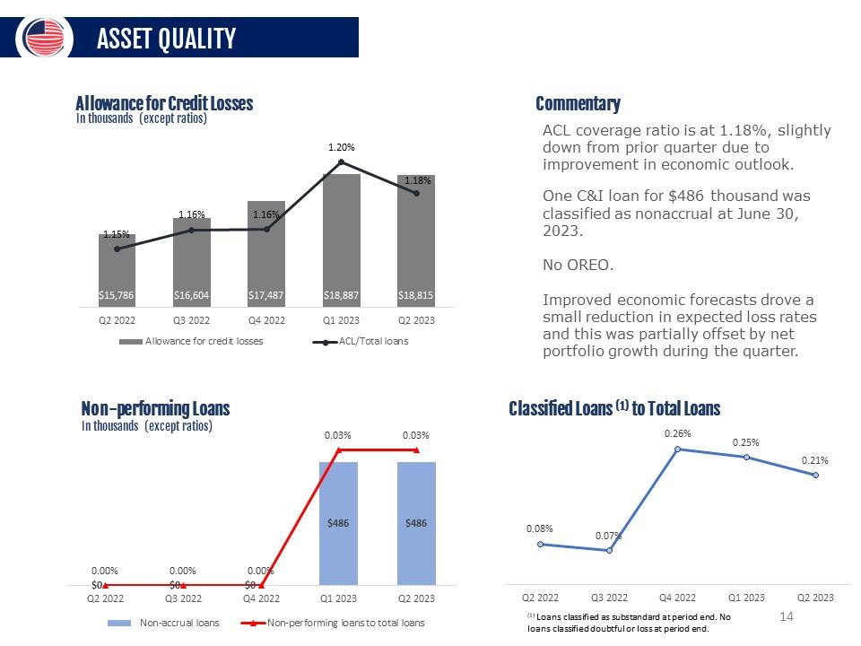
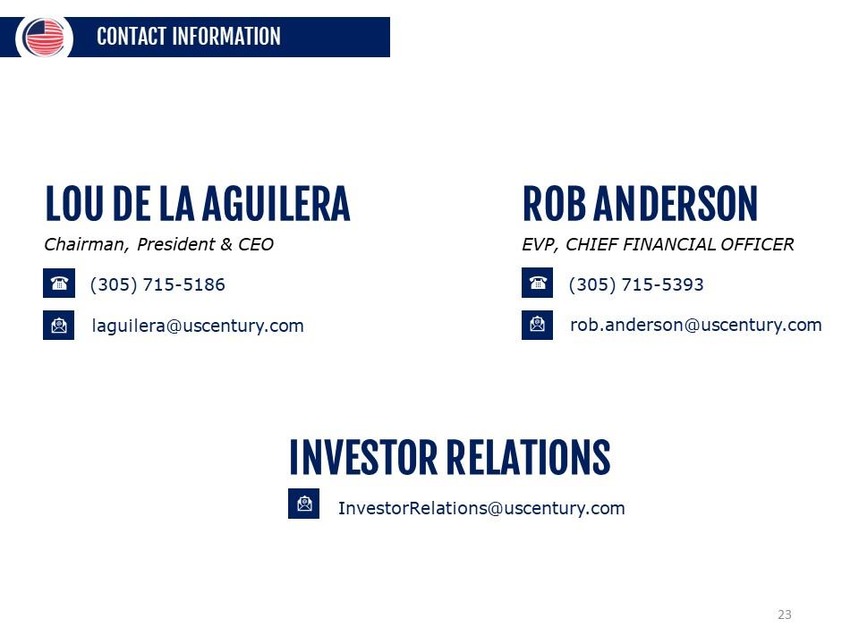
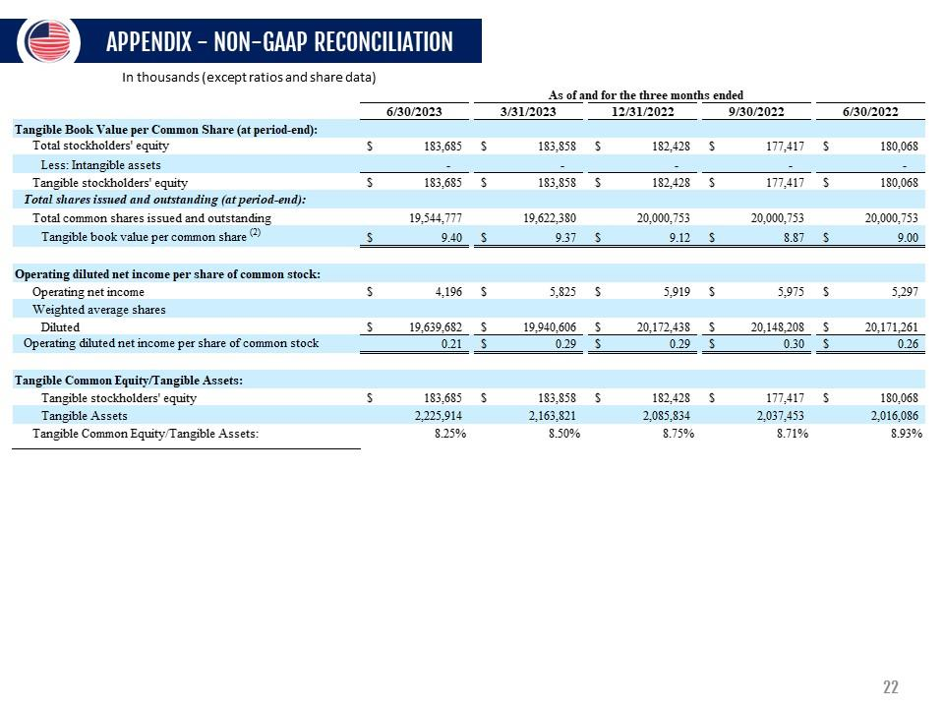
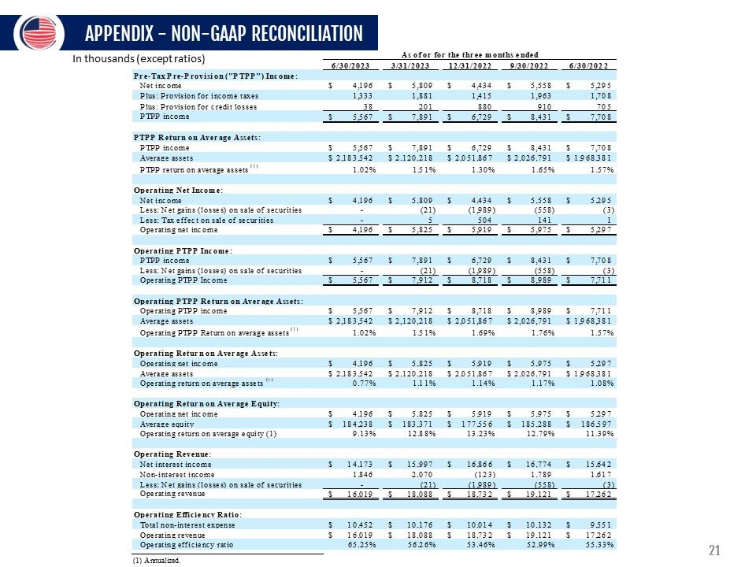
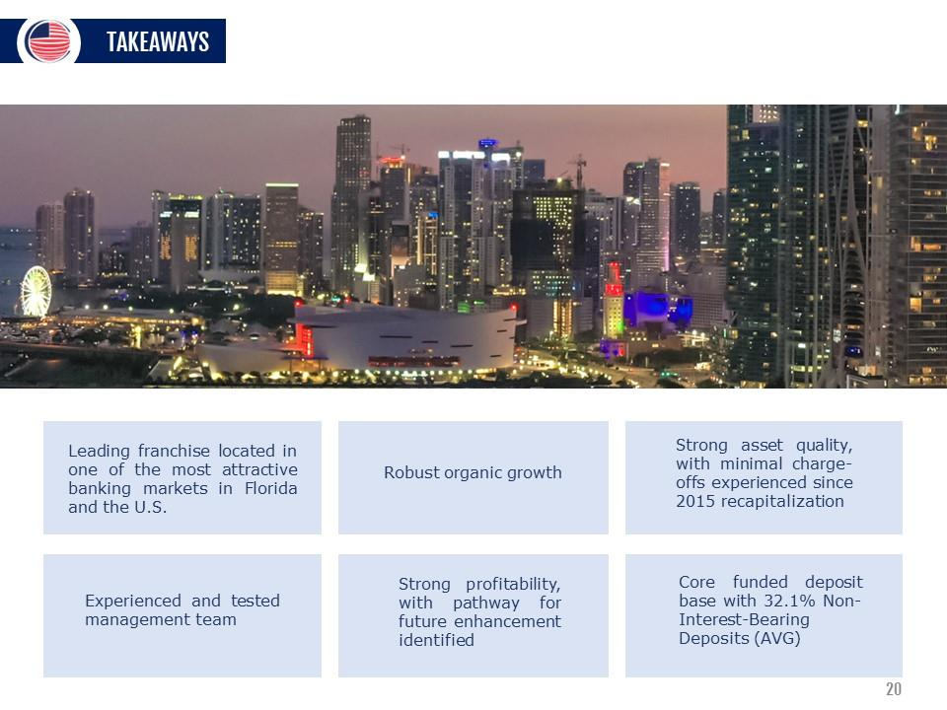
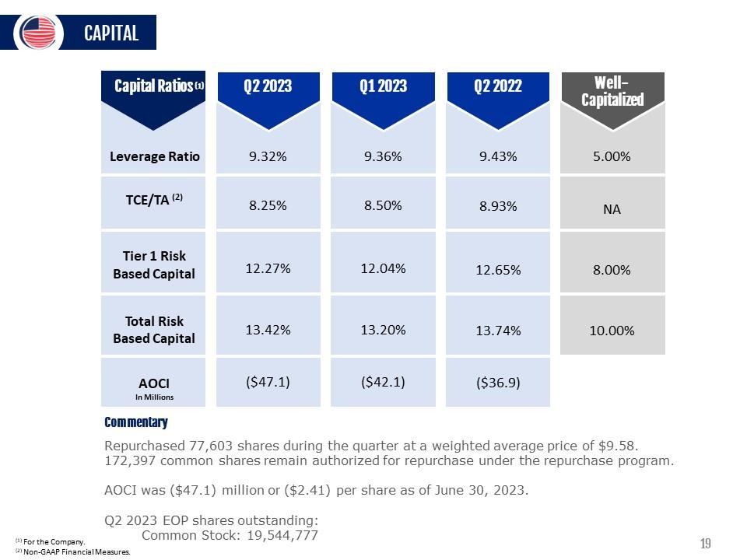
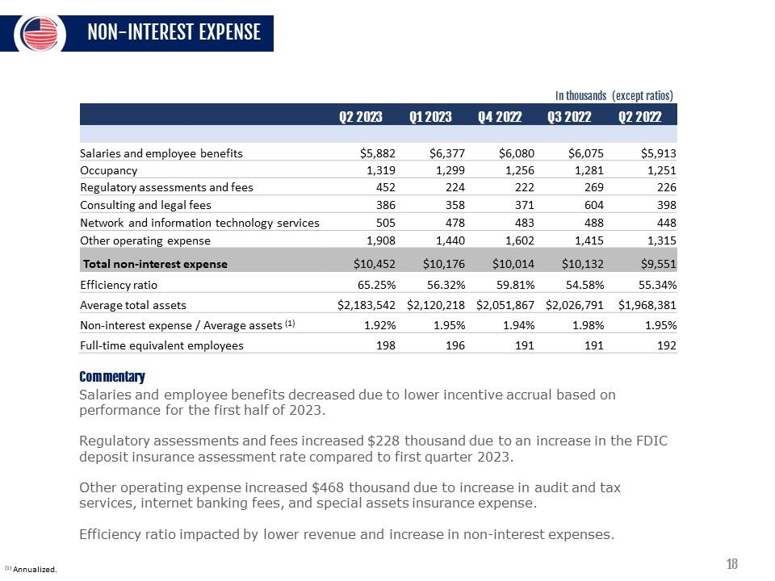
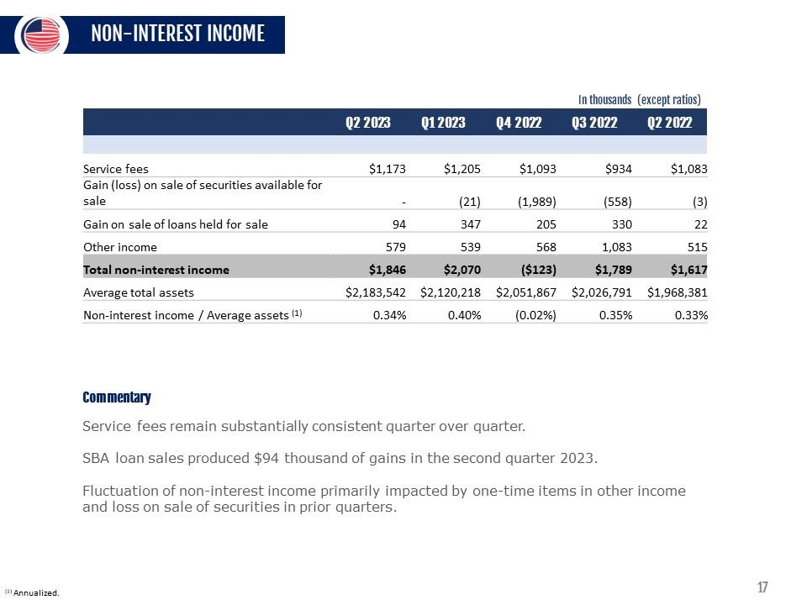
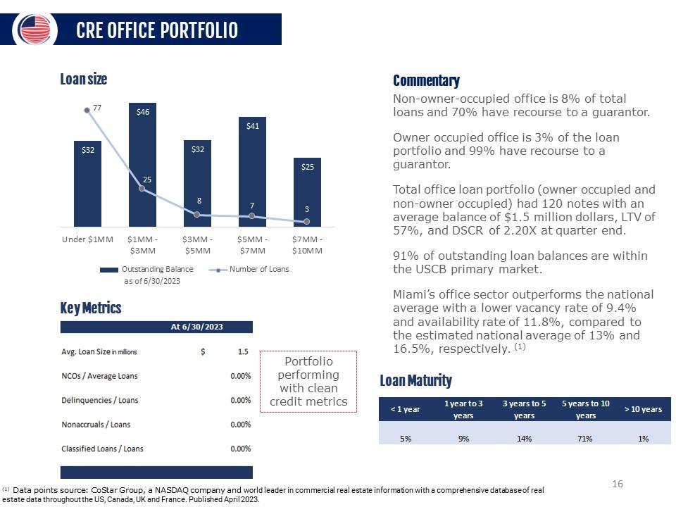
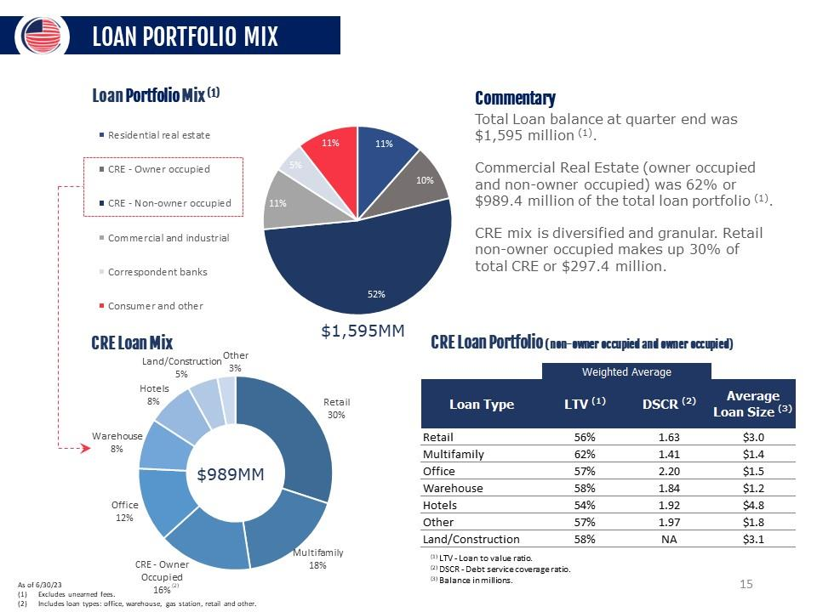
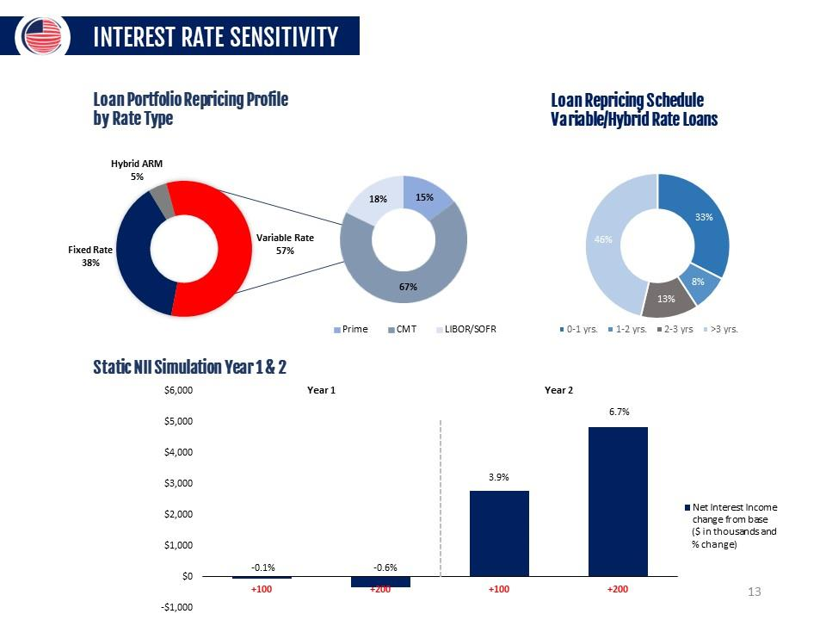
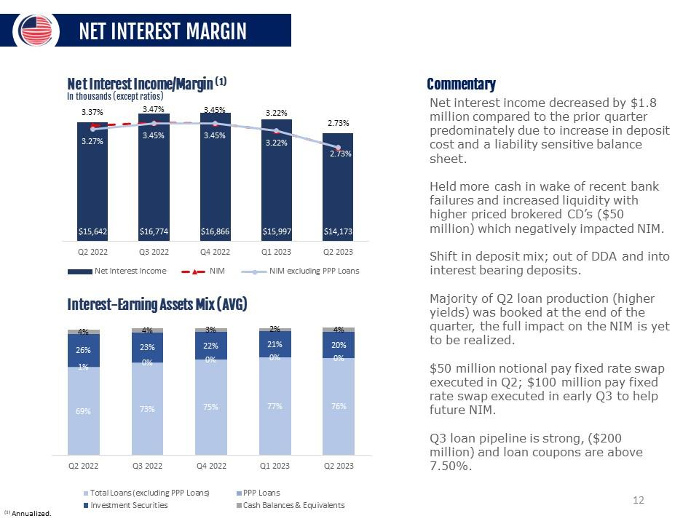
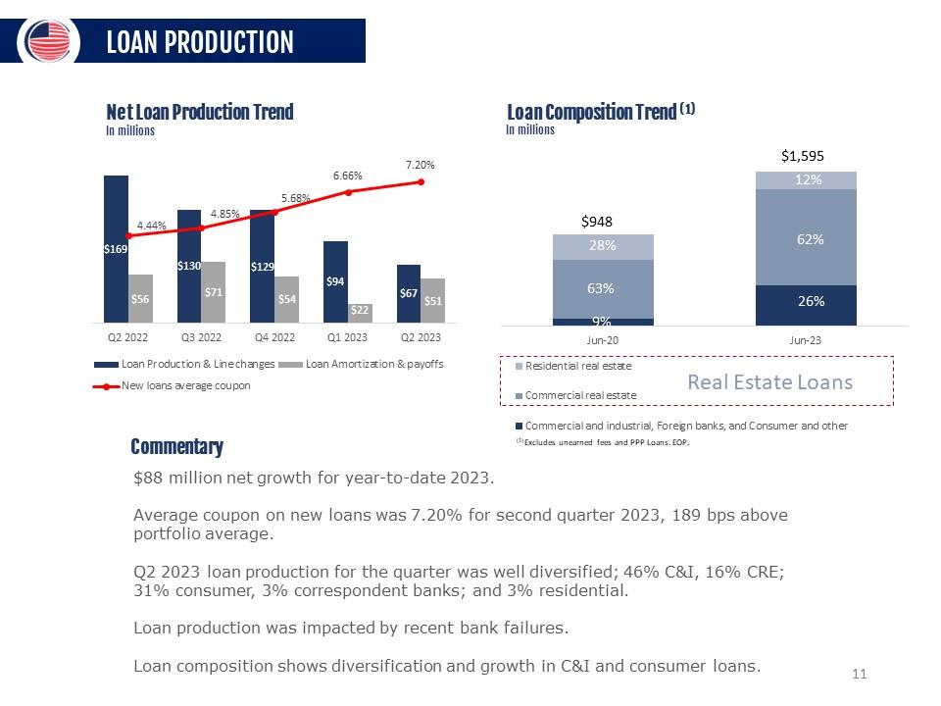
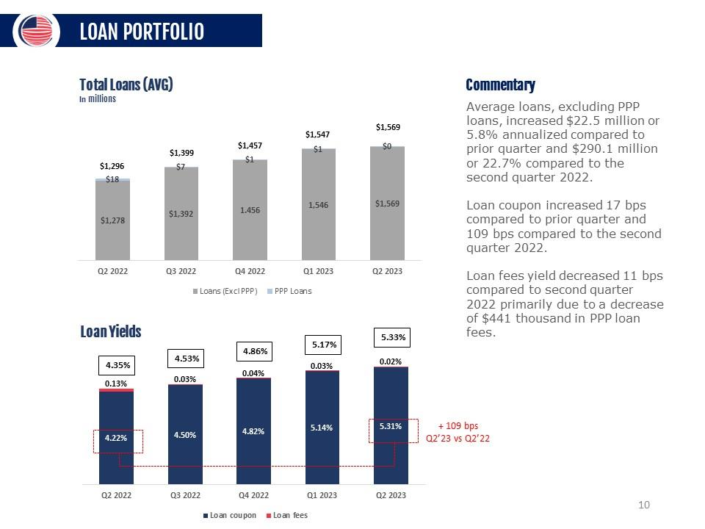
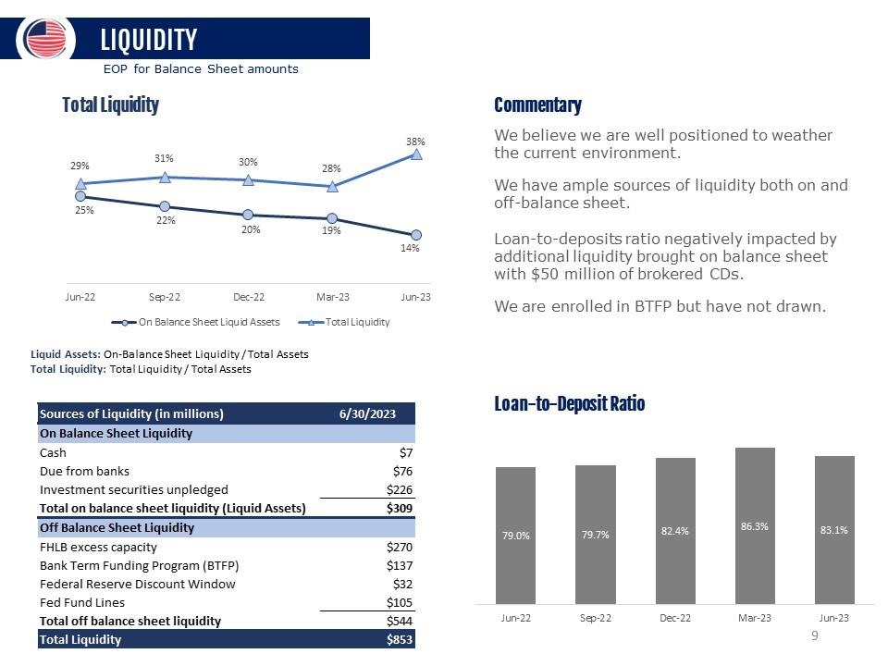
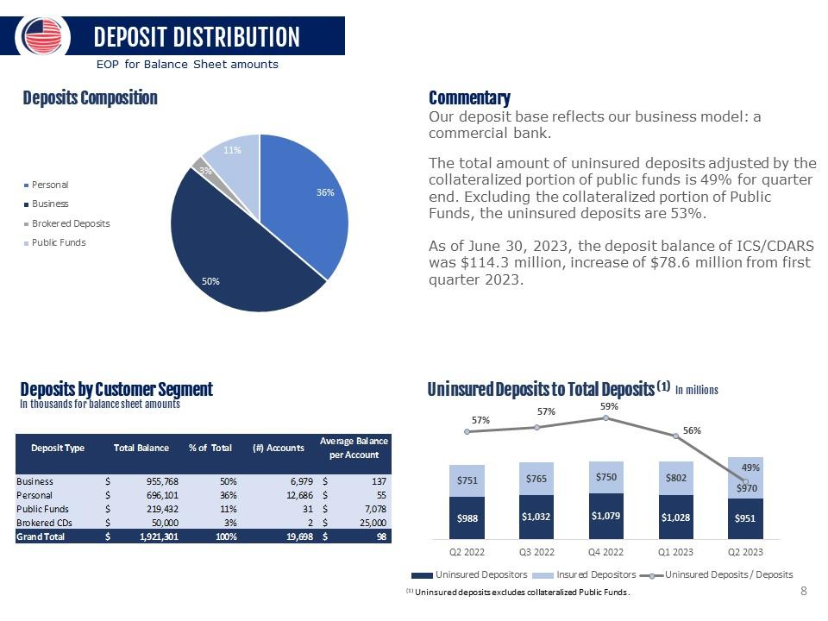
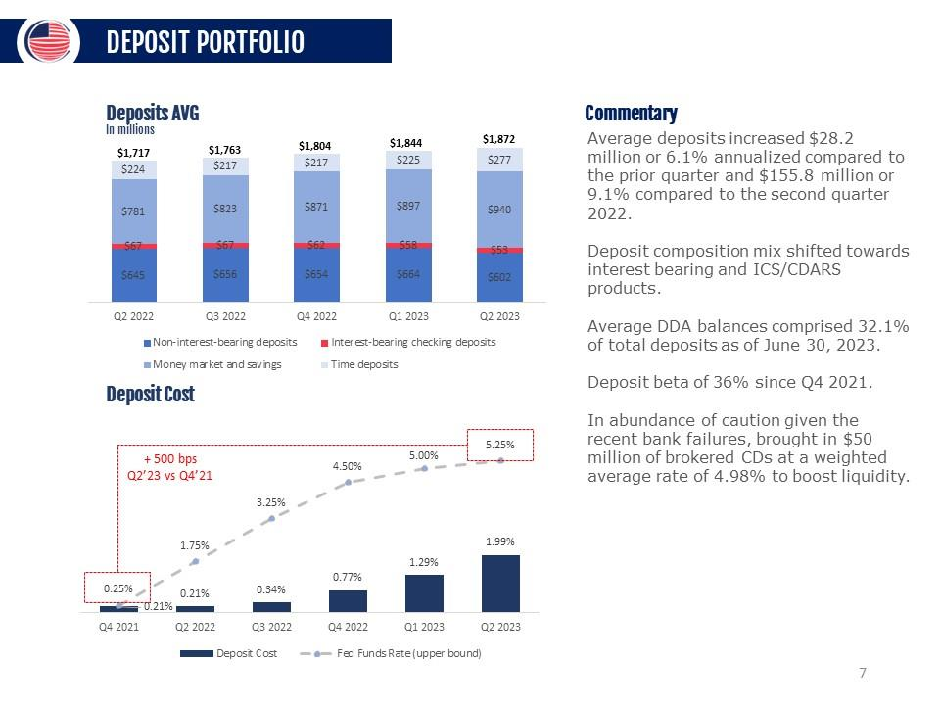
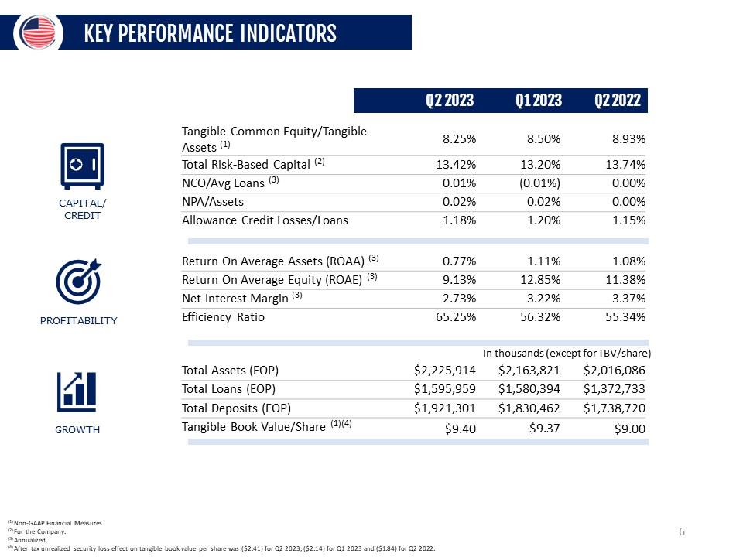
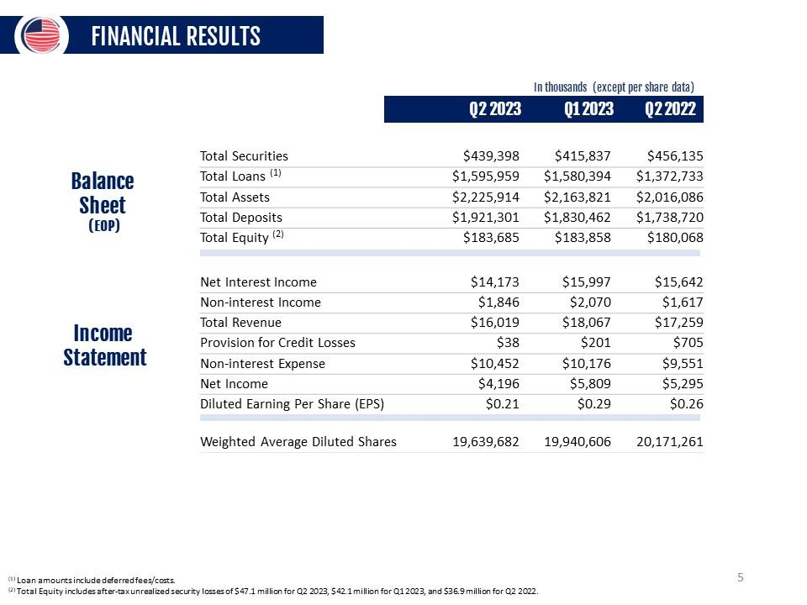
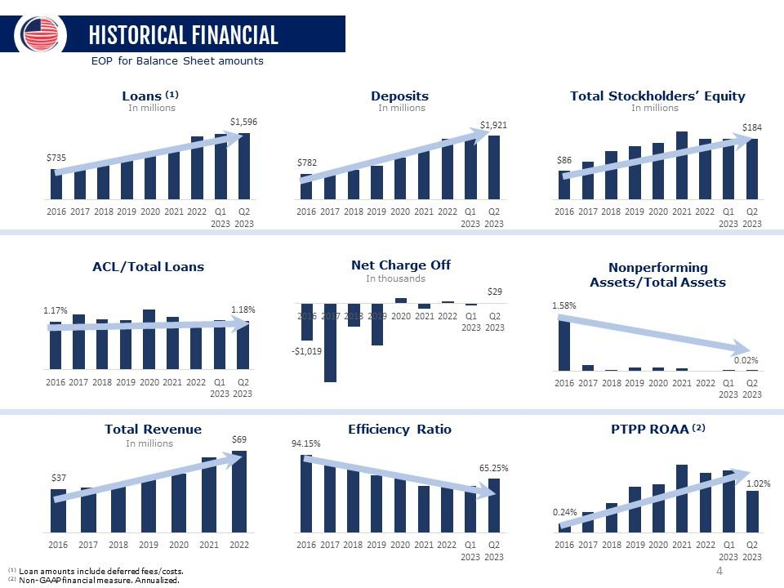
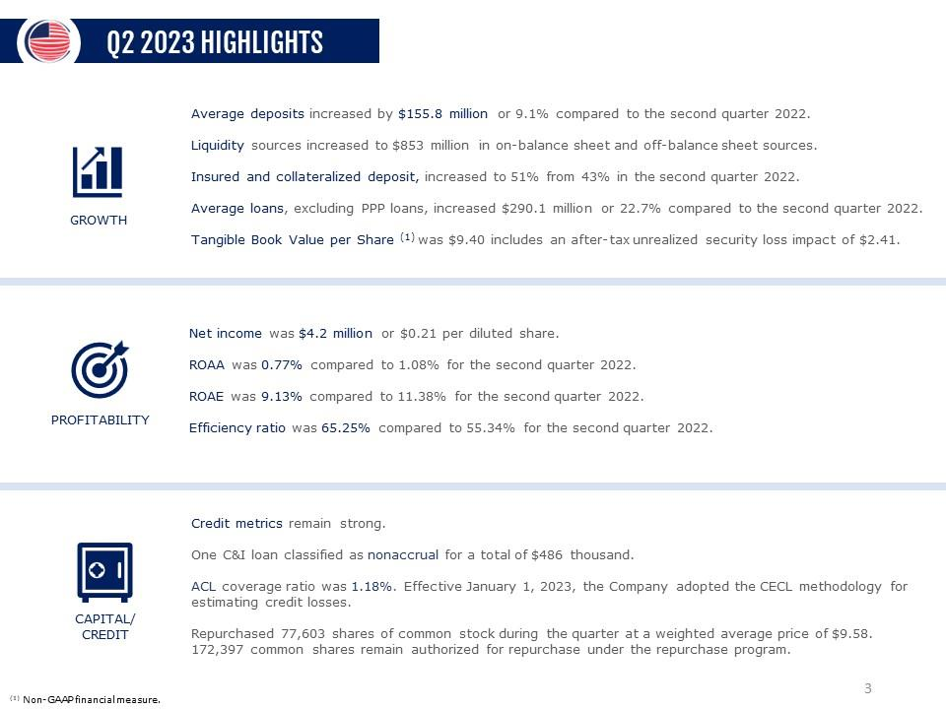
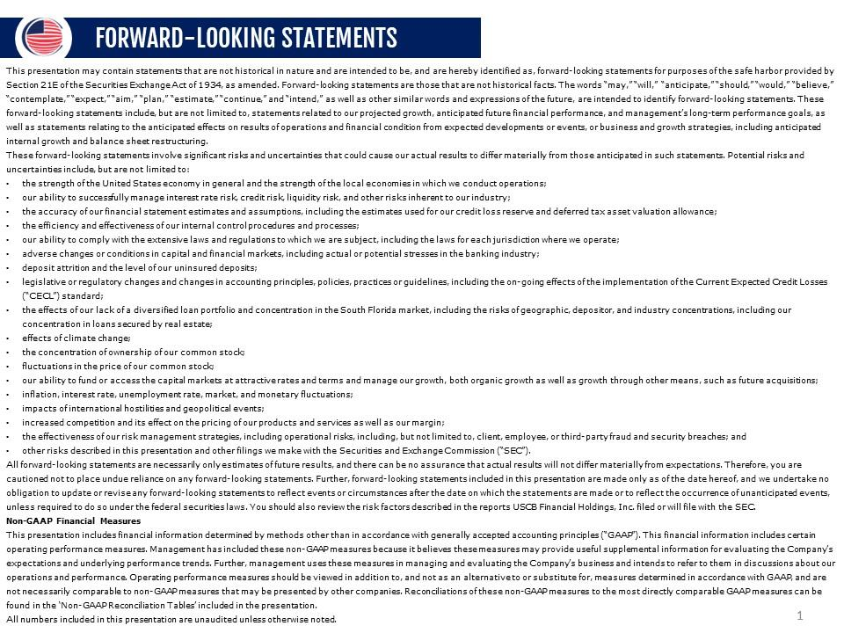
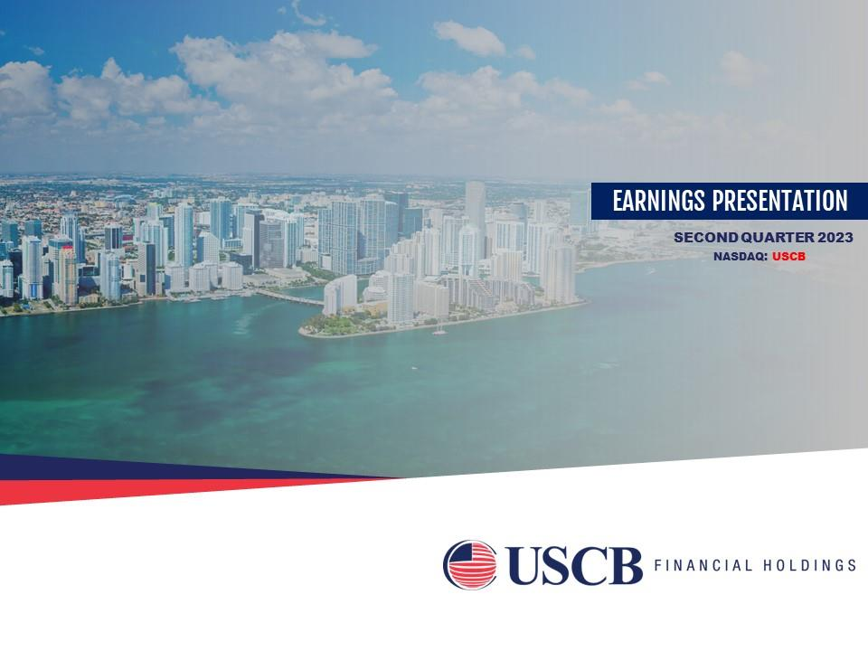


1

UNITED STATES

SECURITIES AND EXCHANGE COMMISSION

WASHINGTON,

D.C. 20549

__________________________

FORM

8-K

__________________________

CURRENT REPORT

Pursuant to Section 13 or 15(d) of the Securities Exchange Act

of 1934

Date of Report (Date of earliest event reported):

July 27, 2023

__________________________

USCB Financial Holdings, Inc.

(Exact name of Registrant as Specified in Its Charter)

__________________________

Florida

001-41196

87-4070846

(State or Other Jurisdiction

of Incorporation)

(Commission File Number)

(IRS Employer

Identification No.)

2301 N.W. 87th Avenue

,

Doral

,

Florida

33172

(Address of Principal Executive Offices)

(Zip Code)

Registrant’s Telephone

Number, Including Area Code: (

305

)

715-5200

__________________________

Check the appropriate box below if the Form 8-K filing is intended to simultaneously satisfy the filing obligation

of the registrant under

any of the following provisions:

☐

Written communications pursuant

to Rule 425 under the Securities Act (17 CFR 230.425)

☐

Soliciting material pursuant to Rule 14a-12 under the Exchange Act (17 CFR 240.14a

-12)

☐

Pre-commencement communications pursuant to Rule 14d-2(b)

under the Exchange Act (17 CFR 240.14d-2(b))

☐

Pre-commencement communications pursuant to Rule 13e-4(c) under the Exchange

Act (17 CFR 240.13e-4(c))

Securities registered pursuant to Section 12(b) of the Act:

Title of each class

Trading

Symbol(s)

Name of each exchange on which registered

Class A common stock, $1.00 par value per share

USCB

The Nasdaq Stock Market LLC

Indicate by

check mark

whether the

registrant is

an emerging

growth company

as defined

in Rule

405 of

the Securities

Act of

1933

(§ 230.405 of this chapter) or Rule 12b-2 of the Securities Exchange Act of 1934 (§ 240.12b

-2 of this chapter).

Emerging growth company

☒

If

an

emerging

growth

company,

indicate

by

check

mark

if

the

registrant

has

elected

not

to

use

the

extended

transition

period

for

complying with any new or revised financial accounting standards provided

pursuant to Section 13(a) of the Exchange Act.

☐

2

Item 2.02. Results of Operations and Financial Condition.

On July 27, 2023, USCB Financial

Holdings, Inc. (the “Company”), issued

a press release announcing its financial

results for

the second quarter ended June 30, 2023. A copy of the

press release is furnished as Exhibit 99.1 to this

Current Report on Form 8-K and

is incorporated herein by reference.

The information

in this Item

2.02, including

Exhibit 99.1, is

being furnished

and shall not

be deemed

“filed” for purposes

of

Section 18 of the

Securities Exchange Act

of 1934 (the “Exchange

Act”), or otherwise subject

to the liability of

that section, and

shall

not be deemed

to be incorporated

by reference into

any filing under

the Securities Act of

1933 (the “Securities

Act”) or the

Exchange

Act.

Item 7.01. Regulation FD Disclosure.

As previously announced, at 11:00 a.m. ET on July 28, 2023, the Company will hold an earnings conference

call to discuss its

financial performance for the quarter ended June 30, 2023. A copy of the slides forming

the basis of the presentation is being furnished

as Exhibit 99.2 to this Current Report on Form 8-K and is incorporated herein by reference. A copy of the slides has

also been posted to

the Company’s investor relations website,

located at investors.uscenturybank.com.

The information

in this Item

7.01, including

Exhibit 99.2, is

being furnished

and shall not

be deemed

“filed” for purposes

of

Section 18

of the

Exchange Act,

or otherwise

subject to

the

liability of

that section,

and

shall not

be deemed

to be

incorporated

by

reference into any filing under the Securities Act or the Exchange Act.

Item 9.01. Financial Statements and Exhibits.

(d) Exhibits.

Exhibit No.

Description

99.1

USCB Financial Holdings, Inc. Press Release, dated July 27, 2023

99.2

Earnings Presentation, dated July 27, 2023

104

Cover Page Interactive Data File (embedded within the Inline XBRL document)

1

Exhibit 99.1

EARNINGS RELEASE

USCB Financial Holdings, Inc. Reports EPS of $0.21 for Q2 2023

MIAMI, FL – July 27, 2023 – USCB Financial Holdings, Inc. (the “Company”) (NASDAQ: USCB)

, the holding company for U.S.

Century Bank

(the “Bank”), reported

net income of

$4.2 million or

$0.21 per diluted

share for the

three months ended

June 30, 2023,

compared with net income of $5.3 million or $0.26 per diluted share, for the

same period in 2022.

The Company announced

on June 28, 2023 the

appointment of Luis de la

Aguilera to succeed Aida

Levitan, Ph.D. as Chairman

of the

Board of Directors

for both the

Company and the

Bank. Levitan had

served as chairman

of the Board

since 2017 and

will continue

to

contribute as a valued member of the Board.

“I am deeply grateful

for the privilege of

serving as Chairman of

this respected institution

for the past six years.

I extend my

heartfelt

thanks

to

the

Board

of

Directors,

our

dedicated

employees,

and

supportive

community

for

their

unwavering

commitment

and

collaboration,” said Aida Levitan, Ph.D., who will continue

as Board Director. “It is with

great confidence, that our Board of Directors

passes its leadership

as Chairman to

Luis de La

Aguilera, President and

CEO, along with

confirming Kirk

Wycoff,

Managing Partner

of Patriot Financial Partners, as Lead Independent Director.”

“As President

and CEO

of USCB

Financial Holdings,

Inc., I

am honored

to assume

the additional

responsibility of

Chairman of

the

Board.

Our unwavering

focus remains

on organic

and sustainable

growth,

ensuring

that USCB

Financial

Holdings

Inc. continues

to

thrive in

a sound

and prudent

manner.

We

are a

leading franchise

in what

I feel

is one

of the

most attractive

banking markets

in the

United States,” said de la

Aguilera. “On behalf of the

Board and the entire USCB team,

I thank Aida Levitan for her

leadership for the

past six years.”

“Like others in the industry today,

we are navigating a challenging operational environment with an inverted yield curve,

higher deposit

cost,

and

liquidity

concerns.

Despite

these

headwinds,

we

continue

to

execute

our

plans,

steadily

growing

both

loans

and

deposits,

underscoring our

resilience and

commitment to

serve our

customers and

community.

As we

look forward

to the

third quarter,

we are

encouraged by

increased and diversified

loan demand, which

positions us well

for the second

half of 2023,”

said Luis de

la Aguilera,

Chairman, President, and CEO.

Unless

otherwise

stated,

all

percentage

comparisons

in

the

bullet

points

below

are

calculated

for

the

quarter

ended

June 30,

2023

compared to the quarter ended June 30, 2022 and annualized where

appropriate.

Profitability

•

Annualized return on

average assets for the

quarter ended June 30,

2023 was 0.77%

compared to 1.08%

for the second

quarter of

2022.

•

Annualized

return on

average stockholders’

equity for

the quarter

ended June

30, 2023

was 9.13

%

compared to

11.38%

for the

second quarter of 2022.

•

The efficiency ratio for the quarter ended June 30, 2023 was 65.25%

compared to 55.34% for the second quarter of 2022.

•

Net interest margin for the quarter ended June 30, 2023 was 2.73

%

compared to 3.37% for the same quarter ended 2022.

•

Net

interest

income

before

provision

for

credit

losses

was

$14.2 million

for

the

quarter

ended

June 30,

2023,

a

decrease

of

$1.5 million or 9.4% compared to the second quarter of 2022.

Balance Sheet

•

Total assets were $2.2

billion at June 30, 2023, representing an increase of $209.8 million or

10.4% from June 30, 2022.

•

Total loans were $1.6

billion at June 30, 2023, representing an increase of $223.2 million or 16.3% from

June 30, 2022.

•

Total deposits were $1.

9

billion at June 30, 2023, representing an increase of $182.6 million or 10.5%

from June 30, 2022.

2

•

Total

stockholders’

equity was

$183.7 million

at June 30,

2023, representing

an increase

of $3.6

million or

2.0%

from June 30,

2022.

Total

stockholders’ equity includes

after-tax unrealized security

losses of $47.1 million

at June 30, 2023 compared

to after-

tax unrealized security losses of $36.9 million at June 30, 2022.

Asset Quality

•

Allowance for

credit losses

(“ACL”) was

calculated under

the Current

Expected Credit

Losses (“CECL”)

standard methodology

for the first and second quarter of 2023 and the incurred loss methodology for the

preceding quarters.

•

The ACL increased by $3.0 million to $18.8 million at June 30, 2023 from

$15.8 million at June 30, 2022.

•

The allowance for credit losses represented 1.18% of total loans at June 30, 2023

compared to 1.15% at

June 30, 2022.

•

Non-performing loans to total loans was 0.03% at June 30, 2023 compared

to 0.00% at June 30, 2022.

Non-interest Income and Non-interest Expense

•

Non-interest income was $1.8 million for the three months ended

June 30, 2023, an increase of $229 thousand or 14.2%

compared

to $1.6 million for the same period in 2022.

•

Non-interest expense was $10.5 million for the three months ended June 30, 2023, an increase of $901 thousand or 9.4% compared

to the same period in 2022.

Capital

•

During the quarter the Company repurchased 77,603 shares of USCB Financial Holdings Inc. at a weighted average price per

share

of $9.58. The

aggregate purchase price

for these transactions

was approximately $746.9

thousand, including transaction

costs. These

repurchases were

made through

open market pursuant

to the Company’s

publicly announced

repurchase program.

As of June

30,

2023, 172,397 shares remain authorized for repurchase under the program.

•

As of June 30, 2023,

total risk-based capital ratios for the Company and the Bank were 13.42% and

13.38%, respectively.

•

Tangible book value per

common share (a

non-GAAP measure) of

$9.40 was negatively

affected by $2.41

due to after

tax unrealized

security losses of $47.1 million at

June 30, 2023. At June 30, 2022, tangible book

value of $9.00 was negatively affected

by $1.84

due to $36.9 million after tax unrealized security losses.

Conference Call and Webcast

The Company

will host

a conference

call on

Friday,

July 28,

2023, at

11:00

a.m. Eastern Time

to discuss

the Company’s

unaudited

financial results for the quarter

ended June 30, 2023. To

access the conference call, dial (800)

715-9871 (U.S. toll-free)

and ask to join

the USCB Financial Holdings Call or provide conference ID 6813115

.

Additionally,

interested

parties can

listen to

a live

webcast

of the

call in

the “Investor

Relations” section

of the

Company’s

website

at www.uscentury.com

.

An archived version of the webcast will be available in the same location shortly after

the live call has ended.

About USCB Financial Holdings, Inc.

USCB Financial Holdings, Inc.

is the bank holding company for

U.S. Century Bank. Established in 2002,

U.S. Century Bank is one of

the largest

community banks

headquartered

in Miami,

and one

of the

largest community

banks in

the State

of Florida.

U.S. Century

Bank is rated 5-Stars by BauerFinancial, the nation’s leading independent

bank rating firm. U.S. Century Bank offers customers a wide

range of

financial products

and services

and supports

numerous community

organizations,

including

the Greater

Miami Chamber

of

Commerce, the South

Florida Hispanic Chamber

of Commerce, and

ChamberSouth. For more

information or to

find a banking

center

near you, please call (305) 715-5200 or visit www.uscentury.com.

Forward-Looking Statements

This earnings

release may contain

statements that are

not historical in

nature and are

intended to be,

and are hereby

identified as,

forward-

looking

statements

for

purposes

of

the

safe

harbor

provided

by

Section

21E

of

the

Securities

Exchange

Act

of

1934,

as

amended.

Forward-looking statements are those that are not historical facts. The words “may,” “will,” “anticipate,” “should,” “would,” “believe,”

“contemplate,”

“expect,”

“aim,” “plan,”

“estimate,” “continue,”

and

“intend,”

as well

as other

similar words

and

expressions

of the

future, are intended to

identify forward-looking statements. These forward-looking statements

include,

but are not limited

to,

statements

3

related to

our projected

growth, anticipated

future financial

performance, and

management’s

long-term performance

goals, as

well as

statements relating to the anticipated

effects on results of

operations and financial

condition from expected developments

or events, or

business and growth strategies, including anticipated internal growth

and balance sheet restructuring.

These forward-looking statements involve significant risks and uncertainties that could cause our actual

results to differ materially from

those anticipated in such statements. Potential risks and uncertainties include,

but are not limited to:

•

the strength of the United States economy in general and the strength of the local

economies in which we conduct operations;

•

our ability to successfully manage interest rate risk, credit risk, liquidity risk,

and other risks inherent to our industry;

•

the

accuracy

of

our

financial

statement

estimates

and

assumptions,

including

the

estimates

used

for

our

credit

loss

reserve

and

deferred tax asset valuation allowance;

•

the efficiency and effectiveness of our internal

control procedures and processes;

•

our ability to comply with

the extensive laws and

regulations to which we are

subject, including the laws for

each jurisdiction where

we operate;

•

adverse changes or conditions in capital and financial markets, including

actual or potential stresses in the banking industry;

•

deposit attrition and the level of our uninsured deposits;

•

legislative

or

regulatory

changes and

changes

in

accounting

principles,

policies,

practices or

guidelines,

including

the on-going

effects of the implementation of the Current Expected Credit Losses (“CECL”)

standard;

•

the effects of

our lack of

a diversified loan

portfolio and concentration in

the South Florida

market, including the

risks of geographic,

depositor, and industry concentrations, including

our concentration in loans secured by real estate;

•

effects of climate change;

•

the concentration of ownership of our common stock;

•

fluctuations in the price of our common stock;

•

our ability to

fund or access

the capital markets

at attractive rates

and terms and

manage our growth,

both organic

growth as well

as growth through other means, such as future

acquisitions;

•

inflation, interest rate, unemployment rate, market and monetary fluctuations;

•

impacts of international hostilities and geopolitical events;

•

increased competition and its effect on the pricing of our products

and services as well as our margin;

•

the effectiveness

of our risk management

strategies, including operational

risks, including, but

not limited to, client,

employee, or

third-party fraud and security breaches; and

•

other risks described in this earnings release and other filings we make with the

Securities and Exchange Commission (“SEC”).

All forward-looking statements are necessarily only estimates of future results, and there can be no assurance that actual results will not

differ materially from

expectations. Therefore, you

are cautioned not

to place undue

reliance on any

forward-looking statements. Further,

forward-looking

statements included

in this

earnings release

are made

only as

of the

date hereof,

and we

undertake no

obligation

to

update or revise any forward-looking statement

to reflect events or circumstances after the date on which the statements

are made or to

reflect the occurrence of unanticipated events, unless required to

do so under the federal securities

laws. You should also review the risk

factors described in the reports the Company filed or will file with the SEC.

Non-GAAP Financial Measures

This earnings

release includes financial

information determined by

methods other than

in accordance with

generally accepted accounting

principles (“GAAP”). This financial

information includes certain

operating performance measures. Management

has included these

non-

GAAP

measures

because

it

believes

these

measures

may

provide

useful

supplemental

information

for

evaluating

the

Company’s

operations and

underlying performance

trends. Further,

management uses these

measures in

managing and

evaluating the Company’s

business and intends to refer to

them in discussions about our operations

and performance. Operating performance

measures should be

viewed

in

addition

to,

and

not

as

an

alternative

to

or

substitute

for,

measures

determined

in

accordance

with

GAAP,

and

are

not

necessarily

comparable

to

non-GAAP

measures

that

may

be

presented

by

other

companies.

Reconciliations

of

these

non-GAAP

measures

to

the most

directly

comparable

GAAP measures

can be

found

in the

‘Non-GAAP

Reconciliation

Tables’

included

in the

exhibits to this earnings

release.

All numbers included in this press release are unaudited unless otherwise noted.

Contacts:

Investor Relations

InvestorRelations@uscentury.com

Media Relations

Martha Guerra-Kattou

MGuerra@uscentury.com

4

USCB FINANCIAL HOLDINGS, INC.

CONSOLIDATED STATEMENTS

OF INCOME (UNAUDITED)

(Dollars in thousands, except per share data)

Three Months Ended June 30,

Six Months Ended June 30,

2023

2022

2023

2022

Interest income:

Loans, including fees

$

20,847

$

14,053

$

40,558

$

27,035

Investment securities

2,382

2,510

4,668

4,839

Interest-bearing deposits in financial institutions

1,051

121

1,433

152

Total interest income

24,280

16,684

46,659

32,026

Interest expense:

Interest-bearing checking

200

17

243

33

Savings and money market accounts

6,968

615

11,753

1,166

Time deposits

2,145

271

3,202

530

FHLB advances and other borrowings

794

139

1,291

276

Total interest expense

10,107

1,042

16,489

2,005

Net interest income before provision for credit losses

14,173

15,642

30,170

30,021

Provision for credit losses

38

705

239

705

Net interest income after provision for credit losses

14,135

14,937

29,931

29,316

Non-interest income:

Service fees

1,173

1,083

2,378

1,983

Gain (loss) on sale of securities available for sale, net

-

(3)

(21)

18

Gain on sale of loans held for sale, net

94

22

441

356

Loan settlement

-

-

-

161

Other non-interest income

579

515

1,118

1,044

Total non-interest income

1,846

1,617

3,916

3,562

Non-interest expense:

Salaries and employee benefits

5,882

5,913

12,259

11,788

Occupancy

1,319

1,251

2,618

2,521

Regulatory assessments and fees

452

226

676

439

Consulting and legal fees

386

398

744

915

Network and information technology services

505

448

983

835

Other operating expense

1,908

1,315

3,348

2,665

Total non-interest expense

10,452

9,551

20,628

19,163

Net income before income tax expense

5,529

7,003

13,219

13,715

Income tax expense

1,333

1,708

3,214

3,566

Net income

4,196

5,295

10,005

10,149

Per share information:

Net income per common share, basic

$

0.21

$

0.26

$

0.51

$

0.51

Net income per common share, diluted

$

0.21

$

0.26

$

0.51

$

0.50

Weighted average shares outstanding:

Common shares, basic

19,590,359

20,000,753

19,722,152

19,997,869

Common shares, diluted

19,639,682

20,171,261

19,790,756

20,192,918

5

USCB FINANCIAL HOLDINGS, INC.

SELECTED FINANCIAL DATA (UNAUDITED)

(Dollars in thousands, except per share data)

As of or For the Three Months Ended

6/30/2023

3/31/2023

12/31/2022

9/30/2022

6/30/2022

Income statement data:

Net interest income

$

14,173

$

15,997

$

16,866

$

16,774

$

15,642

Provision for credit losses

38

201

880

910

705

Net interest income after provision for credit losses

14,135

15,796

15,986

15,864

14,937

Service fees

1,173

1,205

1,093

934

1,083

Gain (loss) on sale of securities available for sale, net

-

(21)

(1,989)

(558)

(3)

Gain on sale of loans held for sale, net

94

347

205

330

22

Other income

579

539

568

1,083

515

Total non-interest income

1,846

2,070

(123)

1,789

1,617

Salaries and employee benefits

5,882

6,377

6,080

6,075

5,913

Occupancy

1,319

1,299

1,256

1,281

1,251

Regulatory assessments and fees

452

224

222

269

226

Consulting and legal fees

386

358

371

604

398

Network and information technology services

505

478

483

488

448

Other operating expense

1,908

1,440

1,602

1,415

1,315

Total non-interest expense

10,452

10,176

10,014

10,132

9,551

Net income before income tax expense

5,529

7,690

5,849

7,521

7,003

Income tax expense

1,333

1,881

1,415

1,963

1,708

Net income

$

4,196

$

5,809

$

4,434

$

5,558

$

5,295

Per share information:

Net income per common share, basic

$

0.21

$

0.29

$

0.22

$

0.28

$

0.26

Net income per common share, diluted

$

0.21

$

0.29

$

0.22

$

0.28

$

0.26

Balance sheet data (at period-end):

Cash and cash equivalents

$

87,280

$

63,251

$

54,168

$

73,326

$

83,272

Securities available-for-sale

$

218,442

$

229,409

$

230,140

$

248,571

$

339,464

Securities held-to-maturity

$

220,956

$

186,428

$

188,699

$

178,865

$

116,671

Total securities

$

439,398

$

415,837

$

418,839

$

427,436

$

456,135

Loans held for investment

(1)

$

1,595,959

$

1,580,394

$

1,507,338

$

1,431,513

$

1,372,733

Allowance for credit losses

$

(18,815)

$

(18,887)

$

(17,487)

$

(16,604)

$

(15,786)

Total assets

$

2,225,914

$

2,163,821

$

2,085,834

$

2,037,453

$

2,016,086

Non-interest-bearing deposits

$

572,360

$

633,606

$

629,776

$

662,808

$

653,708

Interest-bearing deposits

$

1,348,941

$

1,196,856

$

1,199,505

$

1,133,834

$

1,085,012

Total deposits

$

1,921,301

$

1,830,462

$

1,829,281

$

1,796,642

$

1,738,720

FHLB advances and other borrowings

$

87,000

$

120,000

$

46,000

$

26,000

$

66,000

Total liabilities

$

2,042,229

$

1,979,963

$

1,903,406

$

1,860,036

$

1,836,018

Total stockholders' equity

$

183,685

$

183,858

$

182,428

$

177,417

$

180,068

Capital ratios:

(2)

Leverage ratio

9.32%

9.36%

9.61%

9.48%

9.43%

Common equity tier 1 capital

12.27%

12.04%

12.53%

12.56%

12.65%

Tier 1 risk-based capital

12.27%

12.04%

12.53%

12.56%

12.65%

Total risk-based capital

13.42%

13.20%

13.65%

13.65%

13.74%

(1)

Loan amounts include deferred fees/costs.

(2) Reflects the Company's regulatory capital ratios

6

USCB FINANCIAL HOLDINGS, INC.

AVERAGE BALANCES, RATIOS, AND OTHER DATA

(UNAUDITED)

(Dollars in thousands)

As of or For the Three Months Ended

6/30/2023

3/31/2023

12/31/2022

9/30/2022

6/30/2022

Average balance sheet data:

Cash and cash equivalents

$

94,313

$

50,822

$

61,892

$

77,887

$

80,254

Securities available-for-sale

$

224,913

$

230,336

$

242,144

$

331,206

$

370,933

Securities held-to-maturity

$

192,628

$

187,826

$

184,459

$

116,733

$

120,130

Total securities

$

417,541

$

418,162

$

426,603

$

447,939

$

491,063

Loans held for investment

(1)

$

1,569,266

$

1,547,393

$

1,456,780

$

1,398,761

$

1,296,476

Total assets

$

2,183,542

$

2,120,218

$

2,051,867

$

2,026,791

$

1,968,381

Interest-bearing deposits

$

1,270,657

$

1,179,878

$

1,150,049

$

1,107,129

$

1,071,709

Non-interest-bearing deposits

$

601,778

$

664,369

$

653,820

$

655,853

$

644,975

Total deposits

$

1,872,435

$

1,844,247

$

1,803,869

$

1,762,982

$

1,716,684

FHLB advances and other borrowings

$

93,075

$

61,600

$

37,500

$

43,935

$

36,330

Total liabilities

$

1,999,304

$

1,936,847

$

1,874,311

$

1,841,503

$

1,781,784

Total stockholders' equity

$

184,238

$

183,371

$

177,556

$

185,288

$

186,597

Performance ratios:

Return on average assets

(2)

0.77%

1.11%

0.86%

1.09%

1.08%

Return on average equity

(2)

9.13%

12.85%

9.91%

11.90%

11.38%

Net interest margin

(2)

2.73%

3.22%

3.45%

3.47%

3.37%

Non-interest income to average assets

(2)

0.34%

0.40%

(0.02)%

0.35%

0.33%

Efficiency ratio

(3)

65.25%

56.32%

59.81%

54.58%

55.34%

Loans by type (at period end):

(4)

Residential real estate

$

183,093

$

184,427

$

185,636

$

186,551

$

203,662

Commercial real estate

$

989,401

$

987,757

$

970,410

$

928,531

$

843,445

Commercial and industrial

$

169,401

$

160,947

$

126,984

$

121,145

$

131,271

Foreign banks

$

85,409

$

97,405

$

93,769

$

94,450

$

84,770

Consumer and other

$

167,845

$

149,410

$

130,429

$

100,845

$

109,250

Asset quality data:

Allowance for credit losses to total loans

1.18%

1.20%

1.16%

1.16%

1.15%

Allowance for credit losses to non-performing loans

3,871%

3,886%

- %

- %

- %

Total non-performing loans

(5)

$

486

$

486

$

-

$

-

$

-

Non-performing loans to total loans

0.03%

0.03%

- %

- %

- %

Non-performing assets to total assets

0.02%

0.02%

- %

- %

- %

Net charge-offs (recoveries of) to average loans

(2)

0.01%

(0.01)%

(0.00)%

0.03%

(0.00)%

Net charge-offs (recovery of) credit losses

$

29

$

(49)

$

(2)

$

91

$

(7)

Interest rates and yields:

(2)

Loans

5.33%

5.17%

4.86%

4.53%

4.35%

Investment securities

2.26%

2.20%

2.13%

1.94%

2.04%

Total interest-earning assets

4.68%

4.51%

4.21%

3.82%

3.60%

Deposits

1.99%

1.29%

0.77%

0.34%

0.21%

FHLB advances and other borrowings

3.42%

3.27%

2.27%

1.63%

1.53%

Total interest-bearing liabilities

2.97%

2.08%

1.25%

0.59%

0.38%

Other information:

Full-time equivalent employees

198

196

191

191

192

(1)

Loan amounts include deferred fees/costs.

(2)

Annualized.

(3)

Efficiency ratio is defined as total non-interest expense divided

by sum of net interest income and total non-interest

income.

(4)

Loan amounts exclude deferred fees/costs.

(5)

The amounts for total non-performing loans and total non-performing

assets are the same at the dates presented since there were

no impaired investments or other

real estate owned (OREO) recorded.

7

USCB FINANCIAL HOLDINGS, INC.

NET INTEREST MARGIN (UNAUDITED)

(Dollars in thousands)

Three Months Ended June 30,

2023

2022

Average

Balance

Interest

Yield/Rate

(1)

Average

Balance

Interest

Yield/Rate

(1)

Assets

Interest-earning assets:

Loans

(2)

$

1,569,266

$

20,847

5.33%

$

1,296,476

$

14,053

4.35%

Investment securities

(3)

422,544

2,382

2.26%

493,352

2,510

2.04%

Other interest-earnings assets

87,536

1,051

4.82%

69,503

121

0.70%

Total interest-earning assets

2,079,346

24,280

4.68%

1,859,331

16,684

3.60%

Non-interest-earning assets

104,196

109,050

Total assets

$

2,183,542

$

1,968,381

Liabilities and stockholders' equity

Interest-bearing liabilities:

Interest-bearing checking

$

53,561

200

1.50%

$

66,349

17

0.10%

Saving and money market deposits

940,095

6,968

2.97%

781,076

615

0.32%

Time deposits

277,001

2,145

3.11%

224,284

271

0.48%

Total interest-bearing deposits

1,270,657

9,313

2.94%

1,071,709

903

0.34%

FHLB advances and other borrowings

93,075

794

3.42%

36,330

139

1.53%

Total interest-bearing liabilities

1,363,732

10,107

2.97%

1,108,039

1,042

0.38%

Non-interest-bearing demand deposits

601,778

644,975

Other non-interest-bearing liabilities

33,794

28,770

Total

liabilities

1,999,304

1,781,784

Stockholders' equity

184,238

186,597

Total liabilities and stockholders' equity

$

2,183,542

$

1,968,381

Net interest income

$

14,173

$

15,642

Net interest spread

(4)

1.71%

3.22%

Net interest margin

(5)

2.73%

3.37%

(1)

Annualized.

(2)

Average loan balances include non-accrual loans. Interest income on loans includes accretion

of deferred loan fees, net of deferred loan costs.

(3)

At fair value except for securities held to maturity. This amount includes FHLB

stock.

(4)

Net interest spread is the average yield earned on total

interest-earning assets minus the average rate paid on total interest-bearing

liabilities.

(5)

Net interest margin is the ratio of net interest income to total

interest-earning assets.

8

USCB FINANCIAL HOLDINGS, INC.

NON-GAAP FINANCIAL MEASURES (UNAUDITED)

(Dollars in thousands)

As of or For the Three Months Ended

6/30/2023

3/31/2023

12/31/2022

9/30/2022

6/30/2022

Pre-tax pre-provision ("PTPP") income:

(1)

Net income

$

4,196

$

5,809

$

4,434

$

5,558

$

5,295

Plus: Provision for income taxes

1,333

1,881

1,415

1,963

1,708

Plus: Provision for credit losses

38

201

880

910

705

PTPP income

$

5,567

$

7,891

$

6,729

$

8,431

$

7,708

PTPP return on average assets:

(1)

PTPP income

$

5,567

$

7,891

$

6,729

$

8,431

$

7,708

Average assets

$

2,183,542

$

2,120,218

$

2,051,867

$

2,026,791

$

1,968,381

PTPP return on average assets

(2)

1.02%

1.51%

1.30%

1.65%

1.57%

Operating net income:

(1)

Net income

$

4,196

$

5,809

$

4,434

$

5,558

$

5,295

Less: Net gains (losses) on sale of securities

-

(21)

(1,989)

(558)

(3)

Less: Tax effect on sale of securities

-

5

504

141

1

Operating net income

$

4,196

$

5,825

$

5,919

$

5,975

$

5,297

Operating PTPP income:

(1)

PTPP income

$

5,567

$

7,891

$

6,729

$

8,431

$

7,708

Less: Net gains (losses) on sale of securities

-

(21)

(1,989)

(558)

(3)

Operating PTPP income

$

5,567

$

7,912

$

8,718

$

8,989

$

7,711

Operating PTPP return on average assets:

(1)

Operating PTPP income

$

5,567

$

7,912

$

8,718

$

8,989

$

7,711

Average assets

$

2,183,542

$

2,120,218

$

2,051,867

$

2,026,791

$

1,968,381

Operating PTPP return on average assets

(2)

1.02%

1.51%

1.69%

1.76%

1.57%

Operating return on average assets:

(1)

Operating net income

$

4,196

$

5,825

$

5,919

$

5,975

$

5,297

Average assets

$

2,183,542

$

2,120,218

$

2,051,867

$

2,026,791

$

1,968,381

Operating return on average assets

(2)

0.77%

1.11%

1.14%

1.17%

1.08%

Operating return on average equity:

(1)

Operating net income

$

4,196

$

5,825

$

5,919

$

5,975

$

5,297

Average equity

$

184,238

$

183,371

$

177,556

$

185,288

$

186,597

Operating return on average equity

(2)

9.13%

12.88%

13.23%

12.79%

11.39%

Operating Revenue:

(1)

Net interest income

$

14,173

$

15,997

$

16,866

$

16,774

$

15,642

Non-interest income

1,846

2,070

(123)

1,789

1,617

Less: Net gains (losses) on sale of securities

-

(21)

(1,989)

(558)

(3)

Operating revenue

$

16,019

$

18,088

$

18,732

$

19,121

$

17,262

Operating Efficiency Ratio:

(1)

Total non-interest expense

$

10,452

$

10,176

$

10,014

$

10,132

$

9,551

Operating revenue

$

16,019

$

18,088

$

18,732

$

19,121

$

17,262

Operating efficiency ratio

65.25%

56.26%

53.46%

52.99%

55.33%

(1) The Company believes these non-GAAP measurements are

key indicators of the ongoing earnings power of the

Company.

(2)

Annualized.

9

USCB FINANCIAL HOLDINGS, INC.

NON-GAAP FINANCIAL MEASURES (UNAUDITED)

(Dollars in thousands, except per share data)

As of or For the Three Months Ended

6/30/2023

3/31/2023

12/31/2022

9/30/2022

6/30/2022

Tangible book value per common share (at period-end):

(1)

Total stockholders' equity

$

183,685

$

183,858

$

182,428

$

177,417

$

180,068

Less: Intangible assets

-

-

-

-

-

Tangible stockholders' equity

$

183,685

$

183,858

$

182,428

$

177,417

$

180,068

Total shares issued and outstanding (at period-end):

Total common shares issued and outstanding

19,544,777

19,622,380

20,000,753

20,000,753

20,000,753

Tangible book value per common share

(2)

$

9.40

$

9.37

$

9.12

$

8.87

$

9.00

Operating diluted net income per common share:

(1)

Operating net income

$

4,196

$

5,825

$

5,919

$

5,975

$

5,297

Total weighted average diluted shares of common stock

19,639,682

19,940,606

20,172,438

20,148,208

20,171,261

Operating diluted net income per common share:

$

0.21

$

0.29

$

0.29

$

0.30

$

0.26

Tangible Common Equity/Tangible Assets

Tangible stockholders' equity

$

183,685

$

183,858

$

182,428

$

177,417

$

180,068

Tangible assets

$

2,225,914

$

2,163,821

$

2,085,834

$

2,037,453

$

2,016,086

Tangible Common Equity/Tangible Assets

8.25%

8.50%

8.75%

8.71%

8.93%

(1)

The Company believes these non-GAAP measurements

are key indicators of the ongoing earnings power

of the Company.

(2)

Excludes the dilutive effect, if any, of shares of common stock issuable upon exercise of outstanding

stock options.

Exhibit 99.2

EARNINGS PRESENTATION SECOND QUARTER 2023

NASDAQ: USCB

FORWARD-LOOKING STATEMENTS This presentation

may contain statements that are not historical in nature and are

intended to be, and are hereby identified as, forward-looking statements

for purposes of the safe harbor provided by Section 21E of the

Securities Exchange Act of 1934, as amended.

Forward-looking statements are those that are not historical facts.

The words “may,” “will,” “anticipate,” “should,” “would,”

“believe,” “contemplate,” “expect,” “aim,” “plan,” “estimate,”

“continue,” and “intend,” as well as other similar words and expressions

of the future, are intended to identify forward-looking statements.

These forward-looking statements include, but are not limited to,

statements related to our projected growth, anticipated future financial

performance, and management’s long-term performance

goals, as well as statements relating to the anticipated effects

on results of operations and financial condition from expected developments

or events, or business and growth strategies, including anticipated

internal growth and balance sheet restructuring. These forward

-looking statements involve significant risks and uncertainties that could cause

our actual results to differ materially from those anticipated

in such statements. Potential risks and uncertainties include, but

are not limited to: the strength of the United States economy

in general and the strength of the local economies in which we conduct

operations; our ability to successfully manage interest rate

risk, credit risk, liquidity risk, and other risks inherent to our

industry; the accuracy of our financial statement estimates and assumptions,

including the estimates used for our credit loss reserve and deferred

tax asset valuation allowance; the efficiency and effectiveness

of our internal control procedures and processes; our ability to comply with

the extensive laws and regulations to which we are subject, including

the laws for each jurisdiction

where we operate; adverse changes or conditions in capital and financial

markets, including actual or potential stresses in the banking

industry; deposit attrition and the level of our uninsured deposits;

legislative or regulatory changes and changes in accounting principles,

policies, practices or guidelines, including the on-going effects

of the implementation of the Current Expected Credit Losses (“CECL”)

standard; the effects of our lack of a diversified loan portfolio and concentration

in the South Florida market, including the risks of geographic, depositor,

and industry concentrations, including our concentration in loans secured

by real estate; effects of climate change; the concentration of

ownership of our common stock; fluctuations in the price of our common

stock; our ability to fund or access the capital markets at attractive

rates and terms and manage our growth, both organic growth as

well as growth through other means, such as future acquisitions; inflation,

interest rate, unemployment rate, market, and monetary fluctuations;

impacts of international hostilities and geopolitical events; increased

competition and its effect on the pricing of our products and services

as well as our margin; the effectiveness of our risk management

strategies, including operational risks, including, but not limited

to, client, employee, or third-party fraud and security breaches;

and other risks described in this presentation and other filings we

make with the Securities and Exchange Commission (“SEC”).

All forward-looking statements are necessarily only estimates of

future results, and there can be no assurance that actual results will not

differ materially from expectations. Therefore, you are

cautioned not to place undue reliance on any forward-looking statements.

Further, forward-looking statements included in this presentation

are made only as of the date hereof, and we undertake no obligation to

update or revise any

forward-looking statements to reflect events or circumstances after

the date on which the statements are made or to reflect the occurrence

of unanticipated events, unless required to do so under the federal securities

laws. You

should also review the risk factors described in the reports USCB

Financial Holdings, Inc. filed or will file with the SEC. Non-GAAP

Financial Measures This presentation includes financial information

determined by methods other than in accordance

with generally accepted accounting principles (“GAAP”). This financial information

includes certain operating performance measures. Management

has included these non-GAAP measures because it believes these

measures may provide useful supplemental information for evaluating

the Company’s expectations and underlying performance

trends. Further, management uses these measures in managing and evaluating

the Company’s business and intends to refer to them in discussions

about our operations and performance. Operating performance

measures should be viewed in addition to, and not as an alternative to

or substitute for, measures determined in accordance

with GAAP, and are not necessarily comparable to non-GAAP measures

that may be presented by other companies. Reconciliations of these

non-GAAP measures to the most directly comparable GAAP

measures can be found in the ‘Non-GAAP Reconciliation Tables’

included in the presentation. All numbers included in this presentation

are unaudited unless otherwise noted. 2

Q2 2023 HIGLIGHTS GROWTH Average deposits increased

by $155.8 million or 9.1% compared to the second quarter 2022. Liquidity

sources increased to $853 million in on-balance sheet and off-balance

sheet sources. Insured and collateralized deposit, increased to 51% from 43%

in the second quarter 2022. Average loans, excluding

PPP loans, increased $290.1 million or 22.7% compared to

the second quarter 2022. Tangible Book Value per

Share (1) was $9.40 includes an after-tax unrealized security loss impact

of $2.41. PROFITABILITY Net income was $4.2 million

or $0.21 per diluted share. ROAA was 0.77% compared to 1.08%

for the second quarter 2022. ROAE was 9.13% compared

to 11.38% for the second quarter 2022. Efficiency ratio was

65.25% compared to 55.34% for the second quarter 2022. CAPITAL/

CREDIT Credit metrics remain strong. One C&I loan classified

as nonaccrual for a total of $486 thousand. ACL coverage

ratio was 1.18%. Effective January 1, 2023, the Company adopted the

CECL methodology for estimating credit losses.

Repurchased 77,603 shares of common stock during the quarter

at a weighted average price of $9.58. 172,397 common shares remain

authorized for repurchase under the repurchase program.

(1) Non-GAAP financial measure. 3

HISTORICAL FINANCIAL EOP for Balance Sheet amounts

Loans (1)

In millions $735 $1,596 2016 2017 2018 2019 2020 2021 2022 Q1 Q2

2023 2023 Deposits In millions $782 $1,921 2016 2017 2018

2019 2020 2021 2022 Q1 Q2 2023 2023 Total Stockholder’s

Equity In millions $86 $184 2016 2017 2018 2019 2020 2021 2022

Q1 Q2 2023 2023 ACL/Total Loans 1.17% 1.18% 2016 2017

2018 2019 2020 2021 2022 Q1 Q2 2023 2023 Net Charge

Off In thousands -$1,019 $29 2016 2017 2018 2019 2020 2021 2022

Q1 Q2 2023 2023 Nonperforming Assets/Total Assets 1.58%

0.02% 2016 2017 2018 2019 2020 2021 2022 Q1 Q2 2023 2023

Total Revenue In millions $37 $69 2016 2017 2018 2019

2020 2021 2022 Efficiency Ratio 94.15% 65.25% 2016 2017 2018

2019 2020 2021 2022 Q1 Q2 2023 2023 PTPP ROAA (2) 0.24%

1.02% 2016 2017 2018 2019 2020 2021 2022 Q1 Q2 2023 2023

(1) Loan amounts include deferred fees/costs. (2) Non-GAAP

financial measure. Annualized. 4

FINANCIAL RESULTS In thousands (except per share

data) Q2 2023 Q1 2023 Q2 2022 Balance Sheet (EOP) Total

Securities $439,398 $415,837 $456,135 Total Loans (1) $1,595,959

$1,580,394 $1,372,733 Total Assets $2,225,914 $2,163,821

$2,016,086 Total Deposits $1,921,301 $1,830,462 $1,738,720

Total Equity (2) $183,685 $183,858 $180,068 Income Statement

Net Interest Income $14,173 $15,997 $15,642 Non-interest Income

$1,846 $2,070 $1,617 Total Revenue $16,019 $18,067

$17,259 Provision for Credit Losses $38 $201 $705 Non-interest

Expense $10,452 $10,176 $9,551 Net Income $4,196 $5,809

$5,295 Diluted Earning Per Share (EPS) $0.21 $0.29 $0.26 Weighted

Average Diluted Shares 19,639,682 19,940,606 20,171,261

(1) Loan amounts include deferred fees/costs. (2) Total Equity

includes after-tax unrealized security losses of $47.1 million for Q2

2023, $42.1 million for Q1 2023, and $36.9 million for Q2 2022. 5

KEY PERFORMANCE INDICATORS CAPITAL/

CREDIT PROFITABILITY GROWTH Q2 2023 Q1 2023 Q2 2022

Tangible Common Equity/Tangible Assets (1) 8.25%

8.50% 8.93% Total Risk-Based Capital (2) 13.42% 13.20% 13.74%

NCO/Avg Loans (3) 0.01% (0.01%) 0.00% NPA/Assets

0.02% 0.02% 0.00% Allowance Credit Losses/Loans 1.18% 1.20%

1.15% Return On Average Assets (ROAA) (3) 0.77%

1.11% 1.08%

Return On Average Equity (ROAE) (3) 9.13% 12.85% 11.38%

Net Interest Margin (3) 2.73% 3.22% 3.37% Efficiency Ratio 65.25%

56.32% 55.34% Total Assets (EOP) $2,225,914 $2,163,821

$2,016,086 Total Loans (EOP) $1,595,959 $1,580,394 $1,372,733

Total Deposits (EOP) $1,921,301 $1,830,462 $1,738,720 Tangible

Book Value/Share (1)(4) $9.40 $9.37 $9.00 (1) Non-GAAP

Financial Measures. (2) For the Company. (3) Annualized. (4) After

tax unrealized security loss effect on tangible book value per share

was ($2.41) for Q2 2023, ($2.14) for Q1 2023 and ($1.84) for

Q2 2022. 6

DEPOSIT PORTFOLIO Deposits AVG In millions $1,717

$1,763 $1,804 $1,844 $1,872 $224 $217 $217 $225 $277 $781

$823 $871 $897 $940 $67 $67 $62 $58 $53 $645 $656 $654 $664

$602 Q2 2022 Q3 2022 Q4 2022 Q1 2023 Q2 2023 Non-interest-bearing

deposits Money market and savings Interest-bearing checking

deposits Time deposits Deposit Cost "+500 bps Q2'23 vs Q4'21"

0.25% 1.75% 3.25% 4.50% 5.00% 5.25% 0.21% 0.21%

0.34% 0.77% 1.29% 1.99% Q2 2022 Q3 2022 Q4 2022 Q1 2023 Q2

2023 Deposit Costs Fed Funds Rate (upper bound) Commentary

Average deposits increased $28.2 million or 6.1% annualized

compared to the prior quarter and $155.8 million or 9.1% compared

to the second quarter 2022. Deposit composition mix shifted

towards interest bearing and ICS/CDARS products. Average

DDA balances comprised 32.1% of total deposits as of June 30, 2023. Deposit

beta of 36% since Q4 2021. In abundance of caution given the recent

bank failures, brought in $50 million of brokered CDs at a weighted average

rate of 4.98% to boost liquidity. 7

DEPOSIT DISTRIBUTION EOP for Balance Sheet amounts Deposits

Composition Public Funds 11% Personal 36% Broker Deposits

3% Business 50% Commentary Our deposit base reflects our

business model: a commercial bank. The total amount of uninsured

deposits adjusted by the collateralized portion of public funds is 49%

for quarter end. Excluding the collateralized portion of Public

Funds, the uninsured deposits are 53%. As of June 30, 2023, the

deposit balance of ICS/CDARS was $114.3 million, increase

of $78.6 million from first quarter 2023. Deposits by Customer Segment

In thousands for balance sheet amounts Deposit Type Total

Balance % of Total (#) Accounts Average Balance per

Account Business $ 955,768 50% 6,979 $ 137 Personal $ 696,101

36% 12,686 s 55 PublicFunds $ 219,432 11% 31 $ 7,078 Brokered

CDs $ 50,000 3% 2 $ 25,000 Grand Total $ 1,921,301 100%

19,698 $ 98 Uninsured Deposits to Total Deposits (1) In millions

57% 57% 59% 56% 49% $751 $765 $750 $802 $970 $988 $1,032

$1,079 $1,028 $951 Q2 2022 Q3 2022 Q4 2022 Q1 2023 Q2 2023

Uninsured Depositors Insured Depositors Uninsured Deposits/Deposits

(1) Uninsured deposits excludes collateralized Public Funds . 8

LIQUIDITY EOP for Balance Sheet amounts Total Liquidity 29% 31%

30% 28% 38% 25% 22% 20% 19% 14% Jun-22 Sep-23 Dec-23

Mar-23 Jun-23 On Balance Sheet Liquid Assets Total Liquidity

Liquid Assets: On-Balance Sheet Liquidity / Total Assets

Total Liquidity: total Liquidity / Total Assets Commentary

We believe we are well positioned to weather the current environment.

We have ample sources of liquidity both on and off-balance

sheet. Loan-to-deposits ratio negatively impacted by additional liquidity

brought on balance sheet with $50 million of brokered CDs. We

are enrolled in BTFP but have not drawn. Sources of Liquidity

(in millions) 6/30/2023 On Balance Sheet Liquidity Cash $7 Due

from banks $76 Investment securities unpledged $226 Total

on balance sheet liquidity (Liquid Assets) $309 Off Balance

Sheet Liquidity FHLB excess capacity $270 Bank Term Funding

Program (BTFP) $137 Federal Reserve Discount Window $32 Fed

Fund Lines $105 Total off balance sheet liquidity $544 Total

Liquidity $853 Loan-to-Deposit Ratio 79.0% 79.7% 82.4% 86.3%

83.1% Jun-22 Sep-23 Dec-23 Mar-23 Jun-23 9

LOAN PORTFOLIO Total Loans (AVG) In millions Loans

(Excl PPP) PPP Loans Loans Yields 4.35% 4.53% 4.86% 5.17%

5.33% 0.13% 0.03% 0.04% 0.03% 0.02% +109 bps 4.22% 4.50%

4.82% 5.14% 5.31% Q2'23 vs Q2'22 Q2 2022 Q3 2022 Q4 2022 Q1

2023 Q2 2023 Loan coupon Loan fees Commentary Average

loans, excluding PPP loans, increased $22.5 million or 5.8% annualized

compared to prior quarter and $290.1 million or 22.7% compared

to the second quarter 2022. Loan coupon increased 17 bps compared

to prior quarter and 109 bps compared to the second quarter

2022. Loan fees yield decreased 11 bps compared to second quarter

2022 primarily due to a decrease of $441 thousand in PPP loan

fees. 10

LOAN PRODUCTION Net Loan Production Trend In millions

4.44% 4.85% 5.68% 6.66% 7.20% $169 $56 $130 $71 $129 $54

$94 $22 $67 $51 Q2 2022 Q3 2022 Q4 2022 Q1 2023 Q2 2023 Loan

Production & Line Changes Loan Amortization & payoffs New loans average

coupon Loan Composition Trend (1) In millions $948 $1,595 28% 12

%

63% 62% 9% 26% Jun-20 Jun-23 Residential real etate Commercial

real estate Real Estate Loans Commercial and industrial, Foreign

banks, and Consumer and other (1) Excludes unearned fees

and PPP Loans. EOP. Commentary $88 million net growth for year

-to-date 2023. Average coupon on new loans was 7.20% for

second quarter 2023, 189 bps above portfolio average. Q2 2023 loan

production for the quarter was well diversified; 46% C&I, 16%

CRE; 31% consumer, 3% correspondent banks; and 3% residential.

Loan production was impacted by recent bank failures. Loan composition

shows diversification and growth in C&I and consumer loans.

11

NET INTEREST MARGIN Net Interest Income/Margin (1) In thousands

(except ratios) 3.37% 3.47% 3.45% 3.22% 2.73% 3.27% 3.45%

3.45% 3.22% 2.73% $15,642 $16,774 $16,866 $15,997 $14,173

Q2 2022 Q3 2022 Q4 2022 Q1 2023 Q2 2023 Net Interest Income

NIM NIM excluding PPP Loans Interest-Earning Assets Mix

(AVG) 4% 4% 3% 2% 4% 26% 23% 22% 21% 20% 1%

0% 0% 0% 0% 69% 73% 75% 77% 76% Q2 2022 Q3 2022 Q4 2022

Q1 2023 Q2 2023 Total Loans (excluding PPP Loans) Investment

Securities PPP Loans Cash Balances & Equivalents Commentary Net

interest income decreased by $1.8 million compared to the prior quarter

predominately due to increase in deposit cost and a liability sensitive

balance sheet. Held more cash in wake of recent bank failures and

increased liquidity with higher priced brokered CD’s ($50

million) which negatively impacted NIM. Shift in deposit mix; out

of DDA and into interest bearing deposits. Majority of Q2 loan

production (higher yields) was booked at the end of the quarter,

the full impact on the NIM is yet to be realized. $50 million notional

pay fixed rate swap executed in Q2; $100 million pay fixed rate

swap executed in early Q3 to help future NIM. Q3 loan pipeline

is strong, ($200 million) and loan coupons are above 7.50%. (1)

Annualized. 12

INTEREST RATE SENSITIVITY Loan Portfolio Repricing

Profile By Rate Type Hybrid ARM 5% Fixed Rate 38% Variable

Rate 57% 18% 15% 67% Prime CMT LIBOR/SOFR 46%

33% 8% 13% 46% yrs. 1-2 yrs 2-3 yrs. >3yrs. Static NII Simulation

Year 1 & 2 Year 1 Year 2 -0.1% -0.6% 3.9%

6.7% +100 +200 +100 +200 Net interest income changes from base

($ in thousands and % change) 13

ASSET QUALITY Allowance for Credit Losses In thousands (except

ratios) 1.15% 1.16% 1.16% 1.20% 1.18% $15,786 $16,604 $17,487 $18,887

$18,815 Q2 2022 Q3 2022 Q4 2022 Q1 2023 Q2 2023 Allowance

for credit loss ACL/Total loans Commentary ACL coverage

ratio is at 1.18%, slightly down from prior quarter due to improvement

in economic outlook. One C&I loan for $486 thousand was classified

as nonaccrual at June 30, 2023. No OREO. Improved economic

forecasts drove a small reduction in expected loss rates and this was

partially offset by net portfolio growth during the quarter.

Non-performing Loans In thousands (except ratios) 0.00% 0.00%

0.00% 0.03% 0.03% $486 $486 Q2 2022 Q3 2022 Q4 2022 Q1

2023 Q2 2023 Non-accrual loans Non-performing loans to total loans

Classified Loans (1) to Total Loans 0.08% 0.07% 0.26% 0.25%

0.21% (1) Loans classified as substandard at period end. No loans classified

doubtful or loss at period end. 14

LOAN PORTFOLIO MIX Loan Portfolio Mix (1) Residential real

estate CRE - Owner occupied CRE - Non-owner occupied Commercial

and industrial Correspondent banks Consumer and other

11% 11% 10% 52% 11% 50% $1,595MM Commentary Total

Loan balance at quarter end was $1,595 million (1). Commercial

Real Estate (owner occupied and non-owner occupied) was 62%

or $989.4 million of the total loan portfolio (1). CRE mix is diversified

and granular. Retail non-owner occupied makes up 30%

of total CRE or $297.4 million. CRE Loan Mix Land/Construction

5% Other 3% Retail 30% Multifamily 18% CRE - Owner

Occupied 16% Office 12% Warehouse 8% Hotels 8% Land/Construction

5% CRE Loan Portfolio (non-owner occupied and owner occupied)

Weighted Average Loan Type LTV»> DSCR<2>

Average Loan Size (3) Retail 56% 1.63 $3.0 Multifamily

62% L41 $1.4 Office 57% 2.20 $1.5 Warehouse 58% L84

$1.2 Hotels 54% L92 $4.8 Other 57% L97 $1.8 Land/Construction

58% NA $3.1 (1) LTV - Loan to value ratio. (2) DSCR -

Debt service coverage ratio. (3) Balance in millions. As of

6/30/23 Excludes unearned fees. Includes loan types: office,

warehouse, gas station, retail and other. 15

CRE OFFICE PORTFOLIO Loan size 77 25 8 7 3 $32 $46 $32

$41 $25 Under $1MM "$1MM- $3MM" "$3MM-

$5MM" "$5MM-

$7MM" "$7MM-

$10MM" Outstanding Balance as of 6/30/2023 Number of Loans

Key Metrics At 6/30/2023 Avg. Loan Size in millions $ 1.5

Portfolio NCOs/ Average Loans 0.00% performing with clean

Delinquencies/Loans 0.00% credit metrics Nonaccruals/Loan

s

0.00% Classified Loans/Loans 0.00% Loan Maturity < 1 year

1 year to 3 3 years to 5 5 years to 10 >10 years years years

years

5% 9% 14% 71% 1% Commentary Non-owner-occupied office

is 8% of total loans and 70% have recourse to a guarantor. Owner

occupied office is 3% of the loan portfolio and 99% have recourse

to a guarantor. Total office loan portfolio (owner occupied

and non-owner occupied) had 120 notes with an average

balance of $1.5 million dollars, LTV of 57%, and DSCR of 2.20X

at quarter end. 91% of outstanding loan balances are within the USCB

primary market. Miami’s office sector outperforms the national

average with a lower vacancy rate of 9.4% and availability rate

of 11.8%, compared to the estimated national average of

13% and 16.5%, respectively. (1) (1) Data points source: CoStar

Group, a NASDAQ company and world leader in commercial

real estate information with a comprehensive database of real

estate data throughout the US, Canada, UK and France. Published April

2023. 16

NON-INTEREST INCOME In thousands (except ratios) Q2 2023 Q1

2023 Q4 2022 Q3 2022 Q2 2022 Service fees $1,173 $1,205 $1,093

$934 $1,083 Gain (loss) on sale of securities available for

sale - (21) (1,989) (558) (3) Gain on sale of loans held for sale

94 347 205 330 22 Other income 579 539 568 1,083 515 Total

non-interest income $1,846 $2,070 ($123) $1,789 $1,617 Average

total assets $2,183,542 $2,120,218 $2,051,867 $2,026,791 $1,968,381

Non-interest income / Average assets (1) 0.34% 0.40% (0.02%)

0.35% 0.33% Commentary Service fees remain substantially consistent

quarter over quarter. SBA loan sales produced $94 thousand

of gains in the second quarter 2023. Fluctuation of non-interest

income primarily impacted by one-time items in other income and

loss on sale of securities in prior quarters. (1) Annualized. 17

NON-INTEREST EXPENSE In thousands (except ratios) Q2 2023 Q1

2023 Q4 2022 Q3 2022 Q2 2022 Salaries and employee benefits

$5,882 $6,377 $6,080 $6,075 $5,913 Occupancy 1,319 1,299 1,256

1,281 1,251 Regulatory assessments and fees 452 224 222

269 226 Consulting and legal fees 386 358 371 604 398 Network and

information technology services 505 478

483 488 448 Other operating expense 1,908 1,440 1,602 1,415

1,315 Total non-interest expense $10,452 $10,176 $10,014 $10,132

$9,551 Efficiency ratio 65.25% 56.32% 59.81% 54.58% 55.34%

Average total assets $2,183,542 $2,120,218 $2,051,867 $2,026,791

$1,968,381 Non-interest expense / Average assets (1)

1.92% 1.95% 1.94% 1.98% 1.95% Full-time equivalent employees

198 196 191 191 192 Commentary Salaries and employee benefits

decreased due to lower incentive accrual based on performance

for the first half of 2023. Regulatory assessments and fees increased

$228 thousand due to an increase in the FDIC deposit insurance

assessment rate compared to first quarter 2023. Other operating expense

increased $468 thousand due to increase in audit and tax services,

internet banking fees, and special assets insurance expense.

Efficiency ratio impacted by lower revenue and increase

in non-interest expenses. (1) Annualized. 18

CAPITAL Capital Ratios Q2 2023 Q1 2023 Q2 2022 Well-Capitalized

Leverage Ratio 9.32% 9.36% 9.43% 5.00% TCE/TA 8.25%

8.50% 8.93% NA Tier 1 Risk Based Capital 12.27% 12.04%

12.65% 8.00% Total Risk Based Capital 13.42% 13.20% 13.74%

10.00 AOCI In Millions ($47.1) ($42.1) ($36.9) Commentary

Repurchased 77,603 shares during the quarter at a weighted average

price of $9.58. 172,397 common shares remain authorized for repurchase

under the repurchase program. AOCI was ($47.1) million or ($2.41) per

share as of June 30, 2023. Q2 2023 EOP shares outstanding:

Common Stock: 19,544,777 (1) For the Company. (2) Non-GAAP

Financial Measures. 19

TAKEAWAYS Leading franchise located in

one of the most attractive banking markets in Florida and the U.S.

Robust organic growth Strong asset quality, with minimal

charge-offs experienced since 2015 recapitalization Experienced

and tested management team Strong profitability, with pathway

for future enhancement identified Core funded deposit base

with 32.1% Non-Interest-Bearing Deposits (AVG) 20

APPENDIX - NON-GAAP RECONCILIATION In thousand$(except

ratios) A$of or for the three month$ended 6/30/2023 3/31/2023

12/31/2022 9/30/2022 6/30/2022 U/JUí _u¿o Pre-Tax Pre-Provision

("PTPP") Income: Net income $4:196 Plus: Provision for income

taxe$1:333 Plus: Provision for credit losse$ 3S_ PTPP income $5.567

PTPP Return on Average Assets: PTPP income $5:567 Average

asset$$2,183,542 PTPP return on average asset$1 1.02% Operating Net

Income: Net income $4:196 Less: Net gain$(losses) on sale

of securities Less: Tax effect on sale of securitie$ - Operating

net income $4,196 Operating PTPP Income: PTPP income $5:567

Less: Net gain$(losses) on sale of securitie$ - Operating PTPP Income

$ 5,567 Operating PTPP Return on Average Assets: Operating

PTPP income $5,567 Average asset$$2,183,542 Operating PTPP

Return on average asset$‘ 1.02% Jl J II íí! O ÍI¿.V $5,809 $4,434

$5,558 $5,295 1,881 1,415 1,963 1,708 201 880 910 705 $7,891 $6,729

$8,431 $7,708 $7,891 $2,120,218 1.51% $6,729 $2,051,867

1.3 0% $8,431 $2,026,791 1.65% $7,708 $1,968,381 1.57% $5,809

$4,434 $5,558 $5,295 (21) (1,9 89) (558) (3) 5 504 141 1_

$5,825 $5,919 $5,975 $5,297 $7,891 $6,729 $8,431 $7,708 ^211

(1Î989) (558) _Q1 $7,912 $8,718 $8,989 $7,711 $7,912 $8,718

$8,989 $7,711 $2,120,218 $2,051,867 $2,026,791 $1,968,381 1.51%

1.57% 1.69% 1.76% Operating Return on Average Assets: Operating

net income $4:196 Average asset$$2,183,542 Operating

return on average asset$<1J 0.77% Operating Return on Average

Equity: Operating net income $4:196 Average equity $184,238

Operating return on average equity (1) 9.13% Operating Revenue:

Net interest income $14,173 Non-interest income 1,846 Less: Net

gain$(losses) on sale of securitie$ - Operating revenue

$16,019 Operating Efficiency Ratio: Total non-interest expense

$10,452 Operating revenue

$16,019 Operating efficiency ratio 65.25% (1) Annualized. $5,825

$2,120,218 1.11% $5,919 $2,051,867 1.14% $5,975 $2,026,791

1.17% $5,297 $1,968,381 1.08% $5,825 $5,919 $5,975 $5,297 $183,371

$177,556 $185,288 $186,597 12.88% 13.23% 12.79% 11.39%

$15,997 $16,866 $16,774 $15,642 2,070 (123) 1,789 1,617 (21)

(1:989) (558) (3) $18,088 $18,732 $19,121 $17,262 $10,176

$18,088 56.26% $10,014 $18,732 53.46% $10,132 $19,121 52.99%

$9,551 $17,262 55.33% (1) Annualized 21

APPENDIX - NON-GAAP RECONCILIATION In thousands

(except ratios and share data) 6/30/2023 Tangible Book Value

per Common Share (at period-end): Total stockholders

'equity S 183:685 Less: Intangible assets - Tangible stockholders

'equity S 183:685 Total shares issued and outstanding (at period-end):

Total common shares issued and outstanding 19:544:777 Tangible

book value per common share$ 9.40 Operating diluted net

income per share of common stock: Operating net income S 4:196

Weighted average shares Diluted S 19;639;682 Operating diluted

net income per share of common stock 0.21 Tangible Common

Equity/Tangible Assets: Tangible stockholders 'equity

$ 183:685 Tangible Assets 2:225:914 Tangible Common Equity

/Tangible Assets: 8.25% As of and for the three months ended

3/31/2023 12/31/2022 9/30/2022 6/30/2022 S 183,858 S 181428 S

177,417 S 180:068 S 183,858 S 181428 S 177,417 S 180,068

19,622,380 20,000,753 20,000,753 20,000,753 S 9.37 $ 9.12

S 8.87 $ 9.00 S 5,825 S 5,919 S 5,975 S 5197 S 19,940,606 S 20,172,438

S 20,148,208 S 20,171161 S 0.29 S 0.29 S 0.30 S 0.26 S 183,858

S 182,428 S 177,417 S 180,068 2,163,821 8.50% 2,085,834 8.75%

2,037,453 8.71% 2,016,086 8.93% 22

CONTACT INFORMATION LOU DE LA AGUILERA

Chairman, President & CEO (305) 715-5186 laguilera@uscentury.com

ROB ANDERSON EVP, CHIEF FINANCIAL OFFICER

(305) 715-5393 rob.anderson@uscentury.com INVESTOR

RELATIONS InvestorRelations@uscentury.com 23

