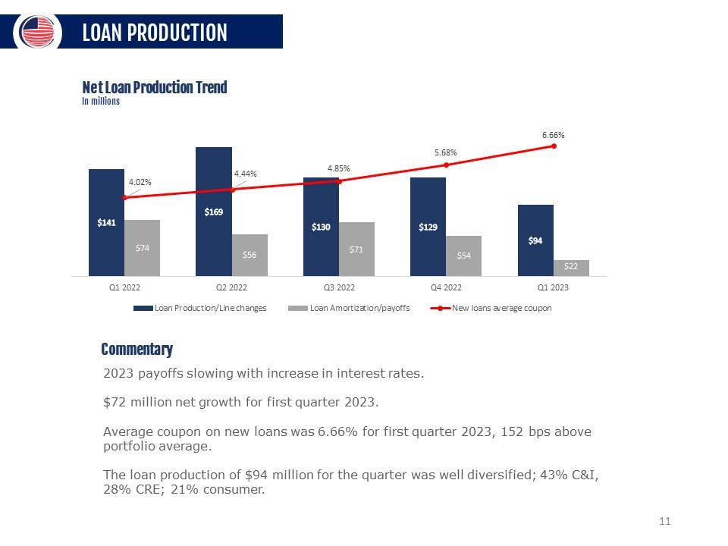

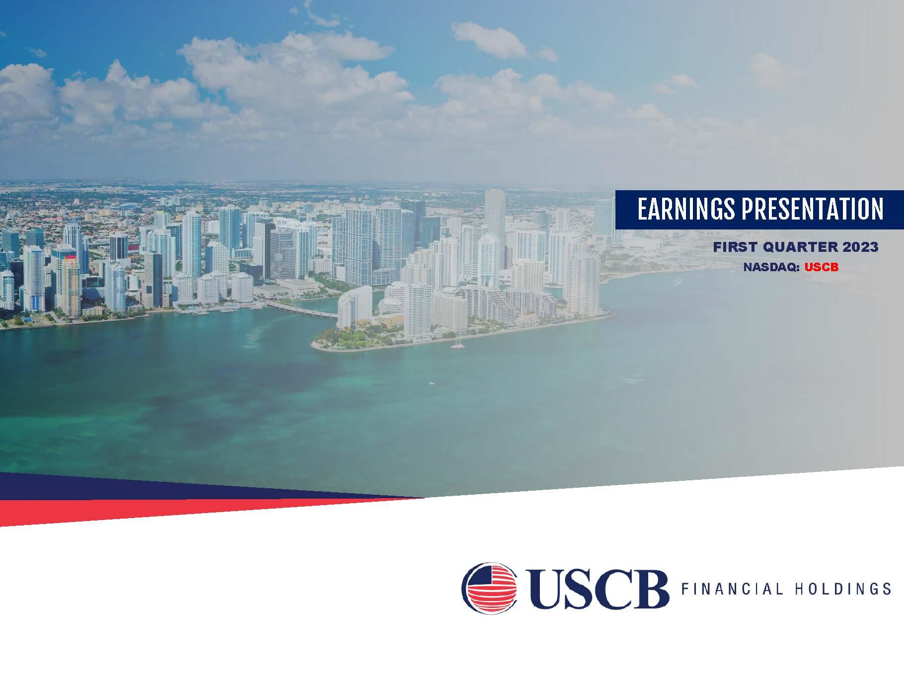
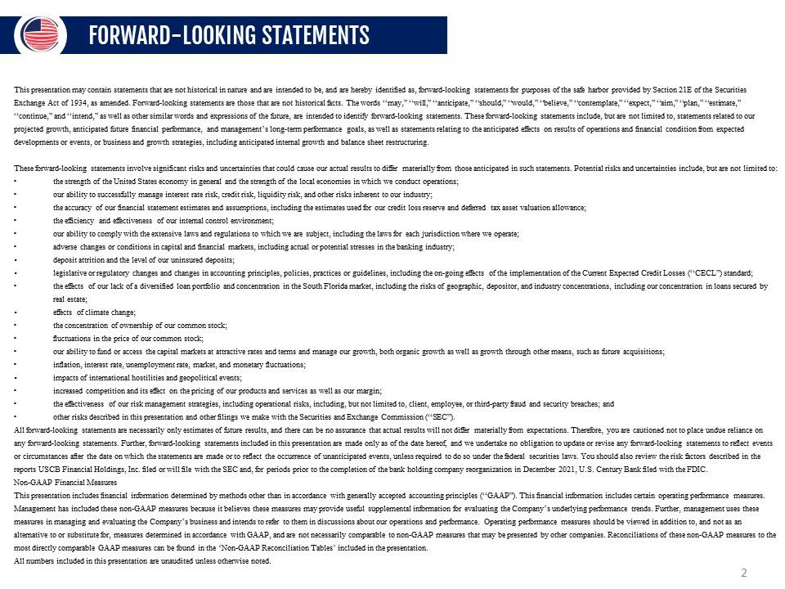
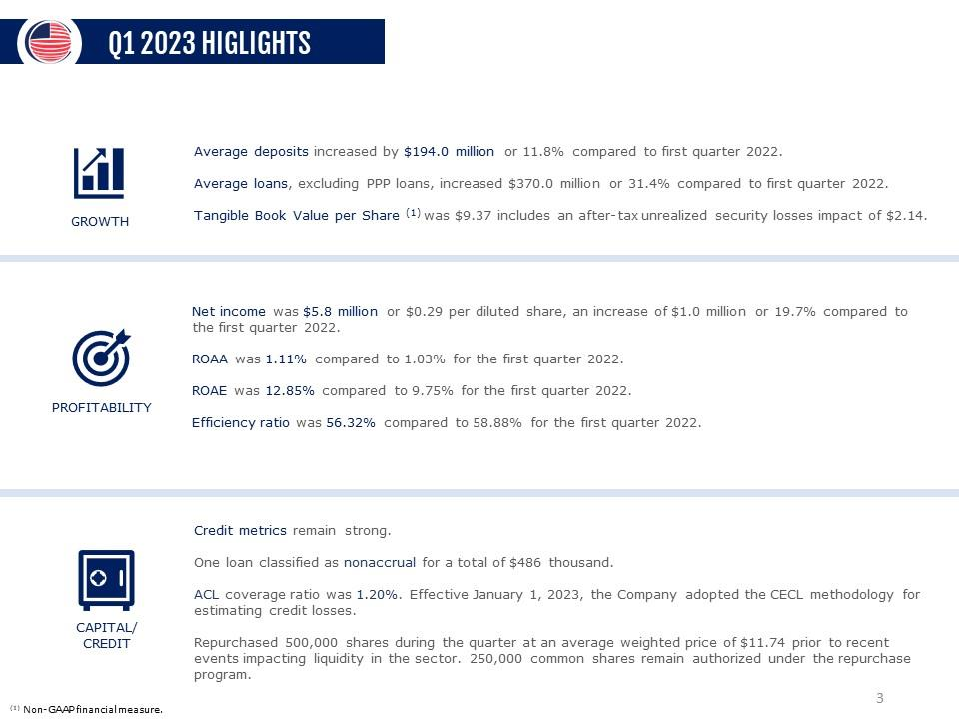
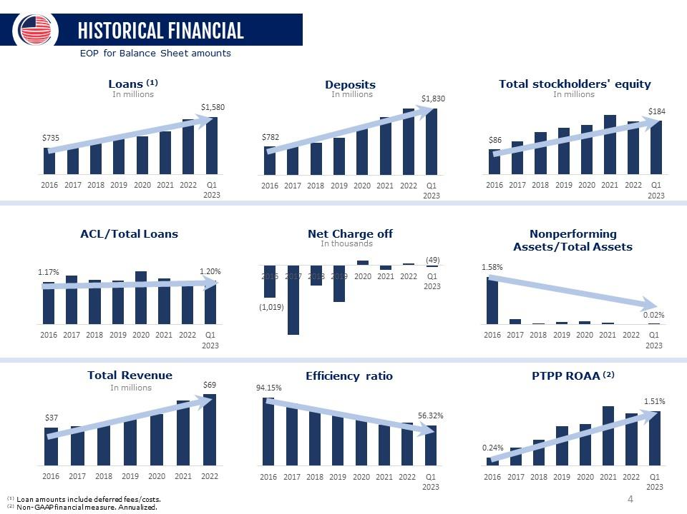
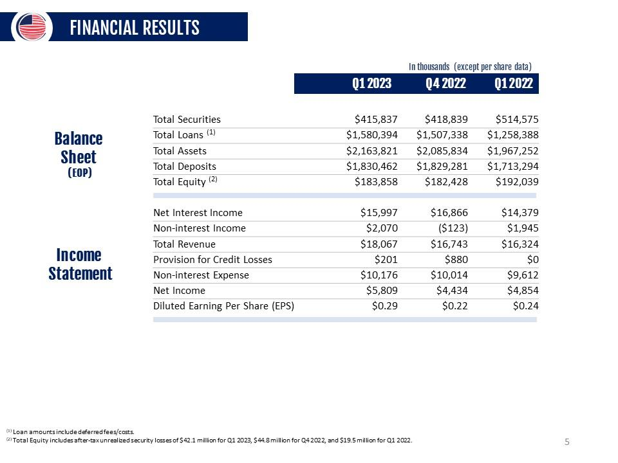
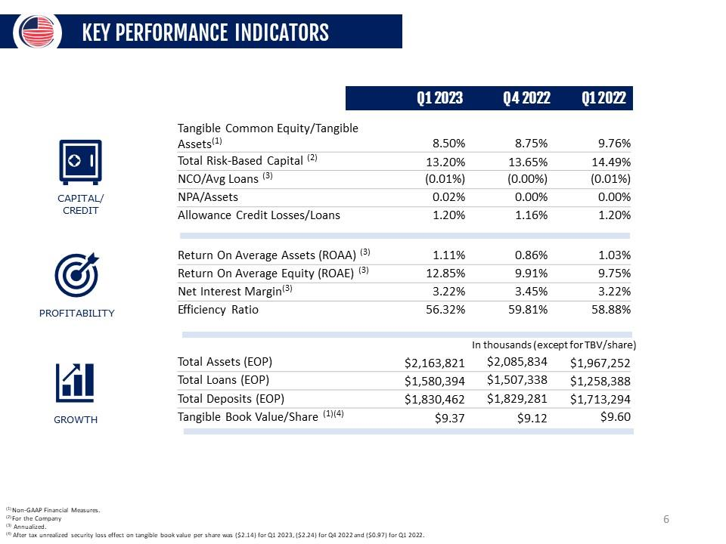
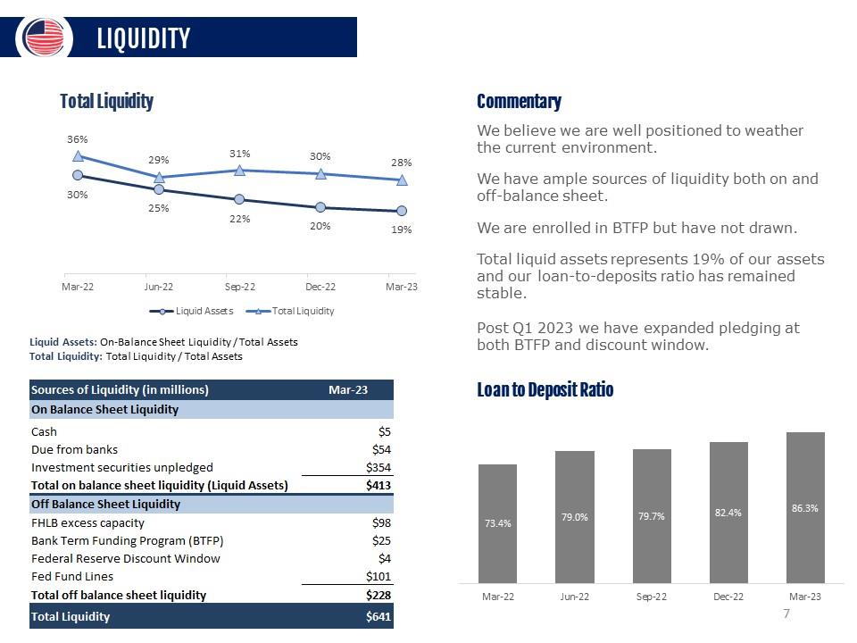
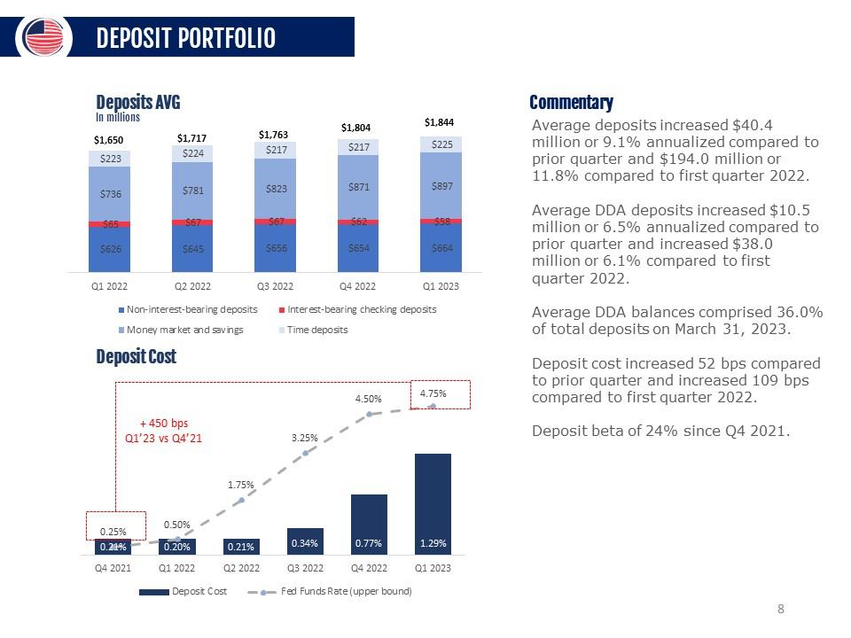
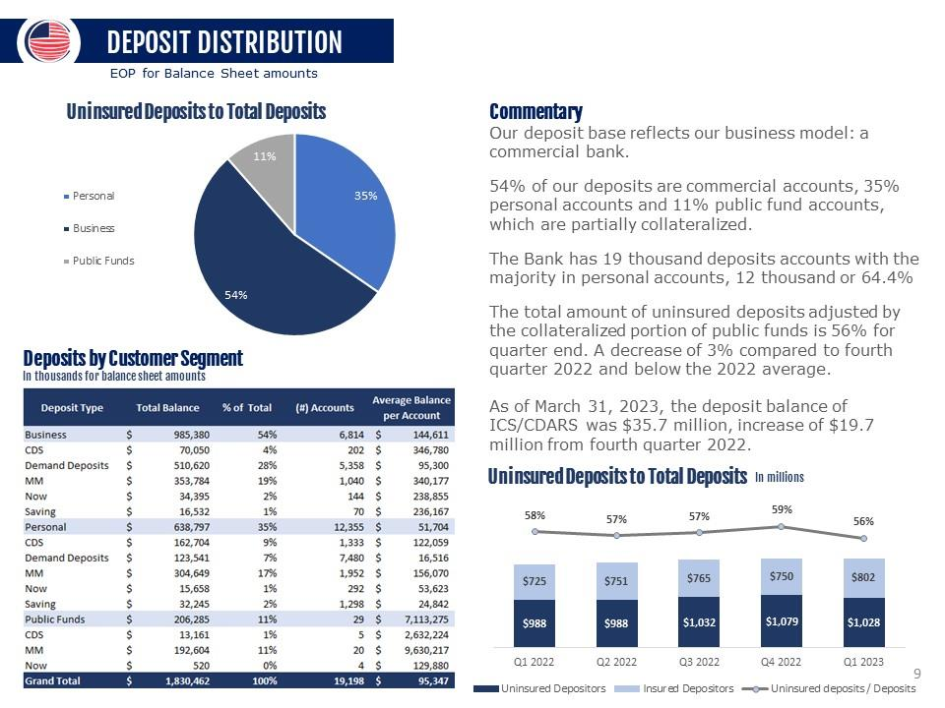
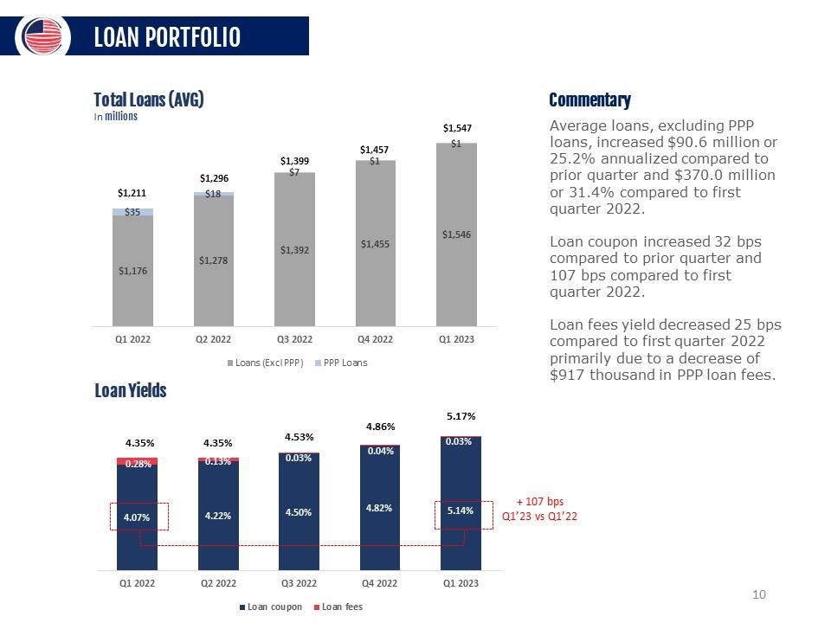
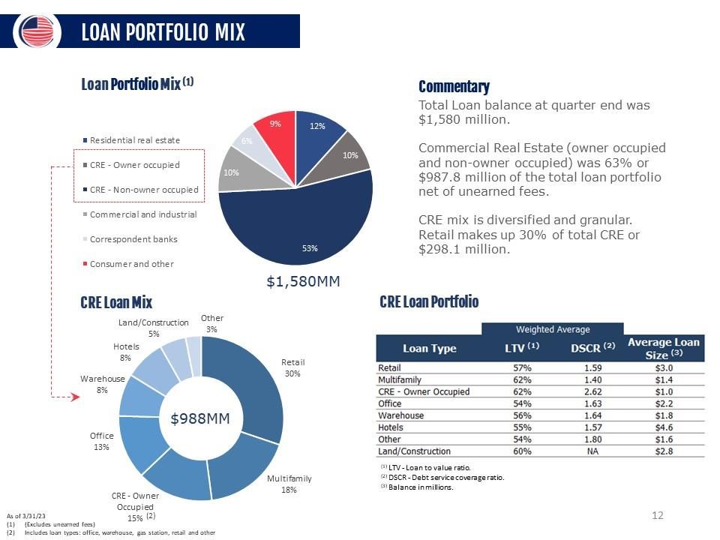
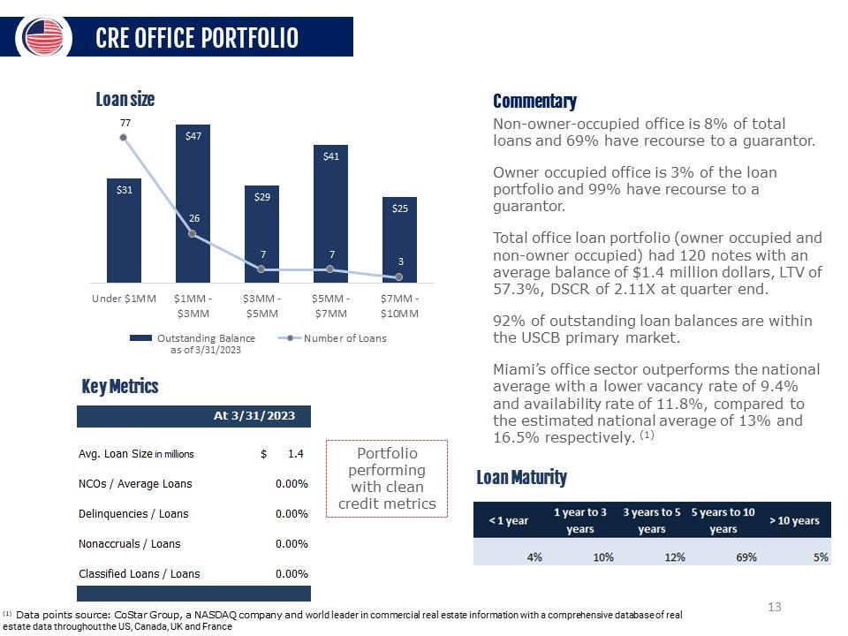
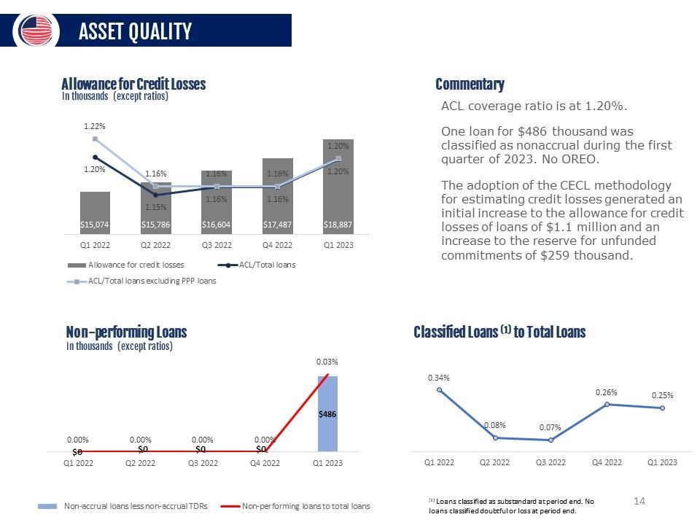
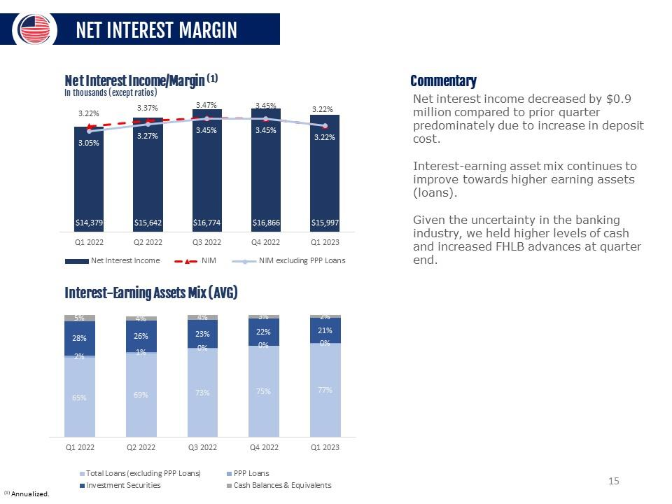
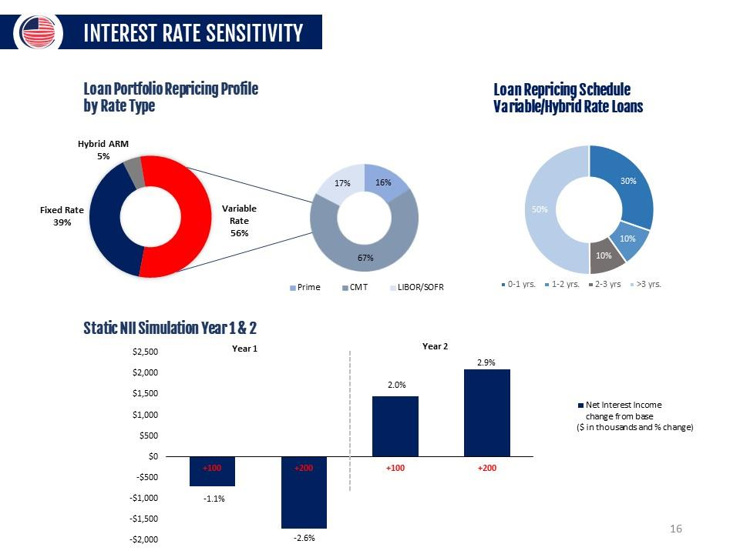
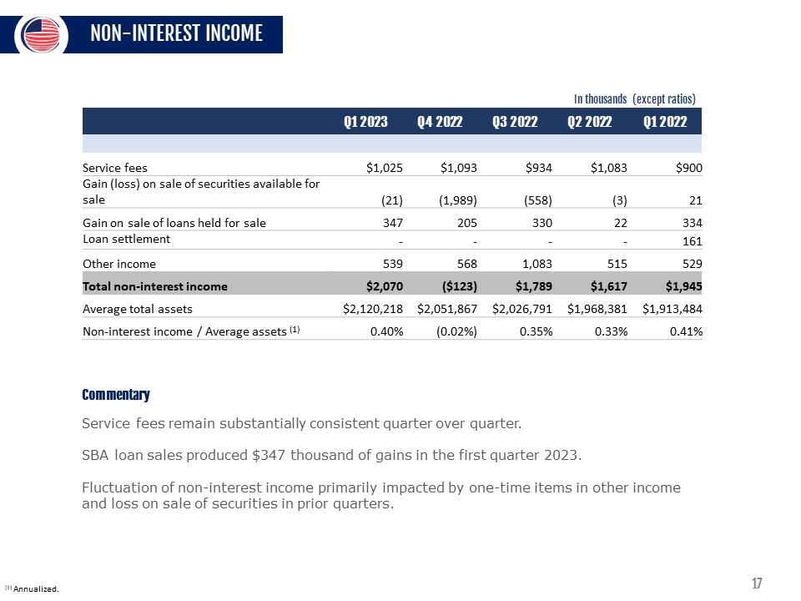
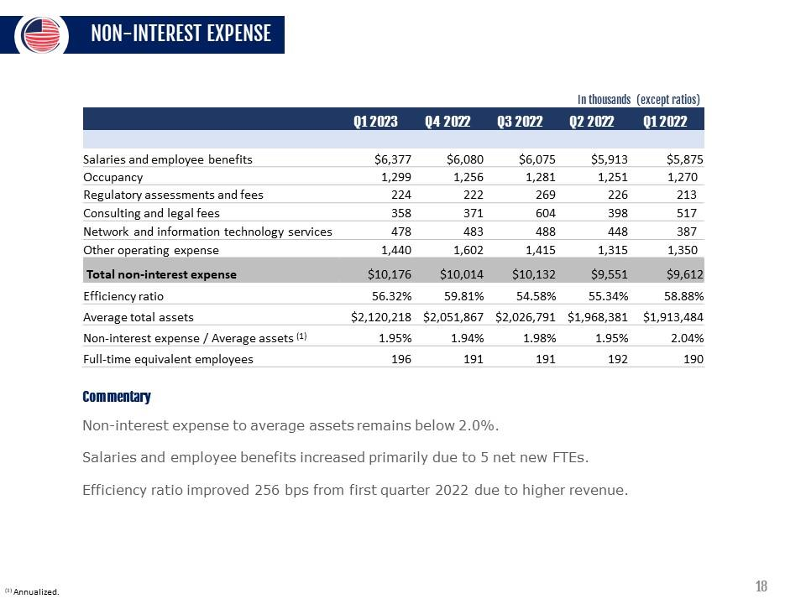
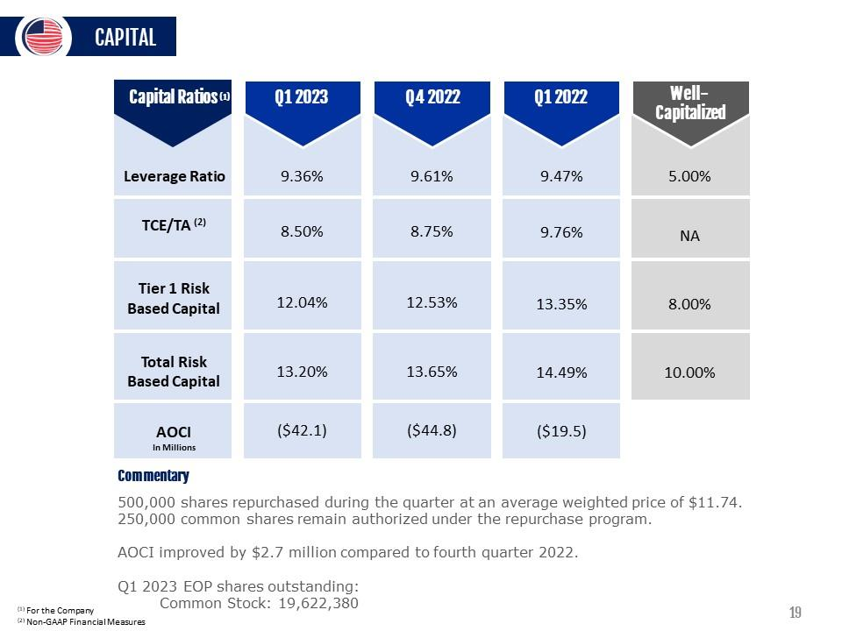
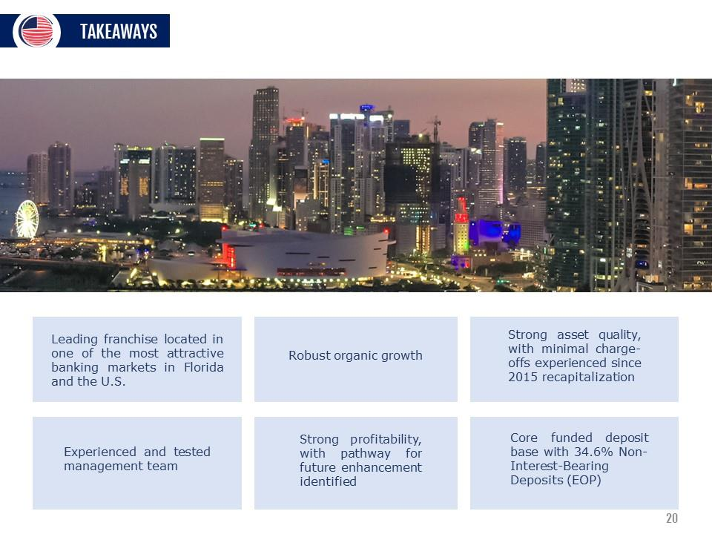
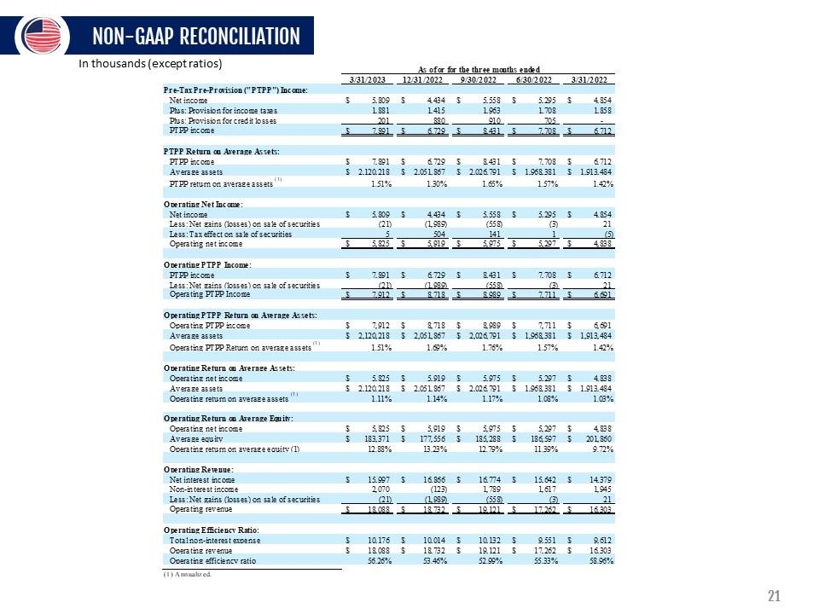
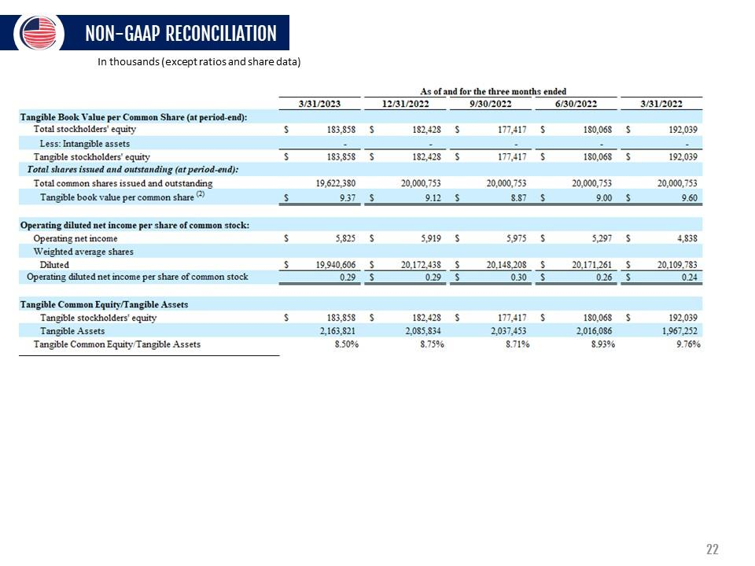
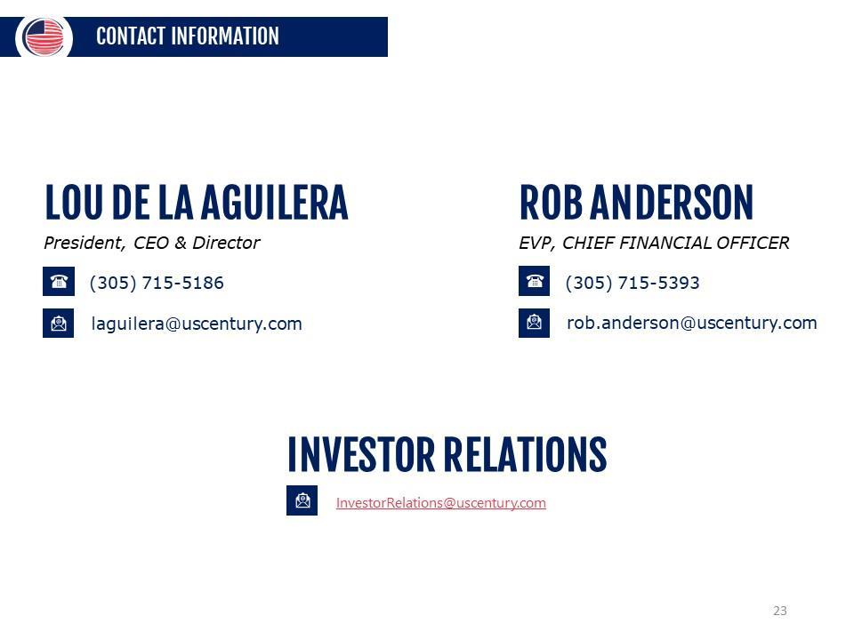

1

UNITED STATES

SECURITIES AND EXCHANGE COMMISSION

WASHINGTON,

D.C. 20549

__________________________

FORM

8-K

__________________________

CURRENT REPORT

Pursuant to Section 13 or 15(d) of the Securities Exchange Act

of 1934

Date of Report (Date of earliest event reported):

April 27, 2023

__________________________

USCB Financial Holdings, Inc.

(Exact name of Registrant as Specified in Its Charter)

__________________________

Florida

001-41196

87-4070846

(State or Other Jurisdiction

of Incorporation)

(Commission File Number)

(IRS Employer

Identification No.)

2301 N.W. 87th Avenue

,

Doral

,

Florida

33172

(Address of Principal Executive Offices)

(Zip Code)

Registrant’s Telephone

Number, Including Area Code: (

305

)

715-5200

__________________________

Check the appropriate box below if the Form 8-K filing is intended to simultaneously satisfy the filing obligation

of the registrant under

any of the following provisions:

☐

Written communications pursuant

to Rule 425 under the Securities Act (17 CFR 230.425)

☐

Soliciting material pursuant to Rule 14a-12 under the Exchange Act (17 CFR 240.14a

-12)

☐

Pre-commencement communications pursuant to Rule 14d-2(b)

under the Exchange Act (17 CFR 240.14d-2(b))

☐

Pre-commencement communications pursuant to Rule 13e-4(c) under the Exchange

Act (17 CFR 240.13e-4(c))

Securities registered pursuant to Section 12(b) of the Act:

Title of each class

Trading

Symbol(s)

Name of each exchange on which registered

Class A common stock, $1.00 par value per share

USCB

The Nasdaq Stock Market LLC

Indicate by

check mark

whether the

registrant is

an emerging

growth company

as defined

in Rule

405 of

the Securities

Act of

1933

(§ 230.405 of this chapter) or Rule 12b-2 of the Securities Exchange Act of 1934 (§ 240.12b

-2 of this chapter).

Emerging growth company

☒

If

an

emerging

growth

company,

indicate

by

check

mark

if

the

registrant

has

elected

not

to

use

the

extended

transition

period

for

complying with any new or revised financial accounting standards provided

pursuant to Section 13(a) of the Exchange Act.

☐

2

Item 2.02. Results of Operations and Financial Condition.

On April 27, 2023, USCB Financial Holdings, Inc. (the “Company”), issued a press release announcing its financial results for

the first quarter ended March 31, 2023. A copy of the press release is furnished as Exhibit 99.1 to this Current Report on Form 8-K and

is incorporated herein by reference.

The information

in this Item

2.02, including

Exhibit 99.1, is

being furnished

and shall not

be deemed

“filed” for purposes

of

Section 18 of the

Securities Exchange Act

of 1934 (the “Exchange

Act”), or otherwise subject

to the liability of

that section, and

shall

not be deemed

to be incorporated

by reference into

any filing under

the Securities Act of

1933 (the “Securities

Act”) or the

Exchange

Act.

Item 7.01. Regulation FD Disclosure.

As previously

announced, at 11:00

a.m. ET on

April 28, 2023,

the Company will

hold an earnings

conference call to

discuss

its financial

performance

for the

quarter

ended

March 31,

2023.

A copy

of the

slides forming

the basis

of

the

presentation

is being

furnished as Exhibit 99.2 to this Current Report on Form

8-K and is incorporated herein by reference. A copy of the

slides has also been

posted to the Company’s investor relations

website, located at investors.uscenturybank.com.

The information

in this Item

7.01, including

Exhibit 99.2, is

being furnished

and shall not

be deemed

“filed” for purposes

of

Section 18

of the

Exchange Act,

or otherwise

subject to

the

liability of

that section,

and

shall not

be deemed

to be

incorporated

by

reference into any filing under the Securities Act or the Exchange Act.

Item 9.01. Financial Statements and Exhibits.

(d) Exhibits.

Exhibit No.

Description

99.1

USCB Financial Holdings, Inc. Press Release, dated April 27, 2023

99.2

Earnings Presentation, dated April 27, 2023

104

Cover Page Interactive Data File (embedded within the Inline XBRL document)

1

Exhibit 99.1

EARNINGS RELEASE

USCB Financial Holdings, Inc. Reports EPS of $0.29 and ROAA of

1.11%

for Q1 2023

MIAMI, FL

– April

27, 2023

– USCB

Financial Holdings,

Inc. (the

“Company”) (NASDAQ:

USCB)

, the

holding company

for

U.S. Century Bank

(the “Bank”), reported

net income of $5.8

million or $0.29 per

diluted share for the

three months ended March

31,

2023, compared with net income of $4.9 million or $0.24 per diluted

share, for the same period in 2022.

"The beginning

of 2023

was marked

by significant

events such

as the

sudden failure

of three

banks, prompting

heightened concerns

about the safety and

soundness of the banking industry,

and ongoing discussions of a

potential recession. Despite these

challenges, we

are pleased to announce that the USCB team delivered strong performance in the first quarter of 2023,

reflecting our ability to navigate

this challenging

operating environment

with prudent

consistency.

Our financial

results demonstrate

robust earnings,

driven by

strong

loan

production,

and

disciplined

credit

underwriting

and

risk

management

practices”

said

Luis

de

la

Aguilera,

President

and

Chief

Executive

Officer.

"Our strength

and stability

are reinforced

by our

growing core

customer relationships,

which have

enabled us

to

build a granular deposit base and diversified loan portfolio,

in one of the most vibrant markets in the United States.” Mr. de la Aguilera

went on to say,

“ our deposits are derived primarily

from our local customers and communities.

We do

not have any material exposure

to either crypto currencies or investments or to crypto-related business.”

Unless otherwise

stated,

all percentage

comparisons

in

the bullet

points

below

are

calculated

for

the

quarter

ended

March 31,

2023

compared to the quarter ended March 31, 2022 and annualized where

appropriate.

Profitability

•

Annualized return

on average

assets for

the quarter

ended March 31,

2023 was

1.11%

compared to

1.03% for

the first

quarter of

2022.

•

Annualized return

on average stockholders’

equity for the

quarter ended March

31, 2023 was

12.85%

compared to 9.75%

for the

first quarter of 2022.

•

The efficiency ratio for the quarter ended March 31, 2023

was 56.32%

compared to 58.88%

for the first quarter of 2022.

•

Net interest margin was 3.22% for both quarters ended March 31, 2023

and 2022.

•

Net

interest

income

before

provision

for

credit

losses

was

$16.0

million

for

the

quarter

ended

March 31,

2023,

an

increase

of

$1.6 million or 11.3% compared to the

first quarter of 2022.

Balance Sheet

•

Total assets were $2.2

billion at March 31, 2023, representing an increase of $196.6 million or 10.0%

from March 31, 2022.

•

Total loans were $1.6

billion at March 31, 2023, representing an increase of $322.0 million or 25.6%

from March 31, 2022.

•

Total deposits were $1.

8

billion at March 31, 2023, representing an increase of $117.2

million or 6.8% from March 31, 2022.

•

Total stockholders’

equity was $183.9 million at March 31, 2023,

representing a decrease of $8.2 million

or 4.3% from March 31,

2022. Total stockholders’ equity includes after-tax unrealized security losses of $42.1 million at March 31, 2023 compared to

after-

tax unrealized security losses of $19.5 million at March 31, 2022.

Asset Quality

•

Effective

January

1,

2023,

the

Company

adopted

ASU

2016-13

Current

Expected

Credit

Losses

(“CECL”)

methodology

for

estimating credit losses, which

resulted in an increase to

the allowance for credit losses

of loans of $1.1 million

and an increase to

the reserve for unfunded commitments of $259 thousand.

This one-time cumulative adjustment resulted in an after-tax

decrease of

$1.0

million in retained earnings.

2

•

The allowance for credit losses increased by

$3.8 million to $18.9 million at

March 31, 2023 from $15.1 million at

March 31, 2022.

•

The allowance for credit losses represented 1.20% of total loans at March 31, 2023

and at March 31, 2022.

•

Non-performing loans to total loans was 0.03% at March 31, 2023 compared

to 0.00% at March 31, 2022.

Non-interest Income and Non-interest Expense

•

Non-interest income was $2.1 million for the three months ended March 31, 2023, an increase of $125 thousand or 6.4% compared

to $1.9 million for the same period in 2022.

•

Non-interest expense was

$10.2

million for the

three months

ended March 31, 2023,

an increase

of $564 thousand

or 5.9%

compared

to the same period in 2022.

Capital

•

During the quarter the Company repurchased 500,000 shares

of USCB Financial Holdings Inc at

a weighted average price per

share

of $11.74.

The aggregate purchase price

for these transactions was

approximately $5.9 million,

including transaction costs.

These

repurchases were made through open market pursuant to the Company’s publicly announced

repurchase program.

As of March 31,

2023, 250,000 shares remain authorized under this program.

•

As of March 31, 2023,

total risk-based capital ratios for the Company and the Bank were 13.20% and 13.12%,

respectively.

•

Tangible

book value

per common

share of

$9.37 was

negatively affected

by $2.14

due to

after tax

unrealized security

losses of

$42.1 million at

March 31, 2023. At

March 31, 2022, tangible

book value of

$9.60 was negatively

affected by $0.97

due to $19.5

million after tax unrealized security losses.

Conference Call and Webcast

The Company

will host

a conference

call on

Friday,

April 28,

2023, at

11:00

a.m. Eastern Time

to discuss

the Company’s

unaudited

financial results for the quarter ended March 31,

2023. To access the conference call, dial (866) 652-5200 (U.S. toll-free)

and ask to join

the USCB Financial Holdings Call.

Additionally,

interested

parties can

listen to

a live

webcast

of the

call in

the “Investor

Relations” section

of the

Company’s

website

at www.uscentury.com

.

An archived version of the webcast will be available in the same location shortly after

the live call has ended.

About USCB Financial Holdings, Inc.

USCB Financial Holdings, Inc.

is the bank holding company for

U.S. Century Bank. Established in 2002,

U.S. Century Bank is one of

the largest

community banks

headquartered

in Miami,

and one

of the

largest community

banks in

the State

of Florida.

U.S. Century

Bank is rated 5-Stars by BauerFinancial, the nation’s leading independent

bank rating firm. U.S. Century Bank offers customers a wide

range of

financial products

and services

and supports

numerous community

organizations,

including

the Greater

Miami Chamber

of

Commerce, the South

Florida Hispanic Chamber

of Commerce, and

ChamberSouth. For more

information or to

find a banking

center

near you, please call (305) 715-5200 or visit www.uscentury.com.

Forward-Looking Statements

This earnings

release may contain

statements that are

not historical in

nature and are

intended to be,

and are hereby

identified as,

forward-

looking

statements

for

purposes

of

the

safe

harbor

provided

by

Section

21E

of

the

Securities

Exchange

Act

of

1934,

as

amended.

Forward-looking statements are those that are not historical facts. The words “may,” “will,” “anticipate,” “should,” “would,” “believe,”

“contemplate,”

“expect,”

“aim,” “plan,”

“estimate,” “continue,”

and

“intend,”

as well

as other

similar words

and

expressions

of the

future, are intended to

identify forward-looking statements. These forward-looking statements

include,

but are not limited

to,

statements

related to

our projected

growth, anticipated

future financial

performance, and

management’s

long-term performance

goals, as

well as

statements relating to the anticipated

effects on results of

operations and financial

condition from expected developments

or events, or

business and growth strategies, including anticipated internal growth

and balance sheet restructuring.

These forward-looking statements involve significant risks and uncertainties that could cause our actual

results to differ materially from

those anticipated in such statements. Potential risks and uncertainties include,

but are not limited to:

•

the strength of the United States economy in general and the strength

of the local economies in which we conduct operations;

•

our ability to successfully manage interest rate risk, credit risk, liquidity risk,

and other risks inherent to our industry;

3

•

the

accuracy

of

our

financial

statement

estimates

and

assumptions,

including

the

estimates

used

for

our

credit

loss

reserve

and

deferred tax asset valuation allowance;

•

the efficiency and effectiveness of our internal

control environment;

•

our ability to comply with

the extensive laws and

regulations to which we are

subject, including the laws for

each jurisdiction where

we operate;

•

adverse changes or conditions in capital and financial markets, including

actual or potential stresses in the banking industry;

•

deposit attrition and the level of our uninsured deposits;

•

legislative

or

regulatory

changes and

changes

in

accounting

principles,

policies,

practices or

guidelines,

including

the on-going

effects of the implementation of the Current Expected Credit Losses (“CECL”)

standard;

•

the effects of

our lack of

a diversified loan

portfolio and concentration in

the South Florida

market, including the

risks of geographic,

depositor, and industry concentrations, including

our concentration in loans secured by real estate;

•

effects of climate change;

•

the concentration of ownership

of our common stock;

•

fluctuations in the price of our common stock;

•

our ability to

fund or access

the capital markets

at attractive rates

and terms and

manage our growth,

both organic

growth as well

as growth through other means, such as future acquisitions;

•

inflation, interest rate, unemployment rate, market and monetary fluctuations;

•

impacts of international hostilities and geopolitical events;

•

increased competition and its effect on the pricing of our products

and services as well as our margin;

•

the effectiveness

of our risk management

strategies, including operational

risks, including, but

not limited to, client,

employee, or

third-party fraud and security breaches; and

•

other risks described in this earnings release and other filings we make with the

Securities and Exchange Commission (“SEC”).

All forward-looking statements are necessarily only estimates of future results, and there can be no assurance that actual results will not

differ materially from

expectations. Therefore, you

are cautioned not

to place undue

reliance on any

forward-looking statements. Further,

forward-looking

statements included

in this

earnings release

are made

only as

of the

date hereof,

and we

undertake no

obligation

to

update or revise any forward-looking statement to

reflect events or circumstances after the date on which the statements

are made or to

reflect the occurrence of unanticipated events, unless required to

do so under the federal securities

laws. You should also review the risk

factors described in the reports the Company filed or will file with the SEC and, for periods prior to the completion of the bank holding

company reorganization in December 2021, the Bank

filed with the FDIC.

Non-GAAP Financial Measures

This earnings

release includes financial

information determined by

methods other than

in accordance with

generally accepted accounting

principles (“GAAP”). This financial

information includes certain

operating performance measures. Management

has included these

non-

GAAP

measures

because

it

believes

these

measures

may

provide

useful

supplemental

information

for

evaluating

the

Company’s

underlying

performance

trends. Further,

management

uses these

measures

in managing

and

evaluating

the

Company’s

business

and

intends to

refer to

them in

discussions about

our operations

and performance.

Operating performance

measures should

be viewed

in

addition

to,

and

not

as

an

alternative

to

or

substitute

for,

measures

determined

in

accordance

with

GAAP,

and

are

not

necessarily

comparable

to non-GAAP

measures that

may be

presented by

other companies.

Reconciliations of

these non-GAAP

measures to

the

most

directly

comparable

GAAP measures

can

be

found

in

the

‘Non-GAAP

Reconciliation

Tables’

included

in

the

exhibits

to

this

earnings

release.

All numbers included in this press release are unaudited unless otherwise noted.

Contacts:

Investor Relations

InvestorRelations@uscentury.com

Media Relations

Martha Guerra-Kattou

MGuerra@uscentury.com

4

USCB FINANCIAL HOLDINGS, INC.

CONSOLIDATED STATEMENTS

OF INCOME (UNAUDITED)

(Dollars in thousands, except per share data)

Three Months Ended March 31,

2023

2022

Interest income:

Loans, including fees

$

19,711

$

12,982

Investment securities

2,286

2,329

Interest-bearing deposits in financial institutions

382

31

Total interest income

22,379

15,342

Interest expense:

Interest-bearing checking

43

16

Savings and money market accounts

4,785

551

Time deposits

1,057

259

FHLB advances and other borrowings

497

137

Total interest expense

6,382

963

Net interest income before provision for credit losses

15,997

14,379

Provision for credit losses

201

-

Net interest income after provision for credit losses

15,796

14,379

Non-interest income:

Service fees

1,205

900

Gain (loss) on sale of securities available for sale, net

(21)

21

Gain on sale of loans held for sale, net

347

334

Loan settlement

-

161

Other non-interest income

539

529

Total non-interest income

2,070

1,945

Non-interest expense:

Salaries and employee benefits

6,377

5,875

Occupancy

1,299

1,270

Regulatory assessments and fees

224

213

Consulting and legal fees

358

517

Network and information technology services

478

387

Other operating expense

1,440

1,350

Total non-interest expense

10,176

9,612

Net income before income tax expense

7,690

6,712

Income tax expense

1,881

1,858

Net income

5,809

4,854

Per share information:

Net income per common share, basic

$

0.29

$

0.24

Net income per common share, diluted

$

0.29

$

0.24

Weighted average shares outstanding:

Common shares, basic

19,855,409

19,994,953

Common shares, diluted

19,940,606

20,109,783

5

USCB FINANCIAL HOLDINGS, INC.

SELECTED FINANCIAL DATA (UNAUDITED)

(Dollars in thousands, except per share data)

As of or For the Three Months Ended

3/31/2023

12/31/2022

9/30/2022

6/30/2022

3/31/2022

Income statement data:

Net interest income

$

15,997

$

16,866

$

16,774

$

15,642

$

14,379

Provision for credit losses

201

880

910

705

-

Net interest income after provision for credit losses

15,796

15,986

15,864

14,937

14,379

Service fees

1,205

1,093

934

1,083

900

Gain (loss) on sale of securities available for sale, net

(21)

(1,989)

(558)

(3)

21

Gain on sale of loans held for sale, net

347

205

330

22

334

Loan settlement

-

-

-

-

161

Other income

539

568

1,083

515

529

Total non-interest income

2,070

(123)

1,789

1,617

1,945

Salaries and employee benefits

6,377

6,080

6,075

5,913

5,875

Occupancy

1,299

1,256

1,281

1,251

1,270

Regulatory assessments and fees

224

222

269

226

213

Consulting and legal fees

358

371

604

398

517

Network and information technology services

478

483

488

448

387

Other operating expense

1,440

1,602

1,415

1,315

1,350

Total non-interest expense

10,176

10,014

10,132

9,551

9,612

Net income before income tax expense

7,690

5,849

7,521

7,003

6,712

Income tax expense

1,881

1,415

1,963

1,708

1,858

Net income

$

5,809

$

4,434

$

5,558

$

5,295

$

4,854

Per share information:

Net income per common share, basic

$

0.29

$

0.22

$

0.28

$

0.26

$

0.24

Net income per common share, diluted

$

0.29

$

0.22

$

0.28

$

0.26

$

0.24

Balance sheet data (at period-end):

Cash and cash equivalents

$

63,251

$

54,168

$

73,326

$

83,272

$

94,113

Securities available-for-sale

$

229,409

$

230,140

$

248,571

$

339,464

$

392,214

Securities held-to-maturity

$

186,428

$

188,699

$

178,865

$

116,671

$

122,361

Total securities

$

415,837

$

418,839

$

427,436

$

456,135

$

514,575

Loans held for investment

(1)

$

1,580,394

$

1,507,338

$

1,431,513

$

1,372,733

$

1,258,388

Allowance for credit losses

$

(18,887)

$

(17,487)

$

(16,604)

$

(15,786)

$

(15,074)

Total assets

$

2,163,821

$

2,085,834

$

2,037,453

$

2,016,086

$

1,967,252

Non-interest-bearing deposits

$

633,606

$

629,776

$

662,808

$

653,708

$

656,622

Interest-bearing deposits

$

1,196,856

$

1,199,505

$

1,133,834

$

1,085,012

$

1,056,672

Total deposits

$

1,830,462

$

1,829,281

$

1,796,642

$

1,738,720

$

1,713,294

FHLB advances and other borrowings

$

120,000

$

46,000

$

26,000

$

66,000

$

36,000

Total liabilities

$

1,979,963

$

1,903,406

$

1,860,036

$

1,836,018

$

1,775,213

Total stockholders' equity

$

183,858

$

182,428

$

177,417

$

180,068

$

192,039

Capital ratios:

(2)

Leverage ratio

9.36%

9.61%

9.48%

9.43%

9.47%

Common equity tier 1 capital

12.04%

12.53%

12.56%

12.65%

13.35%

Tier 1 risk-based capital

12.04%

12.53%

12.56%

12.65%

13.35%

Total risk-based capital

13.20%

13.65%

13.65%

13.74%

14.49%

(1)

Loan amounts include deferred fees/costs.

(2) Reflects the Company's capital ratios

6

USCB FINANCIAL HOLDINGS, INC.

AVERAGE BALANCES, RATIOS, AND OTHER DATA

(UNAUDITED)

(Dollars in thousands)

As of or For the Three Months Ended

3/31/2023

12/31/2022

9/30/2022

6/30/2022

3/31/2022

Average balance sheet data:

Cash and cash equivalents

$

50,822

$

61,892

$

77,887

$

80,254

$

99,911

Securities available-for-sale

$

230,336

$

242,144

$

331,206

$

370,933

$

385,748

Securities held-to-maturity

$

187,826

$

184,459

$

116,733

$

120,130

$

122,381

Total securities

$

418,162

$

426,603

$

447,939

$

491,063

$

508,129

Loans held for investment

(1)

$

1,547,393

$

1,456,780

$

1,398,761

$

1,296,476

$

1,211,432

Total assets

$

2,120,218

$

2,051,867

$

2,026,791

$

1,968,381

$

1,913,484

Interest-bearing deposits

$

1,179,878

$

1,150,049

$

1,107,129

$

1,071,709

$

1,023,844

Non-interest-bearing deposits

$

664,369

$

653,820

$

655,853

$

644,975

$

626,400

Total deposits

$

1,844,247

$

1,803,869

$

1,762,982

$

1,716,684

$

1,650,244

FHLB advances and other borrowings

$

61,600

$

37,500

$

43,935

$

36,330

$

36,011

Total liabilities

$

1,936,847

$

1,874,311

$

1,841,503

$

1,781,784

$

1,711,624

Total stockholders' equity

$

183,371

$

177,556

$

185,288

$

186,597

$

201,860

Performance ratios:

Return on average assets

(2)

1.11%

0.86%

1.09%

1.08%

1.03%

Return on average equity

(2)

12.85%

9.91%

11.90%

11.38%

9.75%

Net interest margin

(2)

3.22%

3.45%

3.47%

3.37%

3.22%

Non-interest income to average assets

(2)

0.40%

(0.02)%

0.35%

0.33%

0.41%

Efficiency ratio

(3)

56.32%

59.81%

54.58%

55.34%

58.88%

Loans by type (at period end):

(4)

Residential real estate

$

184,427

$

185,636

$

186,551

$

203,662

$

204,317

Commercial real estate

$

987,757

$

970,410

$

928,531

$

843,445

$

782,072

Commercial and industrial

$

160,947

$

126,984

$

121,145

$

131,271

$

134,832

Foreign banks

$

97,405

$

93,769

$

94,450

$

84,770

$

63,985

Consumer and other

$

149,410

$

130,429

$

100,845

$

109,250

$

73,765

Asset quality data:

Allowance for credit losses to total loans

1.20%

1.16%

1.16%

1.15%

1.20%

Allowance for credit losses to non-performing loans

3,886%

- %

- %

- %

- %

Total non-performing loans

(5)

$

486

$

-

$

-

$

-

$

-

Non-performing loans to total loans

0.03%

- %

- %

- %

- %

Non-performing assets to total assets

0.02%

- %

- %

- %

- %

Net charge-offs (recoveries of) to average loans

(2)

(0.01)%

(0.00)%

0.03%

(0.00)%

(0.01)%

Net charge-offs (recovery of) credit losses

$

(49)

$

(2)

$

91

$

(7)

$

(17)

Interest rates and yields:

(2)

Loans

5.17%

4.86%

4.53%

4.35%

4.35%

Investment securities

2.20%

2.13%

1.94%

2.04%

1.85%

Total interest-earning assets

4.51%

4.21%

3.82%

3.60%

3.43%

Deposits

1.29%

0.77%

0.34%

0.21%

0.20%

FHLB advances and other borrowings

3.27%

2.27%

1.63%

1.53%

1.54%

Total interest-bearing liabilities

2.08%

1.25%

0.59%

0.38%

0.37%

Other information:

Full-time equivalent employees

196

191

191

192

190

(1)

Loan amounts include deferred fees/costs.

(2)

Annualized.

(3)

Efficiency ratio is defined as total non-interest expense divided

by sum of net interest income and total non-interest

income.

(4)

Loan amounts exclude deferred fees/costs.

(5)

The amounts for total non-performing loans and total non-performing

assets are the same at the dates presented since there were

no impaired investments or other

real estate owned (OREO) recorded.

7

USCB FINANCIAL HOLDINGS, INC.

NET INTEREST MARGIN (UNAUDITED)

(Dollars in thousands)

Three Months Ended March 31,

2023

2022

Average

Balance

Interest

Yield/Rate

(1)

Average

Balance

Interest

Yield/Rate

(1)

Assets

Interest-earning assets:

Loans

(2)

$

1,547,393

$

19,711

5.17%

$

1,211,432

$

12,982

4.35%

Investment securities

(3)

421,717

2,286

2.20%

510,257

2,329

1.85%

Other interest-earnings assets

43,084

382

3.60%

90,137

31

0.14%

Total interest-earning assets

2,012,194

22,379

4.51%

1,811,826

15,342

3.43%

Non-interest-earning assets

108,024

101,658

Total assets

$

2,120,218

$

1,913,484

Liabilities and stockholders' equity

Interest-bearing liabilities:

Interest-bearing checking

$

58,087

43

0.30%

$

64,436

16

0.10%

Saving and money market deposits

897,061

4,785

2.16%

736,134

551

0.30%

Time deposits

224,730

1,057

1.91%

223,274

259

0.47%

Total interest-bearing deposits

1,179,878

5,885

2.02%

1,023,844

826

0.33%

FHLB advances and other borrowings

61,600

497

3.27%

36,011

137

1.54%

Total interest-bearing liabilities

1,241,478

6,382

2.08%

1,059,855

963

0.37%

Non-interest-bearing demand deposits

664,369

626,400

Other non-interest-bearing liabilities

31,000

25,369

Total

liabilities

1,936,847

1,711,624

Stockholders' equity

183,371

201,860

Total liabilities and stockholders' equity

$

2,120,218

$

1,913,484

Net interest income

$

15,997

$

14,379

Net interest spread

(4)

2.43%

3.07%

Net interest margin

(5)

3.22%

3.22%

(1)

Annualized.

(2)

Average loan balances include non-accrual loans. Interest income on loans includes accretion

of deferred loan fees, net of deferred loan costs.

(3)

At fair value except for securities held to maturity. This amount includes FHLB

stock.

(4)

Net interest spread is the average yield on total interest-earning

assets minus the average rate on total interest-bearing liabilities.

(5)

Net interest margin is the ratio of net interest income to total

interest-earning assets.

8

USCB FINANCIAL HOLDINGS, INC.

NON-GAAP FINANCIAL MEASURES (UNAUDITED)

(Dollars in thousands)

As of or For the Three Months Ended

3/31/2023

12/31/2022

9/30/2022

6/30/2022

3/31/2022

Pre-tax pre-provision ("PTPP") income:

Net income

$

5,809

$

4,434

$

5,558

$

5,295

$

4,854

Plus: Provision for income taxes

1,881

1,415

1,963

1,708

1,858

Plus: Provision for credit losses

201

880

910

705

-

PTPP income

$

7,891

$

6,729

$

8,431

$

7,708

$

6,712

PTPP return on average assets:

PTPP income

$

7,891

$

6,729

$

8,431

$

7,708

$

6,712

Average assets

$

2,120,218

$

2,051,867

$

2,026,791

$

1,968,381

$

1,913,484

PTPP return on average assets

(1)

1.51%

1.30%

1.65%

1.57%

1.42%

Operating net income:

Net income

$

5,809

$

4,434

$

5,558

$

5,295

$

4,854

Less: Net gains (losses) on sale of securities

(21)

(1,989)

(558)

(3)

21

Less: Tax effect on sale of securities

5

504

141

1

(5)

Operating net income

$

5,825

$

5,919

$

5,975

$

5,297

$

4,838

Operating PTPP income:

PTPP income

$

7,891

$

6,729

$

8,431

$

7,708

$

6,712

Less: Net gains (losses) on sale of securities

(21)

(1,989)

(558)

(3)

21

Operating PTPP income

$

7,912

$

8,718

$

8,989

$

7,711

$

6,691

Operating PTPP return on average assets:

Operating PTPP income

$

7,912

$

8,718

$

8,989

$

7,711

$

6,691

Average assets

$

2,120,218

$

2,051,867

$

2,026,791

$

1,968,381

$

1,913,484

Operating PTPP return on average assets

(1)

1.51%

1.69%

1.76%

1.57%

1.42%

Operating return on average assets:

Operating net income

$

5,825

$

5,919

$

5,975

$

5,297

$

4,838

Average assets

$

2,120,218

$

2,051,867

$

2,026,791

$

1,968,381

$

1,913,484

Operating return on average assets

(1)

1.11%

1.14%

1.17%

1.08%

1.03%

Operating return on average equity:

Operating net income

$

5,825

$

5,919

$

5,975

$

5,297

$

4,838

Average equity

$

183,371

$

177,556

$

185,288

$

186,597

$

201,860

Operating return on average equity

12.88%

13.23%

12.79%

11.39%

9.72%

Operating Revenue:

Net interest income

$

15,997

$

16,866

$

16,774

$

15,642

$

14,379

Non-interest income

2,070

(123)

1,789

1,617

1,945

Less: Net gains (losses) on sale of securities

(21)

(1,989)

(558)

(3)

21

Operating revenue

$

18,088

$

18,732

$

19,121

$

17,262

$

16,303

Operating Efficiency Ratio:

Total non-interest expense

$

10,176

$

10,014

$

10,132

$

9,551

$

9,612

Operating revenue

$

18,088

$

18,732

$

19,121

$

17,262

$

16,303

Operating efficiency ratio

56.26%

53.46%

52.99%

55.33%

58.96%

(1)

Annualized.

9

USCB FINANCIAL HOLDINGS, INC.

NON-GAAP FINANCIAL MEASURES (UNAUDITED)

(Dollars in thousands, except per share data)

As of or For the Three Months Ended

3/31/2023

12/31/2022

9/30/2022

6/30/2022

3/31/2022

Tangible book value per common share (at period-end):

(1)

Total stockholders' equity

$

183,858

$

182,428

$

177,417

$

180,068

$

192,039

Less: Intangible assets

-

-

-

-

-

Tangible stockholders' equity

$

183,858

$

182,428

$

177,417

$

180,068

$

192,039

Total shares issued and outstanding (at period-end):

Total common shares issued and outstanding

19,622,380

20,000,753

20,000,753

20,000,753

20,000,753

Tangible book value per common share

(2)

$

9.37

$

9.12

$

8.87

$

9.00

$

9.60

Operating diluted net income per common share:

(1)

Operating net income

$

5,825

$

5,919

$

5,975

$

5,297

$

4,838

Total weighted average diluted shares of common stock

19,940,606

20,172,438

20,148,208

20,171,261

20,109,783

Operating diluted net income per common share:

$

0.29

$

0.29

$

0.30

$

0.26

$

0.24

Tangible Common Equity/Tangible Assets

Tangible stockholders' equity

$

183,858

$

182,428

$

177,417

$

180,068

$

192,039

Tangible assets

$

2,163,821

$

2,085,834

$

2,037,453

$

2,016,086

$

1,967,252

Tangible Common Equity/Tangible Assets

8.50%

8.75%

8.71%

8.93%

9.76%

(1)

The Company believes these non-GAAP measurements

are key indicators of the ongoing earnings power

of the Company.

(2)

Excludes the dilutive effect, if any, of shares of common stock issuable upon exercise of outstanding

stock options.

Exhibit 99.2

Exhibit 99.2 EARNINGS PRESENTATION FIRST QUARTER

2023 NASDAQ: USCB USBC FINANCIAL HOLDINGS

FORWARD-LOOKING STATEMENTS This presentation

may contain statements that are not historical in nature and are

intended to be, and are hereby identified as, forward-looking statements

for purposes of the safe harbor provided by Section 21E of the

Securities Exchange Act of 1934, as amended. Forward-looking statements

are those that are not historical facts. The words “may,” “will,”

“anticipate,” “should,” “would,” “believe,” “contemplate,”

“expect,” “aim,” “plan,” “estimate,” “continue,” and “intend,” as well

as other similar words and expressions of the future, are

intended to identify forward-looking statements. These forward-looking

statements include, but are not limited to, statements related to our projected

growth, anticipated future financial performance, and management’s

long-term performance goals, as well as statements relating

to the anticipated effects on results of operations and financial condition

from expected developments or events, or business and growth

strategies, including anticipated internal growth and balance

sheet restructuring. These forward-looking statements involve

significant risks and uncertainties that could cause our actual results

to differ materially from those anticipated in such statements.

Potential risks and uncertainties include, but are not limited to: •

the strength of the United States economy in general and the strength

of the local economies in which we conduct operations; • our

ability to successfully manage interest rate risk, credit risk, liquidity

risk, and other risks inherent to our industry; • the accuracy

of our financial statement estimates and assumptions, including the estimates

used for our credit loss reserve and deferred

tax asset valuation allowance; • the efficiency and effectiveness of our

internal control environment; • our ability to comply with the extensive

laws and regulations to which we are subject, including the laws for

each jurisdiction where

we operate; • adverse changes or conditions in capital and financial

markets, including actual or potential stresses in the banking industry;

deposit attrition and the level of our uninsured deposits; legislative

or regulatory changes and changes in accounting principles,

policies, practices or guidelines, including the on-going effects

of the implementation of the Current Expected Credit Losses (“CECL”)

standard; • the effects of our lack of a diversified loan portfolio and

concentration in the South Florida market, including the

risks of geographic, depositor, and industry concentrations, including

our concentration in loans secured by real estate; effects

of climate change; • the concentration of ownership of our common

stock; • fluctuations in the price of our common stock; • our ability

to fund or access the capital markets at attractive rates and terms

and manage our growth, both organic growth as well as growth

through other means, such as future acquisitions; • inflation, interest rate,

unemployment rate, market, and monetary fluctuations; impacts

of international hostilities and geopolitical events; • increased

competition and its effect on the pricing of our products and services

as well as our margin; • the effectiveness of our risk management strategies,

including operational risks, including, but not limited to, client,

employee, or third-party fraud and security breaches; and • other

risks described in this presentation and other filings we make with the

Securities and Exchange Commission (“SEC”). All forward

-looking statements are necessarily only estimates of future results, and

there can be no assurance that actual results will not differ

materially from expectations. Therefore, you are cautioned not to place

undue reliance on any forward-looking statements. Further, forward

-looking statements included in this presentation are made only as of the

date hereof, and we undertake no obligation to update or revise any

forward-looking statements to reflect events or circumstances after

the date on which the statements are made or to reflect the occur

rence of unanticipated events, unless required to do so under the federal

securities laws. You should also review the risk factors described

in the reports USCB Financial Holdings, Inc. filed or will file with

the SEC and, for periods prior to the completion of the bank

holding company reorganization in December 2021, U.S. Century

Bank filed with the FDIC. Non-GAAP Financial Measures This

presentation includes financial information determined by

methods other than in accordance with generally accepted

accounting principles (“GAAP”). This financial information includes certain

operating performance measures. Management has included

these non-GAAP measures because it believes these measures may

provide useful supplemental information for evaluating the Company’s

underlying performance trends. Further, management

uses these measures in managing and evaluating the Company’s

business and intends to refer to them in discussions about our operations

and performance. Operating performance measures should

be viewed in addition to, and not as an alternative to or substitute

for, measures determined in accordance with GAAP, and

are not necessarily comparable to non-GAAP measures that

may be presented by other companies. Reconciliations of these non

-GAAP measures to the most directly comparable GAAP measures

can be found in the ‘Non-GAAP Reconciliation Tables’

included in the presentation. All numbers included in this presentation

are unaudited unless otherwise noted. 2

Q1 2023 HIGLIGHTS GROWTH Average deposits increased

by $194.0 million or 11.8% compared to first quarter 2022. Average

loans, excluding PPP loans, increased $370.0 million or 31.4% compared

to first quarter 2022. Tangible Book Value per Share

(1) was $9.37 includes an after-tax unrealized security losses impact of

$2.14. PROFITABILITY Net income was $5.8 million

or $0.29 per diluted share, an increase of $1.0 million or 19.7% compared

to the first quarter 2022. ROAA was 1.11% compared to 1.03% for the

first quarter 2022. ROAE was 12.85% compared to 9.75% for the first

quarter 2022. Efficiency ratio was 56.32% compared to 58.88%

for the first quarter 2022. CAPITAL/ CREDIT Credit metrics

remain strong. One loan classified as nonaccrual for

a total of $486 thousand. ACL coverage ratio was 1.20%. Effective

January 1, 2023, the Company adopted the CECL methodology for

estimating credit losses. Repurchased 500,000 shares during the quarter

at an average weighted price of $11.74 prior to recent events impacting

liquidity in the sector. 250,000 common shares remain authorized

under the repurchase program. (1) Non-GAAP financial measure.

3

HISTORICAL FINANCIAL EOP for Balance Sheet amounts Loans

(1) In millions $735 $1,580 Deposits In millions $782 $1,830 Total

stockholders’ equity In millions $86 $184 ACL/Total Loans

1.17% 1.20% Net Charge off In thousands (1,019)

(49) Nonperforming Assets/Total Assets 1.58% 0.02% Total

Revenue In millions $37 $69 Efficiency ratio 94.15% 56.32%

PTPP ROAA (2) 0.24% 1.51% (1) Loan amounts include deferred

fees/costs. (2) Non-GAAP financial measure. Annualized. 4

FINANCIAL RESULTS Balance Sheet (EOP) In thousands (except

per share data) Q1 2023 Q4 2022 Q1 2022 Total Securities $415,837

$418,839 $514,575

Total Loans (1) $1,580,394 $1,507,338 $1,258,388 Total

Assets $2,163,821 $2,085,834 $1,967,252 Total Deposits

$1,830,462 $1,829,281 $1,713,294 Total Equity (2) $183,858

$182,428 $192,039 Income Statement Net Interest Income $15,997

$16,866 $14,379 Non-interest Income $2,070 ($123) $1,945

Total Revenue $18,067 $16,743 $16,324 Provision for Credit

Losses $201 $880 $0 Non-interest Expense $10,176 $10,014 $9,612

Net Income $5,809 $4,434 $4,854 Diluted Earning Per

Share (EPS) $0.29 $0.22 $0.24 (1) Loan amounts include deferred

fees/costs. (2) Total Equity includes after-tax unrealized security losses of

$42.1 million for Q1 2023, $44.8 million for Q4 2022, and $19.5

million for Q1 2022. 5

KEY PERFORMANCE INDICATORS CAPITAL/

CREDIT PROFITABILITY GROWTH Q1 2023 Q4 2022 Q1 2022

Tangible Common Equity/Tangible Assets(1) 8.50% 8.75%

9.76% Total Risk-Based Capital (2) 13.20% 13.65% 14.49%

NCO/Avg Loans (3) (0.01%) (0.00%) (0.01%) NPA/Assets

0.02% 0.00% 0.00% Allowance Credit Losses/Loans 1.20% 1.16%

1.20% Return On Average Assets (ROAA) (3) 1.11%

0.86% 1.03% Return On Average Equity (ROAE) (3) 12.85%

9.91% 9.75% Net Interest Margin(3) 3.22% 3.45% 3.22% Efficiency

Ratio 56.32% 59.81% 58.88% Total Assets (EOP) $2,163,821

$2,085,834 $1,967,252 Total Loans (EOP) $1,580,394

$1,507,338 $1,258,388 Total Deposits (EOP) $1,830,462 $1,829,281

$1,713,294 Tangible Book Value/Share (1)(4)

$9.37 $9.12 $9.60 (1) Non-GAAP Financial Measures. (2) For the Company

(3) Annualized. (4) After tax unrealized security loss effect

on tangible book value per share was ($2.14) for Q1 2023, ($2.24)

for Q4 2022 and ($0.97) for Q1 2022. 6

LIQUIDITY Total Liquidity 36% 29% 31% 30% 28% 30% 25%

22% 20% 19% Liquid Assets Total Liquidity Commentary

We believe we are well positioned to weather the current environment.

We have ample sources of liquidity both on and off-balance

sheet. We are enrolled in BTFP but have not drawn. Total liquid

assets represents 19% of our assets and our loan-to-deposits ratio

has remained stable. Post Q1 2023 we have expanded pledging at

both BTFP and discount window. Liquid Assets: On-Balance

Sheet Liquidity / Total Assets Total Liquidity: Total

Liquidity / Total Assets Sources of Liquidity (in millions)

Mar-23 On Balance Sheet Liquidity Cash Due from banks Investment

securities unpledged Total on balance sheet liquidity (Liquid Assets)

Off Balance Sheet Liquidity FHLB excess capacity Bank Term

Funding Program (BTFP) Federal Reserve Discount Window

Fed Fund Lines Total off balance sheet liquidity $641 Total

Liquidity Loan to Deposit Ratio 73.4% 79.0% 79.7% 82.4% 86.3%

7

DEPOSIT PORTFOLIO Deposits AVG In millions $1,650

$1,717 $1,763 $1,804 $1,844 $223 $224 $217 $217 $225 $736

$781 $823 $871 $897 $65 $67 $67 $62 $58 $625 $645 $656 $654

$664 Q1 2022 Q2 2022 Q3 2022 Q4 2022 Q1 2023 Non-interest-bearing

deposits Interest-bearing checking deposits Money market

and savings Time deposits Deposit Cost 0.25% 0.50% 1.75% 3.25%

4.50% 4.75% 0.21% 0.20% 0.21% 0.34% 0.77% 1.29% Q4 2021 Q1

2022 Q2 2022 Q3 2022 Q4 2022 Q1 2023 Deposit Cost Fed Fund

Rate (upper bound) Commentary Average deposits increased

$40.4 million or 9.1% annualized compared to prior quarter and

$194.0 million or 11.8% compared to first quarter 2022. Average

DDA deposits increased $10.5 million or 6.5% annualized compared

to prior quarter and increased $38.0 million or 6.1% compared to first

quarter 2022. Average DDA balances comprised 36.0% of

total deposits on March 31, 2023. Deposit cost increased 52 bps compared

to prior quarter and increased 109 bps compared to first quarter

2022. Deposit beta of 24% since Q4 2021. 8

DEPOSIT DISTRIBUTION EOP for Balance Sheet amounts Uninsured

Deposits to Total Deposits Personal Business Public Funds

11% 35% 54% Deposits by Customer Segment In thousands

for balance sheet amounts Deposit Type Total Balance

% of Total (#) Accounts Average Balance per Account

Business $ 985,380 54% 6,814 $ 144,611 CDS $ 70,050 4% 202

$ 346,780 Demand Deposits $ 510,620 28% 5,358 $ 95,300 MM $

353,784 19% 1,040 $ 340,177 Now $ 34,395 2% 144 $ 238,855

Saving $ 16,532 1% 70 $ 236,167 Personal $ 638,797 35% 12,355 $

51,704 CDS $ 162,704 9% 1,333 $ 122,059 Demand Deposits $ 123,5

41 7% 7,480 $ 16,516 MM $ 304,649 17% 1,952 $ 156,070

Now $ 15,658 1% 292 $ 53,623 Saving $ 32,245 2% 1,298 $ 24,842

Public Funds $ 206,285 11% 29 $ 7,113,275 CDS $ 13,161 1%

5 $ 2,632,224 MM $ 192,604 11% 20 $ 9,630,217 Now $ 520 0%

4 $ 129,880 Grand

Total $ 1,830,462 100% 19,198 $ 95,347 Commentary Our deposit

base reflects our business model: a commercial bank. 54%

of our deposits are commercial accounts, 35% personal accounts

and 11% public fund accounts, which are partially collateralized.

The Bank has 19 thousand deposits accounts with the majority

in personal accounts, 12 thousand or 64.4% The total amount of uninsured

deposits adjusted by the collateralized portion of public funds

is 56% for quarter end. A decrease of 3% compared to fourth

quarter 2022 and below the 2022 average. As of March 31, 2023,

the deposit balance of ICS/CDARS was $35.7 million, increase

of $19.7 million from fourth quarter 2022. Uninsured Deposits to Total

Deposits In millions 58% 57% 57% $725 $751 $765 $988 $988

$1,032 Q1 2022 Q2 2022 Q3 2022 Uninsured Depositors Insured

Depositors 59% 56% $1,079 $1,028 Q4 2022 Q1 2023 Uninsured

deposits / Deposits 9

LOAN PORTFOLIO Total Loans (AVG) In millions

$1,211 $1,296 $1,399 $1,457 $1,547 $35 $18 $7 $1 $1 $1,176 $1,278

$1,392 $1,455 $1,546 Q1 2022 Q2 2022 Q3 2022 Q4 2022 Q1

2023 Loans (Exd PPP) PPP Loans Loan Yields 4.35%

4.35% 4.53% 4.86% 5.17% 0.28% 0.13% 0.03% 0.04% 0.03%

4.07% 4.22% 4.50% 4.82% 4.14% Q1 2022 Q2 2022 Q3 2022 Q4

2022 Q1 2023 Loan coupon Loan fees Commentary Average

loans, excluding PPP loans, increased $90.6 million or 25.2% annualized

compared to prior quarter and $370.0 million or 31.4% compared

to first quarter 2022. Loan coupon increased 32 bps compared

to prior quarter and 107 bps compared to first quarter 2022. Loan fees

yield decreased 25 bps compared to first quarter 2022 primarily due

to a decrease of $917 thousand in PPP loan fees. 10

LOAN PRODUCTION Net Loan Production Trend In millions

4.02% 4.44% 4.85% 5.68% 6.66 $141 $74 $169 $56 $130 $71

$129 $54 $94 $22 Q1 2022 Q2 2022 Q3 2022 Q4 2022 Q1 2023 Loan

Production/Lien changes Loan Amortization/payoffs New loans average

coupon Commentary 2023 payoffs slowing with increase in interest rates.

$72 million net growth for first quarter 2023. Average

coupon on new loans was 6.66% for first quarter 2023, 152 bps above portfolio

average. The loan production of $94 million for the quarter

was well diversified; 43% C&I, 28% CRE; 21% consumer.

11

LOAN PORTFOLIO MIX Loan Portfolio Mix (1)

Residential real estate -1- CRE - Owner occupied ! I !

CRE - Non-owner occupied

Commercial and Industrial Correspondent banks

Consumer and other 10% 6% 9% 12% 10% 53% $1,580MM Commentary

Total Loan balance at quarter end was $1,580 million.

Commercial Real Estate (owner occupied and non-owner occupied)

was 63% or $987.8 million of the total loan portfolio net of unearned

fees. CRE mix is diversified and granular. Retail makes up 30%

of total CRE or $298.1 million. CRE Loan Mix Land/Construction

5% Other 3% Retail 30% Multifamily 18% CRE - Owner

Occupied 15% Office 13% Warehouse 8% Hotels 8% CRE

Loan Portfolio ) ► Weighted Average Loan Type

LTV DSCR C2) Average Loan Size ™ Retail 57% 1.59 $3.0

Multifamily 62% 1.40 $1.4 CRE - Owner Occupied 62% 2.62

$1.0 Office 54% 1.63 $2.2 Warehouse 56% 1.64 $1.8 Hotels

55% 1.57 $4.6 Other 54% 1.80 $1.6 Land/Construction 60% NA

$2.8 . : : O LTV - Loan to value ratio. '2! DSCR - Debt

service coverage ratio. Balance in millions. (1) LTV - Loan

to value ratio. (2) DSCR - Debt service coverage ratio. (3) Balance

in millions. As of 3/31/23 (1) (Excludes unearned fees)

(2) Includes loan types: office, warehouse, gas station, retail and other

12

CRE OFFICE PORTFOLIO Loan size 77 $47 $31 Under SIMM

SIMM - $3MM - $5MM _ $7MM - $3MM $5MM $7MM $10MM Outstanding

Balance as of 3/31/2023 Number of Loans Key Metrics At 3/31/2023

Avg. Loan Size in millions $ 1.4 NCOs / Average

Loans 0.00% Delinquencies / Loans 0.00% Nonaccruals / Loans 0.00%

Classified Loans / Loans 0.00% Portfolio performing with clean

credit metrics Commentary Non-owner-occupied office is 8% of

total loans and 69% have recourse to a guarantor. Owner

occupied office is 3% of the loan portfolio and 99% have recourse

to a guarantor. Total office loan portfolio (owner occupied and

non-owner occupied) had 120 notes with an average balance

of $1.4 million dollars, LTV of 57.3%, DSCR of 2.11X at quarter

end. 92% of outstanding loan balances are within the USCB primary

market. Miami’s office sector outperforms the national average

with a lower vacancy rate of 9.4% and availability rate of 11.8%, compared

to the estimated national average of 13% and 16.5% respectively.

(1) Loan Maturity < 1 year 1 year to 3 3 years to 5 5 years to

10 >10 years years years years 4% 10% 12% 69% 5% (1) Data points

source: CoStar Group, a NASDAQ company and world

leader in commercial real estate information with a comprehensive

database of real estate data throughout the US, Canada, UK

and France 13

ASSET QUALITY Allowance for Credit Losses In thousands (except

ratios) 1.22% 1.16% 1.16% 1.16% 1.20% 1.20% 1.15% 1.16% 1.16%

1.20% $15,074 $15,786 $16,604 $17,487 $18,887 Q1 2022

Q2 2022 Q3 2022 Q4 2022 Q1 2023 Allowance for credit

losses ACL/Total loans ACL/Total loans excluding PPP loans

Commentary ACL coverage ratio is at 1.20%. One loan for $486

thousand was classified as nonaccrual during the first quarter

of 2023. No OREO. The adoption of the CECL methodology for

estimating credit losses generated an initial increase to the allowance

for credit losses of loans of $1.1 million and an increase to the reserve

for unfunded commitments of $259 thousand. Non-performing Loans

In th 0.00% 0.00% 0.00% 0.00% 0.03% $0 $0 $0 $0 $486 Q1

2022 Q2 2022 Q3 2022 Q4 2022 Q1 2023ousands (except ratios) Nin0accrual

loans less non-accrual TDRs Non-performing loans to total loans

Classified Loans M to Total Loans 0.34% 0.08% 0.07% 0.26%

0.25% Q1 2022 Q2 2022 Q3 2022 Q4 2022 Q1 2023 (1) Loans

classified as substandard at period end. No loans classified doubtful

or loss at period end. 14

NET INTEREST MARGIN Net Interest Income/Margin (1) In thousands

(except ratios) Ql 2022 Q2 2022 Q3 2022 3.22% ^,1 3.45%

3.22% $16,866 $15,997 Q4 2022 Ql 2023 Net Interest Income A—

NIM NIM excluding PPP Loans Interest-Earning Assets

Mix (AVG) 5% 4% 4% 3% 2% 28% 26% 23% 22% 21%

2% 1% 0% 0% 0% 65% 69% 73% 75% 77% Q1 2022 Q2 2022

Q3 2022 Q4 2022 Q1 2023 Total Loans (excluding PPP Loans)

Investment Securities ■PPP Loans Cash Balances & Equivalent

s

Commentary Net interest income decreased by $0.9 million compared

to prior quarter predominately due to increase in deposit cost. Interest

-earning asset mix continues to improve towards higher earning assets

(loans). Given the uncertainty in the banking industry, we

held higher levels of cash and increased FHLB advances at quarter

end. (1) Annualized. 15

INTEREST RATE SENSITIVITY Loan Portfolio Repricing

Profile by Rate Type Hybrid ARM 5% Fixed Rate 39% Variable

Rate 56% 17% 16% 67% Prime CMT LIBOR/SOFRA Loan Repricing Schedule

Variable/Hybrid Rate Loans 30% 10% 10% 50% yrs. 1-2 yrs.

2-3 yrs >3 yrs Static NII Simulation Year 1 & 2 100 200

100 200 -1.1% -2.6% 2.0% 2.9% Net Interest Income change

from base ($ in thousands and % change) 16

NON-INTEREST INCOME In thousands (except ratios) Q1 2023 Q4

2022 Q3 2022 Q2 2022 Q1 2022 Service fees $1,025 $1,093 $934

$1,083 $900 Gain (loss) on sale of securities available for

sale (21) (1,989) (558) (3) 21 Gain on sale of loans held for sale 347

205 330 22 334 Loan settlement - - - - 161 Other income 539 568 1,083

515 529 Total non-interest income $2,070 ($123) $1,789

$1,617 $1,945 Average total assets $2,120,218 $2,051,867

$2,026,791 $1,968,381 $1,913,484

Non-interest income / Average assets (1) 0.40% (0.02%)

0.35% 0.33% 0.41% Commentary Service fees remain substantially

consistent quarter over quarter. SBA loan sales produced $347 thousand

of gains in the first quarter 2023. Fluctuation of non-interest income

primarily impacted by one-time items in other income and loss on

sale of securities in prior quarters. (1) Annualized. 17

NON-INTEREST EXPENSE In thousands (except ratios) Q1 2023 Q4

2022 Q3 2022 Q2 2022 Q1 2022 Salaries and employee benefits

$6,377 $6,080 $6,075 $5,913 $5,875 Occupancy 1,299 1,256 1,28

1

1,251 1,270 Regulatory assessments and fees 224 222 269

226 213 Consulting and legal fees 358 371 604 398 517 Network and

information technology services 478 483 488 448 387 Other operating

expense 1,440 1,602 1,415 1,315 1,350 Total non-interest

expense $10,176 $10,014 $10,132 $9,551 $9,612 Efficiency ratio

56.32% 59.81% 54.58% 55.34% 58.88% Average total assets $2,120,218

$2,051,867 $2,026,791 $1,968,381 $1,913,484 Non-interest expense

/ Average assets (1) 1.95% 1.94% 1.98% 1.95% 2.04%

Full-time equivalent employees 196 191 191 192 190 Commentary Non-interest

expense to average assets remains below 2.0%. Salaries and employee

benefits increased primarily due to 5 net new FTEs. Efficiency ratio

improved 256 bps from first quarter 2022 due to higher revenue.

(1) Annualized. 18

CAPITAL capital Ratios w 1 Q12023 1 Leverage Ratio 9.36% TCE/TA

<2> 8.50% Tier 1 Risk Based Capital 12.04% Total Risk Based

Capital 13.20% AOCI In Millions ($42.1) 042022 9.61% 8.75% 12.53%

13.65% ($44.8) WpII- IIUH Capitalized 9.47% 5.00% 9.76% NA

13.35% 8.00% 14.49% 10.00% ($19.5) Commentary 500,000 shares

repurchased during the quarter at an average weighted price

of $11.74. 250,000 common shares remain authorized under the repurchase

program. AOCI improved by $2.7 million compared to fourth quarter 2022.

Q1 2023 EOP shares outstanding: Common Stock: 19,622,380

(1) For the Company (2) Non-GAAP Financial Measures

19

TAKEAWAYS Leading franchise located in

one of the most attractive Robust organic growth banking markets

in Florida and the U.S. Strong asset quality, with minimal charge

-

offs experienced since 2015 recapitalization Experienced and tested

management team Strong profitability, with pathway for future

enhancement identified Core funded deposit base with 34.6% Non

-

Interest-Bearing Deposits (EOP) 20

NON-GAAP RECONCILIATION In thousands (except

ratios) 3/31/2023 Pre-Tax Pre-Provision (PTPP") Bicorne: Net income

$ 5,809 Plus: Provision for income taxes 1,881 Plus: Provision for

credit losses 201 PTPP income $ 7,891 PTPP Return ou Average

Assets: PTPP income $ 7,891 Average assets $ 2,120,218 PTPP return

on average assets(1) 1.51% Operating Net Income: Net income

$ 5,809 Less: Net gains (losses) on sale of securities (21) Less:

Tax effect on sale of securities 5_ Operating net income $

5,825 Operating PTPP Bicorne: PTPP income $ 7,891 Less: Net gains

(losses) on sale of securities (21) Operating PTPP Income $

7,912 Operating PTPP Return on Average Assets: Operating

PTPP income $ 7,912 Average assets $ 2,120,218 Operating

PTPP Return on average assets(1; 1.51% As of or for the three

months ended 12/31/2022 9/30/2022 6/30/2022 3/31/2022 $ 4,434

$ 5,558 $ 5295 $ 4,854 1,415 1,963 1,708 1,858 880 910 705 -

$ 6,729 $ S,431 $ 7,708 $ 6,712 $ 6,729 $ 8,431 $ 7,708 $ 6,712

$ 2,051,867 $ 2,026,791 $ 1,968381 $ 1,913,484 130% 1.65%

1.57% 1.42% $ 4,434 $ 5,558 $ 5295 $ 4,854 (1,989) (558) (3)

21 504 141 1 (5)_ $ 5,919 $ 5,975 S 5297 S 4,838 $ 6,729 $ 8,431

$ 7,708 $ 6,712 (1,989) (558) ßl 21 $ 8.7 IS $ S.9S9 $ 7,711

$ 6,691 $ 8,718 $ 8,989 $ 7,711 $ 6,691 $ 2,051,867 $ 2,026,791

$ 1,968381 $ 1,913,484 1.69% 1.76% 1.57% 1.42% Oper a till 2

Return ou .Average Assets : Operating net income Average

assets Operating return on average assets £ 5,825 £ 2,120,218 1.11%

Operating Return on Au?rage Equity: Operating net

income Average equity Operating return on average equity (1)

£ 5,825 £ 183371 12.88% Operating Revenue: net interest income

non-interest income Less: Net gains (losses) on sale of securities Operating

revenue £ 15,997 2,070 1211 £ 18,088 Operating Efficiency

Ratio: Total non-interest expense Operating revenue Operating

efficiency ratio £ 10,176 £ 18,088 56.26% $ 5,919 $ 5,975 $ 5,297 $

4,838 $ 2,051,867 $ 2,026,791 $ 1,968381 $ 1,913,484 1.14%

1.17% 1.08% 1.03% $ 5,919 $ 5,975 $ 5,297 $ 4,838 $ 177,556 $

185288 $ 1S6,597 $ 201,860 1323% 12.79% 1139% 9.72% $ 16,866

$ 16,774 $ 15,642 $ 14379 (123) 1,789 1,617 1,945 (1,989) (558) (31

21_ £ 1S,732 £ 19,121 S 17262 S 16303 £ 10,014 £ 10,132 £ 9,551

£ 9,612 £ 18,732 £ 19,121 £ 17262 £ 16303 53.46% 52.99%

5533% 58.96% (1) Annualized 21

NON-GAAP RECONCILIATION In thousands (except

ratios and share data) As of and for the three months ended Tangible

Book Value per Common Share (at period-end): 3/31/2023

12/31/2022 9/30/2022 6/30/2022 3/31/2022 Total stockholders'

equity S 1S3,S5S S 1S2,42S S 177,417 S ISO,06$ S 192,039

Less: Intangible assets _ _ _ _ _ Tangible

stockholders' equity S 1S3,S5S S 1S2.428 S 177,417 S 180,06S

S 192.039 Total shares issued and outstanding (at period-end):

Total common shares issued and outstanding 19,622,3S0

20,000,753 20,000,753 20,000,753 20,000,753 Tangible book

value per common share w s 9.37 s 9.12 s S.87 s 9.00 s 9.60 Operating

diluted net income per share of common stock: Operating net

income s 5.S25 s 5,919 s 5,975 s 5,297 s 4.S3S Weighted average

shares Diluted S 19.940,606 S 20,172,438 S 20,148,208 S 20,171,261

S 20:109.7S3 Operating diluted net income per share of common stock

0.29 S 0.29 S 0.30 S 0.26 S 0.24 Tangible Common Equity/Tangible

Assets Tangible stockholders’ equity S 1S3,S5S S 181428

S 177,417 S 180,06S S 192,039 Tangible Assets 2,163,821 2,085,834

2,037,453 2,016,0S6 1,967,252 Tangible Common Equity

Tangible Assets S.50% S.75% 8.71% 8.93% 9.76% 22

CONTACT INFORMATION LOU DE LA AGUILERA

President, CEO & Director (305) 715-5186 laguilera@uscentury.com

ROB ANDERSON EVP, CHIEF FINANCIAL OFFICER (305)

715-5393 rob.anderson@uscentury.com INVESTOR RELATIONS

InvestorRelations@uscentury.com 23

