
UNITED STATES

SECURITIES AND EXCHANGE COMMISSION
WASHINGTON, D.C. 20549
__________________________
FORM 8-K
__________________________

CURRENT REPORT

Pursuant to Section 13 or 15(d) of the Securities Exchange Act of 1934

Date of Report (Date of earliest event reported): August 1, 2022

__________________________

USCB Financial Holdings, Inc.

(Exact name of Registrant as Specified in Its Charter)

__________________________

Florida | 001-41196 | 87-4070846
(State or Other Jurisdiction | (Commission File Number) | (IRS Employer
of Incorporation) |  | Identification No.)
2301 N.W. 87th Avenue , |  | 33172
Miami, Florida
(Address of Principal Executive Offices) |  | (Zip Code)

Registrant’s Telephone Number, Including Area Code: (305) 715-5200

__________________________

Check the appropriate box below if the Form 8-K filing is intended to simultaneously satisfy the filing obligation of the registrant under any of the following provisions:

- Written communications pursuant to Rule 425 under the Securities Act (17 CFR 230.425)

- Soliciting material pursuant to Rule 14a-12 under the Exchange Act (17 CFR 240.14a -12)

- Pre-commencement communications pursuant to Rule 14d-2(b) under the Exchange Act (17 CFR 240.14d-2(b))

- Pre-commencement communications pursuant to Rule 13e-4(c) under the Exchange Act (17 CFR 240.13e-4(c))

Securities registered pursuant to Section 12(b) of the Act:

 |  | Trading
Title of each class |  | Symbol(s) |  | Name of each exchange on which registered
Class A common stock, $1.00 par value per share |  | USCB |  | The Nasdaq Stock Market LLC

Indicate by check mark whether the registrant is an emerging growth company as defined in Rule 405 of the Securities Act of 1933 (§ 230.405 of this chapter) or Rule 12b-2 of the Securities Exchange Act of 1934 (§ 240.12b -2 of this chapter).

Emerging growth company ☒

If an emerging growth company, indicate by check mark if the registrant has elected not to use the extended transition period for complying with any new or revised financial accounting standards provided pursuant to Section 13(a) of the Exchange Act. ☐

1


Item 7.01. Regulation FD Disclosure.

USCB Financial Holdings, Inc. is filing an investor presentation (the “Presentation”), which will be used by the management team for presentations to investors and others. A copy of the Presentation is attached hereto as Exhibit 99.1 and incorporated herein by reference. The Presentation is also available on the Company’s website at investors.uscenturybank.com. Information contained herein, including Exhibit 99.1, shall not be deemed filed for the purposes of the Securities Exchange Act of 1934, as amended “Exchange Act”, nor shall such information and Exhibit be deemed incorporated by reference in any filing under the Securities Act of 1933, as amended or the Exchange Act, except as shall be expressly set forth by specific reference in such a filing.

Item 9.01. Financial Statements and Exhibits.

(d) Exhibits.

 | Exhibit No. |  | Description
99.1 |  |  | USCB Financial Holdings, Inc. KBW Investor Presentation Q2 2022
104 |  |  | Cover Page Interactive Data File (embedded within the Inline XBRL document)

2


SIGNATURE

Pursuant to the requirements of the Securities Exchange Act of 1934, the registrant has duly caused this report to be signed on its behalf by the undersigned hereunto duly authorized.

USCB Financial Holdings, Inc.

By: | /s/ Robert Anderson
Name: | Robert Anderson
Title: | Chief Financial Officer

Date: August 1, 2022

3

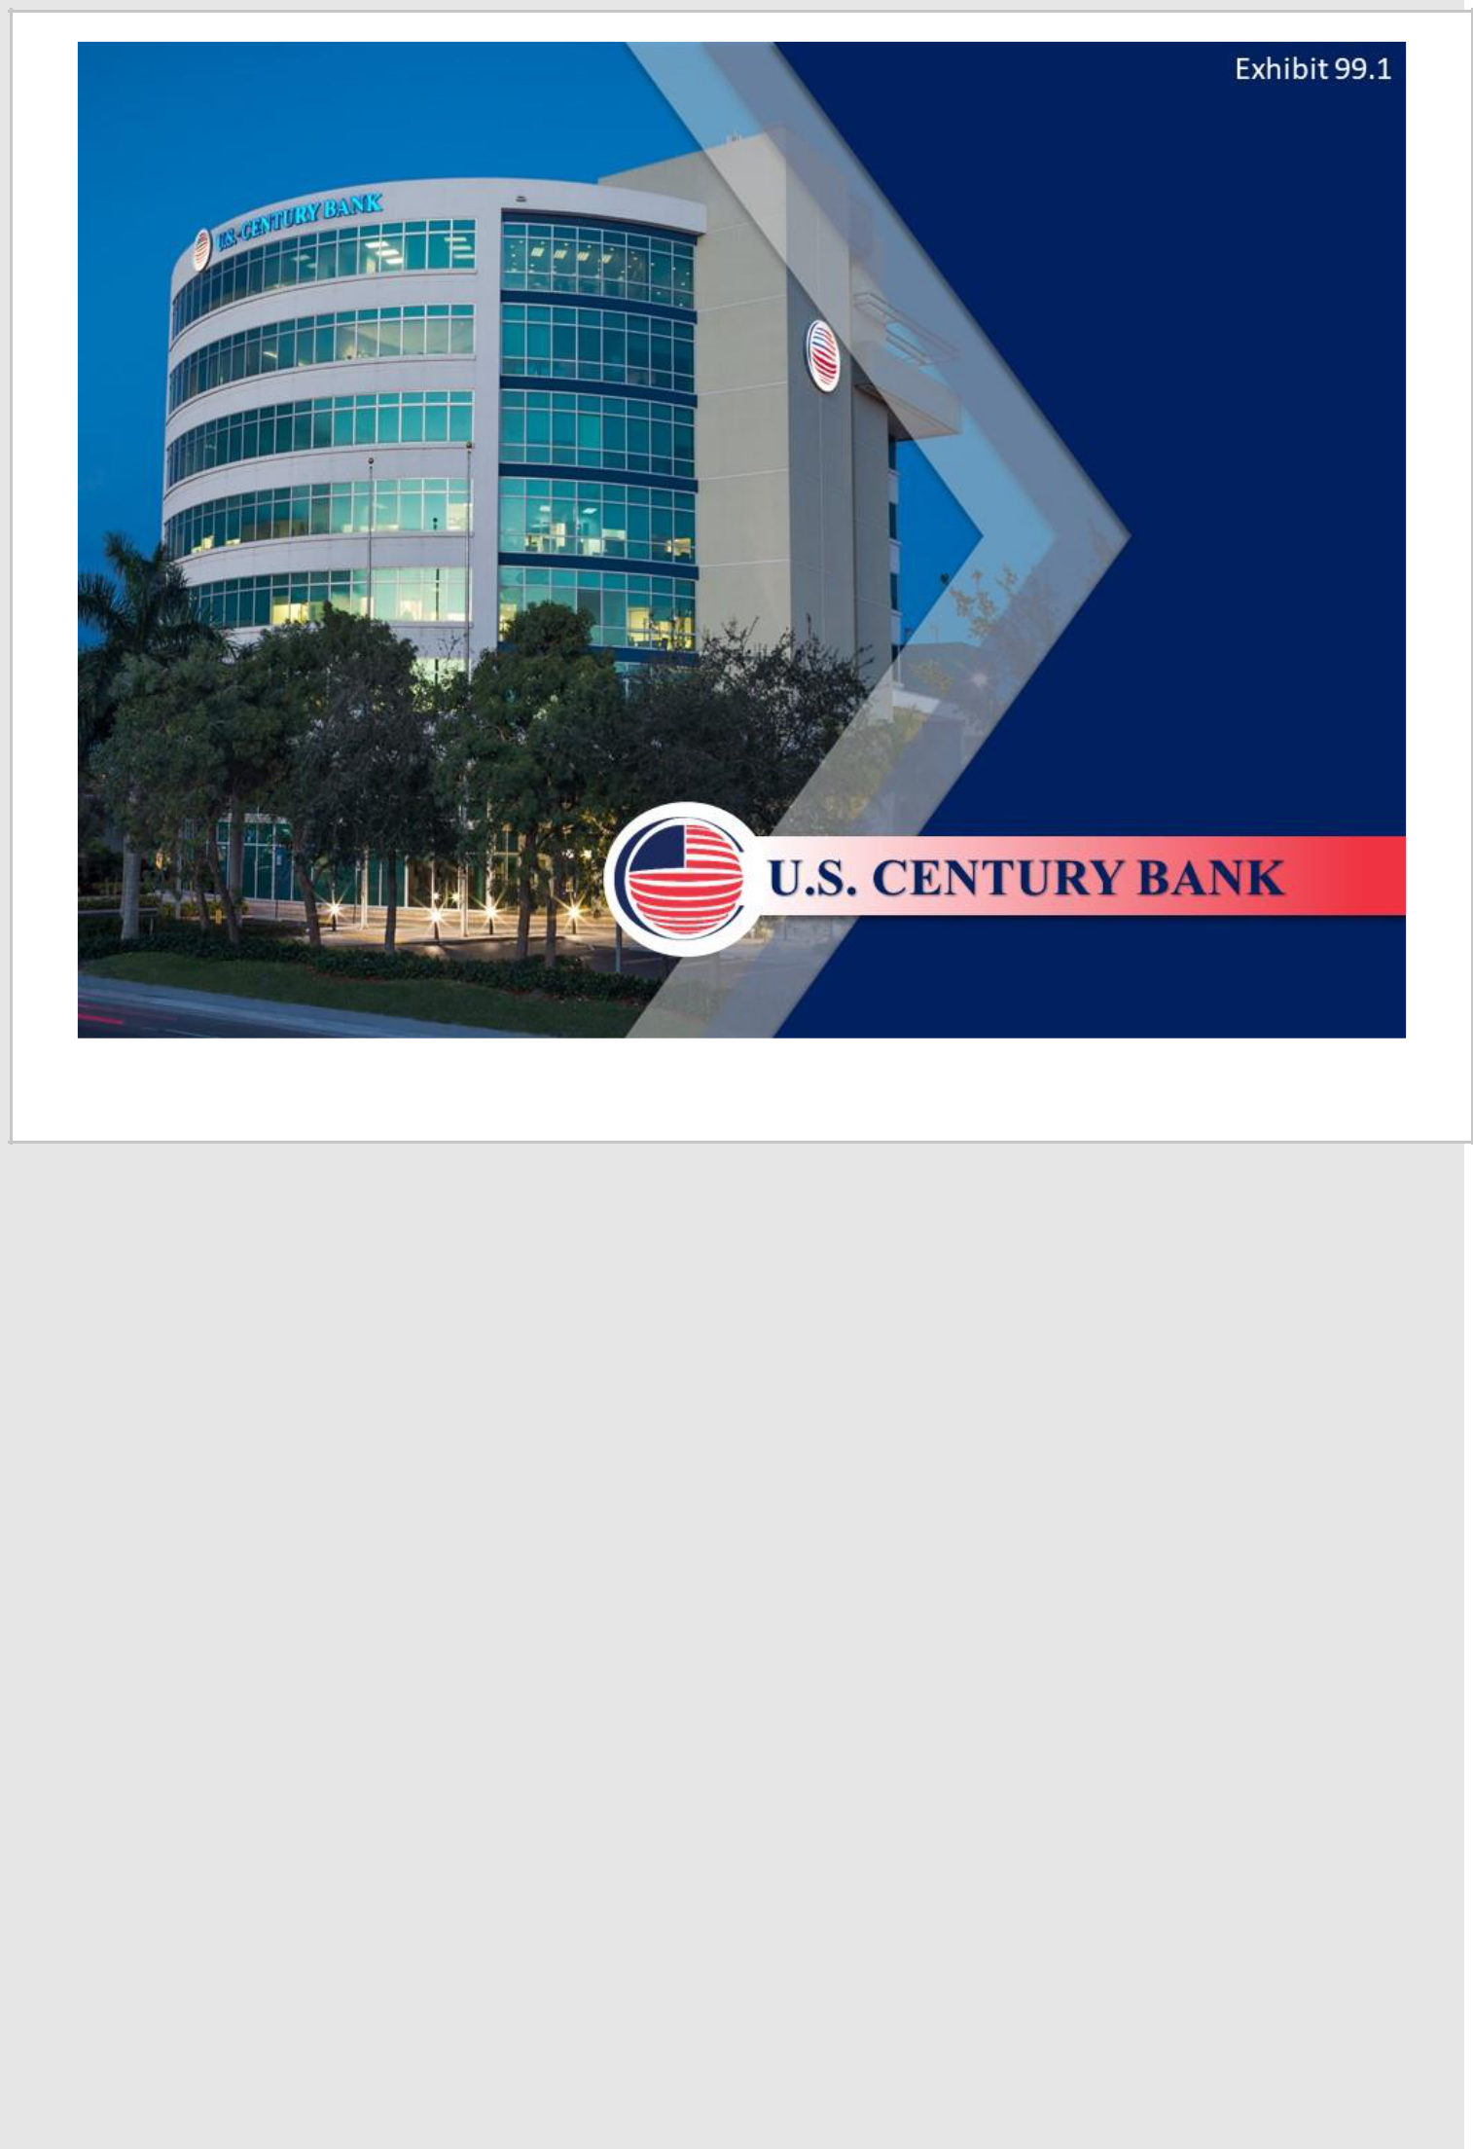

1

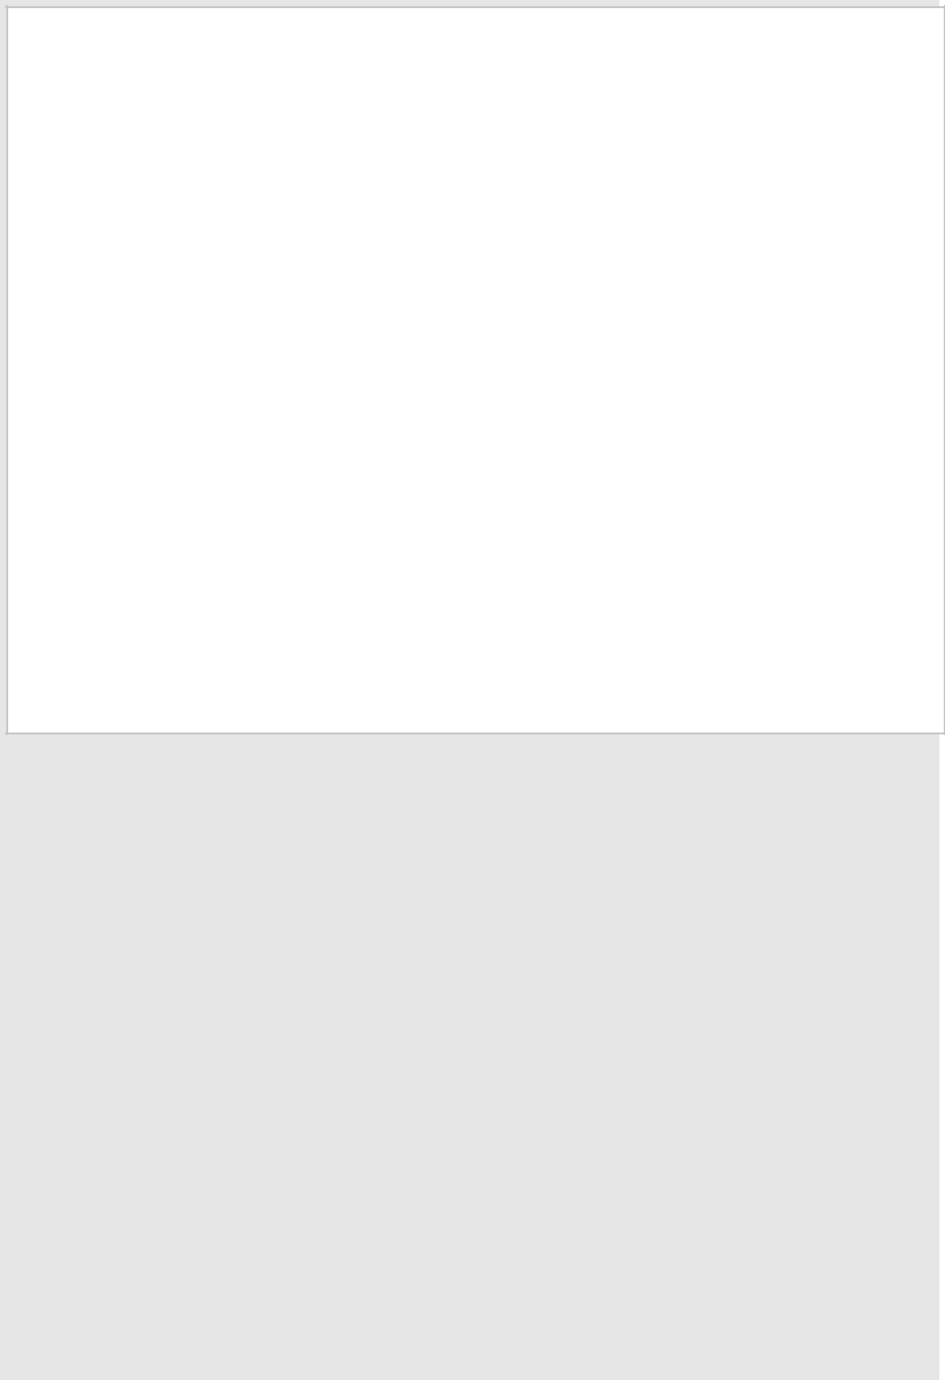

2

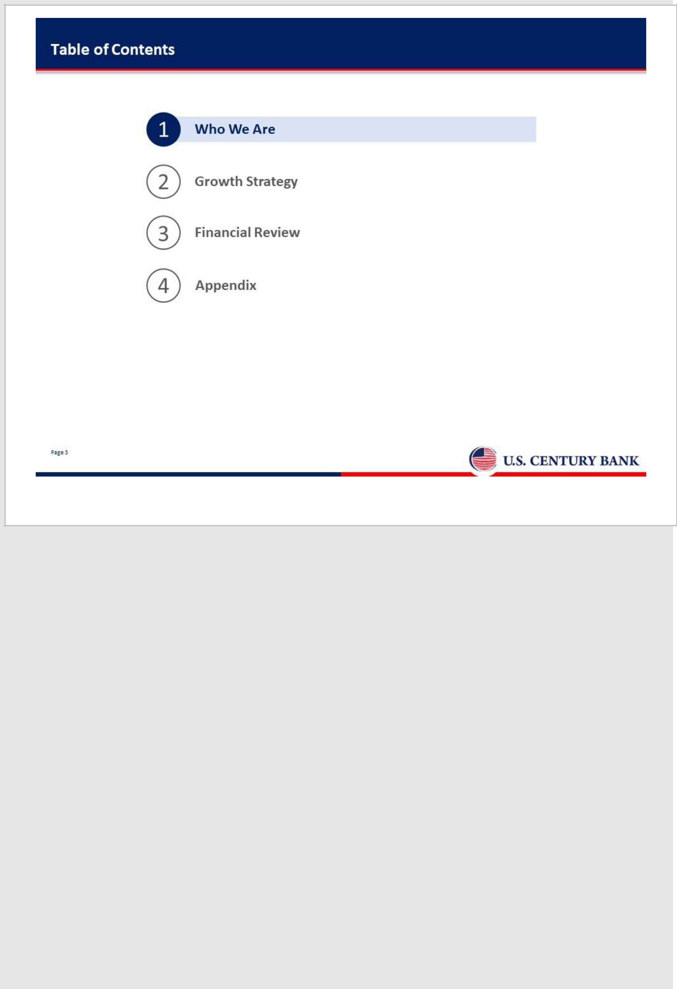

3

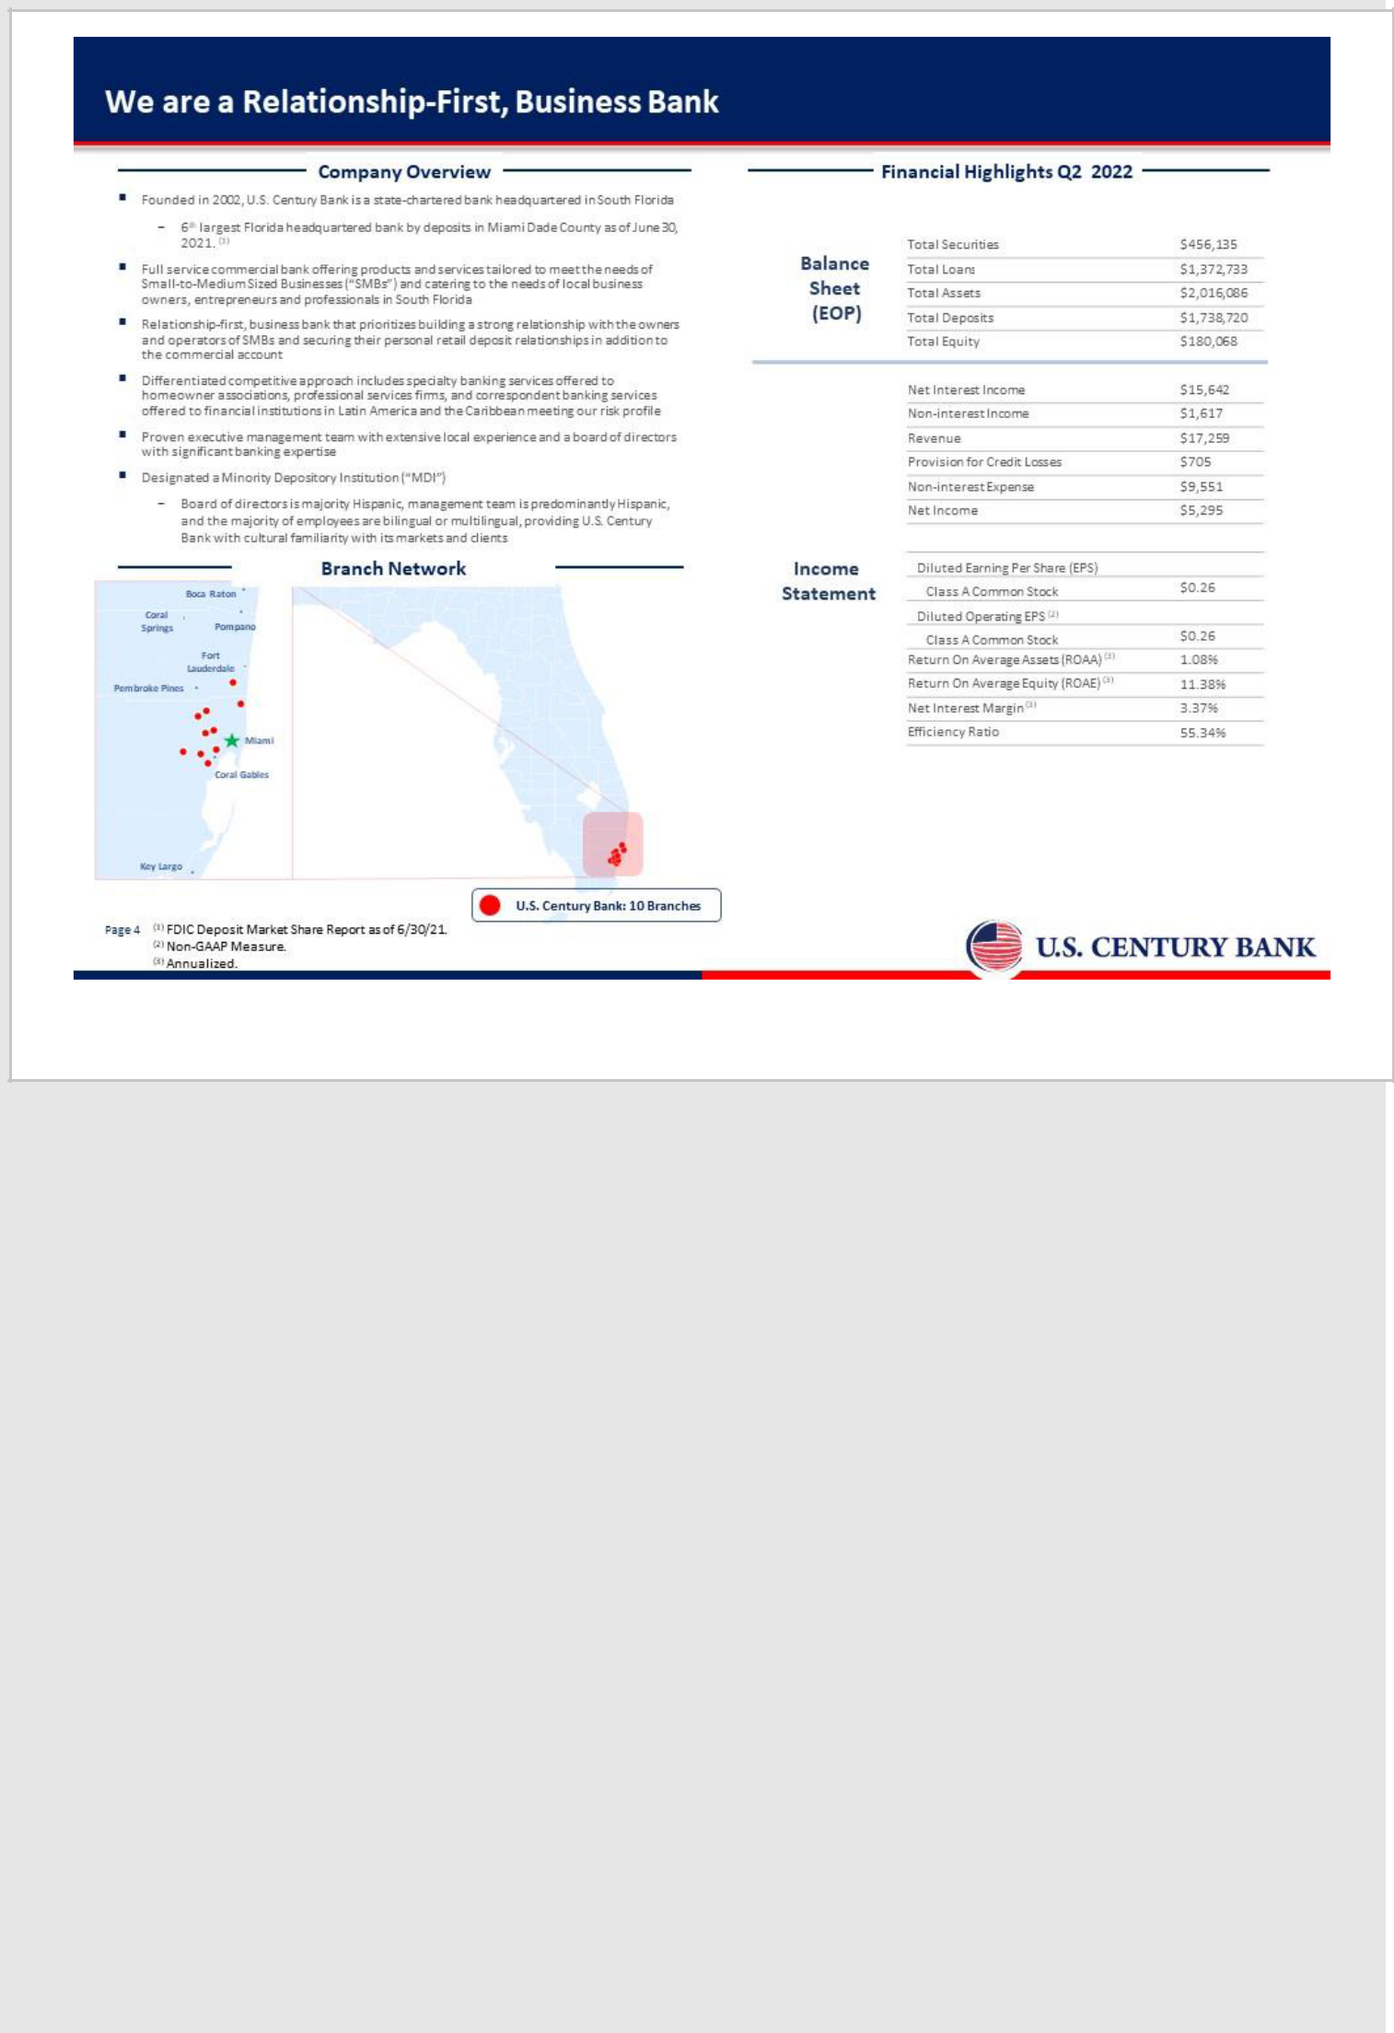

4

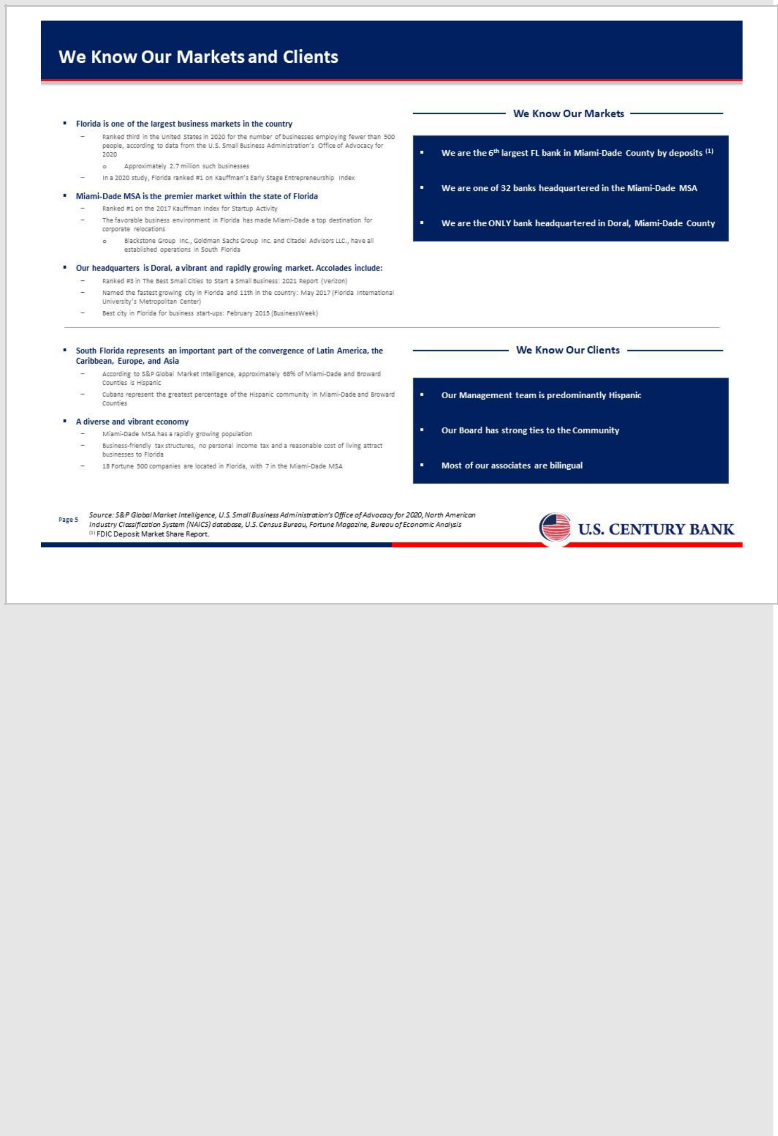

5

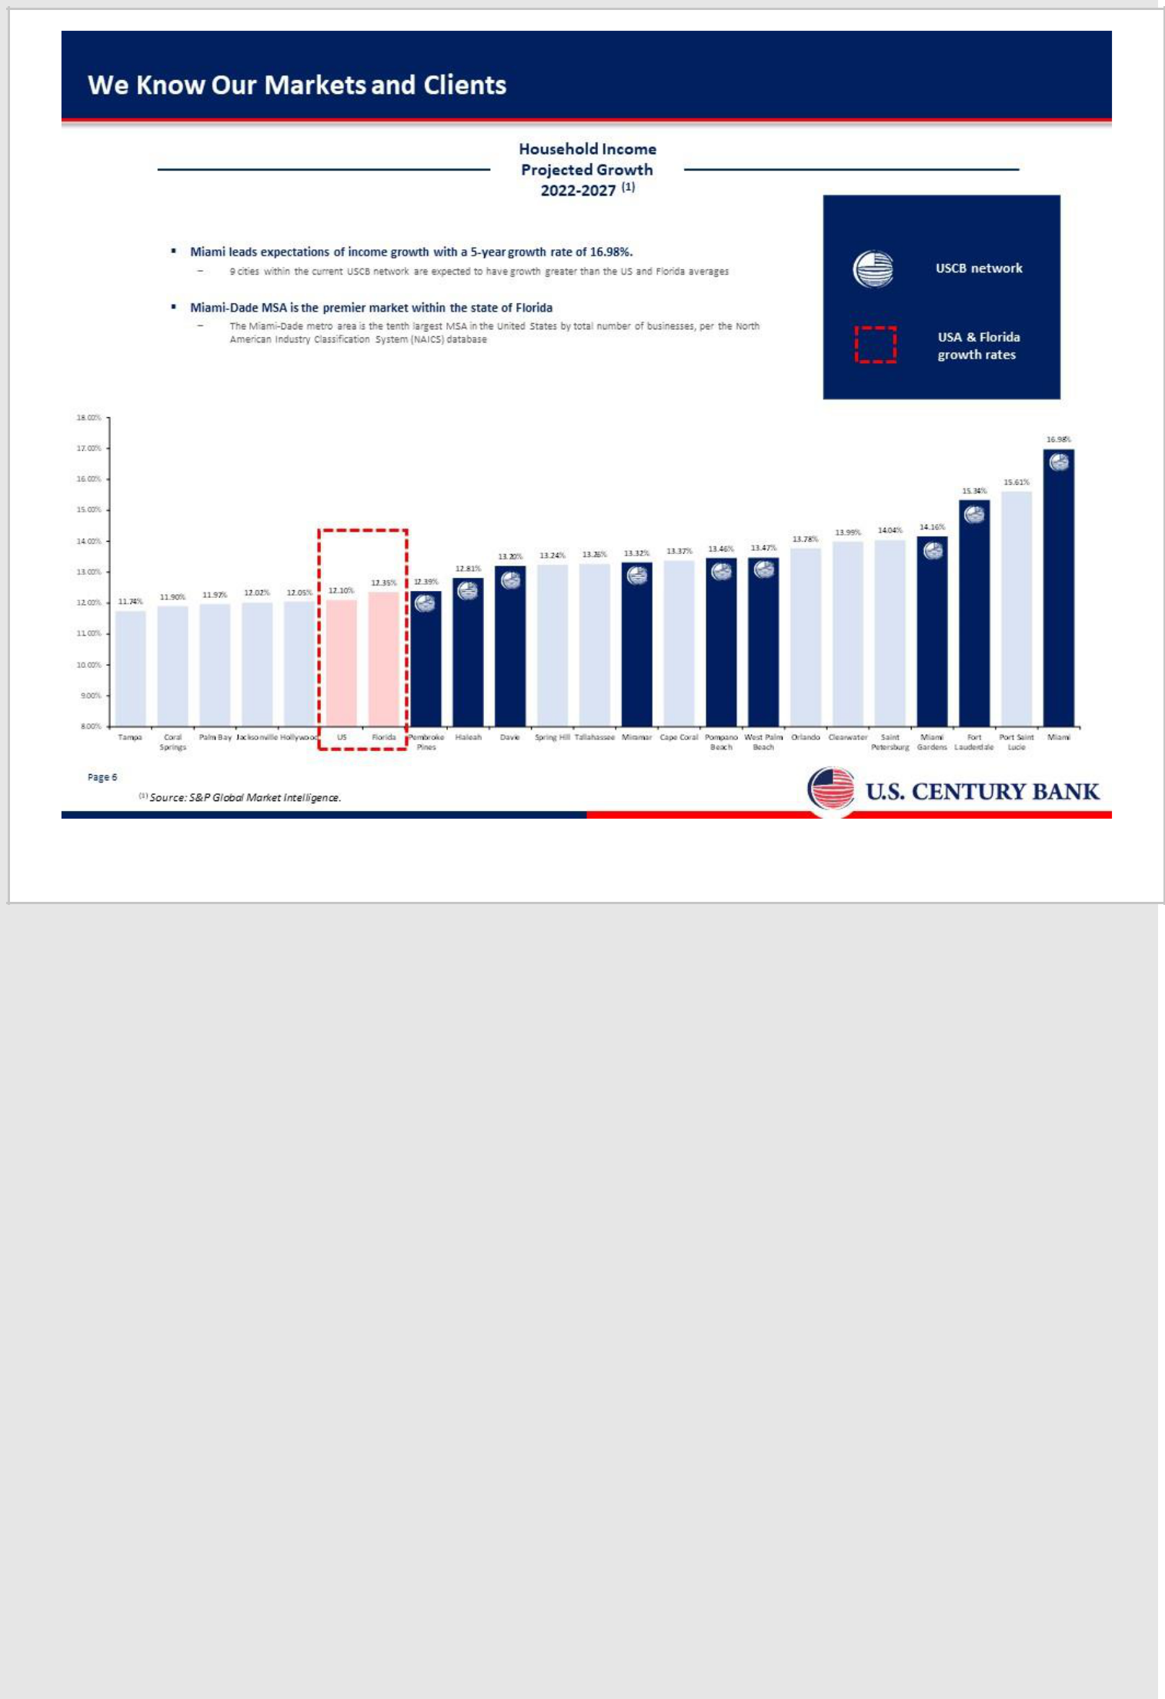

6

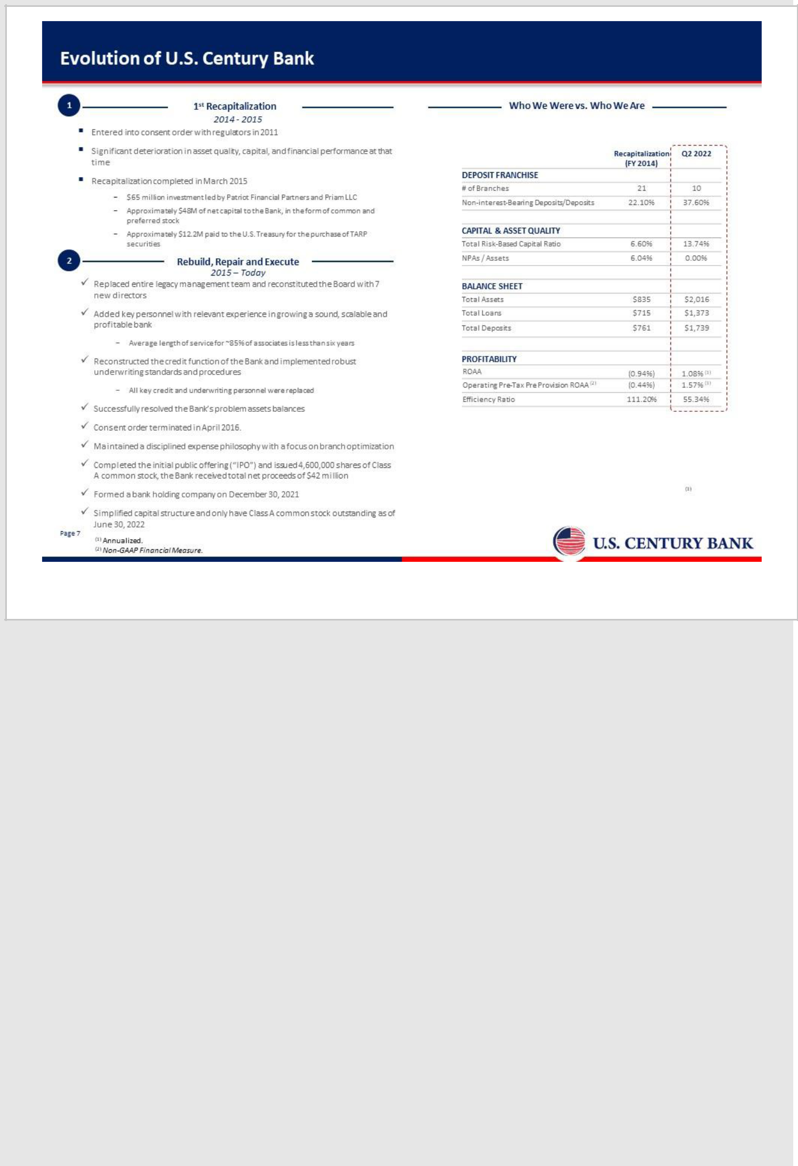

7

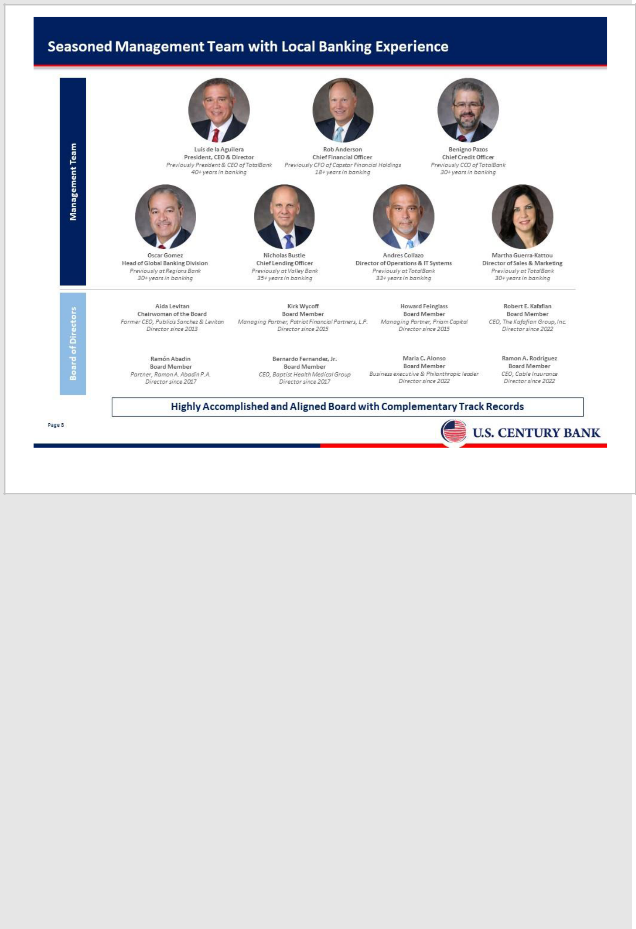

8

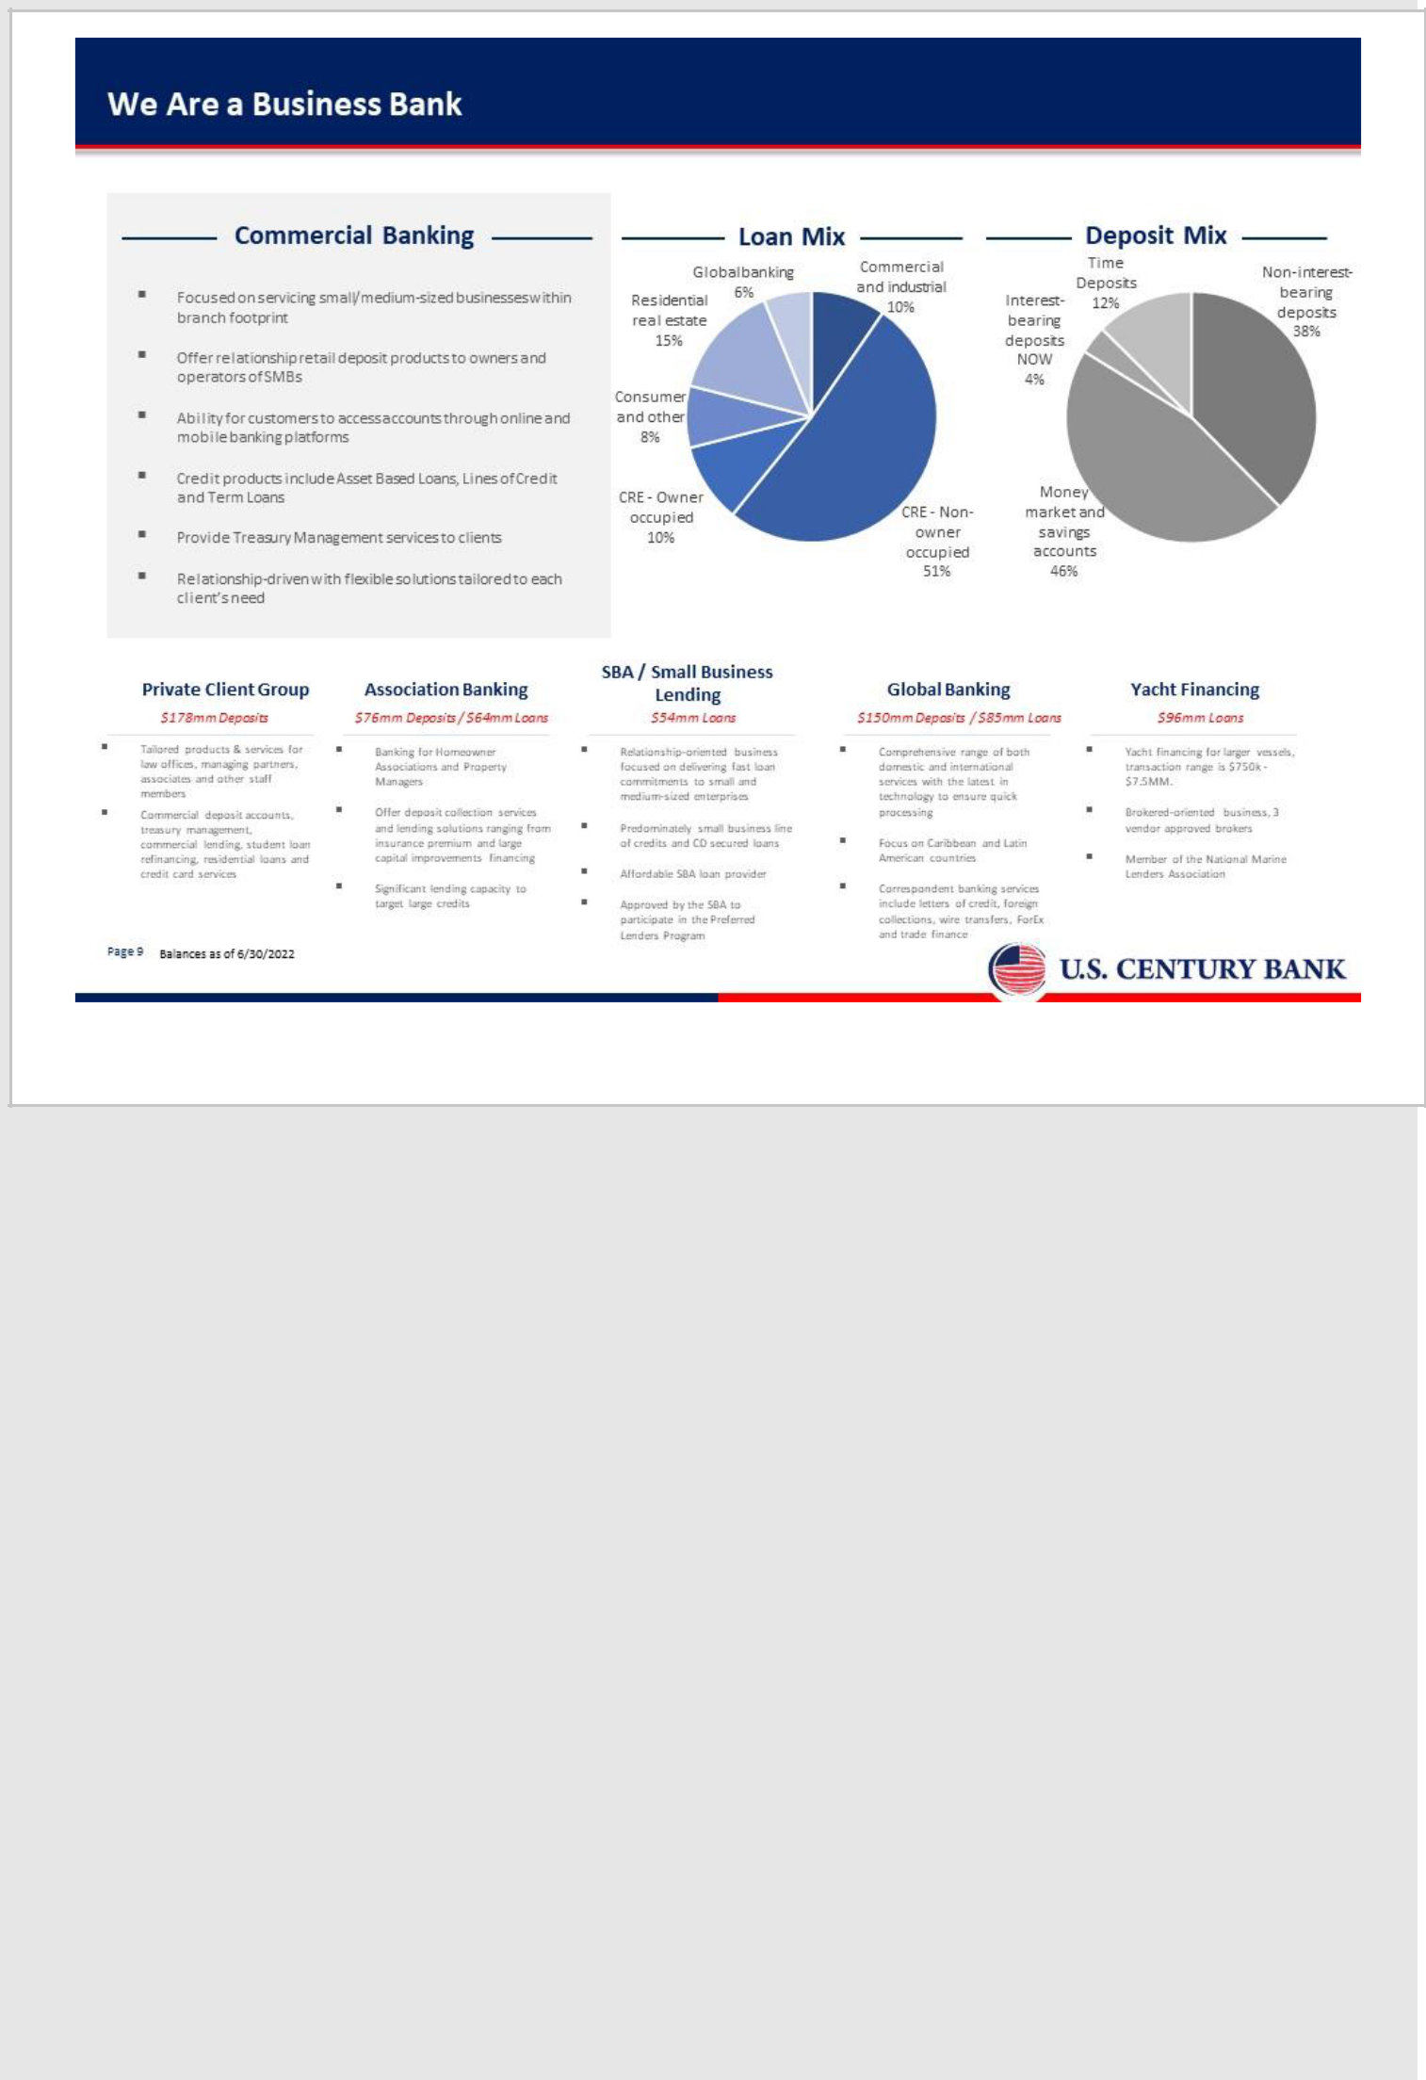

9

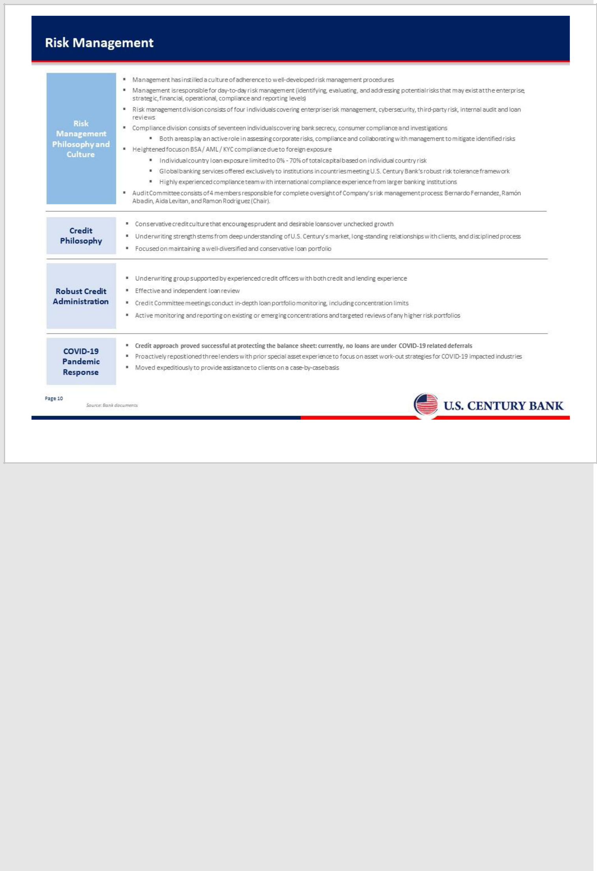

10

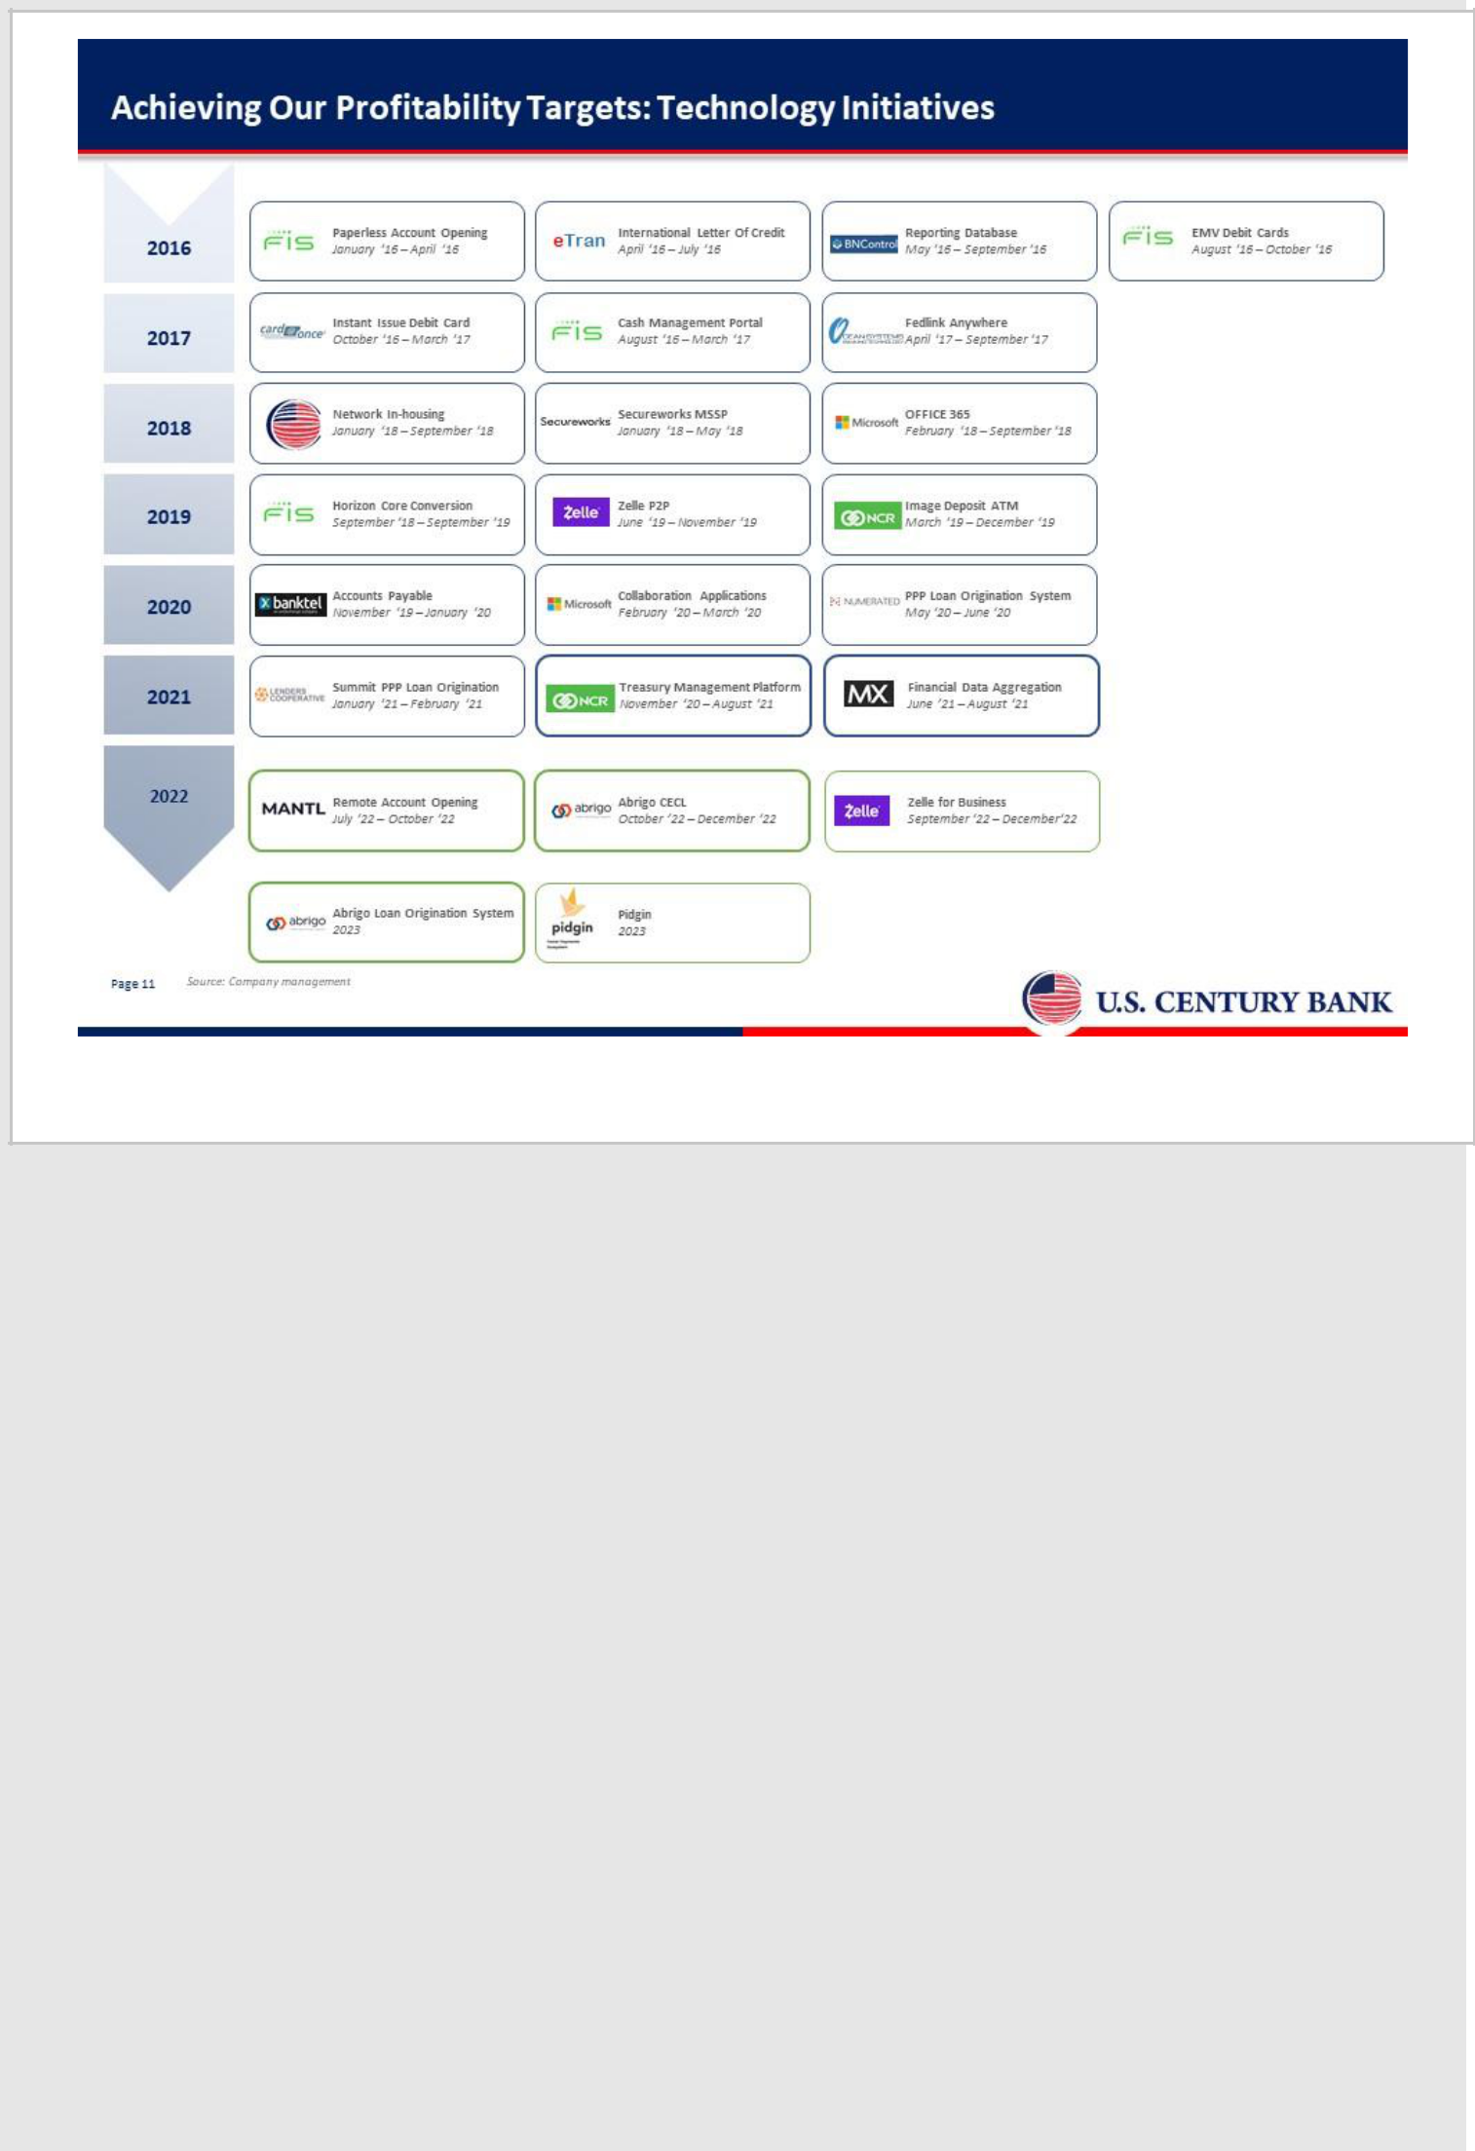

11

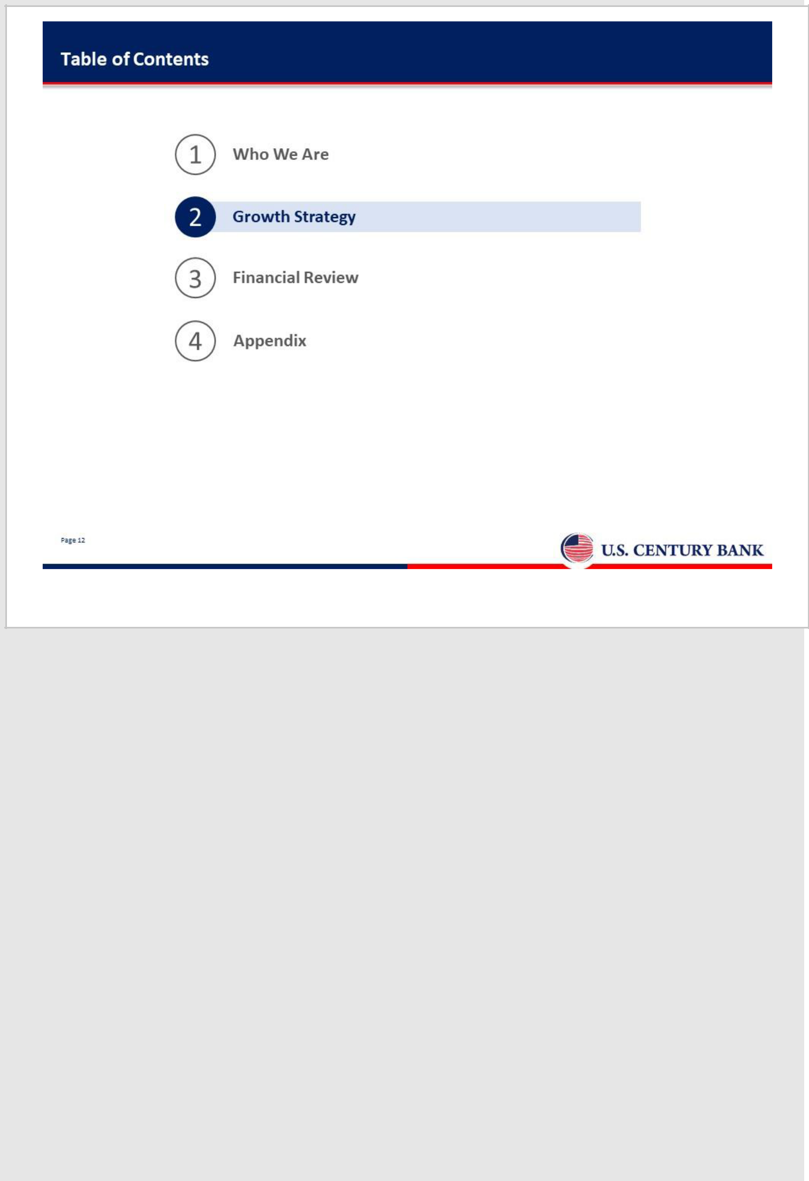

12

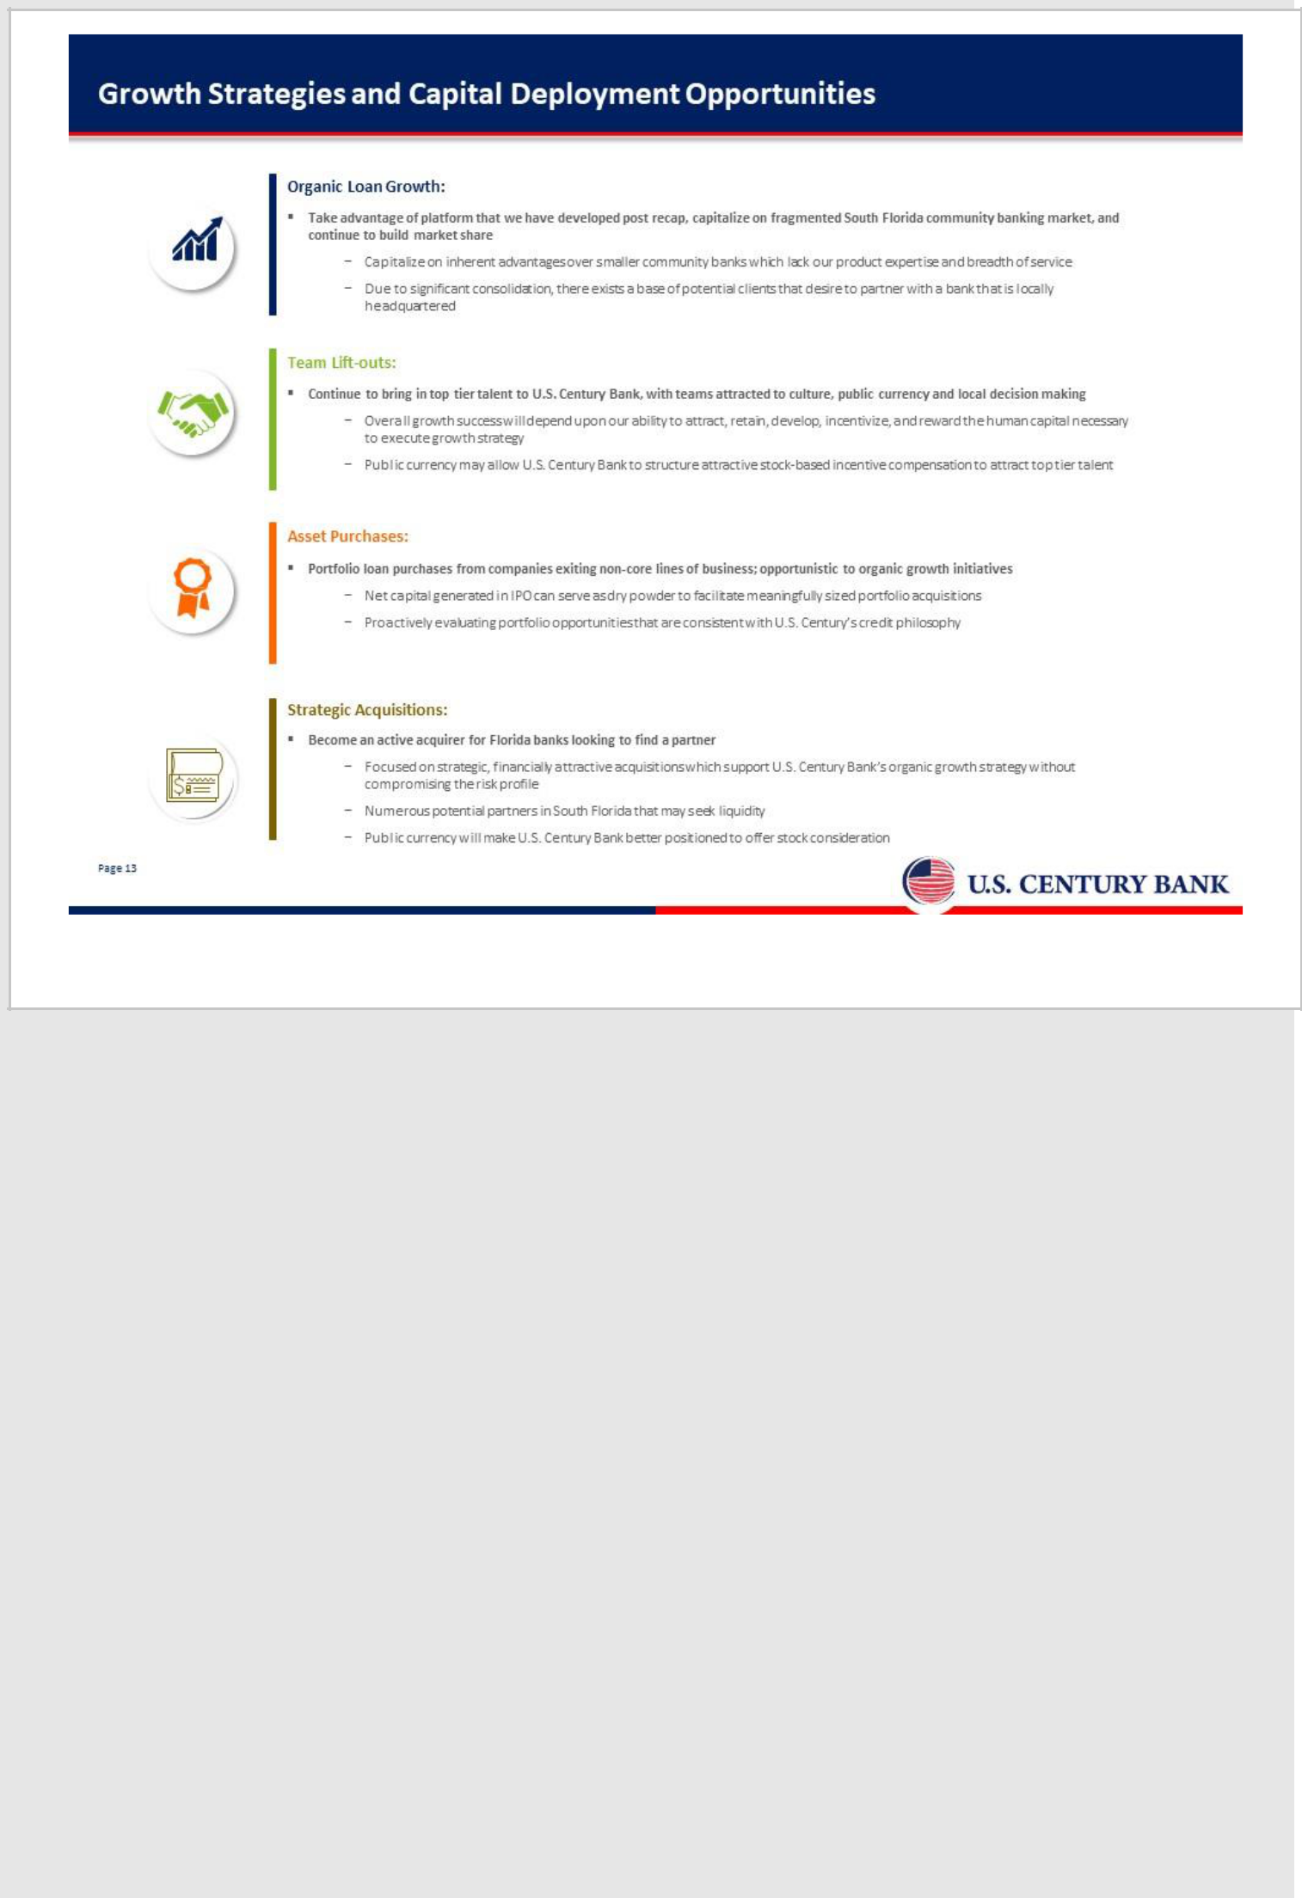

13

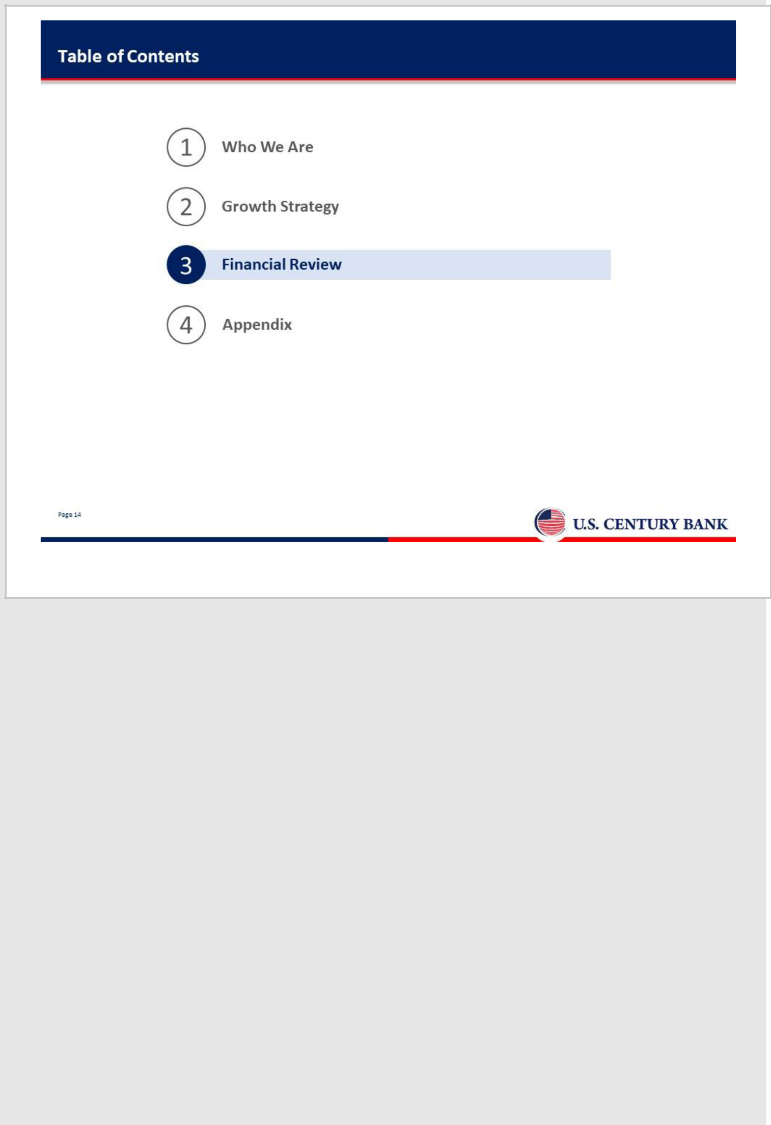

14

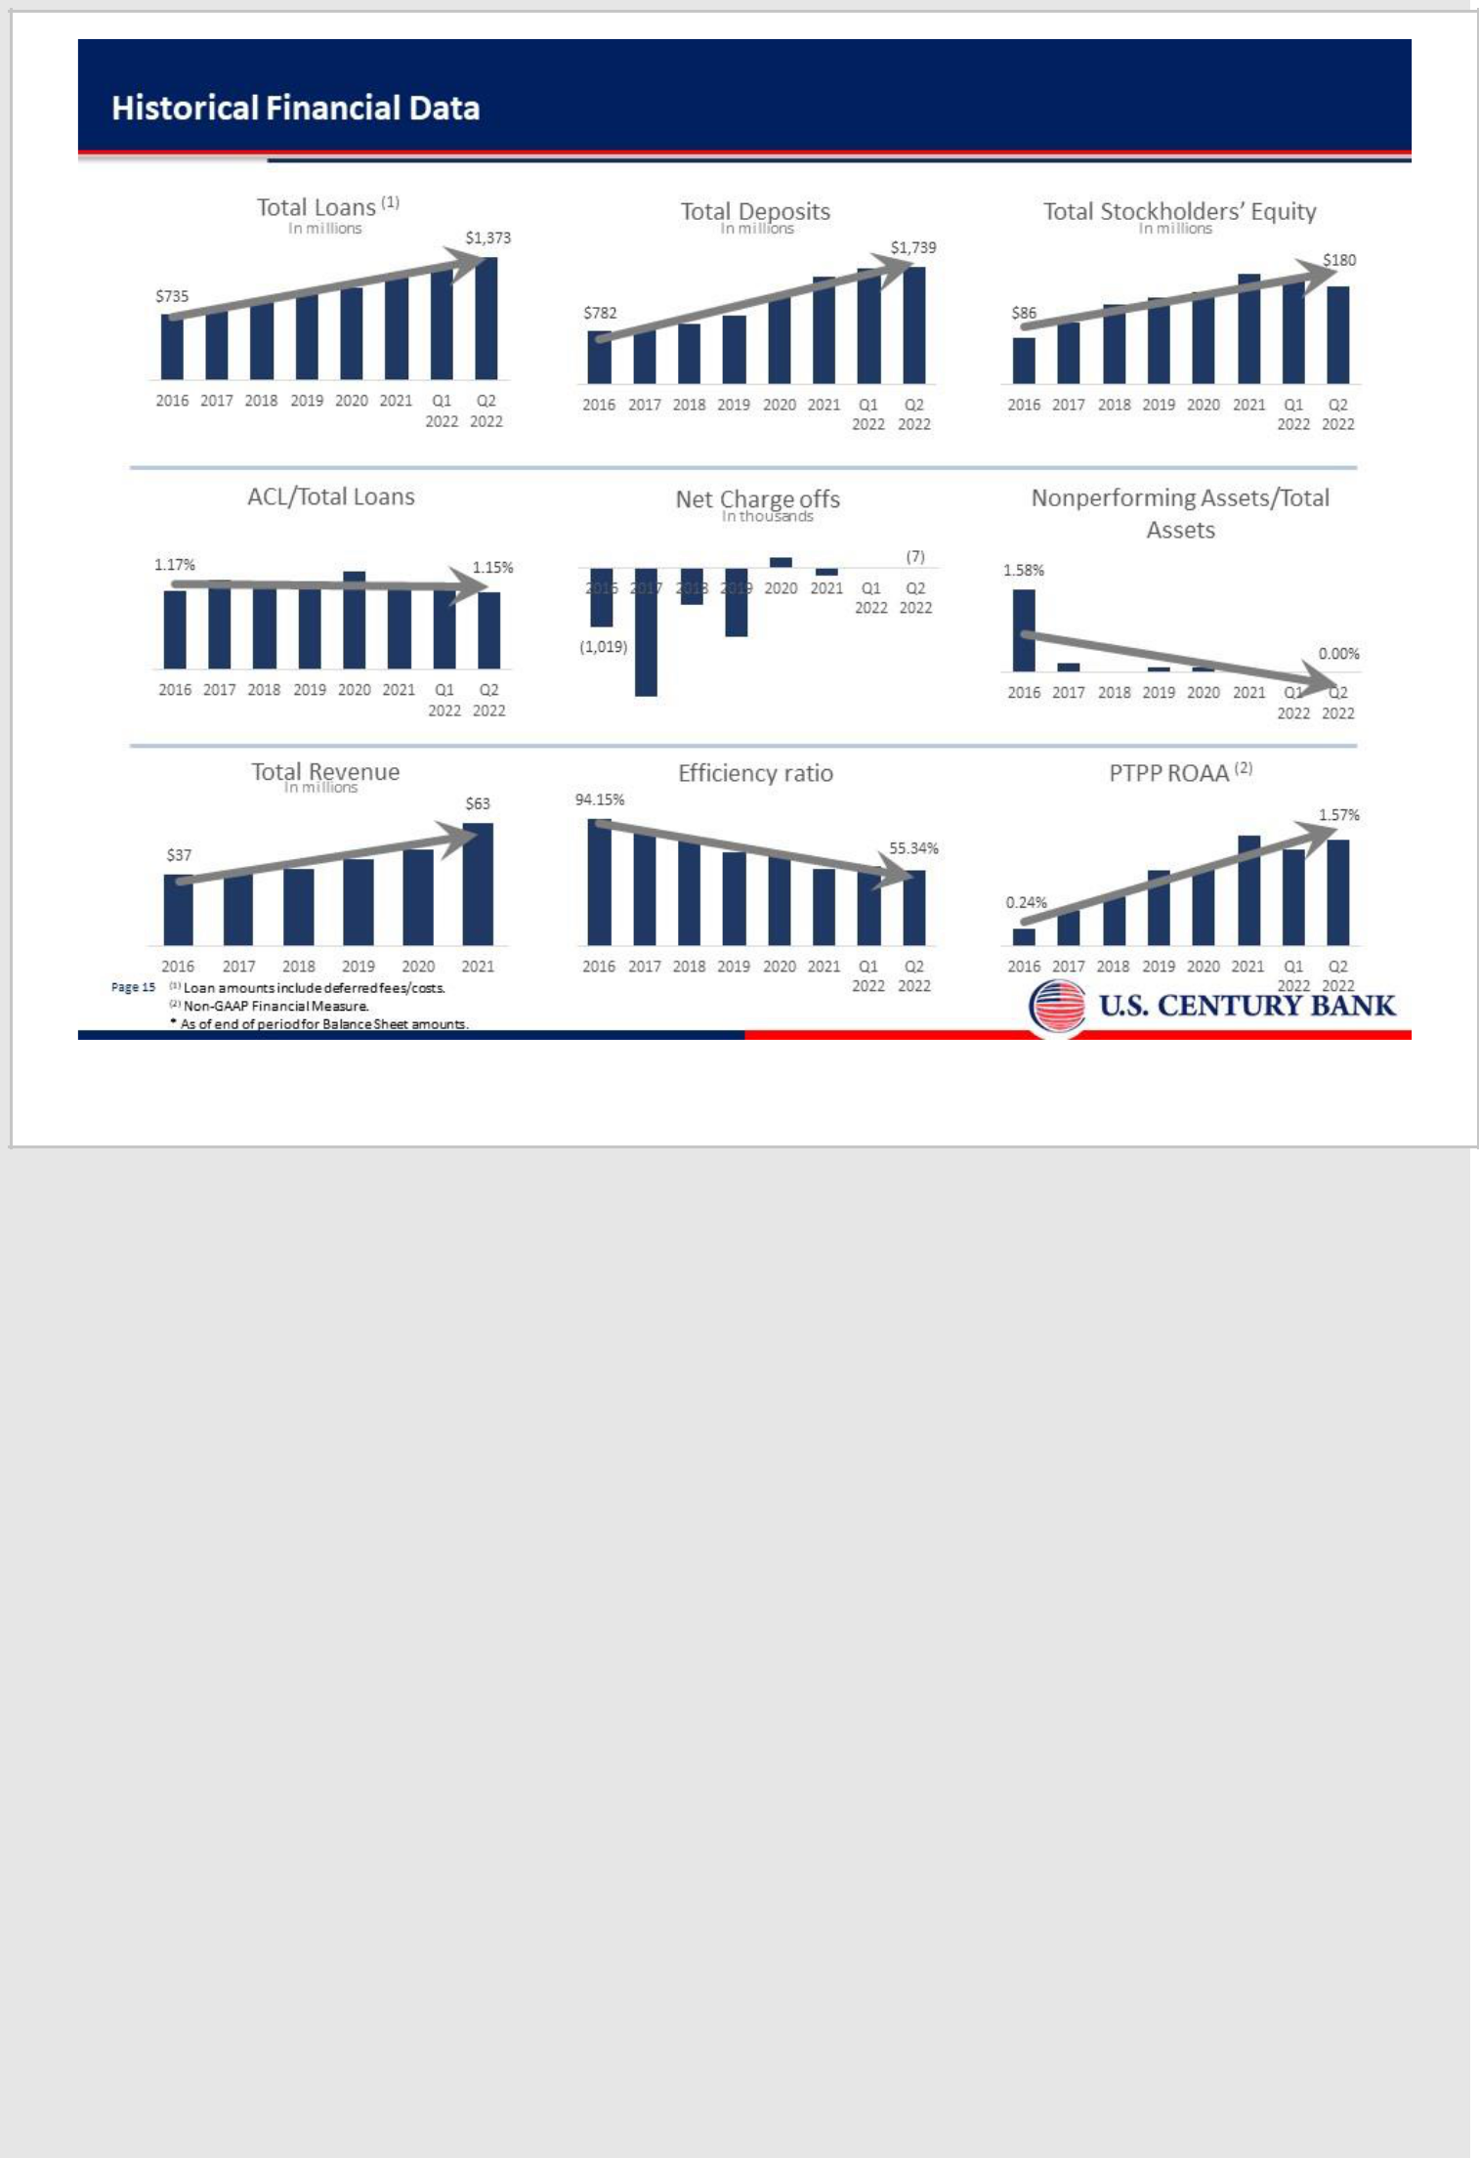

15

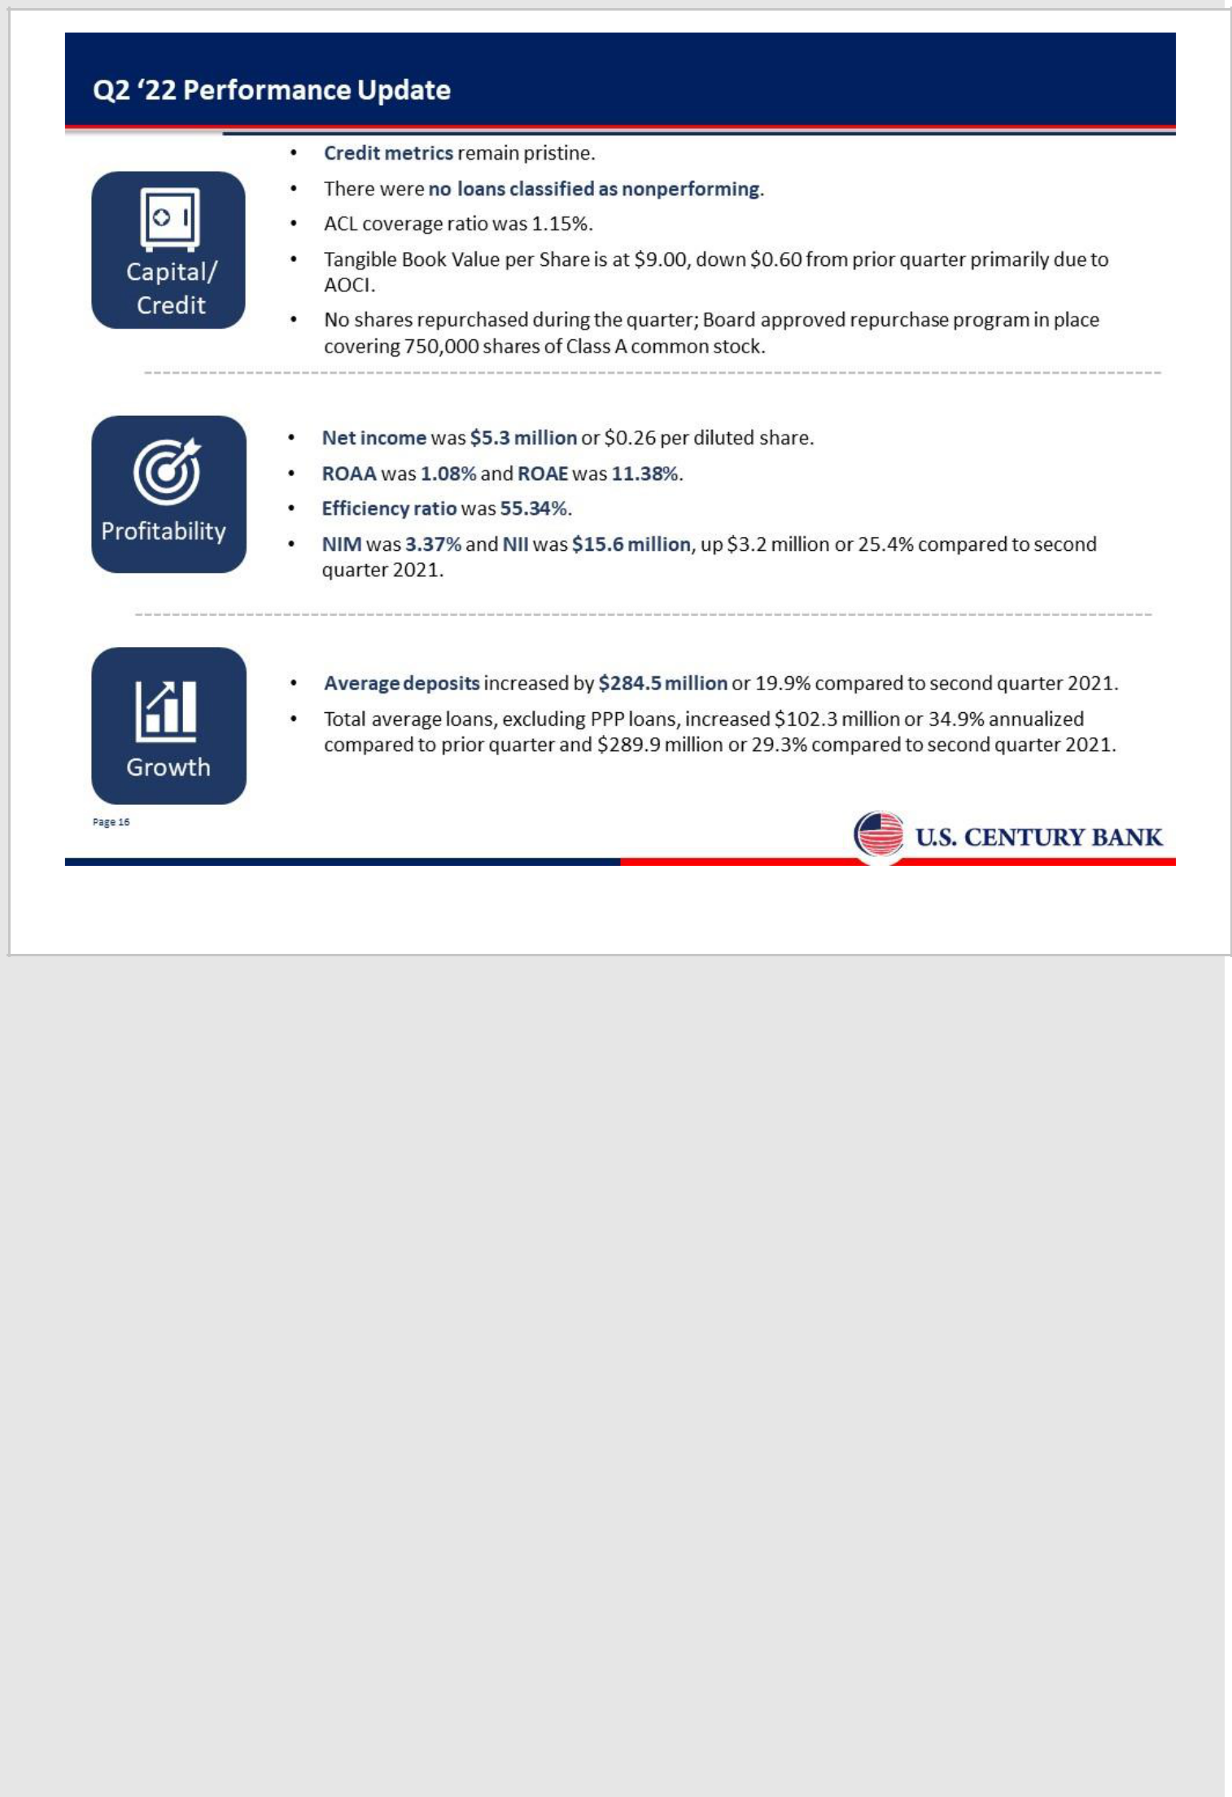

16

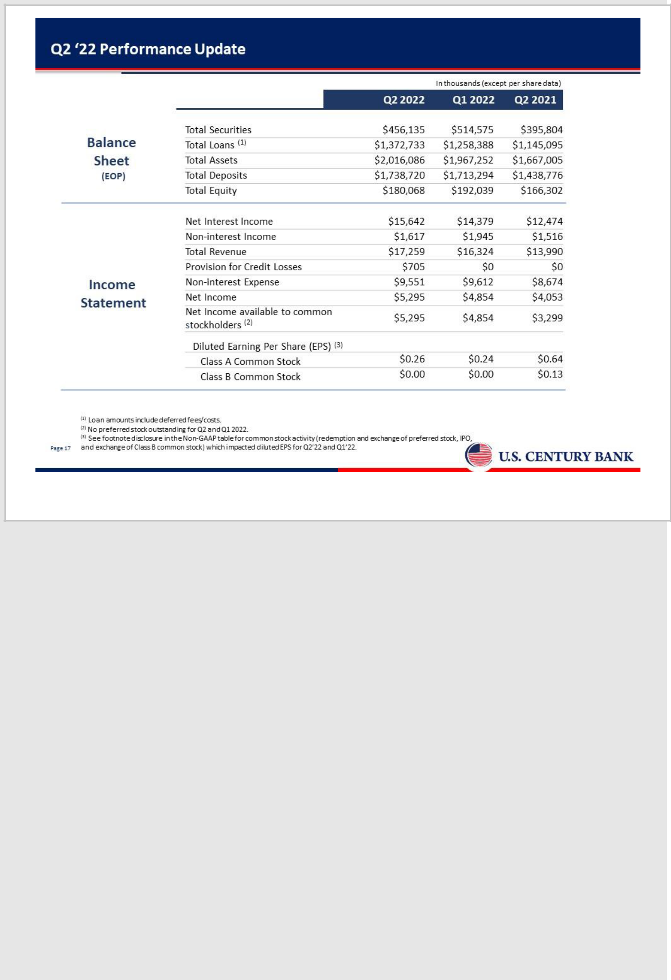

17

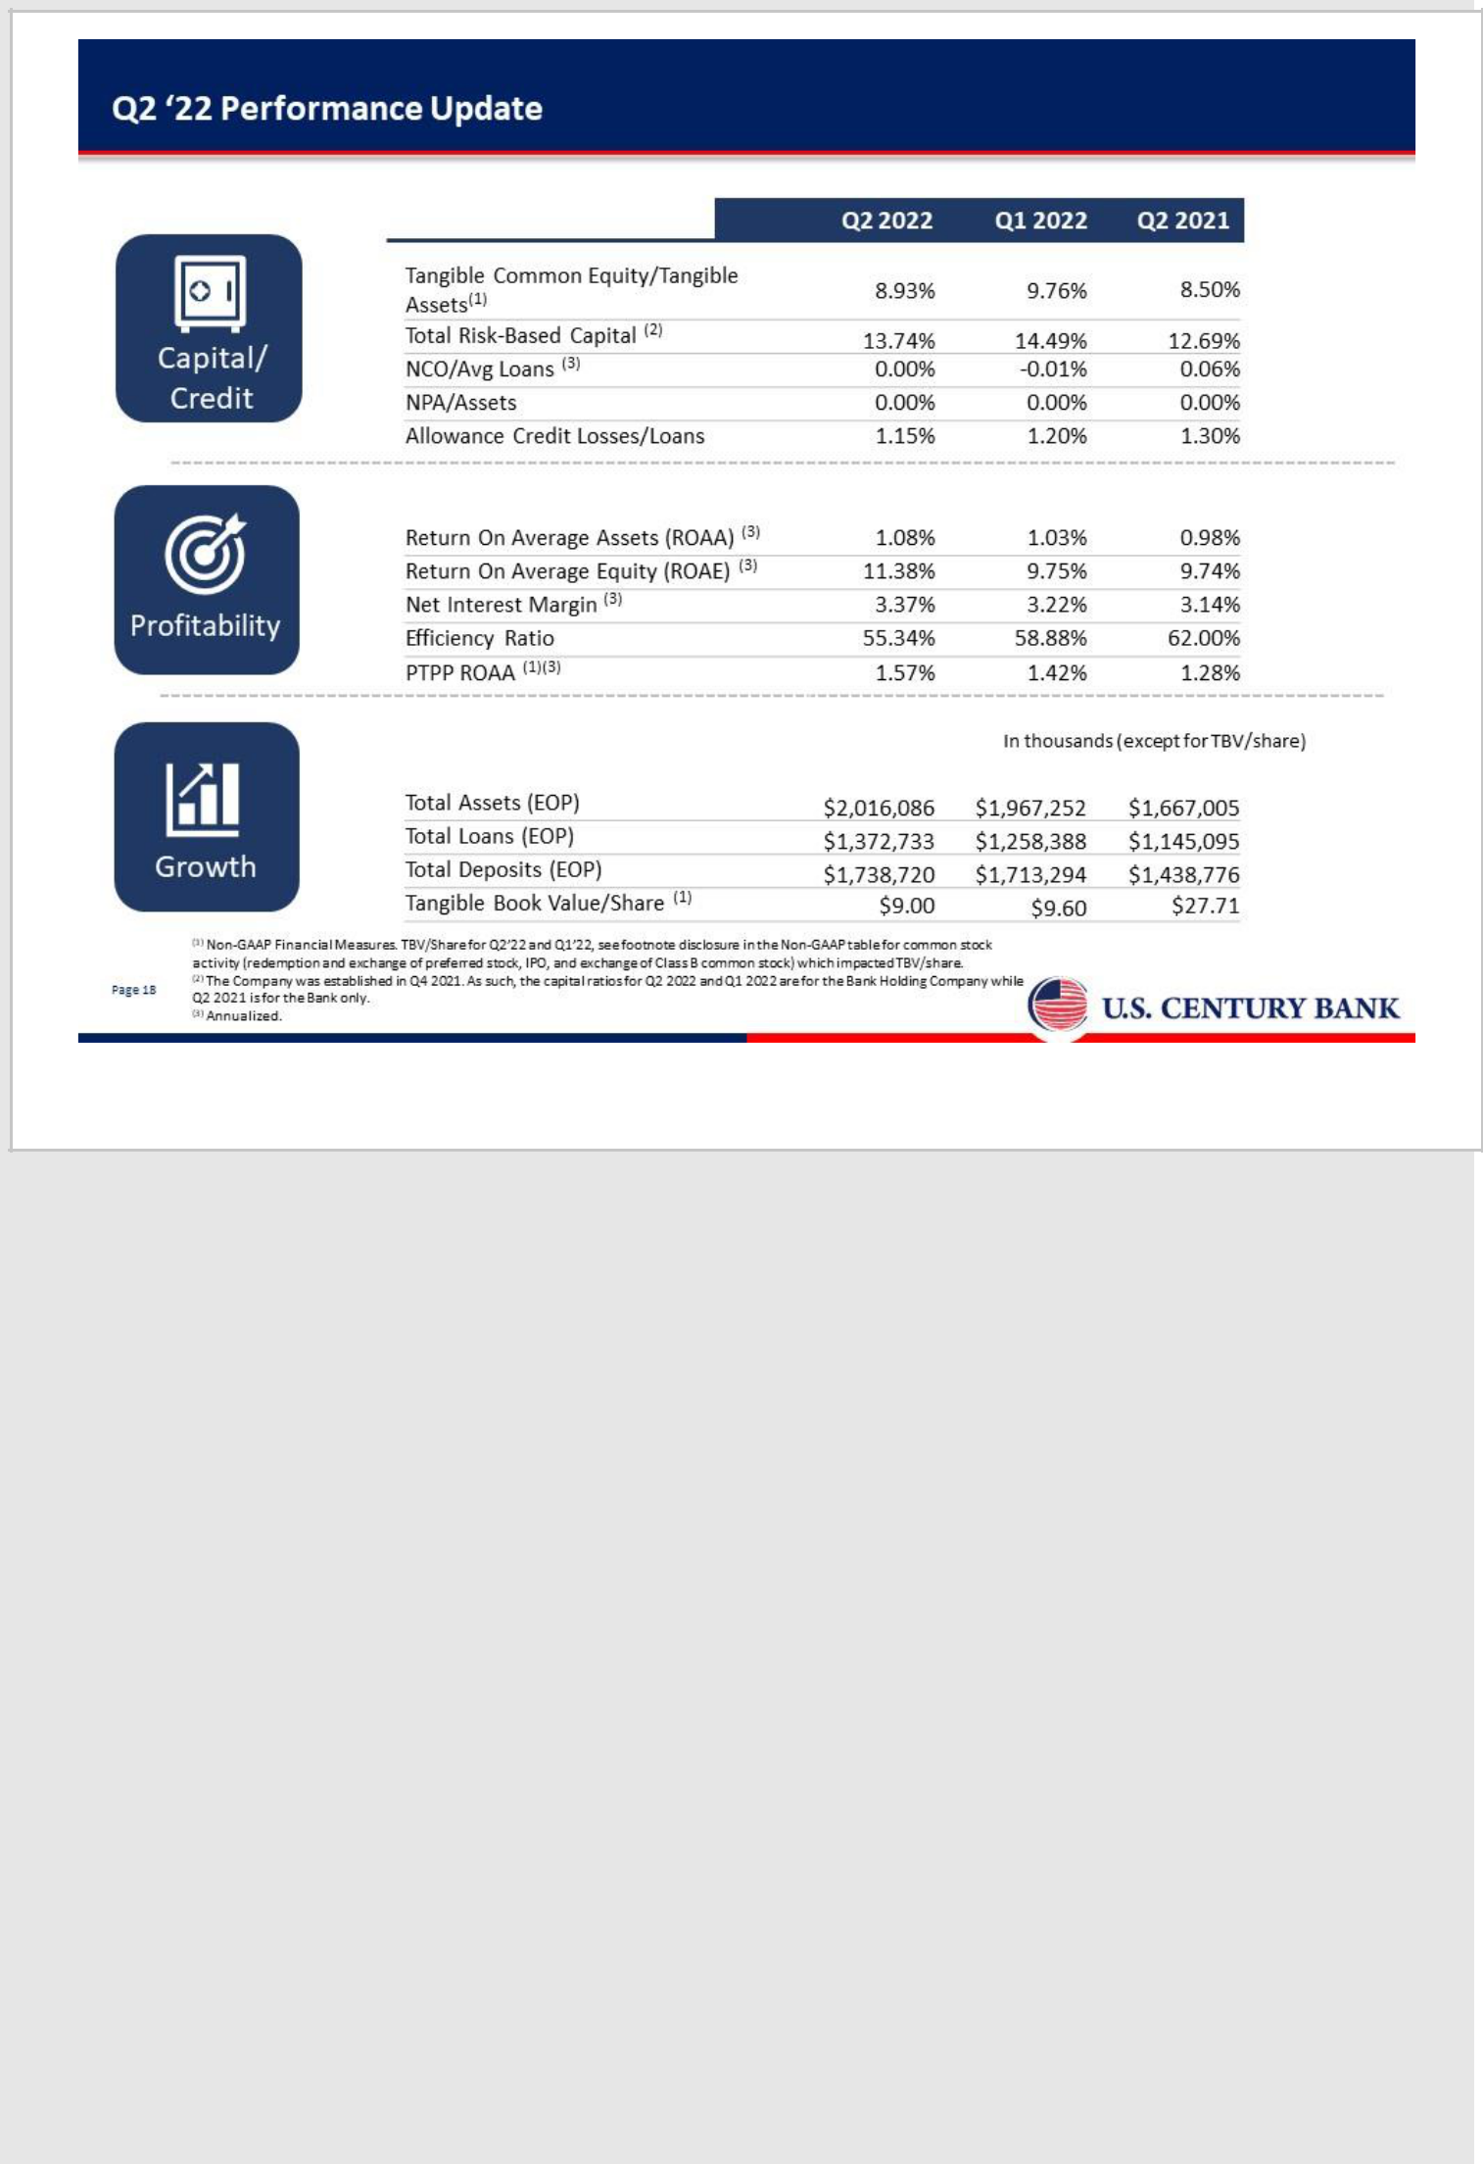

18

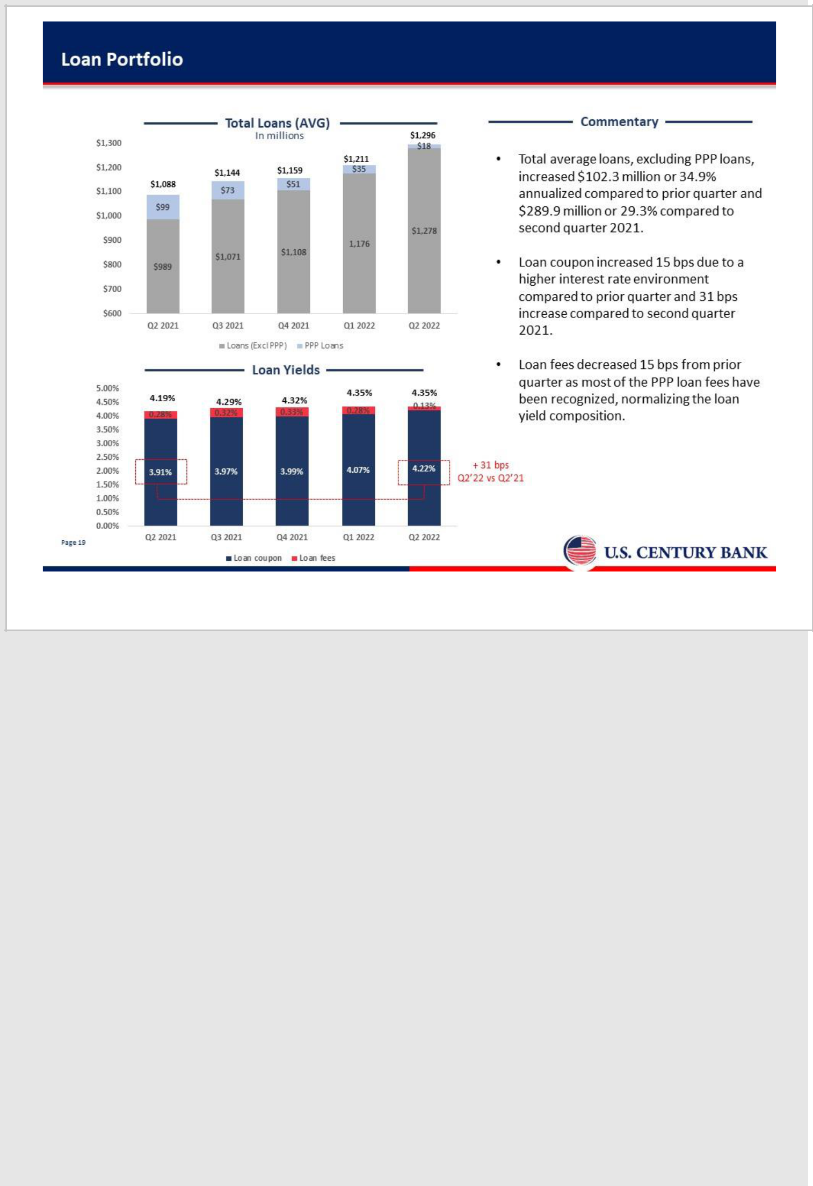

19

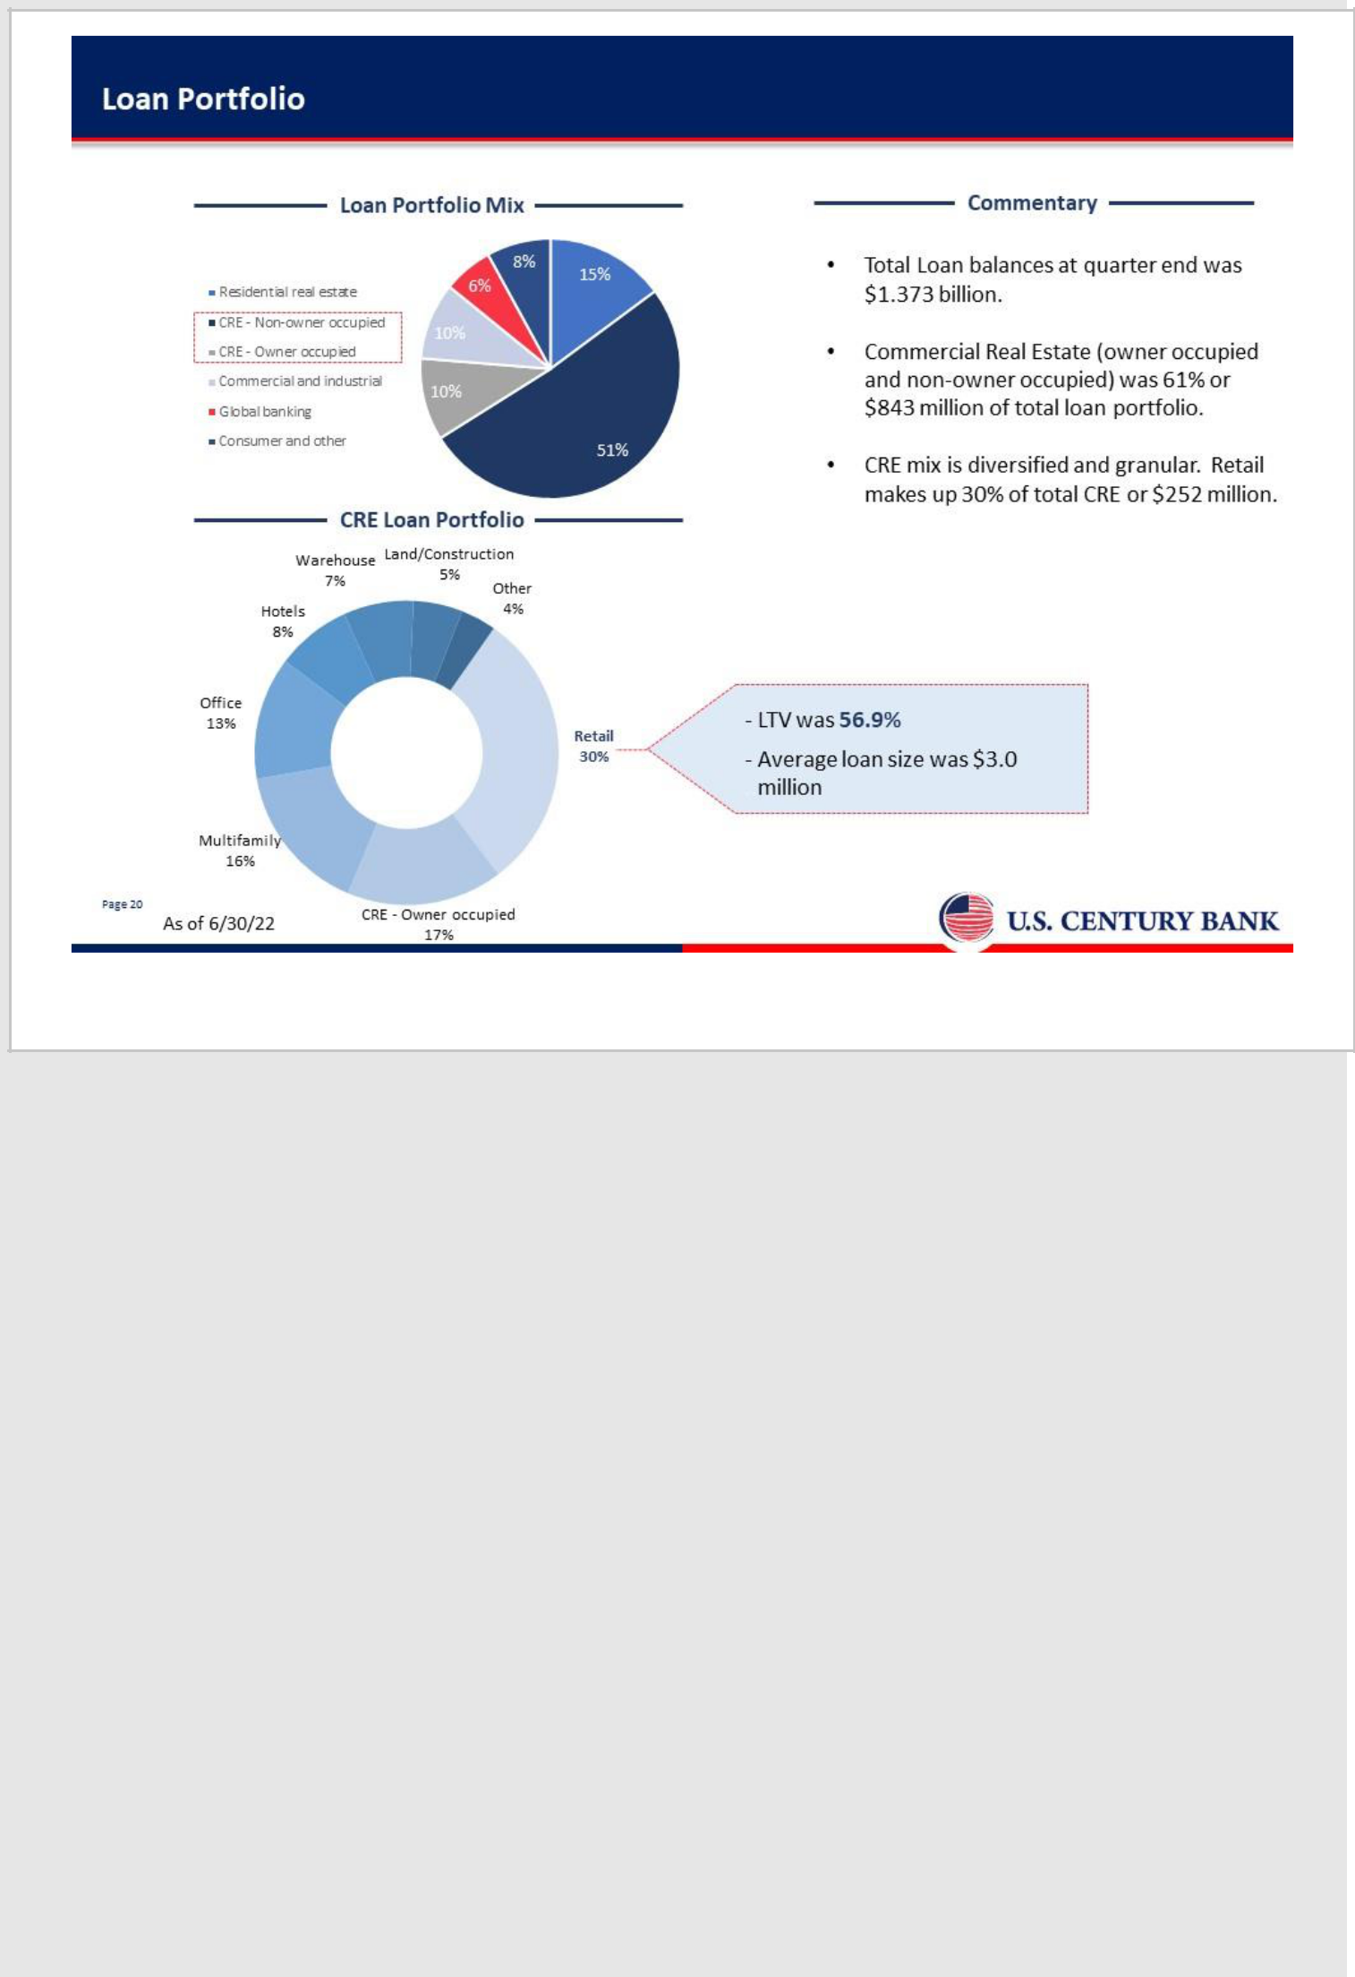

20

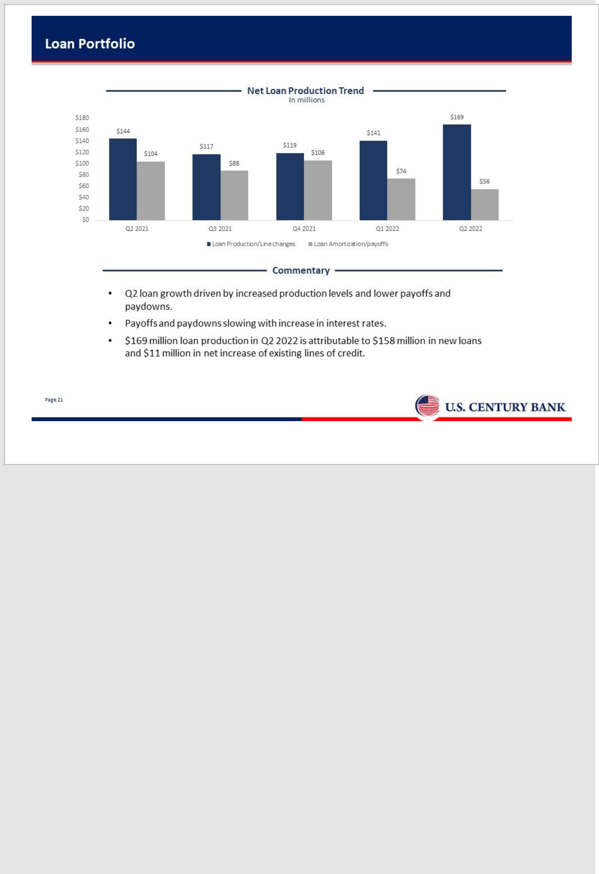

21

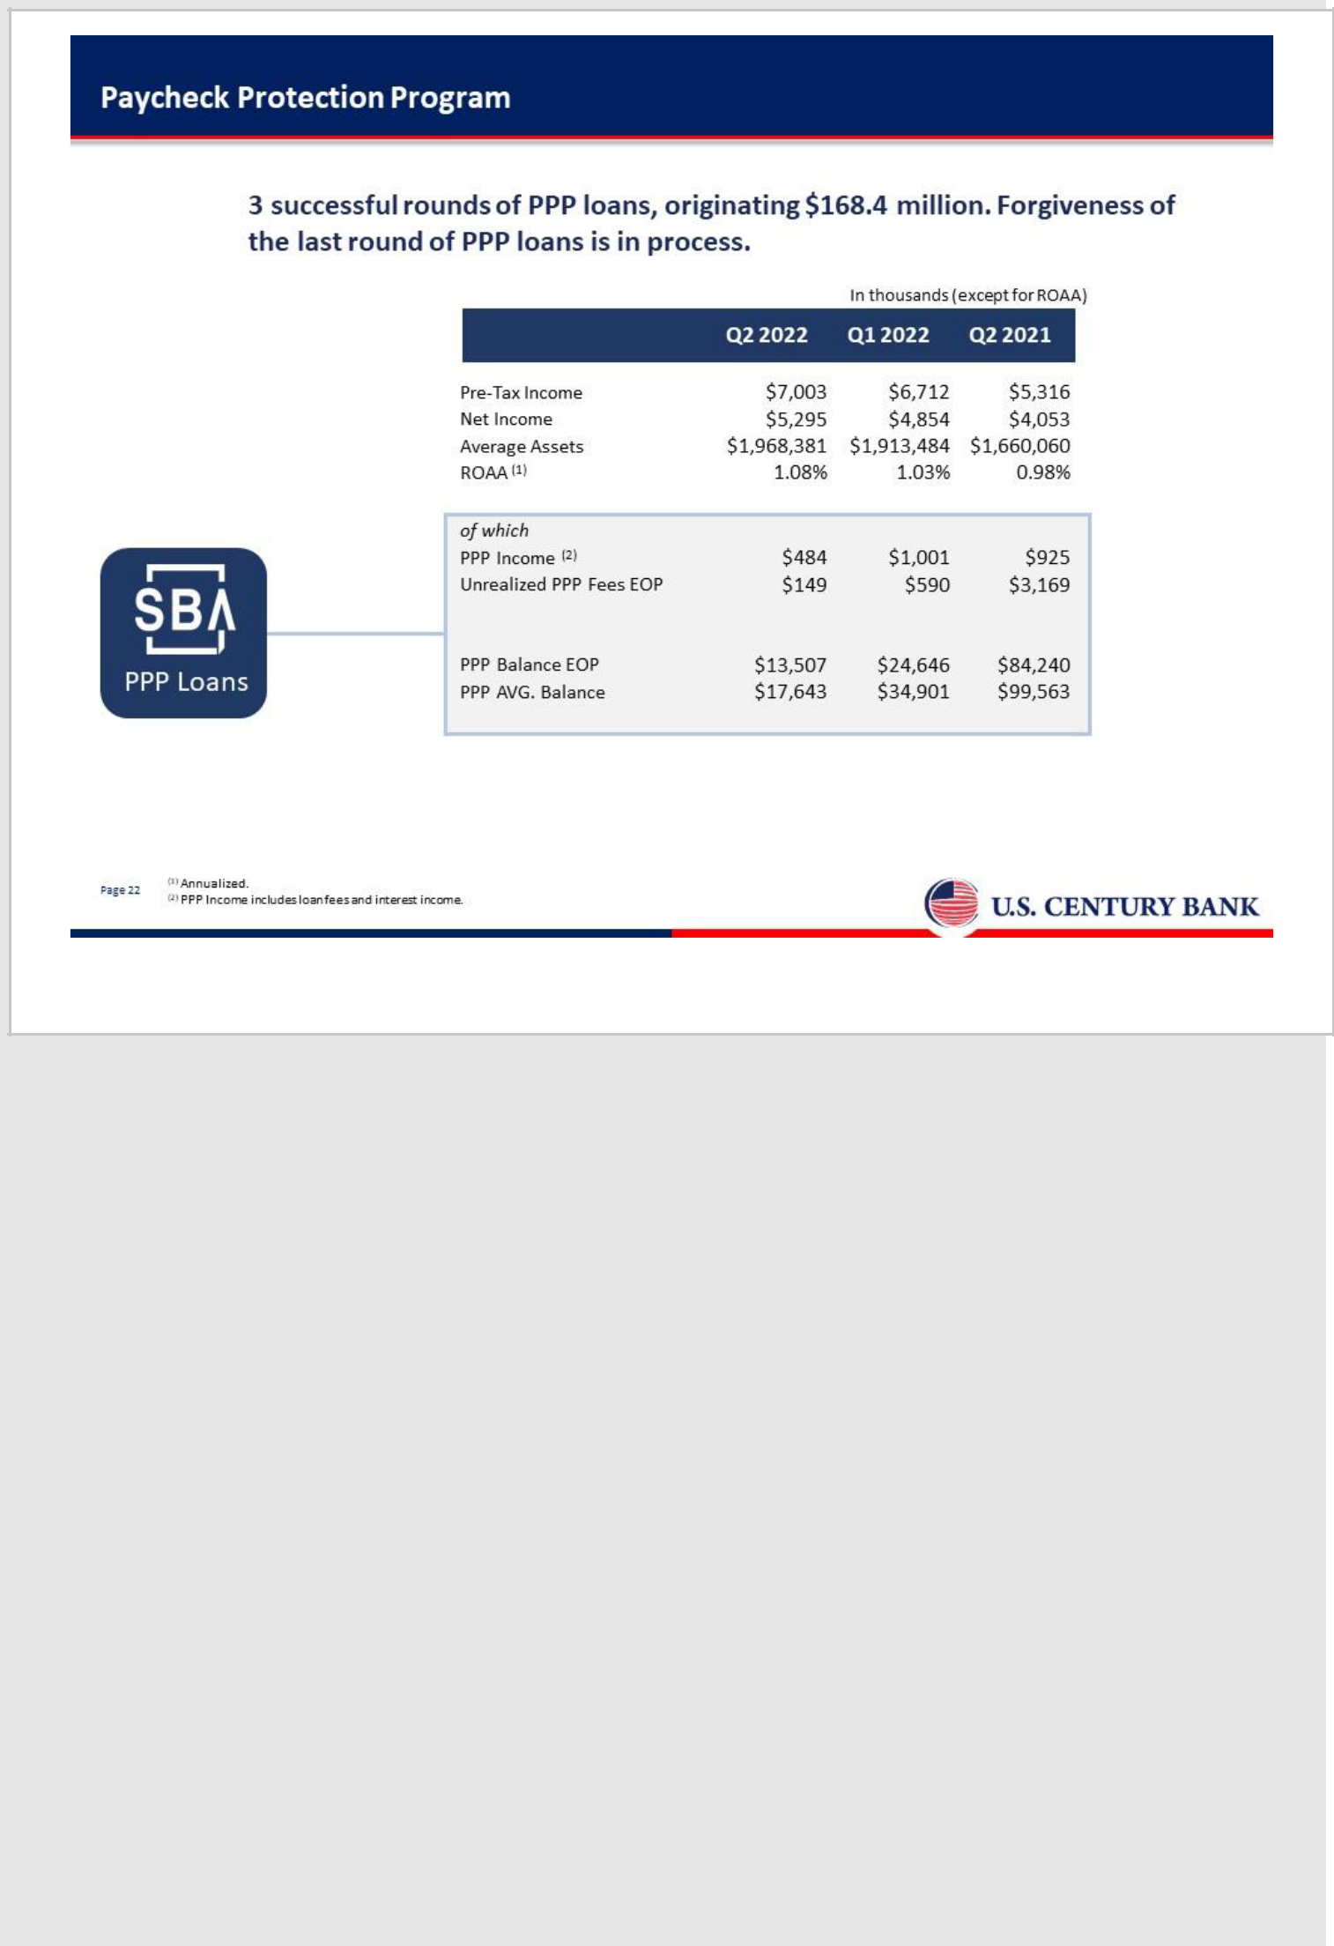

22

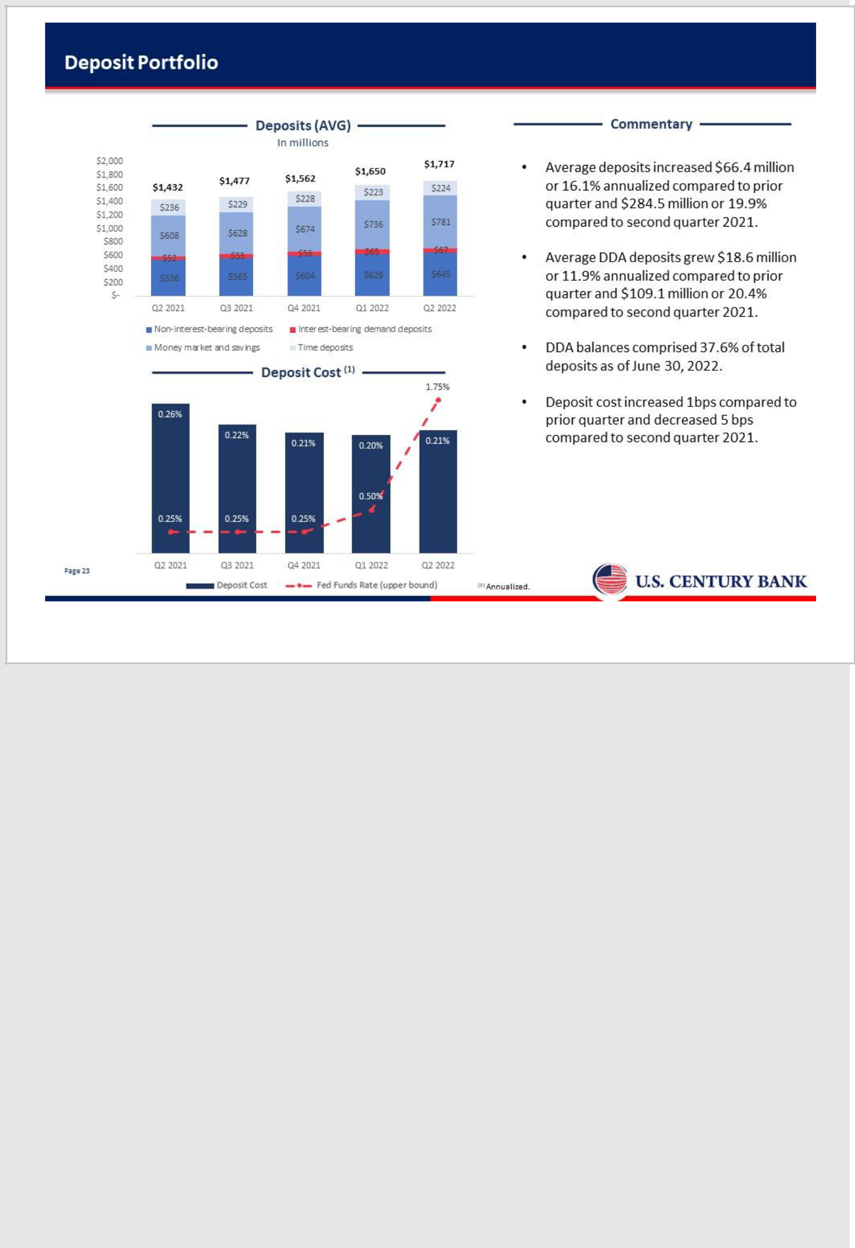

23

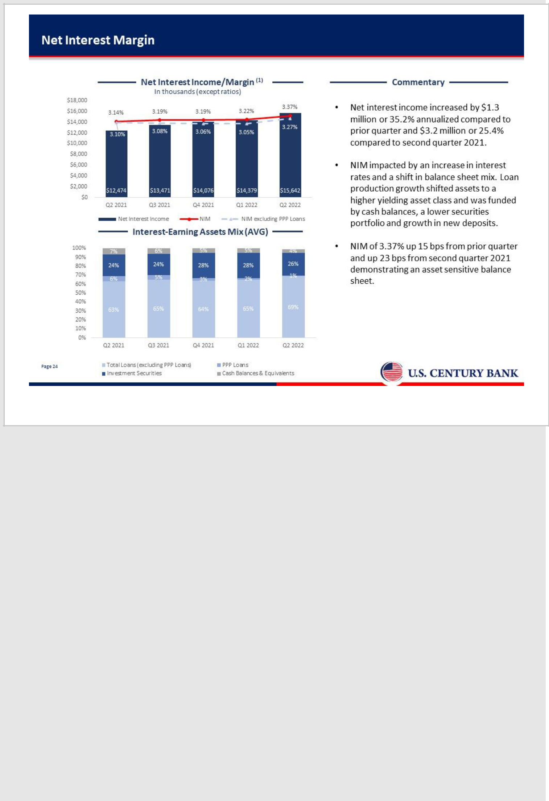

24

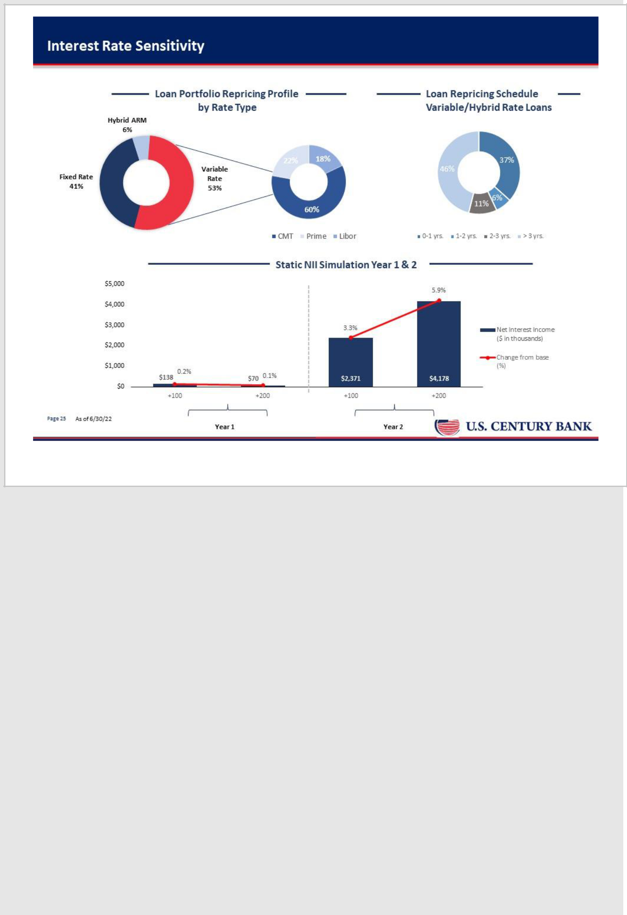

25

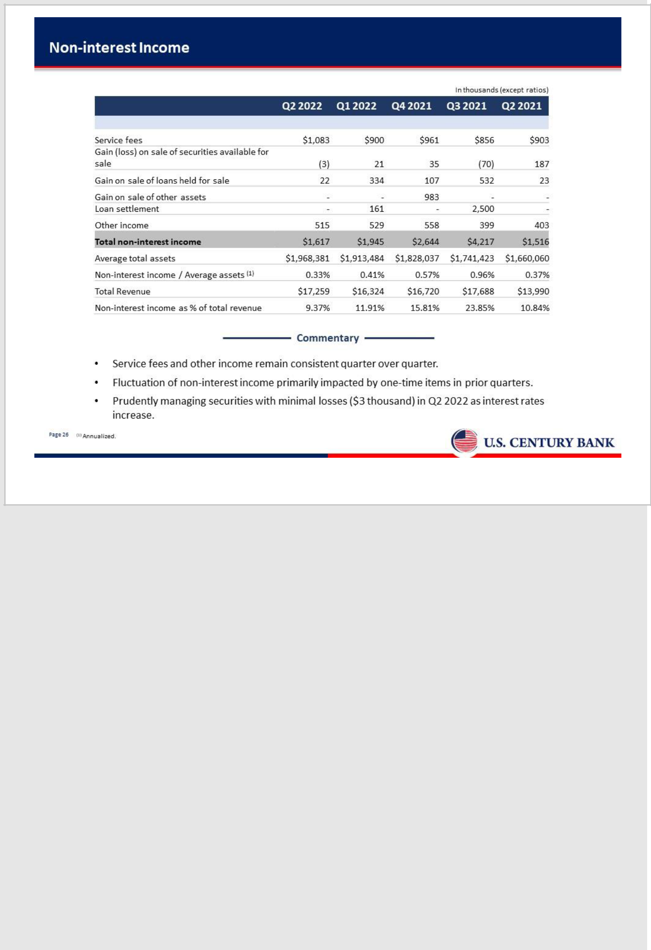

26

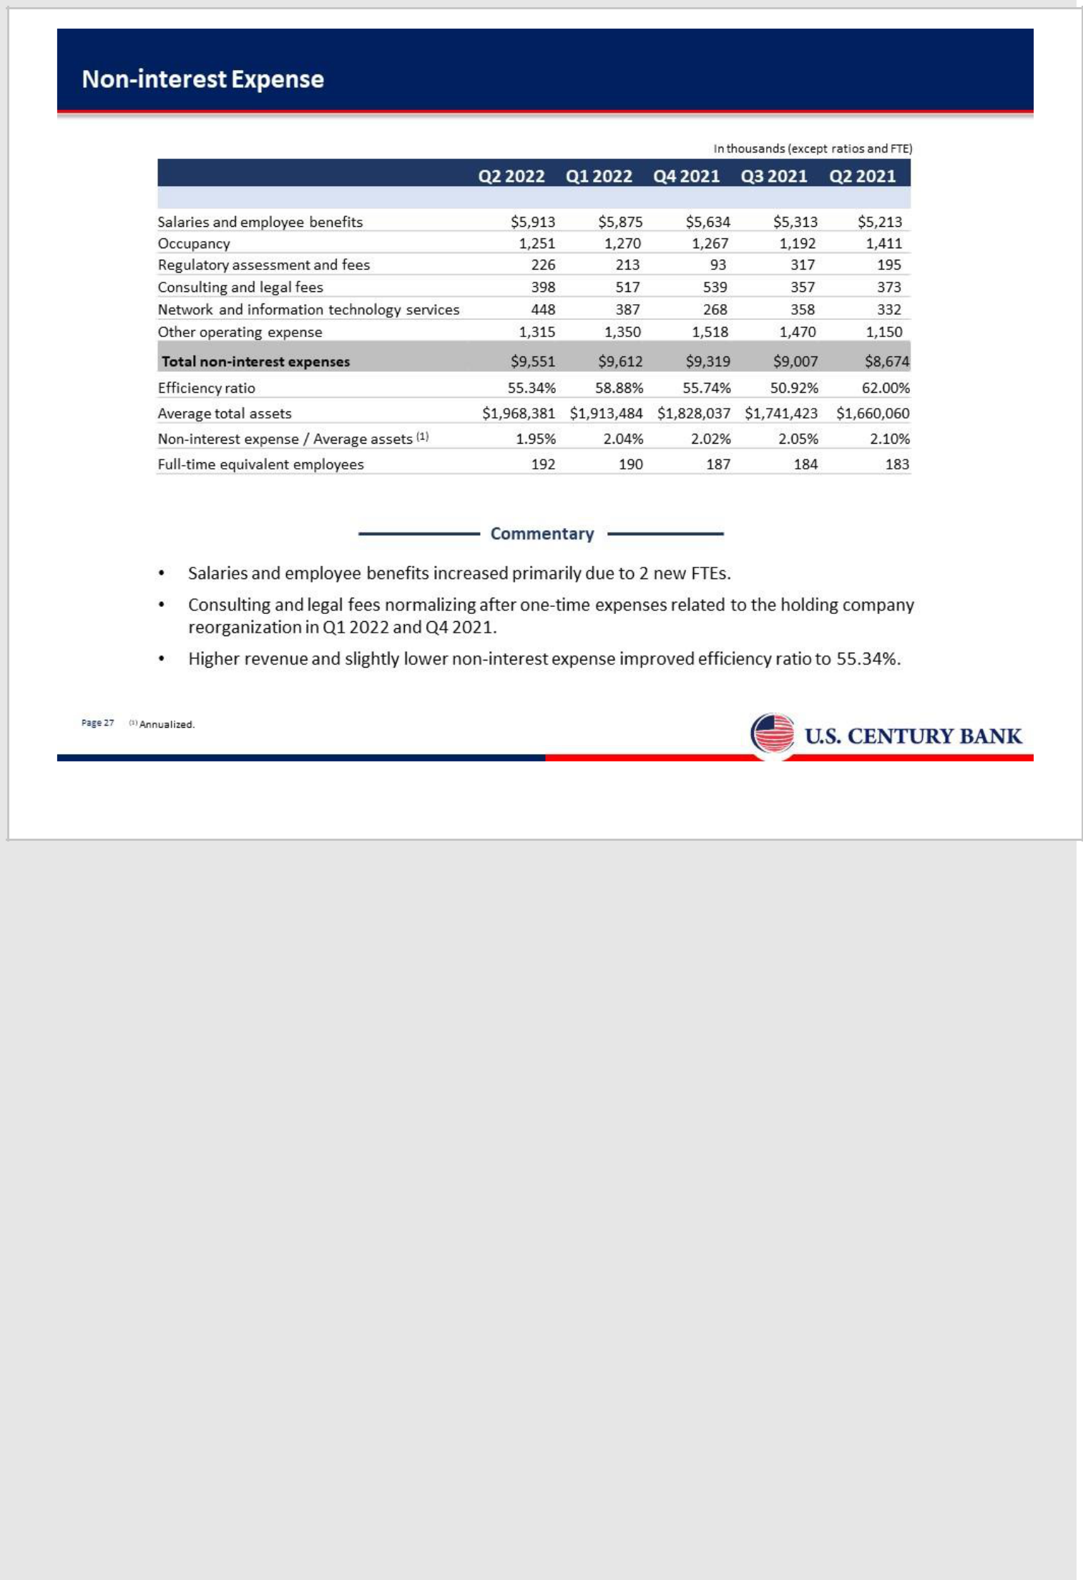

27

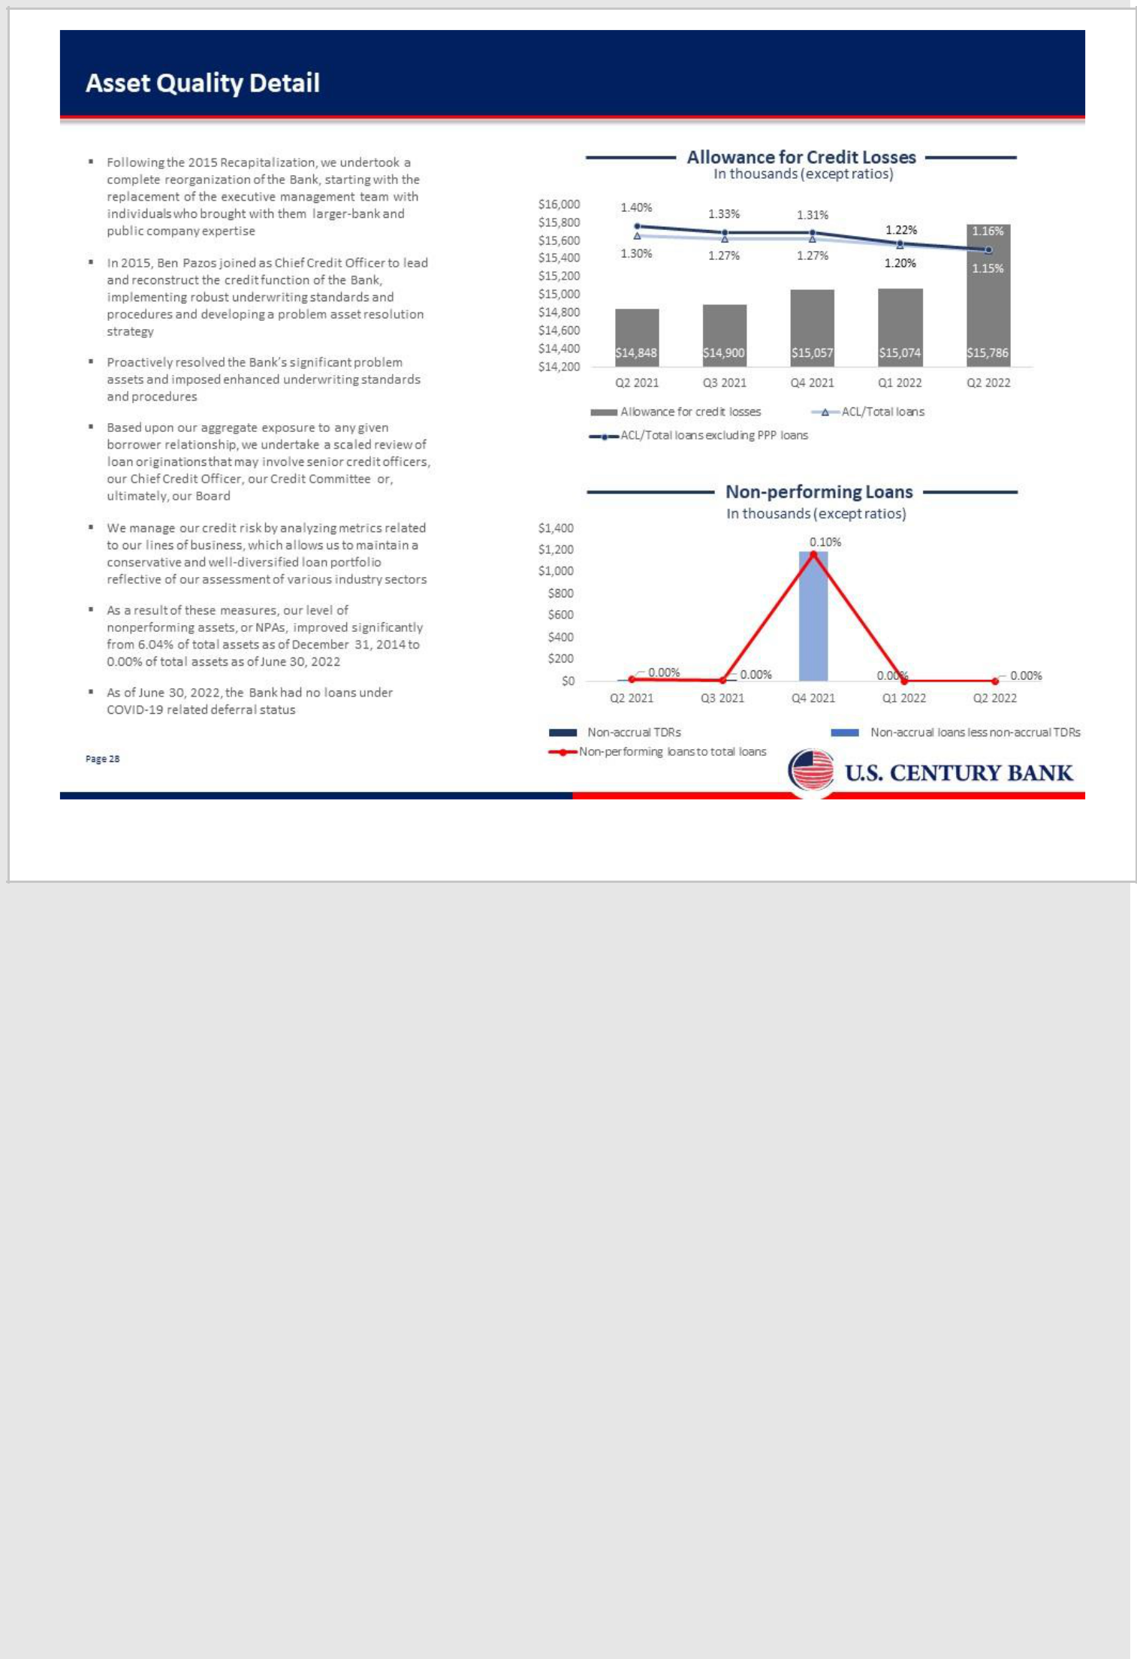

28

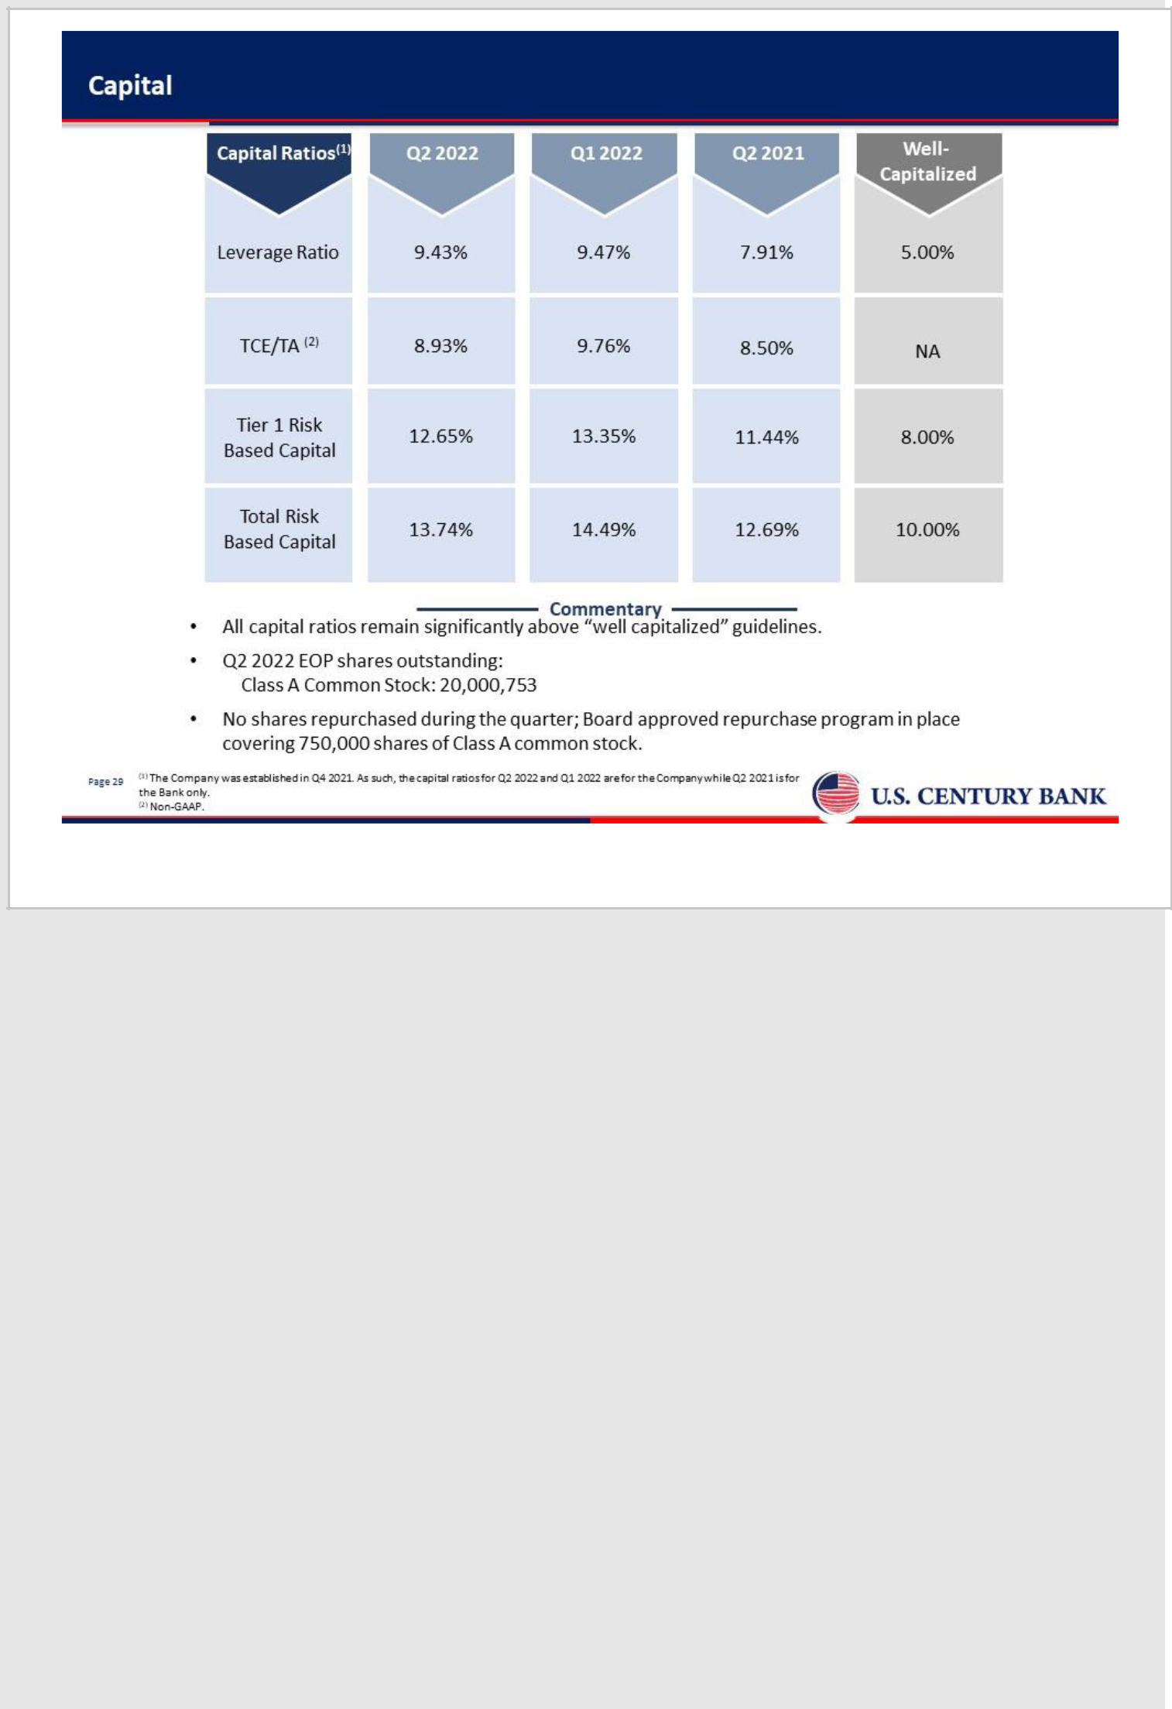

29

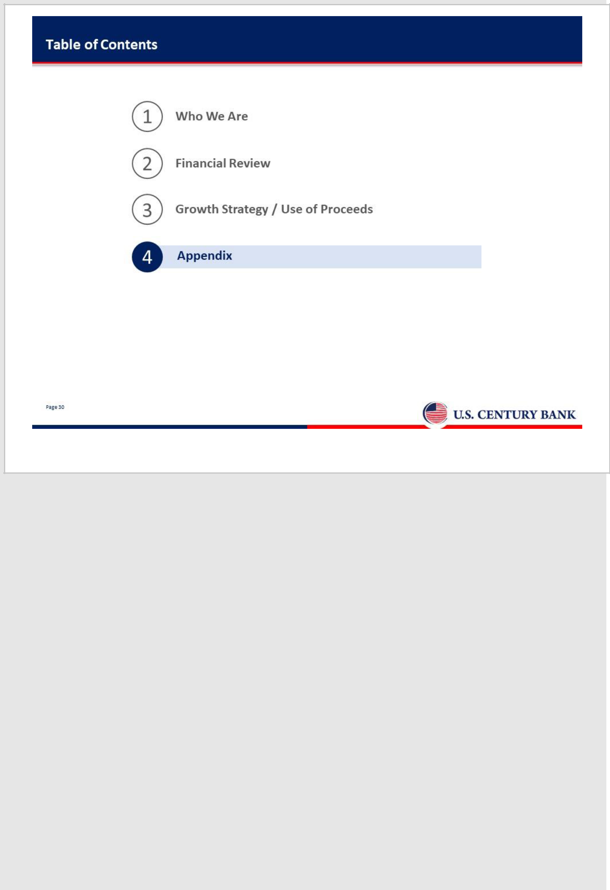

30

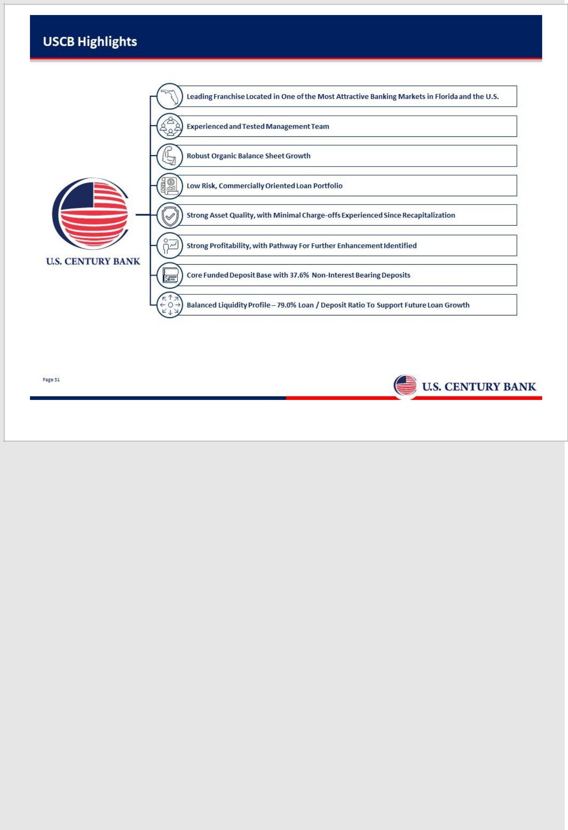

31

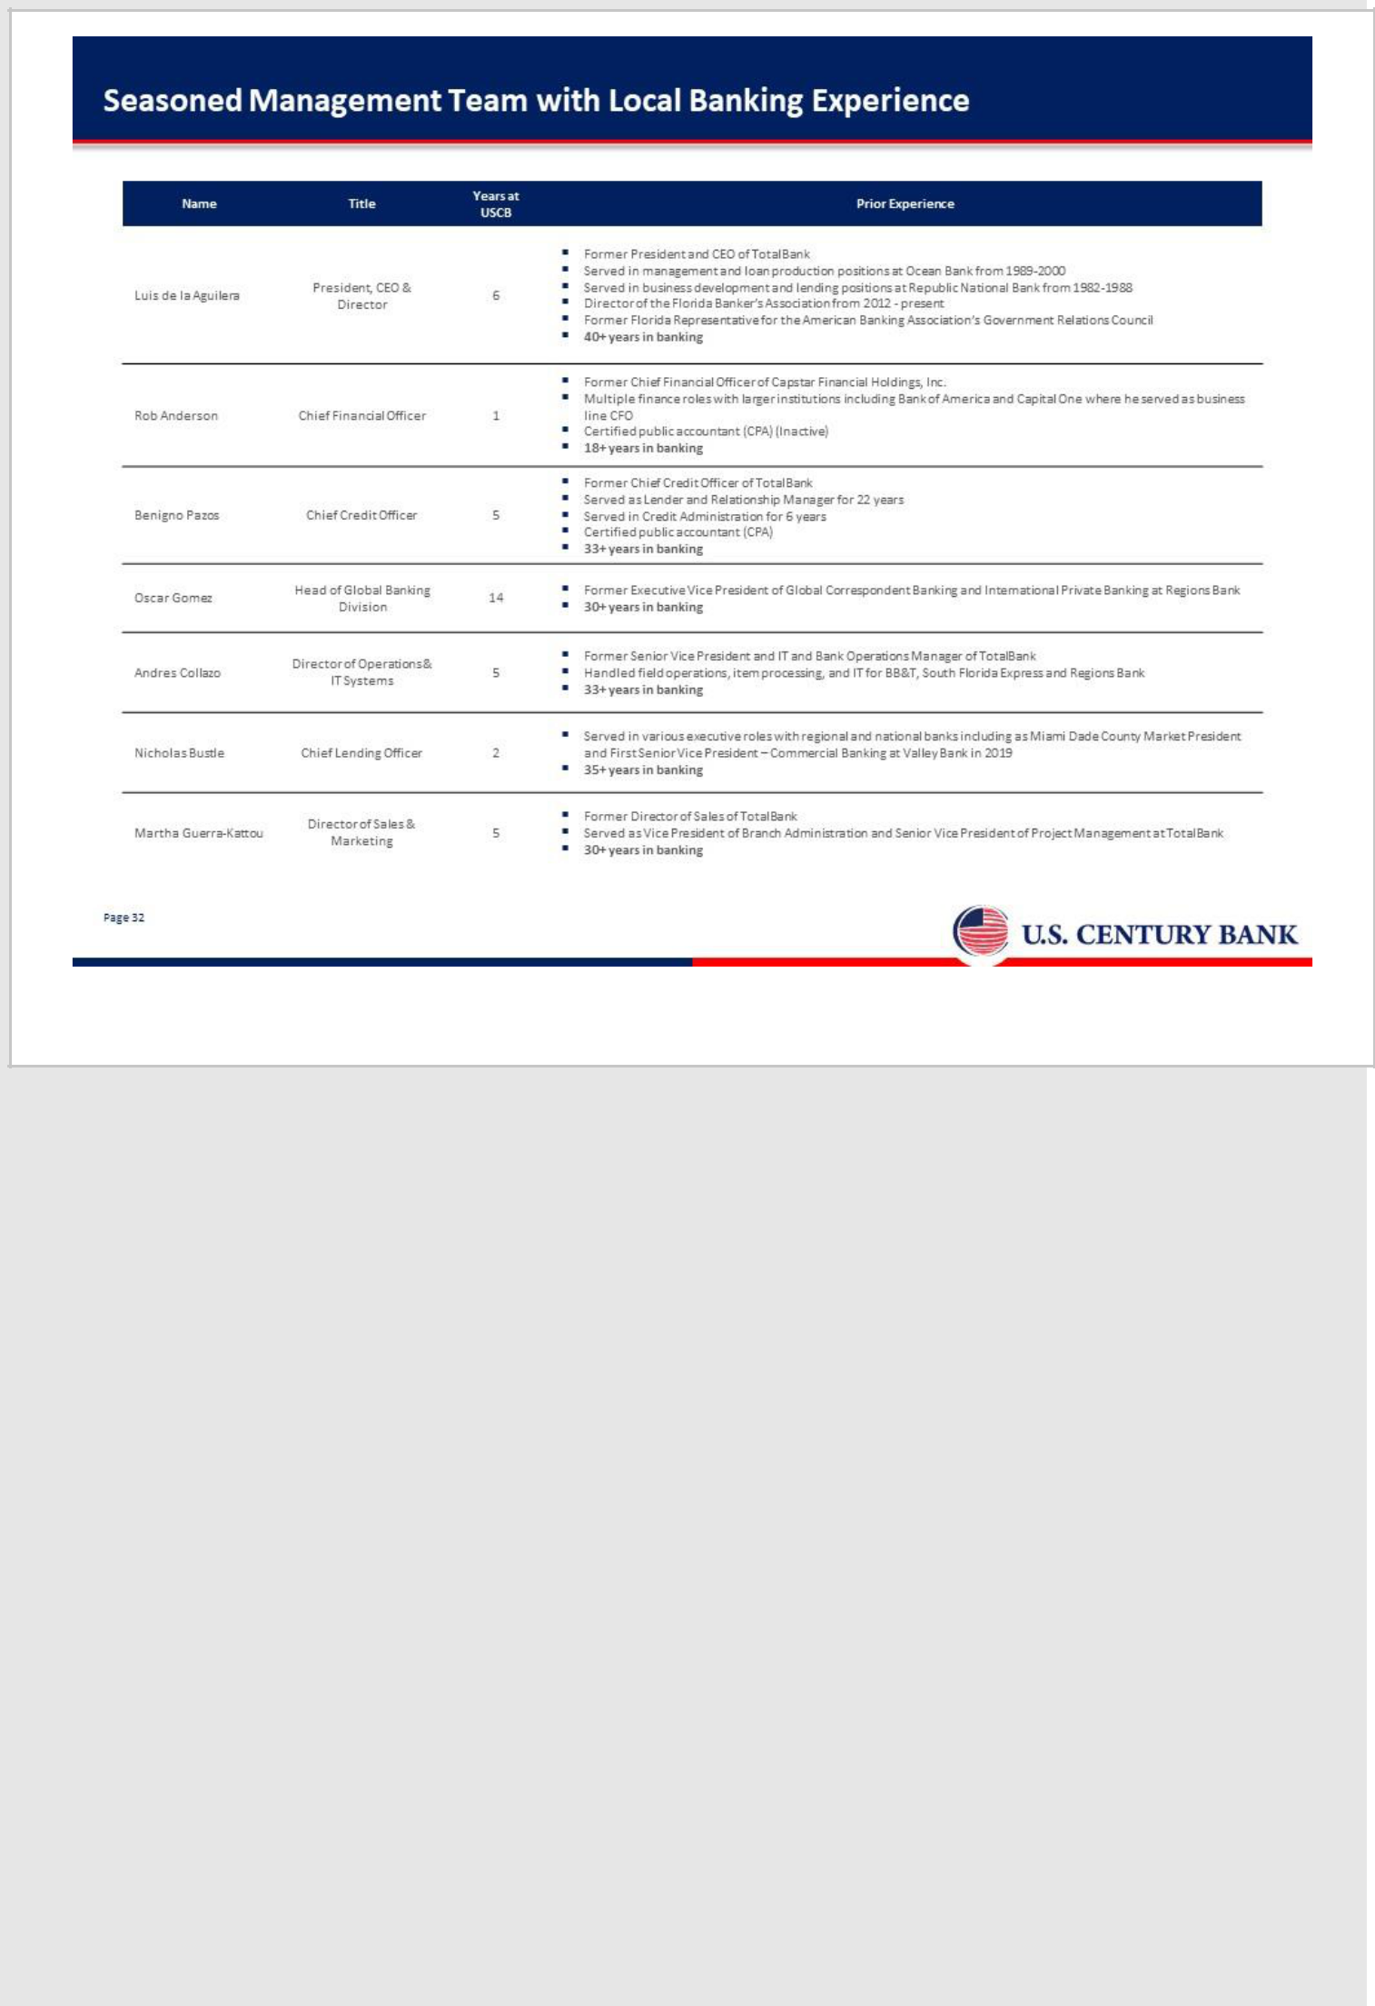

32

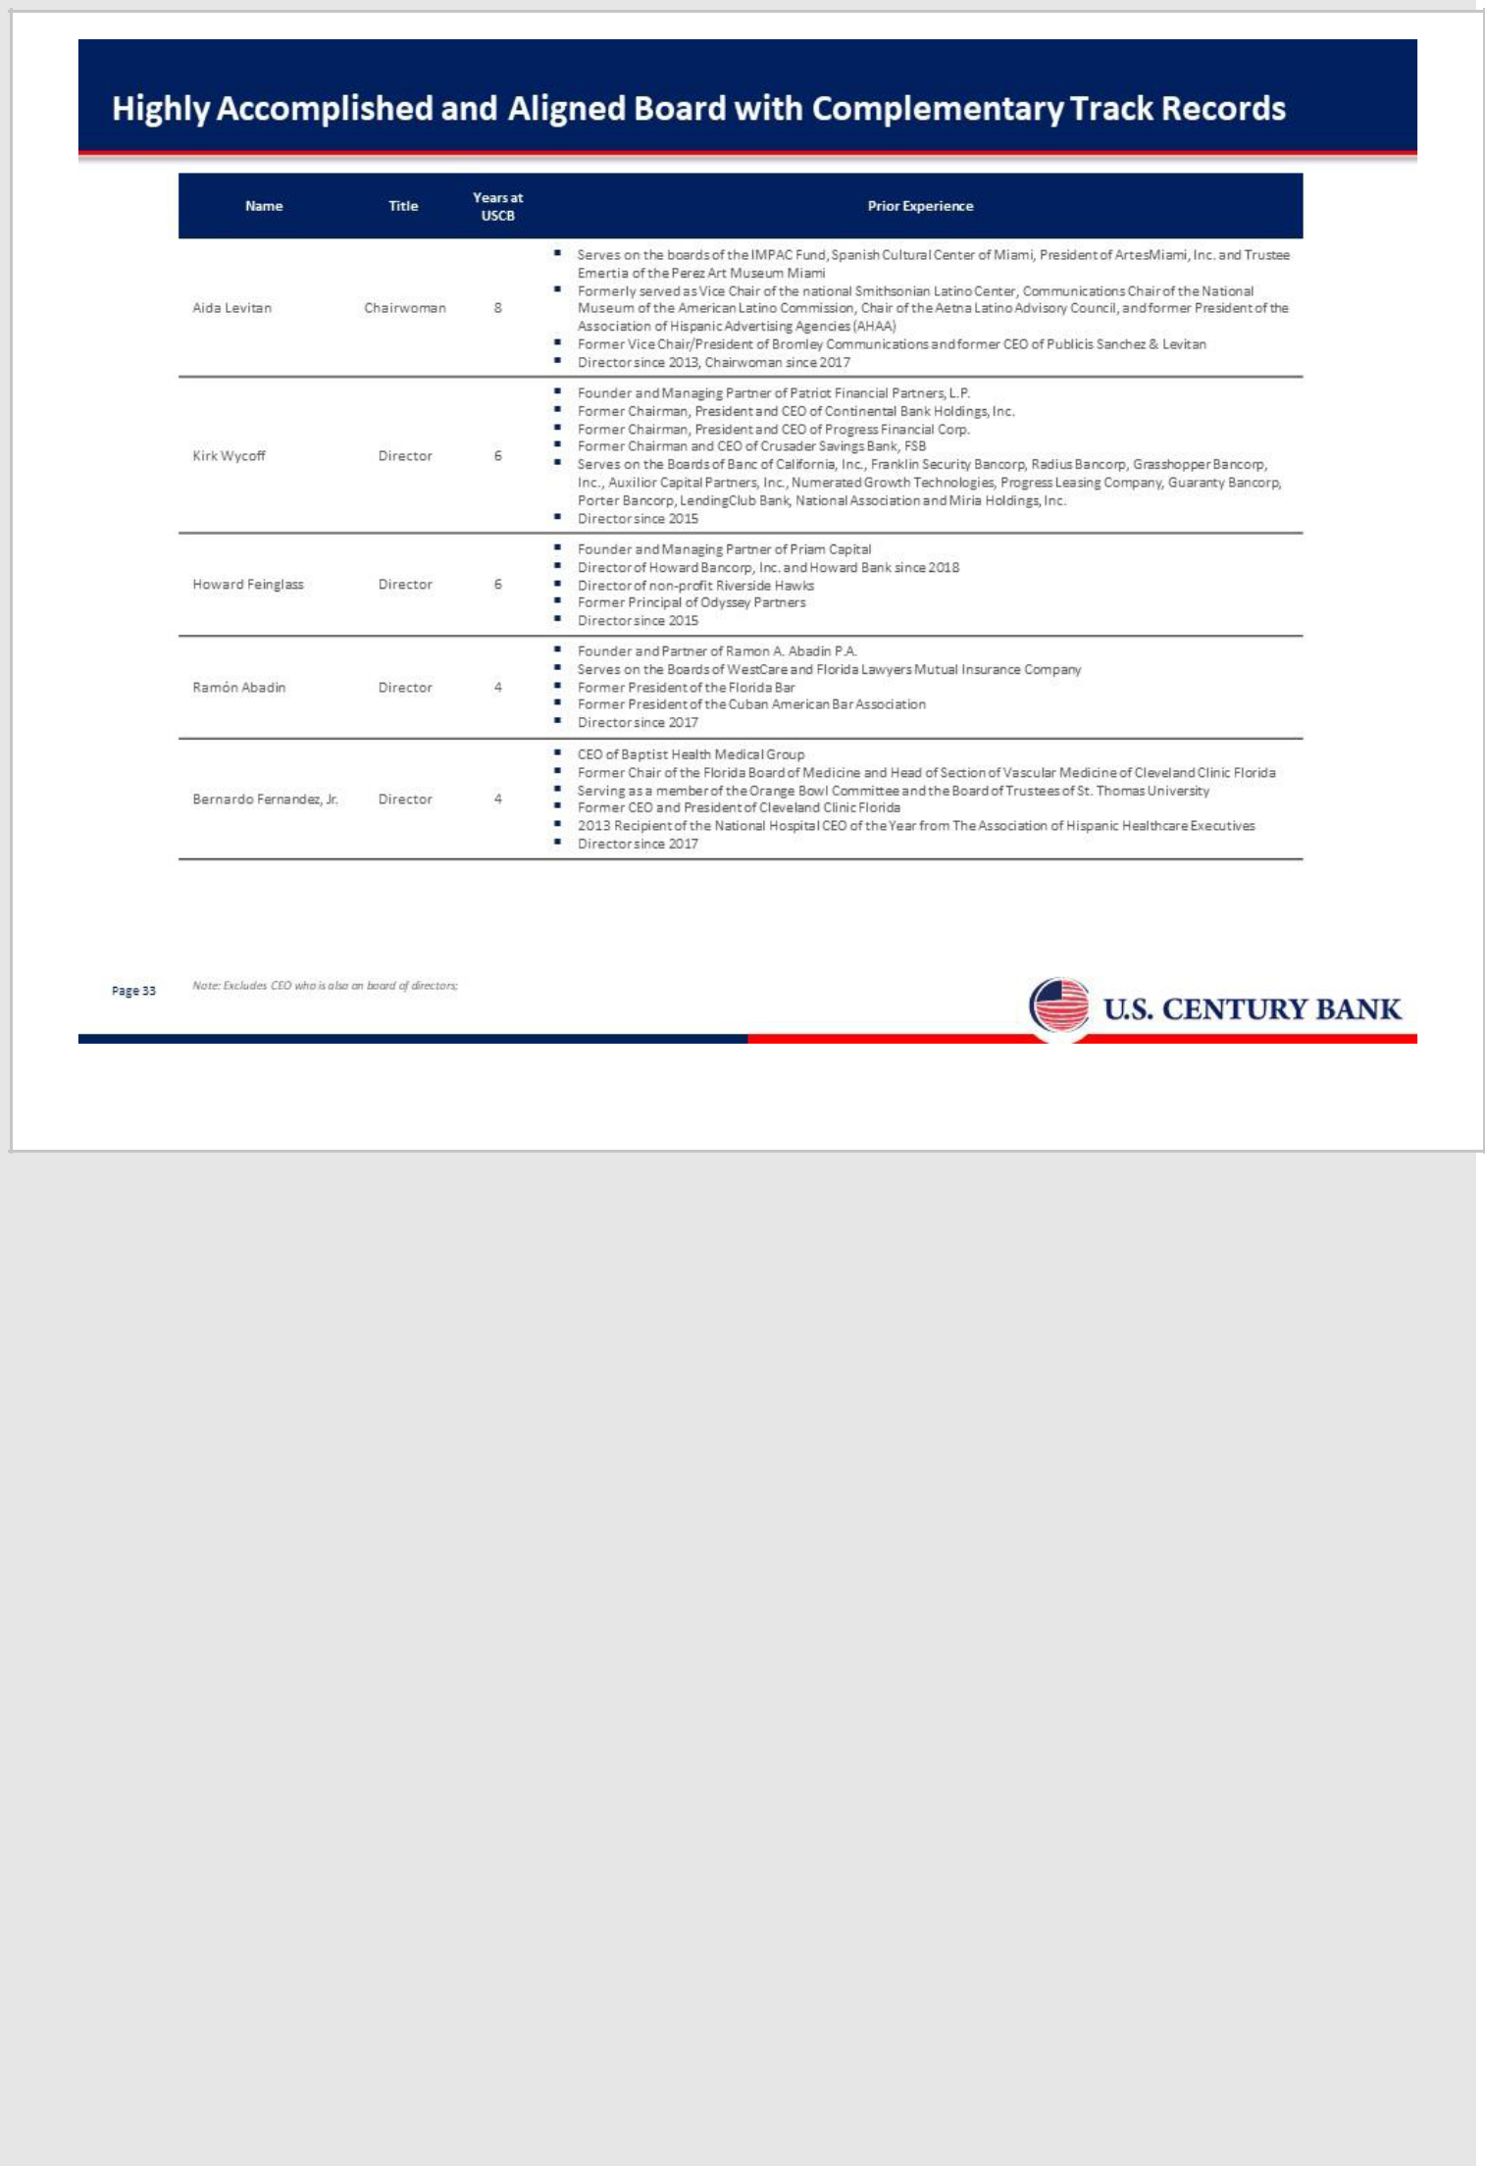

33

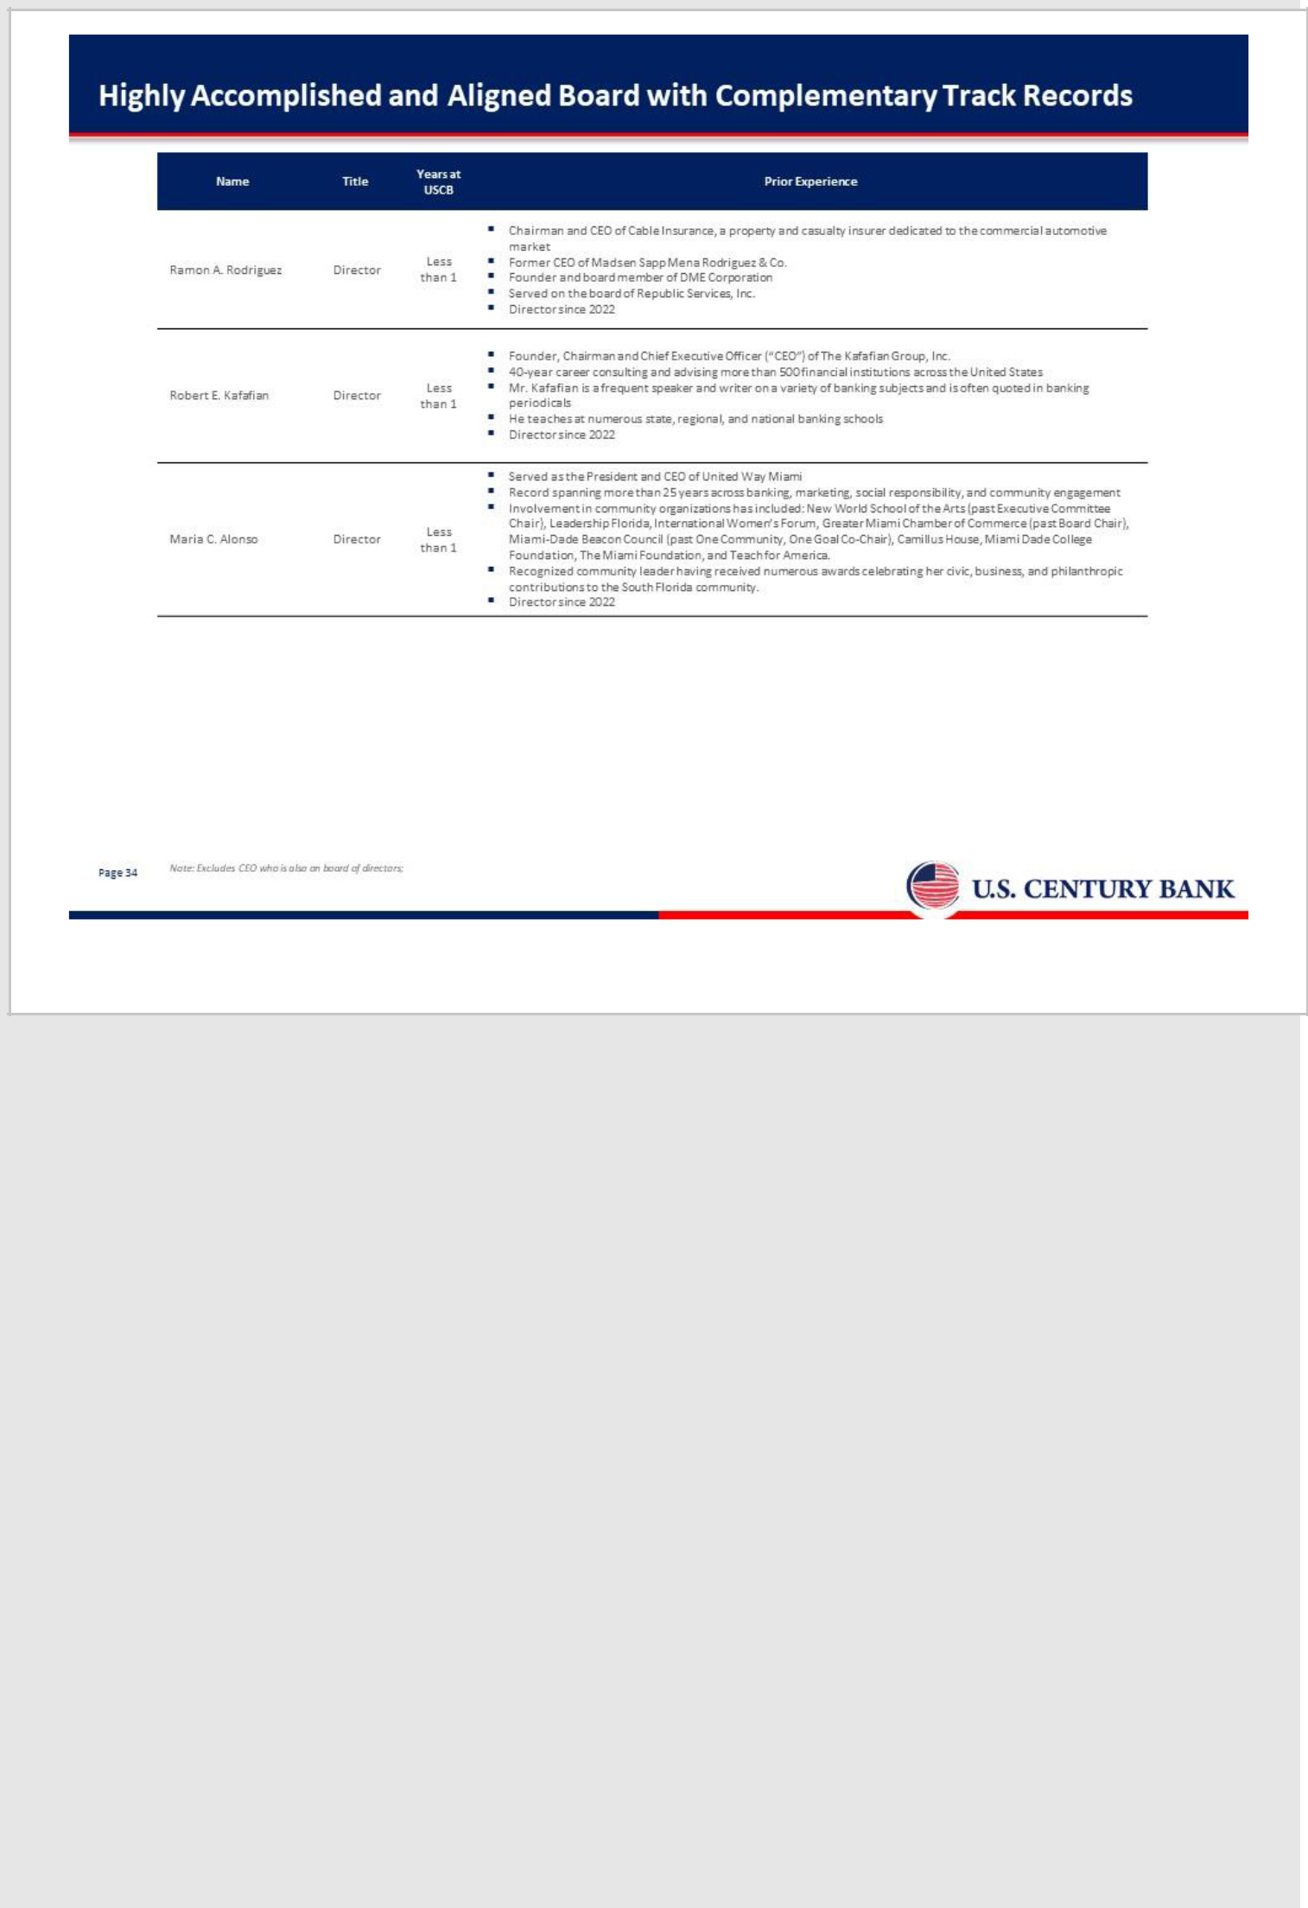

34

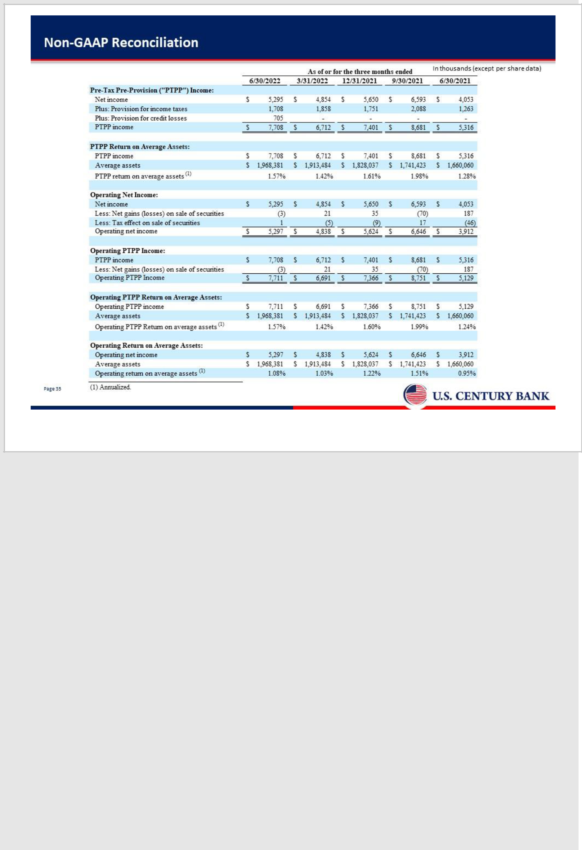

35

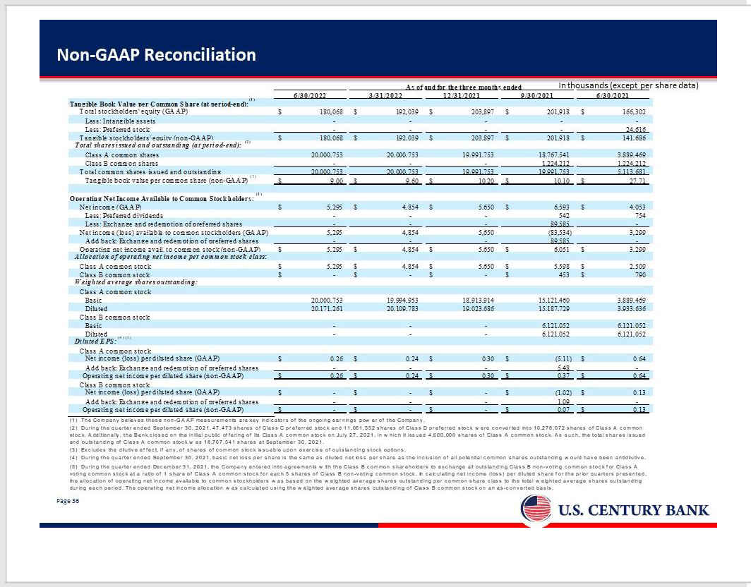

36

