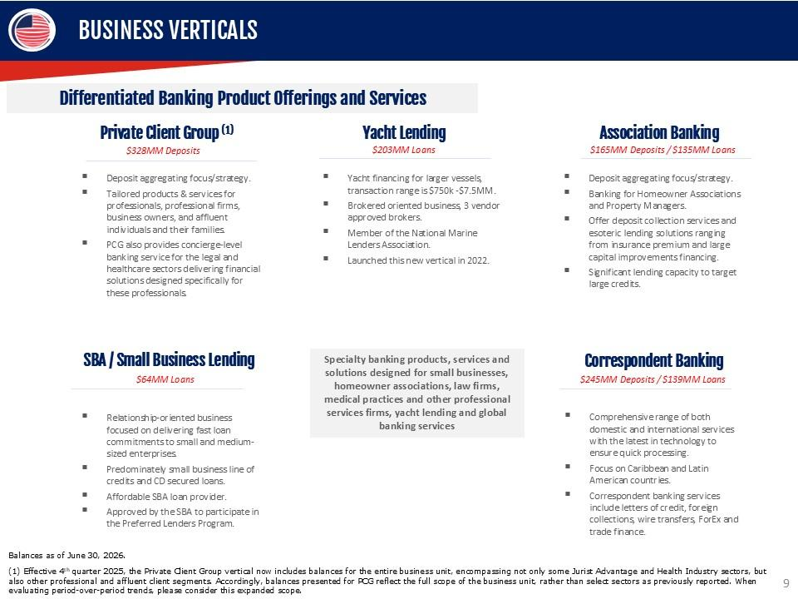
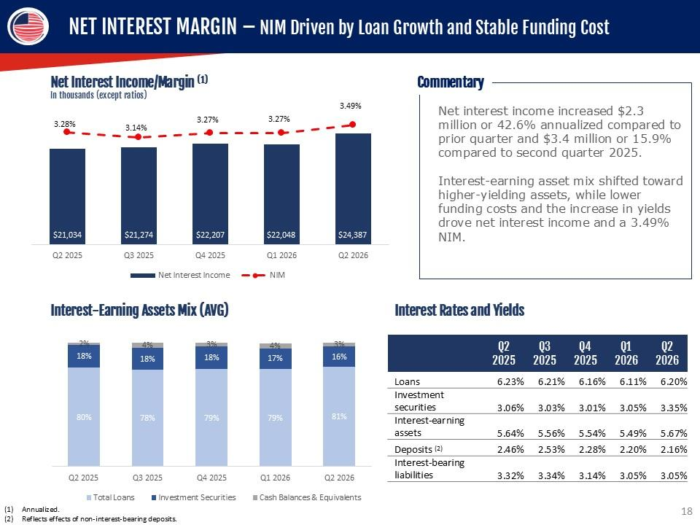
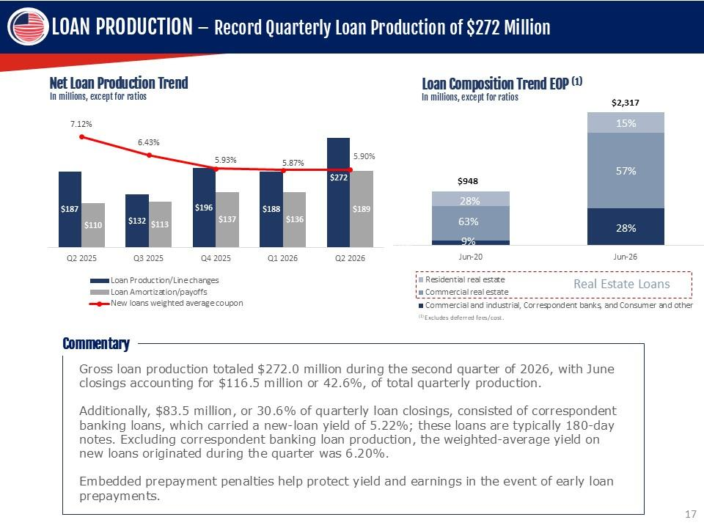
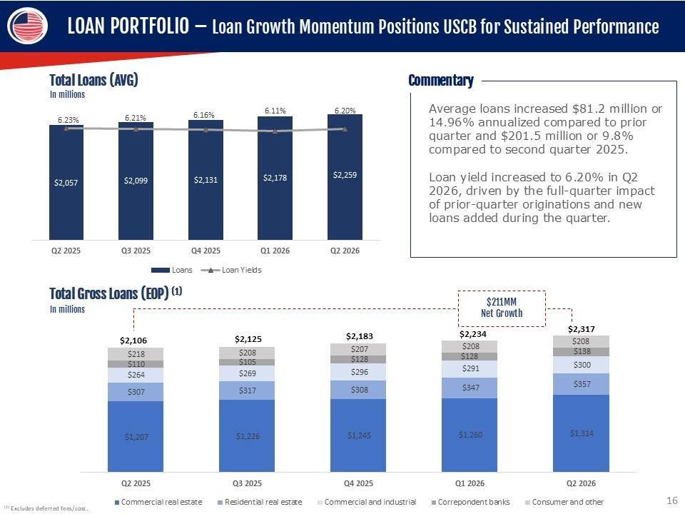
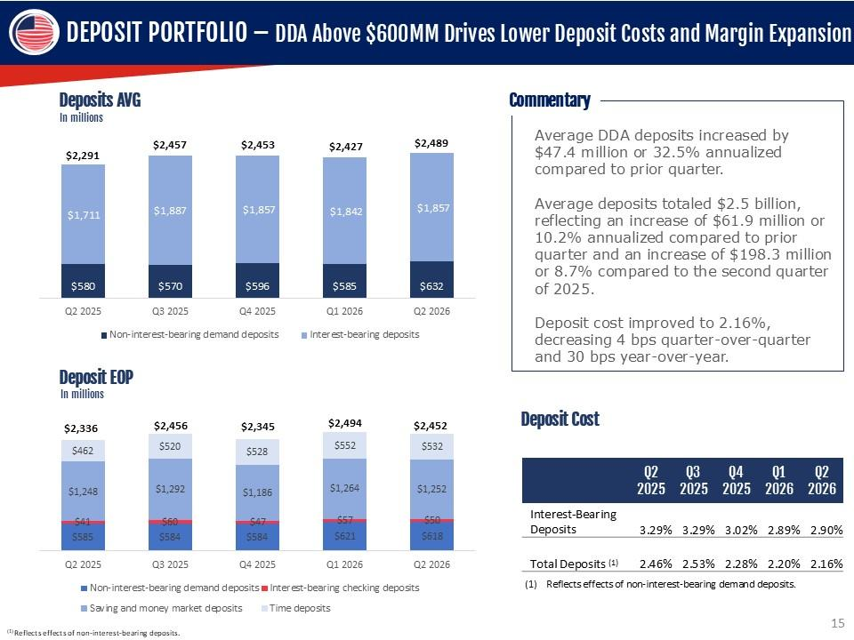
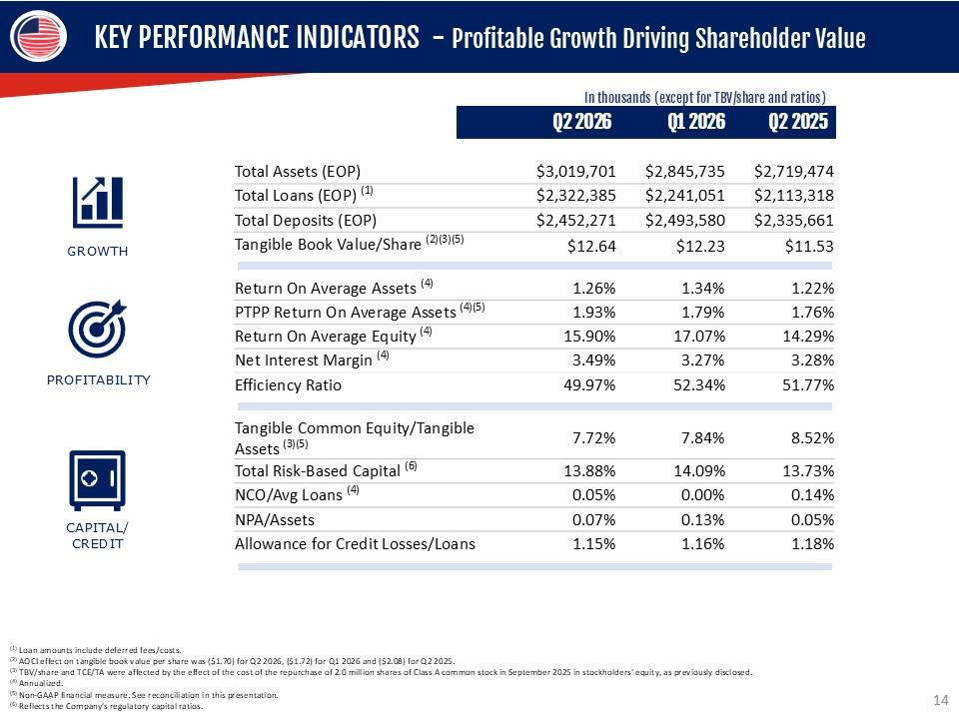
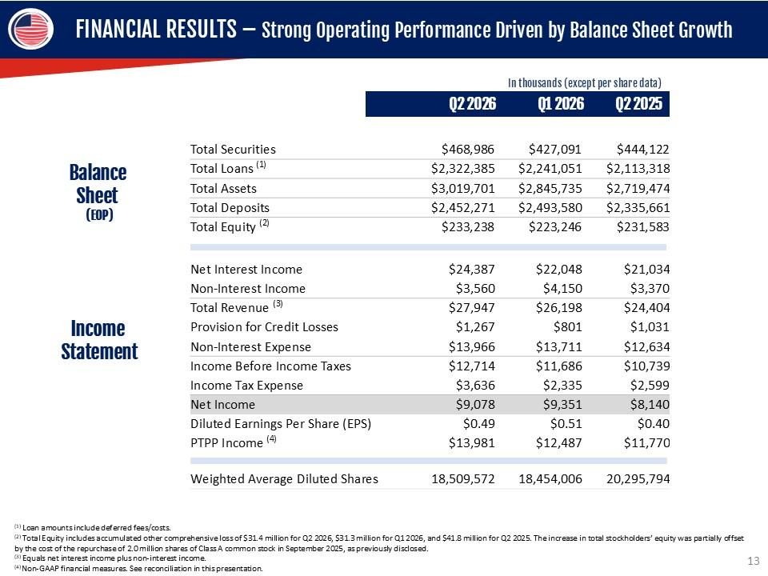
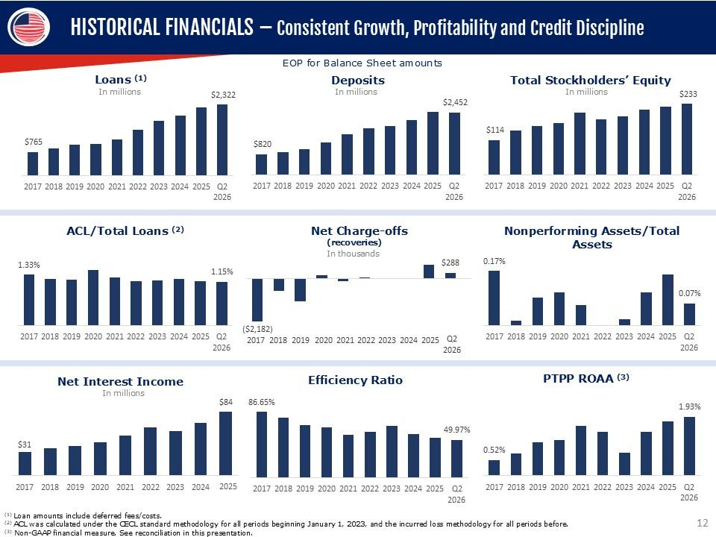
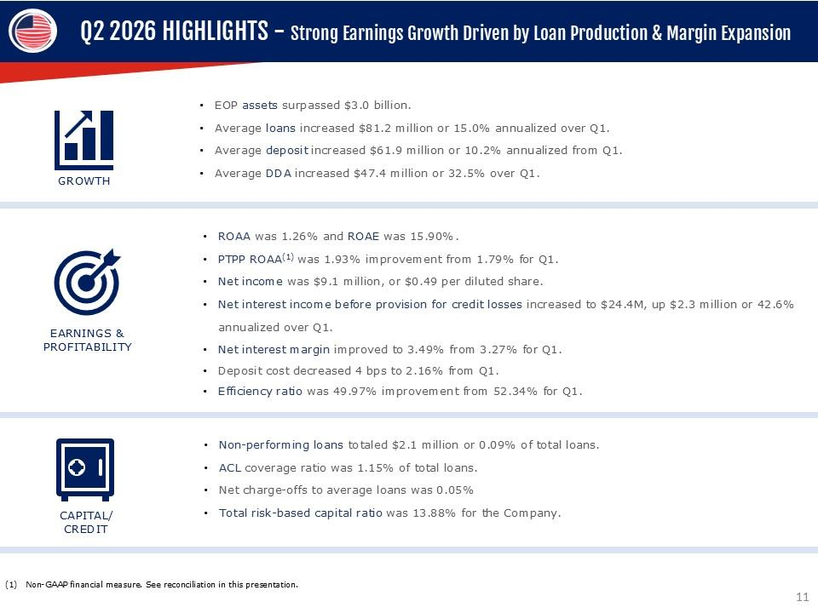
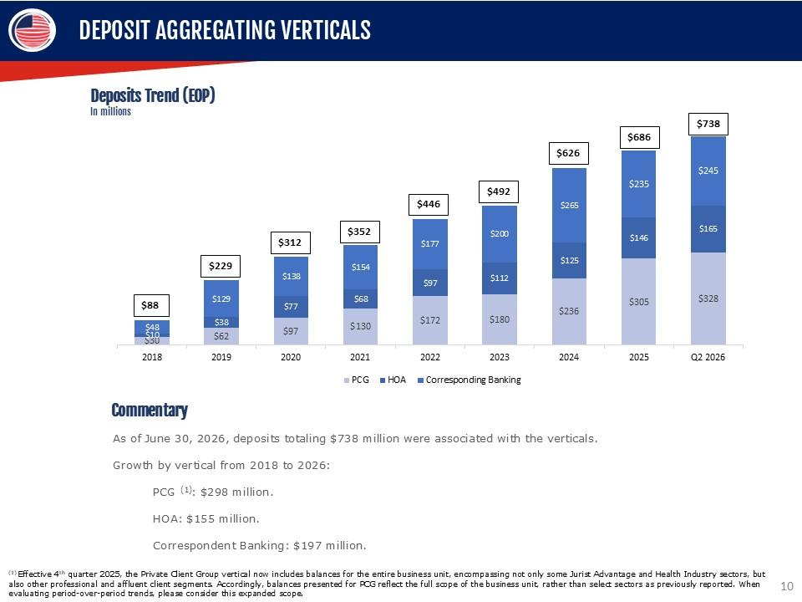
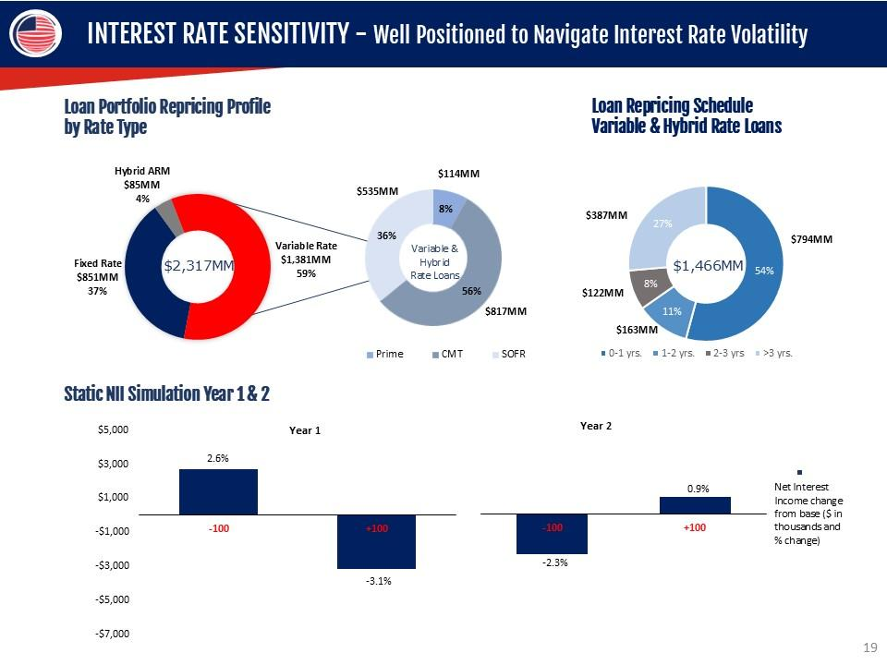
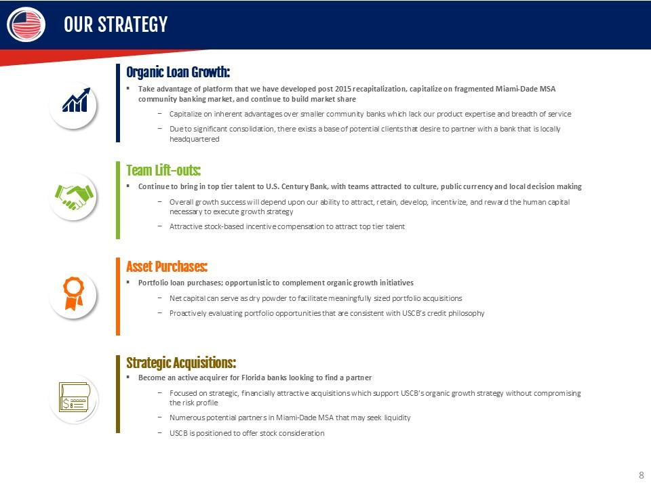
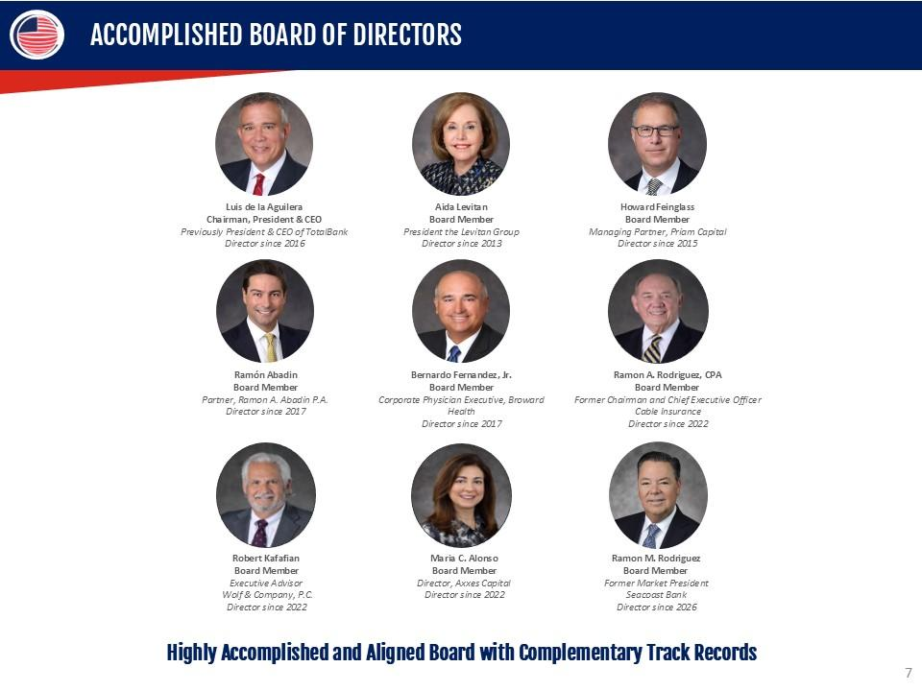
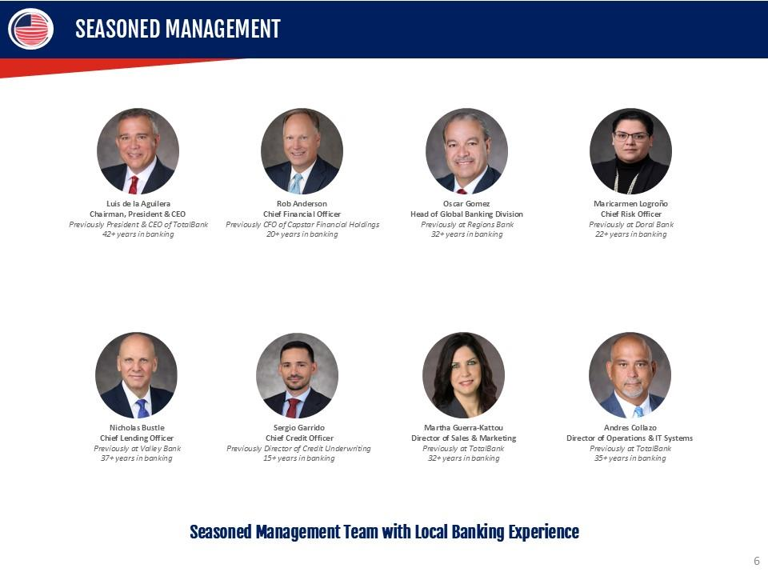
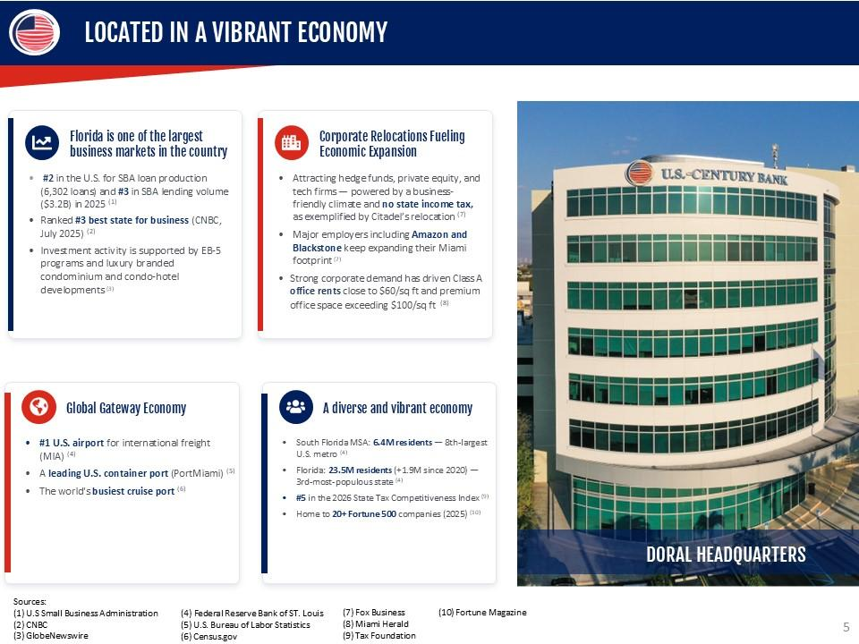
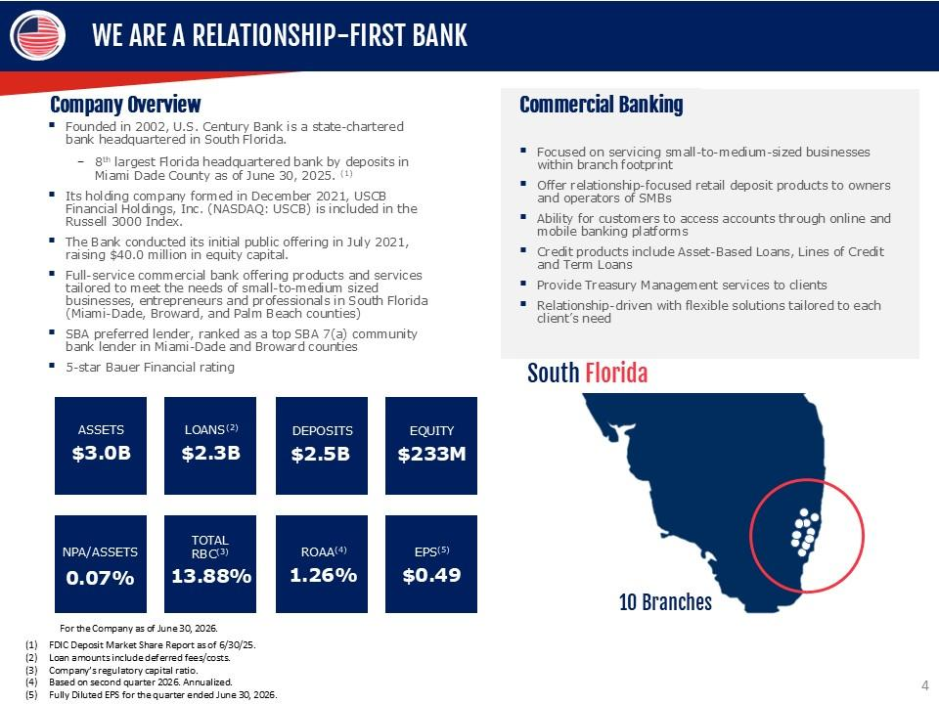
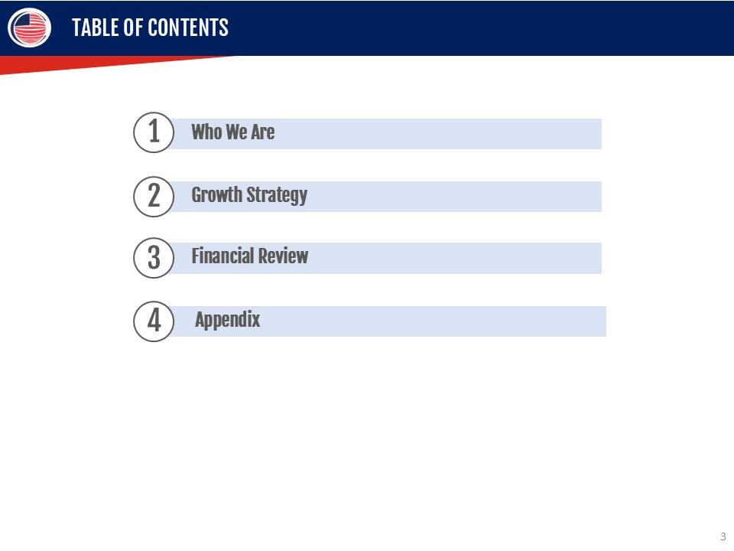
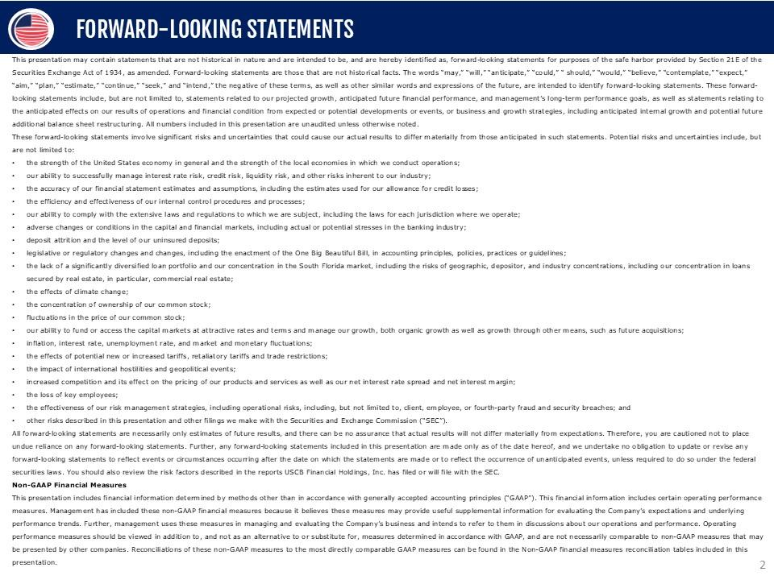
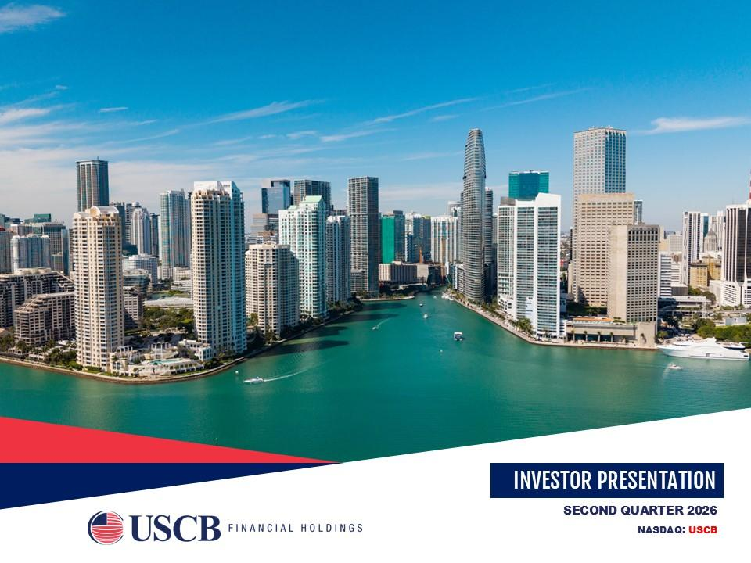
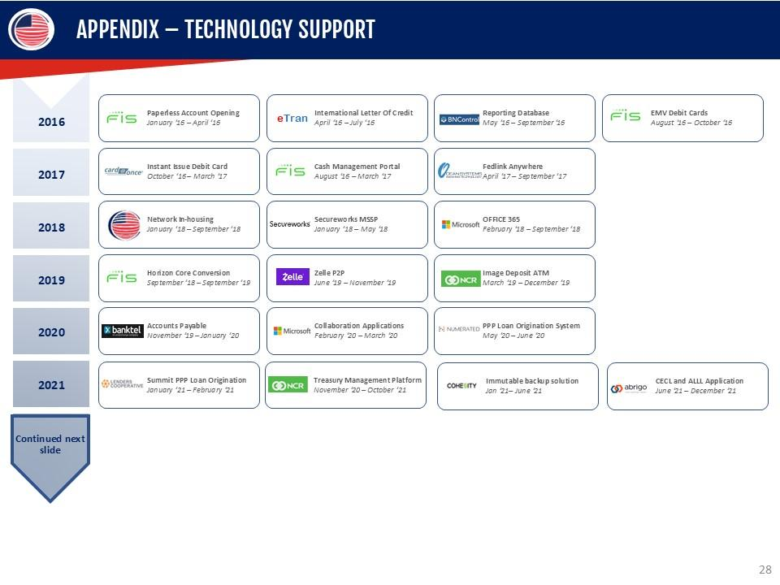
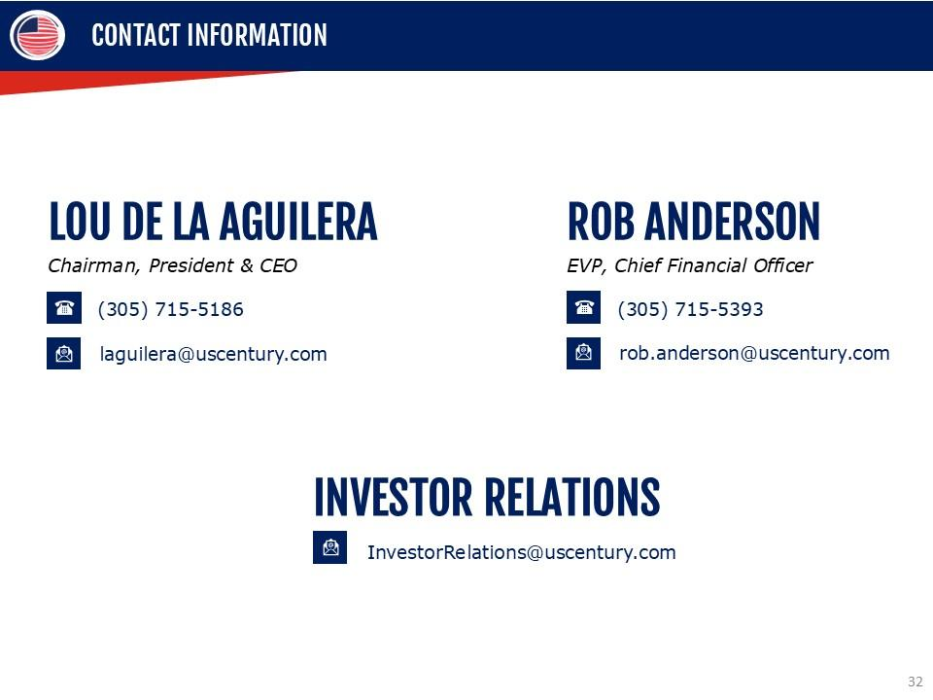
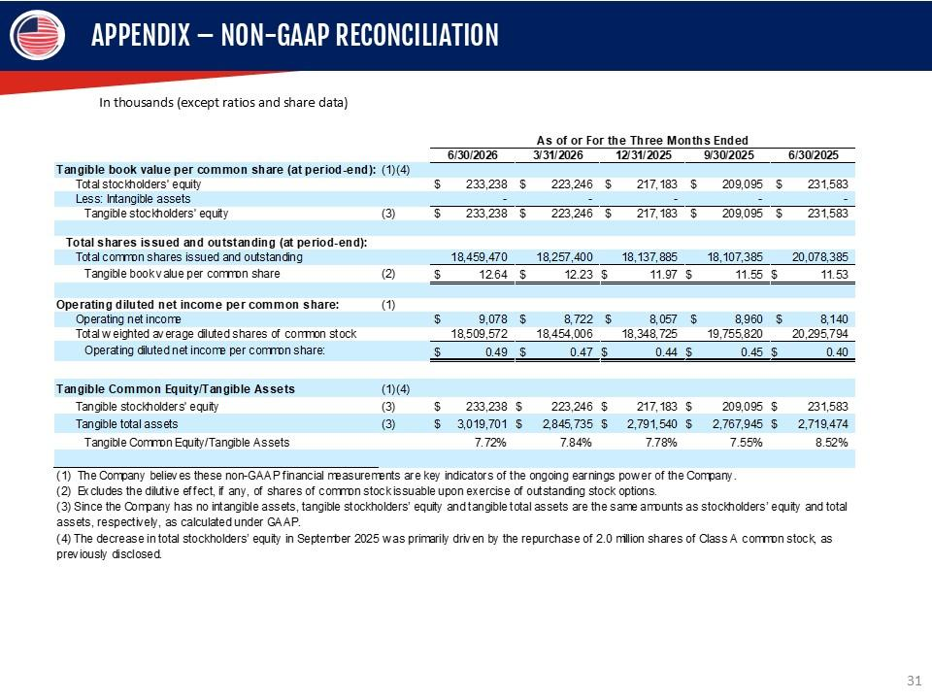
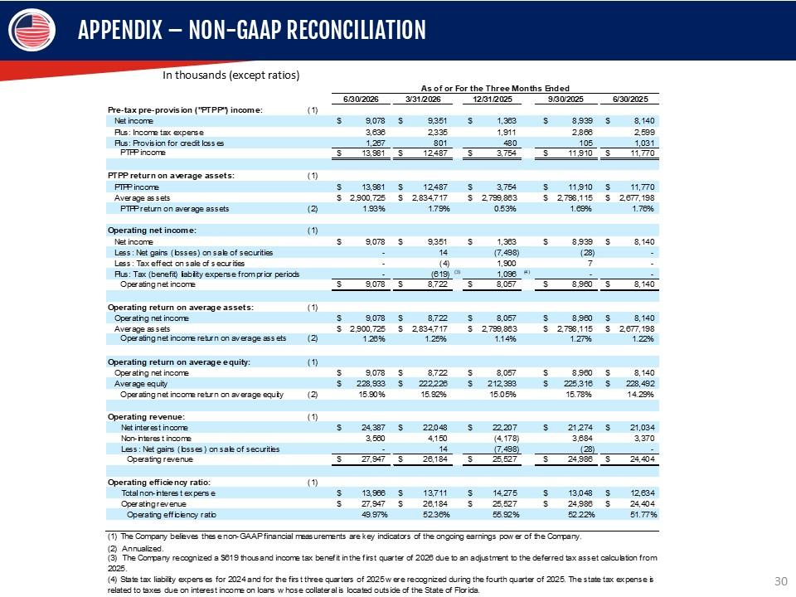
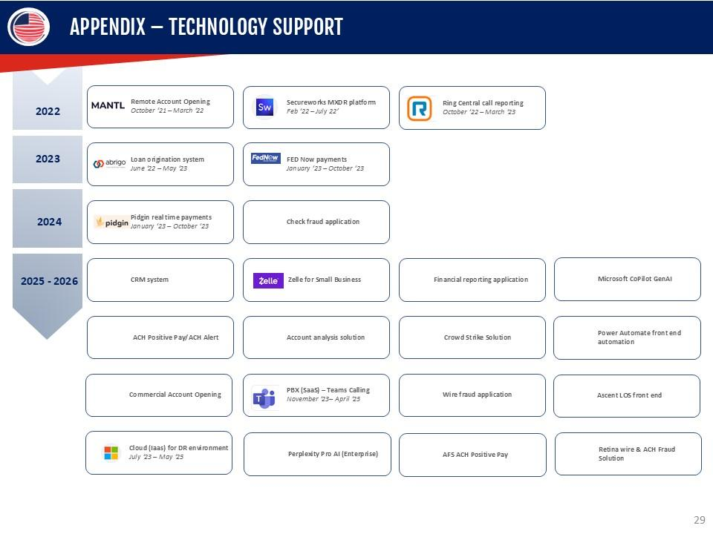
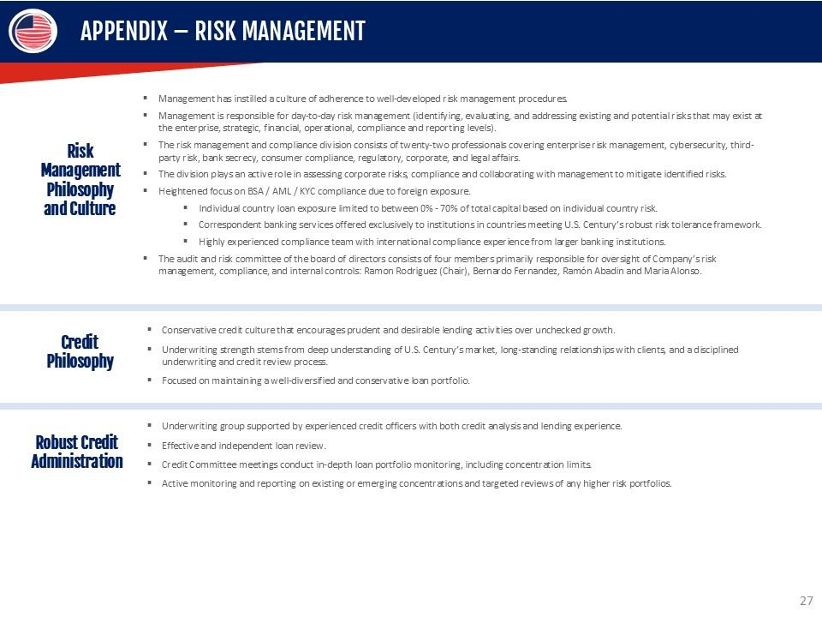
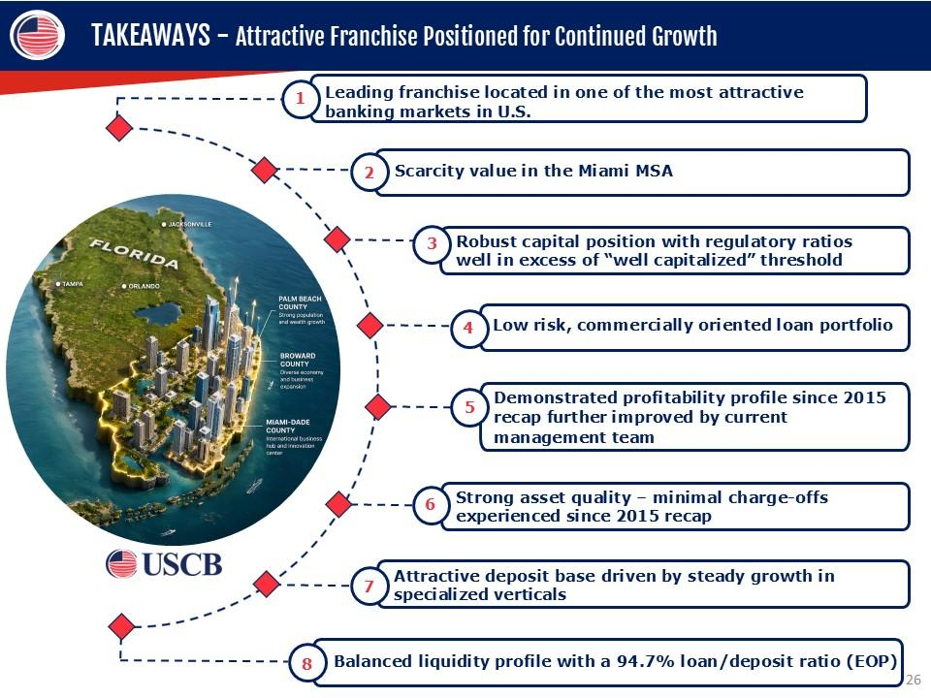
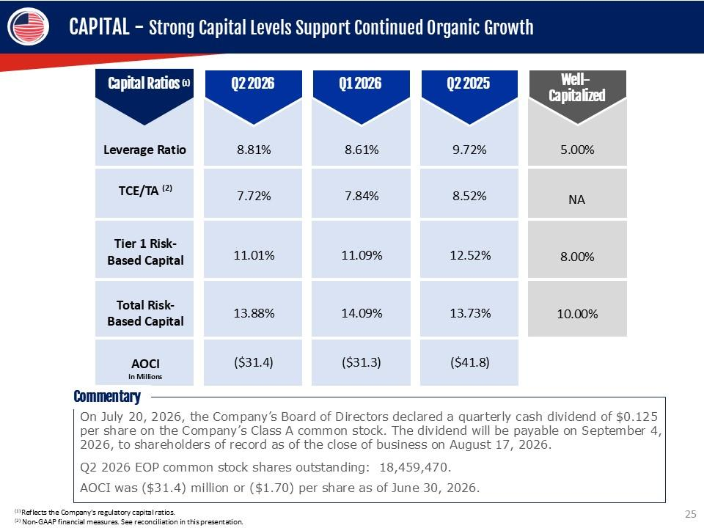
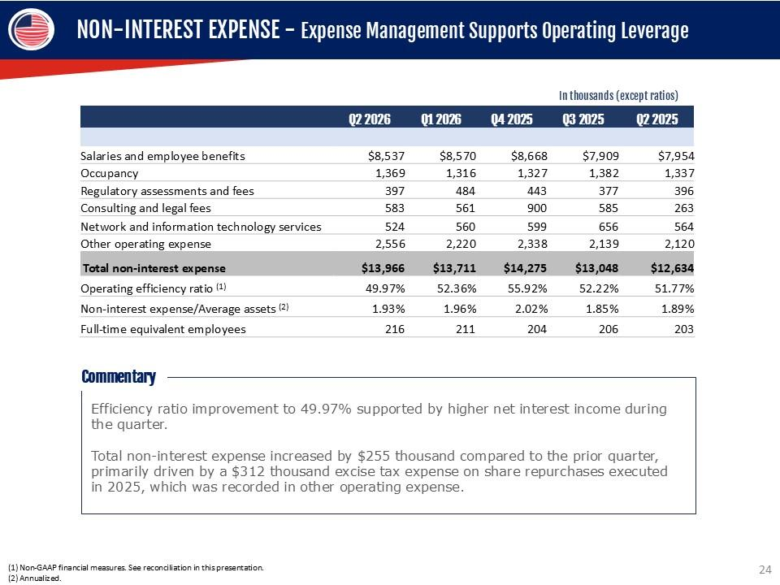
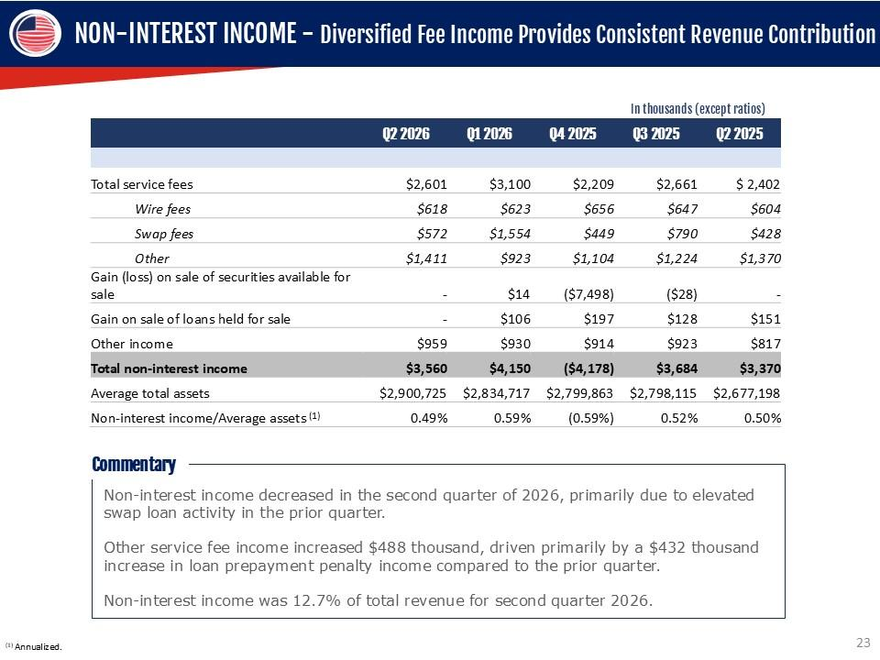
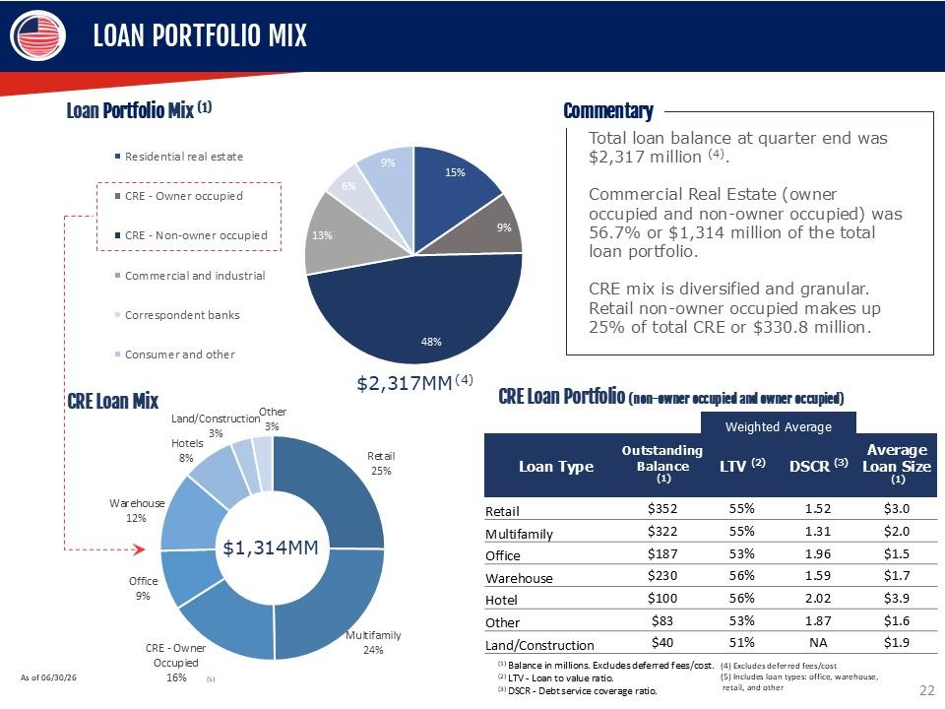
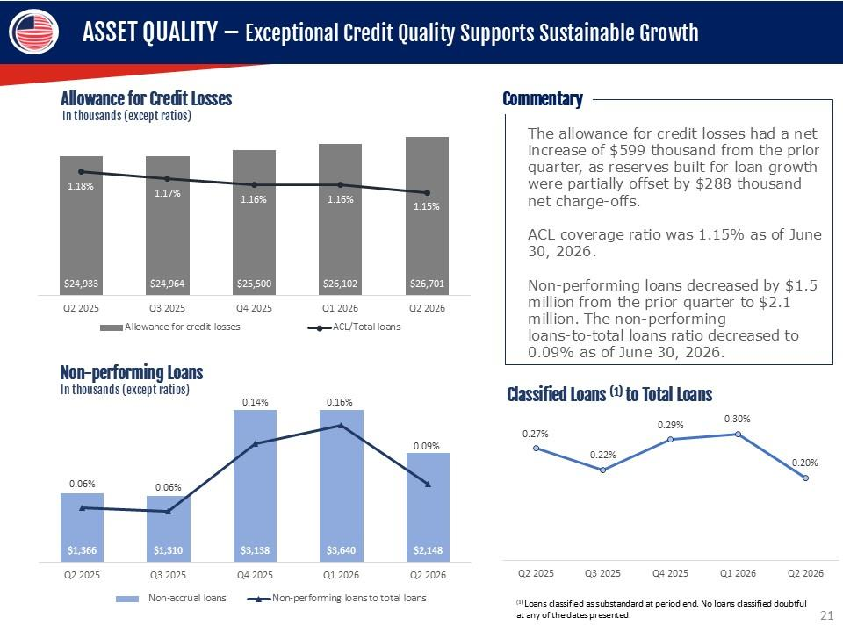
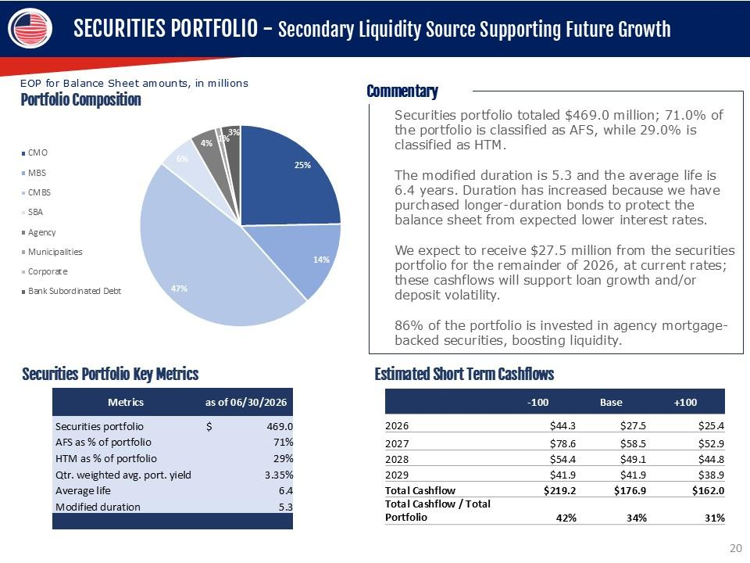

1

UNITED STATES

SECURITIES AND EXCHANGE COMMISSION

WASHINGTON,
D.C. 20549

__________________________

FORM

8-K

__________________________

CURRENT REPORT

Pursuant to Section 13 or 15(d) of the Securities Exchange Act
of 1934

Date of Report (Date of earliest event reported):

July 28, 2026

__________________________

USCB Financial Holdings, Inc.

(Exact name of Registrant as Specified in Its Charter)

__________________________

Florida

001-41196

87-4070846

(State or Other Jurisdiction

of Incorporation)

(Commission File Number)

(IRS Employer

Identification No.)

2301 N.W. 87th Avenue

,

Doral

,

Florida

33172

(Address of Principal Executive Offices)

(Zip Code)

Registrant’s Telephone
Number, Including Area Code: (

305

)

715-5200

__________________________

Check the appropriate box below if the Form 8-K filing is intended to simultaneously satisfy the filing obligation
of the registrant under

any of the following provisions:

☐

Written communications pursuant
to Rule 425 under the Securities Act (17 CFR 230.425)

☐

Soliciting material pursuant to Rule 14a-12 under the Exchange Act (17 CFR 240.14a
-12)

☐

Pre-commencement communications pursuant to Rule 14d-2(b)
under the Exchange Act (17 CFR 240.14d-2(b))

☐

Pre-commencement communications pursuant to Rule 13e-4(c) under the Exchange
Act (17 CFR 240.13e-4(c))

Securities registered pursuant to Section 12(b) of the Act:

Title of each class

Trading

Symbol(s)

Name of each exchange on which registered

Class A common stock, $1.00 par value per share

USCB

The Nasdaq Stock Market LLC

Indicate by
check mark
whether the
registrant is
an emerging
growth company
as defined
in Rule
405 of
the Securities
Act of
1933

(§ 230.405 of this chapter) or Rule 12b-2 of the Securities Exchange Act of 1934 (§ 240.12b
-2 of this chapter).

Emerging growth company

☒

If
an
emerging
growth
company,
indicate
by
check
mark
if
the
registrant
has
elected
not
to
use
the
extended
transition
period
for

complying with any new or revised financial accounting standards provided
pursuant to Section 13(a) of the Exchange Act.

☐

2

Item 7.01. Regulation FD Disclosure.

USCB Financial Holdings, Inc. (“the Company”)
is filing an investor presentation (the “Presentation”), which will be
used by

the
management
team
for
presentations
to
investors
and
others.
A
copy
of
the
Presentation
is
attached
hereto
as
Exhibit
99.1
and

incorporated
herein
by
reference.
The
Presentation
is
also
available
on
the
Company’s
website
at
investors.uscenturybank.com.

Information contained herein, including Exhibit 99.1,
is being furnished and shall not be deemed “filed” for the purposes of
Section 18

of the Securities Exchange Act of 1934,
as amended (“the Exchange Act”), or otherwise subject
to the liability of such section, and
shall

not be deemed incorporated by reference in any filing under the Securities Act of 1933, as amended,
or the Exchange Act, regardless of

any general incorporation language in such filing, except as shall be
expressly set forth by specific reference in such a filing.

Item 9.01. Financial Statements and Exhibits.

(d) Exhibits.

Exhibit No.

Description

99.1

USCB Financial Holdings, Inc. Investor Presentation Q2 2026

104

Cover Page Interactive Data File (embedded within the Inline XBRL document)

3

SIGNATURE

Pursuant to the requirements of the Securities Exchange Act of 1934, the registrant has duly
caused this report to be signed on

its behalf by the undersigned hereunto duly authorized.

USCB Financial Holdings, Inc.

By:

/s/ Robert Anderson

Name:

Robert Anderson

Title:

Chief Financial Officer

Date: July 28, 2026

Exhibit 99.1

SUCB FINANCIAL HOLDINGS INVESTOR PRESENTATION
SECOND QUARTER 2026 NASDAQ: USCB

FORWARD-LOOKING STATEMENTS This presentation
may contain statements that are not historical in nature and are
intended to be, and are hereby identified as, forward-looking statements
for purposes of the safe harbor provided by Section 21E of the
Securities Exchange Act of 1934, as amended. Forward-looking statements
are those that are not historical facts. The words “may,” “will,”
“anticipate,” “could,” “ should,” “would,” “believe,” “contemplate,”
“expect,” “aim,” “plan,” “estimate,” “continue,” “seek,” and
“intend,” the negative of these terms, as well as other similar words and expressions
of the future, are intended to identify forward-looking statements. These
forward-looking statements include, but are not limited to, statements
related to our projected growth, anticipated future
financial performance, and management’s long-term performance
goals, as well as statements relating to the anticipated effects
on our results of operations and financial condition from expected or potential
developments or events, or business and growth strategies, including
anticipated internal growth and potential future additional balance
sheet restructuring. All numbers included in this presentation are
unaudited unless otherwise noted. These forward-looking statements involve
significant risks and uncertainties that could cause our actual
results to differ materially from those anticipated in such statements.
Potential risks and uncertainties include, but are not limited to: the
strength of the United States economy in general and the
strength of the local economies in which we conduct operations; our
ability to successfully manage interest rate risk, credit risk, liquidity
risk, and other risks inherent to our industry; the accuracy
of our financial statement estimates and assumptions, including the estimates
used for our allowance for credit losses; the efficiency
and effectiveness of our internal control procedures and

processes; our ability to comply with the extensive laws and regulations
to which we are subject, including the laws for each jurisdiction
where we operate; adverse changes or conditions in the capital
and financial markets, including actual or potential stresses in
the banking industry; deposit attrition and the level of our uninsured
deposits; legislative or regulatory changes and changes, including
the enactment of the One Big Beautiful Bill, in accounting principles,
policies, practices or guidelines; the lack of a significantly diversified
loan portfolio and our concentration in the South Florida market,
including the risks of geographic, depositor, and industry concentrations,
including our concentration in loans secured by real estate,
in particular, commercial real estate; the effects of climate
change; the concentration of ownership of our common stock; fluctuations
in the price of our common stock; our ability to fund or access
the capital markets at attractive rates and terms and manage our growth,
both organic growth as well as growth through other means, such as
future acquisitions; inflation, interest rate, unemployment rate,
and market and monetary fluctuations; the effects of potential
new or increased tariffs, retaliatory tariffs and trade restrictions;
the impact of international hostilities and geopolitical events; increased
competition and its effect on the pricing of our products and services
as well as our net interest rate spread and net interest margin;
the loss of key employees; the effectiveness of our risk management
strategies, including operational risks, including, but not limited
to, client, employee, or fourth-party fraud and security breaches;
and other risks described in this presentation and other filings we
make with the Securities and Exchange Commission (“SEC”).
All forward-looking statements are necessarily only estimates of
future results, and there can be no assurance that actual results will not

differ materially from expectations. Therefore, you are cautioned
not to place undue reliance on any forward-looking statements. Further,
any forward-looking statements included in this presentation are
made only as of the date hereof, and we undertake no obligation
to update or revise any forward-looking statements to reflect events
or circumstances occurring after the date on which the statements
are made or to reflect the occurrence of unanticipated events,
unless required to do so under the federal securities laws. You
should also review the risk factors described in the reports USCB
Financial Holdings, Inc. has filed or will file with the SEC. Non
-GAAP Financial Measures This presentation includes financial information
determined by methods other than in accordance with generally
accepted accounting principles (“GAAP”). This financial information
includes certain operating performance measures. Management
has included
these non-GAAP financial measures because it believes these measures
may provide useful supplemental information for evaluating the
Company’s expectations and underlying performance trends.
Further, management uses these measures in managing and evaluating
the Company’s business and intends to refer to them in discussions
about our operations and performance. Operating performance
measures should be viewed in addition to, and not as an alternative to
or substitute for, measures determined in accordance
with GAAP, and are not necessarily comparable to non-GAAP
measures that may be presented by other companies. Reconciliations
of these non-GAAP measures to the most directly comparable
GAAP measures can be found in the Non-GAAP financial measures
reconciliation tables included in this presentation. 2

TABLE OF CONTENTS 1. Who We Are 2. Growth
Strategy 3. Financial Review 4. Appendix 3

WE ARE A RELATIONSHIP-FIRST BANK Company Overview
Founded in 2002, U.S. Century Bank is a state-chartered bank
headquartered in South Florida. 8th largest Florida headquartered
bank by deposits in Miami Dade County as of June 30, 2025. (1) Its
holding company formed in December 2021, USCB Financial Holdings,
Inc. (NASDAQ: USCB) is included in the Russell 3000 Index.
The Bank conducted its initial public offering in July 202
1, raising $40.0 million in equity capital. Full-service commercial
bank offering products and services tailored to meet the needs
of small-to-medium sized businesses, entrepreneurs and professionals
in South Florida (Miami-Dade, Broward, and Palm Beach
counties) SBA preferred lender, ranked as a top SBA 7(a)
community bank lender in Miami-Dade and Broward counties 5-star
Bauer Financial rating Assets $3.0B Loans $2.3B Deposits
$2.5B Equity $223M NPA/Assets 0.07% Total RBC 13.88%
ROAA 1.26% EPS $0.49 (1) FDIC Deposit Market Share Report
as of 6/30/25. (2) Loan amounts include deferred fees/costs.
(3) Company’s regulatory capital ratio. (4) Based on second quarter
2026. Annualized. (5) Fully Diluted EPS for the quarter ended June
30, 2026. Commercial Banking Focused on servicing small-to-medium-sized
businesses within branch footprint Offer relationship-focused
retail deposit products to owners and operators of SMBs Ability
for customers to access accounts through online and mobile banking
platforms Credit products include Asset-Based Loans, Lines of
Credit and Term Loans Provide Treasury Management
services to clients Relationship-driven with flexible solutions tailored
to each client’s need For the Company as of June 30, 2026.
South Florida 10 Branches 4

LOCATED IN A VIBRANT ECONOMY Florida is one of
the largest business markets in the country #2 in the U.S. for
SBA loan production (6,302 loans) and #3 in SBA lending volume
($3.2B) in 2025 (1) Ranked #3 best state for business (CNBC, July
2025) (2) Investment activity is supported by EB-5 programs
and luxury branded condominium and condo-hotel developments (3)
Corporate Relocations Fueling Economic Expansion Attracting hedge
funds, private equity, and tech firms — powered by a business
-friendly
climate and no state income tax, as exemplified by Citadel’s
relocation (7) Major employers including Amazon and Blackstone
keep expanding their Miami footprint (7) Strong corporate
demand has driven Class A office rents close to $60/sq ft and premium
office space exceeding $100/sq ft (8) Global Gateway Economy
#1 U.S. airport for international freight (MIA) (4) A leading U.S.
container port (PortMiami) (5) The world's
busiest cruise port (6) A diverse and vibrant economy South
Florida MSA: 6.4M residents — 8th-largest U.S. metro (4) Florida: 23.5M
residents (+1.9M since 2020) — 3rd-most-populous state
(4) #5 in the 2026 State Tax Competitiveness Index (9) Home
to 20+ Fortune 500 companies (2025) (10) DORAL HEADQUARTERS
Sources: (1) U.S Small Business Administration (2) CNBC (3) GlobeNewswire
(4) Federal Reserve Bank of ST. Louis (5) U.S. Bureau of Labor
Statistics (6) Census.gov (7) Fox Business (8) Miami Herald (9)
Tax Foundation (10) Fortune Magazine 5

SEASONED MANAGEMENT Luis de la Aguilera Chairman,
President & CEO Previously President & CEO of TotalBank 42+
years in banking Rob Anderson Chief Financial Officer Previously
CFO of Capstar Financial Holdings 20+ years in banking Oscar Gomez
Head of Global Banking Division Previously at Regions
Bank 32+ years in banking Maricarmen Logroño Chief Risk Officer
Previously at Doral Bank 22+ years in banking Nicholas Bustle Chief
Lending Officer Previously at Valley Bank 37+ years in
banking Sergio Garrido Chief Credit Officer Previously Director
of Credit Underwriting 15+ years in banking Martha Guerra-Kattou
Director of Sales & Marketing Previously at TotalBank 32+
years in banking Andres Collazo Director of Operations & IT
Systems Previously at TotalBank 35+ years in banking Seasoned
Management Team with Local Banking Experience 6

ACCOMPLISHED BOARD OF DIRECTORS Luis de la Aguilera
Chairman, President & CEO Previously President & CEO of TotalBank
Director since 2016 Aida Levitan Board Member President
the Levitan Group Director since 2013 Howard Feinglass Board
Member Managing Partner, Priam Capital Director since
2015 Ramon M. Rodriguez Board Member Former Market President
Seacoast Bank Director since 2026 Bernardo Fernandez, Jr.
Board Member Corporate Physician Executive, Broward Health Director
since 2017 Ramon A. Rodriguez, CPA Board Member Former
Chairman and Chief Executive Officer Cable Insurance
Director since 2022 Robert Kafafian Board Member Executive Advisor
Wolf & Company, P.C. Director since 2022
Maria C. Alonso Board Member Director, Axxes Capital Director
since 2022 Ramon M. Rodriguez Board Member Former Market
President Seacoast Bank Director since 2026 Highly Accomplished and Aligned
Board with Complementary Track Records 7

OUR STRATEGY Organic Loan Growth: Take advantage
of platform that we have developed post 2015 recapitalization, capitalize
on fragmented Miami-Dade MSA community banking market, and
continue to build market share Capitalize on inherent advantages
over smaller community banks which lack our product expertise and
breadth of service Due to significant consolidation, there exists a
base of potential clients that desire to partner with a bank that
is locally headquartered Team Lift-outs: Continue to bring
in top tier talent to U.S. Century Bank, with teams attracted
to culture, public currency and local decision making Overall growth success
will depend upon our ability to attract, retain, develop, incentivize,
and reward the human capital necessary to execute growth strategy
Attractive stock-based incentive compensation to attract top tier
talent Asset Purchases: Portfolio loan purchases; opportunistic to complement
organic growth initiatives Net capital can serve as dry powder
to facilitate meaningfully sized portfolio acquisitions Proactively
evaluating portfolio opportunities that are consistent with USCB’s
credit philosophy Strategic Acquisitions: Become an active acquirer
for Florida banks looking to find a partner Focused on strategic,
financially attractive acquisitions which support USCB’s organic
growth strategy without compromising the risk profile Numerous
potential partners in Miami-Dade MSA that may seek liquidity USCB
is positioned to offer stock consideration 8

BUSINESS VERTICALS Differentiated Banking Product Offerings
and Services Private Client Group (1) $328MM Deposits Deposit aggregating
focus/strategy. Tailored products & services for professionals,
professional firms, business owners, and affluent individuals and
their families. PCG also provides concierge-level banking service
for the legal and healthcare sectors delivering financial solutions
designed specifically for these professionals. Yacht Lending
$203MM Loans Yacht financing for larger vessels, transaction
range is $750k -$7.5MM. Brokered oriented business, 3 vendor
approved brokers. Member of the National Marine Lenders Association.
Launched this new vertical in 2022. Association Banking
$165MM Deposits / $135MM Loans Deposit aggregating focus/strat
egy. Banking for Homeowner Associations and Property
Managers. Offer deposit collection services and esoteric lending
solutions ranging from insurance premium and large capital improvement
s
financing. Significant lending capacity to target large credits.
SBA / Small Business Lending $64MM Loans Relationship
-oriented business focused on delivering fast loan commitments
to small and medium-sized enterprises. Predominately small business
line of credits and CD secured loans. Affordable SBA loan provider.
Approved by the SBA to participate in the Preferred Lenders
Program. Specialty banking products, services and solutions designed for
small businesses, homeowner associations, law firms, medical
practices and other professional services firms, yacht lending
and global banking services Correspondent Banking $245MM
Deposits / $139MM Loans Comprehensive range of both domestic
and international services with the latest in technology to ensure
quick processing. Focus on Caribbean and Latin American countries.
Correspondent banking services include letters of credit, foreign collections,
wire transfers,

ForEx and trade finance. Balances as of June 30, 2026. (1) Effective
4th quarter 2025, the Private Client Group vertical now includes balances
for the entire business unit, encompassing not only some Jurist Advantage
and Health Industry sectors, but also other professional and affluent client
segments. Accordingly, balances presented for PCG reflect
the full scope of the business unit, rather than select sectors as
previously reported. When evaluating period-over-period trends,
please consider this expanded scope. 9

DEPOSIT AGGREGATING VERTICALS Deposits Trend
(EOP) In millions $88 $229 $312 $352 $446 $492 $626 $686
$738 $48 $129 $138 $154 $177 $200 $265 $235 $245 $10 $38
$77 $68 $97 $112 $125 $146 $165 $30 $62 $97 $130 $172
$180 $236 $305 $328 2018 2019 2020 2021 2022 2023 2024 2025 Q2 2026
PCG HOA Corresponding Banking Commentary As of June 30, 2026,
deposits totaling $738 million were associated with the verticals.
Growth by vertical from 2018 to 2026: PCG (1): $298 million
.
HOA: $155 million. Correspondent Banking: $197 million. (1)
Effective 4th quarter 2025, the Private Client Group vertical
now includes balances for the entire business unit, encompassing
not only some Jurist Advantage and Health Industry sectors, but
also other professional and affluent client segments. Accordingly,
balances presented for PCG reflect the full scope of the business
unit, rather than select sectors as previously reported. When
evaluating period-over-period trends, please consider this expanded
scope.

Q2 2026 HIGHLIGHTS - Strong Earnings Growth Driven by Loan Production
& Margin Expansion GROWTH EOP assets surpassed $3.0 billion.
Average loans increased $81.2 million or 15.0% annualized
over Q1. Average deposit increased $61.9 million or 10.2% annualize
d
from Q1. Average DDA increased $47.4 million or 32.5% over
Q1. EARNINGS & PROFITABILITY ROAA was 1.26% and
ROAE was 15.90%. PTPP ROAA(1) was 1.93% improvement from
1.79% for Q1. Net income was $9.1 million, or $0.49 per diluted
share. Net interest income before provision for credit losses increased
to $24.4M, up $2.3 million or 42.6% annualized over Q1. Net interest
margin improved to 3.49% from 3.27% for Q1. Deposit cost decreased
4 bps to 2.16% from Q1. Efficiency ratio was 49.97% improvement from
52.34%
for Q1. CAPITAL/ CREDIT Non-performing loans totaled
$2.1 million or 0.09% of total loans. ACL coverage
ratio was 1.15% of total loans. Net charge-offs to average loans was 0.05% Total
risk-based capital ratio was 13.88% for the Company. (1) Non
-GAAP financial measure. See reconciliation in this presentation.
11

HISTORICAL FINANCIALS – Consistent Growth, Profitability and
Credit Discipline Loans In millions $765 $2,322 2017 2018 2019
2020 2021 2022 2023 2024 2025 Q2 2026 EOP for Balance
Sheet amounts In millions $820 $2,452 2017 2018 2019 2020 2021 2022
2023 2024 2025 Q2 2026 Total Stockholders’ Equity In millions
$114 $233 2017 2018 2019 2020 2021 2022 2023 2024 2025
Q2 2026 ACL/Total Loans 1.33% 1.15% 2017 2018 2019 2020
2021 2022 2023 2024 2025 Q2 2026 Net Charge-offs (recoveries)
In thousands ($2,182) $288 2017 2018 2019 2020 2021 2022 2023 2024 2025
Q2 2026 Nonperforming Assets / Total Assets 0.17%
0.07% 2017 2018 2019 2020 2021 2022 2023 2024 2025 Q2
2026 Net Interest Income In millions $31 $84 2017 2018 2019 2020
2021 2022 2023 2024 2025 Q2 2026 Efficiency Ratio 86.65%
49.97% 2017 2018 2019 2020 2021 2022 2023 2024 2025 Q2 2026
PTPP ROAA 0.52% 1.93% 2017 2018 2019 2020 2021 2022 2023
2024 2025 Q2 2026 (1) Loan amounts include deferred fees/costs.
(2) ACL was calculated under the CECL standard methodology for
all periods beginning January 1, 2023, and the incurred loss methodology
for all periods before. (3) Non-GAAP financial measure.
See reconciliation
in this presentation. 12

FINANCIAL RESULTS – Strong Operating Performance
Driven by Balance Sheet Growth Balance Sheet (EOP) Income In thousands
(except per share data) Statement Q2 2026 Q1 2026 Q2 2025 Total
Securities $468,986 $427,091 $444,122 Total Loans (1) $2,322,385
$2,241,051 $2,113,318 Total Assets $3,019,701 $2,845,735
$2,719,474 Total Deposits $2,452,271 $2,493,580 $2,335,661
Total Equity (2) $233,238 $223,246 $231,583 Net Interest
Income $24,387 $22,048 $21,034 Non-Interest Income $3,560
$4,150 $3,370 Total Revenue (3) $27,947 $26,198 $24,404
Provision for Credit Losses $1,267 $801 $1,031 Non-Interest Expense
$13,966 $13,711 $12,634 Income Before Income Taxes
$12,714 $11,686 $10,739 Income Tax Expense $3,636 $2,335
$2,599 Net Income $9,078 $9,351 $8,140 Diluted Earnings Per
Share (EPS) $0.49 $0.51 $0.40 PTPP Income (4) $13,981 $12,487
$11,770 Weighted Average Diluted Shares 18,509,572 18,454,006
20,295,794 (1) Loan amounts include deferred fees/costs. (2)
Total Equity includes accumulated other comprehensive
loss of $31.4 million for Q2 2026, $31.3 million for Q1 2026, and
$41.8 million for Q2 2025. The increase in total stockholders’
equity was partially offset by the cost of the repurchase of 2.0 million shares
of Class A common stock in September 2025, as previously
disclosed. (3) Equals net interest income plus non-interest income.
(4) Non-GAAP financial measures. See reconciliation in this presentation.
13

KEY PERFORMANCE INDICATORS - Profitable Growth
Driving Shareholder Value In thousands (except for
TBV/share and ratios) Q2 2026 Q1 2026 Q2 2025 GROWTH PROFITABILITY
CAPITAL/CREDIT Total Assets (EOP) $3,019,701 $2,845,735
$2,719,474 Total Loans (EOP) (1) $2,322,385 $2,241,051
$2,113,318 Total Deposits (EOP) $2,452,271 $2,493,580
$2,335,661 Tangible Book Value/Share (2)(3)(5)
$12.64 $12.23 $11.53 Return On Average Assets (4) 1.26% 1.34%
1.22% PTPP Return On Average Assets (4)(5) 1.93% 1.79%
1.76% Return On Average Equity (4) 15.90% 17.07% 14.29%
Net Interest Margin (4) 3.49% 3.27% 3.28% Efficiency Ratio 49.97%
52.34% 51.77% Tangible Common Equity/Tangible Assets
(3)(5) 7.72% 7.84% 8.52% Total Risk-Based Capital (6)
13.88% 14.09% 13.73% NCO/Avg Loans (4) 0.05% 0.00%
0.14% NPA/Assets 0.07% 0.13% 0.05% Allowance for
Credit Losses/Loans 1.15% 1.16% 1.18% (1) Loan amounts include deferred
fees/costs. (2) AOCI effect on tangible book value per share was ($1.70)
for Q2 2026, ($1.72) for Q1 2026 and ($2.08) for Q2 2025. (3) TBV/share
and TCE/TA were affected by the effect of the cost of the
repurchase of 2.0 million shares of Class A common stock in September
2025 in stockholders' equity, as previously disclosed. (4) Annualized.
(5) Non-GAAP financial measure. See reconciliation in this
presentation. (6) Reflects the Company's regulatory capital ratios.
14

DEPOSIT PORTFOLIO – DDA Above $600MM Drives Lower
Deposit Costs and Margin Expansion Deposits AVG In
millions $2,291 $2,457 $2,453 $2,427 $2,489 $1,711 $1,887 $1,857
$1,842 $1,857 $580 $570 $596 $585 $632 Q2 2025 Q3 2025
Q4 2025 Q1 2026 Q2 2026 Non-interest-beraing demand deposits Interst-bearing
deposits Deposit EOP In millions $2,336 $2,456 $2,345 $2,494
$2,452 $462 $520 $528 $552 $532 $1,248 $1,292 $1,186 $1,264
$1,252 $41 $60 $47 $57 $50 $585 $584 $584 $621 $618 Q2 2025 Q3
2025 Q4 2025 Q1 2026 Q2 2026 Non-interest-bearing demand deposits
Interest-bearing checking deposits Saving and money market deposits
Time deposits Q2 2025 Q3 2025 Q4 2025 Q1 2026 Q2 2026 Interest
-Bearing Deposits 3.29% 3.29% 3.02% 2.89% 2.90% Total
Deposits (1) 2.46% 2.53% 2.28% 2.20% 2.16% Commentary
Average DDA deposits increased by $47.4 million or 32.5% annualized
compared to prior quarter. Average deposits totaled $2.5
billion, reflecting an increase of $61.9 million or 10.2% annualized
compared to prior quarter and an increase of $198.3 million or 8.7%
compared to the second quarter of 2025. Deposit cost improved
to 2.16%, decreasing 4 bps quarter-over-quarter and 30 bps year-over-year.
Deposit Cost (1) Reflects effects of non-interest-bearing deposits. Reflects
effects of non-interest-bearing demand deposits. 15

LOAN PORTFOLIO – Loan Growth Momentum Positions USCB
for Sustained Performance Total Loans (AVG) In
millions 6.23% 6.21% 6.16% 6.11% 6.20% $2,057 $2,099 $2,131
$2,178 $2,259 Q2 2025 Q3 2025 Q4 2025 Q1 2026 Q2 2026 Loans
Loan Yields Total Gross Loans (EOP) (1) In millions
$211MM Net Growth $2,106 $2,125 $2,183 $2,234 $2,317 $218 $208
$207 $208 $208 $110 $105 $128 $128 $138 $264 $269 $296 $291
$300 $307 $317 $308 $347 $357 1207 1226 1245 1260 1314
Commercial real estate Residential real estate Commercial and Industrial
Correspondent banks Consumer and other Commentary Average
loans increased $81.2 million or 14.96% annualized compared to prior
quarter and $201.5 million or 9.8% compared to second
quarter 2025. Loan yield increased to 6.20% in Q2 2026, driven
by the full-quarter impact of prior-quarter originations and new loans
added during the quarter. (1) Excludes deferred fees/cost.
16

LOAN PRODUCTION – Record Quarterly Loan Production of $272 Million
Net Loan Production Trend In millions, except for ratios 7.12%
6.43% 5.93% 5.87% 5.90% $187 $110 $132 $113 $196 $137
$188 $136 $272 $189 Q2 2025 Q3 2025 Q4 2025 Q1 2026 Q2
2026 Loan Production/Line changes Loan Amortization/payoffs
New loans weighted average coupon Loan Composition Trend
EOP (1) In millions, except for ratios $948 $2,317 28% 15%
63% 57% 9% 28% Jun-26 Jun-26 Real Estate Loans (1) Excludes
deferred fees/cost. Commentary Gross loan production totaled $272.0
million during the second quarter of 2026, with June closings accounting
for $116.5 million or 42.6%, of total quarterly production. Additionally,
$83.5 million, or 30.6% of quarterly loan closings, consisted of
correspondent banking loans, which carried a new-loan yield of 5.22%;
these loans are typically 180-day notes. Excluding correspondent
banking loan production, the weighted-average yield on new loans
originated during the quarter was 6.20%. Embedded prepayment penalties
help protect yield and earnings in the event of early loan prepayments.
17

NET INTEREST MARGIN – NIM Driven by Loan Growth and Stable
Funding Cost Net Interest Income/Margin (1) In thousands (except
ratios) 3.28% 3.14% 3.27% 3.27% 3.49% $21,034 $2,174 $22,207
$22,048 $24,387 Q2 2025 Q3 2025 Q4 2025 Q1 2026 Q2 2026 Net
Interest Income NIM Interest-Earning Assets Mix (AVG)
2% 4% 3% 4% 3% 18% 18% 18% 7% 16% 80% 78% 79%
79% 81% Q2 2025 Q3 2025 Q4 2025 Q1 2026 Q2 2026 Total
Loans Investment Securities Cash Balances & Equivalents Q2
2025 Q3 2025 Q4 2025 Q1 2026 Q2 2026 Loans 6.23% 6.21% 6.16%
6.11% 6.20% Investment securities 3.06% 3.03% 3.01% 3.05%
3.35% Interest-earning assets 5.64% 5.56% 5.54% 5.49% 5.67%
Deposits (2) 2.46% 2.53% 2.28% 2.20% 2.16% Interest-bearing
liabilities 3.32% 3.34% 3.14% 3.05% 3.05% Commentary Net
interest income
increased $2.3 million or 42.6% annualized compared to prior
quarter and $3.4 million or 15.9% compared to second quarter
2025. Interest-earning asset mix shifted toward higher-yielding assets, while
lower funding costs and the increase in yields drove net interest
income and a 3.49% NIM. Interest Rates and Yields Annualized.
Reflects effects of non-interest-bearing deposits. 18

INTEREST RATE SENSITIVITY - Well Positioned to Navigate
Interest Rate Volatility Loan Portfolio Repricing Profile
by Rate Type Hybrid ARM $85MM 4% Fixed Rate $851MM
37% $2,317MM Variable Rate $1,381MM 59% $535MM
36% $114MM 8% $817MM 56% Loan Repricing Schedule
Variable & Hybrid Rate Loans $387MM 27% $794MM 54%
$163MM 11% $122M 8% $387MM 27% $1,466MM 0-1 yrs. 1-2
yrs. 2-3 yrs. >3 yrs. Static NII Simulation Year 1 & 2 Year
1 Variable & Hybrid Rate Loans 2.6% -100 +100 -3.1% Year
2 -100 -2.3% 0.9% +100 Net Interest Income change from base
($ in thousands and % change) 19

SECURITIES PORTFOLIO - Secondary Liquidity Source Supporting
Future Growth EOP for Balance Sheet amounts, in millions Portfolio
Composition CMO 25% MBS 14% CMBS 47% SBA6% Agency 4%
Municipalities 1% Corporate 3% Bank Subordinated Debt Securities
Portfolio Key Metrics Metrics as of 06/30/2026 Securities portfolio
$ 469.0 AFS as % of portfolio 71% HTM as % of portfolio 29% Qtr.
weighted avg. port. yield 3.35% Average life 6.4 Modified
duration 5.3 Commentary Securities portfolio totaled $469.0 million
;
71.0% of the portfolio is classified as AFS, while 29.0% is classified
as HTM. The modified duration is 5.3 and the average life is 6.4 years.
Duration has increased because we have purchased longer-duration
bonds to protect the balance sheet from expected lower interest rates.
We expect to receive $27.5 million from the securities portfolio
for the remainder of 2026, at current rates; these cashflows will support
loan growth and/or deposit volatility. 86% of the portfolio
is invested in agency mortgage-backed securities, boosting liquidity.
Estimated Short Term Cashflows -100 Base +100 2026
$44.3 $27.5 $25.4 2027 $78.6 $58.5 $52.9 2028 $54.4 $49.1 $44.8
2029 $41.9 $41.9 $38.9 Total Cashflow $219.2 $176.9 $162.0
Total Cashflow / Total Portfolio 42% 34% 31% 20

ASSET QUALITY – Exceptional Credit Quality Supports Sustainable
Growth Allowance for Credit Losses In thousands (except
ratios) 1.18% 1.17% 1.16% 1.16% 1.15% $24,933 $24,964 $25,500 $26,102
$26,701 Q2 2025 Q3 2025 Q4 2025 Q1 2026 Q2 2026 Allowance
for credit loss ACL/Total loans Non-performing Loans In thousands
(except ratios) 0.06% 0.06% 0.14% 0.16% 0.09% $1,366 $1,310
$3,138 $3,640 $2,148 Q2 2025 Q3 2025 Q4 2025 Q1 2026 Q2 2026
Non-accrual loans Non-performing loans to total loans Commentary
The allowance for credit losses had a net increase of $599 thousand
from the prior quarter, as reserves built for loan growth were
partially offset by $288 thousand net charge-offs. ACL coverage ratio
was 1.15% as of June 30, 2026. Non-performing loans decreased
by $1.5 million from the prior quarter to $2.1 million. The non-performing
loans-to-total loans ratio decreased to 0.09% as of June 30, 2026.
Classified Loans (1) to Total Loans 0.27% 0.22% 0.29% 0.30%
0.20% Q2 2025 Q3 2025 Q4 2025 Q1 2026 Q2 2026 (1) Loans
classified as substandard at period end. No loans classified doubtful
at any of the dates presented. 21

LOAN PORTFOLIO MIX Loan Portfolio Mix (1) Residential real
estate 15% CRE- Owner occupied 9% CRE – Non-owner occupied
48% Commercial and industrial 13% Correspondent Banks 6%
Consumer and other 9% $2,317MM Commentary Total loan
balance at quarter end was $2,317 million (4). Commercial Real
Estate (owner occupied and non-owner occupied) was 56.7% or
$1,314 million of the total loan portfolio. CRE mix is diversified
and granular. Retail non-owner occupied makes up 25% of
total CRE or $330.8 million.
CRE Loan Mix Retail 25% Multifamily 24% CRE – Owner occupied
16% Office 9% Warehouse 12% Hotels 8% Land/Construction
3% Other 3% $1,314MM CRE Loan Portfolio (non-owner occupied
and owner occupied) Weighted Average Loan
Type Outstanding Balance (1) LTV (2) DSCR (3) Average
Loan Size (1) Retail $352 55% 1.52 $3.0 Multifamily $322 55% 1.31
$2.0 Office $187 53% 1.96 $1.5 Warehouse $230 56% 1.59 $1.7
Hotel $100 56% 2.02 $3.9 Other $83 53% 1.87 $1.6 Land/Construction
$40 51% NA $1.9 As of 06/30/26 (1) Balance in millions. Excludes
deferred fees/cost. (2) LTV - Loan to value ratio. (3)
DSCR - Debt service coverage ratio. (4) Excludes deferred
fees/cost (5) Includes loan types: office, warehouse, retail, and other 22

NON-INTEREST INCOME - Diversified Fee Income Provides
Consistent Revenue Contribution In thousands (except ratios) Q2 2026
Q1 2026 Q4 2025 Q3 2025 Q2 2025 Total service fees
$2,601 $3,100 $2,209 $2,661 $ 2,402 Wire fees $618 $623 $656 $647
$604 Swap fees $572 $1,554 $449 $790 $428 Other $1,411
$923 $1,104 $1,224 $1,370 Gain (loss) on sale of securities
available for sale - $14 ($7,498) ($28) - Gain on sale of loans
held for sale - $106 $197 $128 $151 Other income $959 $930 $914
$923 $817 Total non-interest income $3,560 $4,150 ($4,178)
$3,684 $3,370 Average total assets $2,900,725 $2,834,717
$2,799,863 $2,798,115 $2,677,198 Non-interest income/Average
assets (1) 0.49% 0.59% (0.59%) 0.52% 0.50% Commentary Non-interest
income decreased in the second quarter of 2026, primarily due to
elevated swap loan activity in the prior quarter. Other service
fee income increased $488 thousand,
driven primarily by a $432 thousand increase in loan prepayment
penalty income compared to the prior quarter. Non-interest income
was 12.7% of total revenue for second quarter 2026. (1) Annualized.
23

NON-INTEREST EXPENSE - Expense Management Supports Operating
Leverage In thousands (except ratios) Q2 2026 Q1 2026 Q4 2025 Q3
2025 Q2 2025 Salaries and employee benefits $8,537 $8,570 $8,668
$7,909 $7,954 Occupancy 1,369 1,316 1,327 1,382 1,337 Regulatory
assessments and fees 397 484 443 377 396 Consulting and legal
fees 583 561 900 585 263 Network and information technology services
524 560 599 656 564 Other operating expense 2,556 2,220 2,338
2,139 2,120 Total non-interest expense $13,966 $13,711
$14,275 $13,048 $12,634 Operating efficiency ratio (1) 49.97%
52.36% 55.92% 52.22% 51.77% Non-interest expense/Average
assets (2) 1.93% 1.96% 2.02% 1.85% 1.89% Full-time equivalent employees
216 211 204 206 203 Commentary Efficiency ratio improvement
to 49.97% supported by higher net interest income during
the quarter. Total non-interest expense increased by $255
thousand compared to the prior quarter, primarily driven by a $312
thousand excise tax expense on share repurchases executed
in 2025, which was recorded in other operating expense. (1) Non-GAAP financial
measures. See reconciliation in this presentation. (2) Annualized.
24

CAPITAL - Strong Capital Levels Support Continued Organic Growth
Capital Ratios (1) Leverage Ratio TCE/TA (2) Tier 1 Risk-Based
Capital Total Risk-Based Capital AOCI In Millions Q2 2026 8.81%
7.72% 11.01% 13.88% ($31.4) Q1 2026 8.61% 7.84% 11.09%
14.09% ($31.3) Q2 2025 9.72% 8.52% 12.52% 13.73% ($41.8) Well
-
Capitalized 5.00% NA 8.00% 10.00% Commentary On July 20, 2026,
the Company’s Board of Directors declared a quarterly cash
dividend of $0.125 per share on the Company’s Class A common stock.
The dividend will be payable on September 4, 2026, to shareholders
of record as of the close of business on August 17, 2026. Q2 2026 EOP
common stock shares outstanding: 18,459,470. AOCI was ($31.4)
million or ($1.70) per share as of June 30, 2026. (1) Reflects the
Company's regulatory capital ratios. (2) Non-GAAP financial
measures. See reconciliation in this presentation. 25

TAKEAWAYS - Attractive Franchise Positioned
for Continued Growth Leading franchise located in one of the
most attractive banking markets in U.S. Scarcity value in the Miami MSA
Robust capital position with regulatory ratios well in excess of “well
capitalized” threshold Low risk, commercially oriented loan
portfolio Demonstrated profitability profile since 2015 recap
further improved by current management team Strong asset quality
– minimal charge-offs experienced since 2015 recap
Attractive deposit base driven by steady growth in specialized verticals Balanced
liquidity profile with a 94.7% loan/deposit ratio (EOP) 26

APPENDIX – RISK MANAGEMENT Risk Management Philosophy and
Culture Management has instilled a culture of adherence
to well-developed risk management procedures. Management is responsible
for day-to-day risk management (identifying, evaluating, and addressin
g
existing and potential risks that may exist at the enterprise, strategic,
financial, operational, compliance and reporting levels). The
risk management and compliance division consists of twenty-two
professionals covering enterprise risk management, cybersecurity,
third-party risk, bank secrecy, consumer compliance, regulatory,
corporate, and legal affairs. The division plays an active
role in assessing corporate risks, compliance and collaborating with
management to mitigate identified risks. Heightened focus on BSA / AML
/ KYC compliance due to foreign exposure. Individual country
loan exposure limited to between 0% - 70% of total capital based
on individual country risk. Correspondent banking services
offered exclusively to institutions in countries meeting U.S. Century’s
robust risk tolerance framework. Highly experienced
compliance team with international compliance experience
from larger banking institutions. The audit and risk committee of the board
of directors consists of four members primarily responsible for oversight
of Company’s risk management, compliance, and internal controls:
Ramon Rodriguez (Chair), Bernardo Fernandez, Ramón Abadin and
Maria Alonso. Credit Philosophy Conservative credit culture that
encourages prudent and desirable lending activities over unchecked
growth. Underwriting strength stems from deep understanding
of U.S. Century’s market, long-standing relationships with clients,
and a disciplined underwriting and credit review process.
Focused on maintaining a well-diversified and conservative loan portfolio.
Robust Credit Administration Underwriting group supported by

experienced credit officers with both credit analysis and lending experience.
Effective and independent loan review. Credit Committee
meetings conduct in-depth loan portfolio monitoring, including concentration
limits. Active monitoring and reporting on existing or emerging concentrations
and targeted reviews of any higher risk portfolios. 27

APPENDIX – TECHNOLOGY SUPPORT 2016 Paperless Account
Opening January ‘16 – April ‘16 International Letter Of Credit April
‘16 – July ‘16 "Reporting Database May ‘16 – September ‘16
" EMV Debit Cards August ‘16 – October ‘16

2017 Instant Issue Debit Card October ‘16 – March ‘17 Cash
Management Portal August ‘16 – March ‘17 Fedlink Anywhere
April ‘17 – September ‘17 2018 Network In-housing January ‘18
– September ‘18 "Secureworks MSSP

January ‘18 – May ‘18" OFFICE 365 February ‘18 – September
‘18 2019 Horizon Core Conversion September ‘18 – September
‘19 Zelle P2P June ‘19 – November ‘19 Image Deposit ATM
March ‘19 – December ‘19 2020 Accounts Payable November
‘19 – January ‘20 Collaboration Applications February ‘20 – March
‘20 PPP Loan Origination System May ‘20 – June ‘20 2021
Summit PPP Loan Origination January ‘21 – February ‘21 "Treasury
Management Platform

November ‘20 – October ‘21 " Immutable backup solution
Jan ‘21– June ‘21 "CECL and ALLL Application

June ‘21 – December ‘21"

Contuned next slide

APPENDIX – TECHNOLOGY SUPPORT 2022 "Remote Account
Opening October ‘21 – March ‘22" "Secureworks MXDR platform
Feb ‘22 – July 22’" Ring Central call reporting October ‘22 –
March ‘23 2023 "Loan origination system June ‘22 – May ‘23"
FED Now payments January ‘23 – October ‘23 2024 Pidgin real
time payments January ‘23 – October ‘23 Check fraud application 2025
- 2026 CRM system Zelle for Small Business Financial reporting
application Microsoft CoPilot GenAI ACH Positive Pay/ACH
Alert Account analysis solution Crowd Strike Solution Power
Automate front end automation Commercial Account Opening PBX
(SaaS) – Teams Calling November ‘23– April ‘25 Wire
fraud application Ascent LOS front end Cloud (Iaas) for DR environment
July ‘23 – May ‘25 Perplexity Pro AI (Enterprise) AFS ACH
Positive Pay Retina wire & ACH Fraud Solution 29

APPENDIX – NON-GAAP RECONCILIATION In thousands
(except ratios)

As of or For the Three Months Ended

6/30/2026 3/31/2026 12/31/2025 9/30/2025 6/30/2025 Pre-tax
pre-provision ("PTPP") income: Net income $ 9,078 $ 9,351 $ 1,363
$ 8,939 $ 8,140 Plus: Income tax expense 3,636 2,335
1,911 2,866 2,599 Plus: Provision for credit losses 1,267 801 480 105
1,031 PTPP income $ 13,981 $ 12,487 $ 3,754 $ 11,910 $
11,770 PTPP return on average assets: PTPP income $ 13,981
$ 12,487 $ 3,754 $ 11,910 $ 11,770 Average assets
$ 2,900,725 $ 2,834,717 $ 2,799,863 $ 2,798,115 $ 2,677,198
PTPP return on average assets 1.93% 1.79% 0.53% 1.69% 1.76% Operating
net income: Net income $ 9,078 $ 9,351 $ 1,363 $ 8,939 $ 8,140
Less: Net gains (losses) on sale of securities - 14 (7,498) (28)
- Less: Tax effect on sale of securities - (4) 1,900 7 - Plus:
Tax (benefit) liability expense from prior periods - (640) (619)
1,096 - Operating net income $ 9,078 $ 8,722 $ 8,057 $ 8,960 $ 8,140
Operating return on average assets: Operating net income $ 9,078
$ 8,722 $ 8,057 $ 8,960 $ 8,140 Average assets $ 2,900,725
$ 2,834,717 $ 2,799,863 $ 2,798,115 $ 2,677,198 Operating net
income return on average assets 1.26% 1.25% 1.14% 1.27% 1.22% Operating
return on average equity: Operating net income $ 9,078 $ 8,722
$ 8,057 $ 8,960 $ 8,140 Average equity $ 228,933 $ 222,226
$ 212,393 $ 225,316 $ 228,492 Operating net income return
on average equity 15.90% 15.92% 15.05% 15.78% 14.29% Operating
revenue: Net interest income $ 24,387 $ 22,048 $ 22,207 $ 21,274
$ 21,034 Non-interest income 3,560 4,150 (4,178) 3,684 3,370
Less: Net gains (losses) on sale of securities - 14 (7,498) (28) - Operating
revenue $ 27,947 $ 26,184 $ 25,527 $ 24,986 $ 24,404 Operating
efficiency ratio: Total non-interest expense $ 13,966 $ 13,711
$ 14,275 $ 13,048 $ 12,634 Operating revenue $ 27,947 $ 26,184

$ 25,527 $ 24,986 $ 24,404 Operating efficiency ratio 49.97% 52.36%
55.92% 52.22% 51.77%

Footnotes:

(1) The Company believes these non-GAAP financial measurements are
key indicators of the ongoing earnings power of the Company. (2)
Annualized. (3) The Company recognized a $619 thousand
income tax benefit in the first quarter of 2026 due to an adjustment
to the deferred tax asset calculation from 2025. (4) State tax liability expenses
for 2024 and for the first three quarters of 2025 were recognized
during the fourth quarter of 2025. The state tax expense is related to
taxes due on interest income on loans whose collateral is located
outside of the State of Florida. 30

APPENDIX – NON-GAAP RECONCILIATION In thousands
(except ratios and share data)

As of or For the Three Months Ended

6/30/2026 3/31/2026 12/31/2025 9/30/2025 6/30/2025 Tangible
book value per common share (at period-end): (1)(4) Total
stockholders' equity $ 233,238 $ 223,246 $ 217,183 $ 209,095 Less:
Intangible assets - - - - Tangible stockholders' equity (3) $ 233,238
$ 223,246 $ 217,183 $ 209,095 Total shares issued and outstanding
(at period-end): Total common shares issued and outstanding
18,459,470 18,257,400 18,137,885 18,107,385 Tangible book
value per common share (2) $ 12.64 $ 12.23 $ 11.97 $ 11.55 Operating
diluted net income per common share: (1) Operating net income
$ 9,078 $ 8,722 $ 8,057 $ 8,960 Total weighted average
diluted shares of common stock 18,509,572 18,454,006 18,348,725 19,755,820
Operating diluted net income per common share: $ 0.49 $ 0.47
$ 0.44 $ 0.45 Tangible Common Equity/Tangible Assets (1)(4)
Tangible stockholders' equity (3) $ 233,238 $ 223,246 $ 217,183
$ 209,095 Tangible total assets (3) $ 3,019,701 $ 2,845,735
$ 2,791,540 $ 2,767,945 Tangible Common Equity/Tangible
Assets 7.72% 7.84% 7.78% 7.55%

Footnotes:

(1) The Company believes these non-GAAP financial measurements are
key indicators of the ongoing earnings power of the Company. (2)
Excludes the dilutive effect, if any, of shares of common stock
issuable upon exercise of outstanding stock options. (3) Since
the Company has no intangible assets, tangible stockholders' equity and
tangible total assets are the same amounts as stockholders' equity
and total assets, respectively, as calculated under GAAP. (4)
The decrease in total stockholders' equity in September 2025 was
primarily driven by the repurchase of 2.0 million shares
of Class A common stock, as previously disclosed. 31

CONTACT INFORMATION LOU DE LA AGUILERA
Chairman, President & CEO (305) 715-5186 ROB ANDERSON
EVP, Chief Financial Officer (305) 715-5393 rob.anderson@uscentury.com
laguilera@uscentury.com INVESTOR RELATIONS InvestorRelations@uscentury.com
32

