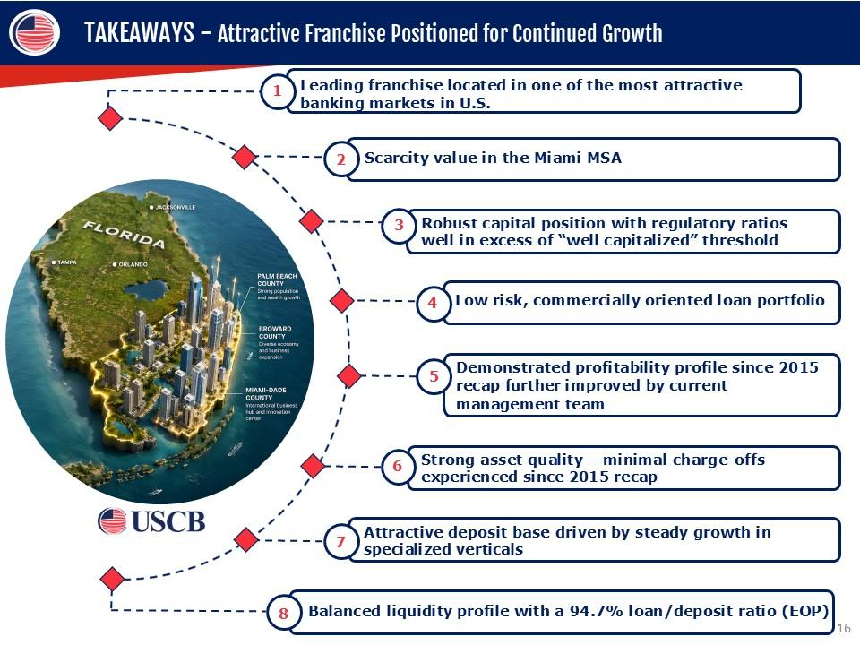
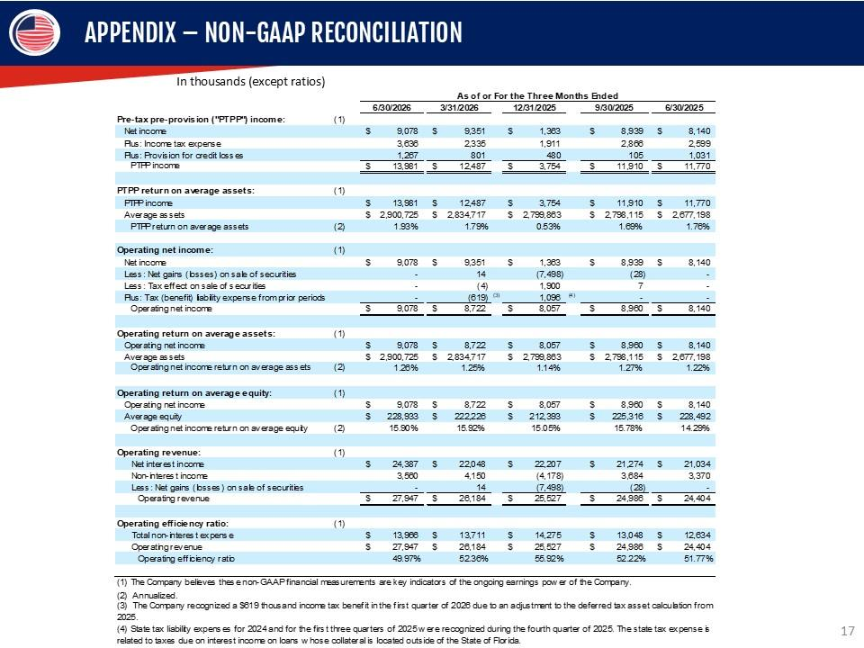
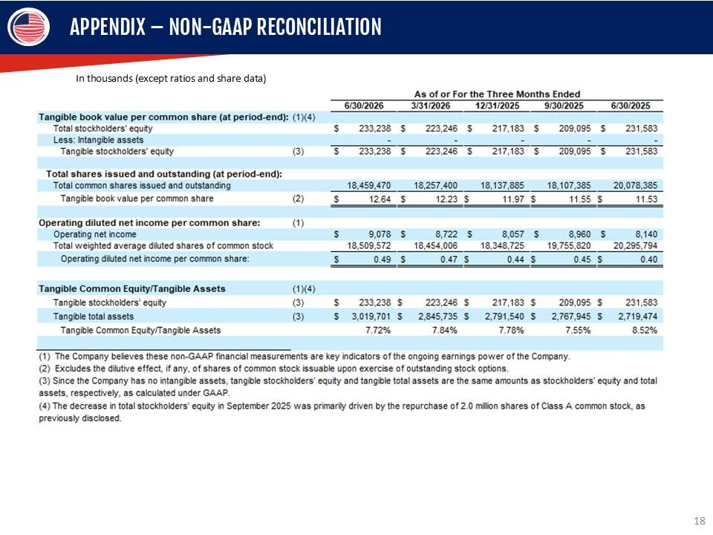
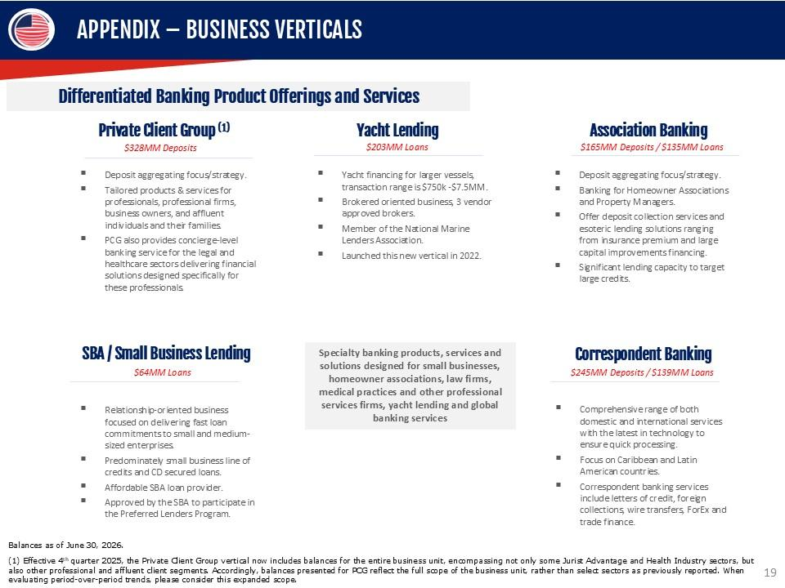
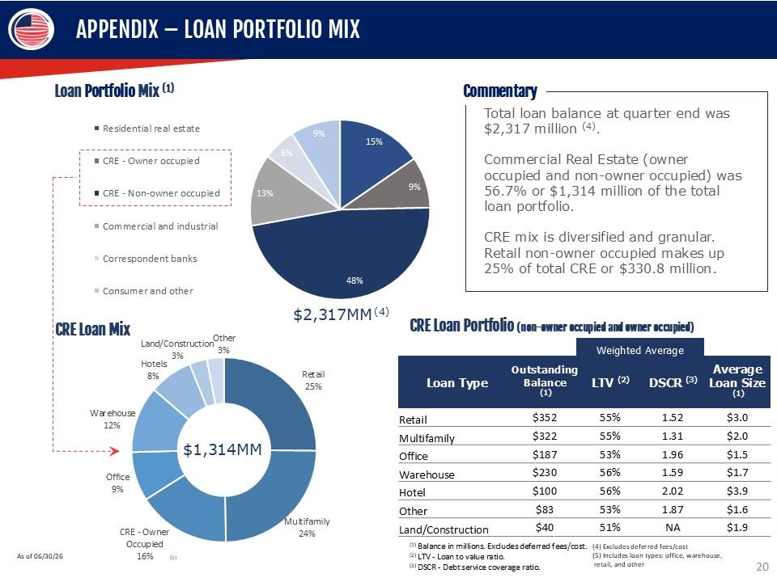
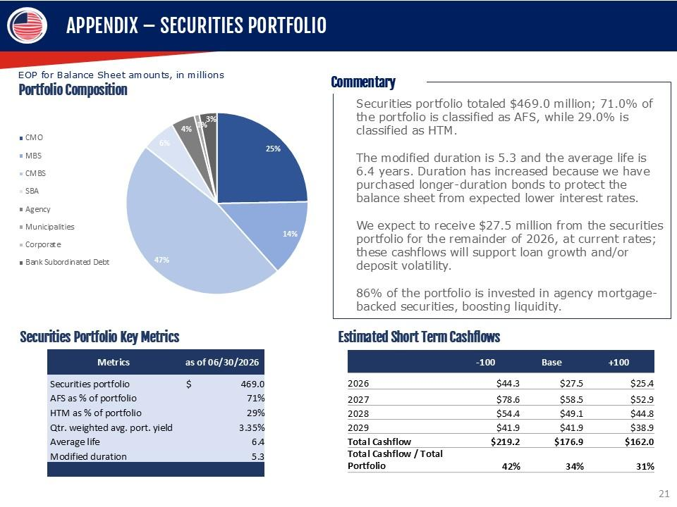
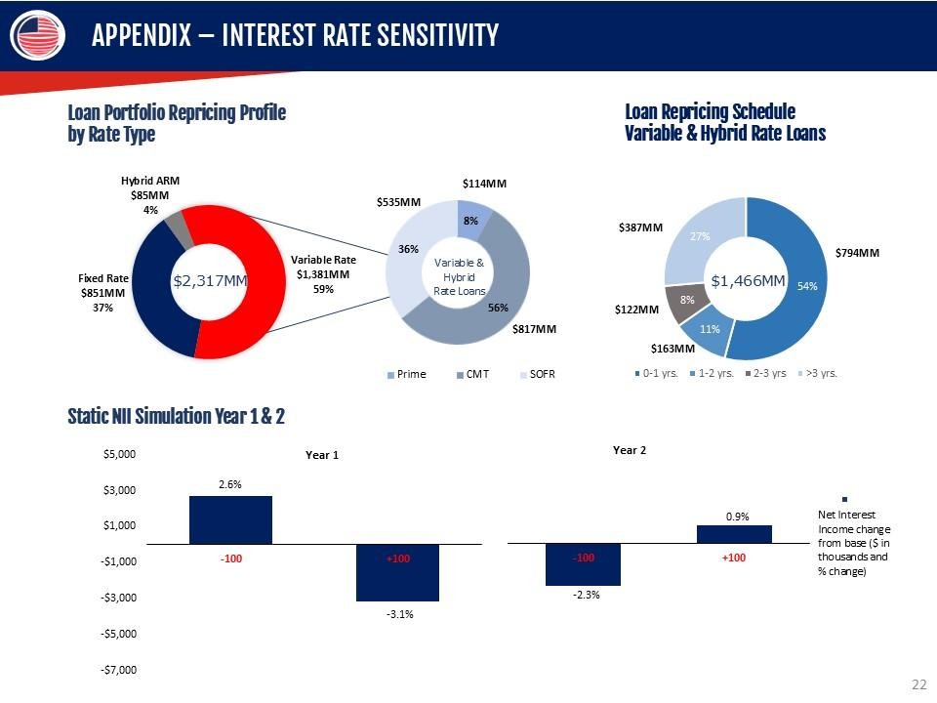
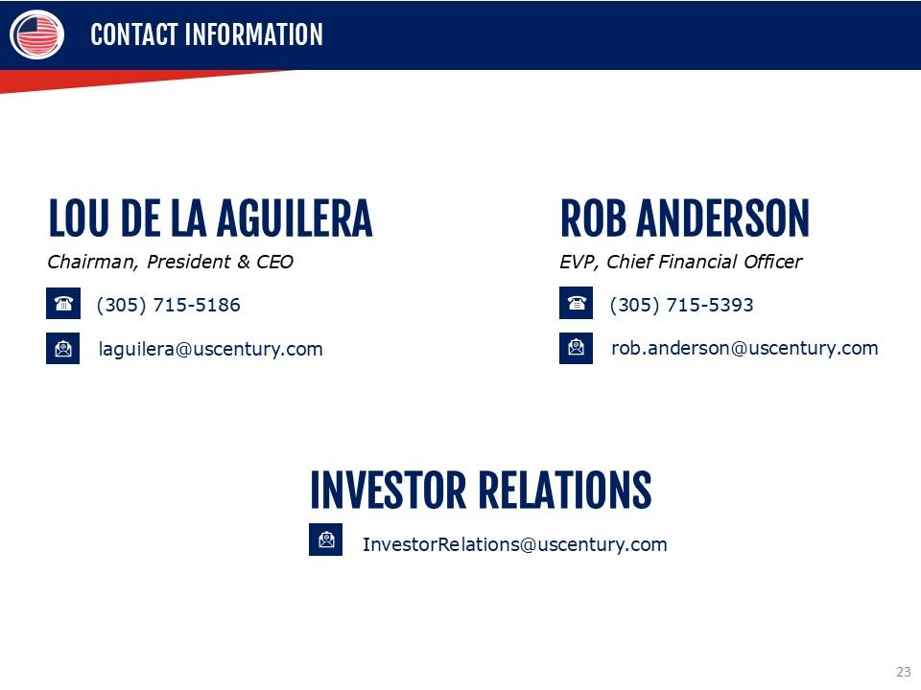
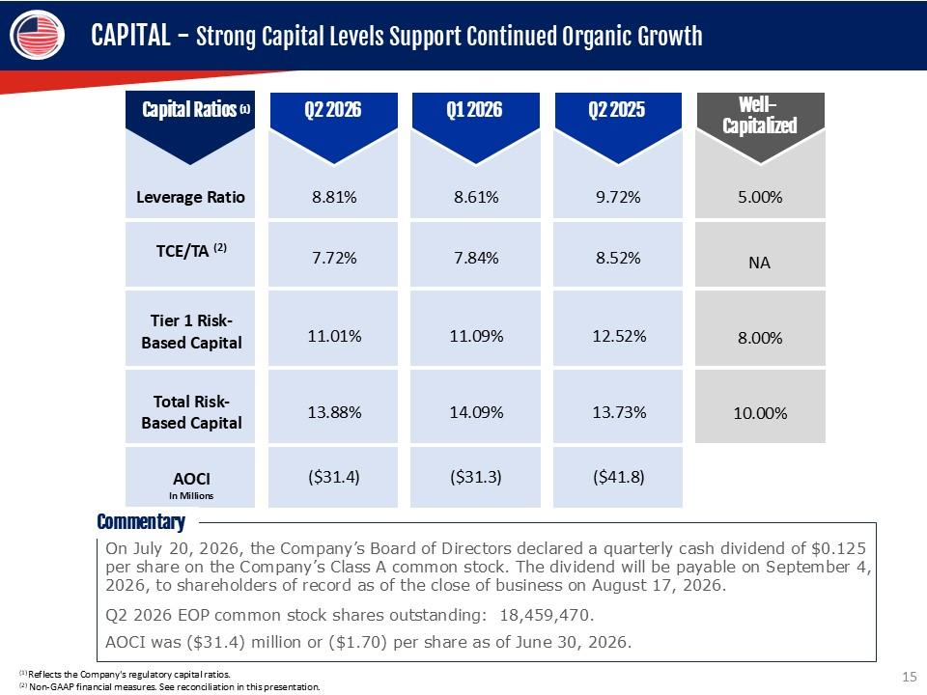
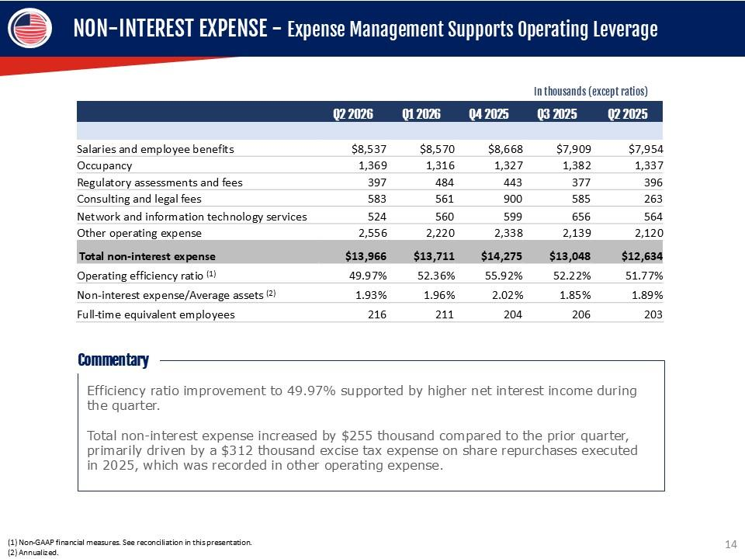
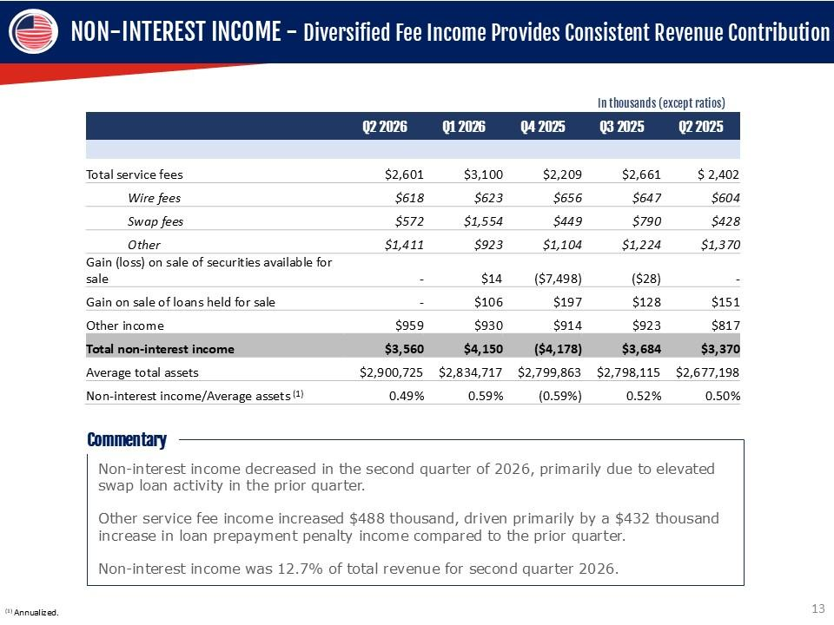
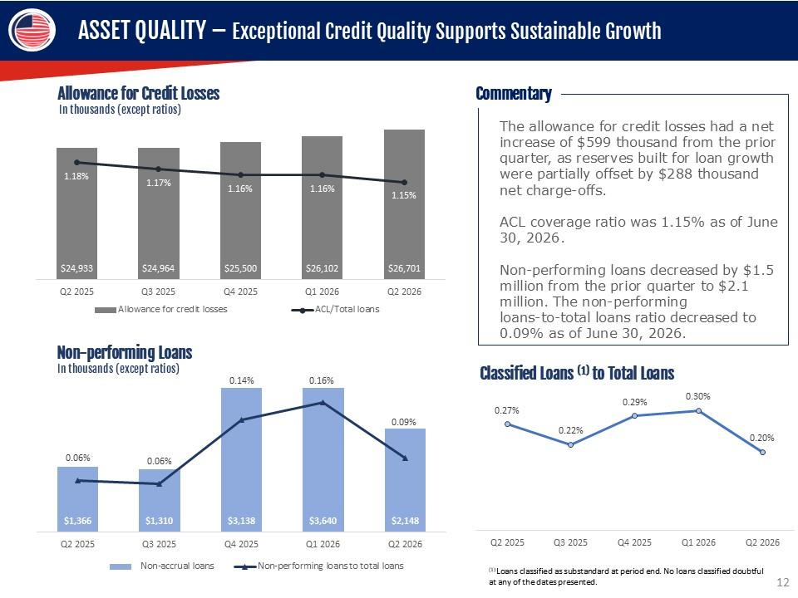
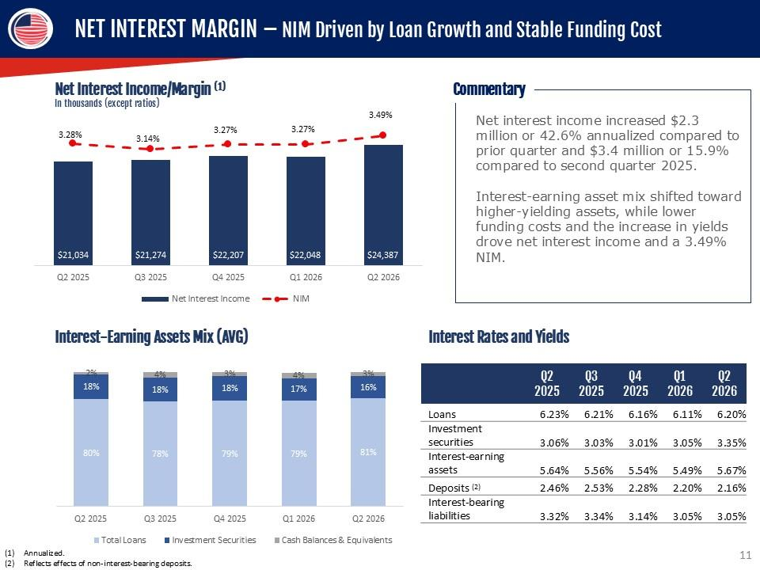
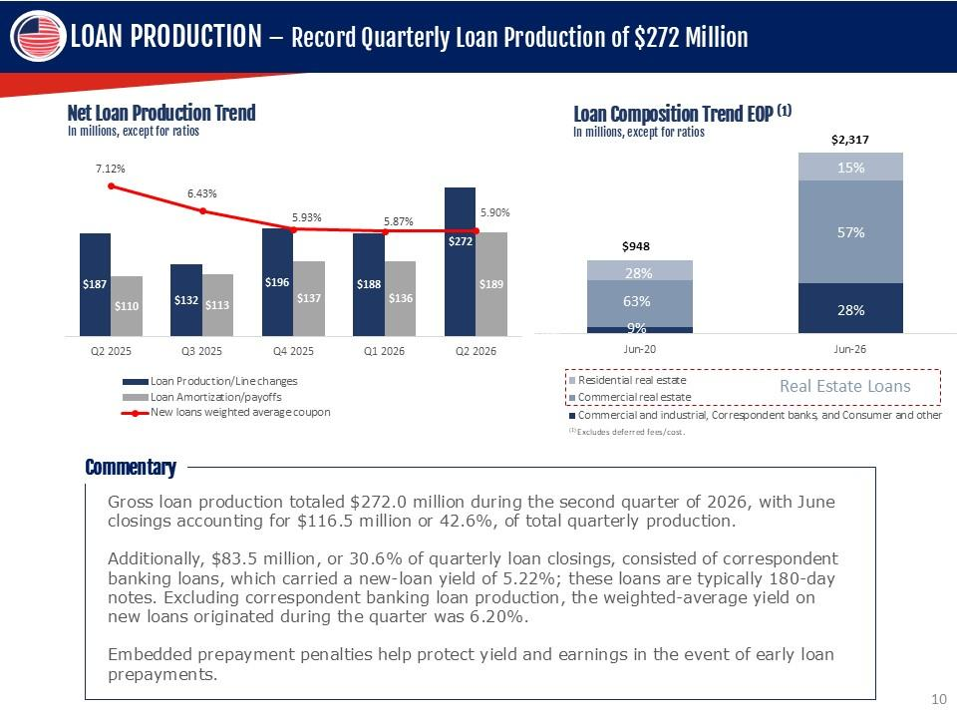
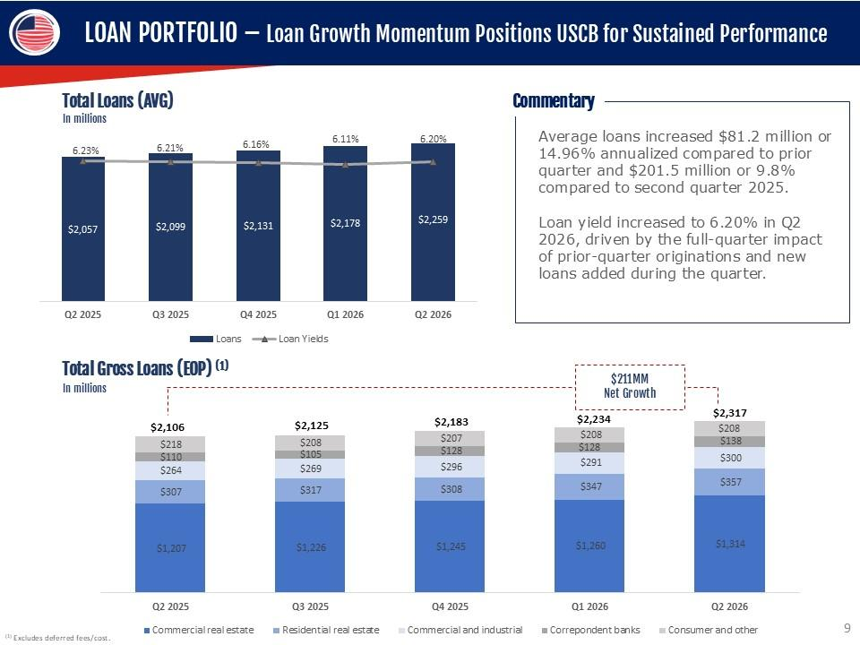
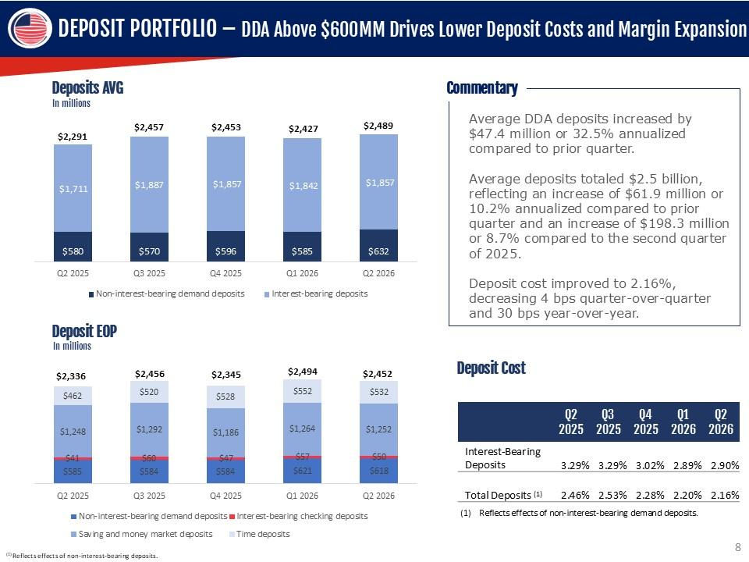
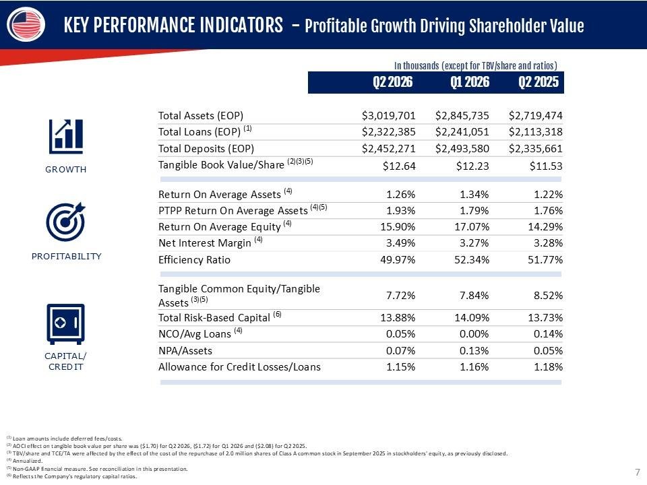
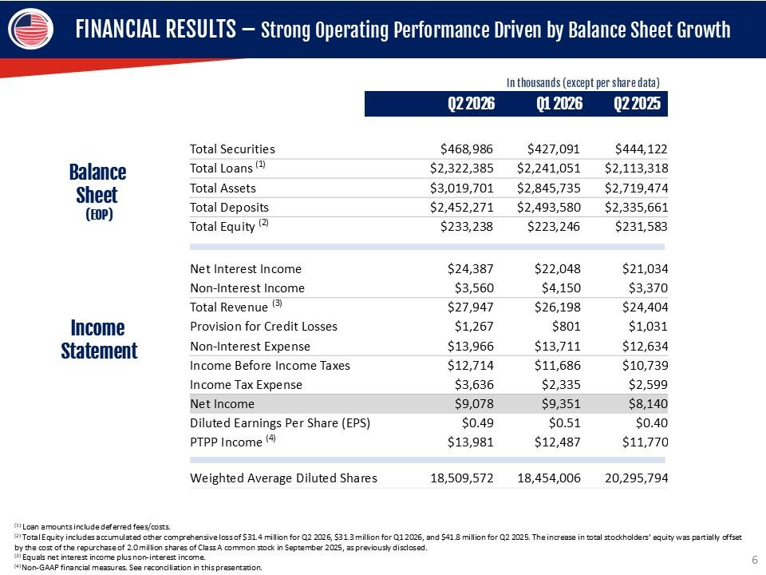
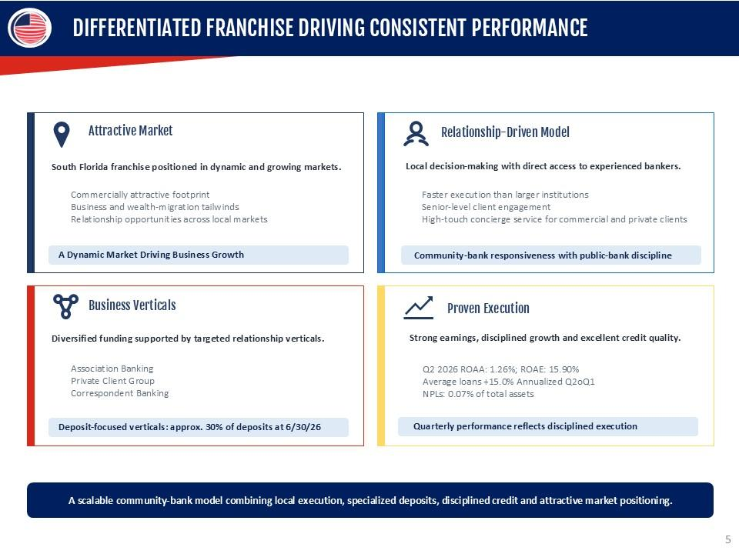
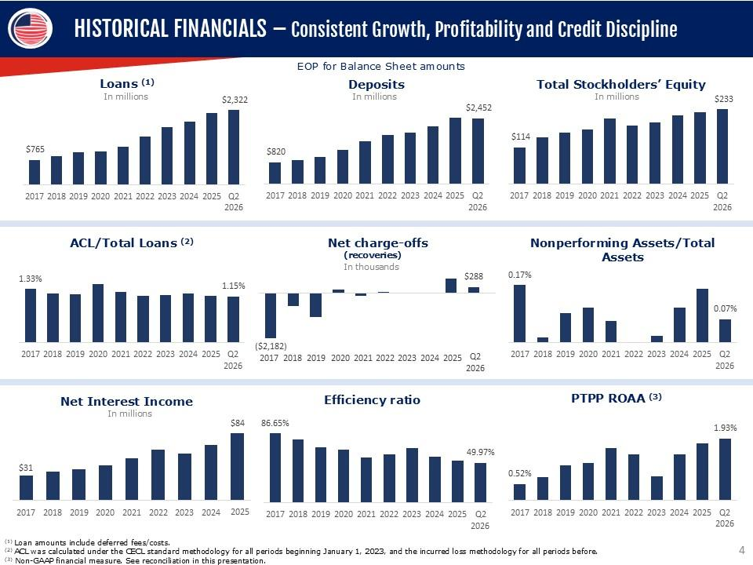
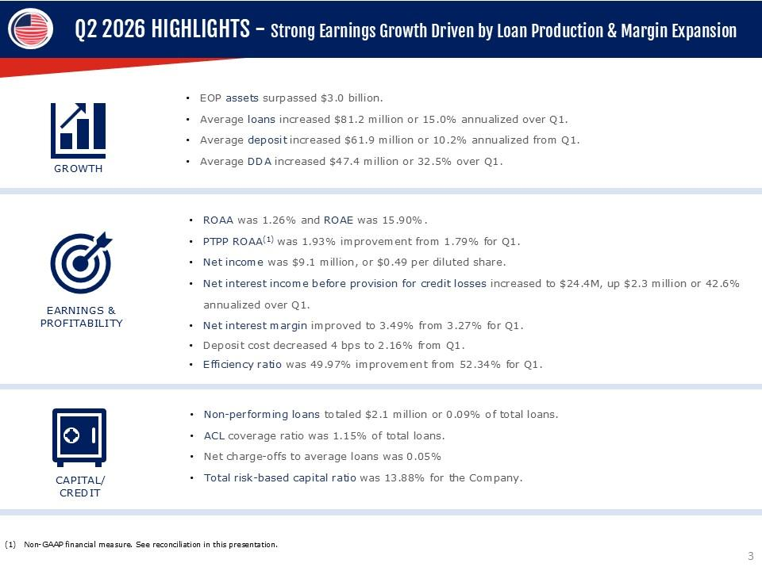
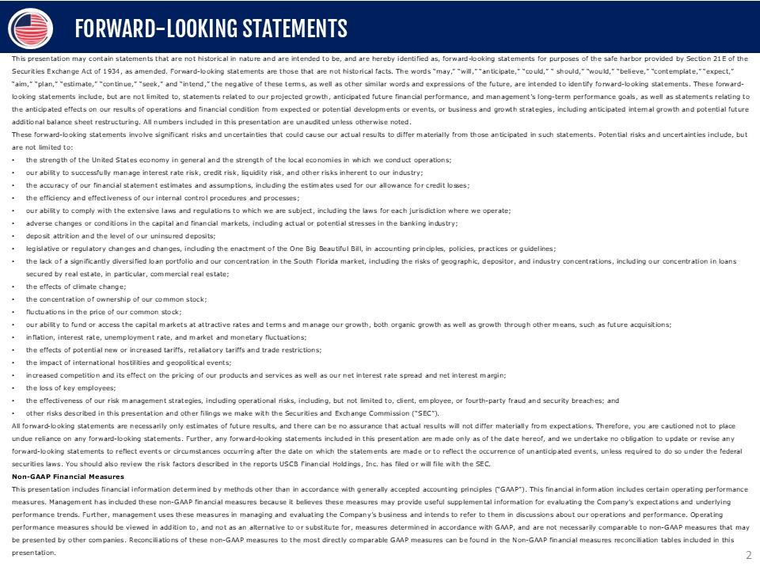
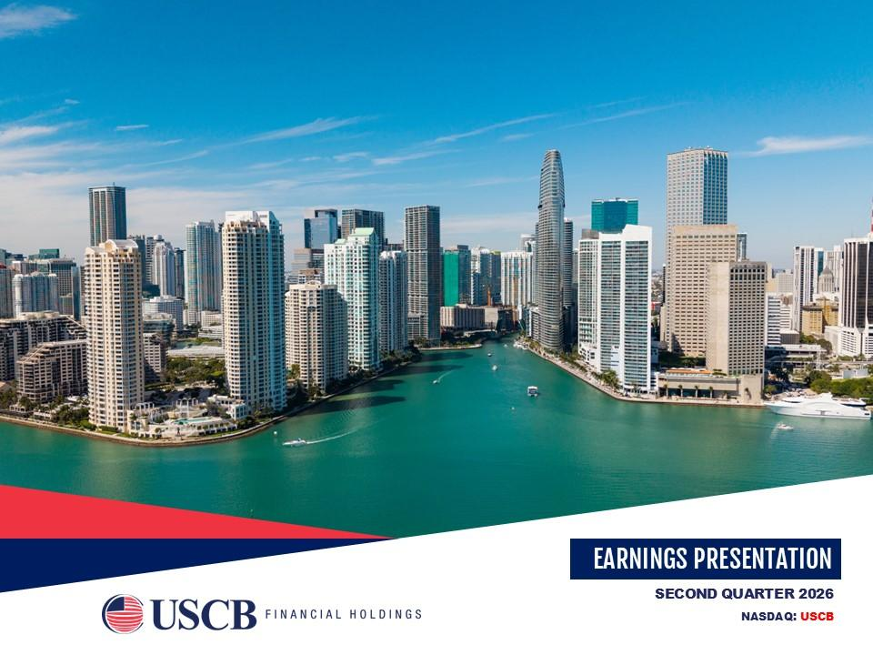


1

UNITED STATES

SECURITIES AND EXCHANGE COMMISSION

WASHINGTON,
D.C. 20549

__________________________

FORM

8-K

__________________________

CURRENT REPORT

Pursuant to Section 13 or 15(d) of the Securities Exchange Act
of 1934

Date of Report (Date of earliest event reported):

July 23, 2026

__________________________

USCB Financial Holdings, Inc.

(Exact name of Registrant as Specified in Its Charter)

__________________________

Florida

001-41196

87-4070846

(State or Other Jurisdiction

of Incorporation)

(Commission File Number)

(IRS Employer

Identification No.)

2301 N.W. 87th Avenue

,

Doral

,

Florida

33172

(Address of Principal Executive Offices)

(Zip Code)

Registrant’s Telephone
Number, Including Area Code: (

305

)

715-5200

__________________________

Check the appropriate box below if the Form 8-K filing is intended to simultaneously satisfy the filing obligation
of the registrant under

any of the following provisions:

☐

Written communications pursuant
to Rule 425 under the Securities Act (17 CFR 230.425)

☐

Soliciting material pursuant to Rule 14a-12 under the Exchange Act (17 CFR 240.14a
-12)

☐

Pre-commencement communications pursuant to Rule 14d-2(b)
under the Exchange Act (17 CFR 240.14d-2(b))

☐

Pre-commencement communications pursuant to Rule 13e-4(c) under the Exchange
Act (17 CFR 240.13e-4(c))

Securities registered pursuant to Section 12(b) of the Act:

Title of each class

Trading

Symbol(s)

Name of each exchange on which registered

Class A common stock, $1.00 par value per share

USCB

The Nasdaq Stock Market LLC

Indicate by
check mark
whether the
registrant is
an emerging
growth company
as defined
in Rule
405 of
the Securities
Act of
1933

(§ 230.405 of this chapter) or Rule 12b-2 of the Securities Exchange Act of 1934 (§ 240.12b
-2 of this chapter).

Emerging growth company

☒

If
an
emerging
growth
company,
indicate
by
check
mark
if
the
registrant
has
elected
not
to
use
the
extended
transition
period
for

complying with any new or revised financial accounting standards provided
pursuant to Section 13(a) of the Exchange Act.

☐

2

Item 2.02. Results of Operations and Financial Condition.

On July 23, 2026,
USCB Financial Holdings,
Inc. (the “Company”) issued
a press release announcing
its financial results for

the quarter ended June 30, 2026. A copy of the press release is furnished as Exhibit 99.1 to this Current Report
on Form 8-K (“Form 8-

K”) and is incorporated herein by reference.

The information in this
Item 2.02, including
Exhibit 99.1 hereto,
is being furnished
and shall not
be deemed “filed”
for purposes

of Section 18 of the
Securities Exchange Act of
1934 (the “Exchange Act”),
or otherwise be subject to
the liability of that section,
and

shall
not
be
deemed
to
be
incorporated
by
reference
into
any
filing
under
the
Securities
Act
of
1933
(the
“Securities
Act”)
or
the

Exchange Act except as expressly set forth by specific reference in such filing to
this Form 8-K.

Item 7.01. Regulation FD Disclosure.

As previously announced, at 11:00 a.m. ET on July 24, 2026, the Company will hold an earnings conference call to discuss its

financial performance for the quarter ended June 30, 2026. A copy of the slides forming
the basis of the presentation is being furnished

as Exhibit 99.2
to this Form
8-K and is
incorporated herein by
reference. A copy
of the slides
has also been
posted to the
Company’s

investor relations website, located at investors.uscenturybank.com.

The information in this
Item 7.01, including
Exhibit 99.2 hereto,
is being furnished
and shall not
be deemed “filed”
for purposes

of Section 18 of the Exchange Act, or otherwise be subject to the liability of that section, and shall not be deemed to be incorporated by

reference into any filing under the
Securities Act or the Exchange Act
except as set forth by
specific reference in such filing to this
Form

8-K.

Item 9.01. Financial Statements and Exhibits.

(d) Exhibits.

Exhibit No.

Description

99.1

USCB Financial Holdings, Inc. Press Release, dated July 23, 2026

99.2

Earnings Presentation, dated July 23, 2026

104

Cover Page Interactive Data File (embedded within the Inline XBRL document)

3

SIGNATURE

Pursuant to the requirements of the Securities Exchange Act of 1934, the registrant has duly
caused this report to be signed on

its behalf by the undersigned hereunto duly authorized.

USCB Financial Holdings, Inc.

By:

/s/ Robert Anderson

Name:

Robert Anderson

Title:

Chief Financial Officer

Date: July 23, 2026

1

Exhibit 99.1

EARNINGS RELEASE

USCB Financial Holdings, Inc. Surpasses $3 Billion in Assets with 14.6% Annualized
Linked-Quarter Loan

Growth; Achieves Q2 2026 EPS of $0.49, 3.49% Net Interest Margin, ROAA of 1.26%, and ROAE
of 15.90%

MIAMI, FL – July 23, 2026 – USCB Financial Holdings, Inc. (the “Company”) (NASDAQ: USCB)

, the holding company for U.S.

Century Bank
(the “Bank”),
reported net
income of
$9.1 million
or $0.49
per fully
diluted share
for the
three months
ended June 30,

2026,
compared with net income of $8.1 million or $0.40 per fully diluted share
for the same period in 2025.

“Our
second
quarter
performance
highlights
the
ongoing
strength
of
our
company
and
the
effective
implementation
of
our
growth

strategy,” said Luis de la Aguilera, Chairman,
President and CEO. “We achieved
record new loan fundings of $272.0 million, resulting

in a 14.6%
annualized increase in
loans from the
previous quarter and
pushing our total
assets above $3
billion. At the
same time, we

improved
profitability
and
operational
efficiency,
with
our
net
interest
margin
rising
to
3.49%
from
3.27%
and
our
efficiency
ratio

improving to 49.97% from 52.34% compared to the first quarter of
2026. These achievements underscore the scalability of our business

model and our dedication to creating long-term value for our shareholders.
”

Unless otherwise stated,
all percentage comparisons
in the bullet points
below are calculated
at or for the
quarter ended June 30,
2026

compared to at or for the quarter ended June 30, 2025 and annualized where
appropriate.

Profitability

•

Annualized return on
average assets for the
quarter ended June 30,
2026 was 1.26%
compared to 1.22%
for the second
quarter of

2025.

•

Annualized return
on average
stockholders’ equity
for the quarter
ended June 30,
2026 was
15.90% compared
to 14.29%
for the

second quarter of 2025.

•

The efficiency ratio for the quarter ended June 30, 2026 was 49.97%
compared to 51.77% for the second quarter of 2025.

•

Net interest margin for the quarter ended June 30, 2026 was 3.49
%
compared to 3.28% for the second quarter of 2025.

•

Net interest
income before
provision for
credit losses
was $24.4 million
for the
quarter ended
June 30, 2026,
an increase
of $3.4

million or 15.9% compared to $21.0 million for the same period in 2025.

Balance Sheet

•

Total
assets were $3.0
billion at June 30,
2026, representing
an increase of
$300.2 million or
11.0%
from $2.7
billion at June 30,

2025.

•

Total
loans held
for investment
were $2.3 billion
at June 30,
2026, representing
an increase
of $209.1 million
or 9.9%
from $2.1

billion at June 30, 2025.

•

Total deposits
were $2.5 billion at June 30,
2026, representing an increase
of $116.6 million
or 5.0% from $2.3
billion at June 30,

2025.

•

Total
stockholders’
equity
was
$233.2 million
at
June 30,
2026,
representing
an
increase
of
$1.7
million
or
0.7%
from
$231.6

million at
June 30, 2025.
Total
stockholders’ equity
included accumulated
other comprehensive
loss of
$31.4 million
at June 30,

2026
compared to
accumulated
other
comprehensive
loss of
$41.8
million
at June 30,
2025.
The increase
in total
stockholders’

equity
was partially
offset
by the
repurchase
of 2.0
million
shares
of Class
A common
stock in
September
2025,
as previously

disclosed.

Asset Quality

•

The allowance for credit losses (“ACL”) increased by $1.8 million to $26.7 million at June 30, 2026 from $24.9 million at
June 30,

2025.

2

•

The ACL represented 1.15% of total loans at June 30, 2026 and 1.18% of
total loans at June 30, 2025.

•

The provision
for credit
losses was
$1.3 million
for the
quarter ended
June 30, 2026,
an increase
of $236
thousand compared
to

$1.0 million for the same period in 2025.

•

The ratio
of non-performing
loans to total
loans was 0.09%
for the quarter
ended June 30,
2026 and
0.06% for
the quarter ended

June 30, 2025. Non-performing loans totaled $2.1 million at June 30, 2026
and $1.4 million at June 30, 2025.

Non-interest Income and Non-interest Expense

•

Non-interest income was
$3.6 million for
the three months ended
June 30, 2026, an
increase of $190 thousand
or 5.6% compared

to $3.4 million for the same period in 2025.

•

Non-interest expense was $14.0 million
for the three months ended June
30, 2026, an increase of $1.3
million or 10.5% compared

to $12.6 million for the three months ended June 30, 2025.

Capital

•

On July 20, 2026,
the Company’s Board of Directors declared
a quarterly cash dividend
of $0.125 per share
of the Company’s Class

A common stock. The dividend will be paid on September 4, 2026
to shareholders of record at the close of business on August 17,

2026.

•

As of June 30,
2026,

total risk-based capital
ratios for the Company
and the Bank
were 13.88% and 13.68%,
respectively,
well in

excess of the well-capitalized minimum threshold regulatory requirements
.

•

Tangible
book value
per common share
(non-GAAP financial
measure) was $12.64
at June 30,
2026, representing
an increase of

$1.11 or 9.6%
from $11.53 at June 30,
2025. At June 30, 2026, tangible
book value per common share
was negatively affected by

($1.70) per share due to an accumulated other comprehensive loss of $31.4 million primarely due to changes in the market value of

the Company’s
available for sale
securities. At
June 30, 2025,
tangible book
value per common
share was negatively
affected by

($2.08) per share due to an accumulated other comprehensive loss of $41.8
million.

Conference Call and Webcast

The Company
will host
a conference
call on
Friday,
July 24,
2026, at
11:00
a.m. Eastern Time
to discuss
the Company’s
unaudited

financial results for the quarter
ended June 30, 2026. To
access the conference call, dial (833)
816-1416 (U.S. toll-free)
and ask to join

the USCB Financial Holdings Call.

Additionally,
interested
parties can
listen to
a live
webcast
of the
call in
the “Investor
Relations” section
of the
Company’s
website

at www.uscentury.com
.
An archived version of the webcast will be available in the same location shortly after
the live call has ended.

About USCB Financial Holdings, Inc.

USCB Financial Holdings, Inc.
is the bank holding company for
U.S. Century Bank. Established in 2002,
U.S. Century Bank is one of

the largest
community banks
headquartered
in Miami,
and one
of the
largest community
banks in
the State
of Florida.
U.S. Century

Bank is rated 5-Stars by BauerFinancial, the nation’s leading independent
bank rating firm. U.S. Century Bank offers customers a wide

range of
financial products
and services
and supports
numerous community
organizations,
including
the Greater
Miami Chamber
of

Commerce, the South Florida Hispanic Chamber of Commerce, and ChamberSouth. For more information about us
or to find a banking

center near you, please call (305) 715-5200 or visit www.uscentury.com.

Forward-Looking Statements

This earnings release
may contain statements
that are not
historical in nature
and are intended
to be, and
are hereby identified
as, forward-

looking
statements
for
purposes
of
the
safe
harbor
provided
by
Section
21E
of
the
Securities
Exchange
Act
of
1934,
as
amended.

Forward-looking statements are
those that are
not historical facts.
The words “may,”
“will,” “anticipate,” “could,”
“should,” “would,”

“believe,” “contemplate,” “expect,” “aim,” “plan,” “estimate,” “seek,” “continue,” and “intend,”, the negative of these terms, as well as

other similar words
and expressions of
the future, are
intended to identify
forward-looking statements. These forward-looking statements

include, but are not limited
to, statements related to our
projected growth, anticipated future
financial performance, and management’s

long-term performance goals, as well as statements
relating to the anticipated effects on our results of
operations and financial condition

from expected or
potential developments or events,
or business and
growth strategies, including anticipated
internal growth and potential

future additional balance sheet restructuring.

3

These forward-looking statements involve significant risks and uncertainties that could cause our actual
results to differ materially from

those anticipated in such statements. Potential risks and uncertainties include,
but are not limited to:

•

the strength of the United States economy in general and the strength of the local economies in
which we conduct operations;

•

our ability to successfully manage interest rate risk, credit risk, liquidity risk,
and other risks inherent to our industry;

•

the accuracy of our financial statement estimates and assumptions, including the estimates used for our allowance for credit losses;

•

the efficiency and effectiveness of our internal
control procedures and processes;

•

our ability to comply with
the extensive laws and
regulations to which we are
subject, including the laws for
each jurisdiction where

we operate;

•

adverse changes or conditions in capital and financial markets, including
actual or potential stresses in the banking industry;

•

deposit attrition and the level of our uninsured deposits;

•

legislative
or
regulatory
changes,
including
the
enactment
of
the
One
Big
Beautiful
Bill
and
changes
in
accounting
principles,

policies, practices or guidelines;

•

the
lack
of
a
significantly
diversified
loan
portfolio
and
our
concentration
in
the
South
Florida
market,
including
the
risks
of

geographic,
depositor,
and
industry
concentrations,
including
our
concentration
in
loans
secured
by
real
estate,
in
particular,

commercial real estate;

•

the effects of climate change;

•

the concentration of ownership of our common stock;

•

fluctuations in the price of our common stock;

•

our ability to
fund or access
the capital markets
at attractive rates
and terms and
manage our growth,
both organic
growth as well

as growth through other means, such as future acquisitions;

•

inflation, interest rate, unemployment rate, and market and monetary
fluctuations;

•

the effects of potential new or increased tariffs,
retaliatory tariffs and trade restrictions;

•

the impact of international hostilities and geopolitical events;

•

increased competition
and its effect
on the pricing
of our products
and services as
well as our
interest rate spread
and net interest

margin;

•

the loss of key employees;

•

the effectiveness
of our risk management
strategies, including operational
risks, including, but
not limited to, client,
employee, or

third-party fraud and security breaches; and

•

other risks described in this earnings release and other filings we make with the
Securities and Exchange Commission (“SEC”).

All forward-looking
statements are
necessarily only
estimates of
future results,
and there
can be
no assurance
that actual
results will

not differ
materially from
expectations. Therefore,
you are
cautioned not
to place
undue reliance
on any
forward-looking statements.

Further,
any forward-looking
statements included
in this
earnings release
are made
only as
of the
date hereof,
and
we undertake
no

obligation to
update or
revise any
forward-looking statement
to reflect
events or
circumstances occurring
after the
date on
which the

statements are made or to reflect the occurrence of unanticipated events,
unless required to do so under the federal securities laws. You

should also review the risk factors described in the reports the Company has filed
or will file with the SEC.

Non-GAAP Financial Measures

This earnings release
includes financial information determined
by methods other
than in accordance
with generally accepted
accounting

principles (“GAAP”). This financial
information includes certain
operating performance measures. Management
has included these non-

GAAP
measures
because
it
believes
these
measures
may
provide
useful
supplemental
information
for
evaluating
the
Company’s

operations and
underlying performance
trends. Further,
management uses these
measures in
managing and
evaluating the Company’s

business and intends to refer to
them in discussions about our operations
and performance. Operating performance
measures should be

viewed
in
addition
to,
and
not
as
an
alternative
to
or
substitute
for,
measures
determined
in
accordance
with
GAAP,
and
are
not

necessarily
comparable
to
non-GAAP
measures
that
may
be
presented
by
other
companies.
Reconciliations
of
these
non-GAAP

measures
to
the most
directly
comparable
GAAP measures
can be
found
in the
‘Non-GAAP
Reconciliation
Tables’
included
in the

exhibits to this earnings release.

All numbers included in this press release are unaudited unless otherwise noted.

Contacts:

Investor Relations

InvestorRelations@uscentury.com

Media Relations

Martha Guerra-Kattou

MGuerra@uscentury.com

4

USCB FINANCIAL HOLDINGS, INC.

CONSOLIDATED STATEMENTS
OF INCOME (UNAUDITED)

(Dollars in thousands, except per share data)

Three Months Ended June 30,

Six Months Ended June 30,

2026

2025

2026

2025

Interest income:

Loans, including fees

$

34,899

$

31,946

$

67,688

$

62,191

Investment securities

3,858

3,432

7,269

6,456

Interest-bearing deposits in financial institutions

823

776

1,655

1,485

Total interest income

39,580

36,154

76,612

70,132

Interest expense:

Interest-bearing checking deposits

311

285

621

623

Savings and money market deposits

8,478

9,410

16,611

18,745

Time deposits

4,628

4,343

9,328

8,261

FHLB advances

976

1,082

2,016

2,354

Subordinated notes

800

-

1,601

-

Total interest expense

15,193

15,120

30,177

29,983

Net interest income before provision for credit losses

24,387

21,034

46,435

40,149

Provision for credit losses

1,267

1,031

2,068

1,712

Net interest income after provision for credit losses

23,120

20,003

44,367

38,437

Non-interest income:

Service fees

2,601

2,402

5,701

4,733

Gain on sale of securities available for sale, net

-

-

14

-

Gain on sale of loans held for sale, net

-

151

106

676

Other non-interest income

959

817

1,889

1,677

Total non-interest income

3,560

3,370

7,710

7,086

Non-interest expense:

Salaries and employee benefits

8,537

7,954

17,107

15,590

Occupancy

1,369

1,337

2,685

2,621

Regulatory assessments and fees

397

396

881

817

Consulting and legal fees

583

263

1,144

456

Network and information technology services

524

564

1,084

1,069

Other operating expense

2,556

2,120

4,776

4,133

Total non-interest expense

13,966

12,634

27,677

24,686

Income before income tax expense

12,714

10,739

24,400

20,837

Income tax expense

3,636

2,599

5,971

5,039

Net income

$

9,078

$

8,140

$

18,429

$

15,798

Per share information:

Net income per common share, basic

$

0.49

$

0.41

$

1.01

$

0.79

Net income per common share, diluted

$

0.49

$

0.40

$

1.00

$

0.78

Cash dividends declared

$

0.125

$

0.10

$

0.250

$

0.20

Weighted average shares outstanding:

Common shares, basic

18,346,946

20,059,264

18,280,860

20,040,205

Common shares, diluted

18,509,572

20,295,794

18,443,486

20,299,585

5

USCB FINANCIAL HOLDINGS, INC.

SELECTED FINANCIAL DATA (UNAUDITED)

(Dollars in thousands, except per share data)

As of or For the Three Months Ended

6/30/2026

3/31/2026

12/31/2025

9/30/2025

6/30/2025

Income statement data:

Net interest income before provision for credit losses

$

24,387

$

22,048

$

22,207

$

21,274

$

21,034

Provision for credit losses

1,267

801

480

105

1,031

Net interest income after provision for credit losses

23,120

21,247

21,727

21,169

20,003

Service fees

2,601

3,100

2,209

2,661

2,402

Gain (loss) on sale of securities available for sale, net

-

14

(7,498)

(28)

-

Gain on sale of loans held for sale, net

-

106

197

128

151

Other non-interest income

959

930

914

923

817

Total non-interest income

3,560

4,150

(4,178)

3,684

3,370

Salaries and employee benefits

8,537

8,570

8,668

7,909

7,954

Occupancy

1,369

1,316

1,327

1,382

1,337

Regulatory assessments and fees

397

484

443

377

396

Consulting and legal fees

583

561

900

585

263

Network and information technology services

524

560

599

656

564

Other operating expense

2,556

2,220

2,338

2,139

2,120

Total non-interest expense

13,966

13,711

14,275

13,048

12,634

Income before income tax expense

12,714

11,686

3,274

11,805

10,739

Income tax expense

3,636

2,335

1,911

2,866

2,599

Net income

$

9,078

$

9,351

$

1,363

$

8,939

$

8,140

Per share information:

Net income per common share, basic

$

0.49

$

0.51

$

0.08

$

0.46

$

0.41

Net income per common share, diluted

$

0.49

$

0.51

$

0.07

$

0.45

$

0.40

Cash dividends declared

$

0.125

$

0.125

$

0.10

$

0.10

$

0.10

Balance sheet data (at period-end):

Cash and cash equivalents

$

118,154

$

78,963

$

38,477

$

56,811

$

54,819

Securities available-for-sale

$

332,859

$

277,160

$

307,490

$

324,179

$

285,382

Securities held-to-maturity

$

136,127

$

149,931

$

153,941

$

156,365

$

158,740

Total securities

$

468,986

$

427,091

$

461,431

$

480,544

$

444,122

Loans held for investment

(1)

$

2,322,385

$

2,241,051

$

2,189,257

$

2,130,966

$

2,113,318

Allowance for credit losses

$

(26,701)

$

(26,102)

$

(25,500)

$

(24,964)

$

(24,933)

Total assets

$

3,019,701

$

2,845,735

$

2,791,540

$

2,767,945

$

2,719,474

Non-interest-bearing demand deposits

$

618,062

$

620,714

$

583,860

$

584,240

$

584,895

Interest-bearing deposits

$

1,834,209

$

1,872,866

$

1,761,220

$

1,871,374

$

1,750,766

Total deposits

$

2,452,271

$

2,493,580

$

2,345,080

$

2,455,614

$

2,335,661

FHLB advances

$

240,900

$

53,000

$

158,250

$

11,000

$

108,000

Subordinated notes

$

39,376

$

39,338

$

39,300

$

39,262

$

-

Total liabilities

$

2,786,463

$

2,622,489

$

2,574,357

$

2,558,850

$

2,487,891

Total stockholders' equity

$

233,238

$

223,246

$

217,183

$

209,095

$

231,583

Capital ratios:

(2)

Leverage ratio

8.81%

8.61%

8.46%

8.47%

9.72%

Common equity tier 1 capital

11.01%

11.09%

10.92%

11.17%

12.52%

Tier 1 risk-based capital

11.01%

11.09%

10.92%

11.17%

12.52%

Total risk-based capital

13.88%

14.09%

13.91%

14.20%

13.73%

(1)
Loan amounts include deferred fees/costs.

(2)
Reflects the Company's regulatory capital ratios. The
Bank's total risk-based capital ratio at June 30,
2026 was 13.68%.

6

USCB FINANCIAL HOLDINGS, INC.

AVERAGE BALANCES, RATIOS, AND OTHER DATA
(UNAUDITED)

(Dollars in thousands)

As of or For the Three Months Ended

6/30/2026

3/31/2026

12/31/2025

9/30/2025

6/30/2025

Average balance sheet data:

Cash and cash equivalents

$

87,949

$

112,107

$

82,338

$

139,389

$

71,388

Securities available-for-sale

$

314,581

$

295,065

$

332,356

$

299,892

$

281,840

Securities held-to-maturity

$

140,533

$

152,144

$

155,269

$

157,702

$

160,443

Total securities

$

455,114

$

447,209

$

487,625

$

457,594

$

442,283

Loans held for investment

(1)

$

2,258,965

$

2,177,734

$

2,130,898

$

2,099,043

$

2,057,445

Total assets

$

2,900,725

$

2,834,717

$

2,799,863

$

2,798,115

$

2,677,198

Interest-bearing deposits

$

1,856,763

$

1,842,283

$

1,857,218

$

1,887,545

$

1,710,568

Non-interest-bearing demand deposits

$

632,198

$

584,784

$

595,969

$

569,522

$

580,121

Total deposits

$

2,488,961

$

2,427,067

$

2,453,187

$

2,457,067

$

2,290,689

FHLB advances

$

100,685

$

110,045

$

51,462

$

40,065

$

116,527

Subordinated notes

$

39,351

$

39,313

$

39,287

$

26,029

$

-

Total liabilities

$

2,671,792

$

2,612,491

$

2,587,470

$

2,572,799

$

2,448,706

Total stockholders' equity

$

228,933

$

222,226

$

212,393

$

225,316

$

228,492

Performance ratios:

Return on average assets

(2)

1.26%

1.34%

0.19%

1.27%

1.22%

Return on average equity

(2)

15.90%

17.07%

2.55%

15.74%

14.29%

Net interest margin

(2)

3.49%

3.27%

3.27%

3.14%

3.28%

Non-interest income to average assets

(2)

0.49%

0.59%

(0.59)%

0.52%

0.50%

Non-interest expense to average assets

(2)

1.93%

1.96%

2.02%

1.85%

1.89%

Efficiency ratio

(3)

49.97%

52.34%

79.18%

52.28%

51.77%

Loans by type (at period end):

(4)

Residential real estate

$

356,747

$

346,917

$

307,692

$

316,557

$

307,020

Commercial real estate

$

1,314,367

$

1,259,642

$

1,244,835

$

1,226,121

$

1,206,621

Commercial and industrial

$

300,265

$

291,333

$

295,548

$

269,430

$

263,966

Correspondent banks

$

137,912

$

128,722

$

127,968

$

104,598

$

110,155

Consumer and other

$

207,404

$

207,794

$

207,215

$

207,939

$

218,426

Asset quality data:

Allowance for credit losses to total loans

1.15%

1.16%

1.16%

1.17%

1.18%

Allowance for credit losses to non-performing loans

1243%

717%

813%

1906%

1825%

Total non-performing loans

(5)

$

2,148

$

3,640

$

3,138

$

1,310

$

1,366

Non-performing loans to total loans

0.09%

0.16%

0.14%

0.06%

0.06%

Non-performing assets to total assets

(5)

0.07%

0.13%

0.11%

0.05%

0.05%

Net charge-offs (recoveries of) to average loans

(2)

0.05%

(0.00)%

(0.00)%

(0.00)%

0.14%

Net charge-offs (recoveries) of credit losses

$

288

$

(4)

$

(11)

$

(4)

$

702

Interest rates and yields:

(2)

Loans held for investment

6.20%

6.11%

6.16%

6.21%

6.23%

Investment securities

3.35%

3.05%

3.01%

3.03%

3.06%

Total interest-earning assets

5.67%

5.49%

5.54%

5.56%

5.64%

Deposits

(6)

2.16%

2.20%

2.28%

2.53%

2.46%

FHLB advances

3.89%

3.83%

3.91%

3.73%

3.72%

Subordinated notes

8.15%

8.26%

8.09%

6.16%

-

Total interest-bearing liabilities

3.05%

3.05%

3.14%

3.34%

3.32%

Other information:

Full-time equivalent employees

216

211

204

206

203

(1)
Loan amounts include deferred fees/costs.

(2)
Annualized.

(3)
Efficiency ratio is defined as total non-interest expense divided
by the sum of net interest income and total non-interest income.

(4)
Loan amounts exclude deferred fees/costs.

(5)
The amounts for total non-performing loans and total non-performing
assets are the same at the dates presented since there was
no other real estate owned (OREO)

recorded at any of the dates presented.

(6) Reflects effect of non-interest-bearing deposits.

7

USCB FINANCIAL HOLDINGS, INC.

NET INTEREST MARGIN (UNAUDITED)

(Dollars in thousands)

Three Months Ended June 30,

2026

2025

Average

Balance

Interest

Yield/Rate

(1)

Average

Balance

Interest

Yield/Rate

(1)

Assets

Interest-earning assets:

Loans held for investment

(2)

$

2,258,965

$

34,899

6.20%

$

2,057,445

$

31,946

6.23%

Investment securities

(3)

461,849

3,858

3.35%

449,624

3,432

3.06%

Other interest-earning assets

80,640

823

4.09%

63,974

776

4.87%

Total interest-earning assets

2,801,454

39,580

5.67%

2,571,043

36,154

5.64%

Non-interest-earning assets

99,271

106,155

Total assets

$

2,900,725

$

2,677,198

Liabilities and stockholders' equity

Interest-bearing liabilities:

Interest-bearing checking deposits

$

51,711

311

2.41%

$

46,694

285

2.45%

Savings and money market deposits

1,280,578

8,478

2.66%

1,211,513

9,410

3.12%

Time deposits

524,474

4,628

3.54%

452,361

4,343

3.85%

Total interest-bearing deposits

1,856,763

13,417

2.90%

1,710,568

14,038

3.29%

FHLB advances

100,685

976

3.89%

116,527

1,082

3.72%

Subordinated notes

39,351

800

8.15%

-

-

- %

Total interest-bearing liabilities

1,996,799

15,193

3.05%

1,827,095

15,120

3.32%

Non-interest-bearing demand deposits

632,198

580,121

Other non-interest-bearing liabilities

42,795

41,490

Total liabilities

2,671,792

2,448,706

Stockholders' equity

228,933

228,492

Total liabilities and stockholders' equity

$

2,900,725

$

2,677,198

Net interest income

$

24,387

$

21,034

Net interest spread

(4)

2.62%

2.32%

Net interest margin

(5)

3.49%

3.28%

(1)
Annualized.

(2)
Average loan balances include non-accrual loans. Interest income on loans includes accretion
of deferred loan fees, net of deferred loan costs.

(3)
At fair value except for securities held to maturity. This amount includes
FHLB stock.

(4)
Net interest spread is the average yield earned on total
interest-earning assets minus the average rate paid on total interest-bearing
liabilities.

(5)
Net interest margin is the ratio of net interest income to total
interest-earning assets.

8

USCB FINANCIAL HOLDINGS, INC.

NON-GAAP FINANCIAL MEASURES (UNAUDITED)

(Dollars in thousands)

As of or For the Three Months Ended

6/30/2026

3/31/2026

12/31/2025

9/30/2025

6/30/2025

Pre-tax pre-provision ("PTPP") income:

(1)

Net income

$

9,078

$

9,351

$

1,363

$

8,939

$

8,140

Plus: Income tax expense

3,636

2,335

1,911

2,866

2,599

Plus: Provision for credit losses

1,267

801

480

105

1,031

PTPP income

$

13,981

$

12,487

$

3,754

$

11,910

$

11,770

PTPP return on average assets:

(1)

PTPP income

$

13,981

$

12,487

$

3,754

$

11,910

$

11,770

Average assets

$

2,900,725

$

2,834,717

$

2,799,863

$

2,798,115

$

2,677,198

PTPP return on average assets

(2)

1.93%

1.79%

0.53%

1.69%

1.76%

Operating net income:

(1)

Net income

$

9,078

$

9,351

$

1,363

$

8,939

$

8,140

Less: Net gains (losses) on sale of securities

-

14

(7,498)

(28)

-

Less: Tax effect on sale of securities

-

(4)

1,900

7

-

Plus: Tax (benefit) liability expense from prior periods

-

(619)

(3)

1,096

(4)

-

-

Operating net income

$

9,078

$

8,722

$

8,057

$

8,960

$

8,140

Operating return on average assets:

(1)

Operating net income

$

9,078

$

8,722

$

8,057

$

8,960

$

8,140

Average assets

$

2,900,725

$

2,834,717

$

2,799,863

$

2,798,115

$

2,677,198

Operating net income return on average assets

(2)

1.26%

1.25%

1.14%

1.27%

1.22%

Operating return on average equity:

(1)

Operating net income

$

9,078

$

8,722

$

8,057

$

8,960

$

8,140

Average equity

$

228,933

$

222,226

$

212,393

$

225,316

$

228,492

Operating net income return on average equity

(2)

15.90%

15.92%

15.05%

15.78%

14.29%

Operating revenue:

(1)

Net interest income

$

24,387

$

22,048

$

22,207

$

21,274

$

21,034

Non-interest income

3,560

4,150

(4,178)

3,684

3,370

Less: Net gains (losses) on sale of securities

-

14

(7,498)

(28)

-

Operating revenue

$

27,947

$

26,184

$

25,527

$

24,986

$

24,404

Operating efficiency ratio:

(1)

Total non-interest expense

$

13,966

$

13,711

$

14,275

$

13,048

$

12,634

Operating revenue

$

27,947

$

26,184

$

25,527

$

24,986

$

24,404

Operating efficiency ratio

49.97%

52.36%

55.92%

52.22%

51.77%

(1) The Company believes these non-GAAP financial measurements
are key indicators of the ongoing earnings power of the
Company.

(2)
Annualized.

(3)
The Company recognized a $619 thousand income tax
benefit in the first quarter of 2026 due to an adjustment to the
deferred tax asset calculation from 2025.

(4) State tax liability expenses for 2024 and for the
first three quarters of 2025 were recognized during the fourth
quarter of 2025. The state tax expense is related to

taxes due on interest income on loans whose collateral is
located outside of the State of Florida.

9

USCB FINANCIAL HOLDINGS, INC.

NON-GAAP FINANCIAL MEASURES (UNAUDITED)

(Dollars in thousands, except per share data)

As of or For the Three Months Ended

6/30/2026

3/31/2026

12/31/2025

9/30/2025

6/30/2025

Tangible book value per common share (at period-end):

(1)(4)

Total stockholders' equity

$

233,238

$

223,246

$

217,183

$

209,095

$

231,583

Less: Intangible assets

-

-

-

-

-

Tangible stockholders' equity

(3)

$

233,238

$

223,246

$

217,183

$

209,095

$

231,583

Total shares issued and outstanding (at period-end):

Total common shares issued and outstanding

18,459,470

18,257,400

18,137,885

18,107,385

20,078,385

Tangible book value per common share

(2)

$

12.64

$

12.23

$

11.97

$

11.55

$

11.53

Operating diluted net income per common share:

(1)

Operating net income

$

9,078

$

8,722

$

8,057

$

8,960

$

8,140

Total weighted average diluted shares of common stock

18,509,572

18,454,006

18,348,725

19,755,820

20,295,794

Operating diluted net income per common share:

$

0.49

$

0.47

$

0.44

$

0.45

$

0.40

Tangible Common Equity/Tangible Assets

(1)(4)

Tangible stockholders' equity

(3)

$

233,238

$

223,246

$

217,183

$

209,095

$

231,583

Tangible total assets

(3)

$

3,019,701

$

2,845,735

$

2,791,540

$

2,767,945

$

2,719,474

Tangible Common Equity/Tangible Assets

7.72%

7.84%

7.78%

7.55%

8.52%

(1)
The Company believes these non-GAAP financial measurements
are key indicators of the ongoing earnings power of the
Company.

(2)
Excludes the dilutive effect, if any, of shares of common stock issuable upon exercise of outstanding
stock options.

(3) Since the Company has no intangible assets, tangible
stockholders’ equity and tangible total assets are the
same amounts as stockholders’ equity and total assets,

respectively, as calculated under GAAP.

(4) The decrease in total stockholders’ equity in September
2025 was primarily driven by the repurchase of 2.0
million shares of Class A common stock, as previously

disclosed.

Exhibit 99.2

USCB FINANCIAL HOLDINGS EARNINGS PRESENTATION
SECOND QUARTER 2026 NASDAQ: USCB

FORWARD-LOOKING STATEMENTS This presentation
may contain statements that are not historical in nature and are
intended to be, and are hereby identified as, forward-looking statements
for purposes of the safe harbor provided by Section 21E of the
Securities Exchange Act of 1934, as amended. Forward-looking statements
are those that are not historical facts. The words “may,” “will,”
“anticipate,” “could,” “ should,” “would,” “believe,” “contemplate,”
“expect,” “aim,” “plan,” “estimate,” “continue,” “seek,” and
“intend,” the negative of these terms, as well as other similar words and expressions
of the future, are intended to identify forward-looking statements. These
forward-looking statements include, but are not limited to, statements
related to our projected growth, anticipated future
financial performance, and management’s long-term performance
goals, as well as statements relating to the anticipated effects
on our results of operations and financial condition from expected or potential
developments or events, or business and growth strategies, including
anticipated internal growth and potential future additional balance
sheet restructuring. All numbers included in this presentation are
unaudited unless otherwise noted. These forward-looking statements involve
significant risks and uncertainties that could cause our actual
results to differ materially from those anticipated in such statements.
Potential risks and uncertainties include, but are not limited to: the
strength
of the United States economy in general and the strength of the local
economies in which we conduct operations; our ability to successfully
manage interest rate risk, credit risk, liquidity risk, and other risks inherent
to our industry; the accuracy of our financial statement estimates
and assumptions, including the estimates used for our allowance
for credit losses; the efficiency and effectiveness of our internal control procedures
and

processes; our ability to comply with the extensive laws and regulations
to which we are subject, including the laws for each jurisdiction
where we operate; adverse changes or conditions in the capital
and financial markets, including actual or potential stresses in
the banking industry; deposit attrition and the level of our uninsured
deposits; legislative or regulatory changes and changes, including
the enactment of the One Big Beautiful Bill, in accounting principles,
policies, practices or guidelines; the lack of a significantly diversified
loan portfolio and our concentration in the South Florida market,
including the risks of geographic, depositor, and industry concentrations,
including our concentration in loans secured by real estate,
in particular, commercial real estate; the effects of climate change;
the concentration of ownership of our common stock; fluctuations
in the price of our common stock; our ability to fund or access
the capital markets at attractive rates and terms and manage our growth,
both organic growth as well as growth through other means, such as
future acquisitions; inflation, interest rate, unemployment rate,
and market and monetary fluctuations; the effects of potential
new or increased tariffs, retaliatory tariffs and trade restrictions;
the impact of international hostilities and geopolitical events; increased
competition and its effect on the pricing of our products and services
as well as our net interest rate spread and net interest margin;
the loss of key employees; the effectiveness of our risk management
strategies, including operational risks, including, but not limited
to, client, employee, or fourth-party fraud and security breaches;
and other risks described in this presentation and other filings we
make with the Securities and Exchange Commission (“SEC”).
All forward-looking statements are necessarily only estimates of
future results, and there can be no assurance that actual results will not

differ materially from expectations. Therefore, you are cautioned
not to place undue reliance on any forward-looking statements. Further,
any forward-looking statements included in this presentation are
made only as of the date hereof, and we undertake no obligation
to update
or revise any forward-looking statements to reflect events or circumstances
occurring after the date on which the statements are made or to reflect
the occurrence of unanticipated events, unless required to do so under
the federal securities laws. You should also review the risk factors
described in the reports USCB Financial Holdings, Inc.
has filed or will file with the SEC. Non-GAAP Financial Measures
This presentation includes financial information determined by methods
other than in accordance with generally accepted accou
nting principles (“GAAP”). This financial information includes certain
operating performance measures. Management has included
these non-GAAP financial measures because it believes these measures
may provide useful supplemental information for evaluating the
Company’s expectations and underlying performance trends.
Further, management uses these measures in managing and evaluating
the Company’s business and intends to refer to them in discussions
about our operations and performance. Operating performance
measures should be viewed in addition to, and not as an alternative to
or substitute for, measures determined in accordance
with GAAP, and are not necessarily comparable to non-GAAP
measures that may be presented by other companies. Reconciliations
of these non-GAAP measures to the most directly comparable
GAAP measures can be found in the Non-GAAP financial measures
reconciliation tables included in this presentation. 2

Q2 2026 HIGHLIGHTS - Strong Earnings Growth Driven by Loan Production
& Margin Expansion GROWTH EOP assets surpassed $3.0 billion.
Average loans increased $81.2 million or 15.0% annualized
over Q1. Average deposit increased $61.9 million or 10.2% annualized
from Q1. Average DDA increased $47.4 million or 32.5%
over Q1. EARNINGS & PROFITABILITY ROAA was 1.26%
and ROAE was 15.90%. PTPP ROAA(1) was 1.93% improvement
from 1.79% for Q1. Net income was $9.1 million, or $0.49 per diluted
share. Net interest income before provision for credit losses increased
to $24.4M, up $2.3 million or 42.6% annualized over Q1. Net interest
margin improved to 3.49% from 3.27% for Q1. Deposit cost decreased
4 bps to 2.16% from Q1. Efficiency ratio was 49.97% improvement from
52.34% for Q1. CAPITAL/ CREDIT Non-performing
loans totaled $2.1 million or 0.09% of total loans. ACL coverage
ratio was 1.15% of total loans. Net charge-offs to average loans was 0.05% Total
risk-based capital ratio was 13.88% for the Company. Non
-GAAP financial measure. See reconciliation in this presentation.
3

HISTORICAL FINANCIALS – Consistent Growth, Profitability and
Credit Discipline Loans In millions $765 $2,322 2017 2018 2019
2020 2021 2022 2023 2024 2025 Q2 2026 Deposits In millions $820
$2,452 2017 2018 2019 2020 2021 2022 2023 2024 2025 Q2 2026
Total Stockholders’ Equity In millions $114 $233 2017
2018 2019 2020 2021 2022 2023 2024 2025 Q2 2026 ACL/Total
Loans 1.33% 1.15% 2017 2018 2019 2020 2021 2022 2023 2024
2025 Q2 2026 Net charge-offs (recoveries) In thousands ($2,182)
$2,885 2017 2018 2019 2020 2021 2022 2023 2024 2025 Q2 2026
Nonperforming Assets/Total Assets 0.17% 0.07% 2017 2018
2019 2020 2021 2022 2023 2024 2025 Q2 2026 Net Interest
Income In millions $31 $84 2017 2018 2019 2020 2021 2022 2023
2024 2025 Q2 2026 Efficiency ratio 86.65% 49.97% 2017 2018 2019
2020 2021 2022 2023 2024 2025 Q2 2026 PTPP ROAA 0.52%
1.93% 2017 2018 2019 2020 2021 2022 2023 2024 2025 Q2 2026 (1) Loan
amounts include deferred fees/costs. (2) ACL was calculated
under the CECL standard methodology for all periods beginning
January 1, 2023, and the incurred loss methodology for all periods
before. (3) Non-GAAP financial measure. See reconciliation in
this presentation. 4

DIFFERENTIATED FRANCHISE DRIVING CONSISTENT
PERFORMANCE Attractive Market South Florida franchise
positioned in dynamic and growing markets. Commercially attractive
footprint Business and wealth-migration tailwinds Relationship opportunities
across local markets A Dynamic Market Driving Business
Growth Business Verticals Diversified funding supported
by targeted relationship verticals. Association Banking Private
Client Group Correspondent Banking Deposit-focused verticals: approx.
30% of deposits at 6/30/26 Relationship-Driven Model Local decision
-making with direct access to experienced bankers. Faster execution
than larger institutions Senior-level client engagement High-touch
concierge service for commercial and private clients Community-bank
responsiveness with public-bank discipline Proven Execution
Strong earnings, disciplined growth and excellent credit quality.
Q2 2026 ROAA: 1.26%; ROAE: 15.90% Average loans
+15.0% Annualized Q2oQ1 NPLs: 0.07% of total assets Quarterly
performance reflects disciplined execution A scalable community
-bank model combining local execution, specialized deposits, disciplined
credit and attractive market positioning. 5

FINANCIAL RESULTS – Strong Operating Performance
Driven by Balance Sheet Growth Balance Sheet (EOP) Income Statement
In thousands (except per share data) Q2 2026 Q1 2026 Q2
2025 Total Securities $468,986 $427,091 $444,122 Total
Loans (1) $2,322,385 $2,241,051 $2,113,318 Total Assets $3,019,701
$2,845,735 $2,719,474 Total Deposits $2,452,271 $2,493,580
$2,335,661 Total Equity (2) $233,238 $223,246 $231,583 Net
Interest Income $24,387 $22,048 $21,034 Non-Interest Income
$3,560 $4,150 $3,370 Total Revenue (3) $27,947 $26,198
$24,404 Provision for Credit Losses $1,267 $801 $1,031 Non-Interest
Expense $13,966 $13,711 $12,634 Income Before Income
Taxes $12,714 $11,686 $10,739 Income Tax Expense
$3,636 $2,335 $2,599 Net Income $9,078 $9,351 $8,140 Diluted
Earnings Per Share (EPS) $0.49 $0.51 $0.40 PTPP Net Income
(4) $13,981 $12,487 $11,770 Weighted Average
Diluted Shares 18,509,572 18,454,006 20,295,794 (1) Loan amounts include
deferred fees/costs. (2) Total Equity includes accumulated other
comprehensive loss of $31.4 million for Q2 2026, $31.3 million for
Q1 2026, and $41.8 million for Q2 2025. The increase
in total stockholders’ equity was partially offset by the cost of the repurchase
of 2.0 million shares of Class A common stock in September 2025, as
previously disclosed. (3) Equals net interest income plus non
-interest income. (4) Non-GAAP financial measures. See reconciliation
in this presentation. 6

KEY PERFORMANCE INDICATORS - Profitable Growth
Driving Shareholder Value In thousands (except for
TBV/share and ratios) Q2 2026 Q1 2026 Q2 2025 GROWTH Profitability
CAPITAL/CREDIT Total Assets (EOP) $3,019,701 $2,845,735
$2,719,474 Total Loans (EOP) (1) $2,322,385 $2,241,051
$2,113,318 Total Deposits (EOP) $2,452,271 $2,493,580
$2,335,661 Tangible Book Value/Share (2)(3)(5)
$12.64 $12.23 $11.53 Return On Average Assets (4) 1.26% 1.34%
1.22% PTPP Return On Average Assets (4)(5) 1.93% 1.79%
1.76% Return On Average Equity (4) 15.90% 17.07% 14.29%
Net Interest Margin (4) 3.49% 3.27% 3.28% Efficiency
Ratio 49.97% 52.34% 51.77% Tangible Common Equity/Tangible
Assets (3)(5) 7.72% 7.84% 8.52% Total Risk-Based Capital (6)
13.88% 14.09% 13.73% NCO/Avg Loans (4) 0.05%
0.00% 0.14% NPA/Assets 0.07% 0.13% 0.05% Allowance
for Credit Losses/Loans 1.15% 1.16% 1.18% (1) Loan amounts
include deferred fees/costs. (2) AOCI effect on tangible book value
per share was ($1.70) for Q2 2026, ($1.72) for Q1 2026 and ($2.08)
for Q2 2025. (3) TBV/share and TCE/TA were affected
by the effect of the cost of the repurchase of 2.0 million shares of Class A common
stock in September 2025 in stockholders' equity, as previously
disclosed. (4) Annualized. (5) Non-GAAP financial measure.
See reconciliation in this presentation. (6) Reflects the Company's regulatory
capital ratios. 7

DEPOSIT PORTFOLIO – DDA Above $600MM Drives Lower
Deposit Costs and Margin Expansion Deposits AVG Non-interest
-bearing demand deposits Interest-bearing deposits Deposit EOP
In millions Non-interest-bearing demand deposits Savings and
money market deposits Interest-bearing checking deposits Time
deposits Commentary Average DDA deposits increased
by $47.4 million or 32.5% annualized compared to prior quarter.
Average deposits totaled $2.5 billion, reflecting an increase
of $61.9 million or 10.2% annualized compared to prior quarter and
an increase of $198.3 million or 8.7% compared to the second quarter
of 2025. Deposit cost improved to 2.16%, decreasing 4 bps quarter
-over-quarter and 30 bps year-over-year. Deposit Cost Q2 2025 Q3
2025 Q4 2025 Q1 2026 Q2 2026 Interest-Bearing Deposits 3.29%
3.29% 3.02% 2.89% 2.90% Total Deposits (1) 2.46% 2.53%
2.28% 2.20% 2.16% (1) Reflects effects of non-interest-bearing
deposits. (1) Reflects effects of non-interest-bearing demand deposits.
8

LOAN PORTFOLIO – Loan Growth Momentum Positions USCB
for Sustained Performance Total Loans (AVG) In
millions 6.23% 6.21% 6.16% 6.11% 6.20% $2,057 $2,099 $2,131
$2,178 $2,259 Q2 2025 Q3 2025 Q4 2025 Q1 2026 Q2 2026 Loans
Loan Yields Total Gross Loans (EOP) (1) In millions
Net Growth $2,106 $2,125 $2,183 $2,234 $2,317 $218 $208 $207 $208
$208 $110 $105 $128 $128 $138 $264 $269 $296 $291 $300 $307
$317 $308 $347 $357 $1,207 $1,226 $1,245 $1,260 $51,314 Q2 2025
Q3 2025 Q4 2025 Q1 2026 Q2 2026 Commercial real
estate Residential real estate Commercial and industrial Correspondent banks
Consumer and other Commentary Average loans increased
$81.2 million or 14.96% annualized compared to prior quarter and
$201.5 million or 9.8% compared to second quarter 2025. Loan
yield increased to 6.20% in Q2 2026, driven by the full-quarter
impact of prior-quarter originations and new loans added during the
quarter. (1) Excludes deferred fees/cost. 9

LOAN PRODUCTION – Record Quarterly Loan Production of $272 Million
Net Loan Production Trend In millions, except for ratios 7.12%
6.43% 5.93% 5.87% 5.90% $187 $110 $132 $113 $196 $137
$188 $136 $272 $189 Q2 2025 Q3 2025 Q4 2025 Q1 2026 Q2 2026
Loan Production/Line changes Loan Amortization/payoffs New
loans weighted average coupon Loan Composition Trend EOP
(1) In millions, except for ratios $948 $2,317 28% 15% 63% 57%
9% 28% Jun-26 Jun-26 Residential real estate Commercial
real estate Real Estate Loans Commercial and industrial, Correspondent
banks, and consumer and other (1) Excludes deferred
fees/cost. Commentary Gross loan production totaled $272.0 million during
the second quarter of 2026, with June closings accounting for $116.5
million or 42.6%, of total quarterly production. Additionally,
$83.5 million, or 30.6% of quarterly loan closings, consisted
of correspondent banking loans, which carried a new-loan yield of
5.22%; these loans are typically 180-day notes. Excluding correspondent
banking loan production, the weighted-average yield on new loans
originated during the quarter was 6.20%. Embedded prepayment penalties
help protect yield and earnings in the event of early loan prepayments.
10

NET INTEREST MARGIN – NIM Driven by Loan Growth and Stable
Funding Cost Net Interest Income/Margin (1) In thousands (except
ratios) Net Interest Income NIM Interest-Earning Assets Mix
(AVG) Total Loans Investment Securities Cash
Balances & Equivalents Commentary Net interest income
increased $2.3 million or 42.6% annualized compared to prior quarter
and $3.4 million or 15.9% compared to second quarter 2025. Interest
-earning asset mix shifted toward higher-yielding assets, while lower
funding costs and the increase in yields drove net interest income and
a 3.49% NIM. Interest Rates and Yields Q2 2025 Q3 2025 Q4
2025 Q1 2026 Q2 2026 Loans 6.23% 6.21% 6.16% 6.11% 6.20%
Investment securities 3.06% 3.03% 3.01% 3.05% 3.35% Interest
-earning assets 5.64% 5.56% 5.54% 5.49% 5.67% Deposits (2) 2.46%
2.53% 2.28% 2.20% 2.16% Interest-bearing liabilities 3.32%
3.34% 3.14% 3.05% 3.05% Annualized. Reflects effects of
non-interest-bearing deposits. 11

ASSET QUALITY – Exceptional Credit Quality Supports Sustainable
Growth Allowance for Credit Losses In thousands (except
ratios) 1.18% 1.17% 1.16% 1.16% 1.15% $24,933 $24,964 $25,500 $26,102
$26,701 Q2 2025 Q3 2025 Q4 2025 Q1 2026 Q2 2026 Allowance
for credit loss ACL/Total loans Non-performing Loans In thousands
(except ratios) 0.06% 0.06% 0.14% 0.16% 0.09% $1,366 $1,310
$3,138 $3,640 $2,148 Q2 2025 Q3 2025 Q4 2025 Q1 2026 Q2 2026
Non-accrual loans Non-performing loans to total loans Commentary
The allowance for credit losses had a net increase of $599 thousand
from the prior quarter, as reserves built for loan growth were
partially offset by $288 thousand net charge-offs. ACL coverage ratio
was 1.15% as of June 30, 2026. Non-performing loans decreased
by $1.5 million from the prior quarter to $2.1 million. The non-performing
loans-to-total loans
ratio decreased to 0.09% as of June 30, 2026. Classified Loans
(1) to Total Loans 0.27% 0.22% 0.29% 0.30% 0.20% Q2
2025 Q3 2025 Q4 2025 Q1 2026 Q2 2026 (1) Loans classified as
substandard at period end. No loans classified doubtful at any of the
dates presented. 12

NON-INTEREST INCOME - Diversified Fee Income Provides
Consistent Revenue Contribution In thousands (except ratios) Q2 2026
Q1 2026 Q4 2025 Q3 2025 Q2 2025 Total service fees
$2,601 $3,100 $2,209 $2,661 $ 2,402 Wire fees $618 $623 $656 $647
$604 Swap fees $572 $1,554 $449 $790 $428 Other $1,411
$923 $1,104 $1,224 $1,370 Gain (loss) on sale of securities
available for sale - $14 ($7,498) ($28) - Gain on sale of loans
held for sale - $106 $197 $128 $151 Other income $959 $930 $914
$923 $817 Total non-interest income $3,560 $4,150 ($4,178)
$3,684 $3,370 Average total assets $2,900,725 $2,834,717
$2,799,863 $2,798,115 $2,677,198 Non-interest income/Average
assets (1) 0.49% 0.59% (0.59%) 0.52% 0.50% Commentary Non-interest
income decreased in the second quarter of 2026, primarily due to
elevated swap loan activity in the prior quarter. Other service
fee income increased $488 thousand, driven primarily by a $432 thousand
increase in loan prepayment penalty income compared to the
prior quarter. Non-interest income was 12.7% of total revenue
for second quarter 2026. (1) Annualized. 13

NON-INTEREST EXPENSE - Expense Management Supports Operating
Leverage In thousands (except ratios) Q2 2026 Q1 2026 Q4 2025 Q3
2025 Q2 2025 Salaries and employee benefits $8,537 $8,570 $8,668
$7,909 $7,954 Occupancy 1,369 1,316 1,327 1,382 1,337 Regulatory
assessments and fees 397 484 443 377 396 Consulting and legal
fees 583 561 900 585 263 Network and information technology services
524 560 599 656 564 Other operating expense 2,556 2,220 2,338
2,139 2,120 Total non-interest expense $13,966 $13,711
$14,275 $13,048 $12,634 Operating efficiency ratio (1) 49.97%
52.36% 55.92% 52.22% 51.77% Non-interest expense/Average
assets (2) 1.93% 1.96% 2.02% 1.85% 1.89% Full-time equivalent employees
216 211 204 206 203 Commentary Efficiency ratio improvement
to 49.97% supported by higher net interest income during
the quarter. Total non-interest expense increased by $255
thousand compared to the prior quarter, primarily driven by a $312
thousand excise tax expense on share repurchases executed
in 2025, which was recorded in other operating expense. (1) Non-GAAP financial
measures. See reconciliation in this presentation. (2) Annualized.
14

CAPITAL - Strong Capital Levels Support Continued Organic Growth
Capital Ratios (1) Leverage Ratio TCE/TA (2) Tier 1 Risk-Based
Capital Total Risk-Based Capital AOCI In Millions Q2 2026 8.81%
7.72% 11.01% 13.88% ($31.4) Q1 2026 8.61% 7.84% 11.09%
14.09% ($31.3) Q2 2025 9.72% 8.52% 12.52% 13.73% ($41.8) Well
-
Capitalized 5.00% NA 8.00% 10.00% Commentary On July 20, 2026,
the Company’s Board of Directors declared a quarterly cash
dividend of $0.125 per share on the Company’s Class A common stock.
The dividend will be payable on September 4, 2026, to shareholders
of record as of the close of business on August 17, 2026. Q2 2026 EOP
common stock shares outstanding: 18,459,470. AOCI was ($31.4)
million or ($1.70) per share as of June 30, 2026. (1) Reflects the
Company's regulatory capital ratios. (2) Non-GAAP financial
measures. See reconciliation in this presentation. 15

TAKEAWAYS - Attractive Franchise Positioned
for Continued Growth Leading franchise located in one of the
most attractive banking markets in U.S. Scarcity value in the Miami MSA
Robust capital position with regulatory ratios well in excess of “well
capitalized” threshold Low risk, commercially oriented loan
portfolio Demonstrated profitability profile since 2015 recap
further improved by current management team Strong asset quality
– minimal charge-offs experienced since 2015 recap
Attractive deposit base driven by steady growth in specialized verticals Balanced
liquidity profile with a 94.7% loan/deposit ratio (EOP) 16

APPENDIX – NON-GAAP RECONCILIATION In thousands
(except ratios) USCB FINANCIAL HOLDINGS, INC. NON-GAAP
FINANCIAL MEASURES (UNAUDITED) (Dollars in thousands)
As of or For the Three Months Ended 6/30/2026 3/31/2026
12/31/2025 9/30/2025 6/30/2025 Pre-tax pre-provision ("PTPP")
income: (1) Net income $ 3078 $ 3351 $ 1363 $ 8939 $ 8140
Plus: Income tax expense 3638 2935 1911 2866 2639 Plus:
Provision for credit losses 1267 501 480 105 1031 PTPP income $ 13981
$ 12487 $ 3754 $ 11910 $ 11770 PTPP return on average
assets: (1) PTPP income $ 13981 $ 12487 $ 3754 $ 11910 $ 11770
Average assets $ 2900725 $ 2834717 $ 2793863 $ 2798315
$ 2877198 PTPP return on average assets 193% 179% 0.53% 169%
176% Operating net income: (1) Net income $ 3078 $ 3351
$ 1363 $ 8939 $ 8140 Less: Net gains (losses) on sale of securities
$ 14 $ (7,498) $ (28) Less: Tax effect on sale of securities (4)
1900 7 Plus: Tax (benefit) liability expense from prior periods
(619) [4] 1096 [4] Operating net income $ 3078 $ 8722 $ 8057 $
8960 $ 8140 Operating return on average assets: (1) Operating net
income $ 3078 $ 8722 $ 8057 $ 8960 $ 8140 Average assets $ 2900725
$ 2834717 $ 2793863 $ 2798115 $ 2677198 Operating net
income return on average assets 128% 125% 114% 127%
122% Operating return on average equity: (1) Operating net income
$ 3078 $ 8722 $ 8057 $ 8960 $ 8140 Average equity $
228333 $ 222326 $ 212393 $ 225316 $ 228432 Operating net income
return on average equity 15.90% 15.32% 15.05% 15.78%
14.23% Operating revenue: (1) Net interest income $ 24387 $ 22048
$ 22207 $ 21274 $ 21034 Non-interest income 3560 4150 (4,178)
3684 3370 Less: Net gains (losses) on sale of securities 14 (7,438)
(28) Operating revenue $ 27347 $ 26184 $ 25527 $ 24386
$ 24404 Operating efficiency ratio: (1) Total non-interest
expense $

13366 $ 13711 $ 14275 $ 13048 $ 12634 Operating revenue $ 27347
$ 26184 $ 25527 $ 24386 $ 24404 Operating efficiency ratio
49.37% 52.36% 55.92% 52.22% 51.77% (1) The Company believes
these non-GAAP financial measurements are key indicators
of the ongoing earnings power of the Company. (2) Annualized.
(3) The Company recognized a $619 thousand income tax benefit
in the first quarter of 2026 due to an adjustment to the deferr
ed tax asset calculation from 2025. (4) State tax liability expenses for
2024 and for the first three quarters of 2025 were recognized
during the fourth quarter of 2025. The state tax expense is related
to taxes due on interest income on loans whose collateral is located
outside of the State of Florida. 17

APPENDIX – NON-GAAP RECONCILIATION In thousands
(except ratios and share data) As of or For the Three Months Ended
6/30/2026 3/31/2026 12/31/2025 9/30/2025 6/30/2025 Tangible
book value per common share (at period-end): (1)(4) Total
stockholders' equity $ 233,238 $ 223,246 $ 217,183 $ 209,095 $ 231,583
Less: Intangible assets Tangible stockholders' equity (3) $
233,238 $ 223,246 $ 217,183 $ 209,095 $ 231,583 Total shares
issued and outstanding (at period-end): Total common shares
issued and outstanding 18,459,470 18,257,400 18,137,885 18,107,385
20,078,385 Tangible book value per common share
(2) $ 12.64 $ 12.23 $ 11.97 $ 11.55 $ 11.53 Operating diluted
net income per common share: (1) Operating net income $ 3,078
$ 8,722 $ 8,057 $ 8,960 $ 8,140 Total weighted average
diluted shares of common stock 18,509,572 18,454,006 18,348,725 19,755,820
20,295,794 Operating diluted net income per common share: $ 0.49
$ 0.47 $ 0.44 $ 0.45 $ 0.40 Tangible Common Equity/Tangible
Assets (1)(4) Tangible stockholders' equity (3) $ 233,238
$ 223,246 $ 217,183 $ 209,095 $ 231,583 Tangible total assets (3)
$ 3,019,701 $ 2,845,735 $ 2,791,540 $ 2,767,945 $ 2,719,474 Tangible
Common Equity/Tangible Assets 7.72% 7.84% 7.78% 7.55% 8.52%
(1) The Company believes these non-GAAP financial measurements are
key indicators of the ongoing earnings power of the Company.
(2) Excludes the dilutive effect, if any, of shares of common
stock issuable upon exercise of outstanding stock options. (3)
Since the Company has no intangible assets, tangible stockholders'
equity and tangible total assets are the same amounts as stockholders'
equity and total assets, respectively, as calculated under GAAP.
(4) The decrease in total stockholders' equity in September 2025 was
primarily driven by the repurchase of 2.0 million shares of Class
A common stock, as previously

disclosed. 18

APPENDIX – BUSINESS VERTICALS Differentiated Banking
Product Offerings and Services Private Client Group (1) $328MM Deposits
Deposit aggregating focus/strategy. Tailored products
& services for professionals, professional firms, business owners, and
affluent individuals and their families. PCG also provides concierge
-level banking service for the legal and healthcare sectors delivering
financial solutions designed specifically for these professionals.
Yacht Lending $203MM Loans Yacht financing for
larger vessels, transaction range is $750k -$7.5MM. Brokered
oriented business, 3 vendor approved brokers. Member of the National
Marine Lenders Association. Launched this new vertical in 2022.
Association Banking $165MM Deposits / $135MM Loans Deposit
aggregating focus/strategy. Banking for Homeowner Associations
and Property Managers. Offer deposit collection services
and esoteric lending solutions ranging from insurance premium and
large capital improvements
financing. Significant lending capacity to target large credits.
SBA / Small Business Lending $64MM Loans Relationship-oriented
business focused on delivering fast loan commitments to small and
medium-sized enterprises. Predominately small business line of
credits and CD secured loans. Affordable SBA loan provider.
Approved by the SBA to participate in the Preferred Lenders
Program. Specialty banking products, services and solutions designed for
small businesses, homeowner associations, law firms, medical
practices and other professional services firms, yacht lending and global
banking services Correspondent Banking $245MM Deposits / $139MM
Loans Comprehensive range of both domestic and international
services with the latest in technology to ensure quick processing.
Focus on Caribbean and Latin American countries. Correspondent
banking services include letters of credit, foreign collections,

wire transfers, ForEx and trade finance. Balances as of June 30, 2026. (1)
Effective 4th quarter 2025, the Private Client Group vertical
now includes balances for the entire business unit, encompassing
not only some Jurist Advantage and Health Industry sectors, but
also other professional and affluent client segments. Accordingly,
balances presented for PCG reflect the full scope of the business
unit, rather than select sectors as previously reported. When
evaluating period-over-period trends, please consider this expanded
scope. 19

APPENDIX – LOAN PORTFOLIO MIX Loan Portfolio Mix (1)
15% Residential real estate 9% CRE – Owner occupied 48%
CRE – Non-owner occupied 13% Commercial and industrial 6%
Correspondent banks 6% Consumer and other 9% $2,317MM
CRE Loan Mix Other 3% Retail 25% Multifamily 24% CRE – Owner
Occupied 16% Office 9 % Warehouse 12% Hotels 8%
Land/Construction 3% $1,314MM Commentary Total loan balance
at quarter end was $2,317 million (4). Commercial Real Estate
(owner occupied and non-owner occupied) was 56.7% or $1,314
million of the total loan portfolio. CRE mix is diversified and granular.
Retail non-owner occupied makes up 25% of total CRE or $330.8
million. CRE Loan Portfolio (non-owner occupied and owner
occupied) Weighted Average Loan Type Outstanding
Balance (1) LTV (2) DSCR (3) Average Loan Size (1)
Retail $352 55% 1.52 $3.0 Multifamily $322 55% 1.31 $2.0 Office
$187 53% 1.96 $1.5 Warehouse $235 56% 1.57 $1.7 Hotel
$100 56% 2.02 $3.9 Other $86 53% 1.84 $1.8 Land/Construction
$41 51% NA $1.9 As of 06/30/26 (1) Balance in millions. Excludes
deferred fees/cost. (2) LTV - Loan to value ratio. (3)
DSCR - Debt service coverage ratio. (4) Excludes deferred
fees/cost (5) Includes loan types: office, warehouse, retail, and other 20

APPENDIX – SECURITIES PORTFOLIO EOP for Balance
Sheet amounts, in millions Portfolio Composition CMO 25% MBS 14%
CMBS 47% SBA 6% Agency 4% Municipalities 1% Corporate
3% Bank Subordinated Debt Securities Portfolio Key Metrics
Metrics as of 06/30/2026 Securities portfolio $ 469.0 AFS as %
of portfolio 71% HTM as % of portfolio 29% Qtr. weighted avg.
port. yield 3.35% Average life 6.4 Modified duration 5.3
Commentary Securities portfolio totaled $469.0 million; 71.0% of the
portfolio is classified as AFS, while 29.0% is classified as HTM.
The modified duration is 5.3 and the average life is 6.4 years.
Duration has increased because we have purchased
longer-duration bonds to protect the balance sheet from expected lower interest
rates. We expect to receive $27.5 million from the securities
portfolio for the remainder of 2026, at current rates; these cashflows
will support loan growth and/or deposit volatility. 86% of
the portfolio is invested in agency mortgage-backed securities, boosting
liquidity. Estimated Short Term Cashflows -100 Base +100
2026 $44.3 $27.5 $25.4 2027 $78.6 $58.5 $52.9 2028 $54.4 $49.1
$44.8 2029 $41.9 $41.9 $38.9 Total Cashflow $219.2 $176.9
$162.0 Total Cashflow / Total Portfolio 42% 34% 31% 21

APPENDIX – INTEREST RATE SENSITIVITY Loan
Portfolio Repricing Profile by Rate Type Hybrid ARM $85MM
4% Fixed Rate $851MM 37% Variable Rate $1,381$ 59%
$2,317MM 8% 56% 36% Loan Repricing Schedule Variable
& Hybrid Rate Loans $387MM 27% $794MM 54% $163MM 11%
$122M 8% $1,466MM 0-1 yrs. 1-2 yrs. 2-3 yrs. >3 yrs. Static NII Simulation
Year 1 & 2 Year 1 Year 2 2.6% -3.1% in this
slide the Static NII Simulation percentages must be updated manually
0.9% -2.3% Net Interest Income change from base ($ in thousands
and % change) 22

CONTACT INFORMATION LOU DE LA AGUILERA
Chairman, President & CEO (305) 715-5186 laguilera@uscentury.com
ROB ANDERSON EVP, Chief Financial Officer (305)
715-5393 rob.anderson@uscentury.com INVESTOR RELATIONS
InvestorRelations@uscentury.com 23

