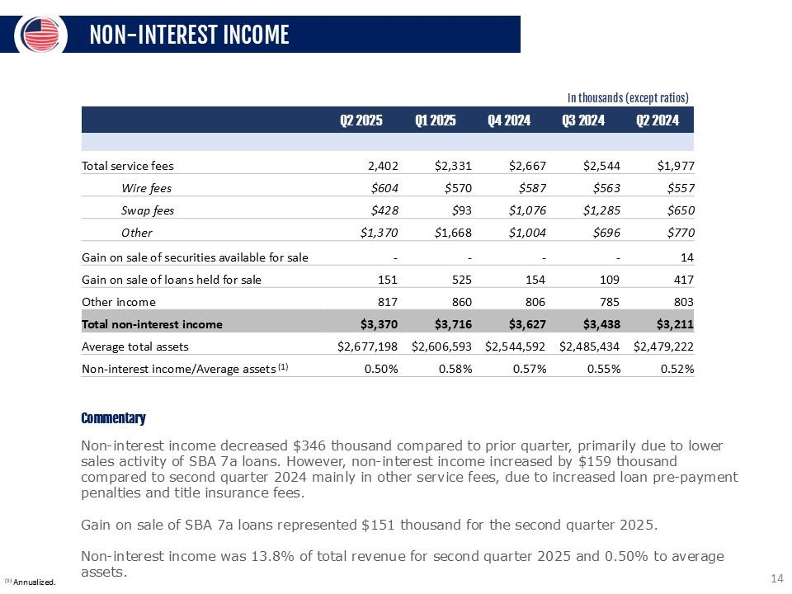
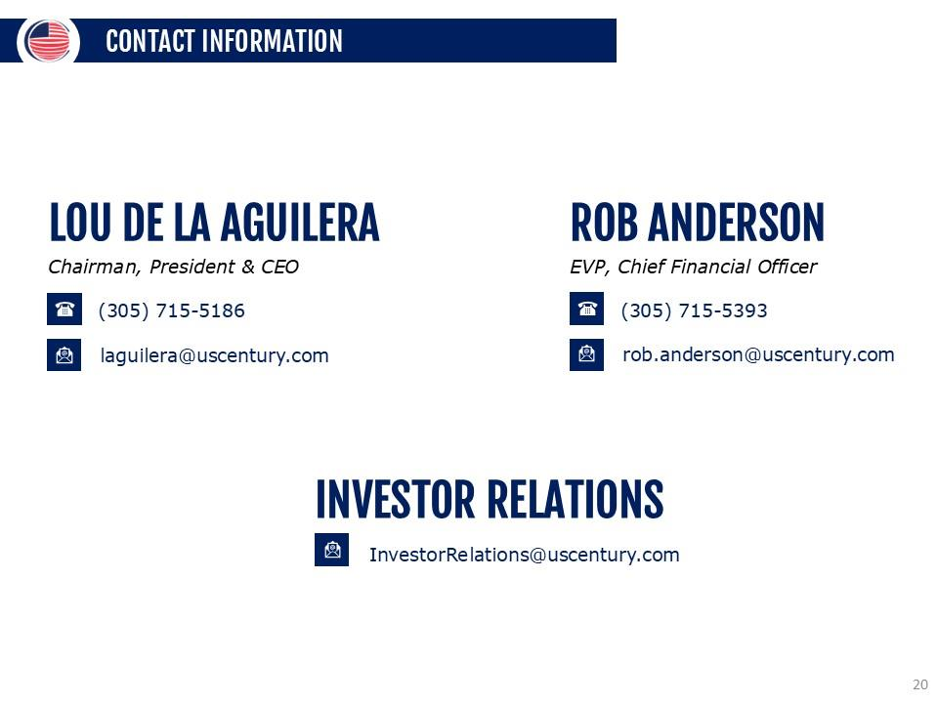
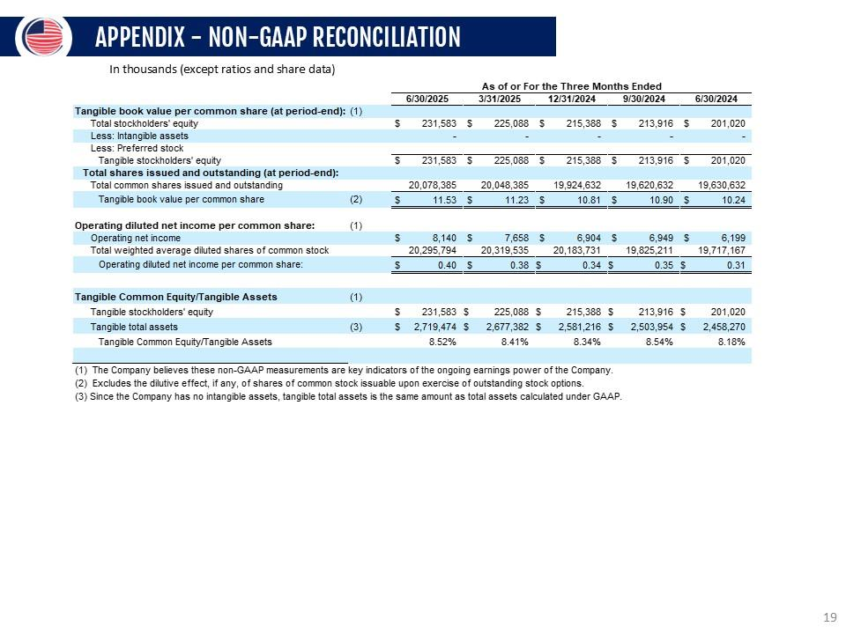
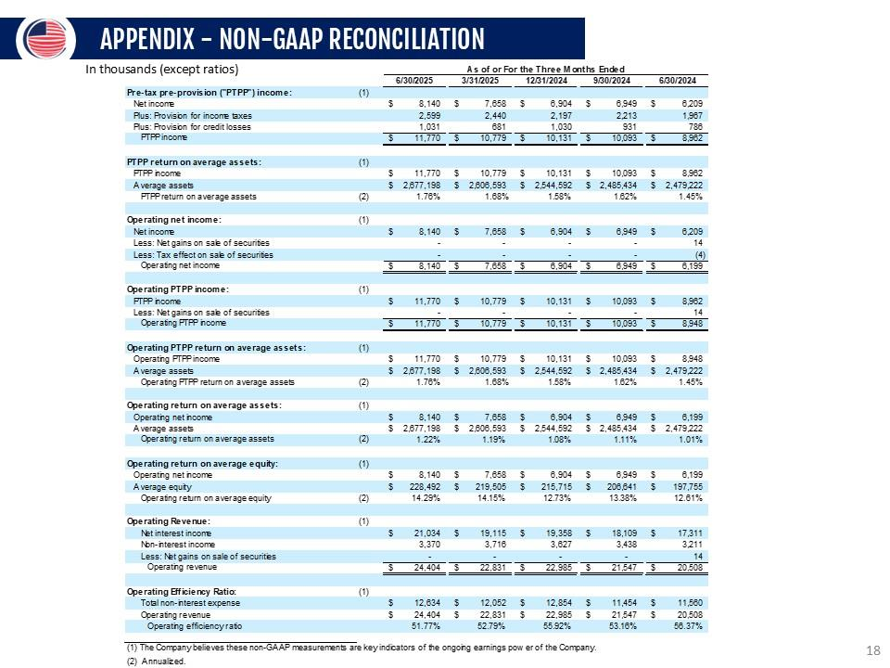
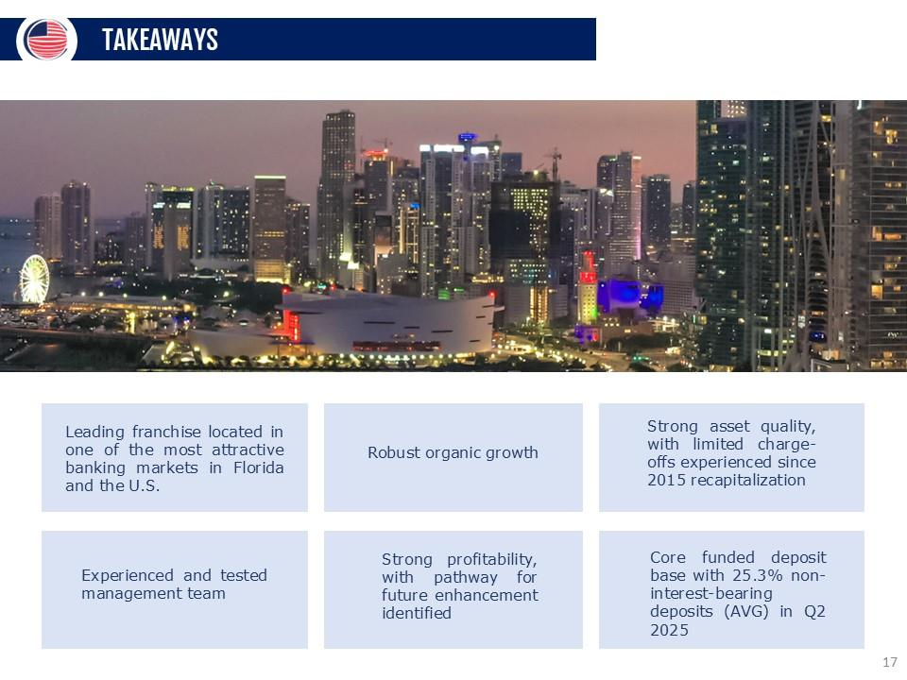
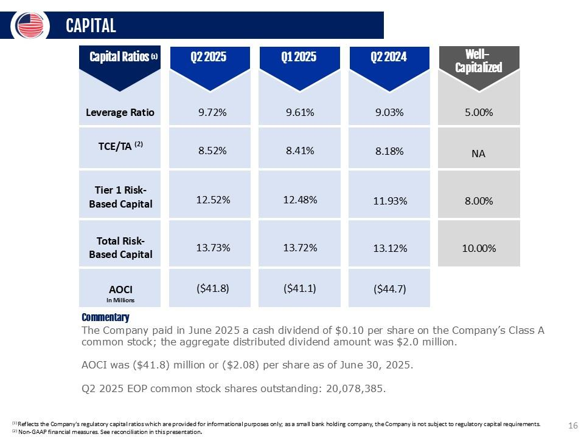
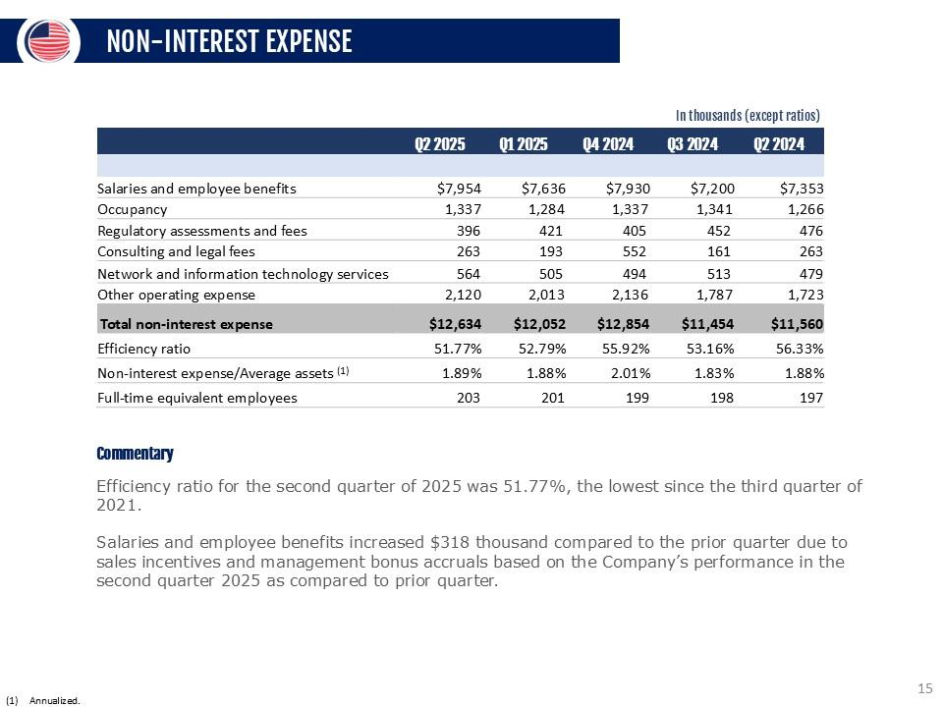
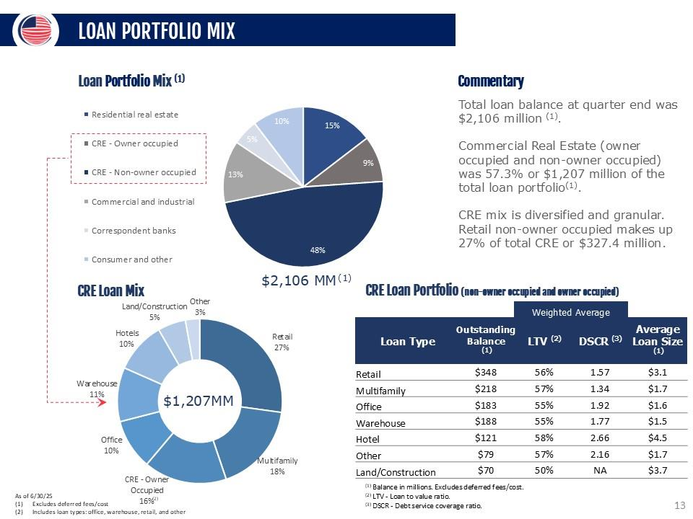
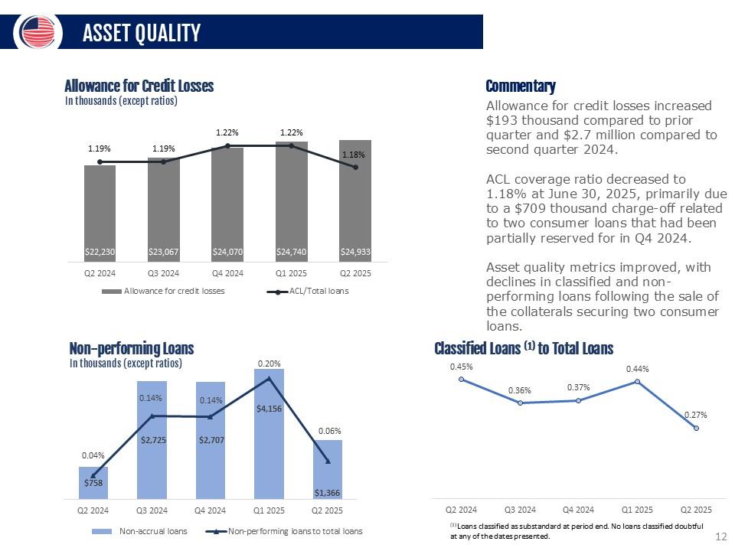
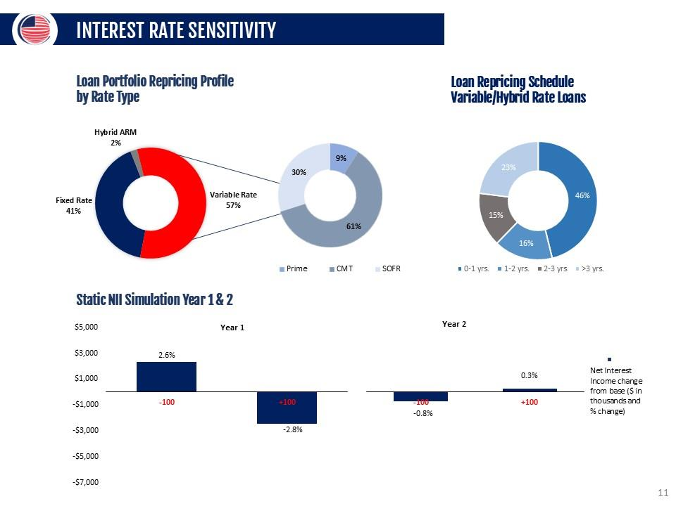
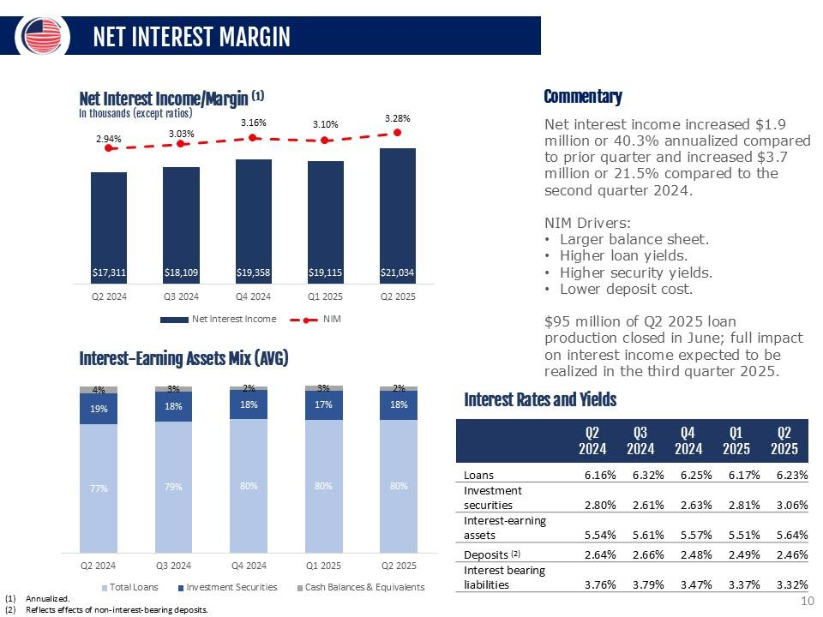
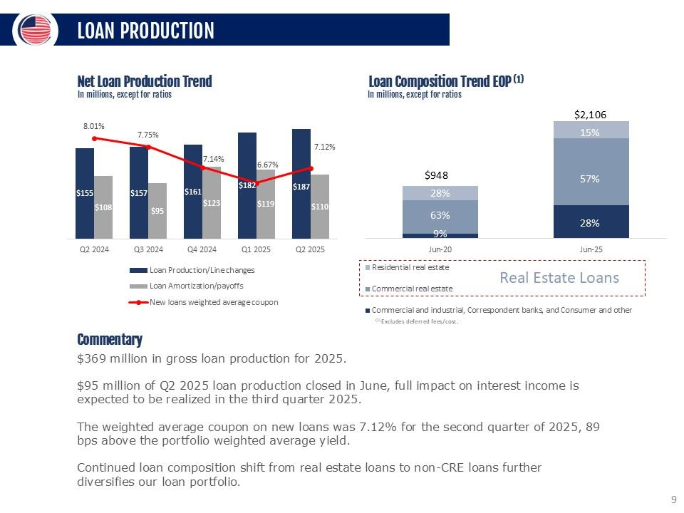
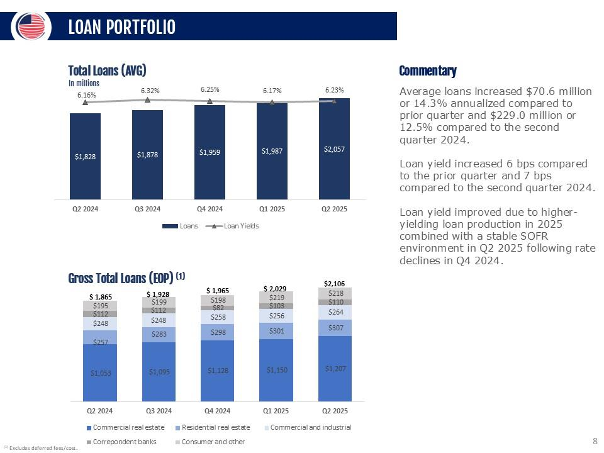
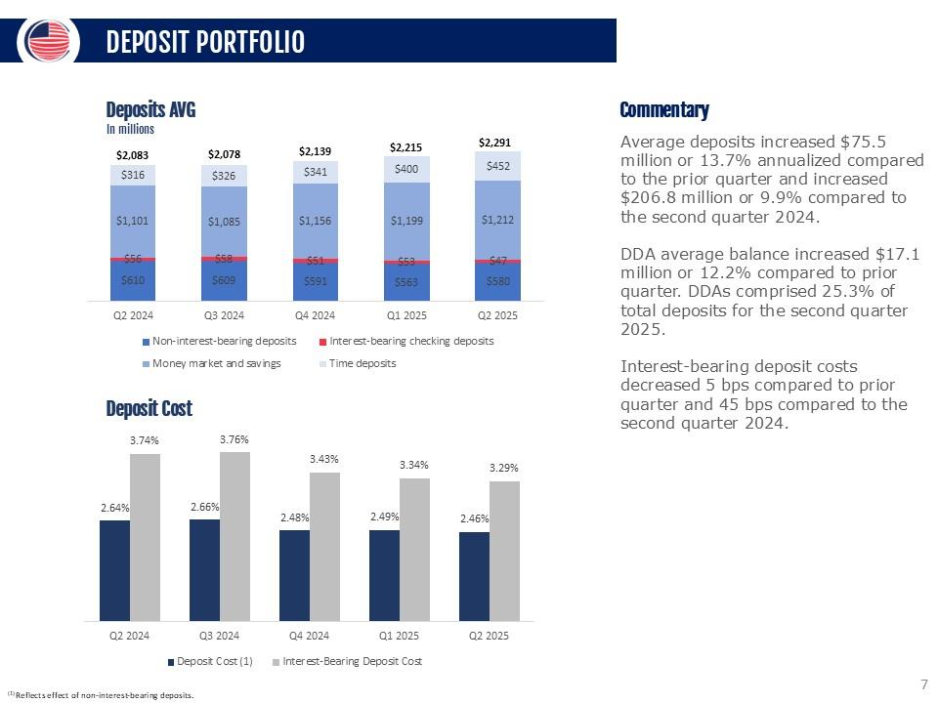
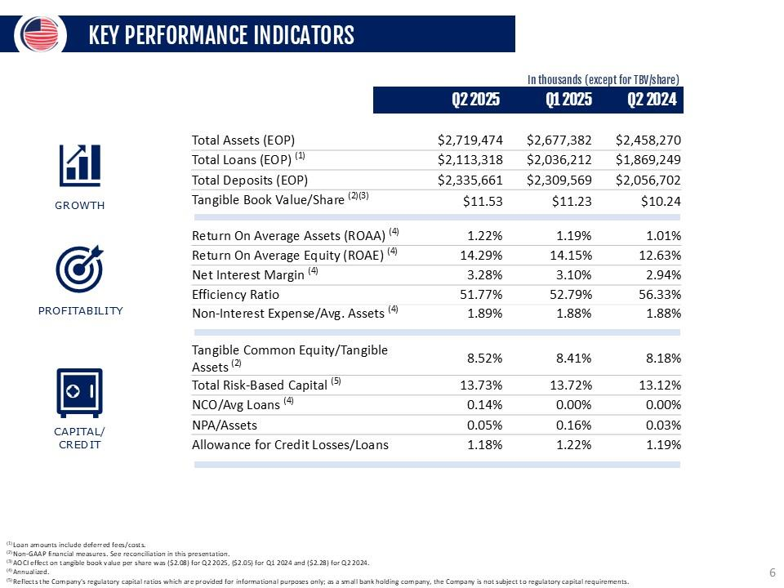
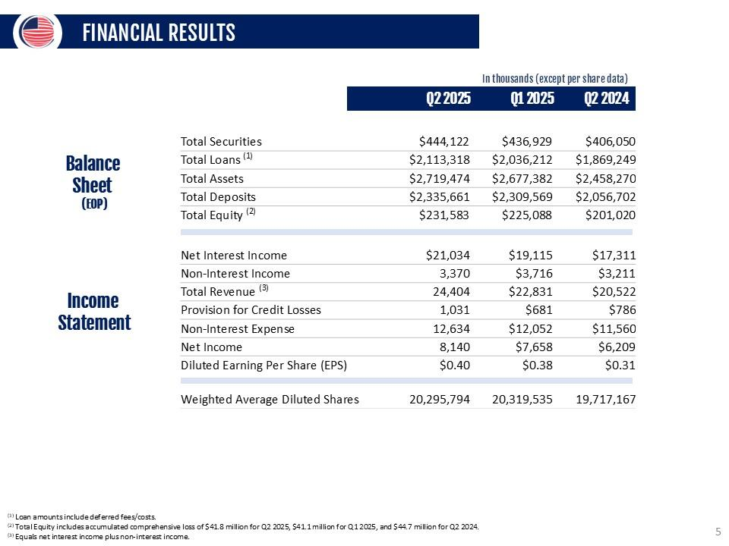
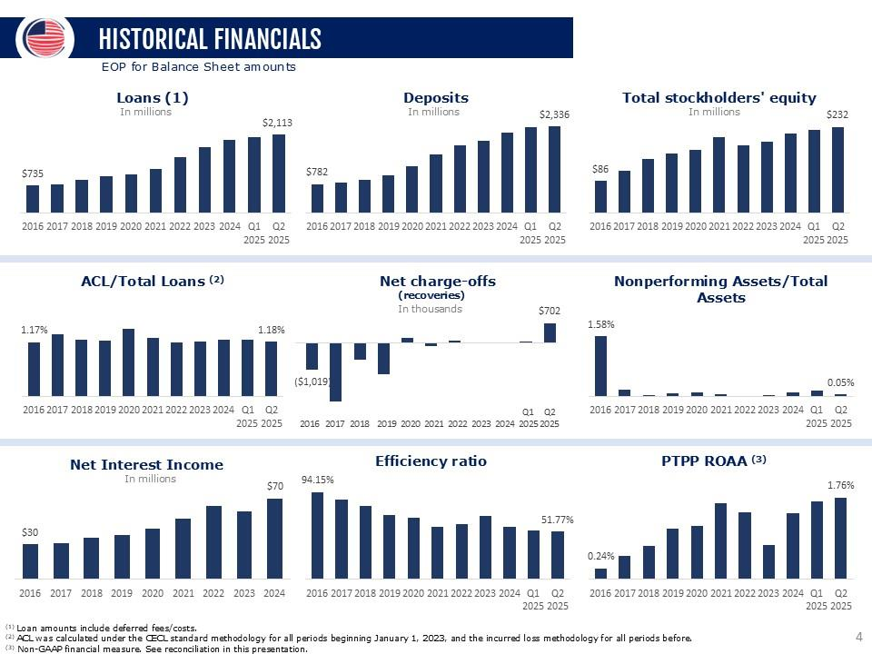
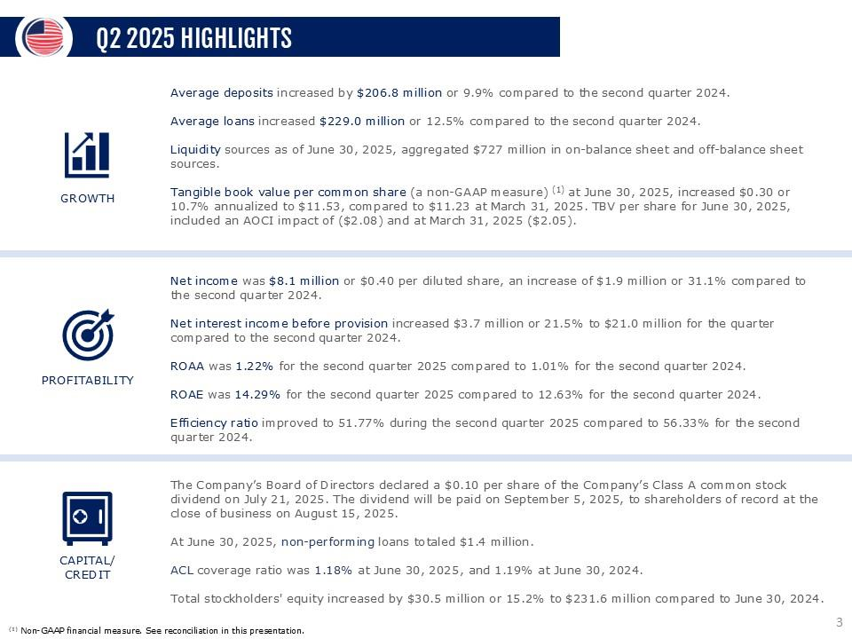
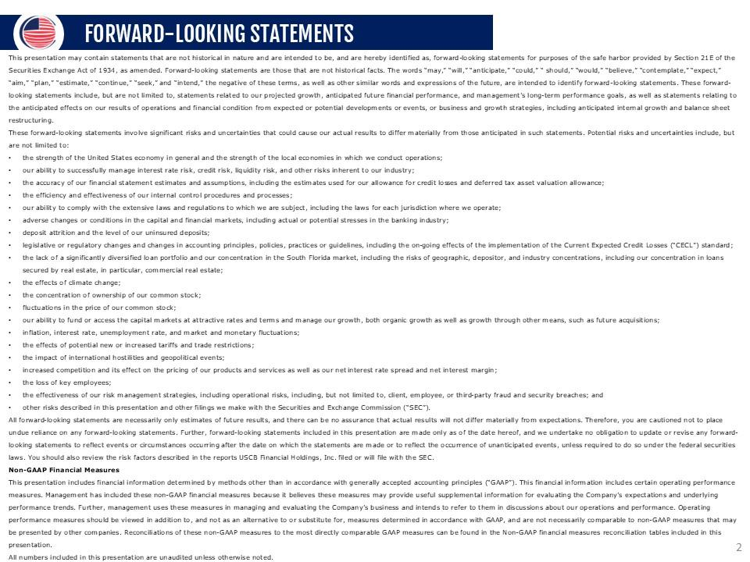
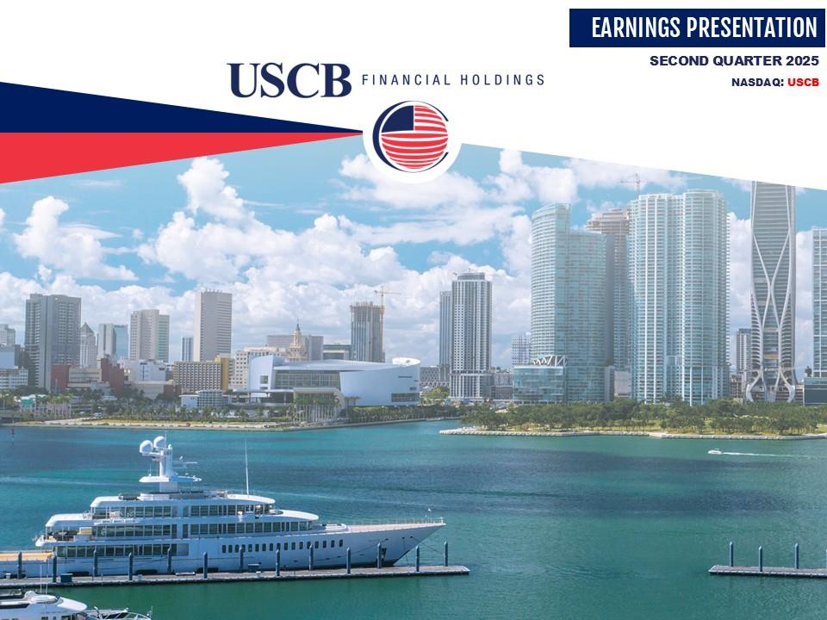


1

UNITED STATES

SECURITIES AND EXCHANGE COMMISSION

WASHINGTON,

D.C. 20549

__________________________

FORM

8-K

__________________________

CURRENT REPORT

Pursuant to Section 13 or 15(d) of the Securities Exchange Act

of 1934

Date of Report (Date of earliest event reported):

July 24, 2025

__________________________

USCB Financial Holdings, Inc.

(Exact name of Registrant as Specified in Its Charter)

__________________________

Florida

001-41196

87-4070846

(State or Other Jurisdiction

of Incorporation)

(Commission File Number)

(IRS Employer

Identification No.)

2301 N.W. 87th Avenue

,

Doral

,

Florida

33172

(Address of Principal Executive Offices)

(Zip Code)

Registrant’s Telephone

Number, Including Area Code: (

305

)

715-5200

__________________________

Check the appropriate box below if the Form 8-K filing is intended to simultaneously satisfy the filing obligation

of the registrant under

any of the following provisions:

☐

Written communications pursuant

to Rule 425 under the Securities Act (17 CFR 230.425)

☐

Soliciting material pursuant to Rule 14a-12 under the Exchange Act (17 CFR 240.14a

-12)

☐

Pre-commencement communications pursuant to Rule 14d-2(b)

under the Exchange Act (17 CFR 240.14d-2(b))

☐

Pre-commencement communications pursuant to Rule 13e-4(c) under the Exchange

Act (17 CFR 240.13e-4(c))

Securities registered pursuant to Section 12(b) of the Act:

Title of each class

Trading

Symbol(s)

Name of each exchange on which registered

Class A common stock, $1.00 par value per share

USCB

The Nasdaq Stock Market LLC

Indicate by

check mark

whether the

registrant is

an emerging

growth company

as defined

in Rule

405 of

the Securities

Act of

1933

(§ 230.405 of this chapter) or Rule 12b-2 of the Securities Exchange Act of 1934 (§ 240.12b

-2 of this chapter).

Emerging growth company

☒

If

an

emerging

growth

company,

indicate

by

check

mark

if

the

registrant

has

elected

not

to

use

the

extended

transition

period

for

complying with any new or revised financial accounting standards provided

pursuant to Section 13(a) of the Exchange Act.

☐

2

Item 2.02. Results of Operations and Financial Condition.

On July 24, 2025,

USCB Financial Holdings,

Inc. (the “Company”) issued

a press release announcing

its financial results for

the quarter ended June 30, 2025. A copy of the press release is furnished as Exhibit 99.1 to this Current Report

on Form 8-K (“Form 8-

K”) and is incorporated herein by reference.

The information in this

Item 2.02, including

Exhibit 99.1 hereto,

is being furnished

and shall not

be deemed “filed”

for purposes

of Section 18 of the Securities

Exchange Act of 1934 (the “Exchange Act”),

or otherwise subject to the liability of

that section, and shall

not be deemed

to be incorporated

by reference into

any filing under

the Securities Act of

1933 (the “Securities

Act”) or the

Exchange

Act except as expressly set forth by specific reference in such filing to this Form 8-K.

Item 7.01. Regulation FD Disclosure.

As previously announced, at 11:00 a.m. ET on July

25, 2025, the Company will hold an earnings conference call to discuss its

financial performance for the quarter ended June 30, 2025. A copy of the slides forming

the basis of the presentation is being furnished

as Exhibit 99.2

to this Form

8-K and is

incorporated herein by

reference. A copy

of the slides

has also been

posted to the

Company’s

investor relations website, located at investors.uscenturybank.com.

The information in this

Item 7.01, including

Exhibit 99.2 hereto,

is being furnished

and shall not

be deemed “filed”

for purposes

of Section

18 of

the Exchange Act,

or otherwise

subject to the

liability of that

section, and

shall not be

deemed to

be incorporated

by

reference into any filing under the

Securities Act or the Exchange Act

except as set forth by

specific reference in such filing to

this Form

8-K.

Item 9.01. Financial Statements and Exhibits.

(d) Exhibits.

Exhibit No.

Description

99.1

USCB Financial Holdings, Inc. Press Release, dated July 24, 2025

99.2

Earnings Presentation, dated July 24, 2025

104

Cover Page Interactive Data File (embedded within the Inline XBRL document)

3

SIGNATURE

Pursuant to the requirements of the Securities Exchange Act of 1934, the registrant has duly

caused this report to be signed on

its behalf by the undersigned hereunto duly authorized.

USCB Financial Holdings, Inc.

By:

/s/ Robert Anderson

Name:

Robert Anderson

Title:

Chief Financial Officer

Date: July 24, 2025

1

Exhibit 99.1

EARNINGS RELEASE

USCB Financial Holdings, Inc. Reports Record Fully Diluted EPS of

$0.40 for Q2 2025; ROAA of 1.22% and

ROAE of 14.29%

MIAMI, FL – July 24, 2025 – USCB Financial Holdings, Inc. (the “Company”) (NASDAQ: USCB)

, the holding company for U.S.

Century Bank

(the “Bank”),

reported net

income of

$8.1 million

or $0.40

per fully

diluted share

for the

three months

ended June 30,

2025, compared with net income of $6.2 million or $0.31 per fully diluted

share for the same period in 2024.

“We are proud to report

another consecutive record

quarter, with continued improvement in

our profitability ratios reflecting

the strength

of our core operations” said Luis de

la Aguilera,

Chairman, President and CEO.

“This quarter, NIM reached

3.28%, driven by healthy

loan growth and disciplined

deposit pricing. We remain focused on

sustaining this momentum while

prudently managing risk and

capital

allocation to deliver long-term value to our shareholders.”

Unless otherwise stated,

all percentage comparisons

in the bullet points

below are calculated

at or for the

quarter ended June 30,

2025

compared to at or for the quarter ended June 30, 2024 and annualized where

appropriate.

Profitability

•

Annualized return on

average assets for the

quarter ended June 30,

2025 was 1.22%

compared to 1.01%

for the second

quarter of

2024.

•

Annualized return

on average

stockholders’ equity

for the quarter

ended June 30,

2025 was

14.29%

compared to

12.63% for

the

second quarter of 2024.

•

The efficiency ratio for the quarter ended June 30, 2025 was 51.77%

compared to 56.33% for the second quarter of 2024.

•

Net interest margin for the quarter ended June 30, 2025 was 3.28

%

compared to 2.94% for the second quarter of 2024.

•

Net interest

income before

provision for

credit losses

was $21.0 million

for the

quarter ended

June 30, 2025,

an increase

of $3.7

million or 21.5% compared to $17.3 million for the same period in

2024.

Balance Sheet

•

Total

assets were $2.7

billion at June 30,

2025, representing

an increase

of $261.2 million or

10.6% from

$2.5 billion

at June 30,

2024.

•

Total

loans held for investment

were $2.1 billion at June 30,

2025, representing an

increase of $244.1 million or

13.1% from $1.9

billion at June 30, 2024.

•

Total deposits were $2.3 billion at June 30, 2025, representing an increase of $279.0 million or 13.6% from $2.1 billion at June 30,

2024.

•

Total

stockholders’ equity

was $231.6 million

at June 30,

2025, representing

an increase

of $30.6

million or

15.2% from

$201.0

million at

June 30, 2024.

Total

stockholders’ equity

included accumulated

comprehensive loss

of $41.8

million at

June 30, 2025

compared to accumulated comprehensive loss of $44.7 million at June 30, 2024.

Asset Quality

•

The allowance for credit losses (“ACL”) increased by $2.7 million to $24.9 million at June 30, 2025 from $22.2 million at

June 30,

2024.

•

The ACL represented 1.18%

of total loans at June 30, 2025 and 1.19% at June 30, 2024.

2

•

The provision for credit loss was $1.0 million for the quarter ended June 30, 2025, an increase of $245 thousand compared to $786

thousand for the same period in 2024.

•

The ratio

of non-performing

loans to

total loans

was 0.06%

at June 30,

2025 and

0.04% at

June 30, 2024.

Non-performing loans

totaled $1.4 million at June 30, 2025 and $758 thousand at June 30, 2024.

Non-interest Income and Non-interest Expense

•

Non-interest income was

$3.4 million for

the three months

ended June 30, 2025, an

increase of $159

thousand or 5.0%

compared

to $3.2 million for the same period in 2024.

•

Non-interest expense was $12.6 million for the three months ended June 30, 2025, an increase of

$1.1 million or 9.3% compared to

$11.6 million for the same period in 2024.

Capital

•

On July 21, 2025, the Company’s Board of Directors declared a quarterly cash dividend of $0.10 per share of the Company’s Class

A common stock. The dividend will be paid on September 5, 2025 to shareholders

of record at the close of business on August 15,

2025.

•

As of June 30,

2025,

total risk-based capital

ratios for the Company

and the Bank

were 13.73% and 13.67%,

respectively,

well in

excess of regulatory requirements.

•

Tangible book

value per common share (a non-GAAP

measure) was $11.53

at June 30, 2025, representing an

increase of $0.30 or

10.7% annualized from $11.23 at March

31, 2025. At June 30,

2025, tangible book value

per common share was

negatively affected

by ($2.08) per share

due to an accumulated

comprehensive loss of

$41.8 million mostly due

to changes in the

market value of the

Company’s

available for

sale securities.

At March

31, 2025,

tangible book

value per

common share

was negatively

affected

by

($2.05) per share due to an accumulated comprehensive loss of $41.1 million.

Conference Call and Webcast

The Company

will host

a conference

call on

Friday,

July

25, 2025,

at 11:00

a.m. Eastern Time

to discuss

the Company’s

unaudited

financial results for the quarter

ended June 30, 2025. To

access the conference call, dial (833)

816-1416 (U.S. toll-free)

and ask to join

the USCB Financial Holdings Call.

Additionally,

interested

parties can

listen to

a live

webcast

of the

call in

the “Investor

Relations” section

of the

Company’s

website

at www.uscentury.com

.

An archived version of the webcast will be available in the same location shortly after

the live call has ended.

About USCB Financial Holdings, Inc.

USCB Financial Holdings, Inc.

is the bank holding company for

U.S. Century Bank. Established in 2002,

U.S. Century Bank is one of

the largest

community banks

headquartered

in Miami,

and one

of the

largest community

banks in

the State

of Florida.

U.S. Century

Bank is rated 5-Stars by BauerFinancial, the nation’s leading independent

bank rating firm. U.S. Century Bank offers customers a wide

range of

financial products

and services

and supports

numerous community

organizations,

including

the Greater

Miami Chamber

of

Commerce, the South Florida Hispanic Chamber of Commerce, and ChamberSouth. For more information about us

or to find a banking

center near you, please call (305) 715-5200 or visit www.uscentury.com.

Forward-Looking Statements

This earnings release

may contain statements

that are not

historical in nature

and are intended

to be, and

are hereby identified

as, forward-

looking

statements

for

purposes

of

the

safe

harbor

provided

by

Section

21E

of

the

Securities

Exchange

Act

of

1934,

as

amended.

Forward-looking statements are

those that are

not historical facts.

The words “may,”

“will,” “anticipate,” “could,”

“should,” “would,”

“believe,” “contemplate,” “expect,” “aim,” “plan,” “estimate,” “seek,” “continue,” and “intend,”, the negative of these terms, as well as

other similar words

and expressions of

the future, are

intended to identify

forward-looking statements. These forward-looking

statements

include, but are not limited

to, statements related to our

projected growth, anticipated future

financial performance, and management’s

long-term performance goals, as well as statements

relating to the anticipated effects on our results of

operations and financial condition

from expected or potential developments or events, or business and

growth strategies, including anticipated internal growth and balance

sheet restructuring.

These forward-looking statements involve significant risks and uncertainties that could cause our actual

results to differ materially from

those anticipated in such statements. Potential risks and uncertainties include,

but are not limited to:

3

•

the strength of the United States economy in general and the strength of the local economies in

which we conduct operations;

•

our ability to successfully manage interest rate risk, credit risk, liquidity risk,

and other risks inherent to our industry;

•

the

accuracy

of

our

financial

statement

estimates

and

assumptions,

including

the

estimates

used

for

our

credit

loss

reserve

and

deferred tax asset valuation allowance;

•

the efficiency and effectiveness of our internal

control procedures and processes;

•

our ability to comply with

the extensive laws and

regulations to which we are

subject, including the laws for

each jurisdiction where

we operate;

•

adverse changes or conditions in capital and financial markets, including

actual or potential stresses in the banking industry;

•

deposit attrition and the level of our uninsured deposits;

•

legislative

or

regulatory

changes and

changes

in

accounting

principles,

policies,

practices or

guidelines,

including

the on-going

effects of the Current Expected Credit Losses (“CECL”) standard;

•

the

lack

of

a

significantly

diversified

loan

portfolio

and

our

concentration

in

the

South

Florida

market,

including

the

risks

of

geographic,

depositor,

and

industry

concentrations,

including

our

concentration

in

loans

secured

by

real

estate,

in

particular,

commercial real estate;

•

the effects of climate change;

•

the concentration of ownership of our common stock;

•

fluctuations in the price of our common stock;

•

our ability to

fund or access

the capital markets

at attractive rates

and terms and

manage our growth,

both organic

growth as well

as growth through other means, such as future acquisitions;

•

inflation, interest rate, unemployment rate, and market

and monetary fluctuations;

•

the effects of potential new or increased tariffs

and trade restrictions;

•

the impact of international hostilities and geopolitical events;

•

increased competition

and its effect

on the pricing

of our products

and services as

well as our

interest rate spread

and net interest

margin;

•

the loss of key employees;

•

the effectiveness

of our risk management

strategies, including operational

risks, including, but

not limited to, client,

employee, or

third-party fraud and security breaches; and

•

other risks described in this earnings release and other filings we make with the

Securities and Exchange Commission (“SEC”).

All forward-looking

statements are

necessarily only

estimates of

future results,

and there

can be

no assurance

that actual

results will

not differ

materially from

expectations. Therefore,

you are

cautioned not

to place

undue reliance

on any

forward-looking statements.

Further, forward-looking statements included in this

earnings release are

made only as

of the date

hereof, and we

undertake no obligation

to update or revise any forward-looking statement to reflect events

or circumstances after the date on which the statements are made

or

to reflect the occurrence of unanticipated

events, unless required to do

so under the federal securities laws.

You

should also review the

risk factors described in the reports the Company filed or will file with the SEC.

Non-GAAP Financial Measures

This earnings release

includes financial information determined

by methods other

than in accordance

with generally accepted

accounting

principles (“GAAP”). This financial

information includes certain

operating performance measures. Management

has included these

non-

GAAP

measures

because

it

believes

these

measures

may

provide

useful

supplemental

information

for

evaluating

the

Company’s

operations and

underlying performance

trends. Further,

management uses these

measures in

managing and

evaluating the Company’s

business and intends to refer to

them in discussions about our operations

and performance. Operating performance

measures should be

viewed

in

addition

to,

and

not

as

an

alternative

to

or

substitute

for,

measures

determined

in

accordance

with

GAAP,

and

are

not

necessarily

comparable

to

non-GAAP

measures

that

may

be

presented

by

other

companies.

Reconciliations

of

these

non-GAAP

measures

to

the most

directly

comparable

GAAP measures

can be

found

in the

‘Non-GAAP

Reconciliation

Tables’

included

in the

exhibits to this earnings release.

All numbers included in this press release are unaudited unless otherwise noted.

Contacts:

Investor Relations

InvestorRelations@uscentury.com

Media Relations

Martha Guerra-Kattou

MGuerra@uscentury.com

4

USCB FINANCIAL HOLDINGS, INC.

CONSOLIDATED STATEMENTS

OF INCOME (UNAUDITED)

(Dollars in thousands, except per share data)

Three Months Ended June 30,

Six Months Ended June 30,

2025

2024

2025

2024

Interest income:

Loans, including fees

$

31,946

$

28,017

$

62,191

$

54,660

Investment securities

3,432

3,069

6,456

5,880

Interest-bearing deposits in financial institutions

776

1,531

1,485

2,964

Total interest income

36,154

32,617

70,132

63,504

Interest expense:

Interest-bearing checking deposits

285

391

623

760

Savings and money market deposits

9,410

10,071

18,745

20,465

Time deposits

4,343

3,222

8,261

6,516

FHLB advances and other borrowings

1,082

1,622

2,354

3,294

Total interest expense

15,120

15,306

29,983

31,035

Net interest income before provision for credit losses

21,034

17,311

40,149

32,469

Provision for credit losses

1,031

786

1,712

1,196

Net interest income after provision for credit losses

20,003

16,525

38,437

31,273

Non-interest income:

Service fees

2,402

1,977

4,733

3,628

Gain on sale of securities available for sale, net

-

14

-

14

Gain on sale of loans held for sale, net

151

417

676

484

Other non-interest income

817

803

1,677

1,549

Total non-interest income

3,370

3,211

7,086

5,675

Non-interest expense:

Salaries and employee benefits

7,954

7,353

15,590

13,663

Occupancy

1,337

1,266

2,621

2,580

Regulatory assessments and fees

396

476

817

909

Consulting and legal fees

263

263

456

855

Network and information technology services

564

479

1,069

986

Other operating expense

2,120

1,723

4,133

3,741

Total non-interest expense

12,634

11,560

24,686

22,734

Net income before income tax expense

10,739

8,176

20,837

14,214

Income tax expense

2,599

1,967

5,039

3,393

Net income

$

8,140

$

6,209

$

15,798

$

10,821

Per share information:

Net income per common share, basic

$

0.41

$

0.32

$

0.79

$

0.55

Net income per common share, diluted

$

0.40

$

0.31

$

0.78

$

0.55

Cash dividends declared

$

0.10

$

0.05

$

0.20

$

0.10

Weighted average shares outstanding:

Common shares, basic

20,059,264

19,650,681

20,040,205

19,642,006

Common shares, diluted

20,295,794

19,717,167

20,299,585

19,707,561

5

USCB FINANCIAL HOLDINGS, INC.

SELECTED FINANCIAL DATA (UNAUDITED)

(Dollars in thousands, except per share data)

As of or For the Three Months Ended

6/30/2025

3/31/2025

12/31/2024

9/30/2024

6/30/2024

Income statement data:

Net interest income before provision for credit losses

$

21,034

$

19,115

$

19,358

$

18,109

$

17,311

Provision for credit losses

1,031

681

1,030

931

786

Net interest income after provision for credit losses

20,003

18,434

18,328

17,178

16,525

Service fees

2,402

2,331

2,667

2,544

1,977

Gain on sale of securities available for sale, net

-

-

-

-

14

Gain on sale of loans held for sale, net

151

525

154

109

417

Other non-interest income

817

860

806

785

803

Total non-interest income

3,370

3,716

3,627

3,438

3,211

Salaries and employee benefits

7,954

7,636

7,930

7,200

7,353

Occupancy

1,337

1,284

1,337

1,341

1,266

Regulatory assessments and fees

396

421

405

452

476

Consulting and legal fees

263

193

552

161

263

Network and information technology services

564

505

494

513

479

Other operating expense

2,120

2,013

2,136

1,787

1,723

Total non-interest expense

12,634

12,052

12,854

11,454

11,560

Net income before income tax expense

10,739

10,098

9,101

9,162

8,176

Income tax expense

2,599

2,440

2,197

2,213

1,967

Net income

$

8,140

$

7,658

$

6,904

$

6,949

$

6,209

Per share information:

Net income per common share, basic

$

0.41

$

0.38

$

0.35

$

0.35

$

0.32

Net income per common share, diluted

$

0.40

$

0.38

$

0.34

$

0.35

$

0.31

Cash dividends declared

$

0.10

$

0.10

$

0.05

$

0.05

$

0.05

Balance sheet data (at period-end):

Cash and cash equivalents

$

54,819

$

97,984

$

77,035

$

38,486

$

77,261

Securities available-for-sale

$

285,382

$

275,139

$

260,221

$

259,527

$

236,444

Securities held-to-maturity

$

158,740

$

161,790

$

164,694

$

167,001

$

169,606

Total securities

$

444,122

$

436,929

$

424,915

$

426,528

$

406,050

Loans held for investment

(1)

$

2,113,318

$

2,036,212

$

1,972,848

$

1,931,362

$

1,869,249

Allowance for credit losses

$

(24,933)

$

(24,740)

$

(24,070)

$

(23,067)

$

(22,230)

Total assets

$

2,719,474

$

2,677,382

$

2,581,216

$

2,503,954

$

2,458,270

Non-interest-bearing demand deposits

$

584,895

$

605,489

$

575,159

$

637,313

$

579,243

Interest-bearing deposits

$

1,750,766

$

1,704,080

$

1,598,845

$

1,489,304

$

1,477,459

Total deposits

$

2,335,661

$

2,309,569

$

2,174,004

$

2,126,617

$

2,056,702

FHLB advances and other borrowings

$

108,000

$

108,000

$

163,000

$

118,000

$

162,000

Total liabilities

$

2,487,891

$

2,452,294

$

2,365,828

$

2,290,038

$

2,257,250

Total stockholders' equity

$

231,583

$

225,088

$

215,388

$

213,916

$

201,020

Capital ratios:

(2)

Leverage ratio

9.72%

9.61%

9.53%

9.34%

9.03%

Common equity tier 1 capital

12.52%

12.48%

12.28%

12.01%

11.93%

Tier 1 risk-based capital

12.52%

12.48%

12.28%

12.01%

11.93%

Total risk-based capital

13.73%

13.72%

13.51%

13.22%

13.12%

(1)

Loan amounts include deferred fees/costs.

(2)

Reflects the Company's regulatory capital ratios which

are provided for informational purposes only; as a small

bank holding company, the Company is not subject

to regulatory capital requirements. The Bank's total risk-based

capital at June 30, 2025 was 13.67%.

6

USCB FINANCIAL HOLDINGS, INC.

AVERAGE BALANCES, RATIOS, AND OTHER DATA

(UNAUDITED)

(Dollars in thousands)

As of or For the Three Months Ended

6/30/2025

3/31/2025

12/31/2024

9/30/2024

6/30/2024

Average balance sheet data:

Cash and cash equivalents

$

71,388

$

82,610

$

56,937

$

87,937

$

107,831

Securities available-for-sale

$

281,840

$

265,154

$

255,786

$

244,882

$

263,345

Securities held-to-maturity

$

160,443

$

163,510

$

165,831

$

168,632

$

171,682

Total securities

$

442,283

$

428,664

$

421,617

$

413,514

$

435,027

Loans held for investment

(1)

$

2,057,445

$

1,986,856

$

1,958,566

$

1,878,230

$

1,828,487

Total assets

$

2,677,198

$

2,606,593

$

2,544,592

$

2,485,434

$

2,479,222

Interest-bearing deposits

$

1,710,568

$

1,652,147

$

1,547,789

$

1,468,067

$

1,473,513

Non-interest-bearing demand deposits

$

580,121

$

563,040

$

590,829

$

609,456

$

610,370

Total deposits

$

2,290,689

$

2,215,187

$

2,138,618

$

2,077,523

$

2,083,883

FHLB advances and other borrowings

$

116,527

$

138,944

$

151,804

$

156,043

$

162,000

Total liabilities

$

2,448,706

$

2,387,088

$

2,328,877

$

2,278,793

$

2,281,467

Total stockholders' equity

$

228,492

$

219,505

$

215,715

$

206,641

$

197,755

Performance ratios:

Return on average assets

(2)

1.22%

1.19%

1.08%

1.11%

1.01%

Return on average equity

(2)

14.29%

14.15%

12.73%

13.38%

12.63%

Net interest margin

(2)

3.28%

3.10%

3.16%

3.03%

2.94%

Non-interest income to average assets

(2)

0.50%

0.58%

0.57%

0.55%

0.52%

Non-interest expense to average assets

(2)

1.89%

1.88%

2.01%

1.83%

1.88%

Efficiency ratio

(3)

51.77%

52.79%

55.92%

53.16%

56.33%

Loans by type (at period end):

(4)

Residential real estate

$

307,020

$

301,164

$

289,961

$

283,477

$

256,807

Commercial real estate

$

1,206,621

$

1,150,129

$

1,136,417

$

1,095,112

$

1,053,030

Commercial and industrial

$

263,966

$

256,326

$

258,311

$

246,539

$

248,525

Correspondent banks

$

110,155

$

103,026

$

82,438

$

103,815

$

112,510

Consumer and other

$

218,426

$

218,711

$

198,091

$

198,604

$

194,644

Asset quality data:

Allowance for credit losses to total loans

1.18%

1.22%

1.22%

1.19%

1.19%

Allowance for credit losses to non-performing loans

1825%

595%

889%

846%

2,933%

Total non-performing loans

(5)

$

1,366

$

4,156

$

2,707

$

2,725

$

758

Non-performing loans to total loans

0.06%

0.20%

0.14%

0.14%

0.04%

Non-performing assets to total assets

(5)

0.05%

0.16%

0.10%

0.11%

0.03%

Net charge-offs (recoveries of) to average loans

(2)

0.14%

0.00%

(0.00)%

(0.00)%

(0.00)%

Net charge-offs (recovery) of credit losses

$

702

$

2

$

(11)

$

(6)

$

(2)

Interest rates and yields:

(2)

Loans held for investment

6.23%

6.17%

6.25%

6.32%

6.16%

Investment securities

3.06%

2.81%

2.63%

2.61%

2.80%

Total interest-earning assets

5.64%

5.51%

5.57%

5.61%

5.54%

Deposits

(6)

2.46%

2.49%

2.48%

2.66%

2.64%

FHLB advances and other borrowings

3.72%

3.71%

3.81%

4.05%

4.03%

Total interest-bearing liabilities

3.32%

3.37%

3.47%

3.79%

3.76%

Other information:

Full-time equivalent employees

203

201

199

198

197

(1)

Loan amounts include deferred fees/costs.

(2)

Annualized.

(3)

Efficiency ratio is defined as total non-interest expense divided

by sum of net interest income and total non-interest

income.

(4)

Loan amounts exclude deferred fees/costs.

(5)

The amounts for total non-performing loans and total non-performing

assets are the same at the dates presented since there was

no other real estate owned (OREO)

recorded at any of the dates presented.

(6) Reflects effect of non-interest-bearing deposits.

7

USCB FINANCIAL HOLDINGS, INC.

NET INTEREST MARGIN (UNAUDITED)

(Dollars in thousands)

Three Months Ended June 30,

2025

2024

Average

Balance

Interest

Yield/Rate

(1)

Average

Balance

Interest

Yield/Rate

(1)

Assets

Interest-earning assets:

Loans held for investment

(2)

$

2,057,445

$

31,946

6.23%

$

1,828,487

$

28,017

6.16%

Investment securities

(3)

449,624

3,432

3.06%

440,559

3,069

2.80%

Other interest-earning assets

63,974

776

4.87%

100,371

1,531

6.13%

Total interest-earning assets

2,571,043

36,154

5.64%

2,369,417

32,617

5.54%

Non-interest-earning assets

106,155

109,805

Total assets

$

2,677,198

$

2,479,222

Liabilities and stockholders' equity

Interest-bearing liabilities:

Interest-bearing checking deposits

$

46,694

285

2.45%

$

56,369

391

2.79%

Saving and money market deposits

1,211,513

9,410

3.12%

1,101,272

10,071

3.68%

Time deposits

452,361

4,343

3.85%

315,872

3,222

4.10%

Total interest-bearing deposits

1,710,568

14,038

3.29%

1,473,513

13,684

3.74%

FHLB advances and other borrowings

116,527

1,082

3.72%

162,000

1,622

4.03%

Total interest-bearing liabilities

1,827,095

15,120

3.32%

1,635,513

15,306

3.76%

Non-interest-bearing demand deposits

580,121

610,370

Other non-interest-bearing liabilities

41,490

35,584

Total liabilities

2,448,706

2,281,467

Stockholders' equity

228,492

197,755

Total liabilities and stockholders' equity

$

2,677,198

$

2,479,222

Net interest income

$

21,034

$

17,311

Net interest spread

(4)

2.32%

1.78%

Net interest margin

(5)

3.28%

2.94%

(1)

Annualized.

(2)

Average loan balances include non-accrual loans. Interest income on loans includes accretion

of deferred loan fees, net of deferred loan costs.

(3)

At fair value except for securities held to maturity. This amount includes

FHLB stock.

(4)

Net interest spread is the average yield earned on total

interest-earning assets minus the average rate paid on total interest-bearing

liabilities.

(5)

Net interest margin is the ratio of net interest income to total

interest-earning assets.

8

USCB FINANCIAL HOLDINGS, INC.

NON-GAAP FINANCIAL MEASURES (UNAUDITED)

(Dollars in thousands)

As of or For the Three Months Ended

6/30/2025

3/31/2025

12/31/2024

9/30/2024

6/30/2024

Pre-tax pre-provision ("PTPP") income:

(1)

Net income

$

8,140

$

7,658

$

6,904

$

6,949

$

6,209

Plus: Provision for income taxes

2,599

2,440

2,197

2,213

1,967

Plus: Provision for credit losses

1,031

681

1,030

931

786

PTPP income

$

11,770

$

10,779

$

10,131

$

10,093

$

8,962

PTPP return on average assets:

(1)

PTPP income

$

11,770

$

10,779

$

10,131

$

10,093

$

8,962

Average assets

$

2,677,198

$

2,606,593

$

2,544,592

$

2,485,434

$

2,479,222

PTPP return on average assets

(2)

1.76%

1.68%

1.58%

1.62%

1.45%

Operating net income:

(1)

Net income

$

8,140

$

7,658

$

6,904

$

6,949

$

6,209

Less: Net gains on sale of securities

-

-

-

-

14

Less: Tax effect on sale of securities

-

-

-

-

(4)

Operating net income

$

8,140

$

7,658

$

6,904

$

6,949

$

6,199

Operating PTPP income:

(1)

PTPP income

$

11,770

$

10,779

$

10,131

$

10,093

$

8,962

Less: Net gains on sale of securities

-

-

-

-

14

Operating PTPP income

$

11,770

$

10,779

$

10,131

$

10,093

$

8,948

Operating PTPP return on average assets:

(1)

Operating PTPP income

$

11,770

$

10,779

$

10,131

$

10,093

$

8,948

Average assets

$

2,677,198

$

2,606,593

$

2,544,592

$

2,485,434

$

2,479,222

Operating PTPP return on average assets

(2)

1.76%

1.68%

1.58%

1.62%

1.45%

Operating return on average assets:

(1)

Operating net income

$

8,140

$

7,658

$

6,904

$

6,949

$

6,199

Average assets

$

2,677,198

$

2,606,593

$

2,544,592

$

2,485,434

$

2,479,222

Operating return on average assets

(2)

1.22%

1.19%

1.08%

1.11%

1.01%

Operating return on average equity:

(1)

Operating net income

$

8,140

$

7,658

$

6,904

$

6,949

$

6,199

Average equity

$

228,492

$

219,505

$

215,715

$

206,641

$

197,755

Operating return on average equity

(2)

14.29%

14.15%

12.73%

13.38%

12.61%

Operating Revenue:

(1)

Net interest income

$

21,034

$

19,115

$

19,358

$

18,109

$

17,311

Non-interest income

3,370

3,716

3,627

3,438

3,211

Less: Net gains on sale of securities

-

-

-

-

14

Operating revenue

$

24,404

$

22,831

$

22,985

$

21,547

$

20,508

Operating Efficiency Ratio:

(1)

Total non-interest expense

$

12,634

$

12,052

$

12,854

$

11,454

$

11,560

Operating revenue

$

24,404

$

22,831

$

22,985

$

21,547

$

20,508

Operating efficiency ratio

51.77%

52.79%

55.92%

53.16%

56.37%

(1) The Company believes these non-GAAP measurements are

key indicators of the ongoing earnings power of the

Company.

(2)

Annualized.

9

USCB FINANCIAL HOLDINGS, INC.

NON-GAAP FINANCIAL MEASURES (UNAUDITED)

(Dollars in thousands, except per share data)

As of or For the Three Months Ended

6/30/2025

3/31/2025

12/31/2024

9/30/2024

6/30/2024

Tangible book value per common share (at period-end):

(1)

Total stockholders' equity

$

231,583

$

225,088

$

215,388

$

213,916

$

201,020

Less: Intangible assets

-

-

-

-

-

Tangible stockholders' equity

$

231,583

$

225,088

$

215,388

$

213,916

$

201,020

Total shares issued and outstanding (at period-end):

Total common shares issued and outstanding

20,078,385

20,048,385

19,924,632

19,620,632

19,630,632

Tangible book value per common share

(2)

$

11.53

$

11.23

$

10.81

$

10.90

$

10.24

Operating diluted net income per common share:

(1)

Operating net income

$

8,140

$

7,658

$

6,904

$

6,949

$

6,199

Total weighted average diluted shares of common stock

20,295,794

20,319,535

20,183,731

19,825,211

19,717,167

Operating diluted net income per common share:

$

0.40

$

0.38

$

0.34

$

0.35

$

0.31

Tangible Common Equity/Tangible Assets

(1)

Tangible stockholders' equity

$

231,583

$

225,088

$

215,388

$

213,916

$

201,020

Tangible total assets

(3)

$

2,719,474

$

2,677,382

$

2,581,216

$

2,503,954

$

2,458,270

Tangible Common Equity/Tangible Assets

8.52%

8.41%

8.34%

8.54%

8.18%

(1)

The Company believes these non-GAAP measurements

are key indicators of the ongoing earnings power

of the Company.

(2)

Excludes the dilutive effect, if any, of shares of common stock issuable upon exercise of outstanding

stock options.

(3) Since the Company has no intangible assets, tangible

total assets is the same amount as total assets calculated

under GAA

P.

Exhibit 99.2

EARNINGS PRESENTATION SECOND QUARTER 2025

NASDAQ: USCB USBC FINANCIAL HOLDINGS

FORWARD-LOOKING STATEMENTS This presentation

may contain statements that are not historical in nature and are

intended to be, and are hereby identified as, forward-looking statements

for purposes of the safe harbor provided by Section 21E of the

Securities Exchange Act of 1934, as amended. Forward-looking statements

are those that are not historical facts. The words “may,” “will,”

“anticipate,” “could,” “ should,” “would,” “believe,” “contemplate,”

“expect,” “aim,” “plan,” “estimate,” “continue,” “seek,” and

“intend,” the negative of these terms, as well as other similar words and expressions

of the future, are intended to identify forward-looking statements. These

forward-looking statements include, but are not limited to, statements

related to our projected growth, anticipated future

financial performance, and management’s long-term performance

goals, as well as statements relating to the anticipated effects

on our results of operations and financial condition from expected or potential

developments or events, or business and growth strategies, including

anticipated internal growth and balance sheet restructuring.

These forward-looking statements involve significant risks and uncertainties

that could cause our actual results to differ materially from those

anticipated in such statements. Potential risks and uncertainties include,

but are not limited to: the strength of the United States economy

in general and the strength of the local economies in which we conduct

operations; our ability to successfully manage interest rate

risk, credit

risk, liquidity risk, and other risks inherent to our industry; the

accuracy of our financial statement estimates and assumptions,

including the estimates used for our allowance for credit losses

and deferred tax asset valuation allowance; the efficiency

and effectiveness of our internal control procedures and processes; our

ability to comply with the extensive laws and

regulations to which we are subject, including the laws for each jurisdiction

where we operate; adverse changes or conditions in the capi

tal and financial markets, including actual or potential stresses in

the banking industry; deposit attrition and the level of our uninsured

deposits; legislative or regulatory changes and changes in accounting

principles, policies, practices or guidelines, including the

on-going effects of the implementation of the Current Expected

Credit Losses (“CECL”) standard; the lack of a significantly diversified

loan portfolio and our concentration in the South Florida market,

including the risks of geographic, depositor, and industry

concentrations, including our concentration in loans secured

by real estate, in particular, commercial real estate; the effects

of climate change; the concentration of ownership of our common stock;

fluctuations in the price of our common stock; our ability to fund

or access the capital markets at attractive rates and terms and manage

our growth, both organic growth as well as growth through other

means, such as future acquisitions; inflation, interest rate, unemployment

rate, and market and monetary fluctuations; the effects

of potential new or increased tariffs and trade restrictions; the impact

of international hostilities and geopolitical events; increased

competition and its effect on the pricing of our products and services as well

as our net interest rate spread and net interest margin; the

loss of key employees; the effectiveness of our risk management strategies,

including operational risks, including, but not limited to, client,

employee, or third-party fraud and security breaches; and other

risks described in this presentation and other filings we make with

the Securities and Exchange Commission (“SEC”). All forward

-looking statements are necessarily only estimates of future results, and

there can be no assurance that actual results will not differ

materially from

expectations. Therefore, you are cautioned not to place undue reliance

on any forward-looking statements. Further, forward-looking statements

included in this presentation are made only as of the date hereof,

and we undertake no obligation to update or revise any forward

-looking statements to reflect events or circumstances occurring after

the date on which the statements are made or to reflect the occurrence

of unanticipated events, unless required to do so under the federal securities

laws. You should also review the risk factors described in

the reports USCB Financial Holdings, Inc. filed or will file with

the SEC. Non-GAAP Financial Measures This presentation includes

financial information determined by methods other than in accordance

with generally accepted accounting principles (“GAAP”). This financial

information includes certain operating performance measures.

Management has included these non-GAAP financial measures

because it believes these measures may provide useful supplemental

information for evaluating the Company’s expectations and underlying

performance trends. Further, management uses these measures

in managing and evaluating the Company’s business and

intends to refer to them in discussions about our operations and

performance. Operating performance measures should be

viewed in addition to, and not as an alternative to or substitute for,

measures determined in accordance with GAAP, and are

not necessarily comparable to non-GAAP measures that may be presented

by other companies. Reconciliations of these non-GAAP measures to

the most directly comparable GAAP measures can be found in the

Non-GAAP financial measures reconciliation tables included in

this presentation. All numbers included in this presentation are

unaudited unless otherwise noted. 2

Q2 2025 HIGHLIGHTS GROWTH Average deposits increased

by $206.8 million or 9.9% compared to the second quarter 2024. Average

loans increased $229.0 million or 12.5% compared to the second

quarter 2024. Liquidity sources as of June 30, 2025, aggregated

$727 million in on-balance sheet and off-balance sheet

sources. Tangible book value per common share (a non-GAAP measure)

(1) at June 30, 2025, increased $0.30 or 10.7% annualized to $11.53, compared

to $11.23 at March 31, 2025. TBV per share for June 30, 2025,

included an AOCI impact of ($2.08) and at March 31, 2025 ($2.05).

PROFITABILITY Net income was $8.1 million or $0.40

per diluted share, an increase of $1.9 million or 31.1% compared to

the second quarter 2024. Net interest income before provision increase

d

$3.7 million or 21.5% to $21.0 million for the quarter compared

to the second quarter 2024. ROAA was 1.22% for the second quarter

2025 compared to 1.01% for the second quarter 2024. ROAE was

14.29% for the second quarter 2025 compared to 12.63% for the

second quarter 2024. Efficiency ratio improved to 51.77% during

the second quarter 2025 compared to 56.33% for the second quarter

2024. CAPITAL/CREDIT The Company’s Board of Directors

declared a $0.10 per share of the Company’s Class A common stock

dividend on July 21, 2025. The dividend will be paid on September

5, 2025, to shareholders of record at the close of business on Augus

t

15, 2025. At June 30, 2025, non-performing loans totaled

$1.4 million. ACL coverage ratio was 1.18% at June 30, 2025, and 1.19%

at June 30, 2024. Total stockholders' equity increased

by $30.5 million or 15.2% to $231.6 million compared to June 30, 2024.

(1) Non-GAAP financial measure. See reconciliation in this

presentation. 3

HISTORICAL FINANCIALS EOP for Balance Sheet amounts Loans

In millions $735 $2,113 2016 2017 2018 2019 2020 2021

2022 2023 2024 Q1 Q2 2025 2025 Deposits In millions $782

$2,336 2016 2017 2018 2019 2020 2021 2022 2023 2024 Q1 Q2

2025 2025 Total stockholder’s equity In millions $86 $232

2016 2017 2018 2019 2020 2021 2022 2023 2024 Q1 Q2 2025

2025 ACL/Total Lonas 1.17% 1.18% 2016 2017 2018 2019

2020 2021 2022 2023 2024 Q1 Q2 2025 2025 Net charge-offs (recoveries)

In millions ($1,019) $702 2016 2017 2018 2019 2020 2021 2022 2023 2024

Q1 Q2 2025 2025 Nonperforming Assets/Total Assets

1.58% 0.05% 2016 2017 2018 2019 2020 2021 2022 2023 2024

Q1 Q2 2025 2025 Net Interest Income In millions $30 $70 2016 2017

2018 2019 2020 2021 2022 2023 2024 Q1 Q2 2025 2025 Efficiency

ratio 94.15% 51.77% 2016 2017 2018 2019 2020 2021 2022 2023

2024 Q1 Q2 2025 2025 PTPP ROAA 0.24% 1.76% 2016 2017 2018 2019

2020 2021 2022 2023 2024 Q1 Q2 2025 2025 (1) Loan amounts

include deferred fees/costs. (2) ACL was calculated under the

CECL standard methodology for all periods beginning January 1, 2023,

and the incurred loss methodology for all periods before.

(3) Non-GAAP financial measure. See reconciliation

in this presentation. 4

FINANCIAL RESULTS In thousands (except per share

date) Q2 2025 Q1 2025 Q2 2024 Balance Sheet (EOP) Total

Securities $444,122 $436,929 $406,050 Total Loans (1) $2,113,318

$2,036,212 $1,869,249 Total Assets $2,719,474 $2,677,382

$2,458,270 Total Deposits $2,335,661 $2,309,569 $2,056,702

Total Equity (2) $231,583 $225,088 $201,020 Income Statement

Net Interest Income $21,034 $19,115

$17,311 Non-Interest Income 3,370 $3,716 $3,211 Total

Revenue (3) 24,404 $22,831 $20,522 Provision for Credit Losses 1,031

$681 $786 Non-Interest Expense 12,634 $12,052 $11,560 Net

Income 8,140 $7,658 $6,209 Diluted Earning Per Share (EPS)

$0.40 $0.38 $0.31 Weighted Average Diluted Shares

20,295,794 20,319,535 19,717,167 (1) Loan amounts include deferred

fees/costs. (2) Total Equity includes accumulated comprehensive

loss of $41.8 million for Q2 2025, $41.1 million for Q1 2025,

and $44.7 million for Q2 2024. (3) Equals net interest income plus non

-interest income. 5

KEY PERFORMANCE INDICATORS In thousands (except

for TBV/share) Q2 2025 Q1 2025 Q2 2024 GROWTH PROFITABILITY

CAPITAL/CREDIT Total Assets (EOP) $2,719,474 $2,677,382

$2,458,270 Total Loans (EOP) (1) $2,113,318 $2,036,212

$1,869,249 Total Deposits (EOP) $2,335,661 $2,309,569 $2,056,702

Tangible Book Value/Share (2)(3) $11.53 $11.23

$10.24 Return On Average Assets (ROAA) (4) 1.22% 1.19%

1.01% Return On Average Equity (ROAE) (4) 14.29%

14.15% 12.63% Net Interest Margin (4) 3.28% 3.10% 2.94%

Efficiency Ratio 51.77% 52.79% 56.33% Non-Interest Expense/Avg.

Assets (4) 1.89% 1.88% 1.88% Tangible Common Equity/Tangible

Assets (2) 8.52% 8.41% 8.18% Total Risk-Based Capital

(5) 13.73% 13.72% 13.12% NCO/Avg Loans (4) 0.14% 0.00%

0.00% NPA/Assets 0.05% 0.16% 0.03% Allowance

for Credit Losses/Loans 1.18% 1.22% 1.19% (1) Loan amounts include

deferred fees/costs. (2) Non-GAAP financial measures. See

reconciliation in this presentation. (3) AOCI effect on tangible

book value per share was ($2.08) for Q2 2025, ($2.05) for Q1 2024

and ($2.28) for Q2 2024. (4) Annualized. (5) Reflects the Company's

regulatory capital ratios which are provided for informational

purposes only; as a small bank holding company, the Company

is not subject to regulatory capital requirements. 6

DEPOSIT PORTFOLIO Deposits AVG In millions $2,083

$2,078 $2,139 $2,215 $2,291 $316 $326 $341 $400 $452 $1,101

$1,085 $1,156 $1,199 $1,212 $56 $58 $51 $53 $47 $610 $690 $591

$563 $580 Q2 2024 Q3 2024 Q4 2024 Q1 2025 Q2 2025 Q2

Q3 Q4 Q1 Q2 Non-interest-bearing deposits Interest-bearing checking

deposits Money market and savings Time deposits Deposit

Cost 2.64% 33.74% 2.66% 3.76% 2.48% 3.43% 2.49% 3.34%

2.46% 3.29% Q2 2024 Q3 2024 Q4 2024 Q1 2025 Q2 2025 Q2 Q3 Q4

Q1 Q2 Deposit Cost Interest-Bearing Deposit cost Commentary

Average deposits increased $75.5 million or 13.7% annualized

compared to the prior quarter and increased $206.8 million

or 9.9% compared to the second quarter 2024. DDA average

balance increased $17.1 million or 12.2% compared to prior quarter.

DDAs comprised 25.3% of total deposits for the second quarter

2025. Interest-bearing deposit costs decreased 5 bps compared to prior

quarter and 45 bps compared to the second quarter 2024. (1) Reflects

effect of non-interest-bearing deposits. 7

LOAN PORTFOLIO Total Loans (AVG) In millions

6.16% 6.32% 6.25% 6.17% 6.23% $1,828 $1,878 $1,959 $1,987

$2,057 Q2 2024 Q3 2024 Q4 2024 Q1 2025 Q2 2025 Loans Loan

Yields Gross Total Loans (EOP) (1) $1,865 $1,928 $1,965

$2,029 $2,106 $195 $199 $198 $219 $218 $248 $248 $258 $256

$264 $257 $283 $298 $301 $307 $1,053 $1,095 $1,128 $1,150 $1,207

Q2 2024 Q3 2024 Q4 2024 Q1 2025 Q2 2025 Commercial

real estate Residential real estate commercial real estate Correspondent

banks Consumer and other Commentary Average loans increased

$70.6 million or 14.3% annualized compared to prior quarter and $229.0

million or 12.5% compared to the second quarter 2024. Loan

yield increased 6 bps compared to the prior quarter and 7 bps compared

to the second quarter 2024. Loan yield improved due to higher-yielding

loan production in 2025 combined with a stable SOFR environment

in Q2 2025 following rate declines in Q4 2024. (1) Excludes deferre

d

fees/cost. 8

LOAN PRODUCTION Net Loan Production Trend In millions,

except for ratios 8.01% 7.75% 7.14% 6.67% 7.12% $155 $108 $157

$95 $161 $123 $182 $119 $187 $110 Q2 2024 Q3 2024 Q4

2024 Q1 2025 Q2 2025 Loan Production/line changes Loan Amortiz

ation/payoffs New loans weighted average coupon $948 $2,106

28% 15% 63% 57% $9 $28 Jun-20 Jun-25 Loan Composition Trend

EOP (1) In millions, except for ratios Residential real estate

Commercial real estate Real Estate Loans Commercial and industrial, corre

spondent banks, and Consumer and other (1) Excludes deferred

fees/cost. Commentary $369 million in gross loan production for 2025. $95 million

of Q2 2025 loan production closed in June, full impact on interest

income is expected to be realized in the third quarter 2025. The

weighted average coupon on new loans was 7.12% for the second

quarter of 2025, 89 bps above the portfolio weighted average

yield. Continued loan composition shift from real estate loans to non-CRE

loans further diversifies our loan portfolio. 9

NET INTEREST MARGIN Net Interest Income/Margin (1) In thousands

(except ratios) 2.94% 3.03% 3.16% 3.10% 3.28% $17,311 $18,109

$19,358 $19,115 $21,034 Q2 2024 Q3 2024 Q4 2024 Q1 2025

Q2 2025 Net Interest Income NIM 4% 3% 2% 3% 2% 19% 18%

18% 17% 18% 77%

79% 80% 80% 80% Q2 2024 Q3 2024 Q4 2024 Q1 2025 Q2

2025 Interest-Earning Assets Mix (AVG) Total Loans

Investment Securities Cash Balances & Equivalents Commentary

Net interest income increased $1.9 million or 40.3% annualized

compared to prior quarter and increased $3.7 million or 21.5% compared

to the second quarter 2024. NIM Drivers: Larger balance sheet. Higher

loan yields. Higher security yields. Lower deposit cost. $95 million

of Q2 2025 loan production closed in June; full impact on interest

income expected to be realized in the third quarter 2025. Interest

Rates and Yields Q2 2024 Q3 2024 Q4 2024 Q1 2025 Q2 2025

Loans 6.16% 6.32% 6.25% 6.17% 6.23% Investment securities

2.80% 2.61% 2.63% 2.81% 3.06% Interest-earning assets

5.54% 5.61% 5.57% 5.51% 5.64% Deposits (2) 2.64% 2.66% 2.48%

2.49% 2.46% Interest bearing liabilities 3.76% 3.79% 3.47% 3.37%

3.32% Annualized. Reflects effects of non-interest-bearing deposits. 10

INTEREST RATE SENSITIVITY Loan Portfolio Profile

By Rate Type Hybrid Arm 2% Fixed Rate 41% Variable

Rate57% 30% 9% 61%

Prime CMT SOFR Loan Repricing Schedule Variable/Hybrid

Rate Loans 23% 46% 16% 15% 0-1 yrs. 1-2 yrs. 2-3 yrs. >3 yrs.

Static NII Simulation year 1&2 2.6% -100 +100 -2.8% -100 -0.8%

0.3% +100 Net interest income charge from base ($ in thousands

and % change) 11

ASSET QUALITY Allowance for Credit Losses In thousands (except

ratios) 1.19% 1.19% 1.22% 1.22% 1.18% $22,230 $23,067 $24,070 $24,740

$24,933 Q2 2024 Q3 2024 Q4 2024 Q1 2025 Q2 2025 Allowance

for credit losses ACL/Total Loans Non-performing Loans In thousands

(except ratios) 0.04% 0.14% 0.14% 0.20% 0.06% $758 $2,725

$2,707 $4,156 $1,366 Q2 2024 Q3 2024 Q4 2024 Q1 2025 Q2

2025 Non-accrual loans Non-performing loans total loans Commentary

Allowance for credit losses increased $193 thousand compared

to prior quarter and $2.7 million compared to second quarter 2024. ACL coverage

ratio decreased to 1.18% at June 30, 2025, primarily due to a $709

thousand charge-off related to two consumer loans that had been

partially reserved for in Q4 2024. Asset quality metrics improved,

with declines in classified and non-performing loans following

the sale of the collaterals securing two consumer loans. Classified

Loans (1) to Total Loans 0.45% 0.36% 0.37% 0.44% 0.27%

Q2 2024 Q3 2024 Q4 2024 Q1 2025 Q2 2025 (1) Loans classified

as substandard at period end. No loans classified doubtful at any of

the dates presented. 12

LOAN PORTFOLIO MIX Loan Portfolio Mix (1) Residential real

estate CRE - Owner occupied CRE - Non-owner occupied Commercial

and industrial Correspondent banks Consumer and other

10% 15% 9% 48% 13% 5% 10% $2,106 MM CRE Loan Mix Land/Construction

5% Other 3% Retail 27% Multifamily 18% CRE-Owner

Occupied 16% Office 10% Warehouse 11% Hotels 10% $1,207MM

Commentary Total loan balance at quarter end was $2,107 million (1).

Commercial Real Estate (owner occupied and non-owner occupied)

was 57.3% or $1,206

million of the total loan portfolio(1). CRE mix is diversified and granular.

Retail non-owner occupied makes up 27% of total CRE or $327.4

million. CRE Loan Portfolio (non-owner occupied and owner occupied)

Weighted Average Loan Type Outstanding Balance

(1) LTV (2) DSCR (3) Average Loan Size (1) Retail $348

56% 1.57 $3.1 Multifamily $218 57% 1.34 $1.7 Office $183

55% 1.92 $1.6 Warehouse $188 55% 1.77 $1.5 Hotel $121

58% 2.66 $4.5 Other $79 57% 2.16 $1.7 Land/Construction $70

50% NA $3.7 As of 6/30/25 (1) Excludes deferred fees/cost

(2) Includes loan types: office, warehouse, retail, and other (1) Balance

in millions. Excludes deferred fees/cost. (2) LTV - Loan

to value ratio. (3) DSCR - Debt service coverage ratio. 13

NON-INTEREST INCOME In thousands (except ratios) Q2 2025 Q1

2025 Q4 2024 Q3 2024 Q2 2024 Total service fees

2,402 $2,331 $2,667 $2,544 $1,977 Wire fees $604 $570 $587 $563

$557 Swap fees $428 $93 $1,076 $1,285 $650 Other $1,370 $1,668

$1,004 $696 $770 Gain on sale of securities available for sale

- - - - 14 Gain on sale of loans held for sale 151 525 154 109 417 Other

income 817 860 806 785 803 Total non-interest income

$3,370 $3,716 $3,627 $3,438 $3,211 Average total assets $2,677,198

$2,606,593 $2,544,592 $2,485,434 $2,479,222 Non-interest income/Average

assets (1) 0.50% 0.58% 0.57% 0.55% 0.52% Commentary Non-interest

income decreased $346 thousand compared to prior quarter,

primarily due to lower sales activity of SBA 7a loans. However,

non-interest income increased by $159 thousand compared

to second quarter 2024 mainly in other service fees, due to increased

loan pre-payment penalties and title insurance fees. Gain on sale of SBA

7a loans represented $151 thousand for the second quarter

2025. Non-interest income was 13.8% of total revenue for second

quarter 2025 and 0.50% to average assets. (1) Annualized. 14

NON-INTEREST EXPENSE In thousands (except ratios) Q2 2025 Q1

2025 Q4 2024 Q3 2024 Q2 2024 Salaries and employee benefits

$7,954 $7,636 $7,930 $7,200 $7,353 Occupancy 1,337 1,284 1,337

1,341 1,266 Regulatory assessments and fees 396 421 405

452 476 Consulting and legal fees 263 193 552 161 263 Network and

information technology services 564 505 494 513 479 Other operating

expense 2,120 2,013 2,136 1,787 1,723 Total non-interest

expense $12,634 $12,052 $12,854 $11,454 $11,560 Efficiency

ratio 51.77% 52.79% 55.92% 53.16% 56.33% Non-interest expense/Average

assets (1) 1.89% 1.88% 2.01% 1.83% 1.88% Full-time equivalent employees

203 201 199 198 197 Commentary Efficiency ratio for the second

quarter of 2025 was 51.77%, the lowest since the third quarter

of 2021. Salaries and employee benefits increased $318 thousand compared

to the prior quarter due to sales incentives and management bonus

accruals based on the Company’s performance in the second

quarter 2025 as compared to prior quarter. (1) Annualized. 15

CAPITAL Capital Ratios (1) Leverage Ratio TCE/TA (2) Tier

1 Risk-Based Capital Total Risk-Based Capital AOCI

In Millions Q2 2025 9.72% 8.52% 12.52% 13.73% ($41.8 Q1

2025 8.41% 12.48% 13.72% ($41.1 Q2 2024 9.03% 8.18% 11.93%

13.12% ($44.7 Well-

Capitalized % NA 8.00% 10.00 Commentary The Company

paid in June 2025 a cash dividend of $0.10 per share on the Company’s

Class A common stock; the aggregate distributed dividend amount

was $2.0 million. AOCI was ($41.8) million or ($2.08) per

share as of June 30, 2025. Q2 2025 EOP common stock shares

outstanding: 20,078,385. (1) Reflects the Company's regulatory capital ratios

which are provided for informational purposes only; as a small

bank holding company, the Company is not subject to regulatory

capital requirements. (2) Non-GAAP financial measures. See reconciliation

in this presentation. 16

TAKEAWAYS Leading franchise located in

one of the most attractive banking markets in Florida and the U.S.

Robust organic growth Strong asset quality, with limited

charge-offs experienced since 2015 recapitalization Experienced

and tested management team Strong profitability, with pathway for

future enhancement identified Core funded deposit base with

25.3% non-interest-bearing deposits (AVG) in Q2 2025

17

APPENDIX - NON-GAAP RECONCILIATION In thousands

(except ratios) As of or For the Three Months Ended 6/30/2025 3/31/2025

12/31/2024 9/30/2024 6/30/2024 Pre-tax pre-provision ("PTPP")

income: (1) Net in come s 8,140 s 7,658 s 6,904 s 6,949 s 6,209

Plus: Provision for in come taxes 2,599 2,440 2,197 2,213 1,967 Plus:

Provision for credit losses 1,031 681 1,030 931 786 PTPP income

s 11,770 s 10,779 s 10,131 s 10,093 s 8,962 PTPP return on average

assets: (1) PTPP income s 11,770 s 10,779 s 10,131 s 10,093 s 8,9

62 Average assets S 2,677,198 S 2,606,593 S 2,544,592

S 2,485,434 S 2,479,222 PTPP return on average assets (2) 1.76% 1.68%

1.58% 1.62% 1.45% Operating net income: (1) Net in come s

8,140 s 7,658 s 6,904 s 6,949 s 6,209 Less: Net gains on sale of securities

- - - - 14 Less: Tax effect on sale of securities - - - - (4) Operating

net income S 8,140 S 7,658 S 6,904 S 6,949 S 6,199 Operating

PTPP income: (1) PTPP income 1 c c c • 74 ran g An pels A c c-

q q rrr 1. c s 11,770 s 10,779 s 10,131 s 10,093 s 8,962 1 A -S3.

Ne- 9al13 01 Sale CI securities Operating PTPP income S 11,770

S 10,779 s 10,131 S 10,093 S 1 4 8,948 Operating PTPP return on average

assets: (1) Operating PTPP income s 11,770 s 10,779 s 10,131 s

10,093 s 8,948 Average assets S 2,677,198 S 2,606,593 S

2,544,592 S 2,485,434 S 2,479,222 Operating PTPP return on average

assets (2) 1.76% 1.68% 1.58% 1.62% 1.45% Operating return on average

assets: (1) Operating net in come s 8,140 s 7,658 $ 6,904 s 6,949 s 6,199 Average

assets S 2,677,198 S 2,606,593 S 2,544,592 s 2,485,434 S 2,479,222

Operating return on average assets (2) 1.22% 1.19% 1.08% 1.11%

1.01% Operating return on average equity: (1) Operating net

in come S 8,140 S 7,658 S 6,90 4 S 6,949 S 6,199 Average

equity S 228,492 S 219,505 S 21 5,715 S 206,641 S 197,755 Operatinq

return on averaqe equity (2) 1 4.29% 14.15% 1

2.73% 13.38% 12.61% Operating Revenue: (a Ioave5% Io rmn. (1) c

2 1 09 A c 40 AAc c 1 o 2c o c 49A no s 17914 Ie. Ine.CS. "I come

Non-interest income • — 1 ,‘9A 3,370 • o, 1 s 3,716 • 1 J,00C

3,627 • i •, i US 3,438 If,— 1 3,211 Less: Net gains on sale of securities

- - - - 14 Operating revenue s 24,40 4 S 22,831 S 22,985

S 21,547 S 20,508 Operating Efficiency Ratio: (1) Total non-interest

expense s 12,634 s 12,052 s 12,854 s 11,454 s 11,560 Operating revenue

s 24,404 s 22,831 s 22,985 s 21,547 s 20,508 Operating efficiency

ratio 51.77% 52.79% 55.92% 53.16% 56.37% (1)The Company believes

these non-GAAP measurements are key indicators of the ongoing

earnings power of the Company. (2) Annualized. 18

APPENDIX - NON-GAAP RECONCILIATION In thousands

(except ratios and share data) As of or For the Three Months Ended

6/30/2025 3/31/2025 12/31/2024 9/30/2024 6/30/2024 Tangible

book value per common share (at period-end): (1) Total stockholders’

equity s 231,583 s 225,088 s 215,388 s 213,916 s 201,020 Less: Intangible

assets - - - - - Less: Preferred stock Tangible stockholders’

equity s 231,583 s 225,088 s 215,388 s 213,916 s 201,020 Total shares

issued and outstanding (at period-end): Total common shares

issued and outstanding 20,078,385 20,048,385 19,924,632 19,620,632

19,630,632 Tangible book value per common share (2)

S 11.53 S 11.23 S 10.81 S 10.90 S 10.24 Operating diluted net

income per common share: (1) Operating net income s 8,140 s 7,658

s 6,904 s 6,949 s 6,199 Total weighted average diluted shares

of common stock 20,295,794 20,319,535 20,183,731 19,825,211

19,717,167 Operating diluted net income per common share: s 0.40

s 0.38 s 0.34 s 0.35 s 0.31 Tangible Com m on Equity/Tangible

Assets (1) Tangible

stockholders’ equity s 231,583 s 225,088 s 215,388 s 213,916

s 201,020 Tangible total assets (3) $ 2,719,474 $ 2,677,382

$ 2,581,216 $ 2,503,954 $ 2,458,270 Tangible Common

Equity/Tangible Assets 8.52% 8.41% 8.34% 8.54% 8.18%

1. The Company believes these non-GAAP measurements are

key indicators of the ongoing earnings pow er of the Company.

2. Excludes the dilutive effect if any, of shares of common stock

Issuable upon exercise of outstanding stock options. 3. Since the

Company has no intangible assets, tangible total assets is the same

amount as total assets calculated under GAAP. 19

CONTACT INFORMATION LOU DE LA AGUILERA

Chairman, President & CEO (305) 715-5186 laguilera@uscentury.com

ROB ANDERSON EVP, Chief Financial Officer (305)

715-5393 rob.anderson@uscentury.com INVESTOR RELATIONS

InvestorRelations@uscentury.com 20

